When the request leaves the server, the first component it reaches is the
Message expiration component
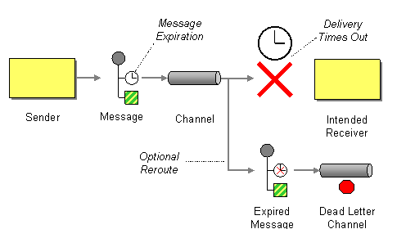

This component timestamps each message passing through (msgTTL is set in the code, default set to 5000ms.) This is done setting by the x-message-ttl param and passing it as args. to queue.declare

Content-based-router component
Next; the different messages gets sorted according to content using the content-based router component
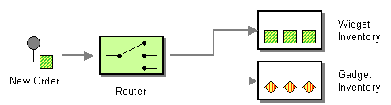

In our case we sort between the types of stock (tech stock and everything else)
Tech stocks are considered ‘ClassA’ and the rest ‘ClassB’
Redirecting the message to correct receiver is done by using the either classA or classB as routingkey

Broker Component
When a new broker is added/joins the system, the broker indicates the following information to the system.
- What type of stock they trade in
- What type of data-format they return their response in (either json or xml)
- Their name
No matter what type of format the broker returns, they add a header field (“resptype”) that indicates the format the message is written in (used by normalizer)

Normalizer component
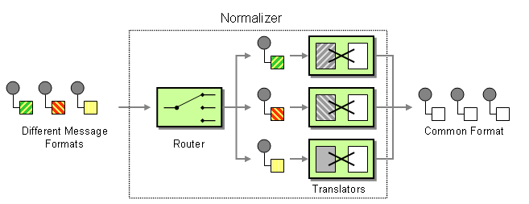
In order to “normalize” the different types of output formats received from the brokers, a Normalizer component is used.

In our case, the internals of this component reads the message header and directs the content to the appropriate parser, the content of the message is converted to json (json → json ¯\_(ツ)_/¯)
All the messages leaving the normalizer component are in “json” - format.

Aggregator component
In order to make sure all brokers have a “chance” to return their offer to the user, the aggregator component has been expanded with a timer (5 secs). Each request has an Id, this is the Id used to couple the messages trickling in before the timing window closes.
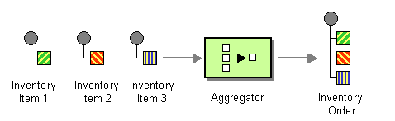

Splitter Component
In order to only server up the best 3 offers to the end user

