BrightMornings
Adam Benjamin

ABSTRACT
There aren’t many worse feelings than waking up in the morning to total darkness. BrightMornings is a sunrise alarm clock that is designed to simulate the sun rising in the morning. By beginning to turn on light gradually beginning 15 minutes before your alarm goes off, you will always wake up to pleasant light, ready to tackle the day ahead of you.

TABLE OF CONTENTS

INTRODUCTION 6
BACKGROUND/PROBLEM STATEMENT 7
SOLUTION 8
CONCLUSION 11
ADDITIONAL RESOURCES 12

[Develop an outline prior to beginning the writing process. The outline will eventually take form as its shorter, more succinct cousin, the Table of Contents. The outline will provide a map and related trails that will keep you on the correct path to meet your originally laid out objectives. It will ensure that your messaging and content are on-target, and the information flows in an easy to follow manner for your readers. The following tips and subsequent section examples provide a good starting point.

Tips:
- DON’T SKIP THE OUTLINE. Yup, the first tip is that you shouldn’t skip the process of creating an outline. Yes, it will take time and delay start of the writing process; however, it will save you an enormous amount of time in the long run, and more importantly, ensure that you have a better final product.
- Target your audience’s needs. It is of the utmost importance that you create a white paper that is focused on the readers’ needs, interests and/or pain points. Take a non-egocentric approach to your content creation, minimizing the attention that you spend on your company and its products. In most cases, there are plenty of other formats to provide company or product-specific information to your audience. (e.g., data sheets) For additional tips on how to align with audience needs, refer to “The Four Steps to Content Marketing Enlightenment”.
- Collaborate with your team for creation of the outline. As the foundational design of your white paper, modifying your course at this stage will be much easier than having to change direction once the white paper is written. Therefore, include team members as part of development and review of the outline to ensure that your white paper plan is on target. Here are some tips about collaborating across your organization.
- Plan on many revisions. Creation of an outline is an iterative process. Don’t hesitate to modify its design during the process.
- Maintain flexibility. Although the outline is intended to be the map or architecture for writing your white paper, maintain the flexibility to adjust your outline as necessary once writing begins.
- Map out sections and subsections. It is important to break up your text into several sections, including section headers and subheads within each section. This increases readability and allows your reader to skim through the document and absorb the sections that are most relevant to their business.

The below sections provide just one example of how to structure a white paper.]
INTRODUCTION

[If you’ve done a good job in creating the title and abstract of your white paper, then your readers will now be ready to dive into your story. The introduction is essentially the next level down from the abstract. More specifically, it’s an opportunity to introduce readers to the problem, need or pain point that is the basis of your white paper, as well as the related solution. Just as you did in the abstract, you need to peak your audience’s interest in the introduction and entice them to read further.

Tips:
- Set up the problem, need or pain point right up front.
- Grab your readers’ attention in the first sentence or two. Strive to make a great first impression. (e.g., a controversial and/or bold statement)
- Use data to support your point(s).
- Provide additional detail than what was included in the Abstract, but avoid going into too much detail: Save the details for later sections in the white paper.
- Introduce a framework that may be used throughout the white paper or may even provide background into the topic.
- Indicate the objective(s) of the white paper, as well as what specifically will be included in subsequent sections. Providing a map or structure to the white paper in the introduction will help your audience follow your thought process and understand how the white paper is organized to achieve its objectives.]
BACKGROUND/PROBLEM STATEMENT

[The introduction provided an overview of the white paper. This section offers the opportunity to expand upon this overview, and thoroughly define the problem statement.

Sample questions to be answered in this section:
- What is currently happening in the market today? (i.e., What’s the current situation?)
- What are companies and/or individuals most struggling with and why?
- What are the specific problems, needs and/or pain points?
- What are the potential benefits of addressing these problems, needs and/or pain points? (Answering this question within your white paper will help your readers understand why your solution is of value; and more importantly, it will entice them to continue reading.
- What data points help to support answers to the above questions?
- What frameworks and/or models can be used to enhance readers’ understanding of this information?]
SOLUTION

[You’ve already provided a succinct description of the most impactful solutions in the Abstract, as well as an overview of these solutions in the Introduction. This section provides the opportunity to go into the specifics of the solutions.

Tips:
- Introduce the solution(s), including a clear definition and even a framework or model.
- Provide a detailed description of each part of the solution. Use subcategories as required to help readers draw distinct boundaries between different parts of the solution. Subcategories will also make it easier for your audience to follow your thought process and absorb the content.
- Be very clear regarding the benefits of each of the solutions, including how it specifically impacts your audience.
- Target your solutions to different segments of your audience, thereby improving the relevancy of your content.
- Provide specific, real-world examples to support your solution(s). These examples provide another opportunity to connect with different segments of your audience. (e.g., providing examples that are targeted for 3 different buyer personas)
- Create a figure and/or table as a stand-alone sheet to help readers visualize your solution(s). This sheet can also serve as a stand-alone asset for your readers and/or for your internal sales enablement efforts. A few examples of charts and figures from Curata’s recent studies can be seen below.

FIGURE 1
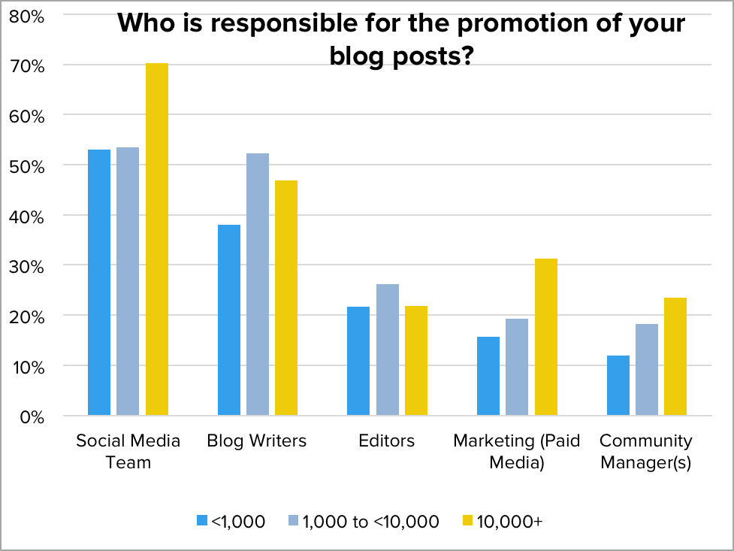
SOURCE: Business Blogging Secrets Revealed

KEY FINDINGS
Bloggers with 10,000+ page views a month:
- They are better aligned with their social media team.
- Their blog writers are more involved with promotion. (not a simple hand-off)
- They better leverage paid media. (especially as companies get larger)

FIGURE 2

Content Marketing Measurement Model

Consumption
Sharing
Retention
Engagement
Content Marketing ROI
Performance
Operations
Cost
Production
Sales Pipeline Impact
Marketing Pipeline Impact
Next Generation
Top of Funnel
Middle of Funnel
BOFU

SOURCE: The Comprehensive Guide to Content Marketing Analytics & Metrics
CONCLUSION

[By this point you’ve told them what you’re going to tell them in the Abstract and Introduction; you’ve told them in the Problem Statement and Solution; and now you need to tell them what you told them. The Conclusion provides the opportunity to:

- Summarize the objectives of the white paper.
- Review the problem statement(s).
- Highlight the solutions and their value for your audience. Be clear regarding how these solutions address the problem statement(s).
- Finish with a strong statement. (e.g., a vision of future solutions; how your audience can develop new solutions on their own; where your audience can go for addition information and/or resources)]

ADDITIONAL RESOURCES

[Provide a list of available resources for your audience. This list may include resources that you have sourced throughout the white paper.]

FOR MORE INFORMATION

Copyright Information [© followed by the year the white paper was published and the name of your company. You can also add “All Rights Reserved” at the end]
For more information, please contact john@doe.com

Additional Tips for Creating White Papers

- Formatting & Coloring: Create a consistent color scheme based on the color of your logo. Use the most dominant color for your section headers. Use a softer version or a shade of gray as the subhead color. Use these same colors throughout all visual elements of your white paper (e.g. charts, graphs or figures).
- Grammar & Editing: Ensure that your white paper has been run through several editors for quality control. Once someone downloads your white paper, it is in his or her possession and you are unable to make further edits. Correct spelling and grammar will elevate your message and back up the credibility of your company.
- Promoting Other Assets: Use the white paper to link to several of your other content marketing assets. These could be other white papers, eBooks or blog posts. Do ensure that these assets are highly relevant to the topic at hand and focused on answers the audience may need, rather than pushing your company’s product.
- Curating Expert Content: Substantiate your message by including content from experts on the topic; either directly getting quotes from these experts or curating their content. Be sure to follow ethical best practices for curating content, such as linking back to the original source, only taking a small portion of the content and adding your own annotation. For a guide to ethical curation, download our complete eBook on the topic: Content Marketing Done Right

