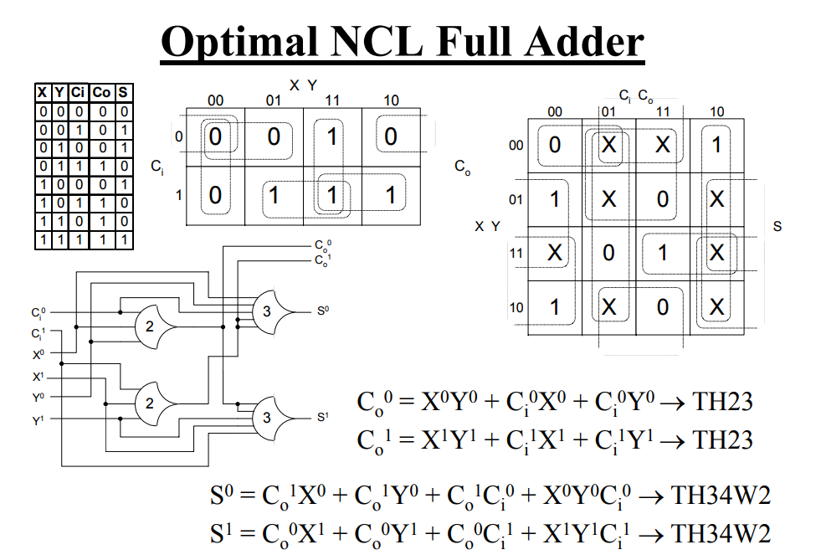

This is the format I’m using to generate the netlist

|  |  |
| --- | --- |
| Variables | Number associated with it |
| Ci 0 | 1 |
| Ci 1 | 2 |
| X0 | 3 |
| X1 | 4 |
| Y0 | 5 |
| Y1 | 6 |
| TopTH23 output | 7 |
| Bottom TH23 output | 8 |
| S0 | 9 |
| S1 | 10 |

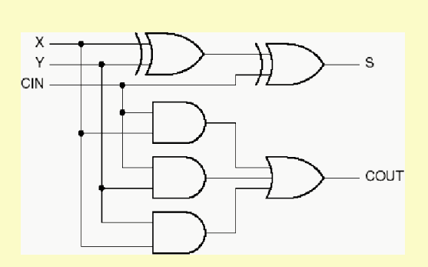

|  |  |
| --- | --- |
| Variables | Number associated with it |
| X | 1 |
| Y | 2 |
| Cin | 3 |
| S | 8 |
| Cout | 9 |
| 1st XOR output | 4 |
| 1st AND | 5 |
| 2nd AND | 5 |
| 3rd AND | 6 |