Parent and Provider Perceptions of Behavioral Healthcare in Pediatric Primary Care (PI: Andrew Riley; BDP2-262)

Benjamin Chan (chanb@ohsu.edu)

2018-07-11

# Import Andrew’s SPSS data

Map new names to variables.

|  |  |
| --- | --- |
| oldnames | newnames |
| record_id | id |
| eng_span | languageSurvey |
| children_totv_1 | totalChildren |
| oldest_middle_youngest | birthOrder |
| child_sexv_1 | childSex |
| child_age_years | childAge |
| child_ethnicity | childEthnicity |
| child_racev_1___1 | childRaceWhite |
| child_racev_1___2 | childRaceAsian |
| child_racev_1___3 | childRaceAfrAm |
| child_racev_1___4 | childRaceAIAN |
| child_racev_1___5 | childRaceNHPI |
| child_racev_1___6 | childRaceOther |
| child_racev_1___7 | childRaceNoResp |
| related_child | childRelationship |
| gender | parentGender |
| parent_sexv_1 | parentSex |
| parent_agev_1 | parentAge |
| parent_ethnicity | parentEthnicity |
| parent_race___1 | parentRaceWhite |
| parent_race___2 | parentRaceAsian |
| parent_race___3 | parentRaceAfrAm |
| parent_race___4 | parentRaceAIAN |
| parent_race___5 | parentRaceNHPI |
| parent_race___6 | parentRaceOther |
| parent_race___7 | parentRaceNoResp |
| marital_status | parentMaritalStatus |
| parenting_situationv_1 | parentSituation |
| number_parents | parentsNumber |
| parent_to_child_ratio | parentChildRatio |
| zipcode_classification_combined | zipcodeClass |
| zipcode | zipcode |
| community_type | community |
| distance | distance |
| parent_educationv_1 | parentEducation |
| annual_income | income |
| internet | internet |
| ECBI_intensity_raw_score | ECBI_intensity_raw_score |
| ECBI_intensity_T_score | ECBI_intensity_T_score |
| ECBI_intensity_clinical_cutoff | ECBI_intensity_clinical_cutoff |
| ECBI_problem_raw_score | ECBI_problem_raw_score |
| ECBI_problem_T_score | ECBI_problem_T_score |
| ECBI_problem_clinical_cutoff | ECBI_problem_clinical_cutoff |
| ECBI_Opp | ECBI_Opp |
| ECBI_Inatt | ECBI_Inatt |
| ECBI_Cond | ECBI_Cond |
| MAPS_PP | MAPS_PP |
| MAPS_PR | MAPS_PR |
| MAPS_WM | MAPS_WM |
| MAPS_SP | MAPS_SP |
| MAPS_HS | MAPS_HS |
| MAPS_LC | MAPS_LC |
| MAPS_PC | MAPS_PC |
| MAPS_POS | MAPS_POS |
| MAPS_NEG | MAPS_NEG |
| SEPTI_nurturance | SEPTI_nurturance |
| SEPTI_n_clinical_cutoff | SEPTI_n_clinical_cutoff |
| SEPTI_discipline | SEPTI_discipline |
| SEPTI_d_clinical_cutoff | SEPTI_d_clinical_cutoff |
| SEPTI_play | SEPTI_play |
| SEPTI_p_clinical_cutoff | SEPTI_p_clinical_cutoff |
| SEPTI_routine | SEPTI_routine |
| SEPTI_r_clinical_cutoff | SEPTI_r_clinical_cutoff |
| SEPTI_total | SEPTI_total |
| SEPTI_total_clin_cutoff | SEPTI_total_clin_cutoff |
| PCB1_Total | PCB1_Total |
| PCB1_CondEmot | PCB1_CondEmot |
| PCB1_DevHab | PCB1_DevHab |
| PCB2_Tot | PCB2_Tot |
| PCB3_Total | PCB3_Total |
| PBC3_PCPonly | PCB3_PCPonly |
| PCB3_Person | PCB3_Person |
| PCB3_Resource | PCB3_Resource |

## Warning: package 'bindrcpp' was built under R version 3.4.4

Remove certain predictor variables:

* Clinical cutoffs
* Raw scores
* Total scores

## [1] "ECBI_intensity_raw_score" "ECBI_intensity_clinical_cutoff"  
## [3] "ECBI_problem_raw_score" "ECBI_problem_clinical_cutoff"   
## [5] "SEPTI_n_clinical_cutoff" "SEPTI_d_clinical_cutoff"   
## [7] "SEPTI_p_clinical_cutoff" "SEPTI_r_clinical_cutoff"   
## [9] "SEPTI_total" "SEPTI_total_clin_cutoff"

Build analysis data set. Exclude if missing any dependent variable, PCB1_Total, PCB2_Tot, PCB3_Total. Exclude rows if there are a high proportion of row-wise NA.

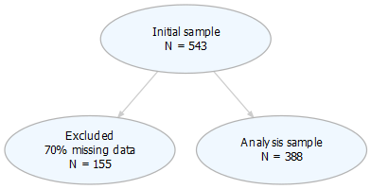

figures/flowChart.png

# Cluster analysis

Use divisive hierarchical clustering (DIANA). See [Divisive Hierarchical Clustering Essentials](http://www.sthda.com/english/articles/28-hierarchical-clustering-essentials/94-divisive-hierarchical-clustering-essentials/).

## Warning: package 'cluster' was built under R version 3.4.4

## Warning: package 'factoextra' was built under R version 3.4.4

## Welcome! Related Books: `Practical Guide To Cluster Analysis in R` at https://goo.gl/13EFCZ

##   
## To cite package 'factoextra' in publications use:  
##   
## Alboukadel Kassambara and Fabian Mundt (2017). factoextra:  
## Extract and Visualize the Results of Multivariate Data Analyses.  
## R package version 1.0.5.  
## https://CRAN.R-project.org/package=factoextra  
##   
## A BibTeX entry for LaTeX users is  
##   
## @Manual{,  
## title = {factoextra: Extract and Visualize the Results of Multivariate Data Analyses},  
## author = {Alboukadel Kassambara and Fabian Mundt},  
## year = {2017},  
## note = {R package version 1.0.5},  
## url = {https://CRAN.R-project.org/package=factoextra},  
## }

Use the **manhattan** metric.

## Cluster on PCB metrics

**Clustering on PCB metrics isn’t terrible.**

* Cluster 1 () has high PCB scores on all domains
* Cluster 2 () has low PCB scores on all domains

## [1] 345 8

## [1] "PCB1_Total" "PCB1_CondEmot" "PCB1_DevHab" "PCB2_Tot"   
## [5] "PCB3_Total" "PCB3_PCPonly" "PCB3_Person" "PCB3_Resource"

## cluster size ave.sil.width  
## 1 1 253 0.43  
## 2 2 92 0.31

* Hopkins statistic is 0.254
* Analysis identified clusters
* Divisive coefficient is 0.929
* Average silhouette width is 0.394

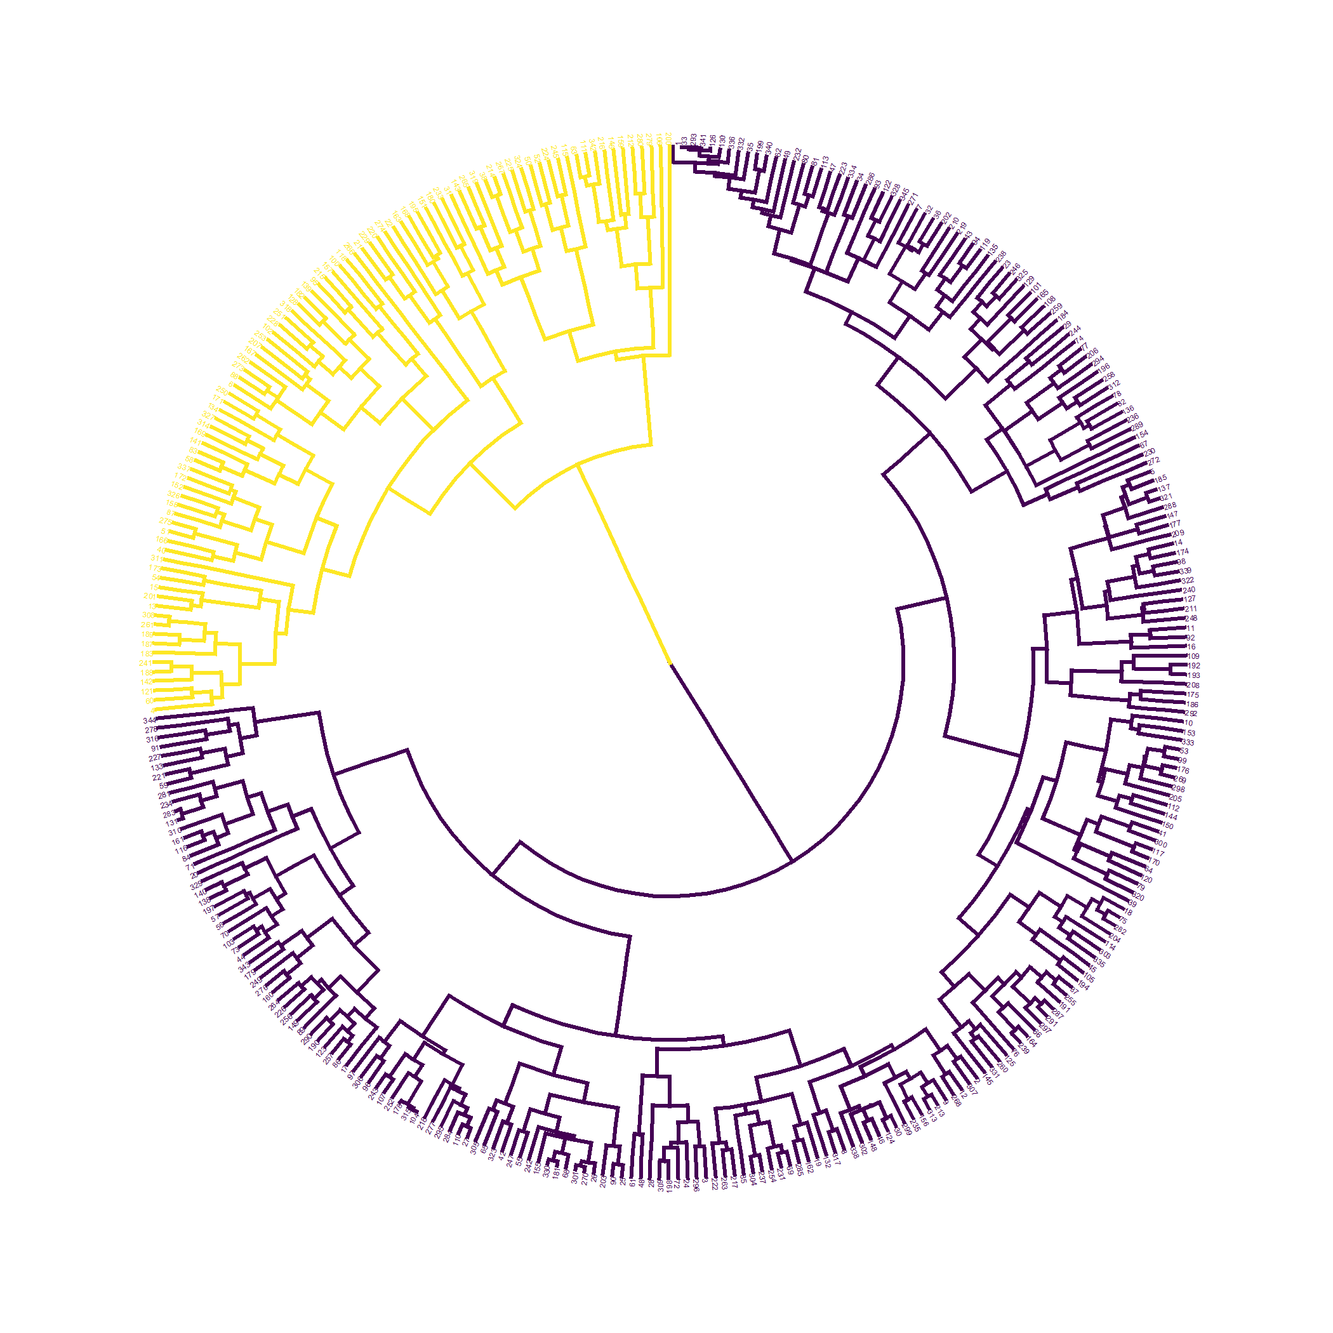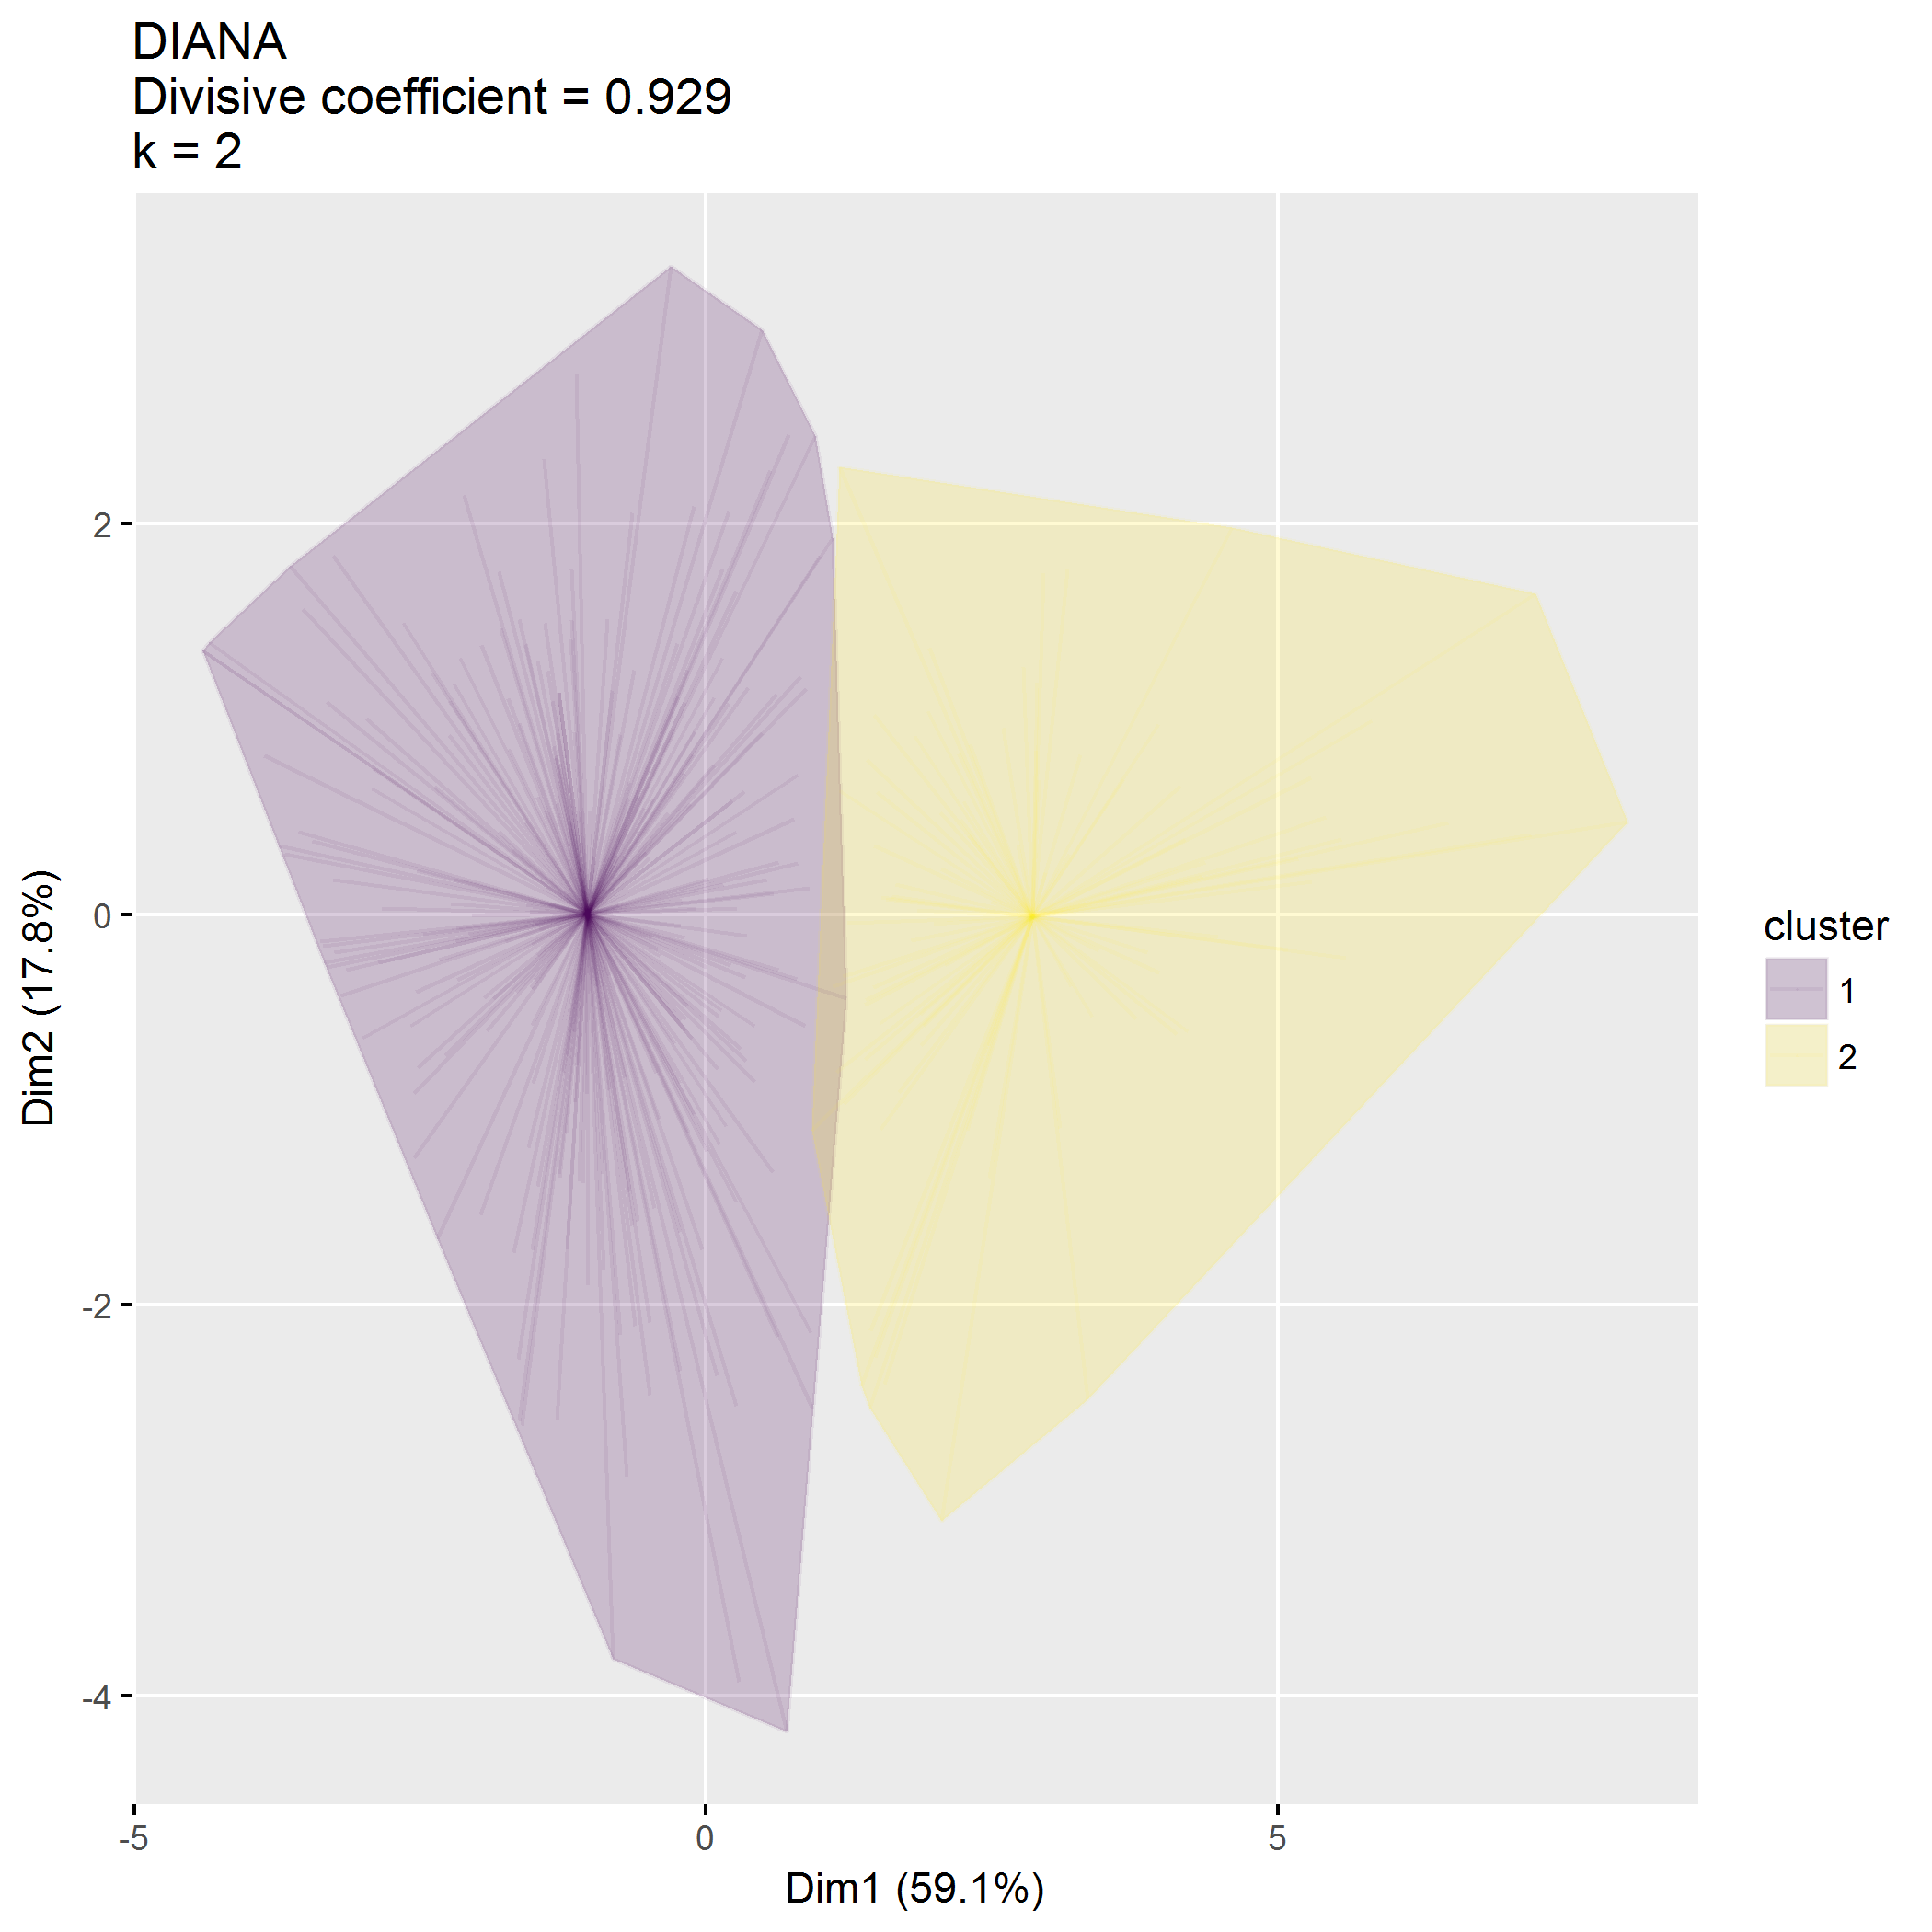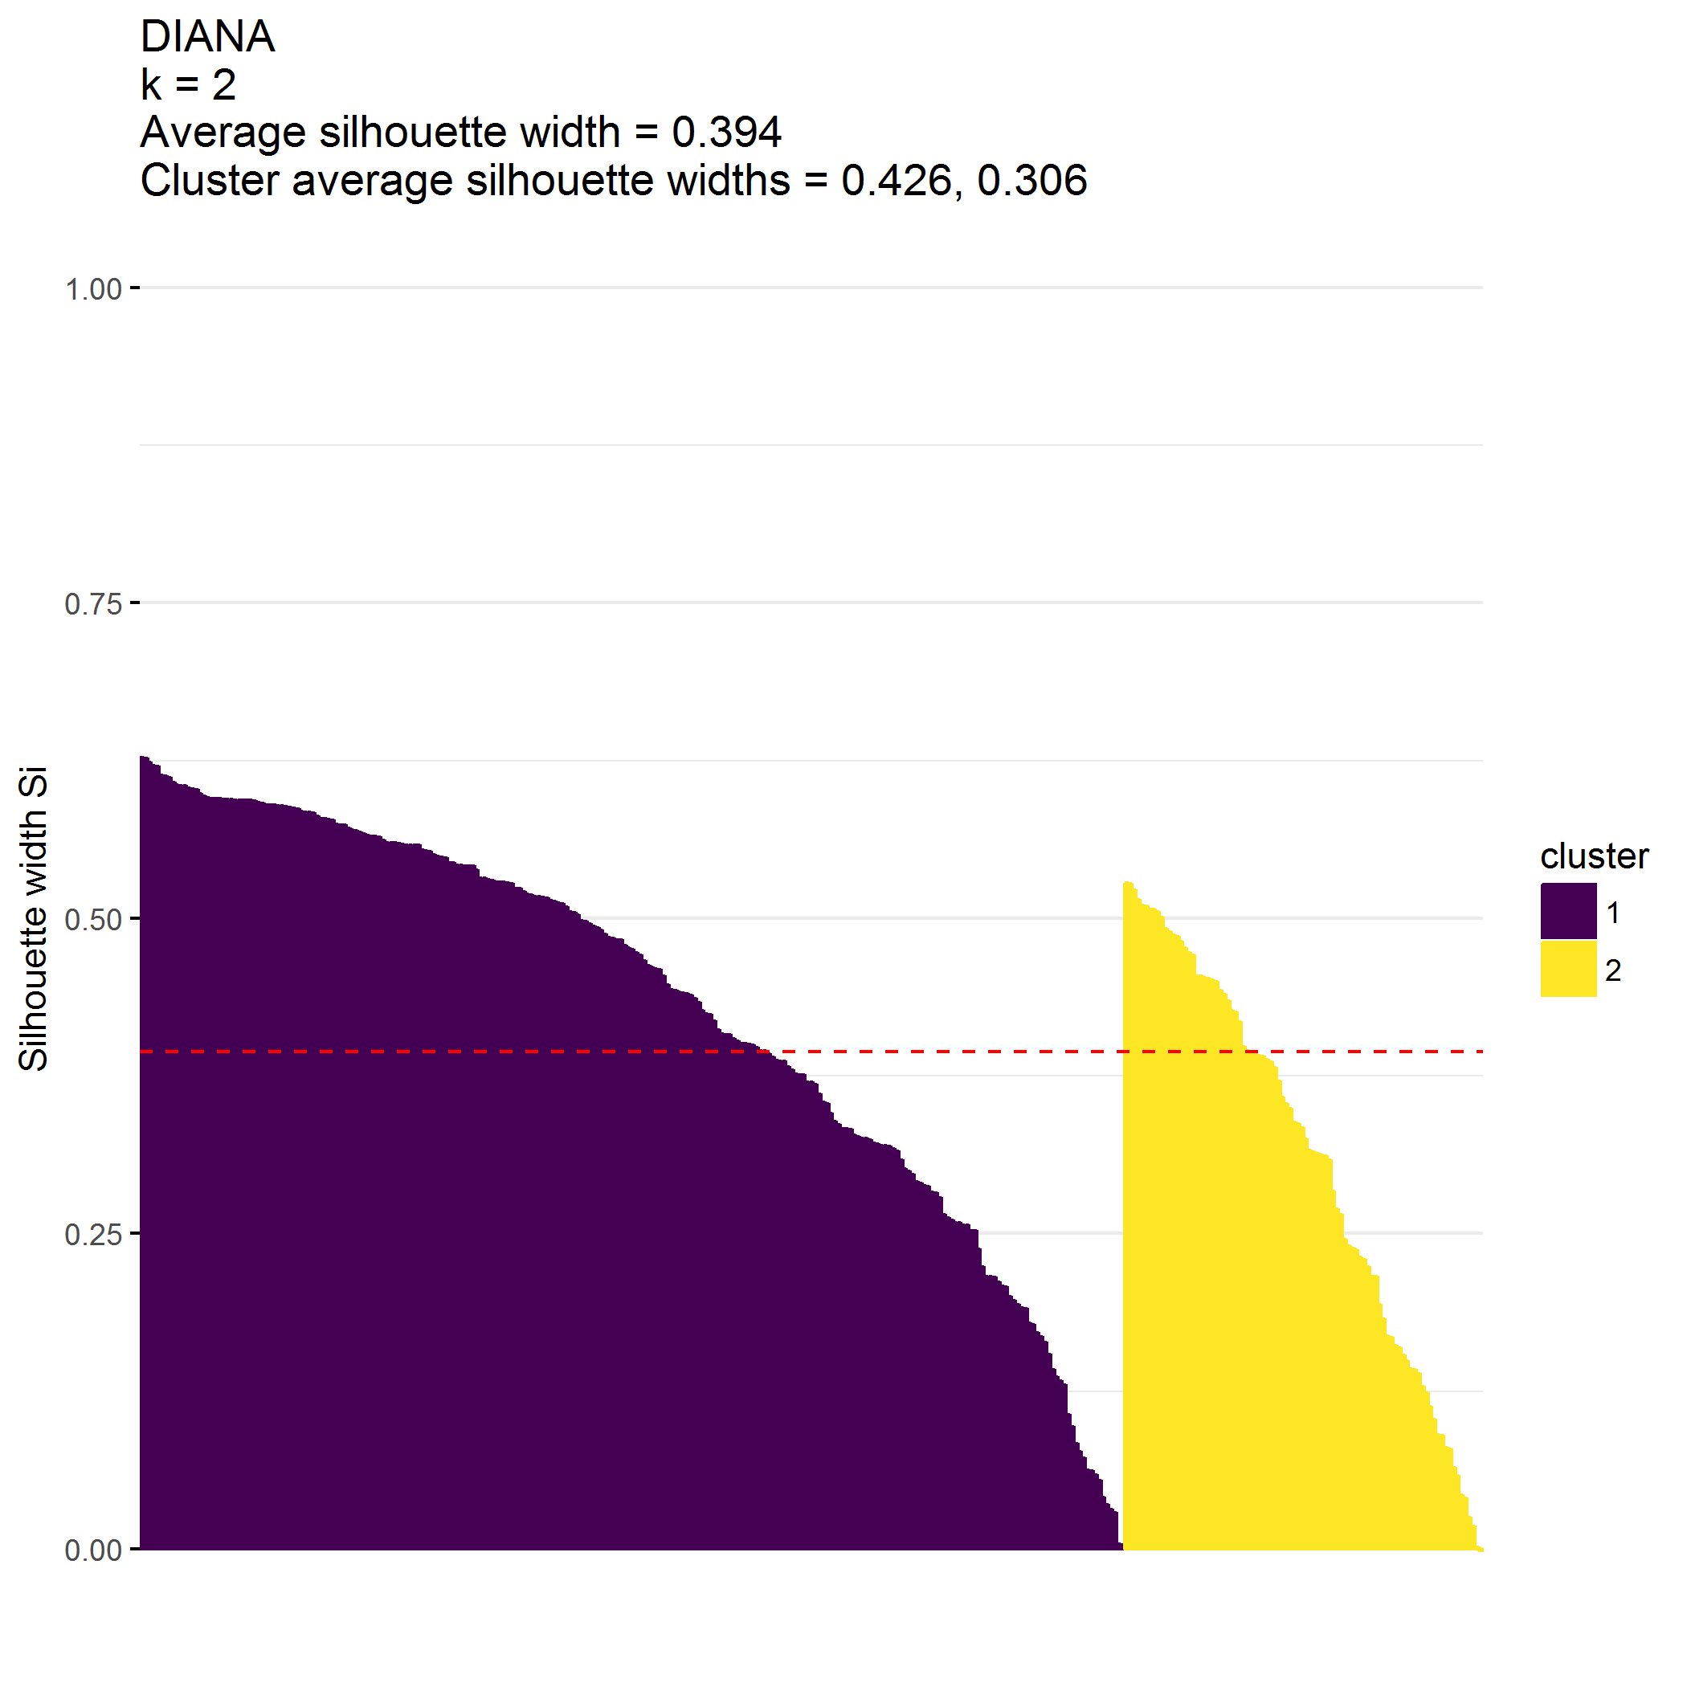

|  |  |  |  |  |
| --- | --- | --- | --- | --- |
| cluster | n | PCB1_Total_mean | PCB1_CondEmot_mean | PCB1_DevHab_mean |
| 1 | 253 | 74.0 | 53.7 | 20.3 |
| 2 | 92 | 47.1 | 33.6 | 13.5 |

|  |  |  |
| --- | --- | --- |
| cluster | n | PCB2_Tot_mean |
| 1 | 253 | 25.9 |
| 2 | 92 | 20.0 |

|  |  |  |  |  |  |
| --- | --- | --- | --- | --- | --- |
| cluster | n | PCB3_Total_mean | PCB3_PCPonly_mean | PCB3_Person_mean | PCB3_Resource_mean |
| 1 | 253 | 51.7 | 4.4 | 17.4 | 30 |
| 2 | 92 | 34.2 | 3.3 | 11.9 | 19 |

## Cluster on ECBI metrics

**Clustering on ECBI alone is good**

* Cluster 1 () has low ECBI scores
* Cluster 2 () has high ECBI scores

## [1] 345 5

## [1] "ECBI_intensity_T_score" "ECBI_problem_T_score"   
## [3] "ECBI_Opp" "ECBI_Inatt"   
## [5] "ECBI_Cond"

## cluster size ave.sil.width  
## 1 1 258 0.45  
## 2 2 87 0.33

* Hopkins statistic is 0.197
* Analysis identified clusters
* Divisive coefficient is 0.950
* Average silhouette width is 0.419

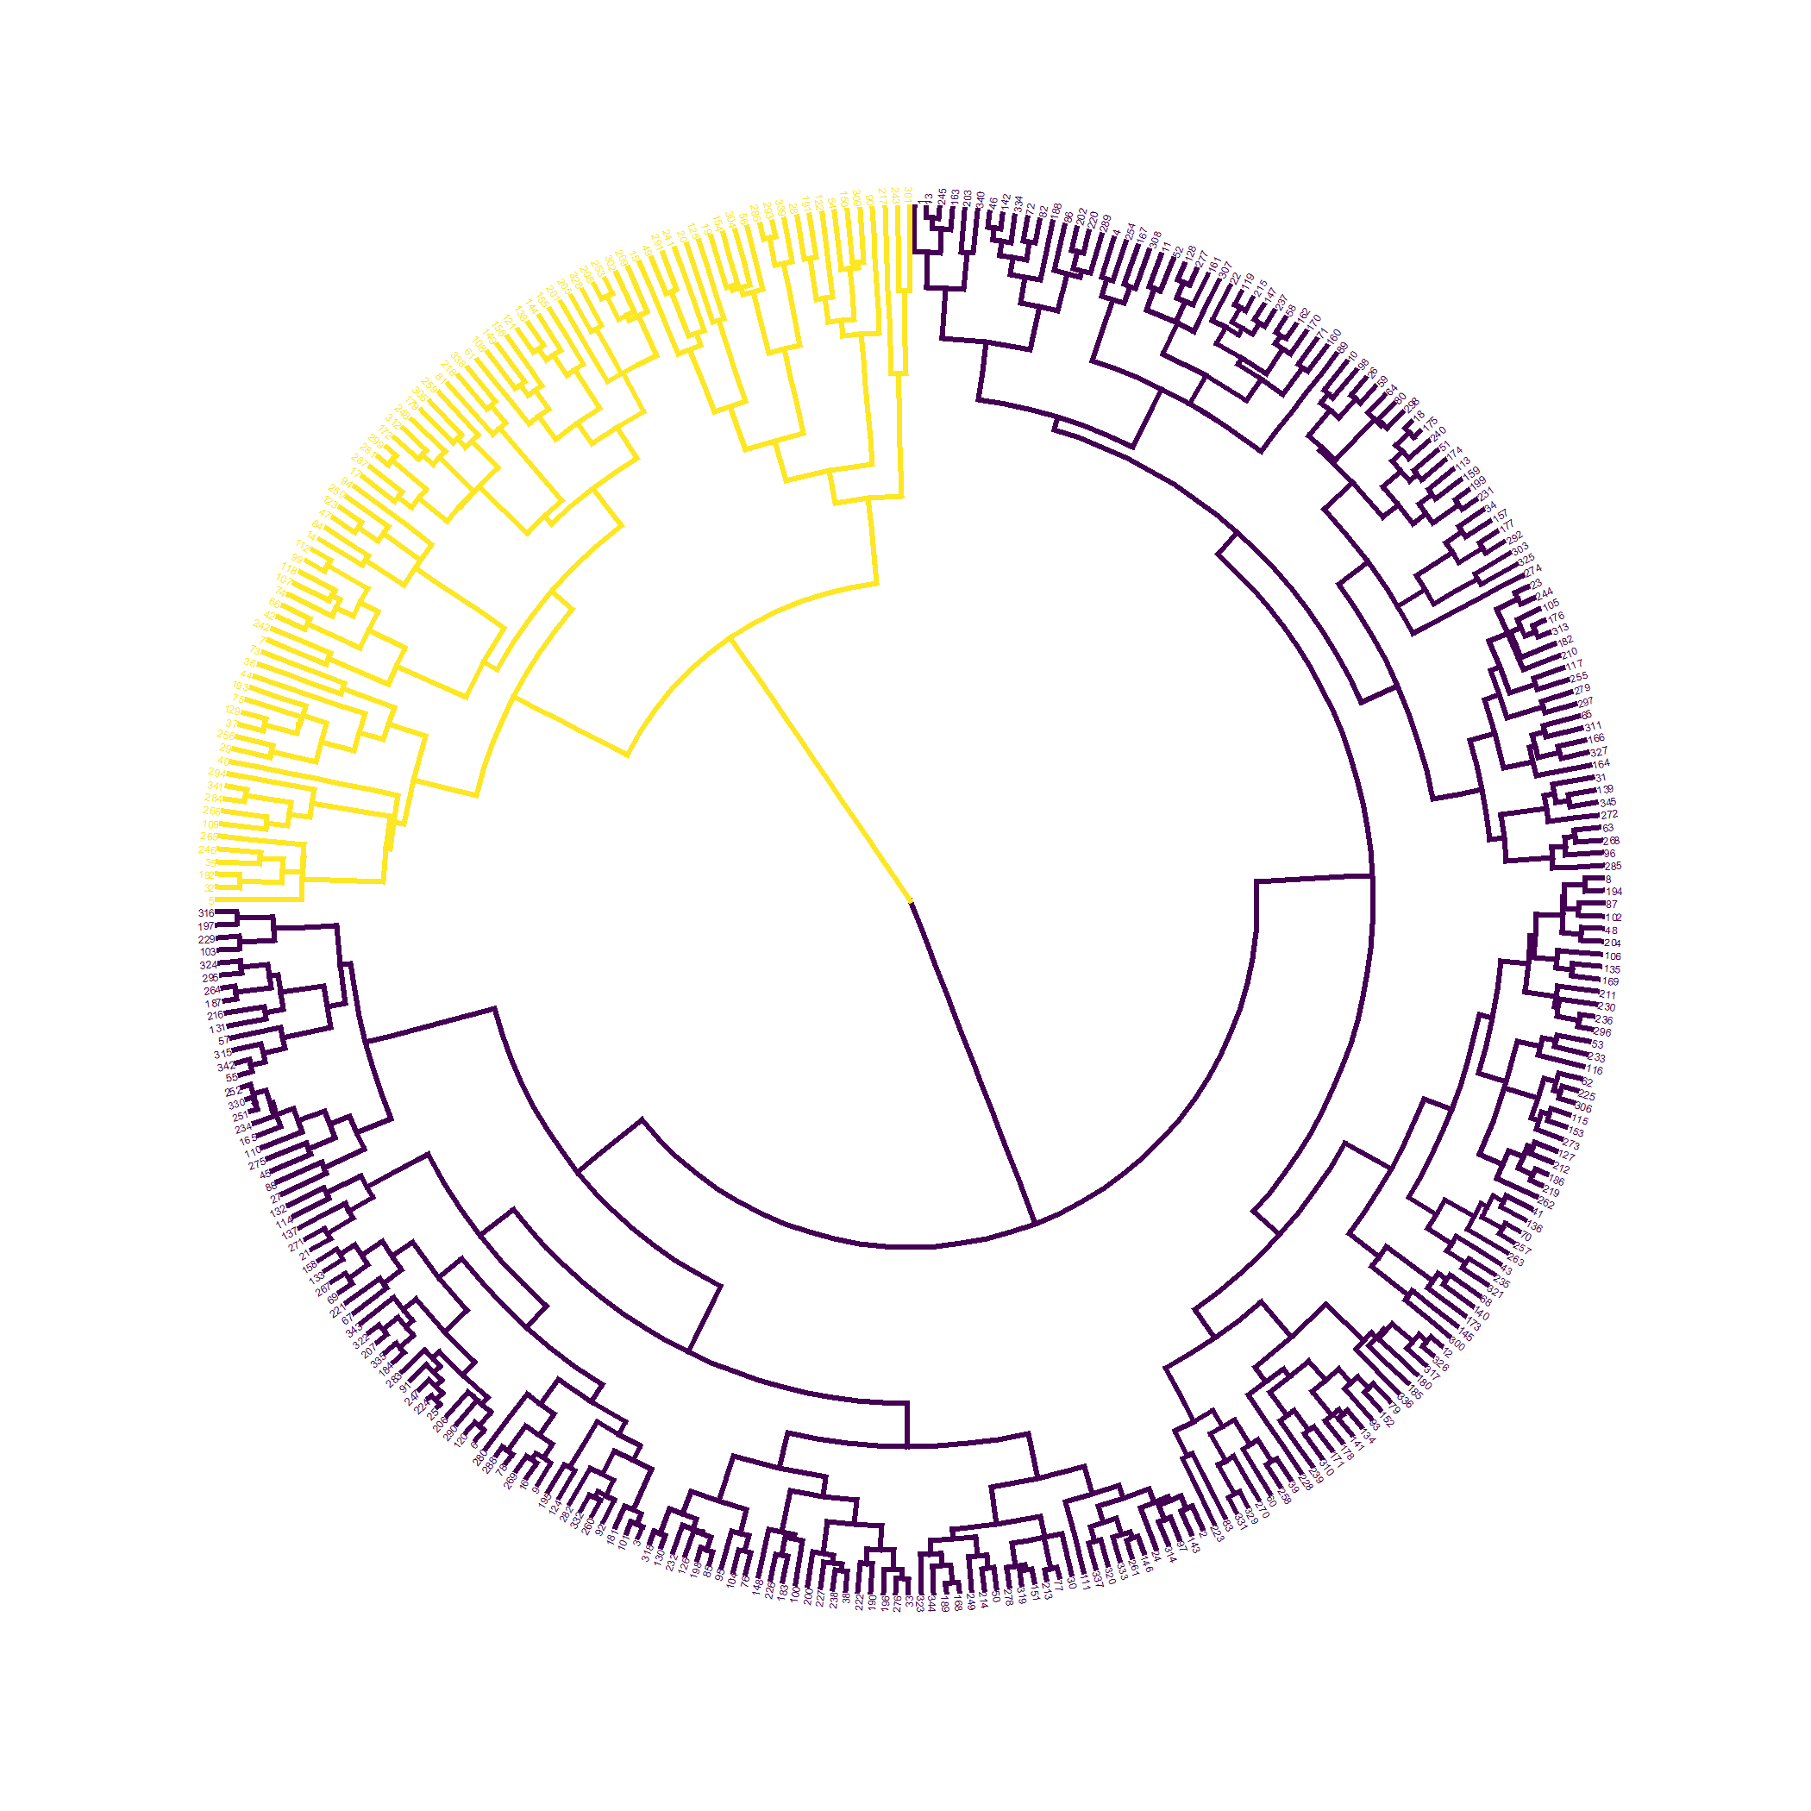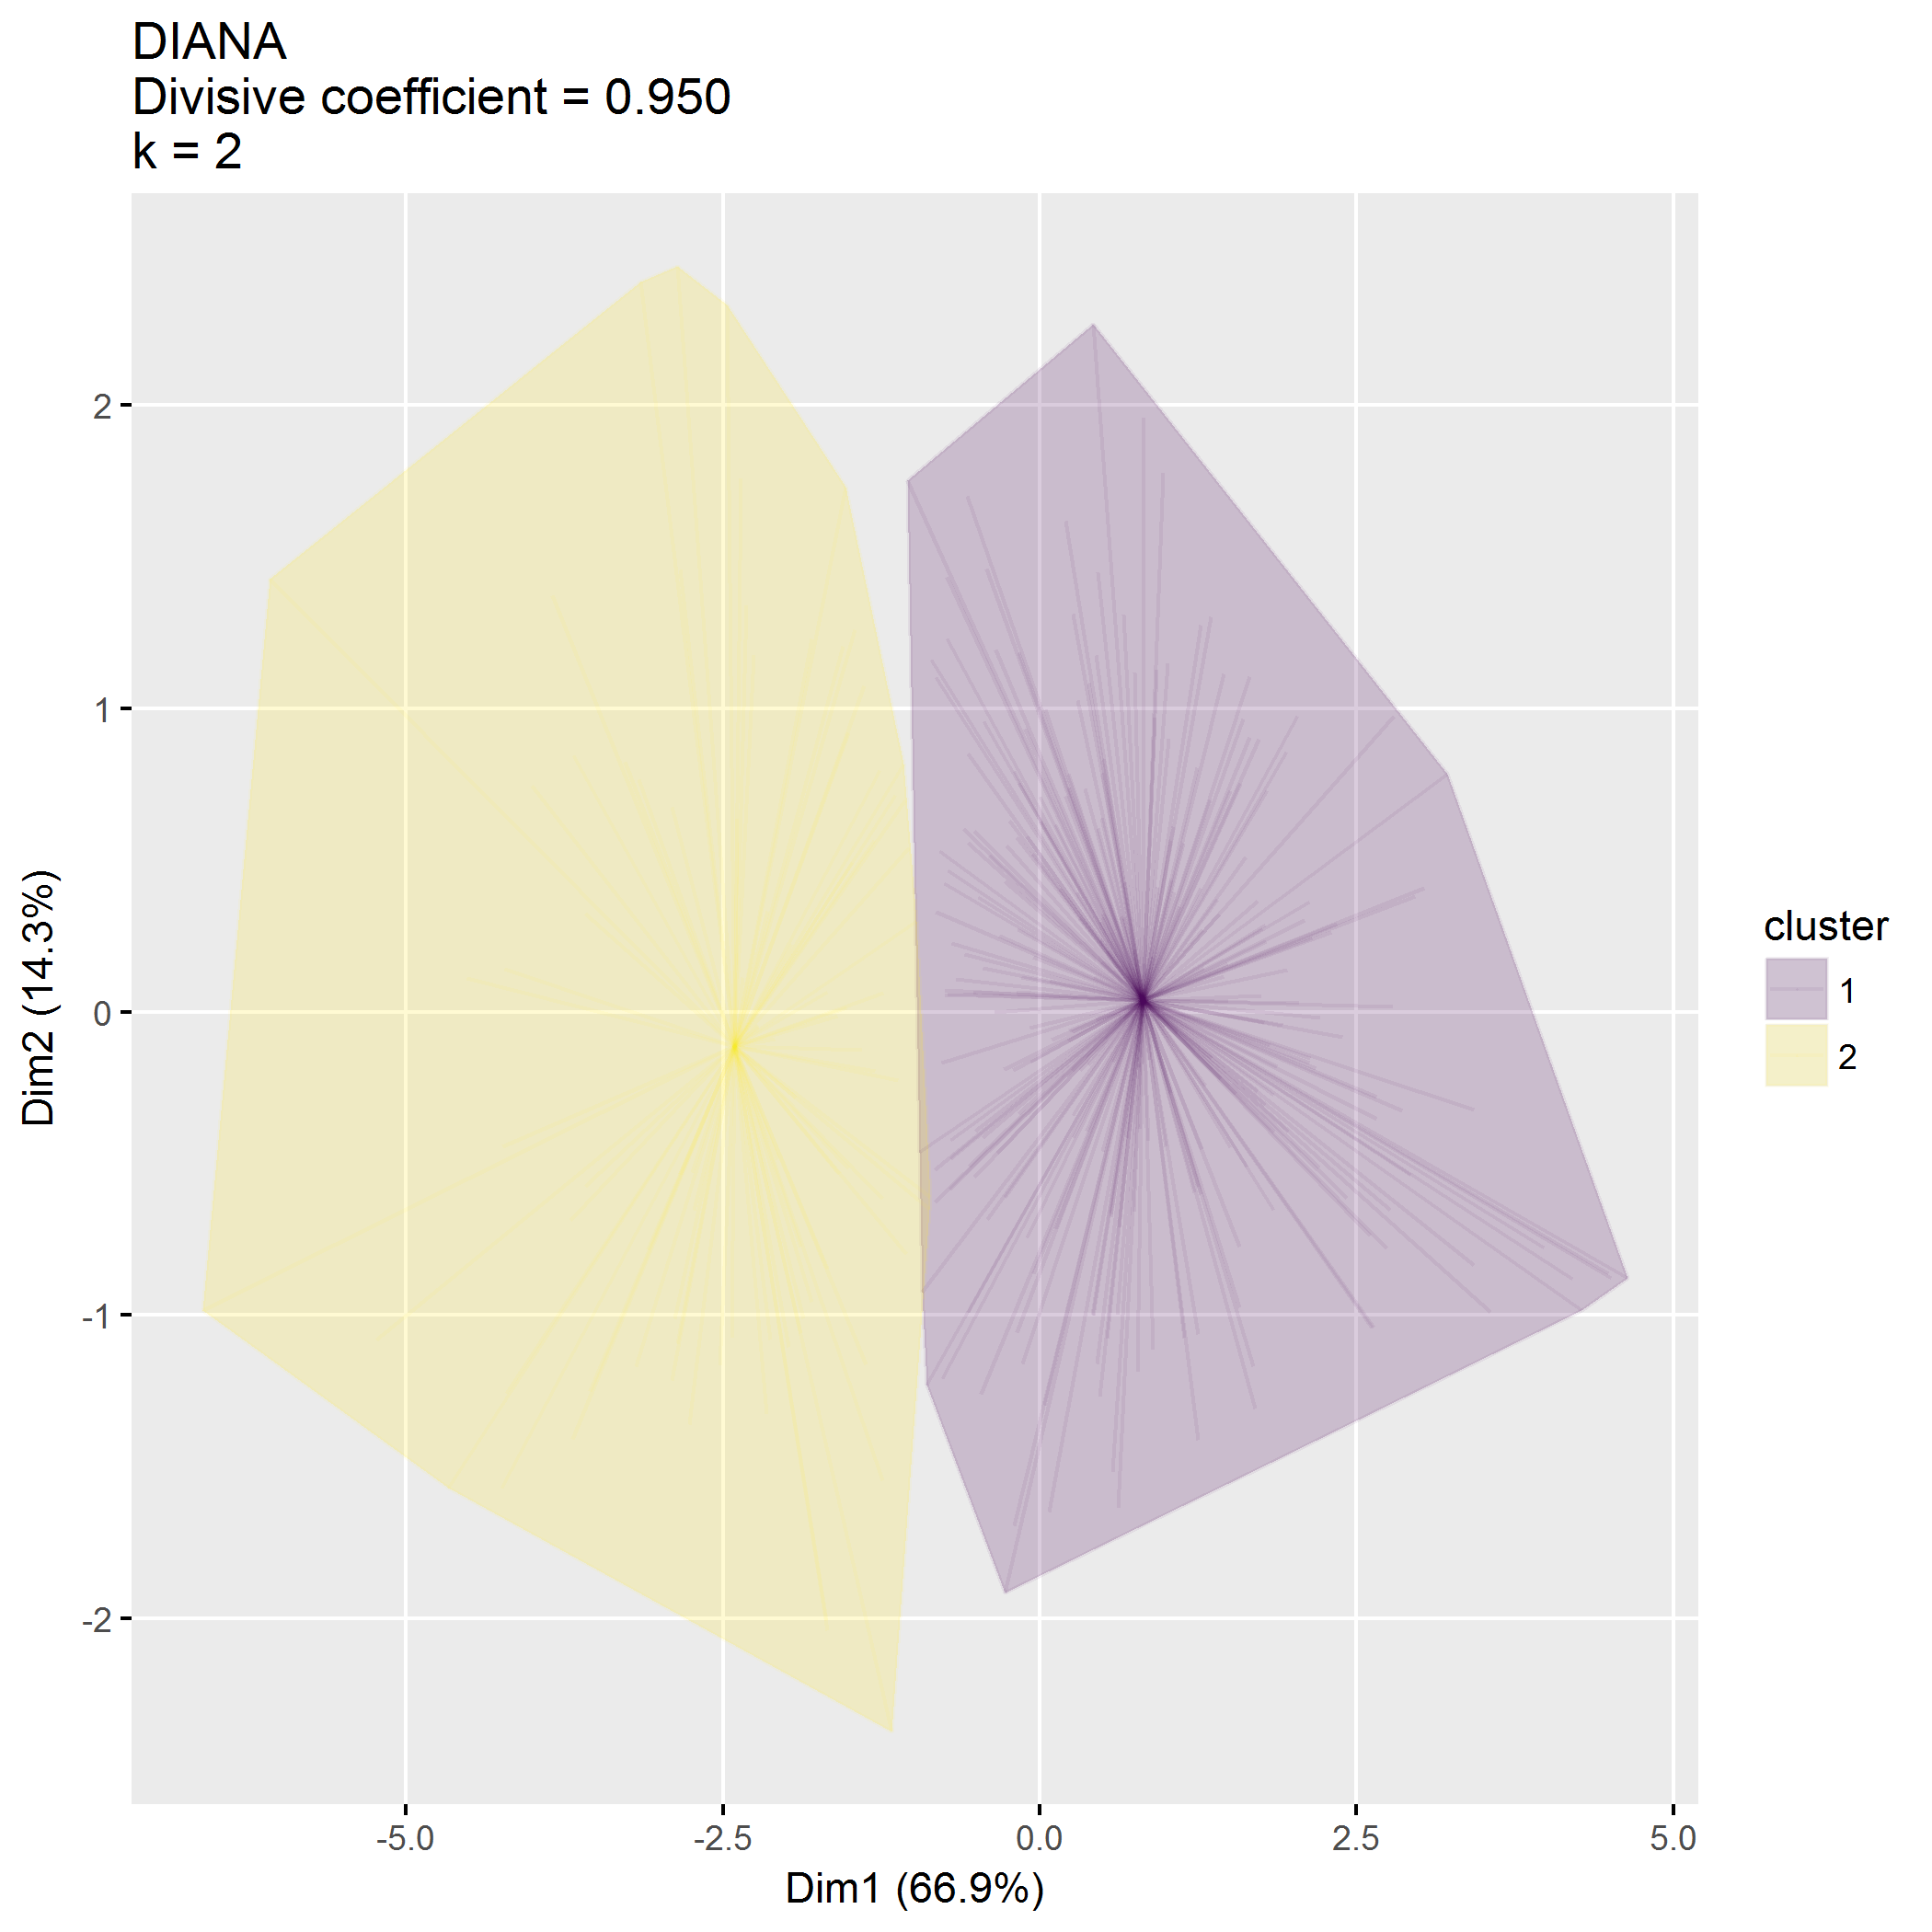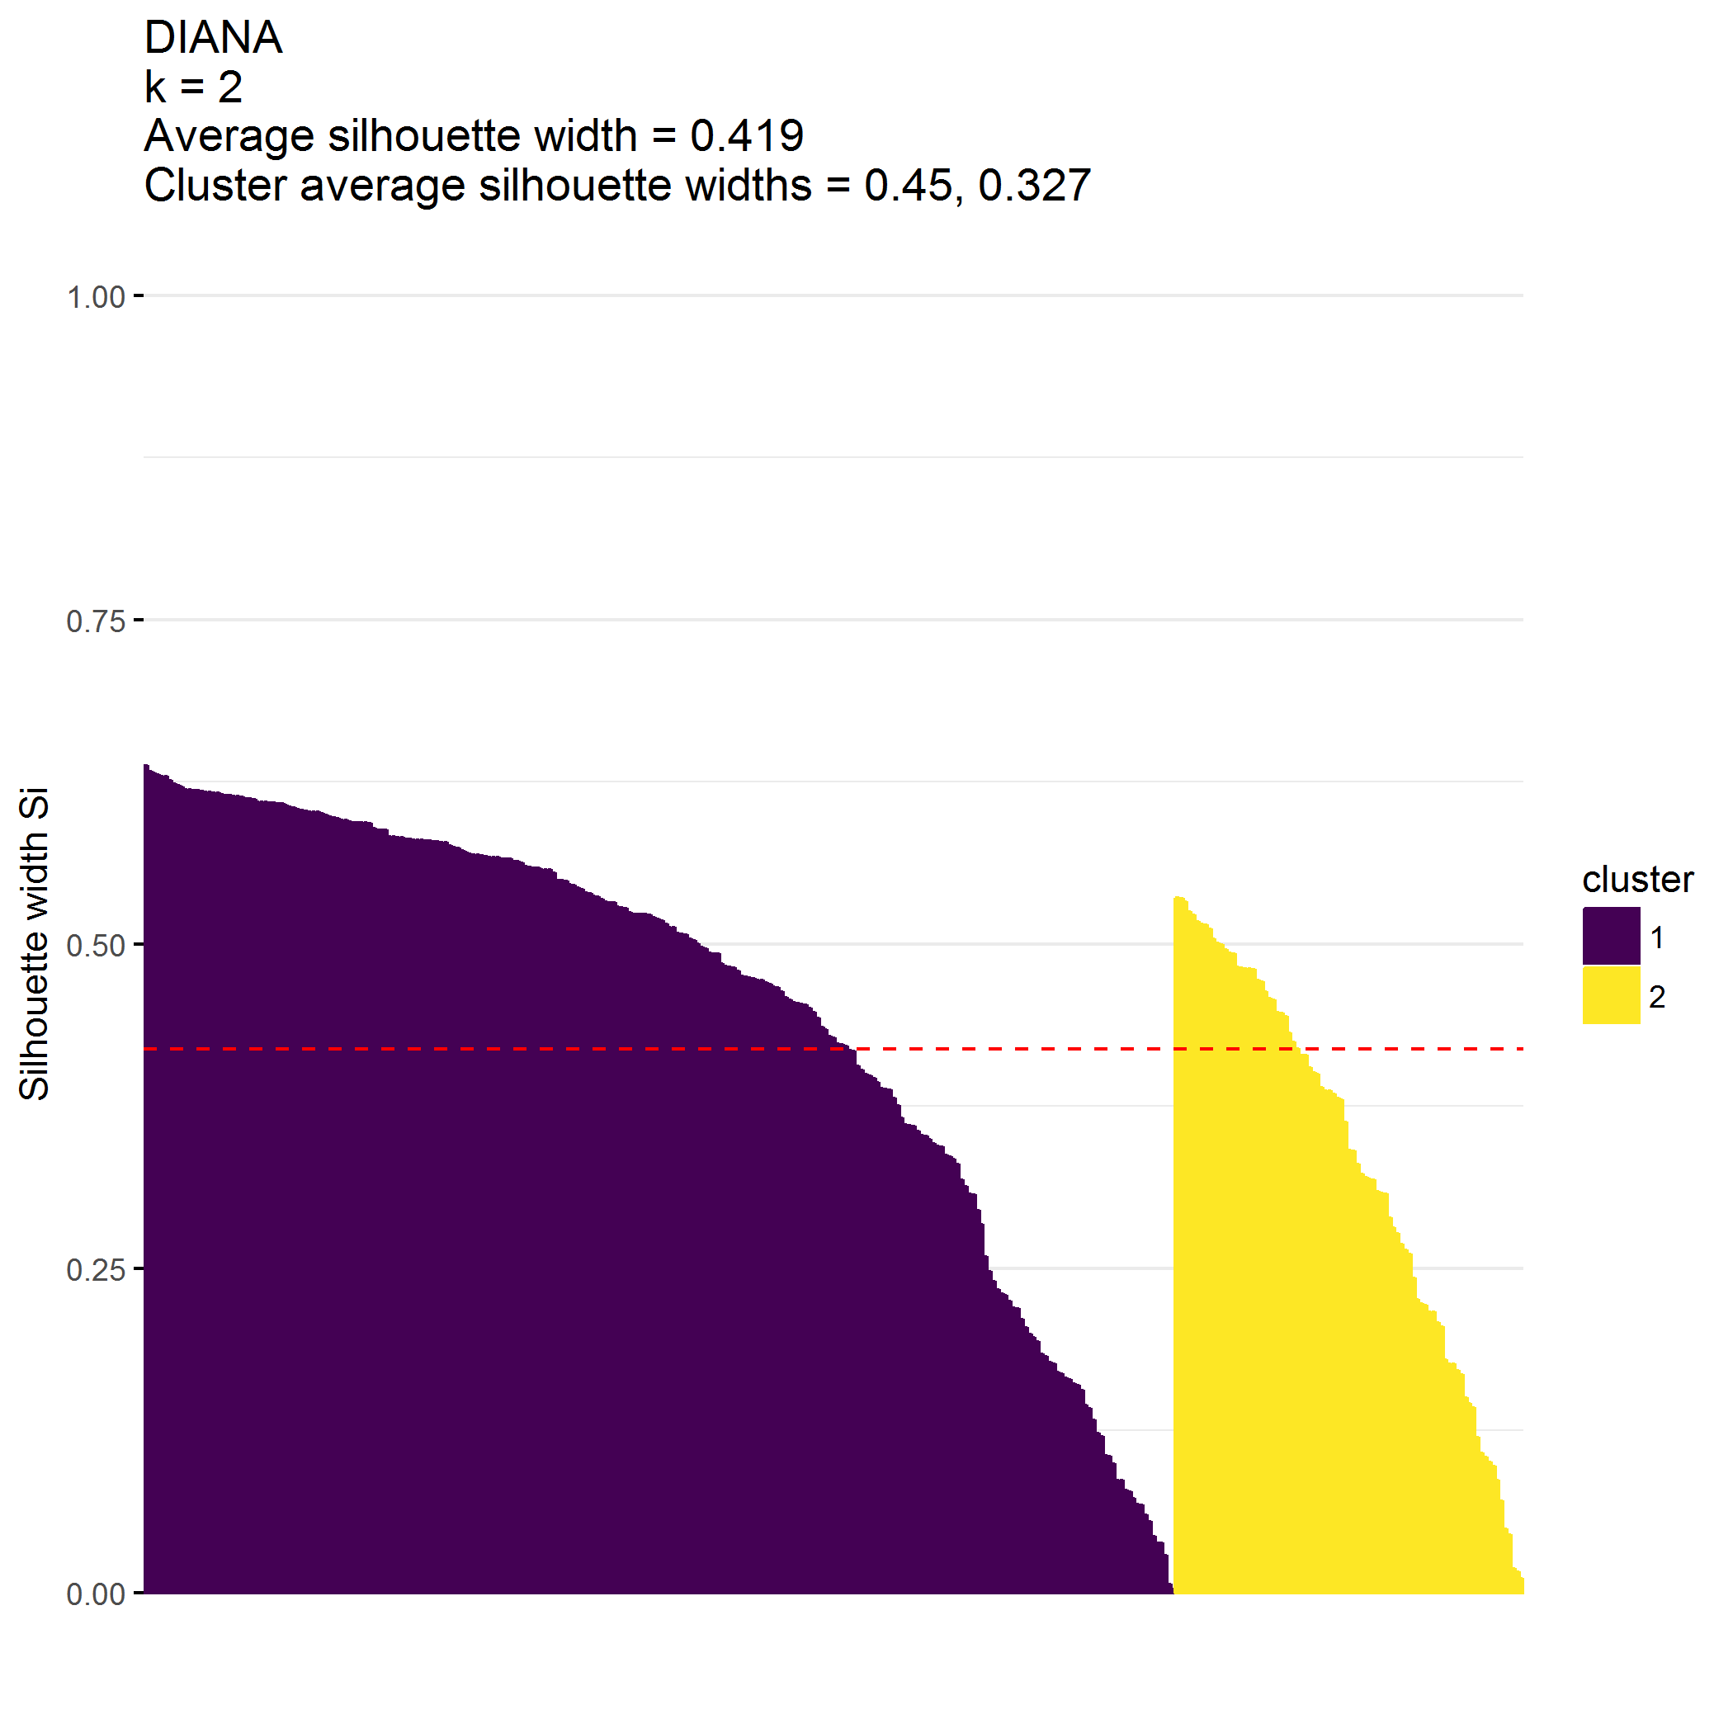

|  |  |  |  |  |  |  |
| --- | --- | --- | --- | --- | --- | --- |
| cluster | n | ECBI_intensity_T_score_mean | ECBI_problem_T_score_mean | ECBI_Opp_mean | ECBI_Inatt_mean | ECBI_Cond_mean |
| 1 | 258 | 50.7 | 49.8 | 30.1 | 12.4 | 13.4 |
| 2 | 87 | 62.4 | 65.4 | 43.7 | 16.9 | 21.9 |

## Cluster on MAPS metrics

**Clustering on MAPS alone is good**

* Cluster 1 () has high *positive* MAPS scores
* Cluster 2 () has high *negative* MAPS scores
* Cluster 3 () is an outlier with low positive and low negative MAPS scores

## [1] 345 9

## [1] "MAPS_PP" "MAPS_PR" "MAPS_WM" "MAPS_SP" "MAPS_HS" "MAPS_LC"   
## [7] "MAPS_PC" "MAPS_POS" "MAPS_NEG"

## cluster size ave.sil.width  
## 1 1 305 0.45  
## 2 2 39 0.30  
## 3 3 1 0.00

* Hopkins statistic is 0.213
* Analysis identified clusters
* Divisive coefficient is 0.923
* Average silhouette width is 0.436

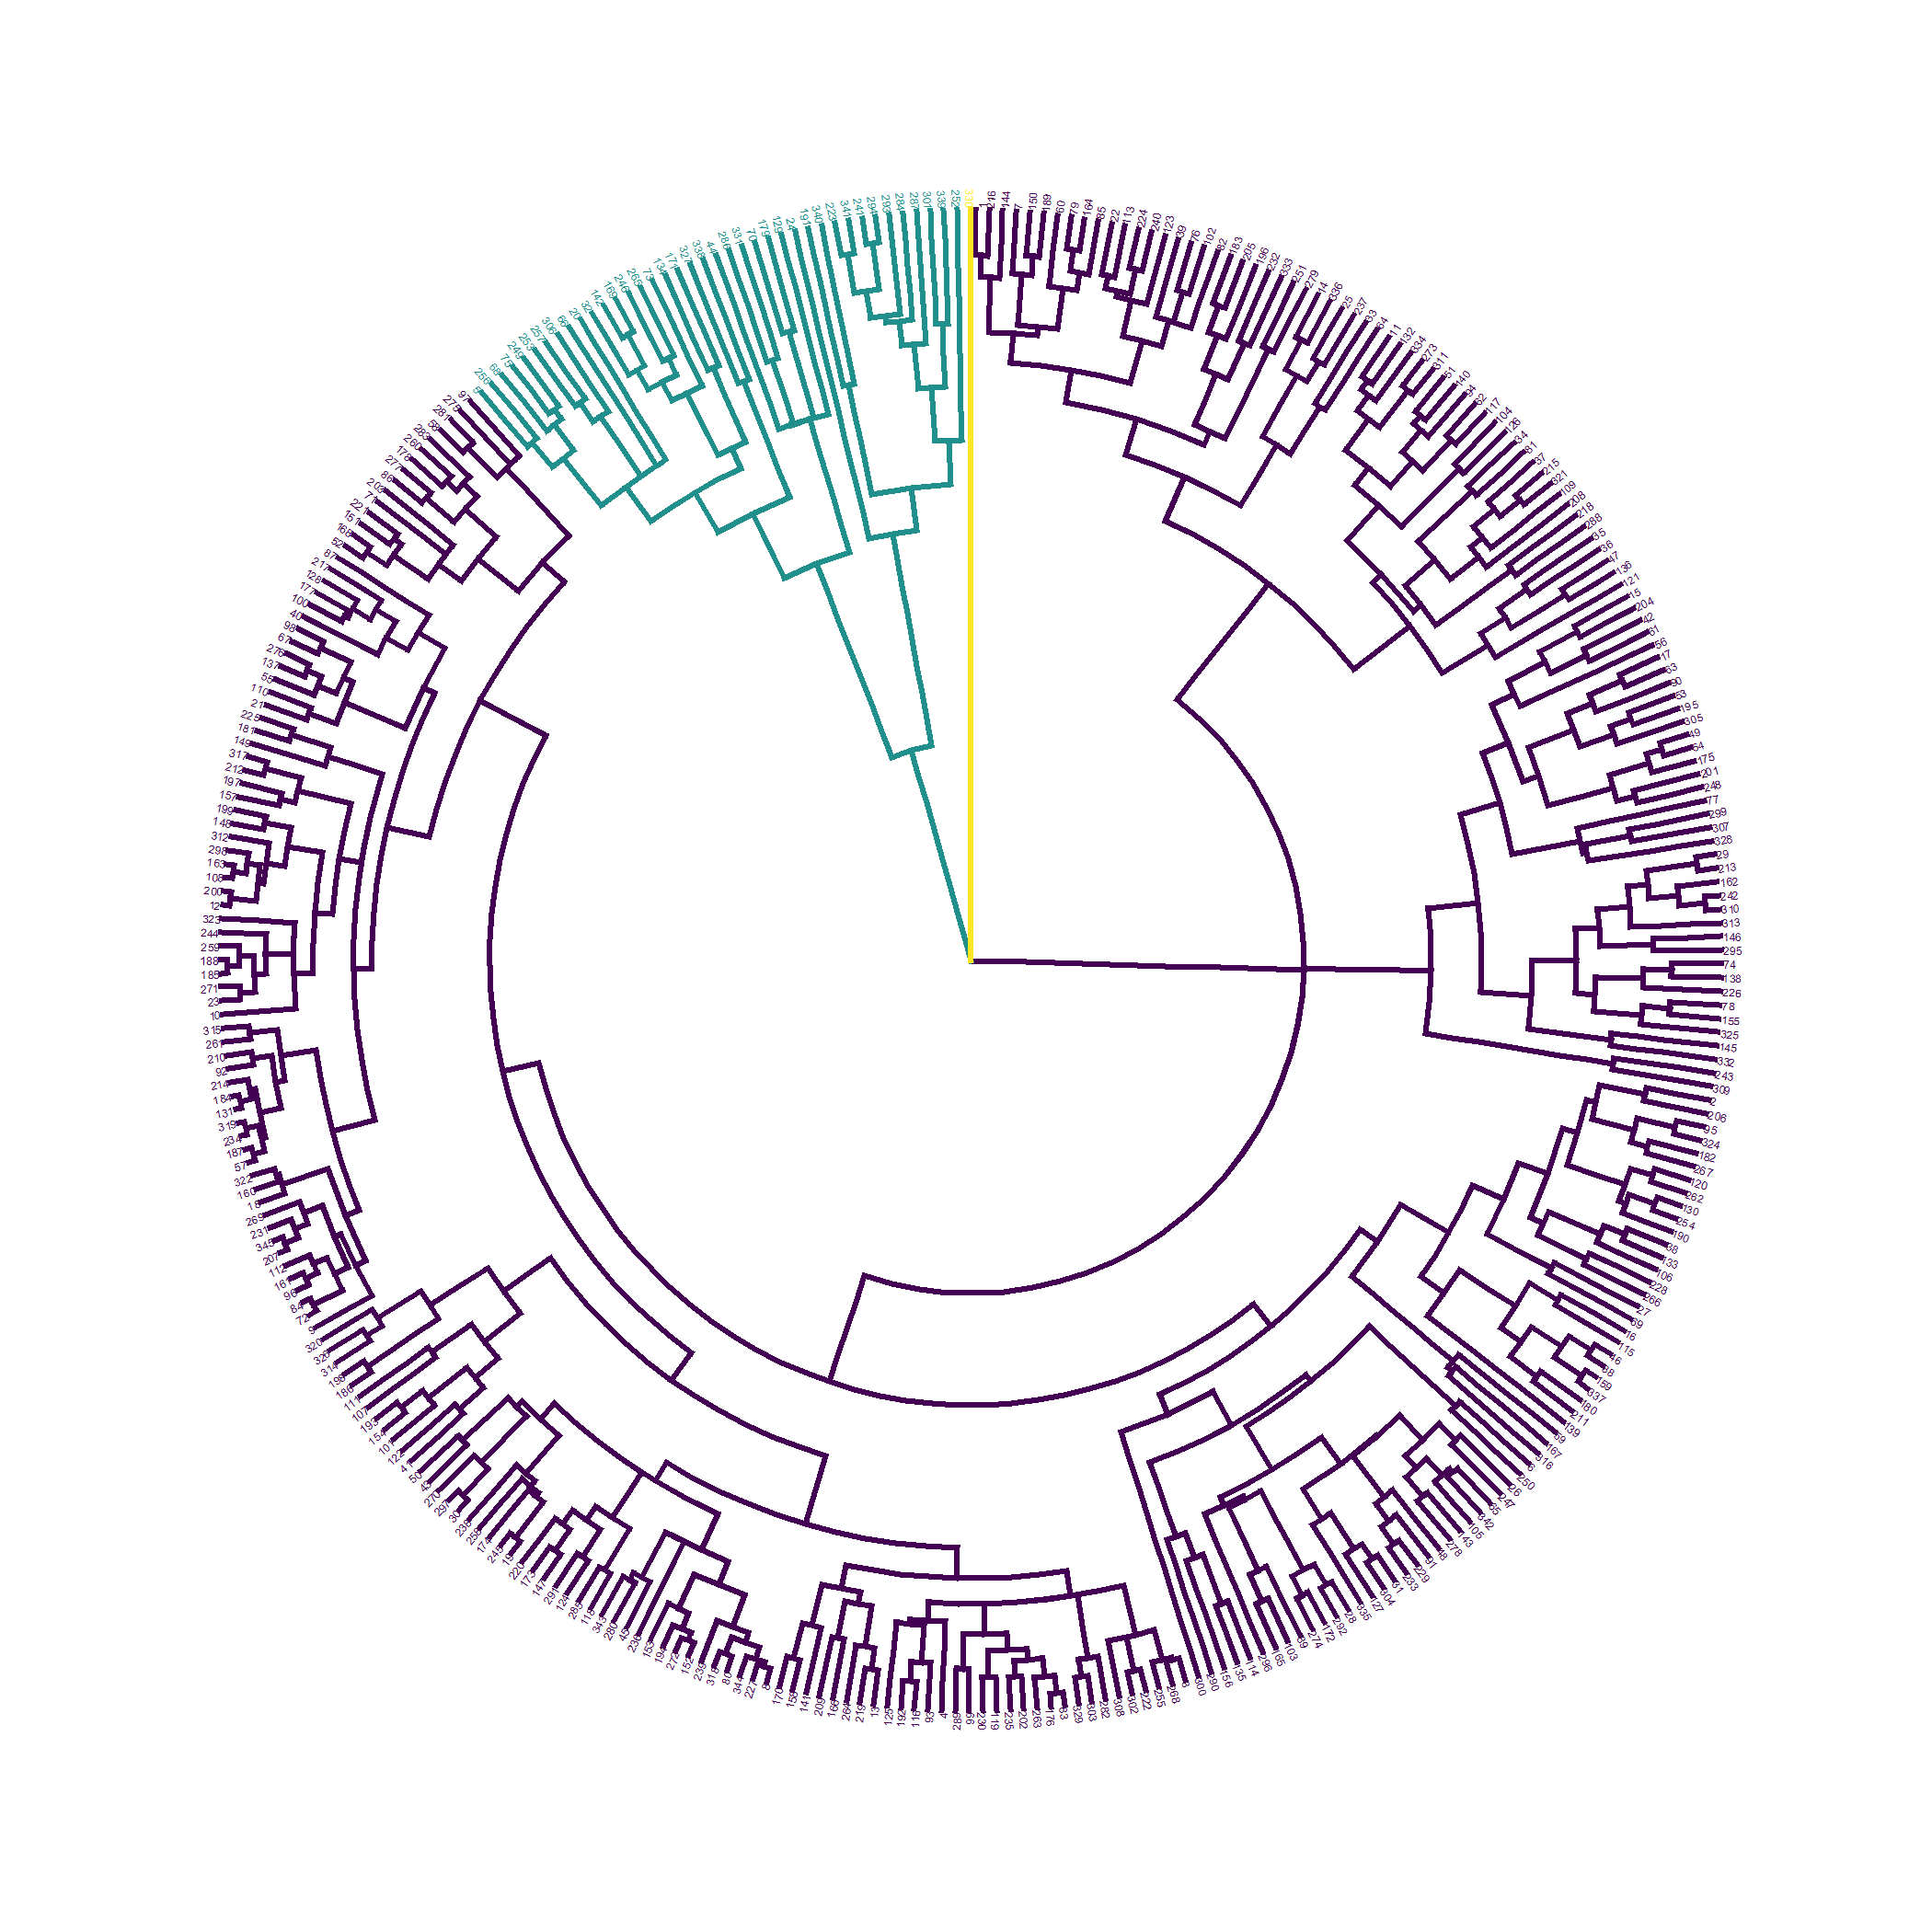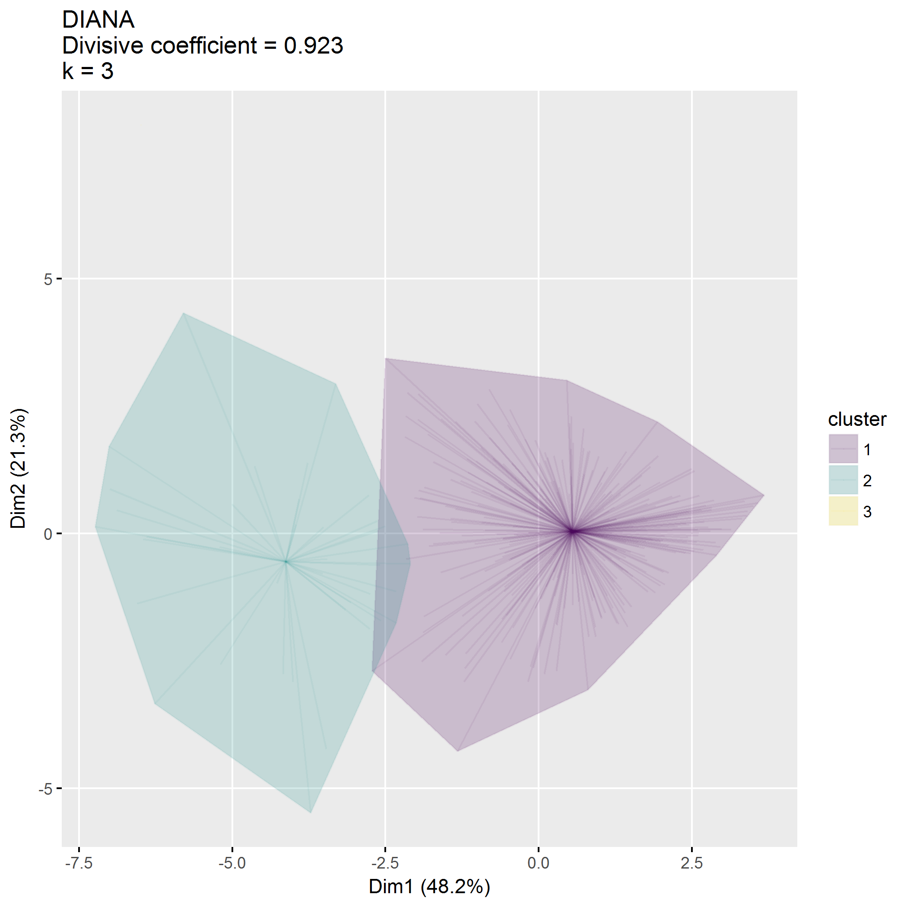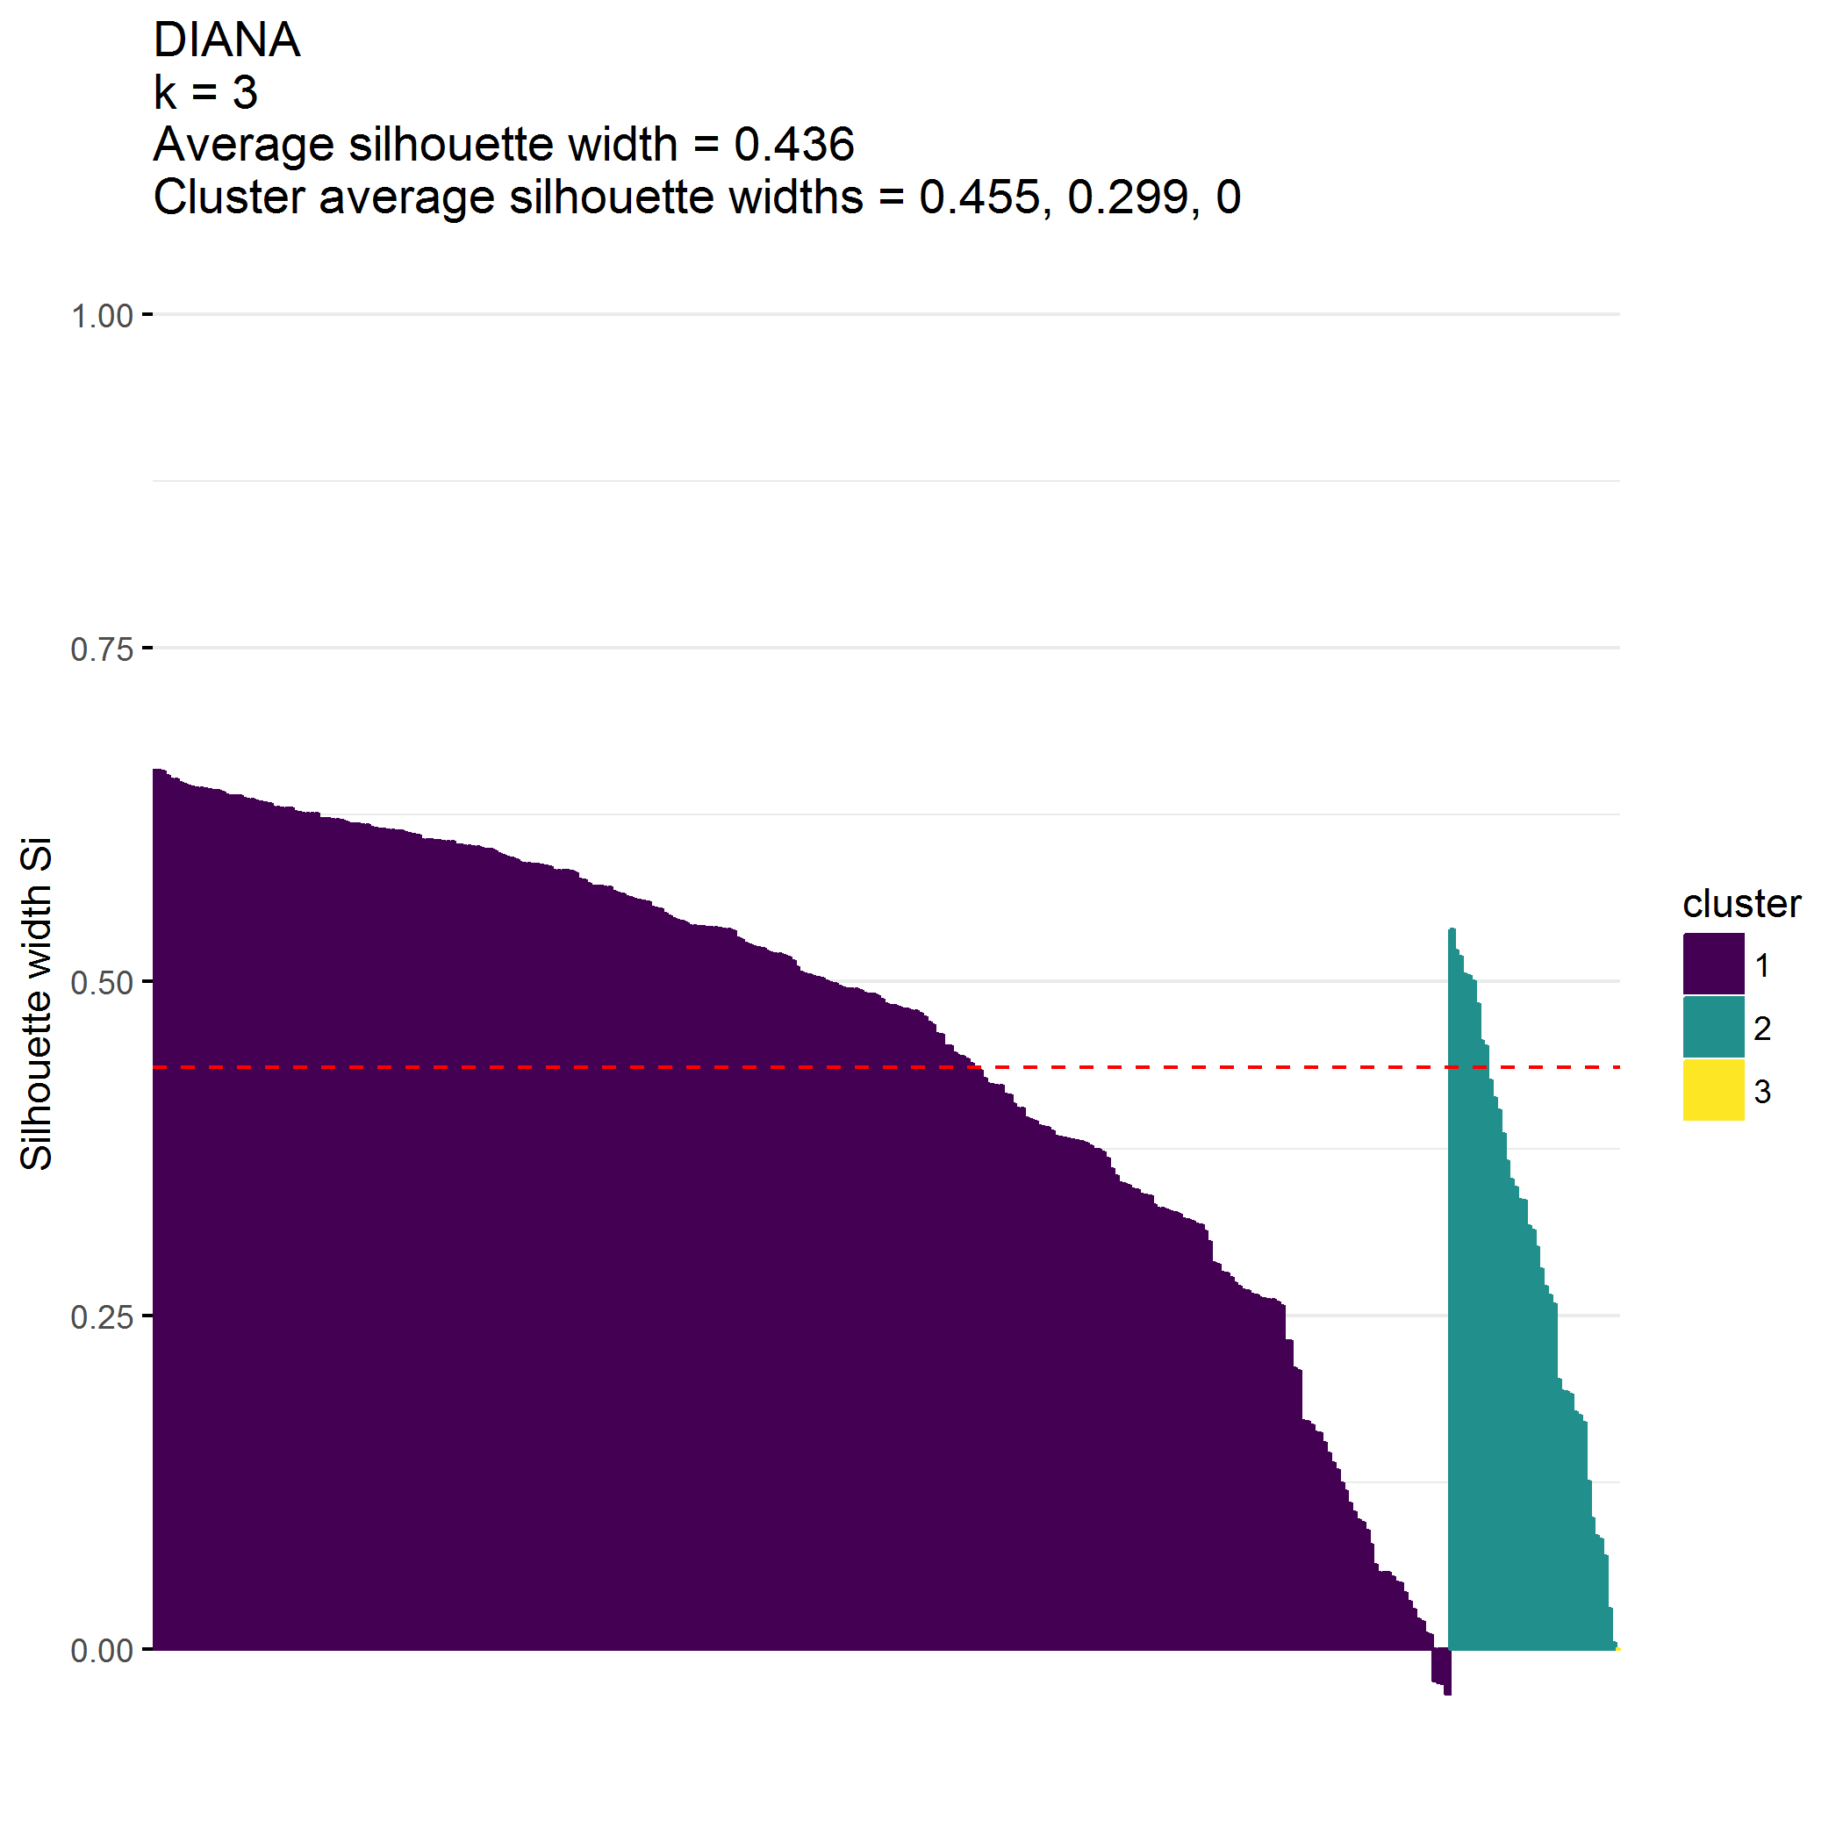

|  |  |  |  |  |  |  |  |  |  |  |
| --- | --- | --- | --- | --- | --- | --- | --- | --- | --- | --- |
| cluster | n | MAPS_PP_mean | MAPS_PR_mean | MAPS_WM_mean | MAPS_SP_mean | MAPS_HS_mean | MAPS_LC_mean | MAPS_PC_mean | MAPS_POS_mean | MAPS_NEG_mean |
| 1 | 305 | 4.1 | 4.6 | 4.7 | 4.5 | 2 | 1.9 | 1.4 | 4.5 | 1.8 |
| 2 | 39 | 3.4 | 3.7 | 4.0 | 3.4 | 3 | 2.6 | 2.6 | 3.7 | 2.7 |
| 3 | 1 | 2.3 | 3.0 | 1.7 | 1.0 | 1 | 1.0 | 1.0 | 2.0 | 1.0 |

## Cluster on SEPTI metrics

**Clustering on ECBI, MAPS, and SEPTI metrics isn’t terrible.**

* Cluster 1 () has high SEPTI scores
* Cluster 2 () has low SEPTI scores

## [1] 345 4

## [1] "SEPTI_nurturance" "SEPTI_discipline" "SEPTI_play"   
## [4] "SEPTI_routine"

## cluster size ave.sil.width  
## 1 1 185 0.38  
## 2 2 160 0.29

* Hopkins statistic is 0.285
* Analysis identified clusters
* Divisive coefficient is 0.929
* Average silhouette width is 0.339

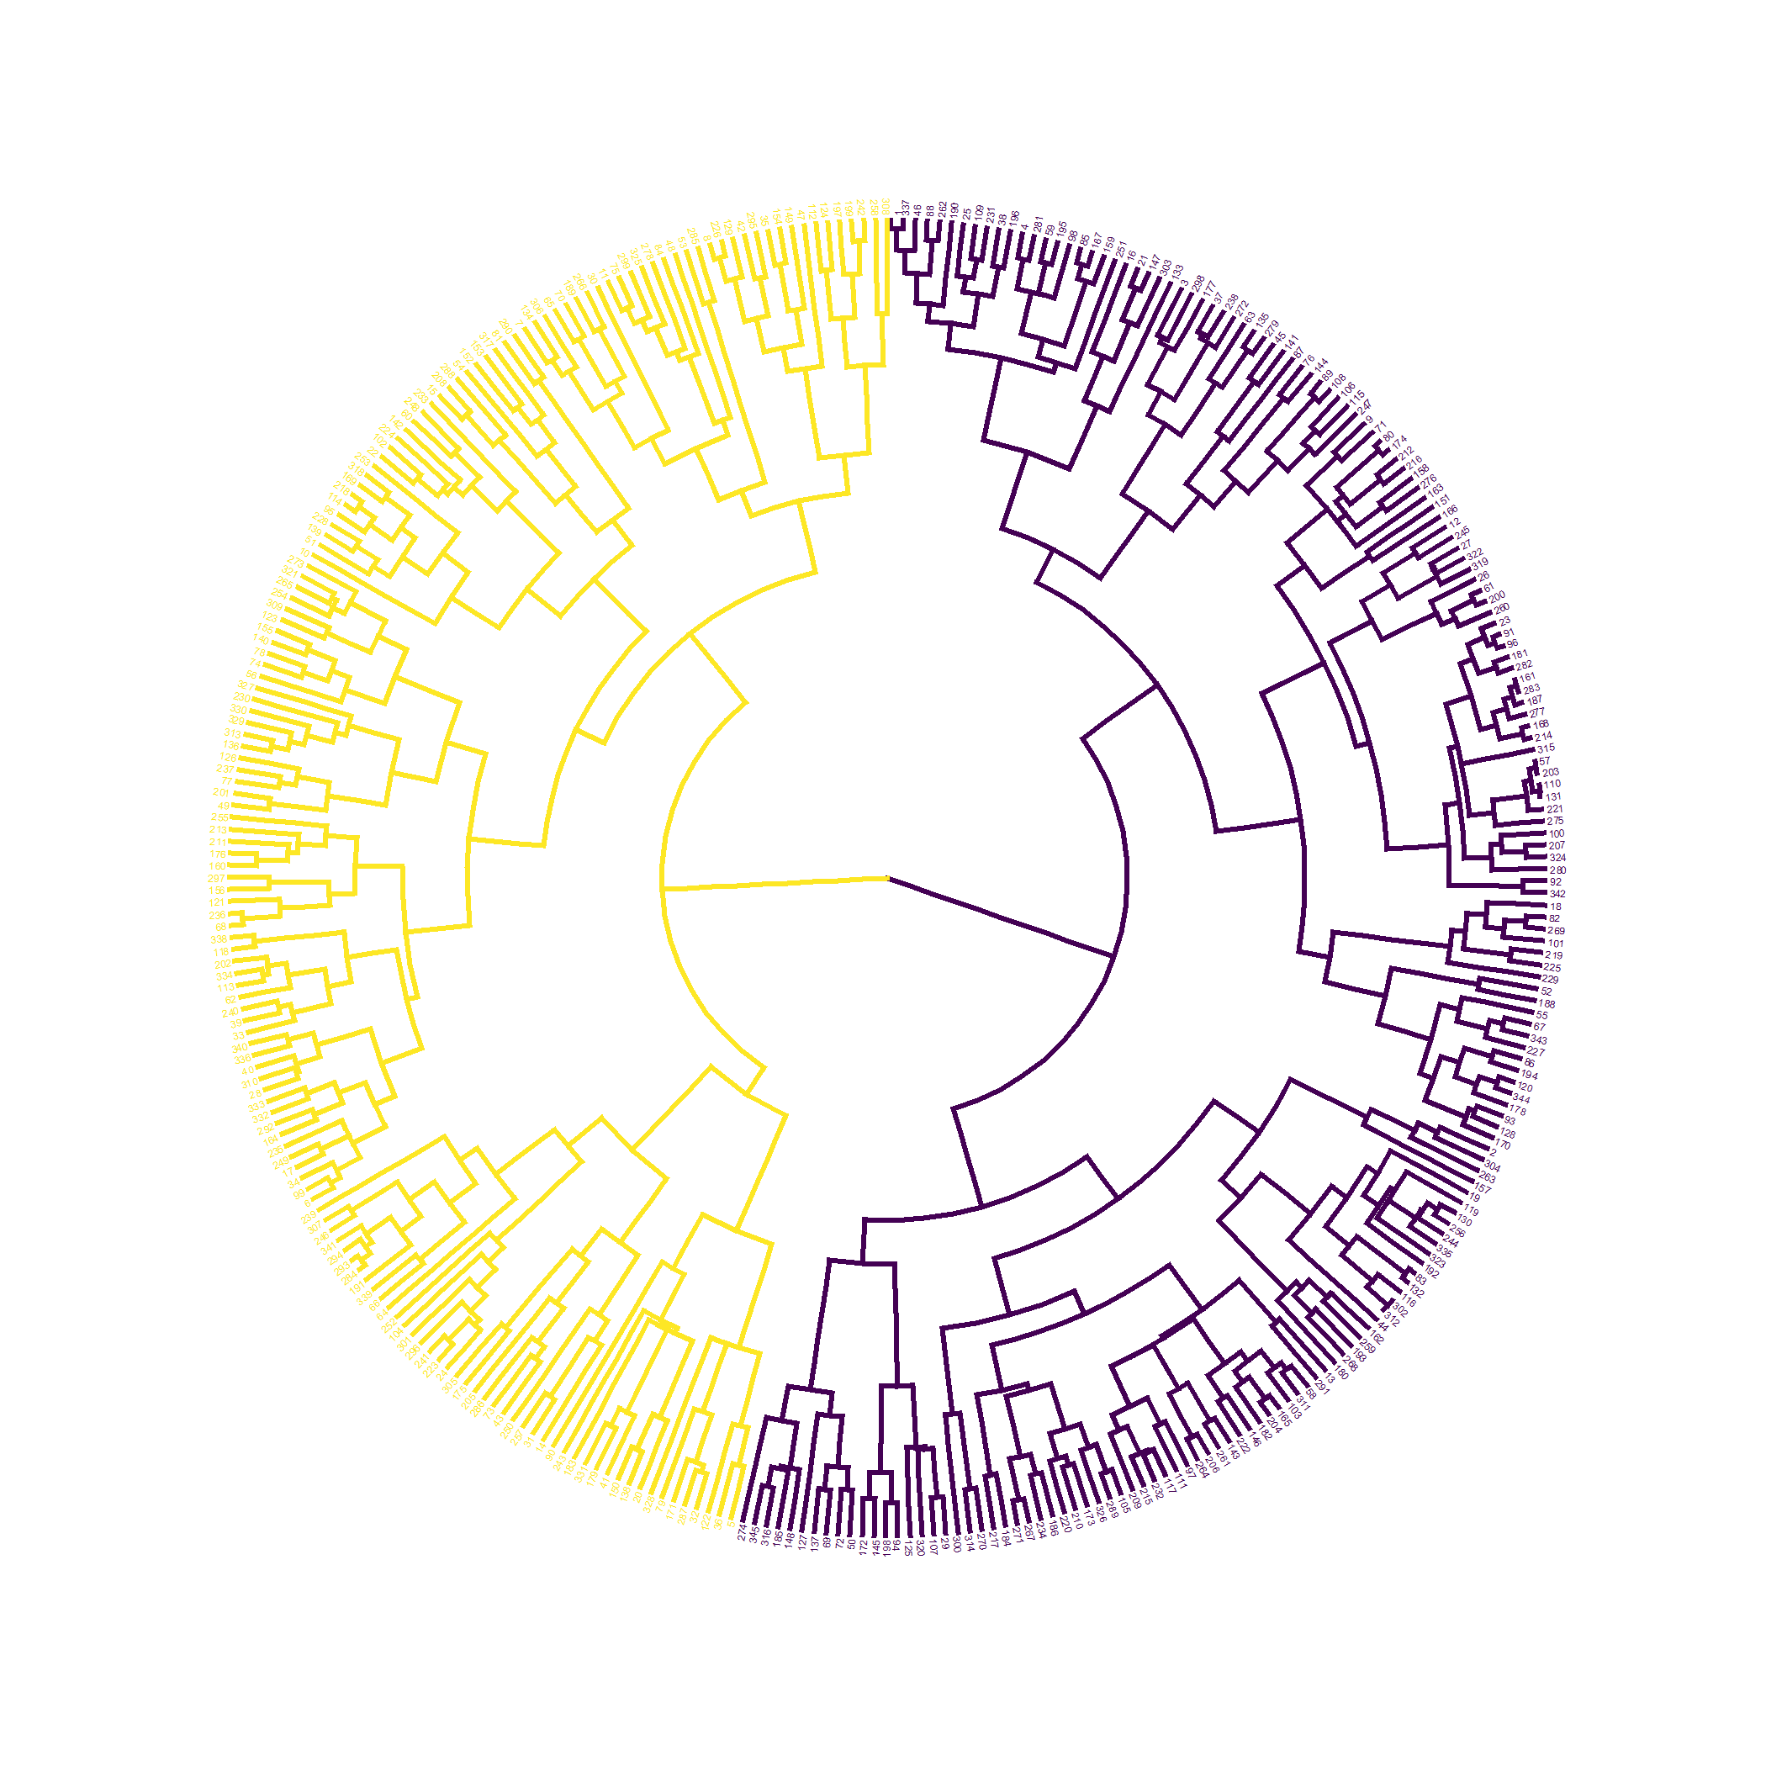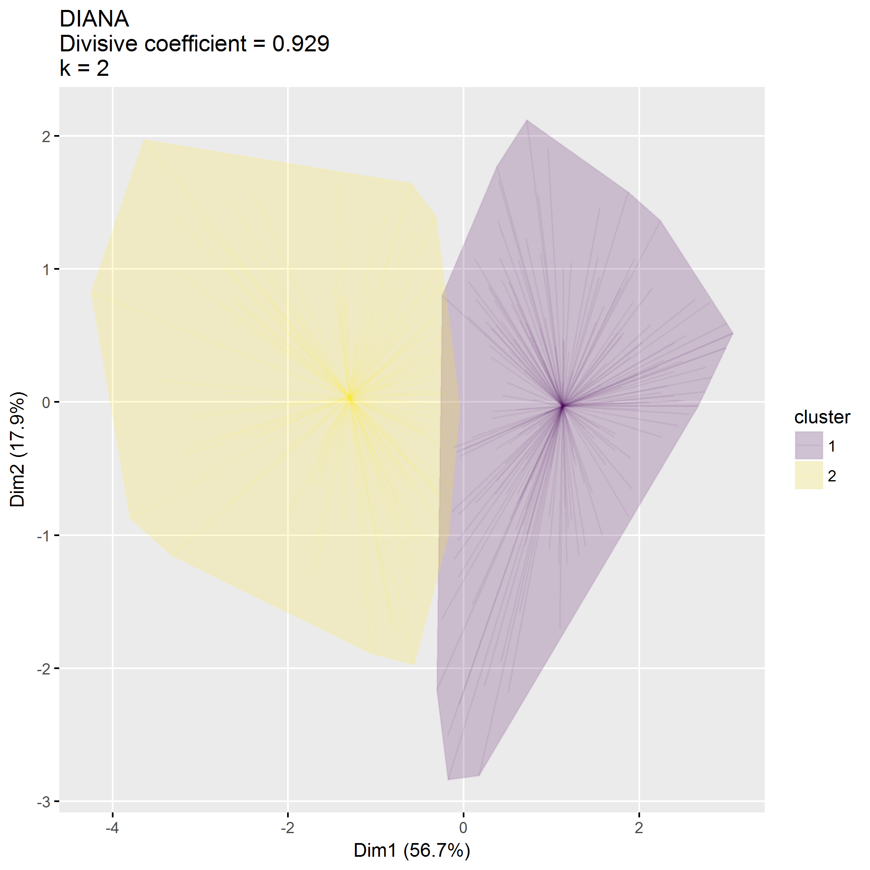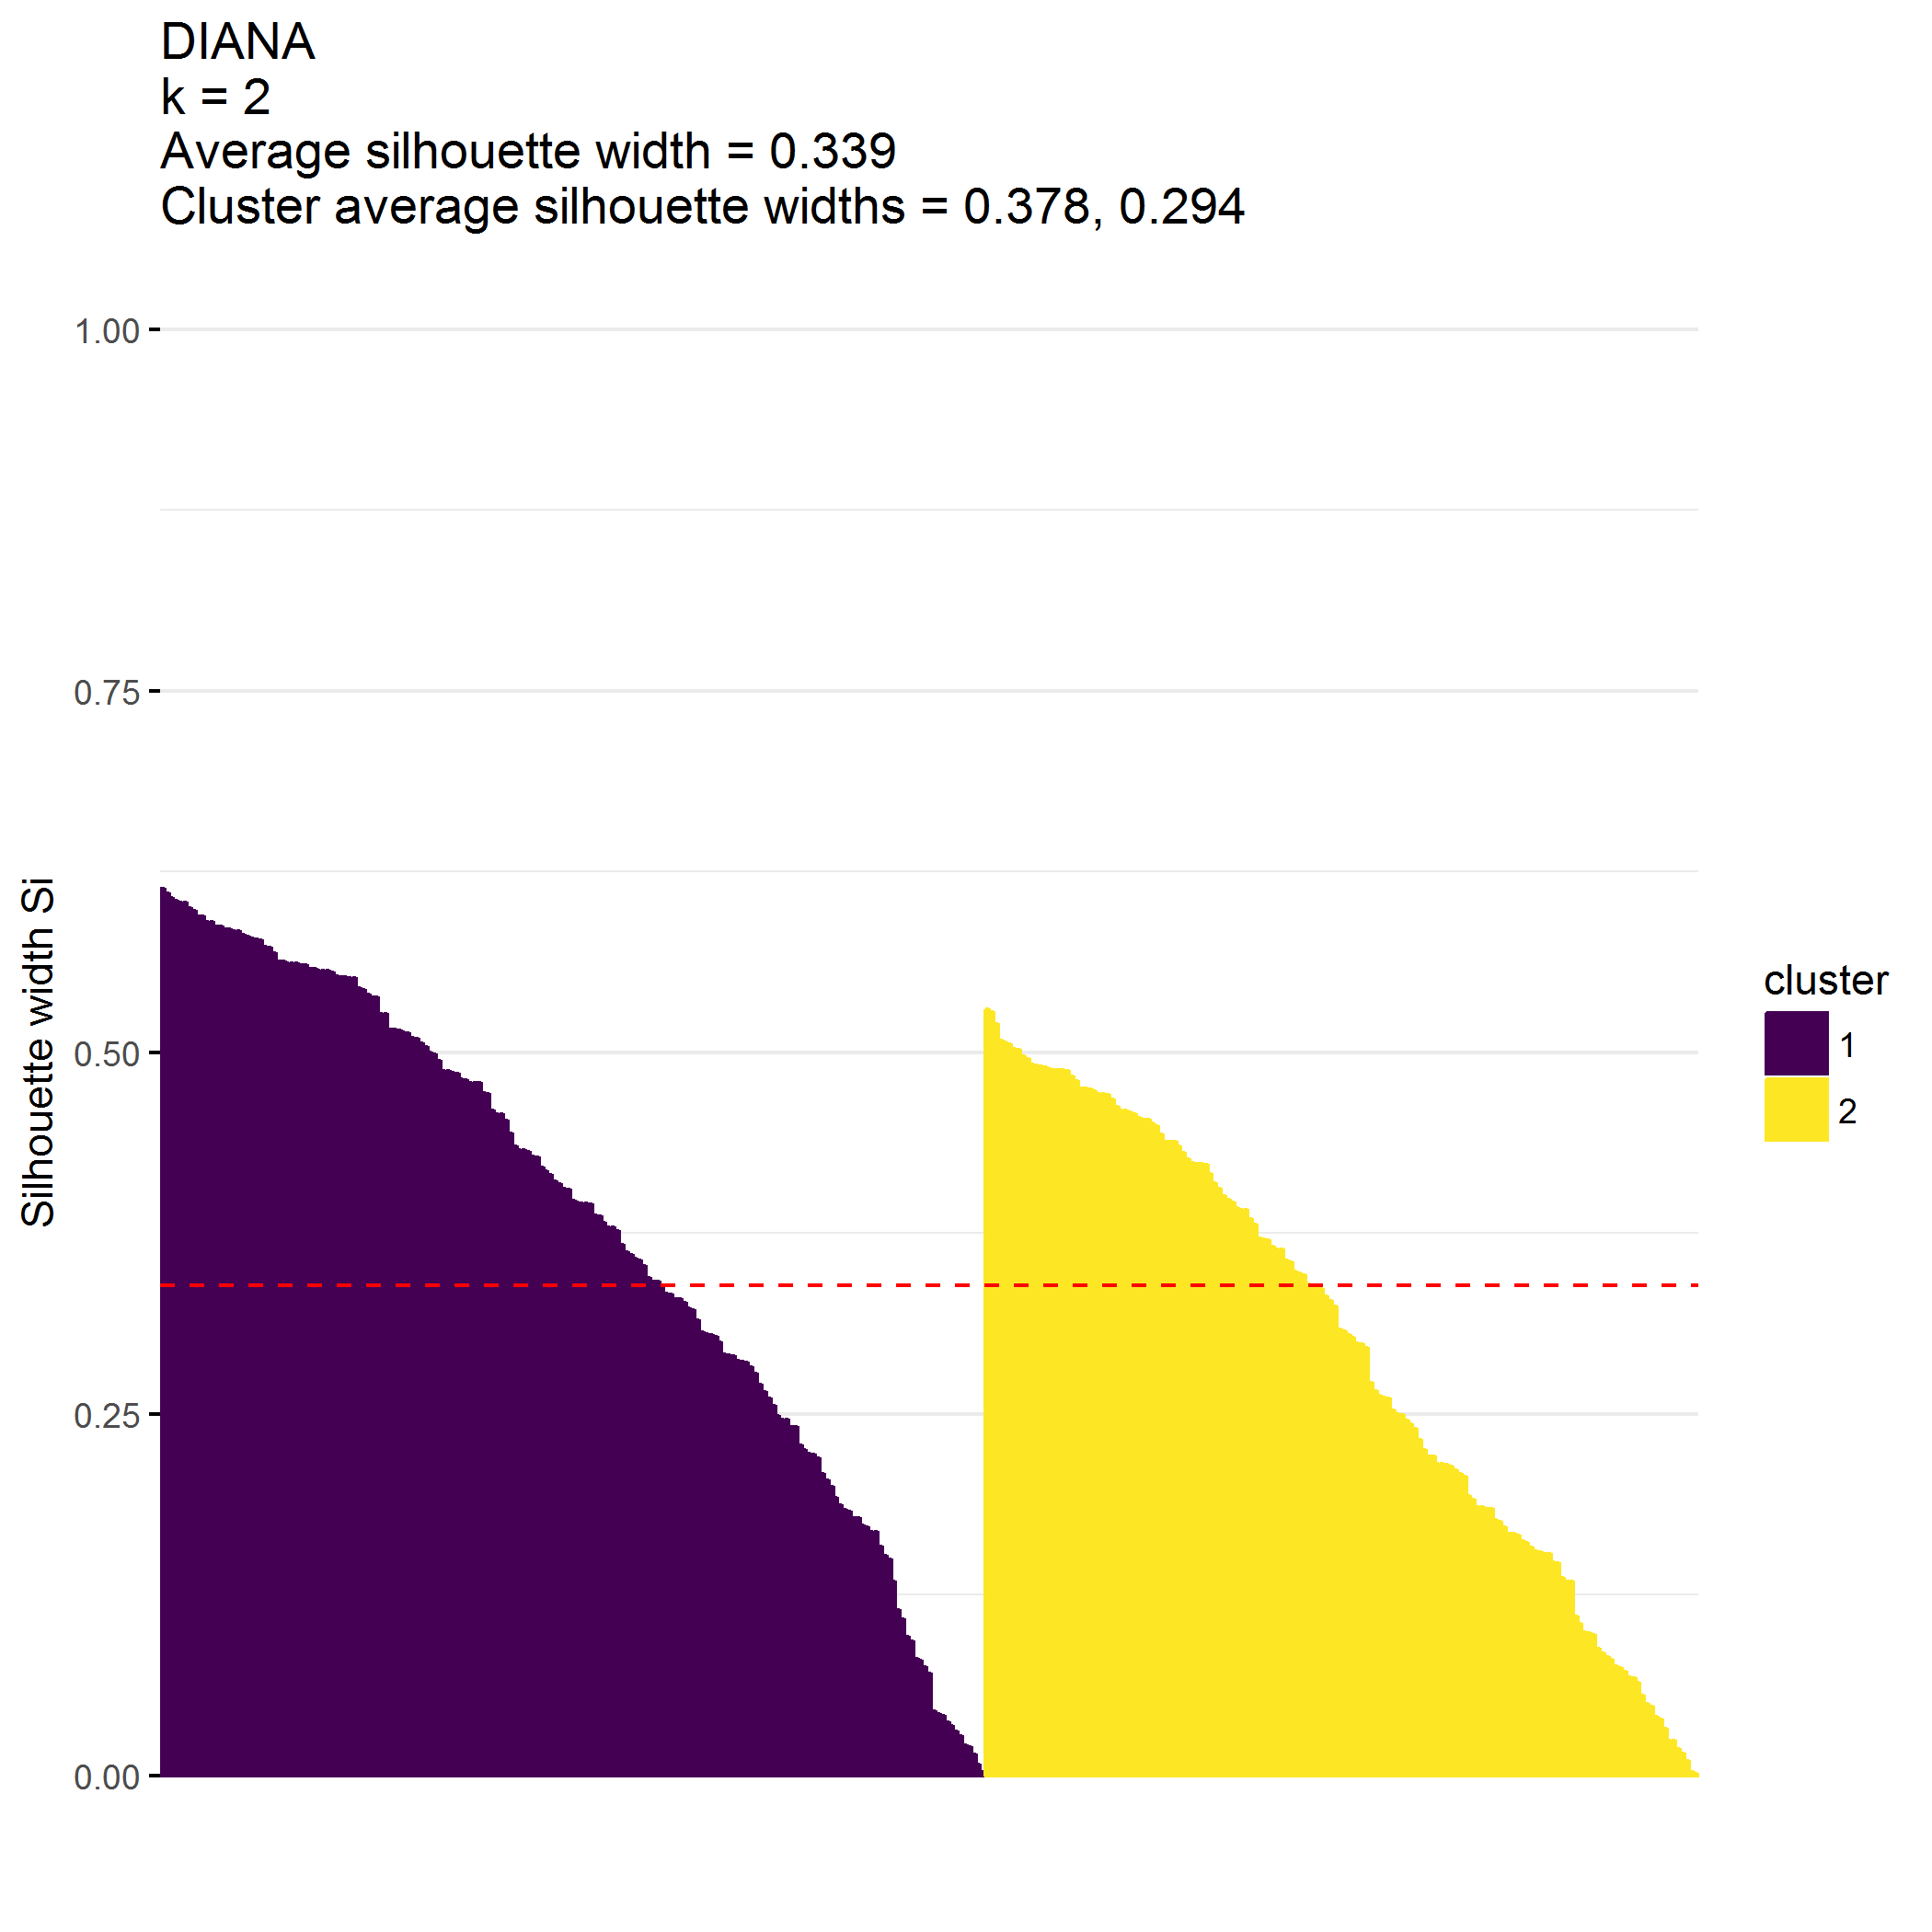

|  |  |  |  |  |  |
| --- | --- | --- | --- | --- | --- |
| cluster | n | SEPTI_nurturance_mean | SEPTI_discipline_mean | SEPTI_play_mean | SEPTI_routine_mean |
| 1 | 185 | 39.6 | 26.8 | 35.8 | 31.5 |
| 2 | 160 | 34.8 | 19.8 | 27.0 | 25.3 |

## Cluster on ECBI, MAPS, SEPTI metrics

Attempt to identify clusters using all metrics.

**Clustering on ECBI, MAPS, and SEPTI metrics isn’t terrible.**

* Cluster 1 () has
  + Low ECBI scores
  + High *positive* MAPS scores
  + High SEPTI scores
* Cluster 2 () has
  + High ECBI scores
  + High *negative* MAPS scores
  + Low SEPTI scores
* Cluster 3 () is the outlier; have low positive and low negative MAPS scores

## [1] 345 18

## [1] "ECBI_intensity_T_score" "ECBI_problem_T_score"   
## [3] "ECBI_Opp" "ECBI_Inatt"   
## [5] "ECBI_Cond" "MAPS_PP"   
## [7] "MAPS_PR" "MAPS_WM"   
## [9] "MAPS_SP" "MAPS_HS"   
## [11] "MAPS_LC" "MAPS_PC"   
## [13] "MAPS_POS" "MAPS_NEG"   
## [15] "SEPTI_nurturance" "SEPTI_discipline"   
## [17] "SEPTI_play" "SEPTI_routine"

## cluster size ave.sil.width  
## 1 1 297 0.36  
## 2 2 45 0.23  
## 3 3 3 0.28

* Hopkins statistic is 0.288
* Analysis identified clusters
* Divisive coefficient is 0.853
* Average silhouette width is 0.340

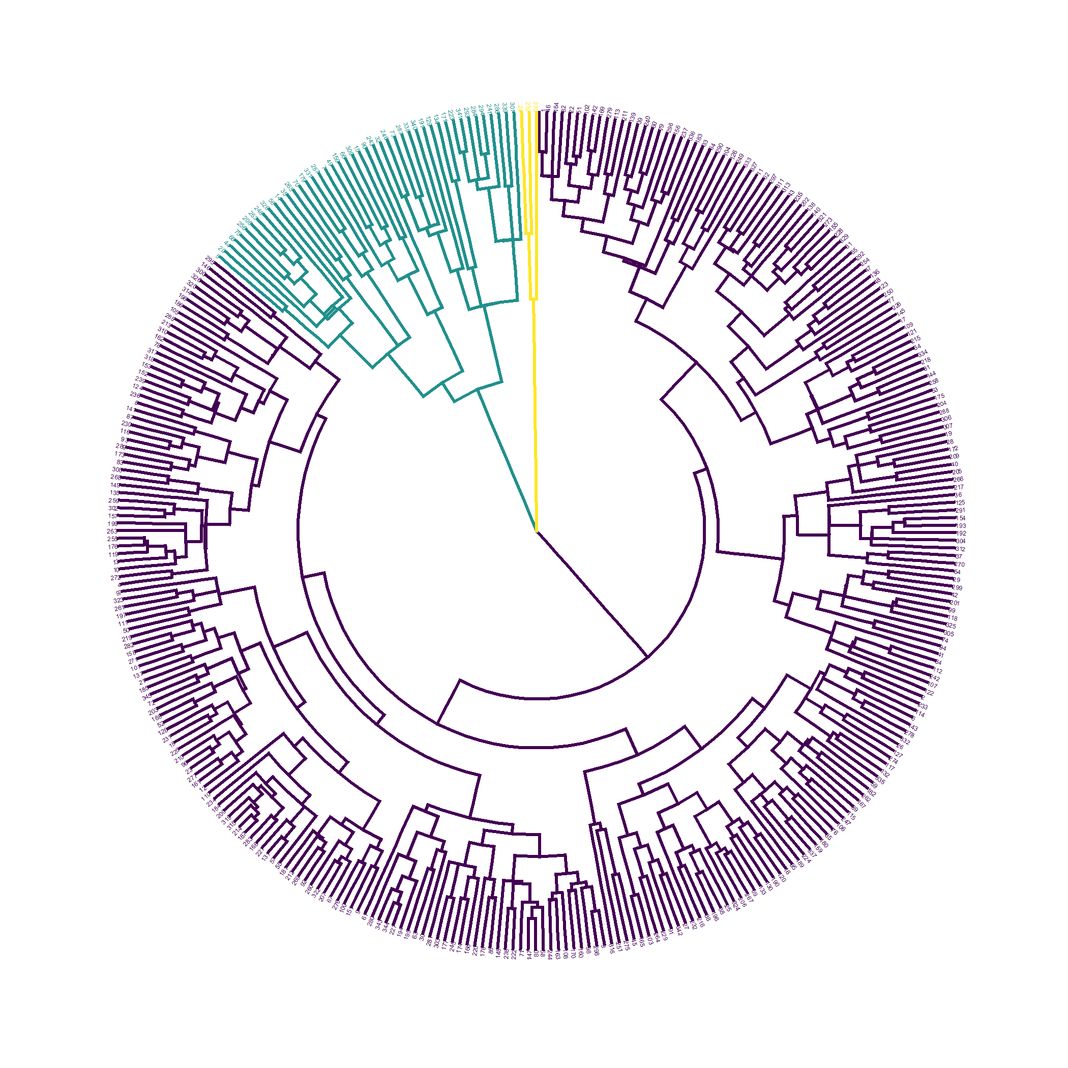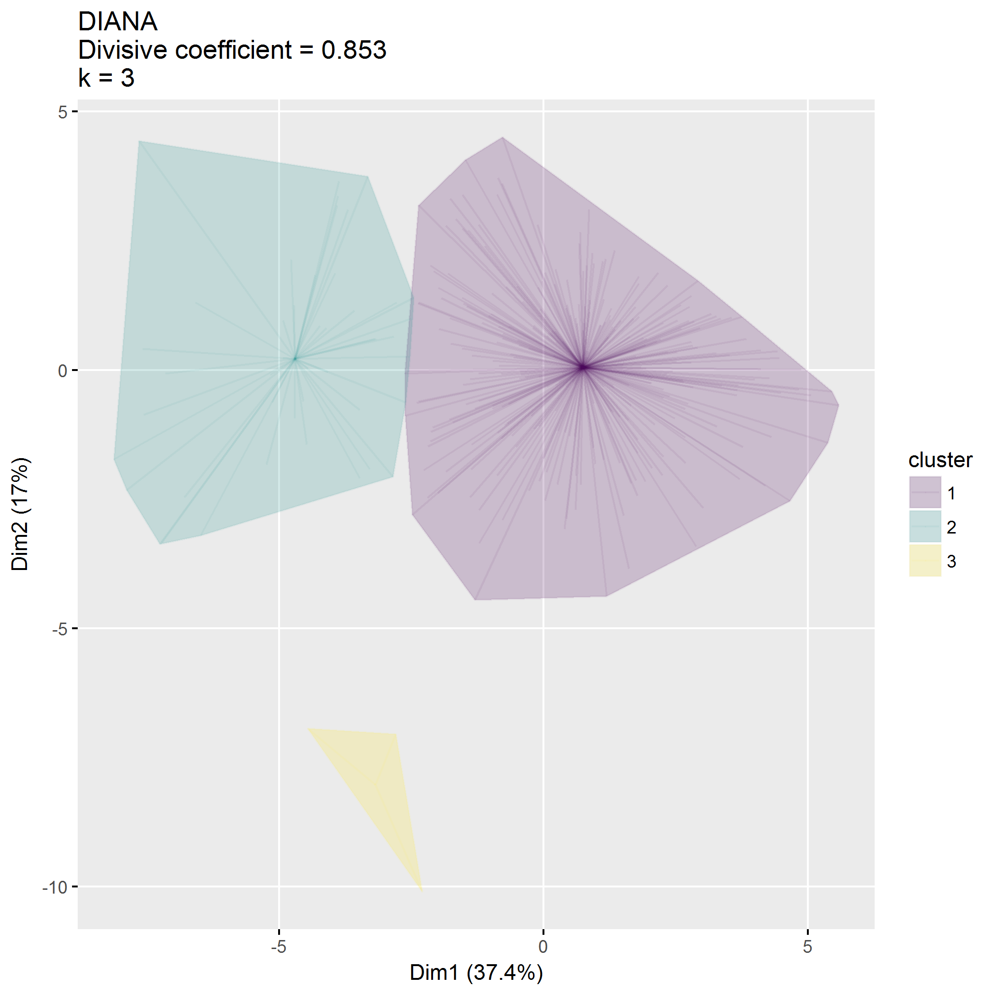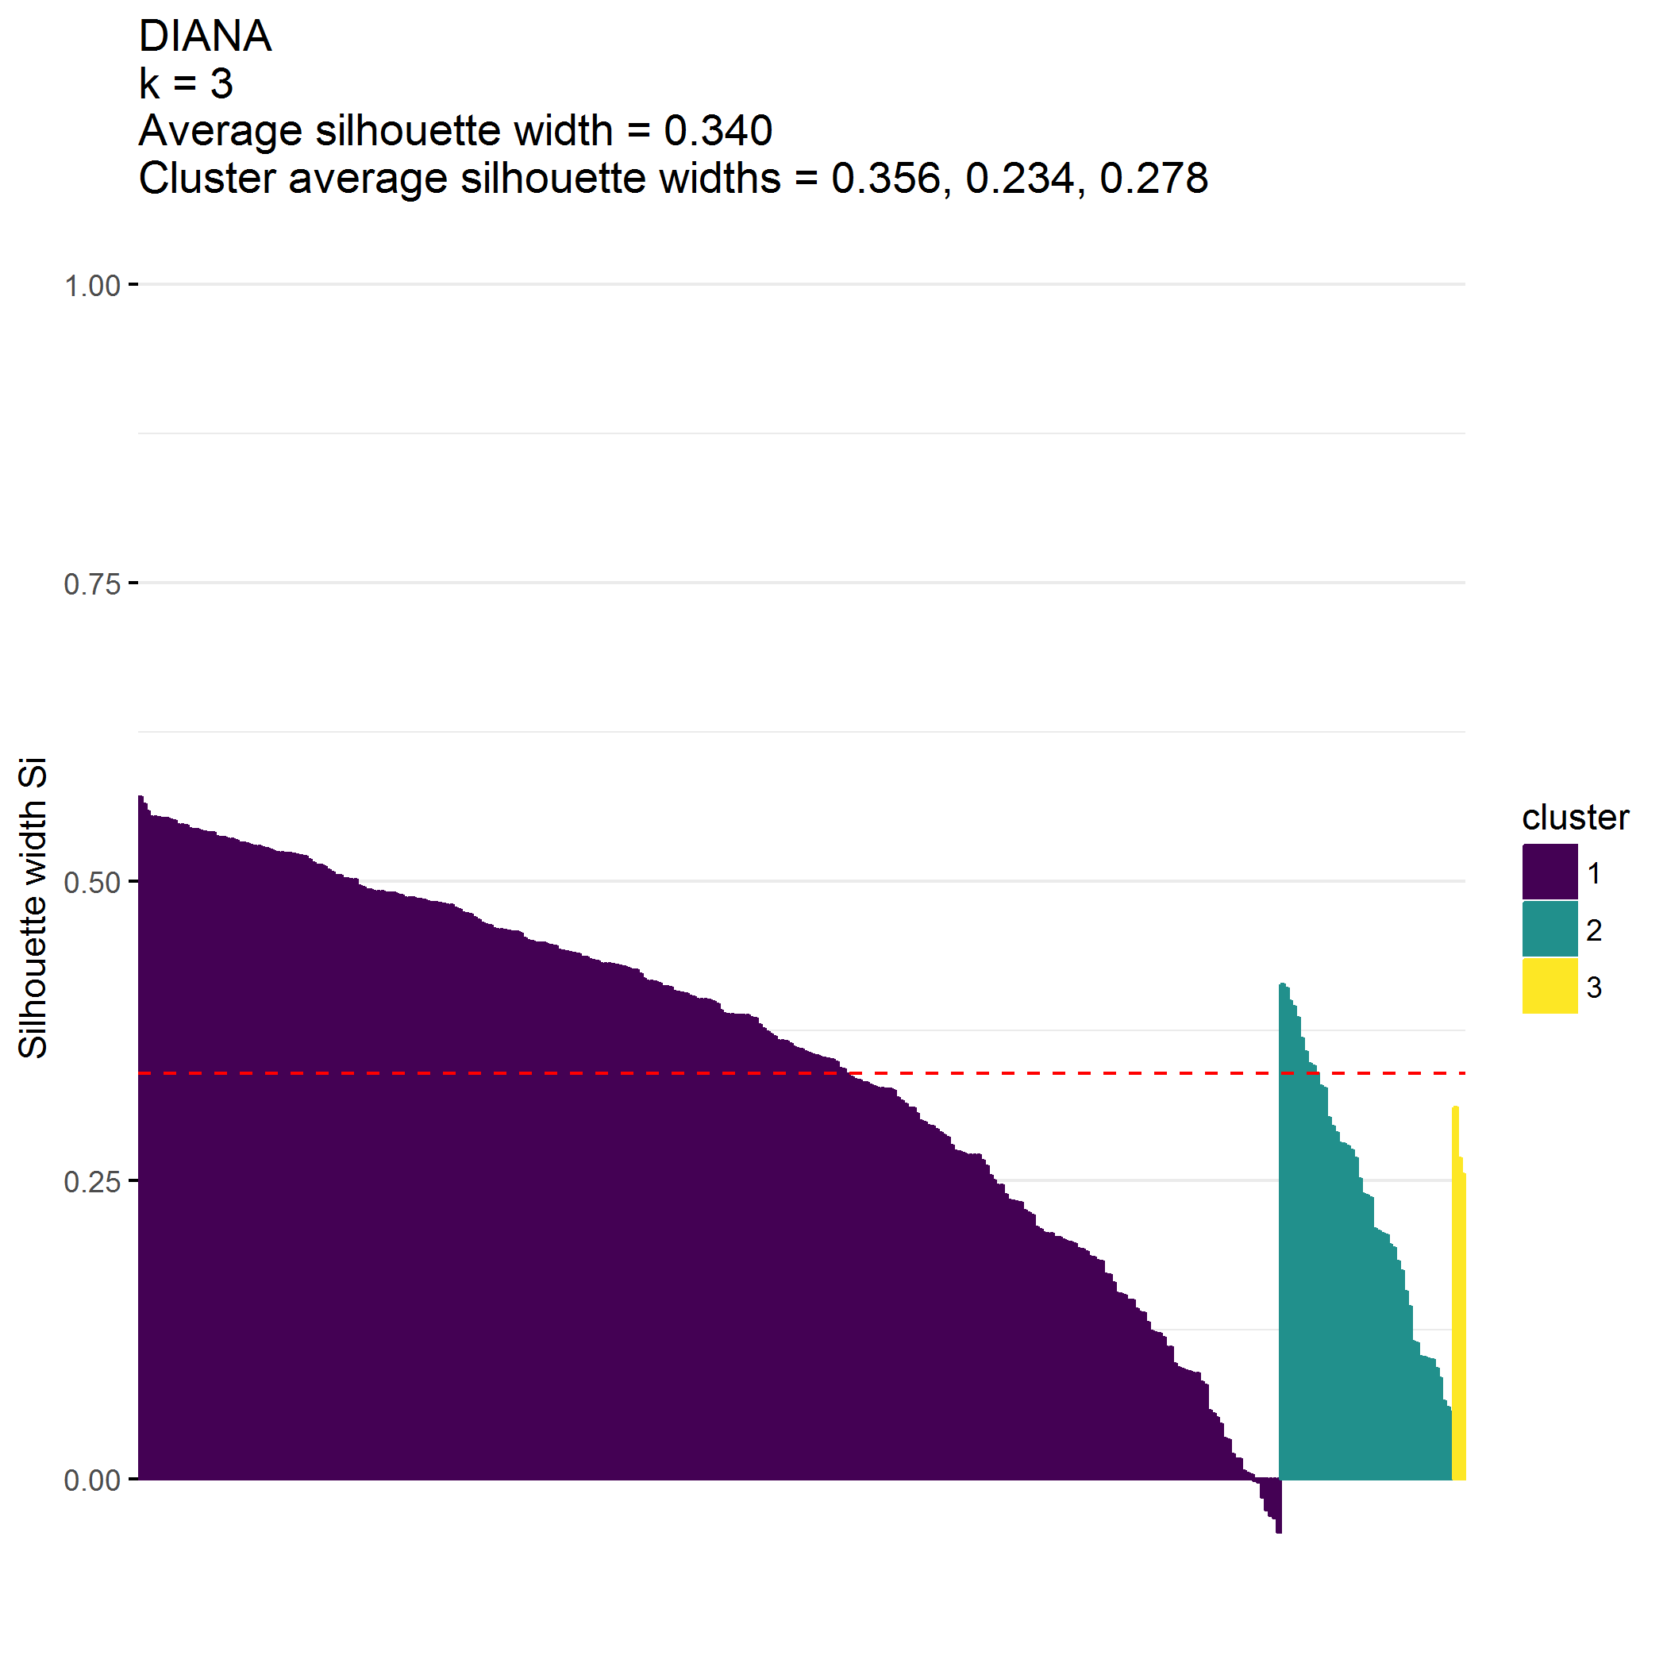

|  |  |  |  |  |  |  |
| --- | --- | --- | --- | --- | --- | --- |
| cluster | n | ECBI_intensity_T_score_mean | ECBI_problem_T_score_mean | ECBI_Opp_mean | ECBI_Inatt_mean | ECBI_Cond_mean |
| 1 | 297 | 52.5 | 52.2 | 32.3 | 13.2 | 14.3 |
| 2 | 45 | 62.3 | 64.6 | 43.2 | 15.8 | 24.4 |
| 3 | 3 | 37.7 | 44.3 | 17.7 | 5.3 | 8.0 |

|  |  |  |  |  |  |  |  |  |  |  |
| --- | --- | --- | --- | --- | --- | --- | --- | --- | --- | --- |
| cluster | n | MAPS_PP_mean | MAPS_PR_mean | MAPS_WM_mean | MAPS_SP_mean | MAPS_HS_mean | MAPS_LC_mean | MAPS_PC_mean | MAPS_POS_mean | MAPS_NEG_mean |
| 1 | 297 | 4.1 | 4.6 | 4.7 | 4.5 | 2.0 | 1.9 | 1.4 | 4.5 | 1.8 |
| 2 | 45 | 3.6 | 4.0 | 4.1 | 3.6 | 3.0 | 2.7 | 2.5 | 3.8 | 2.7 |
| 3 | 3 | 2.4 | 2.9 | 3.2 | 2.1 | 1.5 | 1.9 | 1.9 | 2.7 | 1.8 |

|  |  |  |  |  |  |
| --- | --- | --- | --- | --- | --- |
| cluster | n | SEPTI_nurturance_mean | SEPTI_discipline_mean | SEPTI_play_mean | SEPTI_routine_mean |
| 1 | 297 | 38.1 | 24.3 | 32.8 | 29.4 |
| 2 | 45 | 33.4 | 18.8 | 25.0 | 23.5 |
| 3 | 3 | 26.3 | 19.3 | 25.7 | 24.0 |

## Cluster on ECBI, MAPS, SEPTI metrics and demographics

**Clustering on ECBI, MAPS, and SEPTI metrics isn’t terrible.**

* languageSurvey dropped from consideration;
* Cluster 1 () has high positive MAPS scores and high SEPTI scores
* Cluster 2 () has high negative MAPS scores and high ECBI scores
* Cluster 3 () has low ECBI scores

## [1] 345 29

## [1] "zipcodeClass1" "zipcodeClass2"   
## [3] "communitySuburban" "communityRural"   
## [5] "distance" "income$25,001-$49,999"   
## [7] "income$50,000-$79,999" "income$80,000-$119,999"   
## [9] "income$120,000-$149,999" "income$150,000 or more"   
## [11] "internet" "ECBI_intensity_T_score"   
## [13] "ECBI_problem_T_score" "ECBI_Opp"   
## [15] "ECBI_Inatt" "ECBI_Cond"   
## [17] "MAPS_PP" "MAPS_PR"   
## [19] "MAPS_WM" "MAPS_SP"   
## [21] "MAPS_HS" "MAPS_LC"   
## [23] "MAPS_PC" "MAPS_POS"   
## [25] "MAPS_NEG" "SEPTI_nurturance"   
## [27] "SEPTI_discipline" "SEPTI_play"   
## [29] "SEPTI_routine"

## cluster size ave.sil.width  
## 1 1 280 0.25  
## 2 2 64 0.15  
## 3 3 1 0.00

* Hopkins statistic is 0.272
* Analysis identified clusters
* Divisive coefficient is 0.816
* Average silhouette width is 0.230

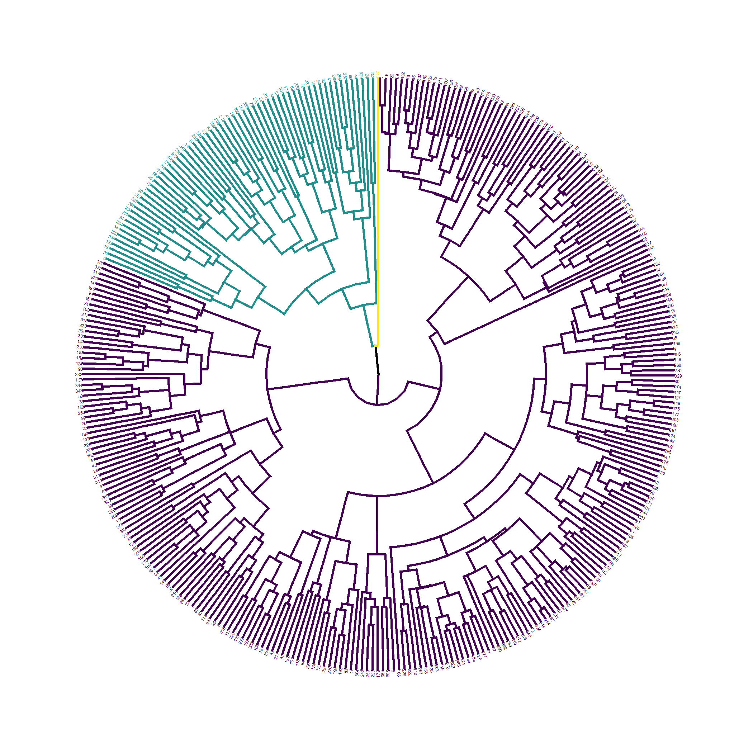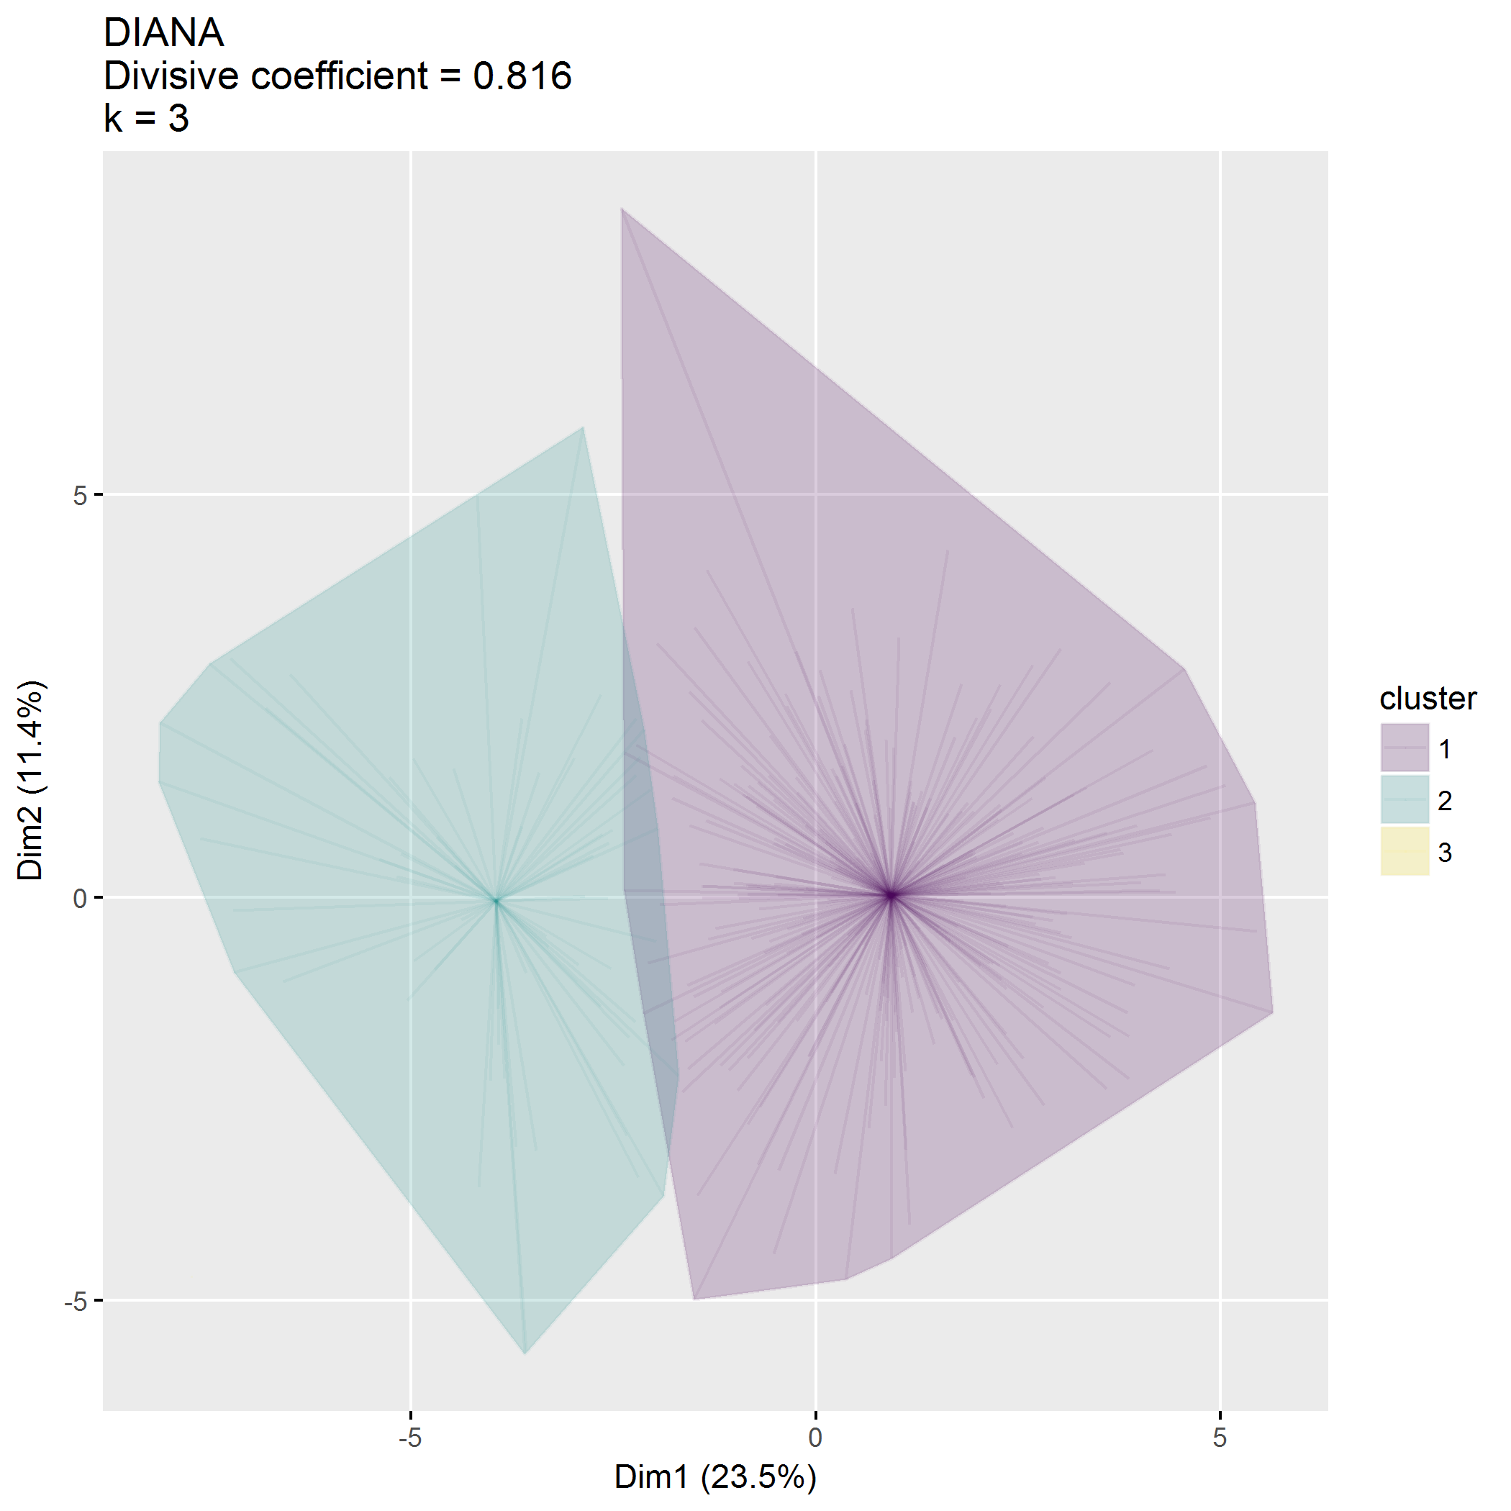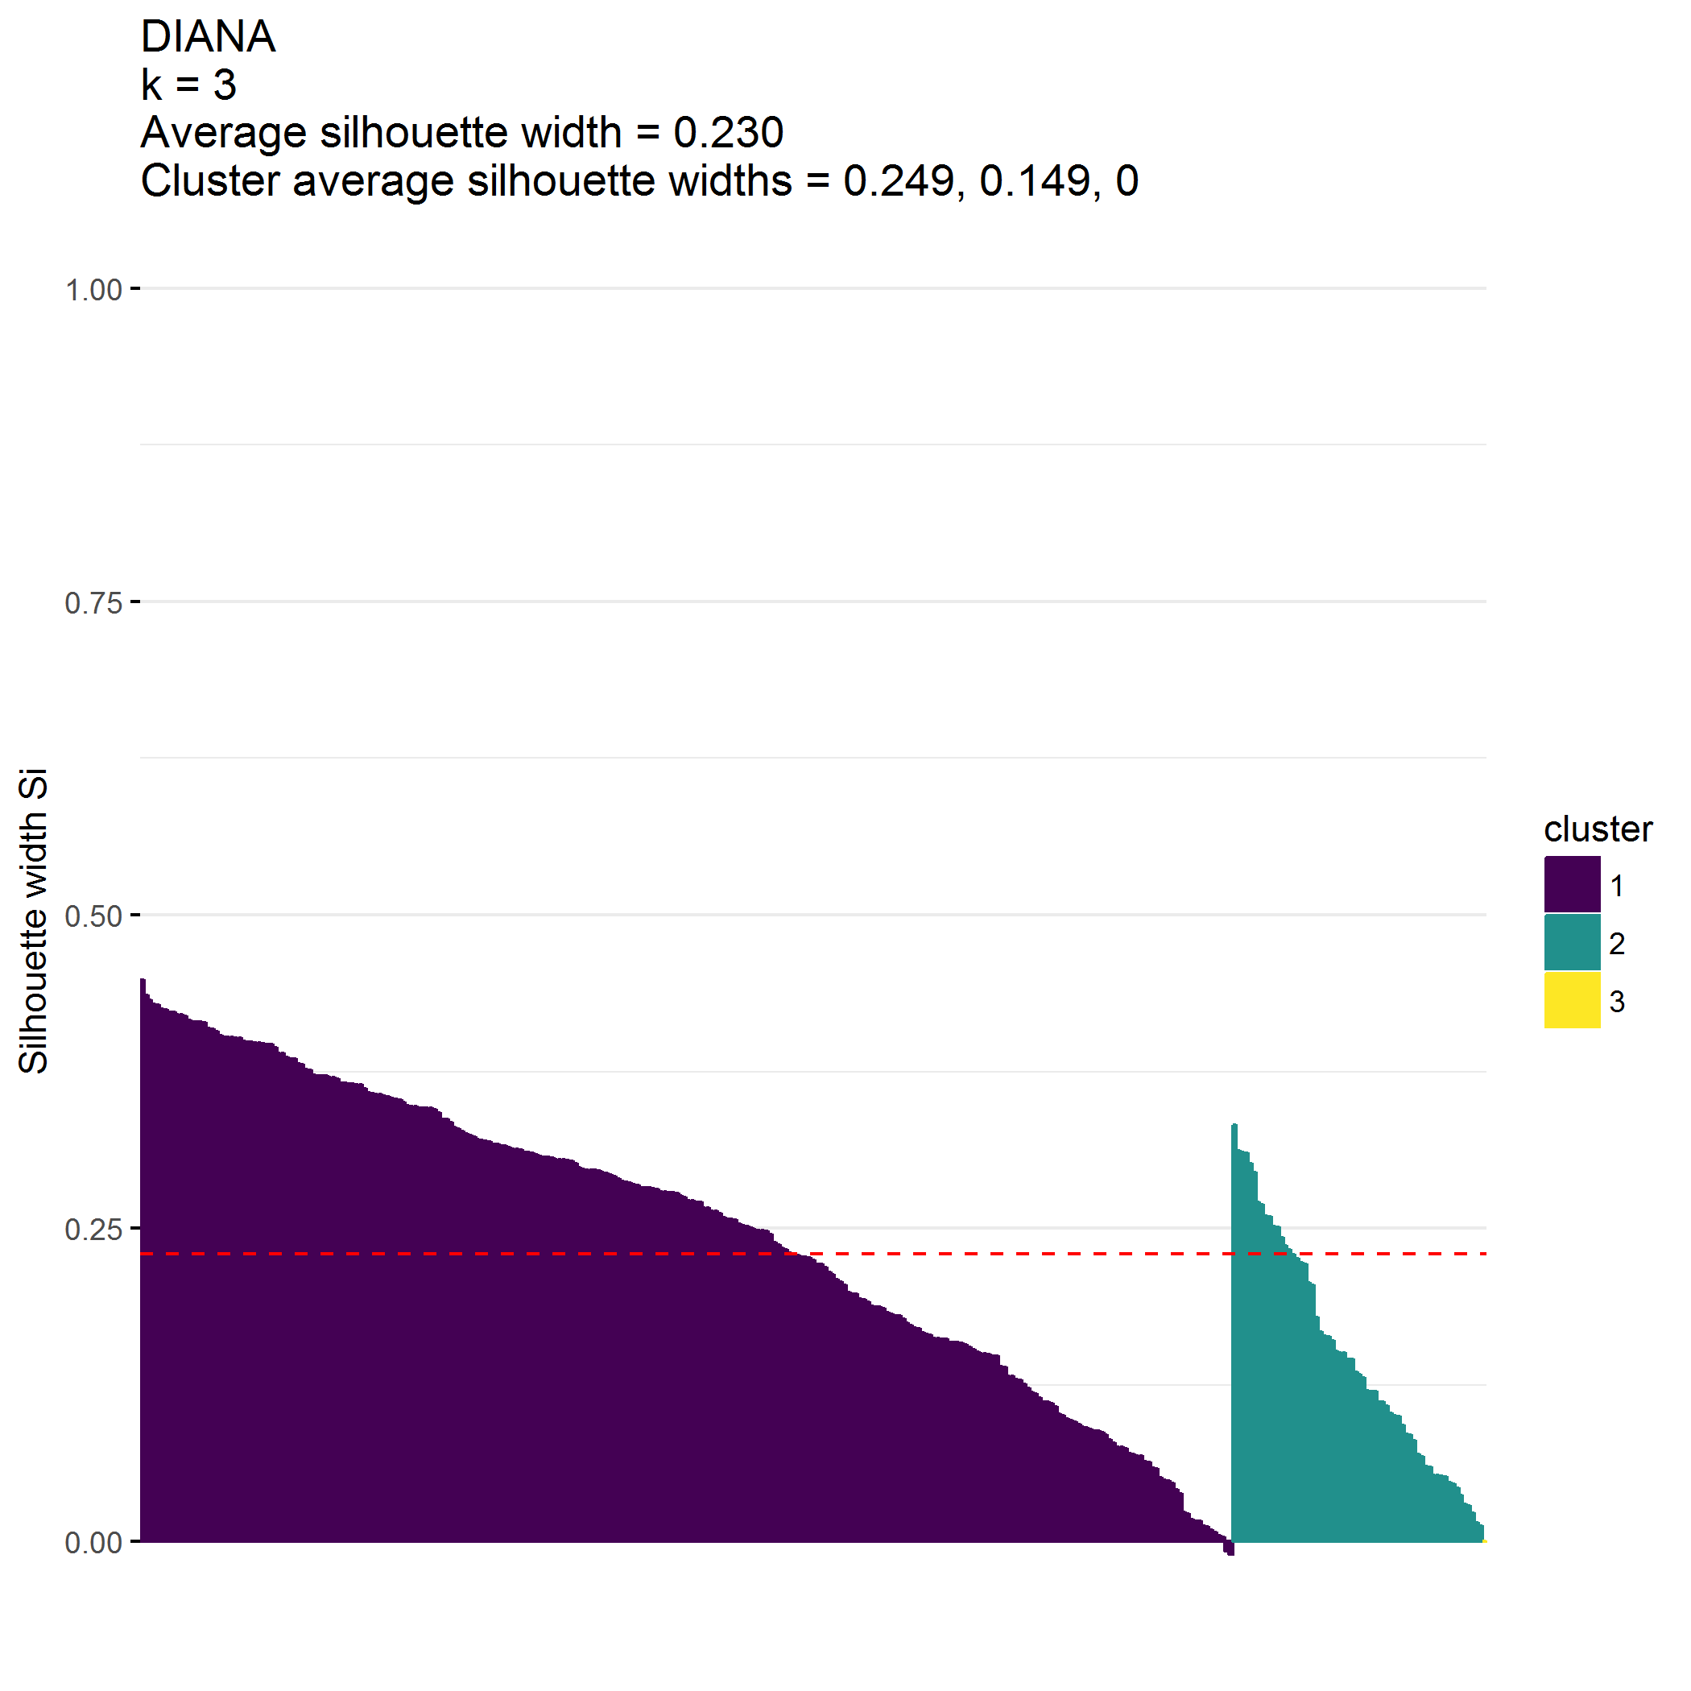

|  |  |  |  |  |  |  |
| --- | --- | --- | --- | --- | --- | --- |
| cluster | n | ECBI_intensity_T_score_mean | ECBI_problem_T_score_mean | ECBI_Opp_mean | ECBI_Inatt_mean | ECBI_Cond_mean |
| 1 | 280 | 52.2 | 51.8 | 31.9 | 13.1 | 14.1 |
| 2 | 64 | 59.7 | 61.8 | 40.6 | 15.2 | 21.7 |
| 3 | 1 | 78.0 | 84.0 | 53.0 | 23.0 | 41.0 |

|  |  |  |  |  |  |  |  |  |  |  |
| --- | --- | --- | --- | --- | --- | --- | --- | --- | --- | --- |
| cluster | n | MAPS_PP_mean | MAPS_PR_mean | MAPS_WM_mean | MAPS_SP_mean | MAPS_HS_mean | MAPS_LC_mean | MAPS_PC_mean | MAPS_POS_mean | MAPS_NEG_mean |
| 1 | 280 | 4.2 | 4.6 | 4.7 | 4.5 | 2.0 | 1.9 | 1.3 | 4.5 | 1.7 |
| 2 | 64 | 3.6 | 4.0 | 4.1 | 3.8 | 2.8 | 2.6 | 2.3 | 3.9 | 2.6 |
| 3 | 1 | 4.3 | 5.0 | 3.0 | 4.7 | 3.6 | 3.9 | 1.8 | 4.2 | 3.1 |

|  |  |  |  |  |  |
| --- | --- | --- | --- | --- | --- |
| cluster | n | SEPTI_nurturance_mean | SEPTI_discipline_mean | SEPTI_play_mean | SEPTI_routine_mean |
| 1 | 280 | 38.3 | 24.6 | 33.2 | 29.7 |
| 2 | 64 | 33.5 | 19.2 | 25.8 | 23.7 |
| 3 | 1 | 29.0 | 13.0 | 11.0 | 20.0 |

|  |  |  |  |  |
| --- | --- | --- | --- | --- |
| cluster | n | distance_mean | distance_median | distance_range |
| 1 | 280 | 9.4 | 5 | 0.4-130.0 |
| 2 | 64 | 12.3 | 9 | 1.0-150.0 |
| 3 | 1 | 10.0 | 10 | 10.0-10.0 |

|  |  |  |  |
| --- | --- | --- | --- |
| cluster | zipcodeClass | n | pct |
| 1 | 1 | 196 | 0.70 |
| 1 | 2 | 84 | 0.30 |
| 2 | 1 | 53 | 0.83 |
| 2 | 2 | 11 | 0.17 |
| 3 | 1 | 1 | 1.00 |

|  |  |  |  |
| --- | --- | --- | --- |
| cluster | community | n | pct |
| 1 | Urban | 95 | 0.34 |
| 1 | Suburban | 129 | 0.46 |
| 1 | Rural | 56 | 0.20 |
| 2 | Urban | 27 | 0.42 |
| 2 | Suburban | 29 | 0.45 |
| 2 | Rural | 8 | 0.12 |
| 3 | Rural | 1 | 1.00 |

|  |  |  |  |
| --- | --- | --- | --- |
| cluster | income | n | pct |
| 1 | $25,000 or less | 27 | 0.10 |
| 1 | $25,001-$49,999 | 57 | 0.20 |
| 1 | $50,000-$79,999 | 79 | 0.28 |
| 1 | $80,000-$119,999 | 50 | 0.18 |
| 1 | $120,000-$149,999 | 24 | 0.09 |
| 1 | $150,000 or more | 43 | 0.15 |
| 2 | $25,000 or less | 7 | 0.11 |
| 2 | $25,001-$49,999 | 26 | 0.41 |
| 2 | $50,000-$79,999 | 12 | 0.19 |
| 2 | $80,000-$119,999 | 6 | 0.09 |
| 2 | $120,000-$149,999 | 8 | 0.12 |
| 2 | $150,000 or more | 5 | 0.08 |
| 3 | $25,000 or less | 1 | 1.00 |

|  |  |  |  |
| --- | --- | --- | --- |
| cluster | internet | n | pct |
| 1 | 0 | 6 | 0.02 |
| 1 | 1 | 274 | 0.98 |
| 2 | 0 | 2 | 0.03 |
| 2 | 1 | 62 | 0.97 |
| 3 | 0 | 1 | 1.00 |

## Cluster on parent factors

**Clustering on parent factors is terrible.**

* First split, with , produces one very small cluster ().

## [1] 345 30

## [1] "totalChildren"   
## [2] "parentGenderMale"   
## [3] "parentGenderFemale"   
## [4] "parentGenderTransgender"   
## [5] "parentGenderOther"   
## [6] "parentGenderPrefer not to respond"   
## [7] "parentSexMale"   
## [8] "parentAge"   
## [9] "parentEthnicityNot Hispanic/Latino"   
## [10] "parentEthnicityUnknown"   
## [11] "parentEthnicityPrefer not to respond"   
## [12] "parentRaceWhite1"   
## [13] "parentRaceAsian1"   
## [14] "parentRaceAfrAm1"   
## [15] "parentRaceAIAN1"   
## [16] "parentRaceNHPI1"   
## [17] "parentRaceOther1"   
## [18] "parentRaceNoResp1"   
## [19] "parentMaritalStatusWidowed"   
## [20] "parentMaritalStatusDivorced"   
## [21] "parentMaritalStatusSeparated"   
## [22] "parentMaritalStatusRemarried"   
## [23] "parentMaritalStatusNever married"   
## [24] "parentSituationCouple parenting with spouse or partner in the same household"  
## [25] "parentSituationCo-parenting in separate households"   
## [26] "parentsNumber"   
## [27] "parentChildRatio"   
## [28] "parentEducationVocational school/some college"   
## [29] "parentEducationCollege"   
## [30] "parentEducationGraduate/professional school"

## cluster size ave.sil.width  
## 1 1 330 0.44  
## 2 2 6 0.48  
## 3 3 7 0.22  
## 4 4 1 0.00  
## 5 5 1 0.00

* Hopkins statistic is 0.078
* Analysis identified clusters
* Divisive coefficient is 0.945
* Average silhouette width is 0.435

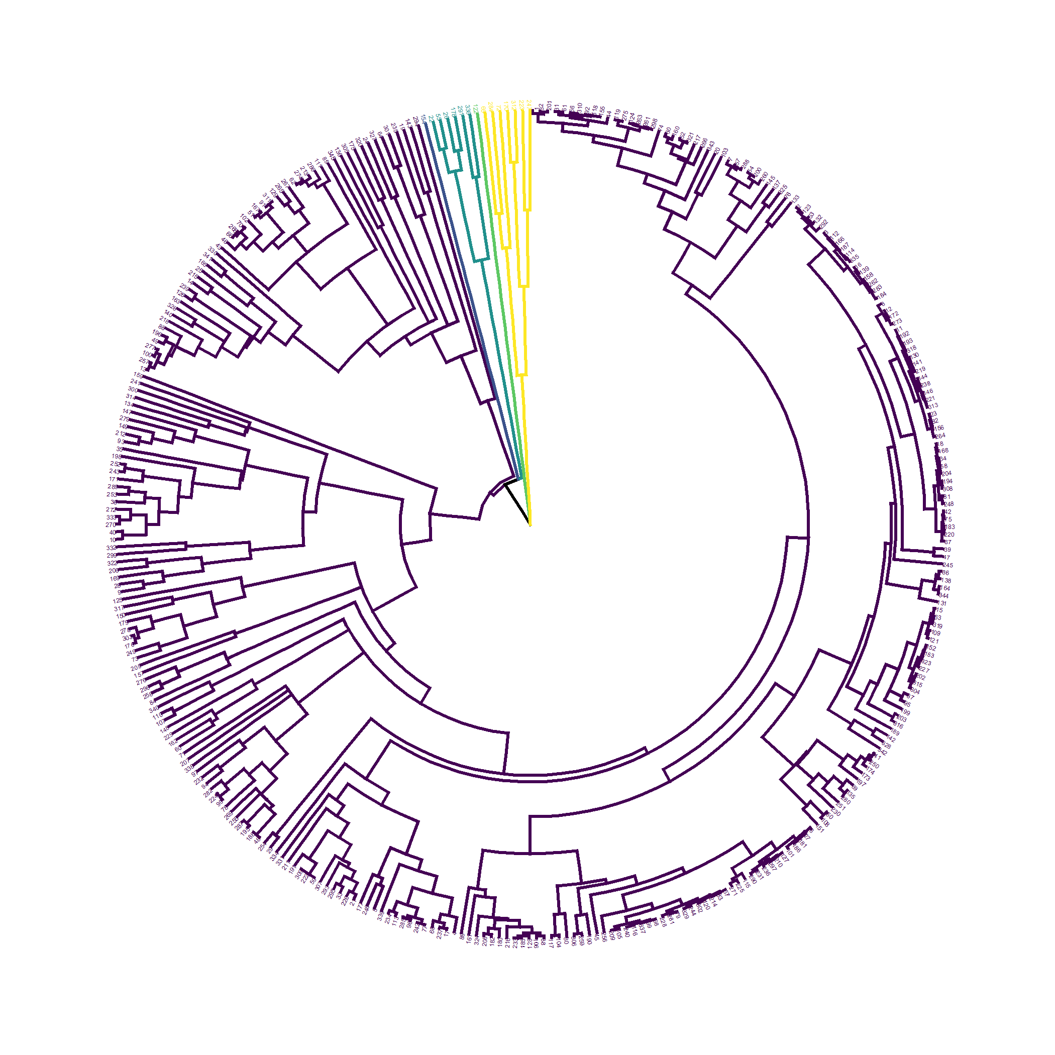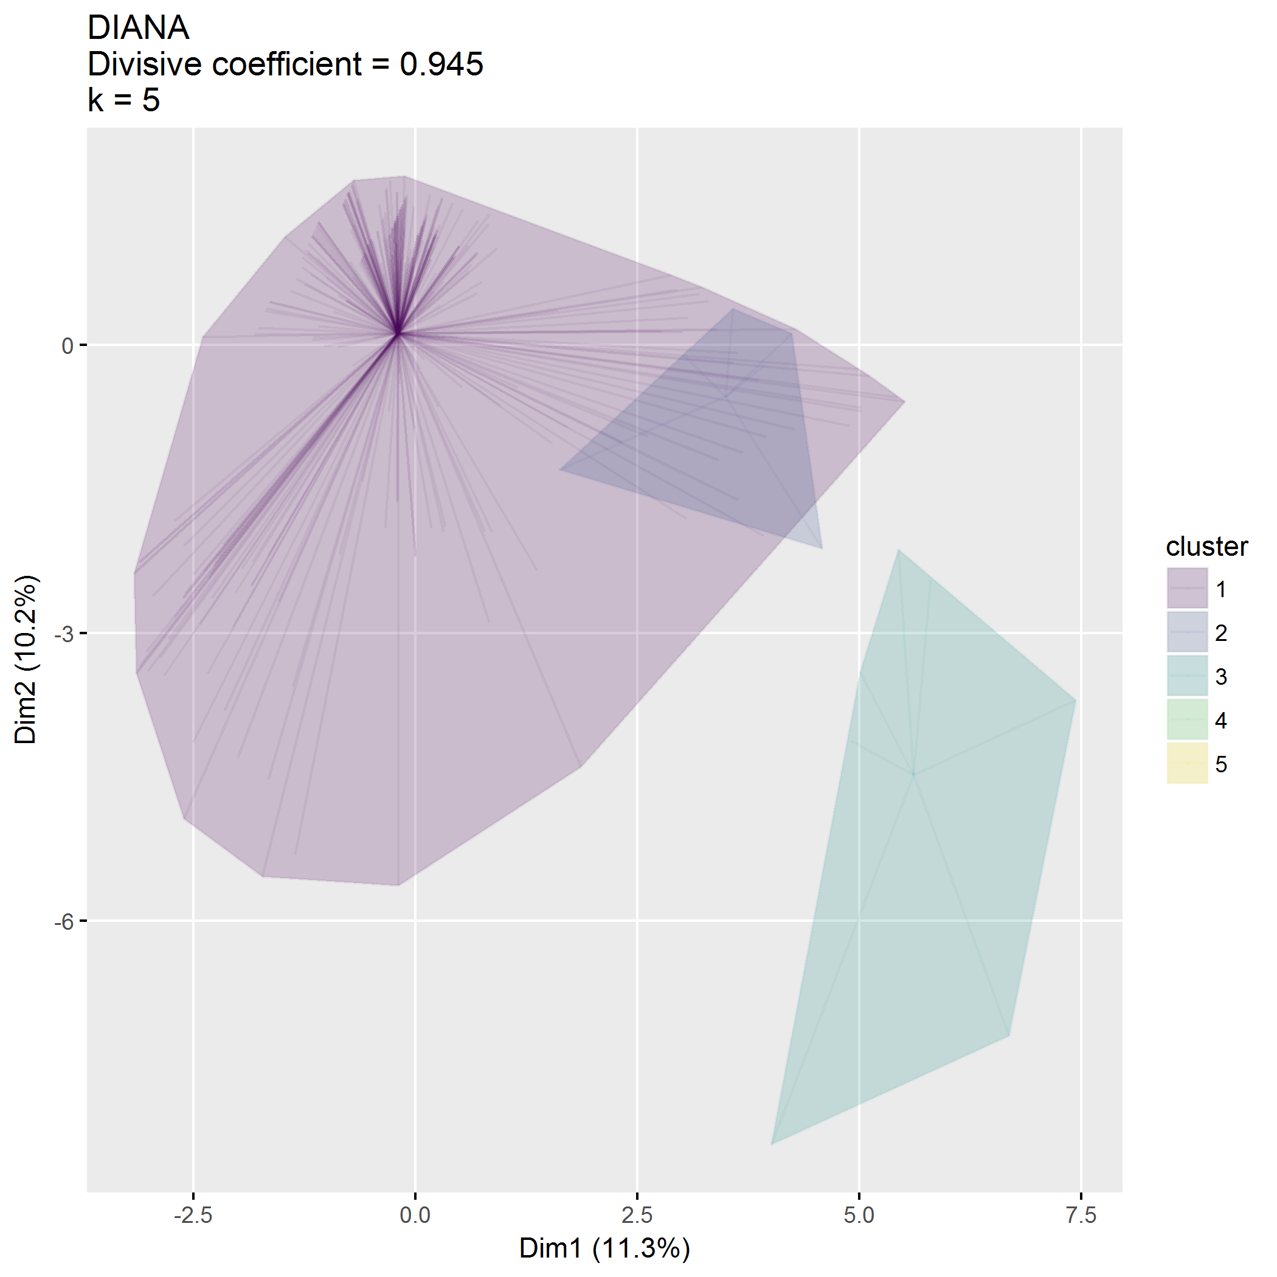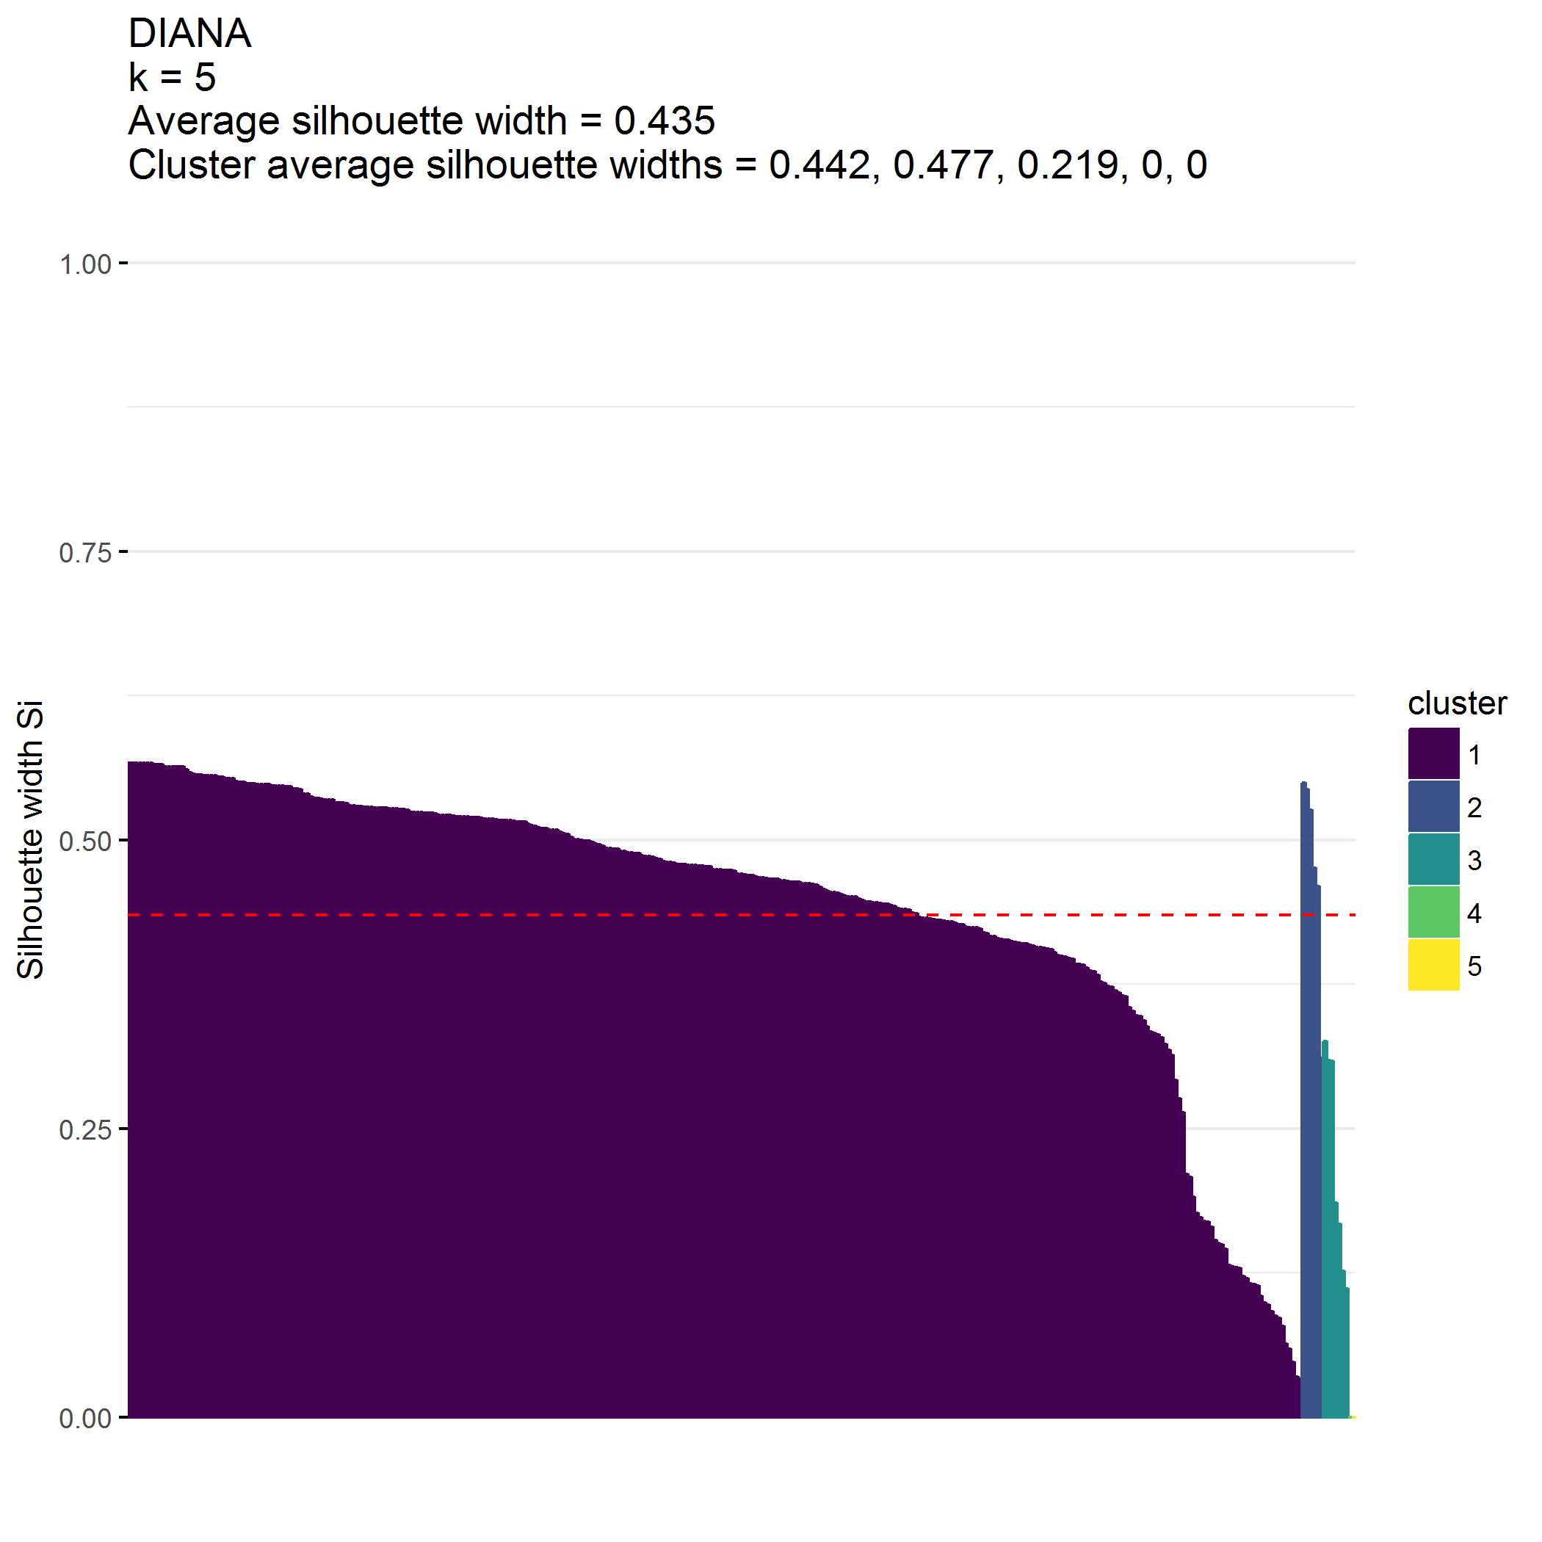

|  |  |  |  |  |  |
| --- | --- | --- | --- | --- | --- |
| cluster | n | totalChildren_mean | totalChildren_median | parentAge_mean | parentAge_median |
| 1 | 330 | 2.0 | 2.0 | 33.6 | 33.0 |
| 2 | 6 | 1.7 | 1.5 | 30.0 | 27.5 |
| 3 | 7 | 3.4 | 3.0 | 39.3 | 36.0 |
| 4 | 1 | 5.0 | 5.0 | 31.0 | 31.0 |
| 5 | 1 | 2.0 | 2.0 | 43.0 | 43.0 |

|  |  |  |  |
| --- | --- | --- | --- |
| cluster | parentGender | n | pct |
| 1 | Male | 51 | 0.15 |
| 1 | Female | 278 | 0.84 |
| 1 | Transgender | 1 | 0.00 |
| 2 | Female | 4 | 0.67 |
| 2 | Prefer not to respond | 2 | 0.33 |
| 3 | Male | 1 | 0.14 |
| 3 | Female | 5 | 0.71 |
| 3 | Prefer not to respond | 1 | 0.14 |
| 4 | Other | 1 | 1.00 |
| 5 | Female | 1 | 1.00 |

|  |  |  |  |
| --- | --- | --- | --- |
| cluster | parentSituation | n | pct |
| 1 | Single parenting | 24 | 0.07 |
| 1 | Couple parenting with spouse or partner in the same household | 299 | 0.91 |
| 1 | Co-parenting in separate households | 7 | 0.02 |
| 2 | Single parenting | 5 | 0.83 |
| 2 | Couple parenting with spouse or partner in the same household | 1 | 0.17 |
| 3 | Single parenting | 1 | 0.14 |
| 3 | Co-parenting in separate households | 6 | 0.86 |
| 4 | Couple parenting with spouse or partner in the same household | 1 | 1.00 |
| 5 | Single parenting | 1 | 1.00 |

|  |  |  |  |
| --- | --- | --- | --- |
| cluster | parentEducation | n | pct |
| 1 | High school or less | 38 | 0.12 |
| 1 | Vocational school/some college | 62 | 0.19 |
| 1 | College | 135 | 0.41 |
| 1 | Graduate/professional school | 95 | 0.29 |
| 2 | High school or less | 3 | 0.50 |
| 2 | Vocational school/some college | 2 | 0.33 |
| 2 | Graduate/professional school | 1 | 0.17 |
| 3 | Vocational school/some college | 3 | 0.43 |
| 3 | College | 3 | 0.43 |
| 3 | Graduate/professional school | 1 | 0.14 |
| 4 | High school or less | 1 | 1.00 |
| 5 | Vocational school/some college | 1 | 1.00 |

|  |  |  |  |
| --- | --- | --- | --- |
| cluster | parentEthnicity | n | pct |
| 1 | Hispanic/Latino | 35 | 0.11 |
| 1 | Not Hispanic/Latino | 272 | 0.82 |
| 1 | Unknown | 4 | 0.01 |
| 1 | Prefer not to respond | 19 | 0.06 |
| 2 | Not Hispanic/Latino | 6 | 1.00 |
| 3 | Not Hispanic/Latino | 2 | 0.29 |
| 3 | Unknown | 2 | 0.29 |
| 3 | Prefer not to respond | 3 | 0.43 |
| 4 | Hispanic/Latino | 1 | 1.00 |
| 5 | Not Hispanic/Latino | 1 | 1.00 |

|  |  |  |  |
| --- | --- | --- | --- |
| cluster | parentRaceWhite | n | pct |
| 1 | 0 | 73 | 0.22 |
| 1 | 1 | 257 | 0.78 |
| 2 | 1 | 6 | 1.00 |
| 3 | 0 | 4 | 0.57 |
| 3 | 1 | 3 | 0.43 |
| 4 | 0 | 1 | 1.00 |
| 5 | 1 | 1 | 1.00 |

## Cluster on child factors

**Clustering on child factors is terrible.** First split, with , produces one very small cluster.

## [1] 345 19

## [1] "birthOrderOnly child"   
## [2] "birthOrderOldest"   
## [3] "birthOrderMiddle"   
## [4] "birthOrderYoungest"   
## [5] "childSexMale"   
## [6] "childAge"   
## [7] "childEthnicityNot Hispanic/Latino"   
## [8] "childEthnicityUnknown"   
## [9] "childEthnicityPrefer not to respond"   
## [10] "childRaceWhite1"   
## [11] "childRaceAsian1"   
## [12] "childRaceAfrAm1"   
## [13] "childRaceAIAN1"   
## [14] "childRaceNHPI1"   
## [15] "childRaceOther1"   
## [16] "childRaceNoResp1"   
## [17] "childRelationshipBiological or adoptive father"  
## [18] "childRelationshipGrandparent"   
## [19] "childRelationshipOther"

## cluster size ave.sil.width  
## 1 1 329 0.43  
## 2 2 7 0.41  
## 3 3 6 0.50  
## 4 4 2 0.90  
## 5 5 1 0.00

* Hopkins statistic is 0.065
* Analysis identified clusters
* Divisive coefficient is 0.967
* Average silhouette width is 0.432

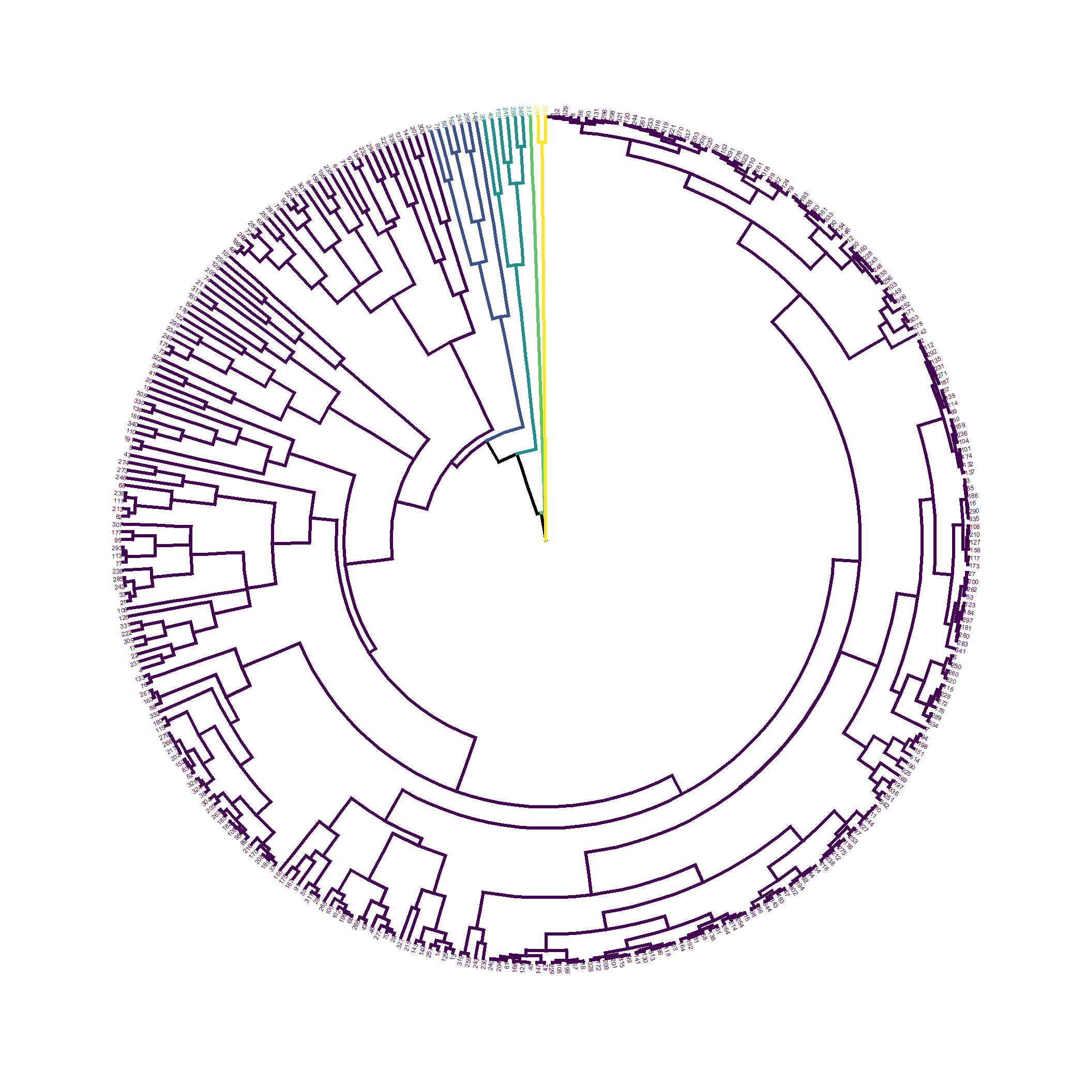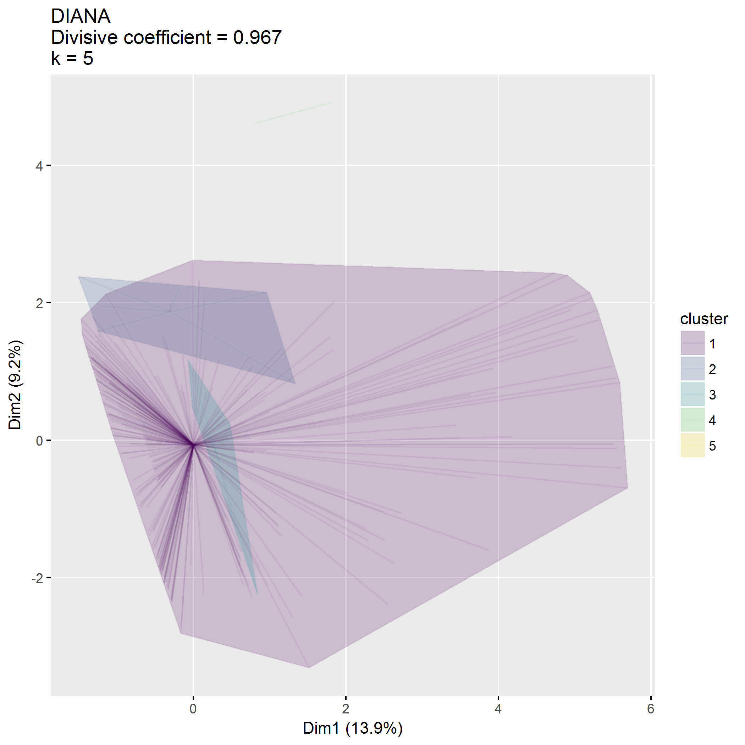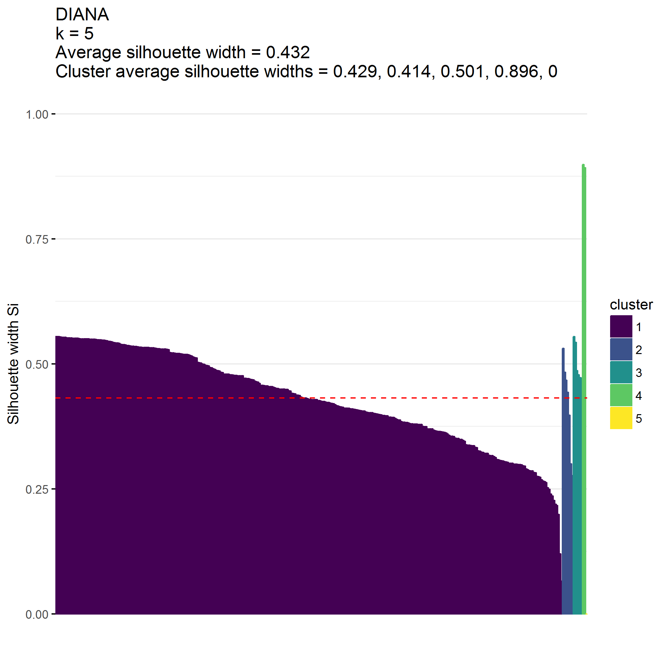

|  |  |  |  |
| --- | --- | --- | --- |
| cluster | n | childAge_mean | childAge_median |
| 1 | 329 | 3.5 | 3.4 |
| 2 | 7 | 4.5 | 4.9 |
| 3 | 6 | 4.0 | 4.2 |
| 4 | 2 | 4.7 | 4.7 |
| 5 | 1 | 4.8 | 4.8 |

|  |  |  |  |
| --- | --- | --- | --- |
| cluster | birthOrder | n | pct |
| 1 | Only child | 109 | 0.33 |
| 1 | Oldest | 90 | 0.27 |
| 1 | Middle | 38 | 0.12 |
| 1 | Youngest | 92 | 0.28 |
| 2 | Only child | 1 | 0.14 |
| 2 | Oldest | 4 | 0.57 |
| 2 | Middle | 2 | 0.29 |
| 3 | Only child | 2 | 0.33 |
| 3 | Oldest | 2 | 0.33 |
| 3 | Middle | 1 | 0.17 |
| 3 | Youngest | 1 | 0.17 |
| 4 | Middle | 2 | 1.00 |
| 5 | Youngest | 1 | 1.00 |

|  |  |  |  |
| --- | --- | --- | --- |
| cluster | childSex | n | pct |
| 1 | Female | 149 | 0.45 |
| 1 | Male | 180 | 0.55 |
| 2 | Female | 4 | 0.57 |
| 2 | Male | 3 | 0.43 |
| 3 | Female | 4 | 0.67 |
| 3 | Male | 2 | 0.33 |
| 4 | Male | 2 | 1.00 |
| 5 | Female | 1 | 1.00 |

|  |  |  |  |
| --- | --- | --- | --- |
| cluster | childEthnicity | n | pct |
| 1 | Hispanic/Latino | 42 | 0.13 |
| 1 | Not Hispanic/Latino | 261 | 0.79 |
| 1 | Prefer not to respond | 26 | 0.08 |
| 2 | Hispanic/Latino | 4 | 0.57 |
| 2 | Not Hispanic/Latino | 3 | 0.43 |
| 3 | Unknown | 6 | 1.00 |
| 4 | Hispanic/Latino | 1 | 0.50 |
| 4 | Not Hispanic/Latino | 1 | 0.50 |
| 5 | Not Hispanic/Latino | 1 | 1.00 |

|  |  |  |  |
| --- | --- | --- | --- |
| cluster | childRaceWhite | n | pct |
| 1 | 0 | 63 | 0.19 |
| 1 | 1 | 266 | 0.81 |
| 2 | 0 | 2 | 0.29 |
| 2 | 1 | 5 | 0.71 |
| 3 | 1 | 6 | 1.00 |
| 4 | 0 | 2 | 1.00 |
| 5 | 1 | 1 | 1.00 |

|  |  |  |  |
| --- | --- | --- | --- |
| cluster | childRelationship | n | pct |
| 1 | Biological or adoptive mother | 285 | 0.87 |
| 1 | Biological or adoptive father | 44 | 0.13 |
| 2 | Biological or adoptive mother | 6 | 0.86 |
| 2 | Biological or adoptive father | 1 | 0.14 |
| 3 | Biological or adoptive mother | 6 | 1.00 |
| 4 | Other | 2 | 1.00 |
| 5 | Grandparent | 1 | 1.00 |

## Cluster on demographic factors

**Clustering on demographic factors is terrible.**

* languageSurvey dropped from consideration;
* First two splits, with , produces two very small clusters
* The next split, at , produces a good sized cluster
* The clustering between clusters 1 () and 2 () appears to have to do more with geography (distance, zipcode class, urban/rural)

## [1] 345 88

## [1] "zipcodeClass1" "zipcodeClass2"   
## [3] "zipcode91020" "zipcode91204"   
## [5] "zipcode91206" "zipcode91210"   
## [7] "zipcode91402" "zipcode97003"   
## [9] "zipcode97006" "zipcode97007"   
## [11] "zipcode97008" "zipcode97023"   
## [13] "zipcode97027" "zipcode97032"   
## [15] "zipcode97034" "zipcode97035"   
## [17] "zipcode97045" "zipcode97056"   
## [19] "zipcode97060" "zipcode97062"   
## [21] "zipcode97068" "zipcode97071"   
## [23] "zipcode97078" "zipcode97086"   
## [25] "zipcode97089" "zipcode97101"   
## [27] "zipcode97116" "zipcode97123"   
## [29] "zipcode97124" "zipcode97140"   
## [31] "zipcode97141" "zipcode97201"   
## [33] "zipcode97202" "zipcode97203"   
## [35] "zipcode97206" "zipcode97209"   
## [37] "zipcode97210" "zipcode97211"   
## [39] "zipcode97212" "zipcode97213"   
## [41] "zipcode97214" "zipcode97215"   
## [43] "zipcode97217" "zipcode97219"   
## [45] "zipcode97220" "zipcode97221"   
## [47] "zipcode97222" "zipcode97223"   
## [49] "zipcode97224" "zipcode97225"   
## [51] "zipcode97227" "zipcode97229"   
## [53] "zipcode97230" "zipcode97232"   
## [55] "zipcode97233" "zipcode97236"   
## [57] "zipcode97239" "zipcode97266"   
## [59] "zipcode97267" "zipcode97321"   
## [61] "zipcode97325" "zipcode97429"   
## [63] "zipcode97527" "zipcode97701"   
## [65] "zipcode97702" "zipcode97703"   
## [67] "zipcode97707" "zipcode97734"   
## [69] "zipcode97738" "zipcode97741"   
## [71] "zipcode97753" "zipcode97754"   
## [73] "zipcode97756" "zipcode97759"   
## [75] "zipcode97760" "zipcode98632"   
## [77] "zipcode98660" "zipcode98683"   
## [79] "zipcode98685" "communitySuburban"   
## [81] "communityRural" "distance"   
## [83] "income$25,001-$49,999" "income$50,000-$79,999"   
## [85] "income$80,000-$119,999" "income$120,000-$149,999"  
## [87] "income$150,000 or more" "internet"

## cluster size ave.sil.width  
## 1 1 249 0.19  
## 2 2 93 0.34  
## 3 3 2 -0.11  
## 4 4 1 0.00

* Hopkins statistic is 0.041
* Analysis identified clusters
* Divisive coefficient is 0.878
* Average silhouette width is 0.231

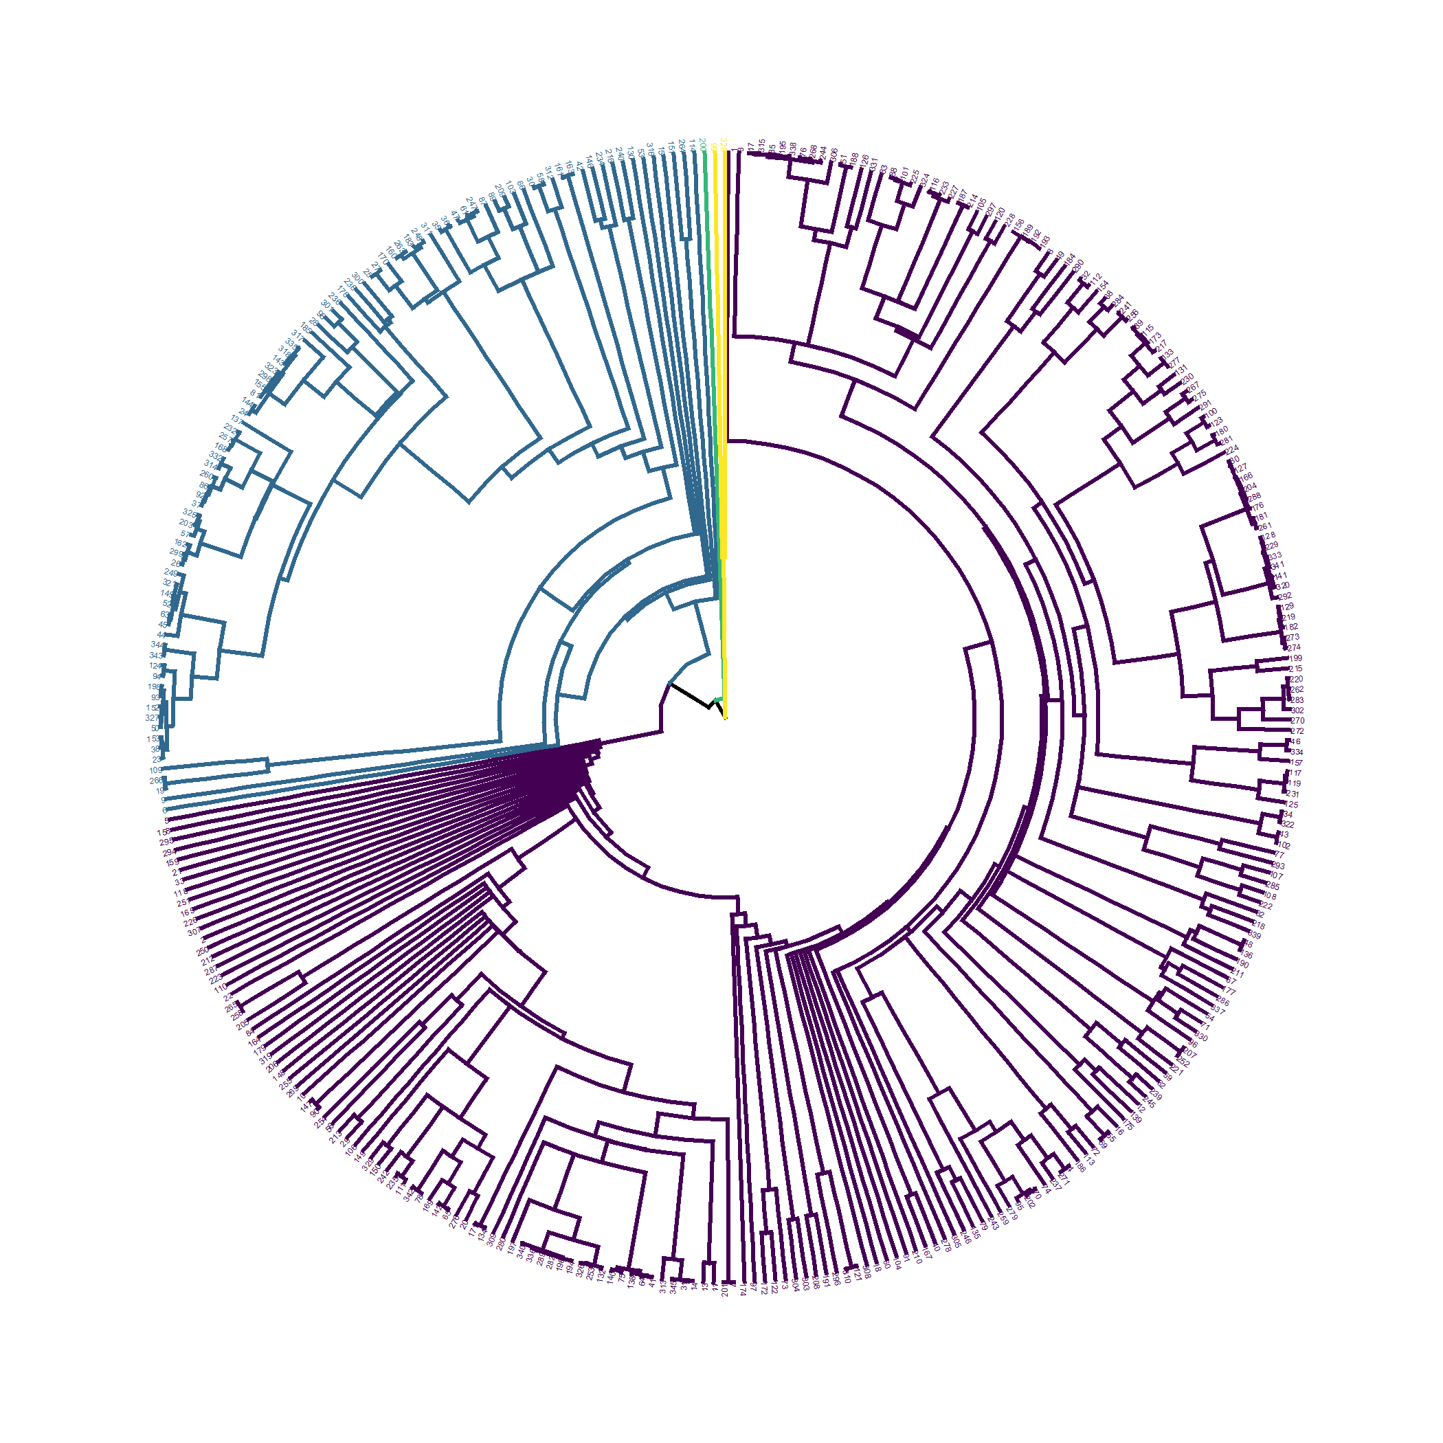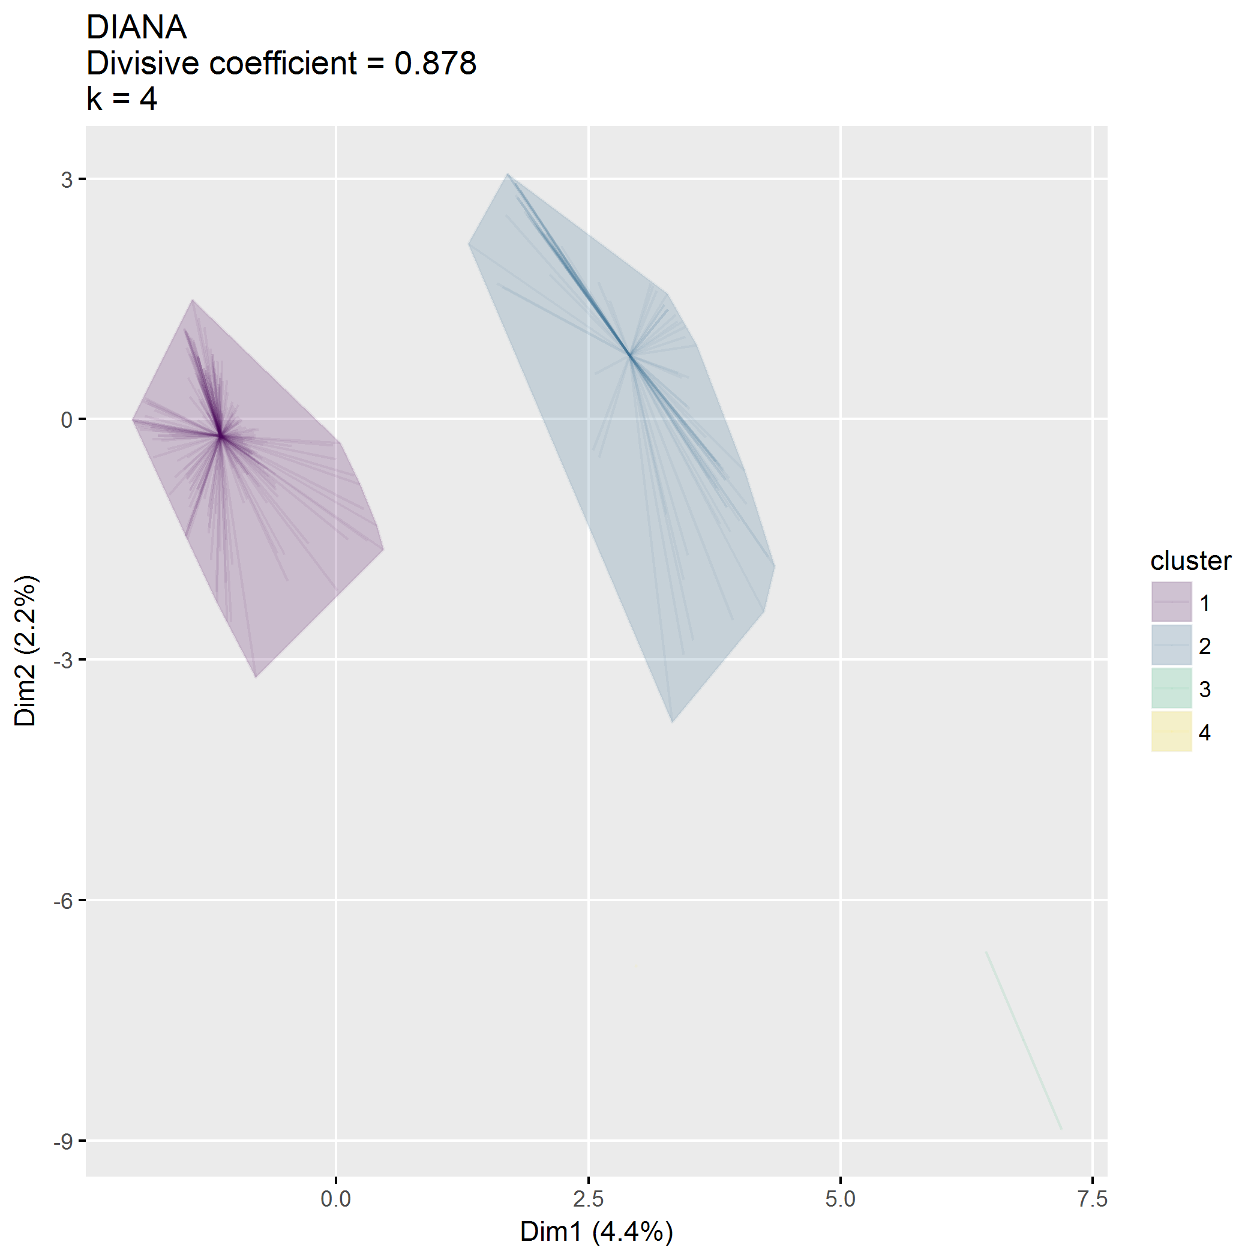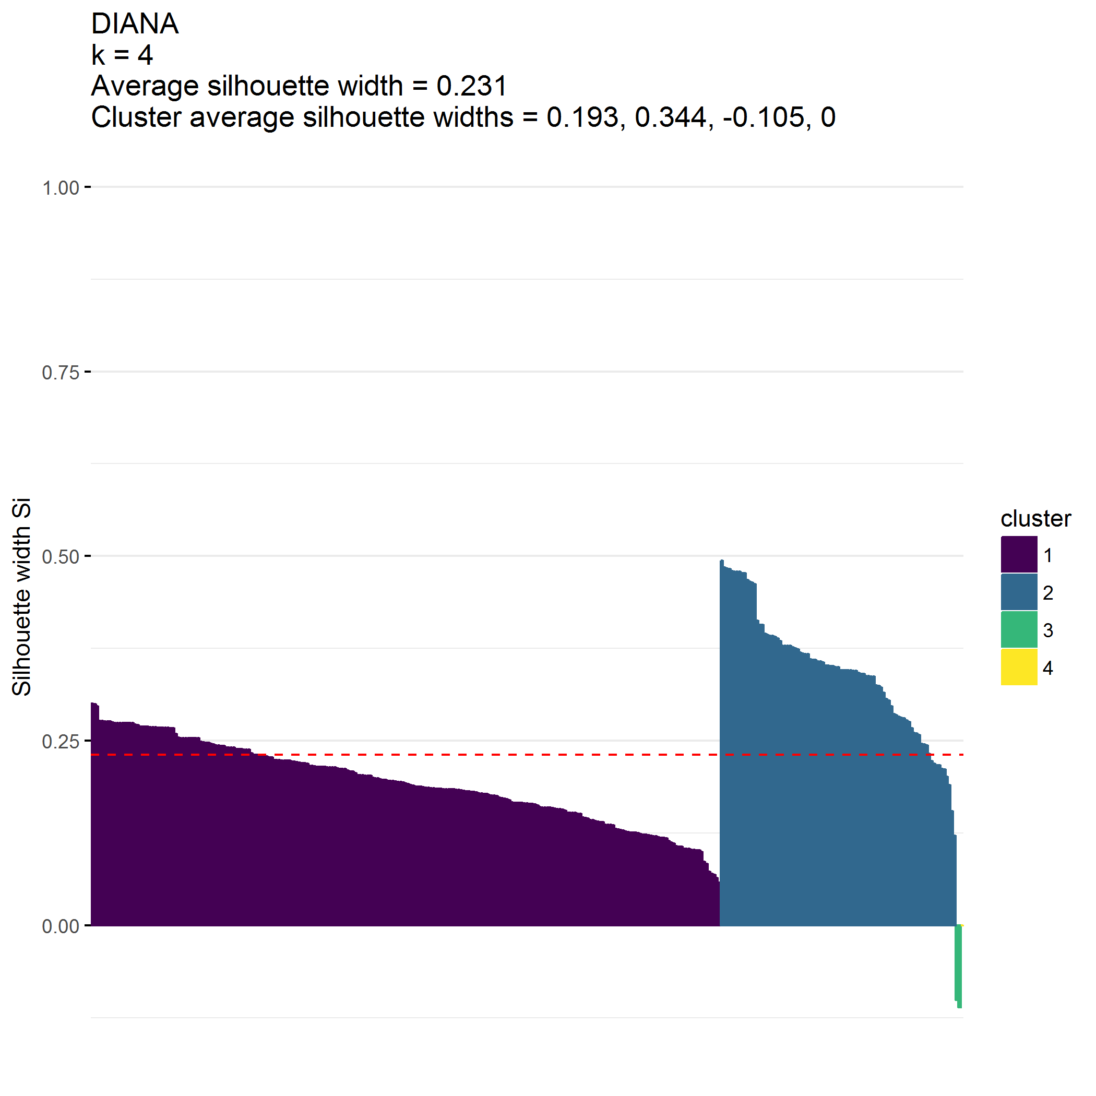

|  |  |  |  |  |
| --- | --- | --- | --- | --- |
| cluster | n | distance_mean | distance_median | distance_range |
| 1 | 249 | 6.7 | 5 | 0.4-30.0 |
| 2 | 93 | 15.1 | 12 | 1.0-100.0 |
| 3 | 2 | 140.0 | 140 | 130.0-150.0 |
| 4 | 1 | 75.0 | 75 | 75.0-75.0 |

|  |  |  |  |
| --- | --- | --- | --- |
| cluster | zipcodeClass | n | pct |
| 1 | 1 | 249 | 1 |
| 2 | 2 | 93 | 1 |
| 3 | 2 | 2 | 1 |
| 4 | 1 | 1 | 1 |

|  |  |  |  |
| --- | --- | --- | --- |
| cluster | community | n | pct |
| 1 | Urban | 109 | 0.44 |
| 1 | Suburban | 128 | 0.51 |
| 1 | Rural | 12 | 0.05 |
| 2 | Urban | 13 | 0.14 |
| 2 | Suburban | 30 | 0.32 |
| 2 | Rural | 50 | 0.54 |
| 3 | Rural | 2 | 1.00 |
| 4 | Rural | 1 | 1.00 |

|  |  |  |  |
| --- | --- | --- | --- |
| cluster | income | n | pct |
| 1 | $25,000 or less | 25 | 0.10 |
| 1 | $25,001-$49,999 | 57 | 0.23 |
| 1 | $50,000-$79,999 | 58 | 0.23 |
| 1 | $80,000-$119,999 | 38 | 0.15 |
| 1 | $120,000-$149,999 | 27 | 0.11 |
| 1 | $150,000 or more | 44 | 0.18 |
| 2 | $25,000 or less | 10 | 0.11 |
| 2 | $25,001-$49,999 | 26 | 0.28 |
| 2 | $50,000-$79,999 | 31 | 0.33 |
| 2 | $80,000-$119,999 | 17 | 0.18 |
| 2 | $120,000-$149,999 | 5 | 0.05 |
| 2 | $150,000 or more | 4 | 0.04 |
| 3 | $50,000-$79,999 | 1 | 0.50 |
| 3 | $80,000-$119,999 | 1 | 0.50 |
| 4 | $50,000-$79,999 | 1 | 1.00 |

|  |  |  |  |
| --- | --- | --- | --- |
| cluster | internet | n | pct |
| 1 | 0 | 4 | 0.02 |
| 1 | 1 | 245 | 0.98 |
| 2 | 0 | 4 | 0.04 |
| 2 | 1 | 89 | 0.96 |
| 3 | 1 | 2 | 1.00 |
| 4 | 0 | 1 | 1.00 |

## Save objects

## size isdir mode  
## data/processed/clusterAnalysis.RData 11981880 FALSE 666  
## mtime  
## data/processed/clusterAnalysis.RData 2018-07-11 14:15:05  
## ctime  
## data/processed/clusterAnalysis.RData 2018-07-06 12:14:44  
## atime exe  
## data/processed/clusterAnalysis.RData 2018-07-06 12:14:44 no