Glutathione ratios as the mechanism of action of lipoic acid in progressive multiple sclerosis (PI: Rebecca Spain)

Benjamin Chan (chanb@ohsu.edu)

2018-03-14

# Import raw data

Joined data set. Include only the

* Study design variables,
* Normalized concentrations, and
* GSH/GSSG ratios

## Clean data

Data check **before cleaning**.

|  |  |  |  |
| --- | --- | --- | --- |
| patientID | hasM0 | hasM3 | hasM12 |
| 120 | 1 | 0 | 1 |
| 122 | 1 | 0 | 1 |
| 134 | 1 | 1 | 2 |
| 143 | 0 | 2 | 0 |

Recode data per Cassidy's email

From: Cassidy Taylor  
Sent: Monday, March 12, 2018 3:17 PM  
To: Benjamin Chan [chanb@ohsu.edu](mailto:chanb@ohsu.edu); Rebecca Spain [spainr@ohsu.edu](mailto:spainr@ohsu.edu)  
Subject: RE: Rebecca Spain Glutathione Study

Just heard back from the lab and based on the remaining levels of blood, the manifest was incorrectly labeled. It should read

Sample 44 = 143 M0  
Sample 45 = 143 M3  
Sample 46 = 143 M12

Data check **after cleaning**. Should return a data frame with only patientID %in% c(120, 122).

|  |  |  |  |
| --- | --- | --- | --- |
| patientID | hasM0 | hasM3 | hasM12 |
| 120 | 1 | 0 | 1 |
| 122 | 1 | 0 | 1 |

Double-check data from patientID == 143.

|  |  |  |  |  |  |  |  |  |  |
| --- | --- | --- | --- | --- | --- | --- | --- | --- | --- |
| sampleID | patientID | visitMonth | studyArm | brainAtrophy | normalizedConcGSH | normalizedConcGSSG | normalizedConcStdEGSH | normalizedConcStdEGSSG | normalizedConcRatio |
| 44 | 143 | 0 | Placebo | -1.74343 | 143.55248 | 1.1407128 | 3.1716859 | 0.2932400 | 125.8445 |
| 45 | 143 | 3 | Placebo | NA | 169.12581 | 1.3286383 | 1.1624269 | 0.3331352 | 127.2926 |
| 46 | 143 | 12 | Placebo | NA | 97.65062 | 0.5544174 | 0.4302695 | 0.1872683 | 176.1319 |

## Create analytic data frames for each aim

Aim 1

## Classes 'tbl_df', 'tbl' and 'data.frame': 58 obs. of 9 variables:  
## $ sampleID : num 1 2 3 4 5 6 7 8 9 10 ...  
## $ patientID : Factor w/ 20 levels "118","119","120",..: 1 1 1 2 2 2 3 3 4 4 ...  
## $ visitMonth : Factor w/ 3 levels "0","3","12": 1 2 3 1 2 3 1 3 1 3 ...  
## $ studyArm : Factor w/ 2 levels "LA","Placebo": 1 1 1 2 2 2 2 2 2 2 ...  
## $ normalizedConcGSH : num 125 101 137 87 171 ...  
## $ normalizedConcGSSG : num 0.931 0.639 0.828 0.693 1.291 ...  
## $ normalizedConcStdEGSH : num 2.287 2.06 0.0847 0.3121 1.1748 ...  
## $ normalizedConcStdEGSSG: num 0.223 0.17 0.229 0.186 0.352 ...  
## $ normalizedConcRatio : num 134 158 166 126 132 ...

Aim 2

## Classes 'tbl_df', 'tbl' and 'data.frame': 20 obs. of 6 variables:  
## $ patientID : Factor w/ 20 levels "118","119","120",..: 1 2 3 4 5 6 7 8 9 10 ...  
## $ studyArm : Factor w/ 2 levels "LA","Placebo": 1 2 2 2 2 1 2 1 1 2 ...  
## $ concRatioM0 : num 134 126 135 128 152 ...  
## $ concRatioM12 : num 166 131 144 135 129 ...  
## $ pctChangeConcRatio: num 23.39 4.4 6.78 5.2 -15.41 ...  
## $ brainAtrophy : num 0.358 -2.026 -1.544 0.534 -0.679 ...

|  |  |  |  |  |  |
| --- | --- | --- | --- | --- | --- |
| patientID | studyArm | concRatioM0 | concRatioM12 | pctChangeConcRatio | brainAtrophy |
| 118 | LA | 134.39 | 165.82 | 23.39 | 0.36 |
| 124 | LA | 168.90 | 171.58 | 1.59 | 0.80 |
| 129 | LA | 171.36 | 175.25 | 2.27 | -1.46 |
| 130 | LA | 148.02 | 176.26 | 19.08 | 0.20 |
| 132 | LA | 139.21 | 165.67 | 19.01 | -1.55 |
| 134 | LA | 140.53 | 176.27 | 25.44 | 0.60 |
| 140 | LA | 166.15 | 147.36 | -11.31 | -1.11 |
| 149 | LA | 157.75 | 160.44 | 1.71 | 0.07 |
| 151 | LA | 170.28 | 166.27 | -2.36 | -0.16 |
| 119 | Placebo | 125.56 | 131.09 | 4.40 | -2.03 |
| 120 | Placebo | 134.69 | 143.82 | 6.78 | -1.54 |
| 122 | Placebo | 127.89 | 134.53 | 5.20 | 0.53 |
| 123 | Placebo | 152.45 | 128.95 | -15.41 | -0.68 |
| 125 | Placebo | 126.19 | 128.79 | 2.06 | -1.12 |
| 131 | Placebo | 124.82 | 125.19 | 0.29 | -1.75 |
| 135 | Placebo | 155.24 | 148.21 | -4.52 | -0.27 |
| 139 | Placebo | 140.65 | 141.52 | 0.62 | -2.17 |
| 143 | Placebo | 125.84 | 176.13 | 39.96 | -1.74 |
| 145 | Placebo | 122.08 | 132.14 | 8.25 | -2.01 |
| 153 | Placebo | 146.84 | 120.52 | -17.93 | -1.22 |

# Aim 1

## Normalized GSH:GSSG concentration ratio

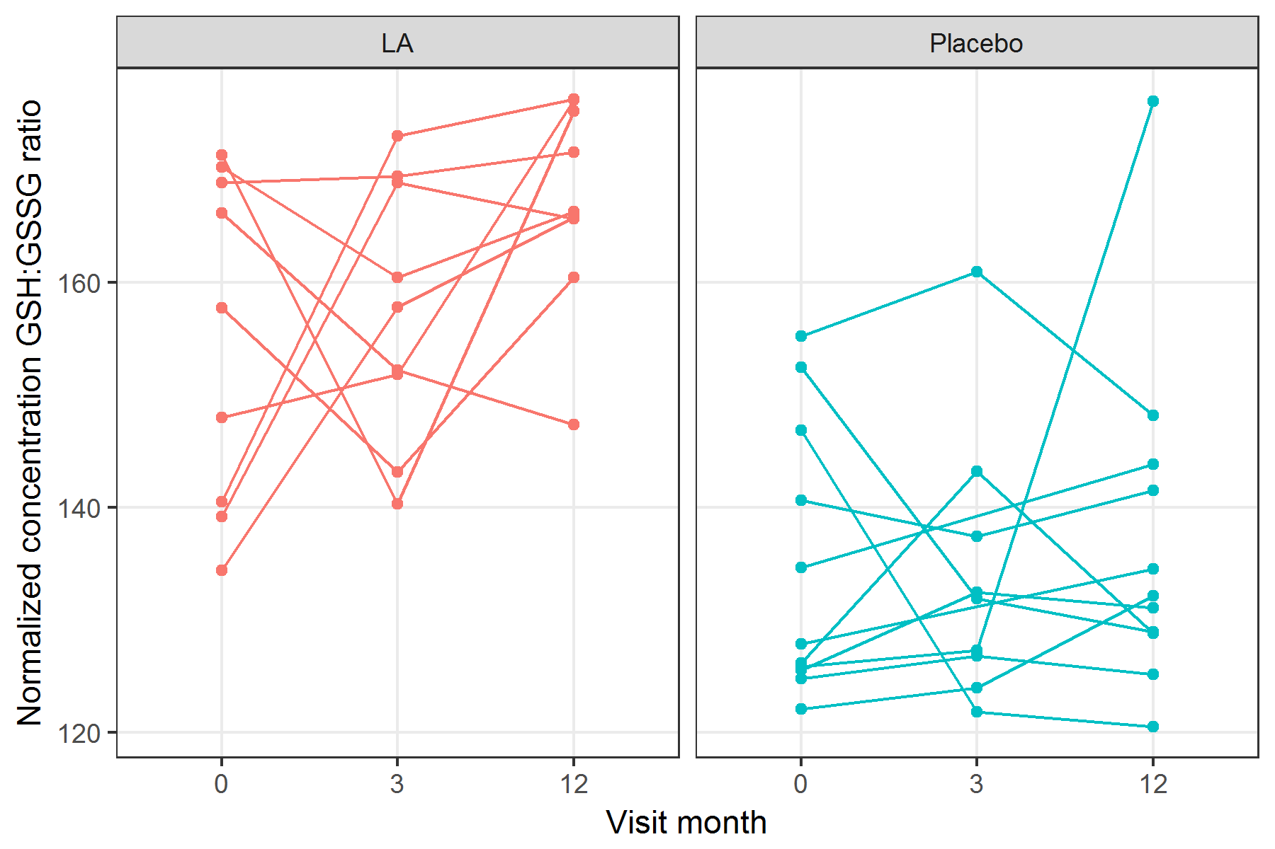

figures/lineplotNormalizedConcRatio.png

Mixed effects model using the **lme4** package.

|  |  |  |  |  |
| --- | --- | --- | --- | --- |
| term | estimate | std.error | statistic | group |
| (Intercept) | 155.18 | 4.26 | 36.42 | fixed |
| studyArmPlacebo | -20.43 | 5.74 | -3.56 | fixed |
| visitMonth3 | 2.29 | 5.94 | 0.38 | fixed |
| visitMonth12 | 12.04 | 5.94 | 2.03 | fixed |
| studyArmPlacebo:visitMonth3 | -3.05 | 8.21 | -0.37 | fixed |
| studyArmPlacebo:visitMonth12 | -9.43 | 8.01 | -1.18 | fixed |
| sd_(Intercept).patientID | 2.17 | NA | NA | patientID |
| sd_Observation.Residual | 12.60 | NA | NA | Residual |

## Linear mixed model fit by REML ['lmerMod']  
## Formula: normalizedConcRatio ~ studyArm * visitMonth + (1 | patientID)  
## Data: df1  
##   
## REML criterion at convergence: 426.1  
##   
## Scaled residuals:   
## Min 1Q Median 3Q Max   
## -1.6030 -0.6777 -0.1108 0.7190 3.0286   
##   
## Random effects:  
## Groups Name Variance Std.Dev.  
## patientID (Intercept) 4.705 2.169   
## Residual 158.643 12.595   
## Number of obs: 58, groups: patientID, 20  
##   
## Fixed effects:  
## Estimate Std. Error t value  
## (Intercept) 155.176 4.260 36.42  
## studyArmPlacebo -20.427 5.745 -3.56  
## visitMonth3 2.285 5.937 0.38  
## visitMonth12 12.038 5.937 2.03  
## studyArmPlacebo:visitMonth3 -3.054 8.209 -0.37  
## studyArmPlacebo:visitMonth12 -9.434 8.006 -1.18  
##   
## Correlation of Fixed Effects:  
## (Intr) stdyAP vstMn3 vstM12 sAP:M3  
## stdyArmPlcb -0.742   
## visitMonth3 -0.697 0.517   
## visitMnth12 -0.697 0.517 0.500   
## stdyArmP:M3 0.504 -0.680 -0.723 -0.362   
## stdyArP:M12 0.517 -0.697 -0.371 -0.742 0.488

## $patientID

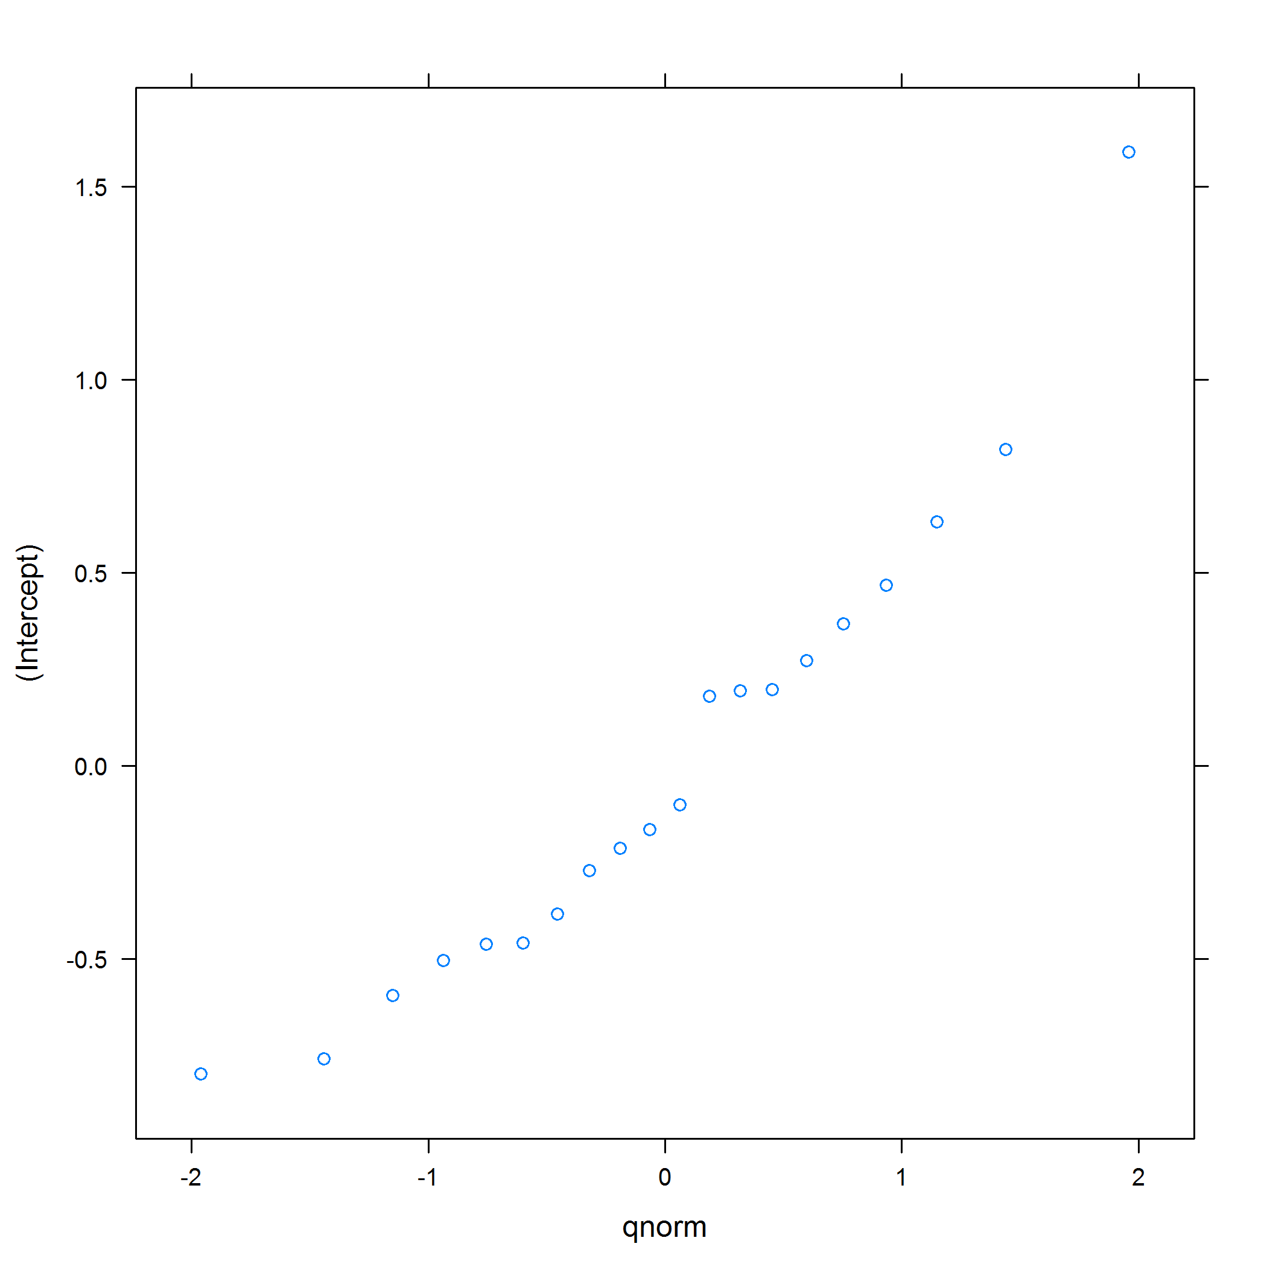 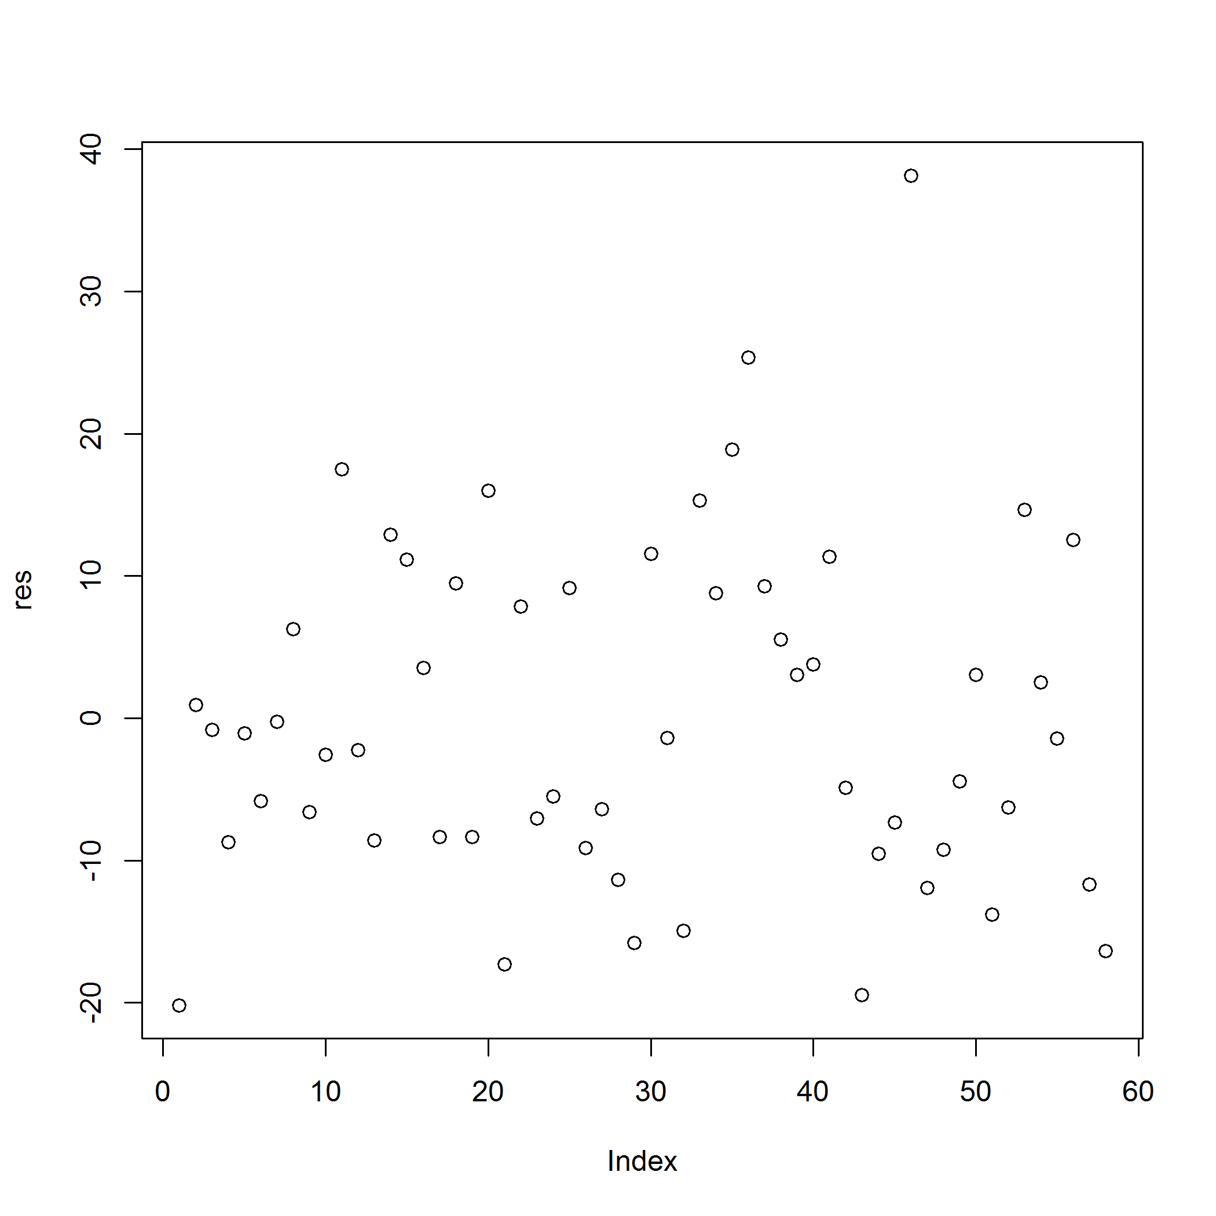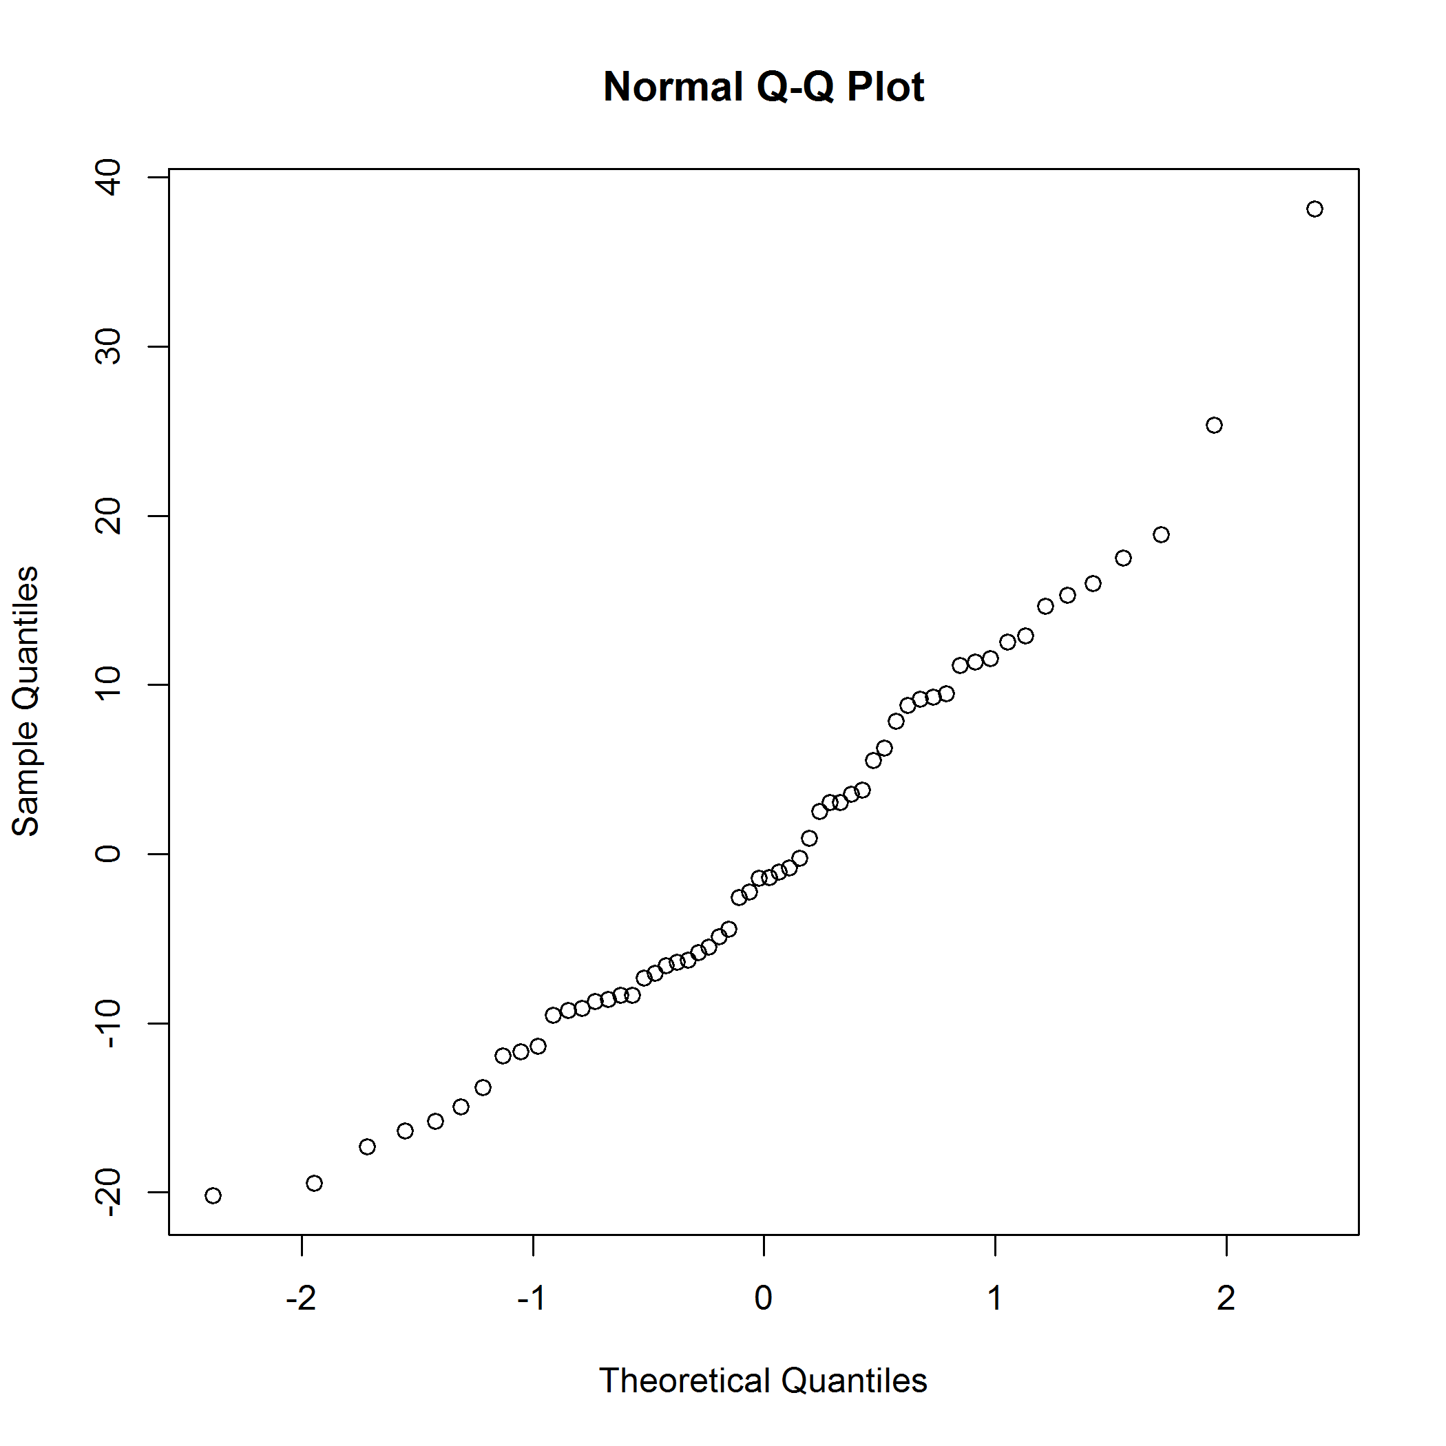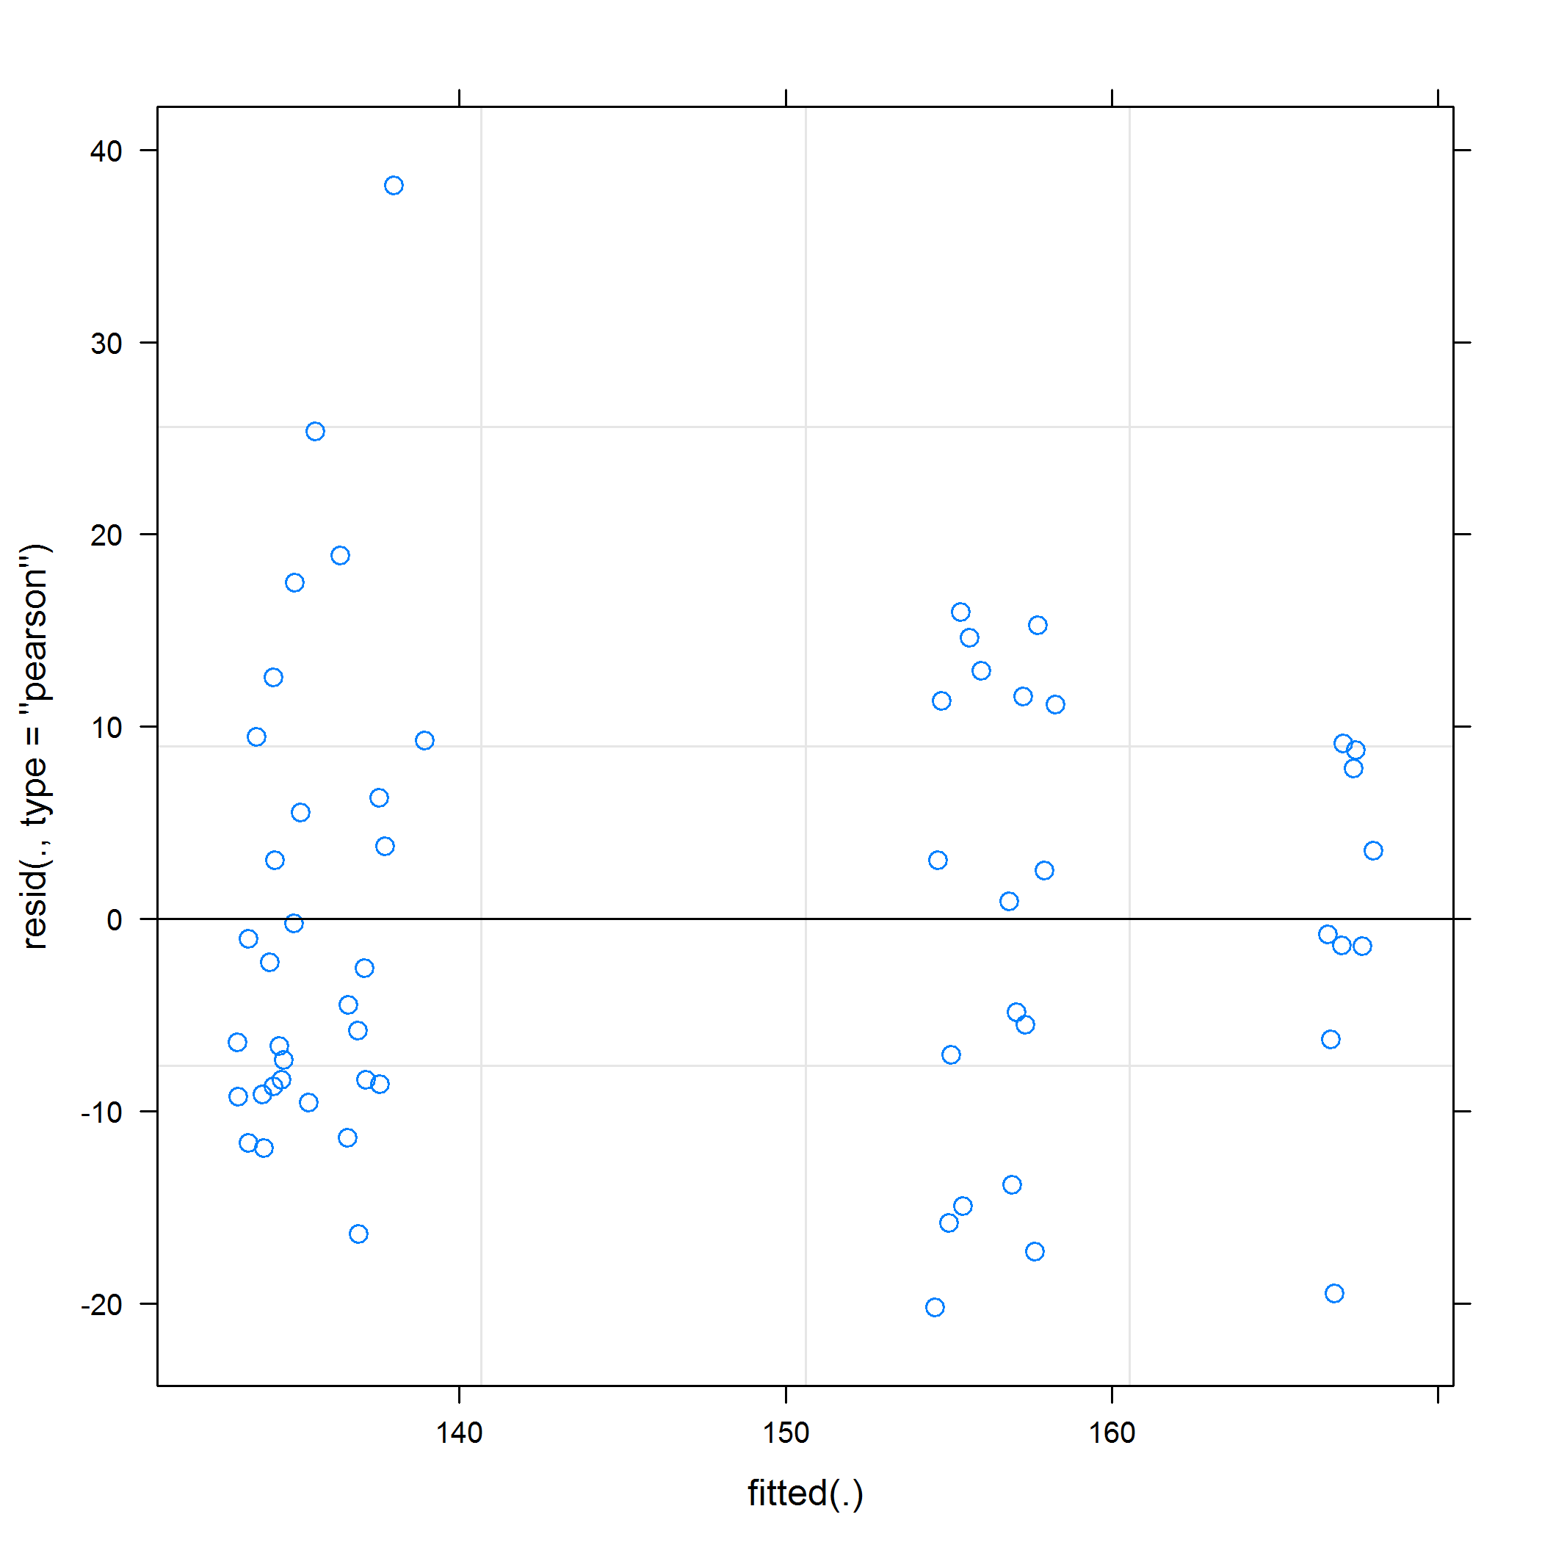

Mixed effects model using the **nlme** package.

|  |  |  |  |  |
| --- | --- | --- | --- | --- |
| term | estimate | std.error | statistic | p.value |
| (Intercept) | 155.18 | 4.26 | 36.42 | 0.0000 |
| studyArmPlacebo | -20.43 | 5.74 | -3.56 | 0.0023 |
| visitMonth3 | 2.29 | 5.94 | 0.38 | 0.7027 |
| visitMonth12 | 12.04 | 5.94 | 2.03 | 0.0505 |
| studyArmPlacebo:visitMonth3 | -3.05 | 8.21 | -0.37 | 0.7121 |
| studyArmPlacebo:visitMonth12 | -9.43 | 8.01 | -1.18 | 0.2469 |

## Linear mixed-effects model fit by REML  
## Data: df1   
## AIC BIC logLik  
## 446.0993 465.6117 -213.0497  
##   
## Random effects:  
## Formula: ~1 | patientID  
## (Intercept)  
## StdDev: 2.169122  
##   
## Formula: ~1 | visitMonth %in% patientID  
## (Intercept) Residual  
## StdDev: 12.213 3.079787  
##   
## Correlation Structure: AR(1)  
## Formula: ~1 | patientID/visitMonth   
## Parameter estimate(s):  
## Phi   
## 0   
## Fixed effects: normalizedConcRatio ~ studyArm * visitMonth   
## Value Std.Error DF t-value p-value  
## (Intercept) 155.17576 4.260250 34 36.42409 0.0000  
## studyArmPlacebo -20.42675 5.744521 18 -3.55587 0.0023  
## visitMonth3 2.28511 5.937499 34 0.38486 0.7027  
## visitMonth12 12.03819 5.937499 34 2.02749 0.0505  
## studyArmPlacebo:visitMonth3 -3.05445 8.209300 34 -0.37207 0.7121  
## studyArmPlacebo:visitMonth12 -9.43367 8.006122 34 -1.17831 0.2469  
## Correlation:   
## (Intr) stdyAP vstMn3 vstM12 sAP:M3  
## studyArmPlacebo -0.742   
## visitMonth3 -0.697 0.517   
## visitMonth12 -0.697 0.517 0.500   
## studyArmPlacebo:visitMonth3 0.504 -0.680 -0.723 -0.362   
## studyArmPlacebo:visitMonth12 0.517 -0.697 -0.371 -0.742 0.488  
##   
## Standardized Within-Group Residuals:  
## Min Q1 Med Q3 Max   
## -0.3919609 -0.1657127 -0.0270804 0.1758109 0.7405603   
##   
## Number of Observations: 58  
## Number of Groups:   
## patientID visitMonth %in% patientID   
## 20 58

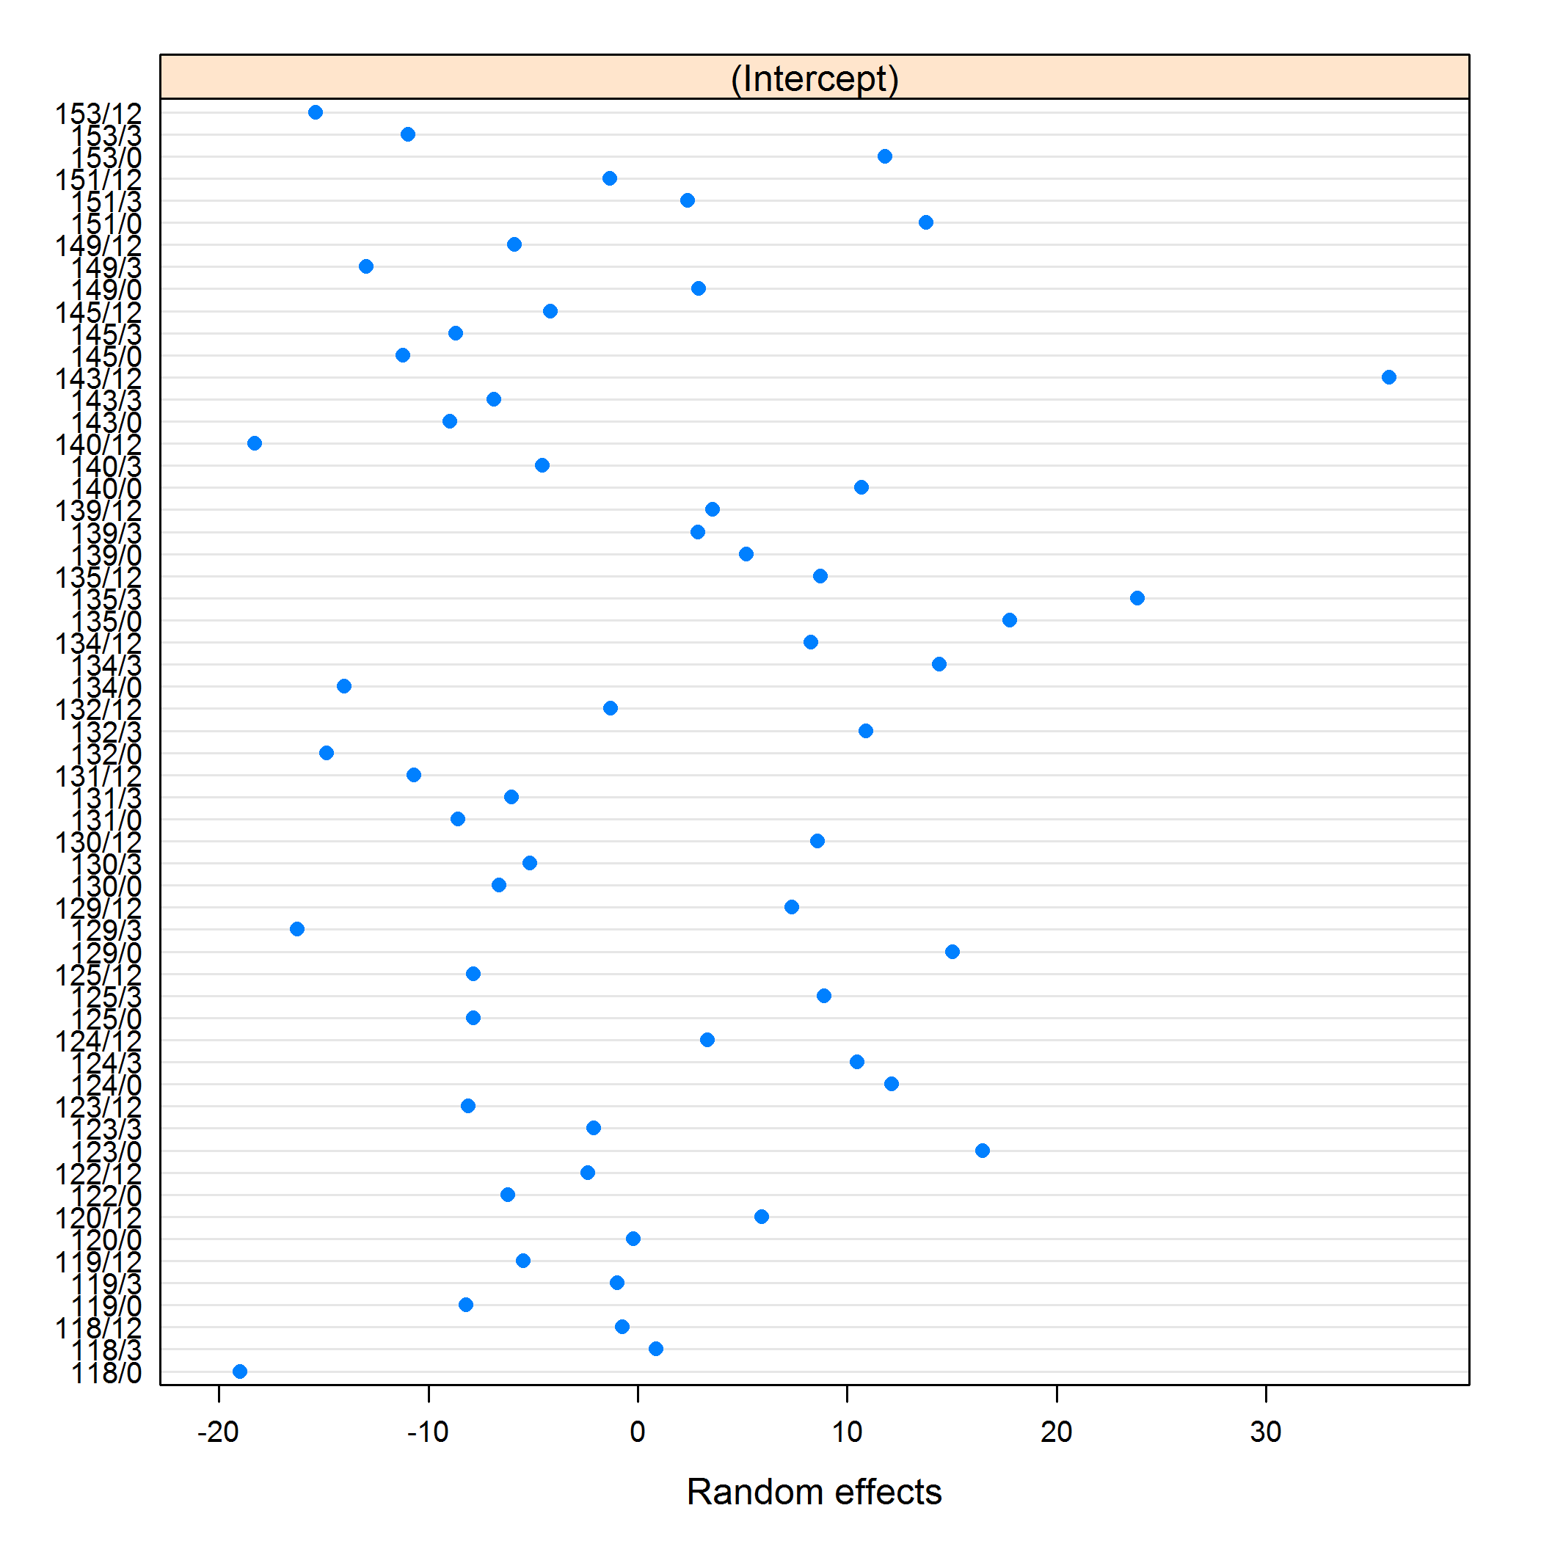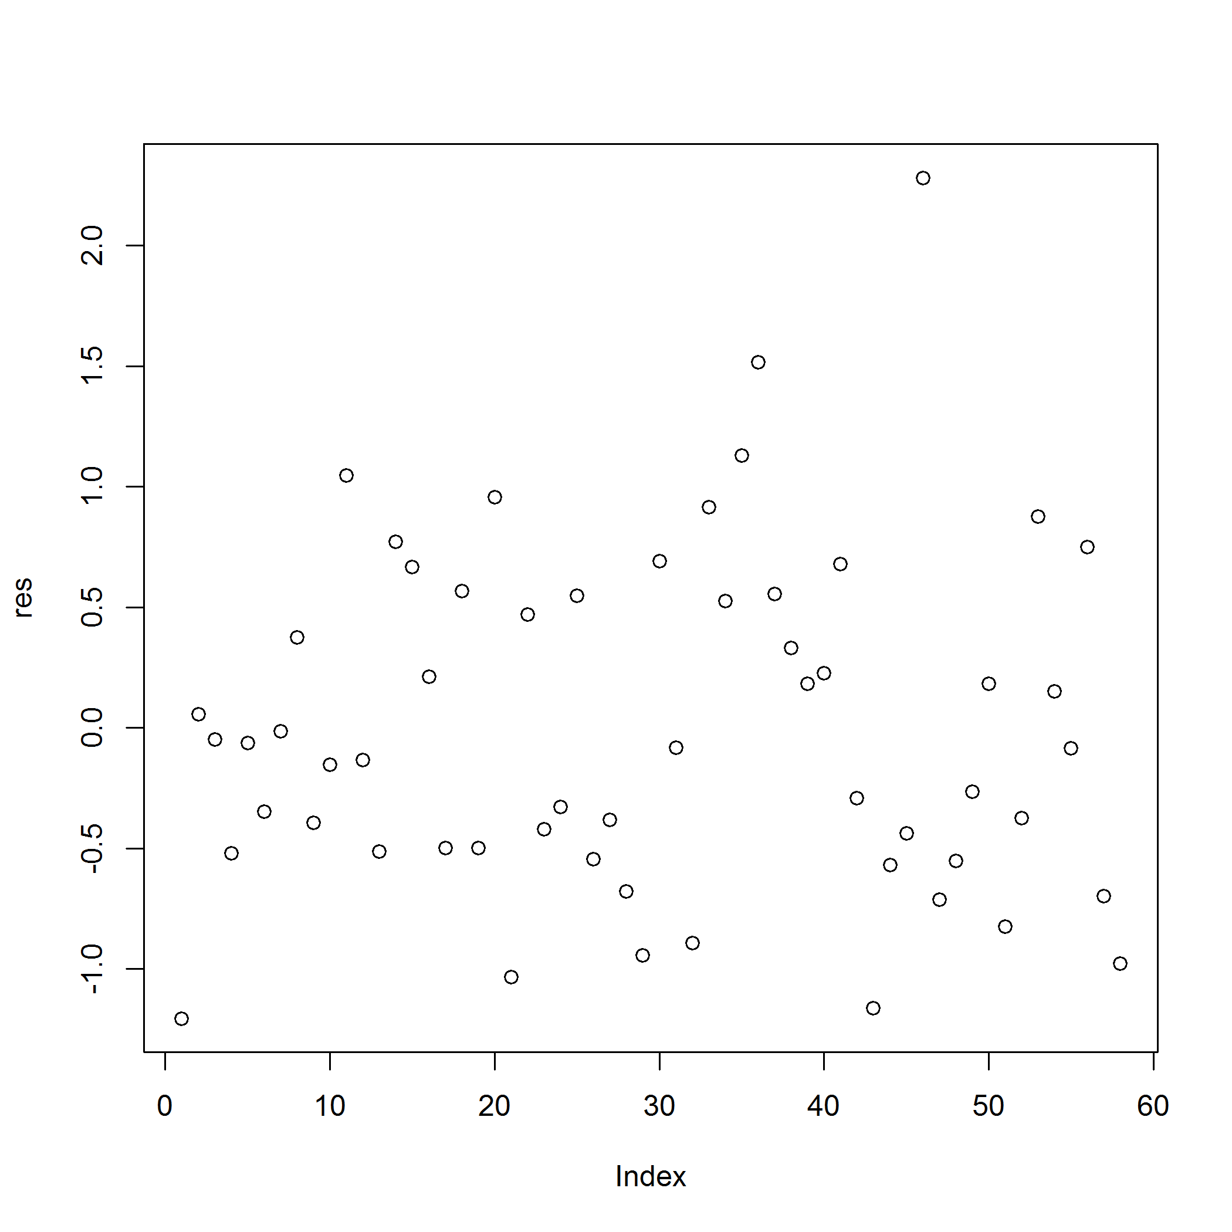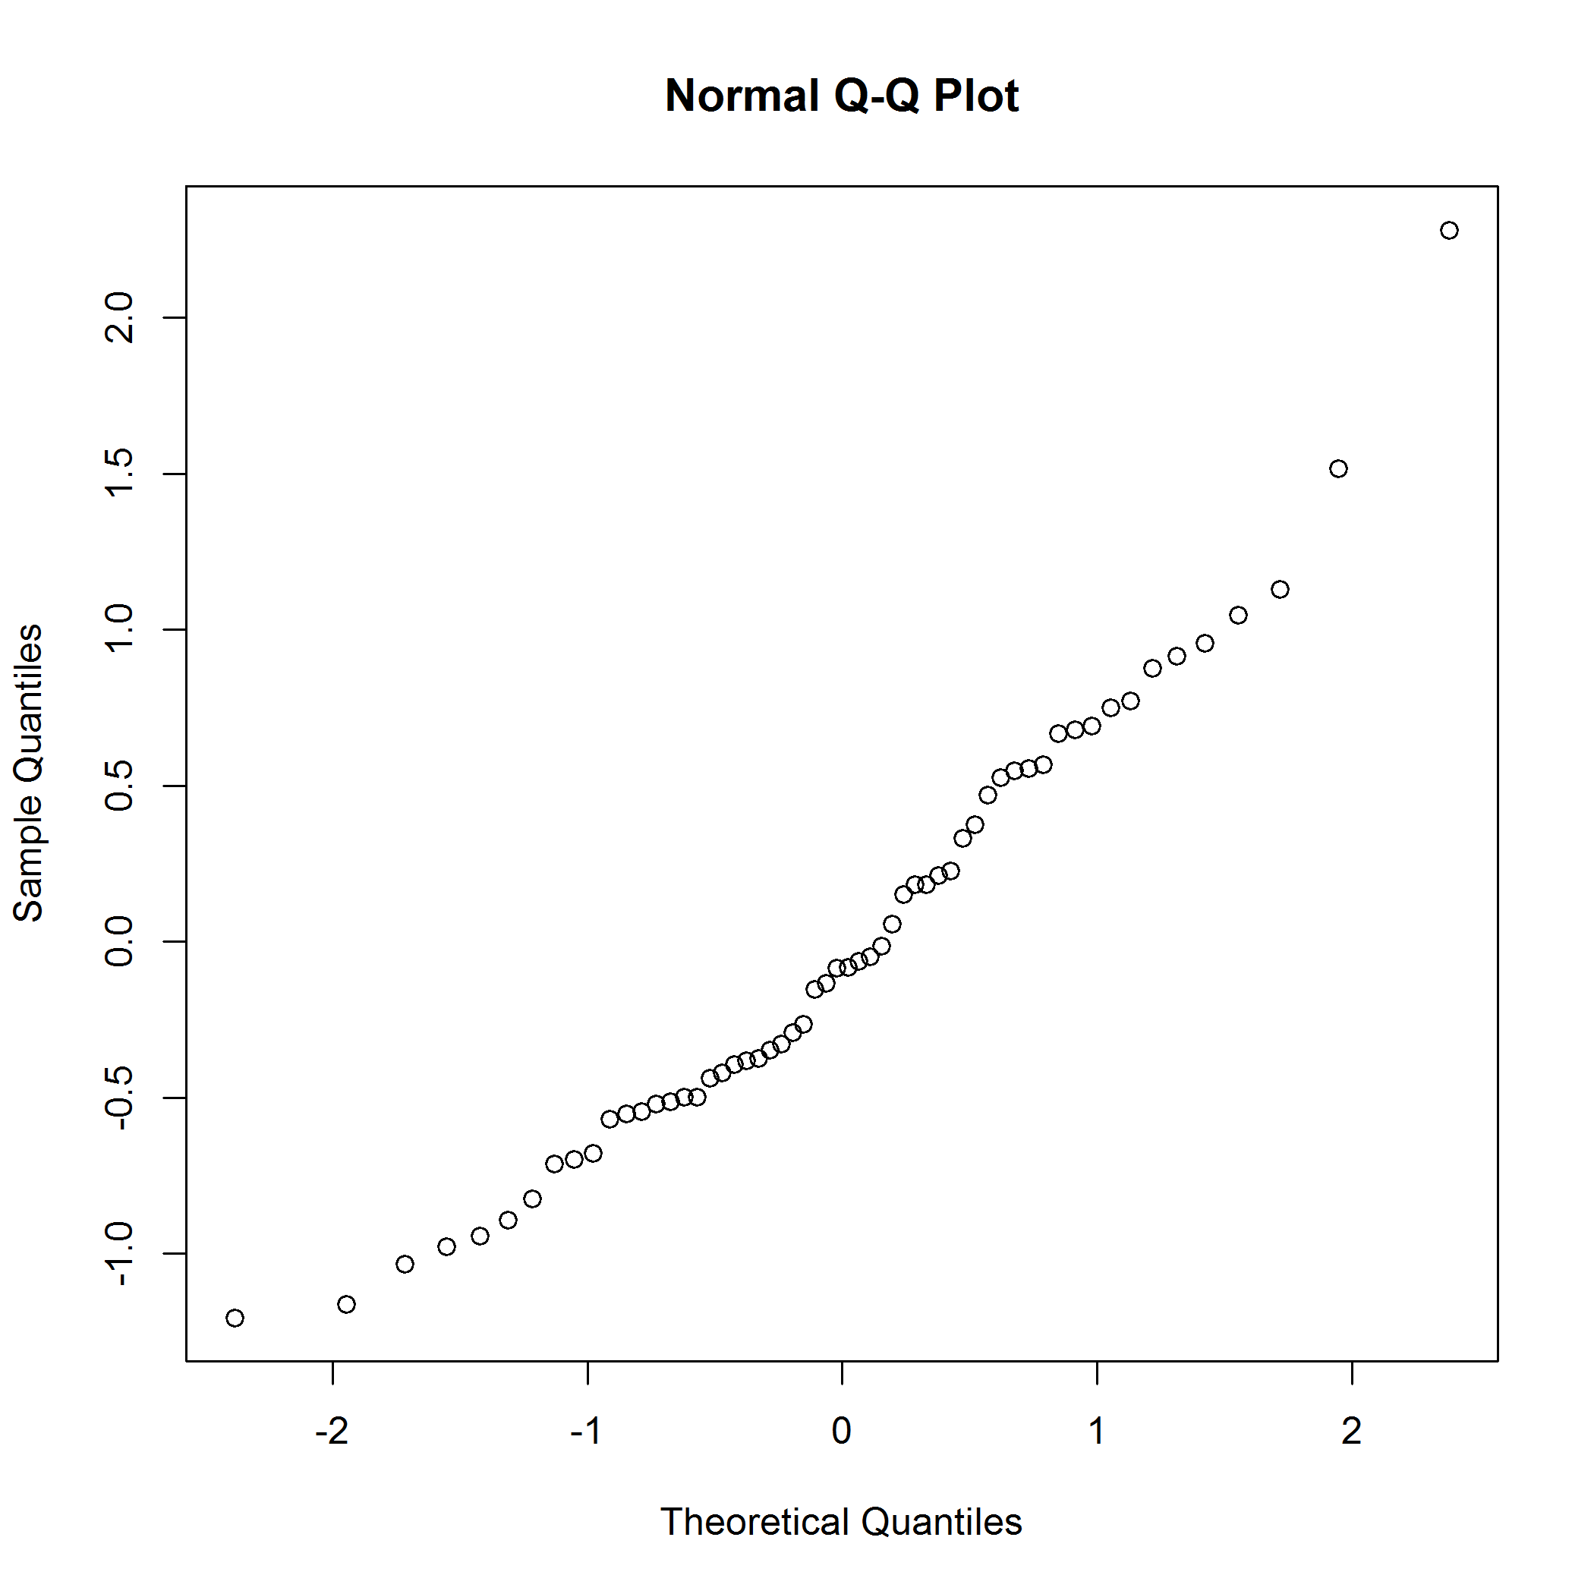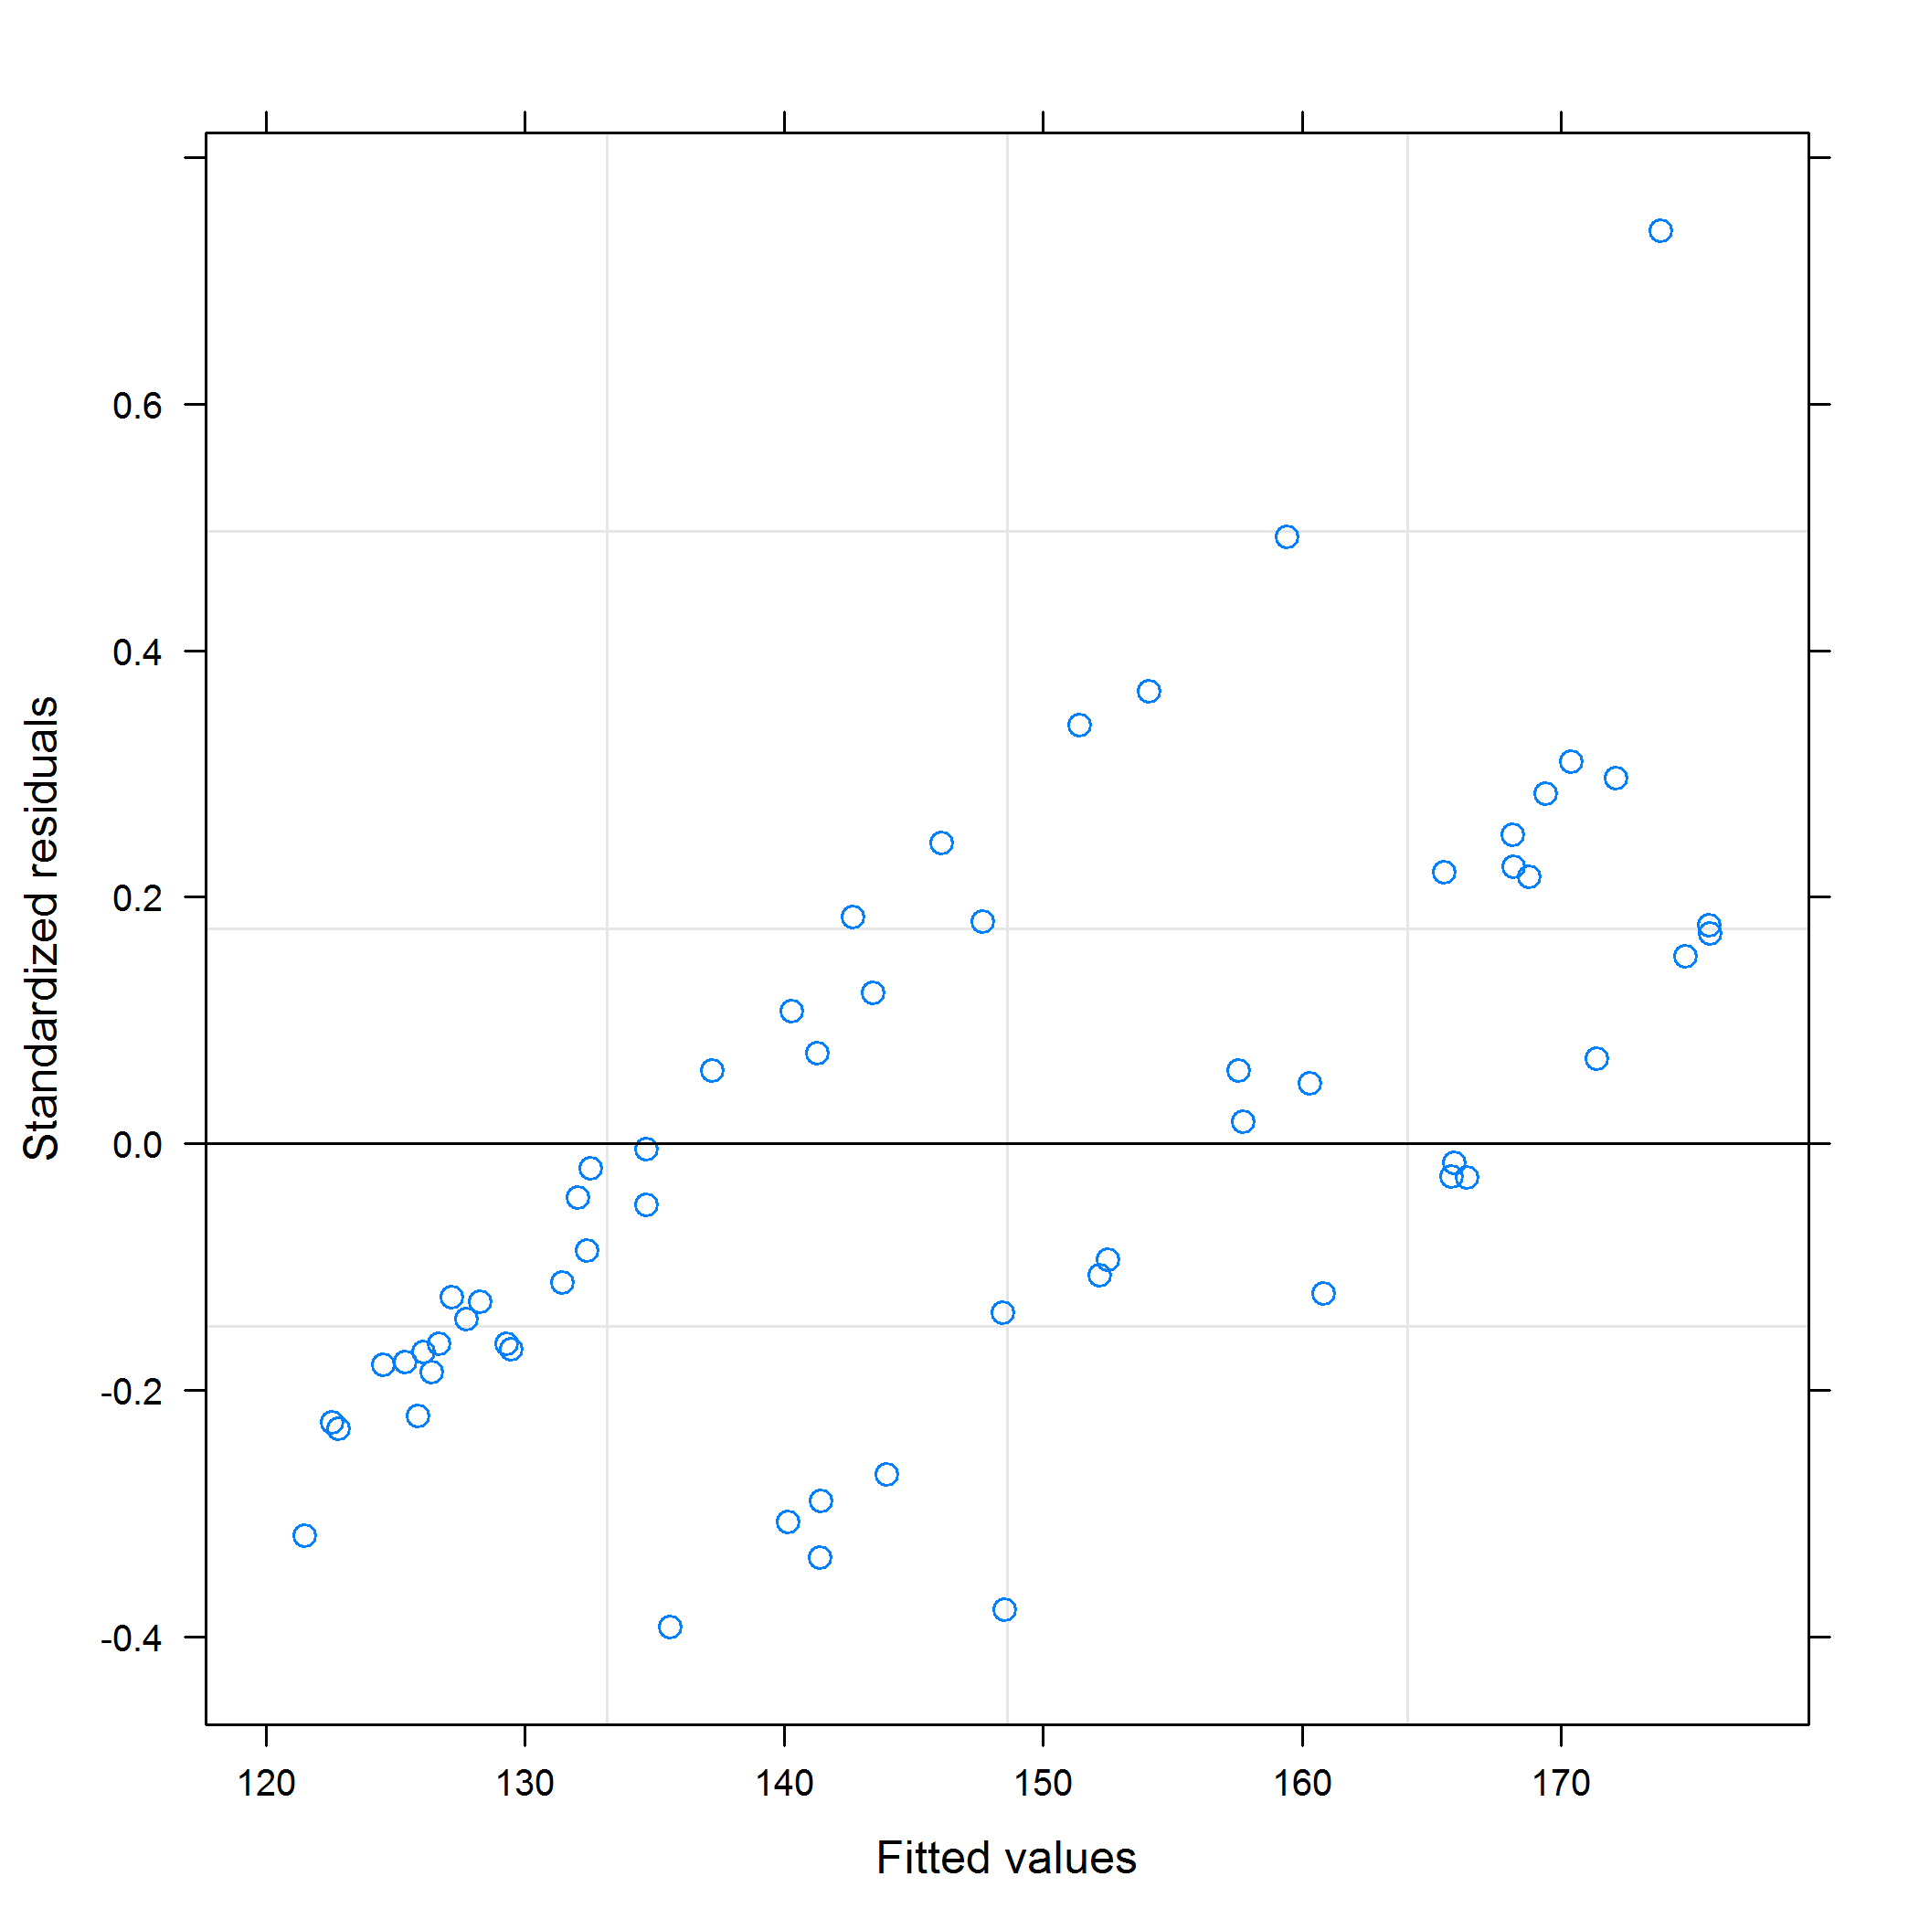

## Normalized concentration GSH

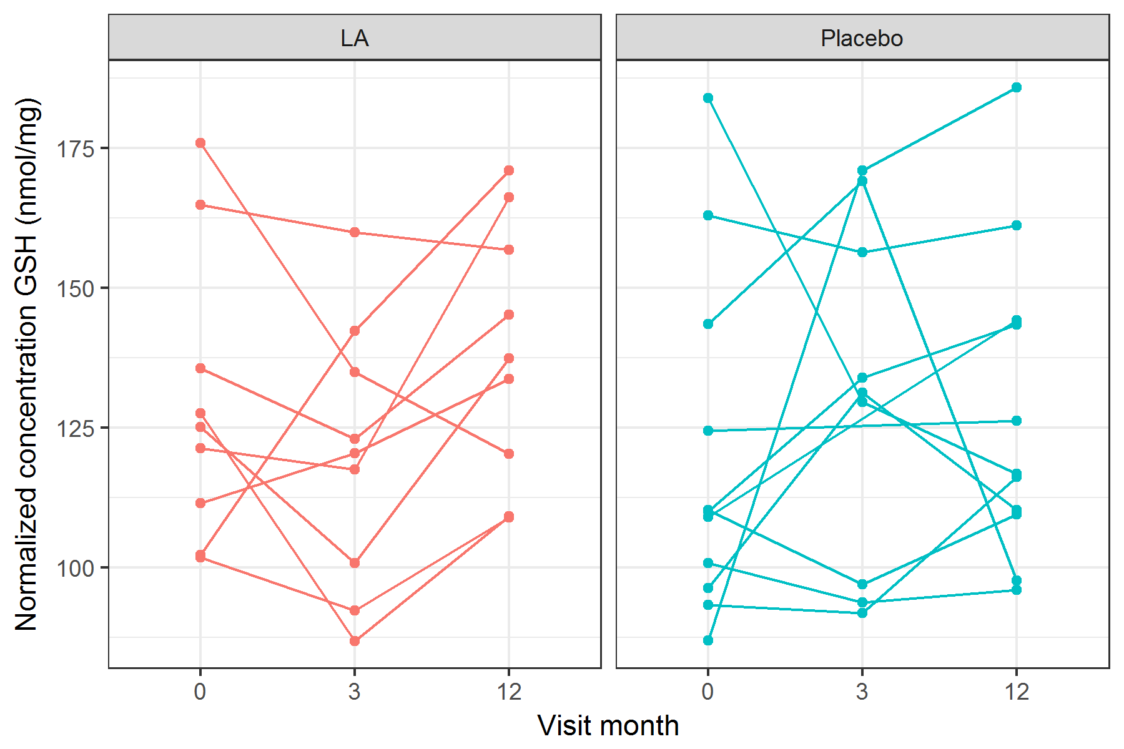

figures/lineplotNormalizedConcGSH.png

Mixed effects model using the **lme4** package.

|  |  |  |  |  |
| --- | --- | --- | --- | --- |
| term | estimate | std.error | statistic | group |
| (Intercept) | 129.52 | 9.15 | 14.15 | fixed |
| studyArmPlacebo | -9.39 | 12.34 | -0.76 | fixed |
| visitMonth3 | -9.74 | 10.99 | -0.89 | fixed |
| visitMonth12 | 9.21 | 10.99 | 0.84 | fixed |
| studyArmPlacebo:visitMonth3 | 20.22 | 15.27 | 1.32 | fixed |
| studyArmPlacebo:visitMonth12 | -1.43 | 14.82 | -0.10 | fixed |
| sd_(Intercept).patientID | 14.49 | NA | NA | patientID |
| sd_Observation.Residual | 23.32 | NA | NA | Residual |

## Linear mixed model fit by REML ['lmerMod']  
## Formula: normalizedConcGSH ~ studyArm * visitMonth + (1 | patientID)  
## Data: df1  
##   
## REML criterion at convergence: 502.1  
##   
## Scaled residuals:   
## Min 1Q Median 3Q Max   
## -1.92185 -0.59053 0.00861 0.55097 2.33953   
##   
## Random effects:  
## Groups Name Variance Std.Dev.  
## patientID (Intercept) 209.8 14.49   
## Residual 543.8 23.32   
## Number of obs: 58, groups: patientID, 20  
##   
## Fixed effects:  
## Estimate Std. Error t value  
## (Intercept) 129.519 9.151 14.154  
## studyArmPlacebo -9.390 12.339 -0.761  
## visitMonth3 -9.741 10.993 -0.886  
## visitMonth12 9.214 10.993 0.838  
## studyArmPlacebo:visitMonth3 20.222 15.268 1.324  
## studyArmPlacebo:visitMonth12 -1.434 14.823 -0.097  
##   
## Correlation of Fixed Effects:  
## (Intr) stdyAP vstMn3 vstM12 sAP:M3  
## stdyArmPlcb -0.742   
## visitMonth3 -0.601 0.445   
## visitMnth12 -0.601 0.445 0.500   
## stdyArmP:M3 0.432 -0.583 -0.720 -0.360   
## stdyArP:M12 0.445 -0.601 -0.371 -0.742 0.485

## $patientID

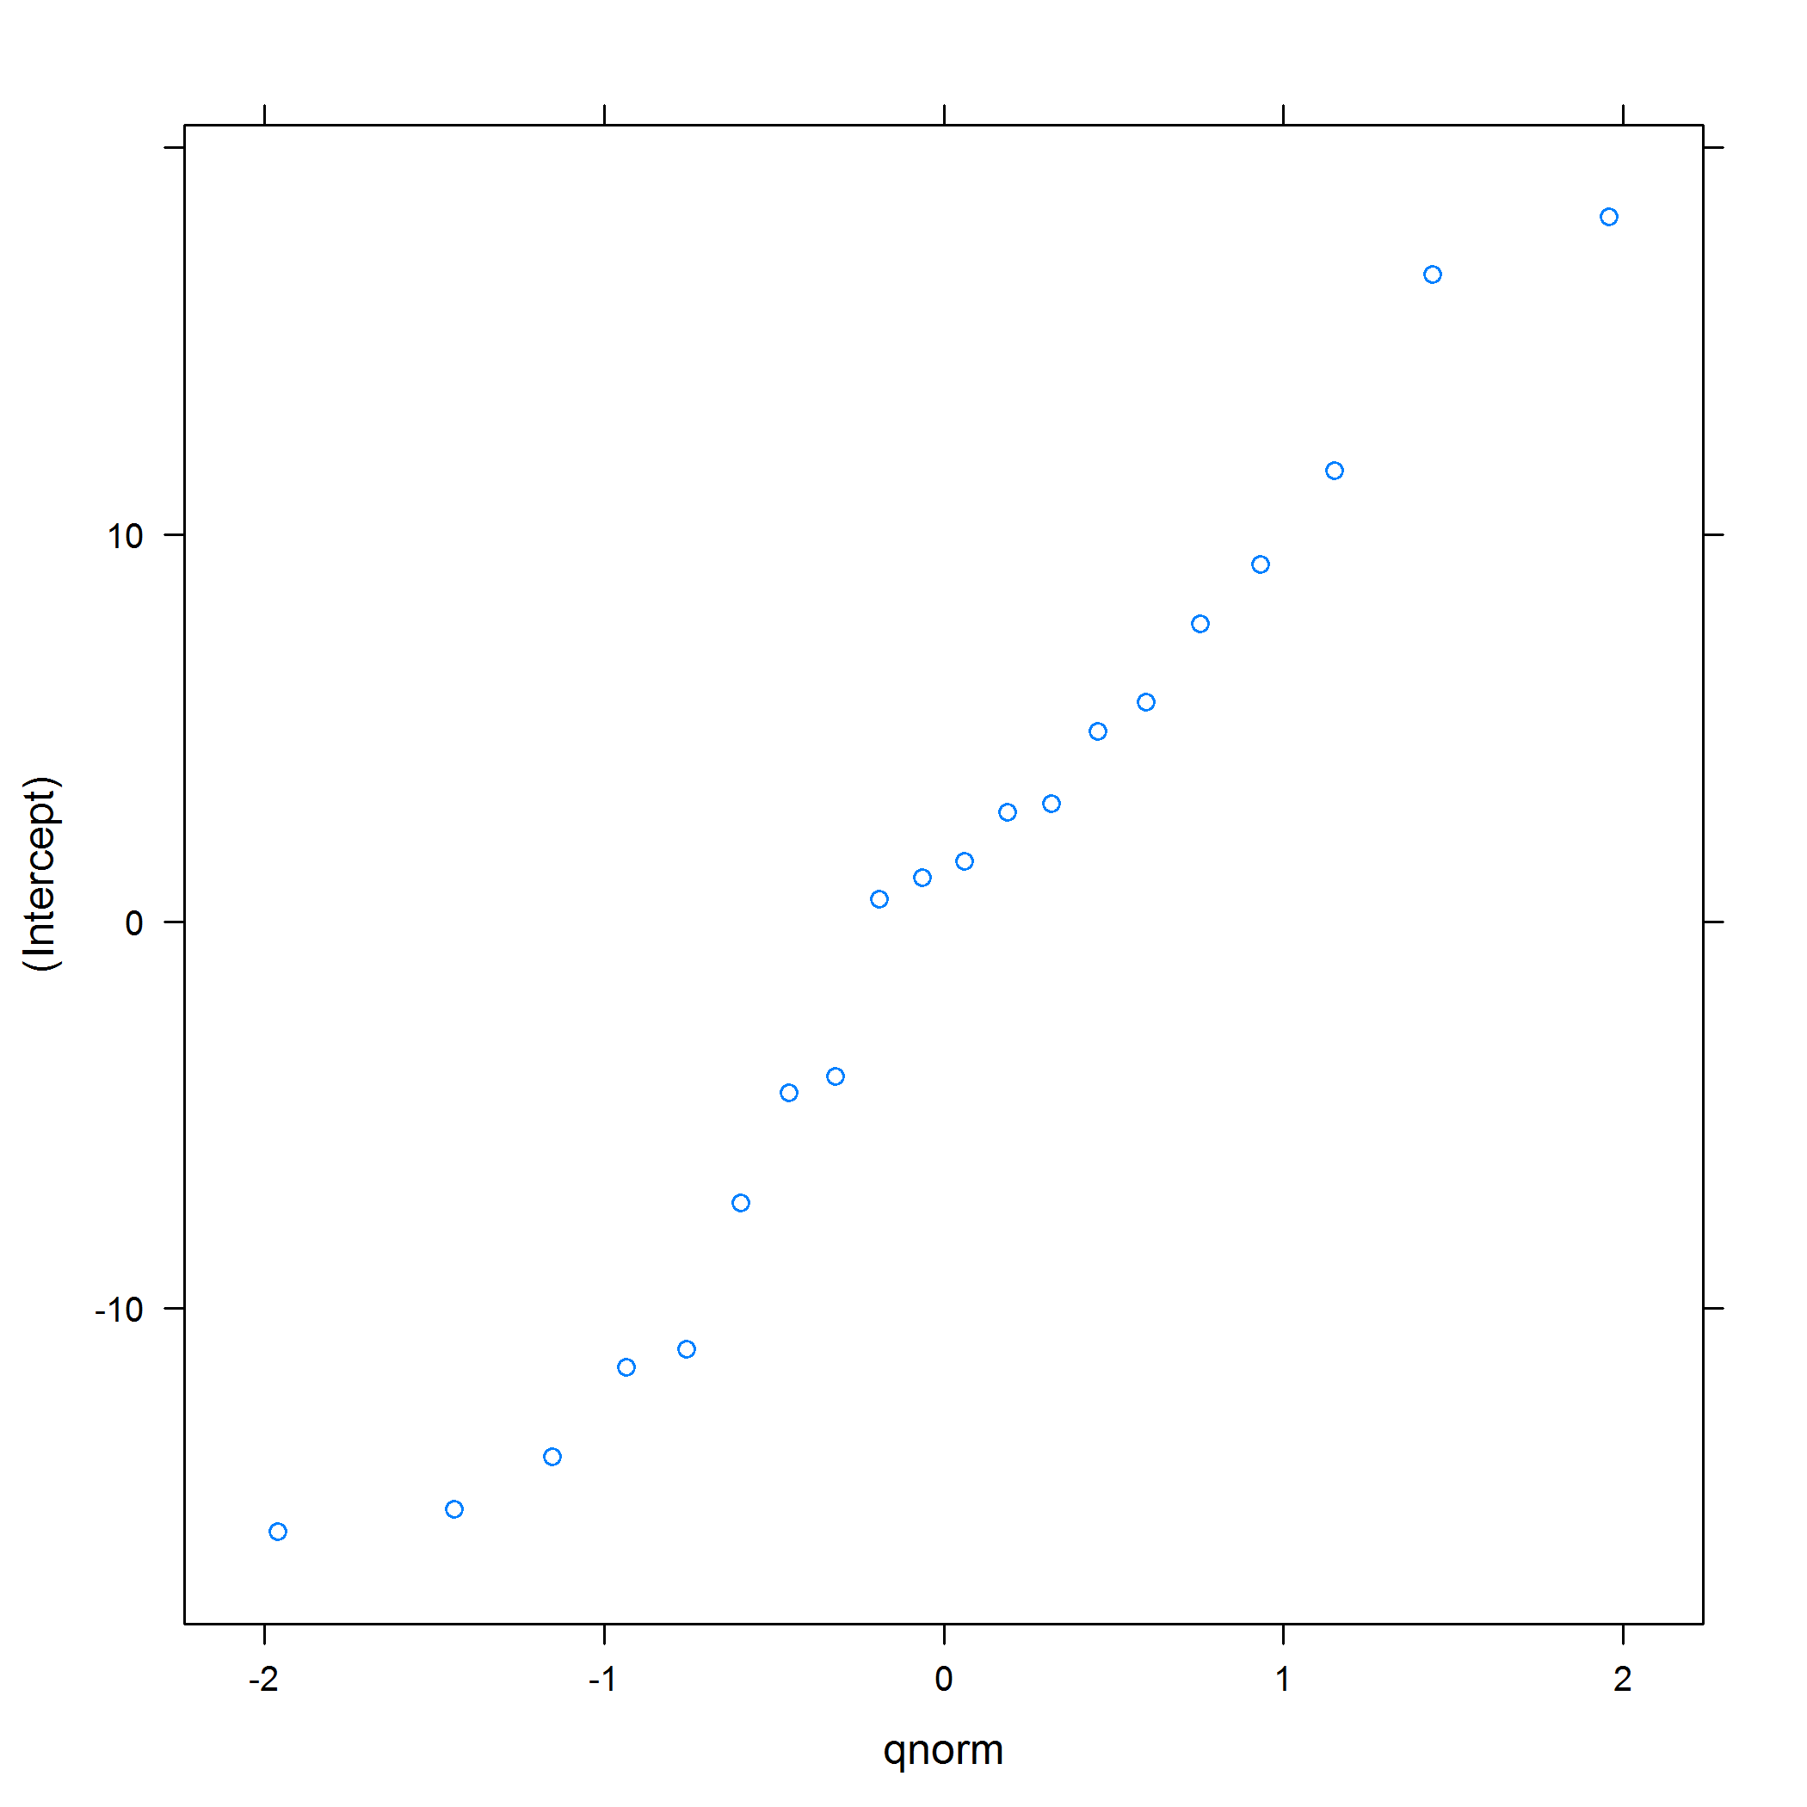 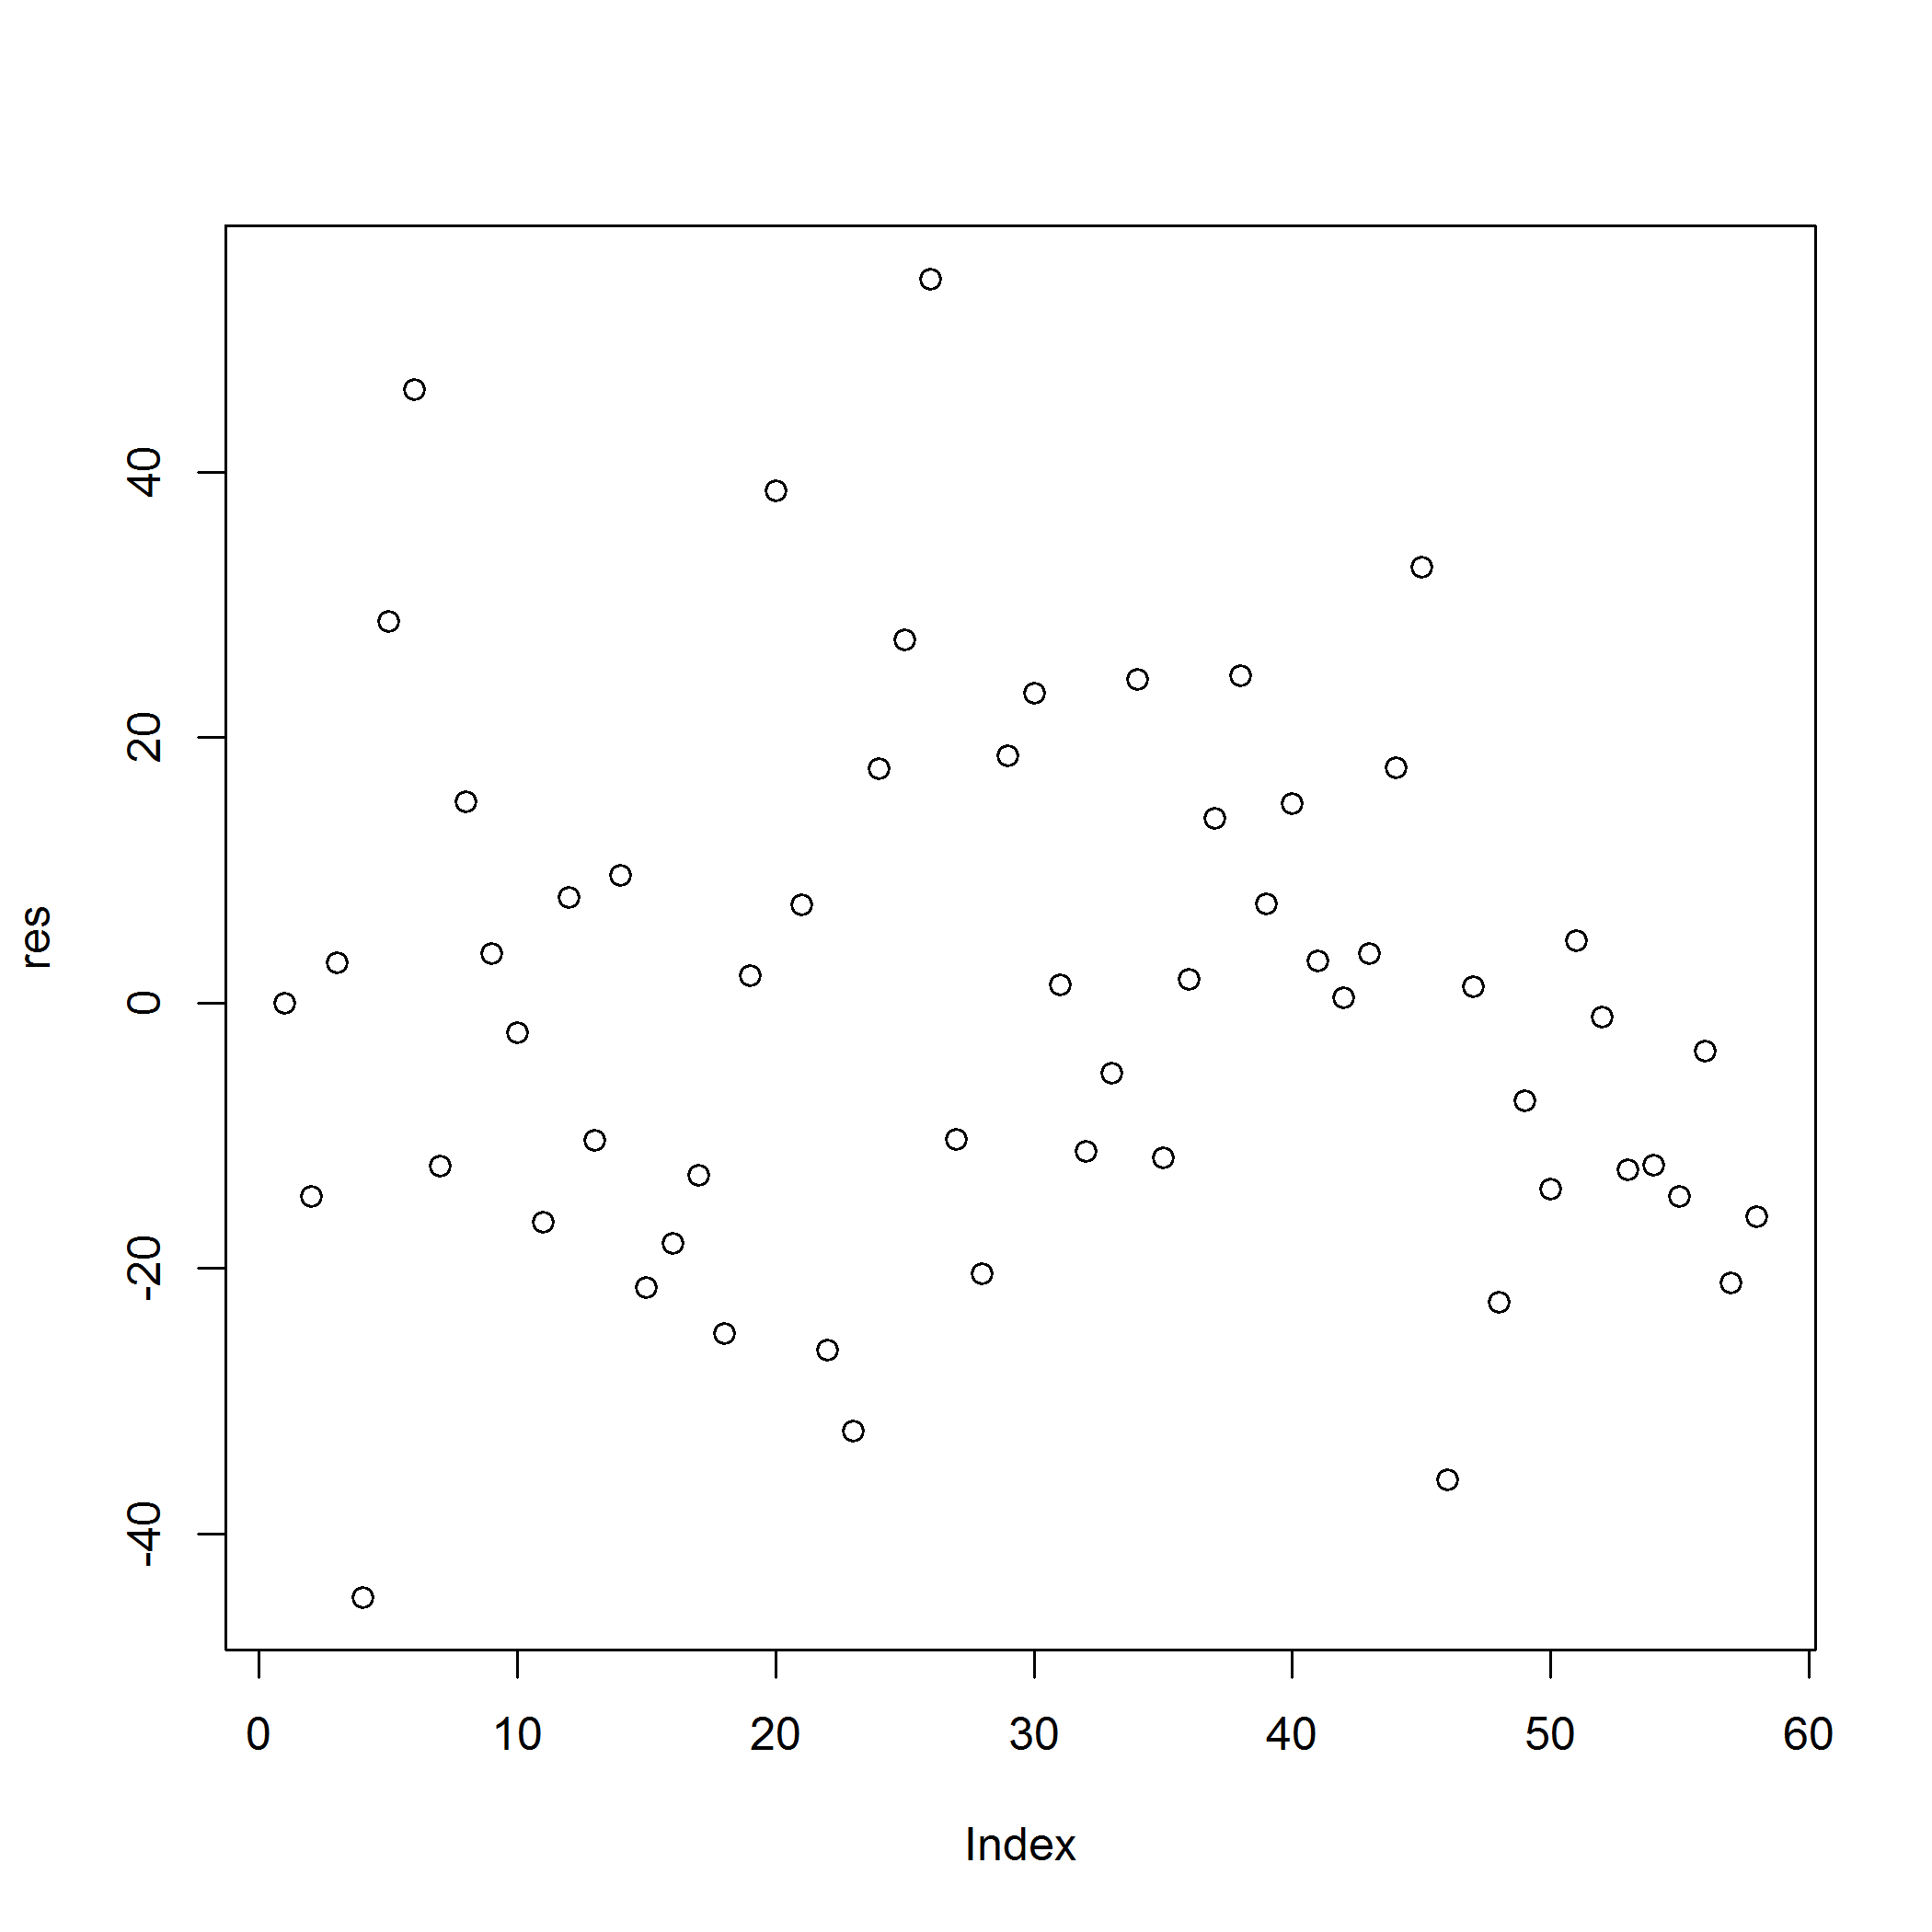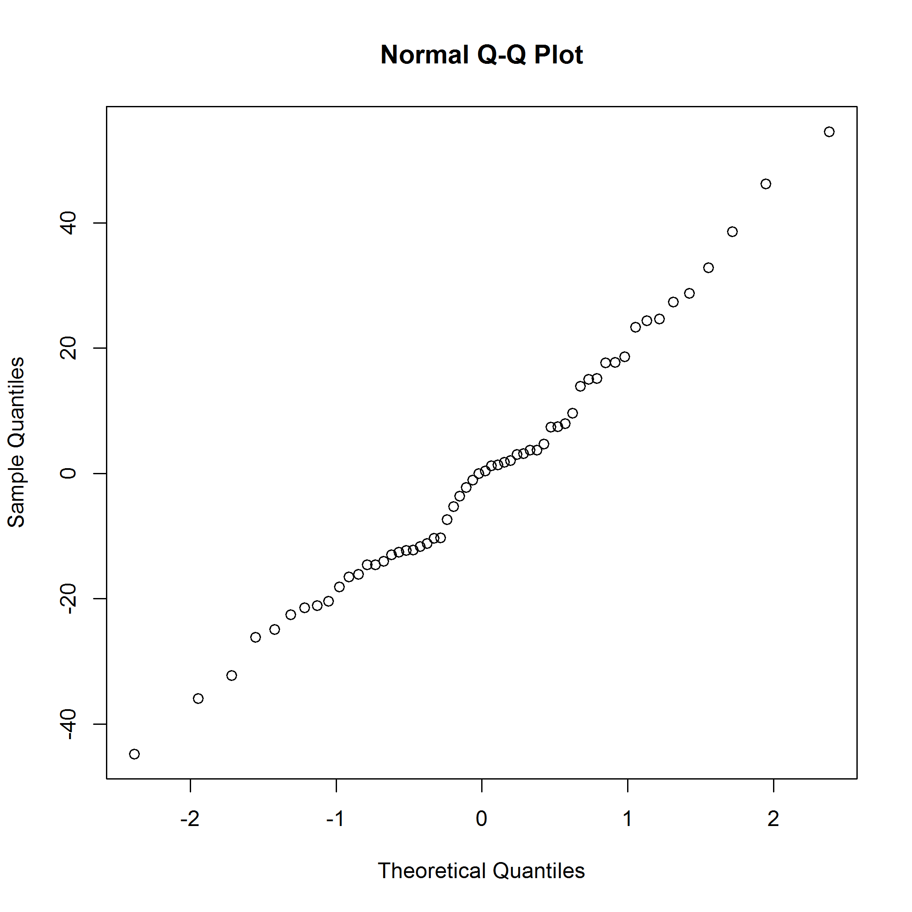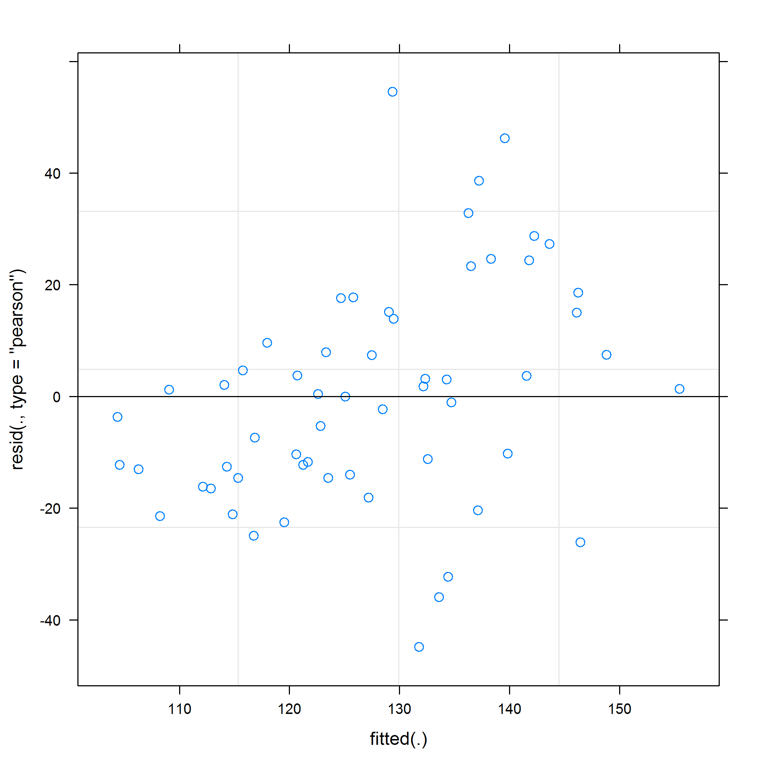

Mixed effects model using the **nlme** package.

|  |  |  |  |  |
| --- | --- | --- | --- | --- |
| term | estimate | std.error | statistic | p.value |
| (Intercept) | 129.52 | 9.15 | 14.15 | 0.0000 |
| studyArmPlacebo | -9.39 | 12.34 | -0.76 | 0.4565 |
| visitMonth3 | -9.74 | 10.99 | -0.89 | 0.3818 |
| visitMonth12 | 9.21 | 10.99 | 0.84 | 0.4078 |
| studyArmPlacebo:visitMonth3 | 20.22 | 15.27 | 1.32 | 0.1942 |
| studyArmPlacebo:visitMonth12 | -1.43 | 14.82 | -0.10 | 0.9235 |

## Linear mixed-effects model fit by REML  
## Data: df1   
## AIC BIC logLik  
## 522.1304 541.6428 -251.0652  
##   
## Random effects:  
## Formula: ~1 | patientID  
## (Intercept)  
## StdDev: 14.48532  
##   
## Formula: ~1 | visitMonth %in% patientID  
## (Intercept) Residual  
## StdDev: 21.75406 8.401907  
##   
## Correlation Structure: AR(1)  
## Formula: ~1 | patientID/visitMonth   
## Parameter estimate(s):  
## Phi   
## 0   
## Fixed effects: normalizedConcGSH ~ studyArm * visitMonth   
## Value Std.Error DF t-value p-value  
## (Intercept) 129.51924 9.15093 34 14.153670 0.0000  
## studyArmPlacebo -9.39040 12.33911 18 -0.761027 0.4565  
## visitMonth3 -9.74082 10.99324 34 -0.886074 0.3818  
## visitMonth12 9.21357 10.99324 34 0.838112 0.4078  
## studyArmPlacebo:visitMonth3 20.22153 15.26791 34 1.324447 0.1942  
## studyArmPlacebo:visitMonth12 -1.43372 14.82329 34 -0.096721 0.9235  
## Correlation:   
## (Intr) stdyAP vstMn3 vstM12 sAP:M3  
## studyArmPlacebo -0.742   
## visitMonth3 -0.601 0.445   
## visitMonth12 -0.601 0.445 0.500   
## studyArmPlacebo:visitMonth3 0.432 -0.583 -0.720 -0.360   
## studyArmPlacebo:visitMonth12 0.445 -0.601 -0.371 -0.742 0.485  
##   
## Standardized Within-Group Residuals:  
## Min Q1 Med Q3 Max   
## -0.692412274 -0.212757447 0.003101933 0.198505154 0.842895260   
##   
## Number of Observations: 58  
## Number of Groups:   
## patientID visitMonth %in% patientID   
## 20 58

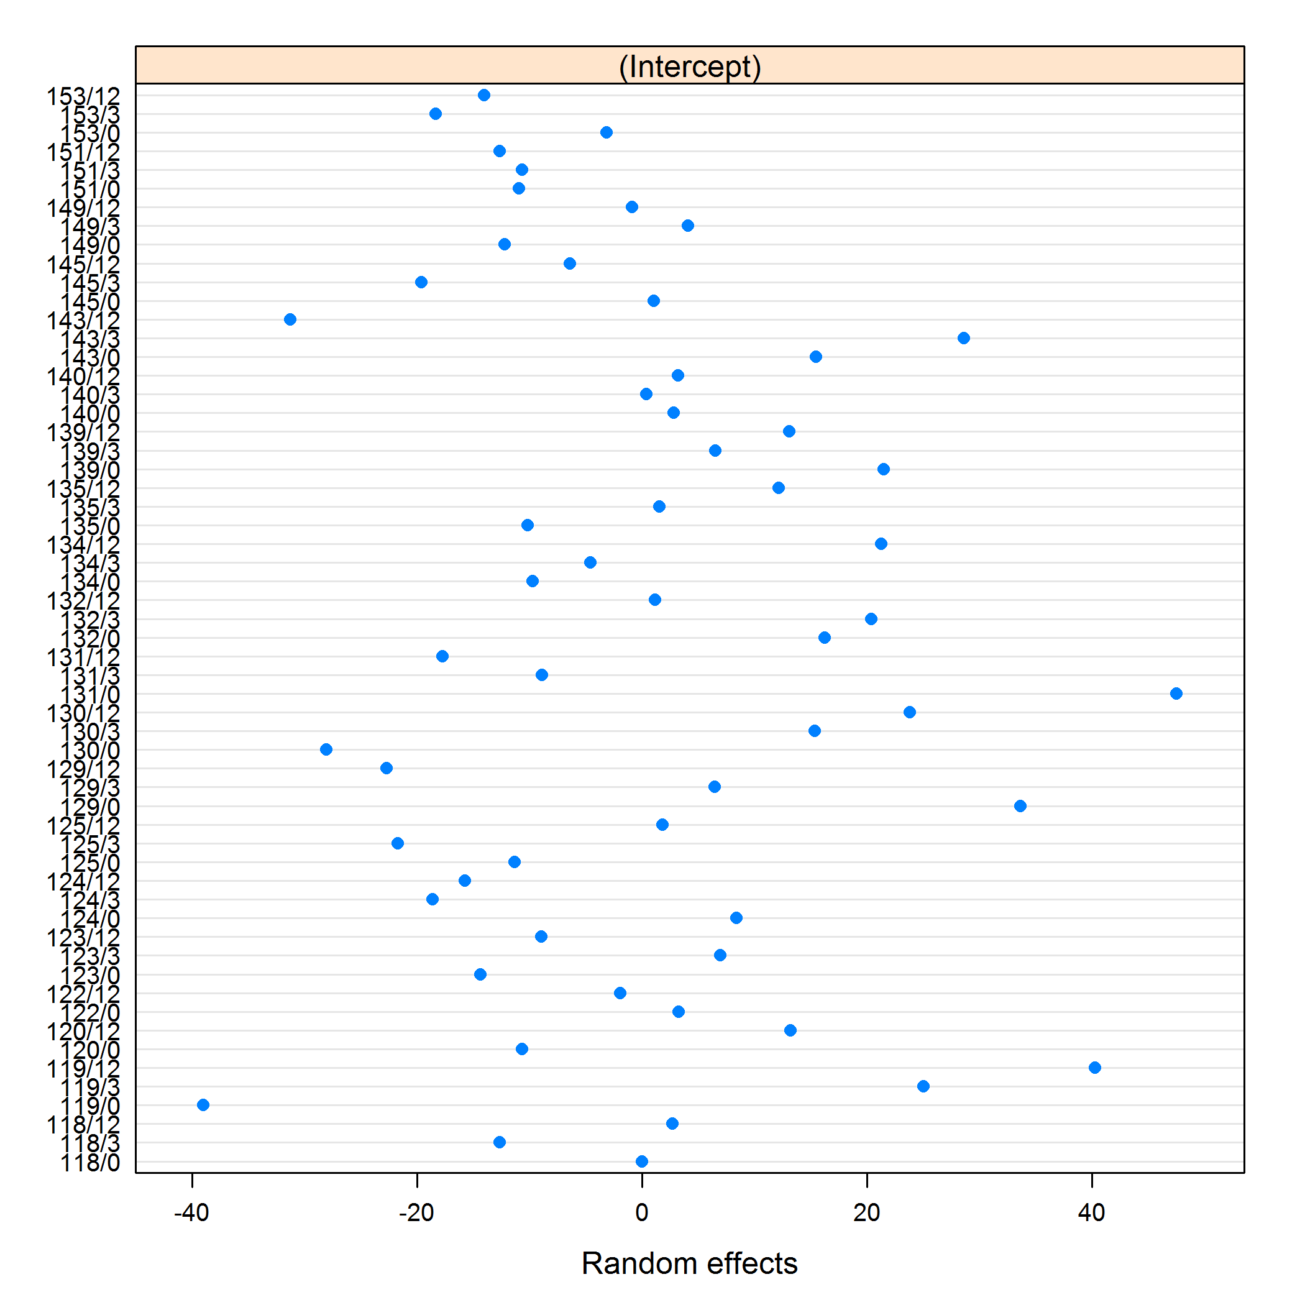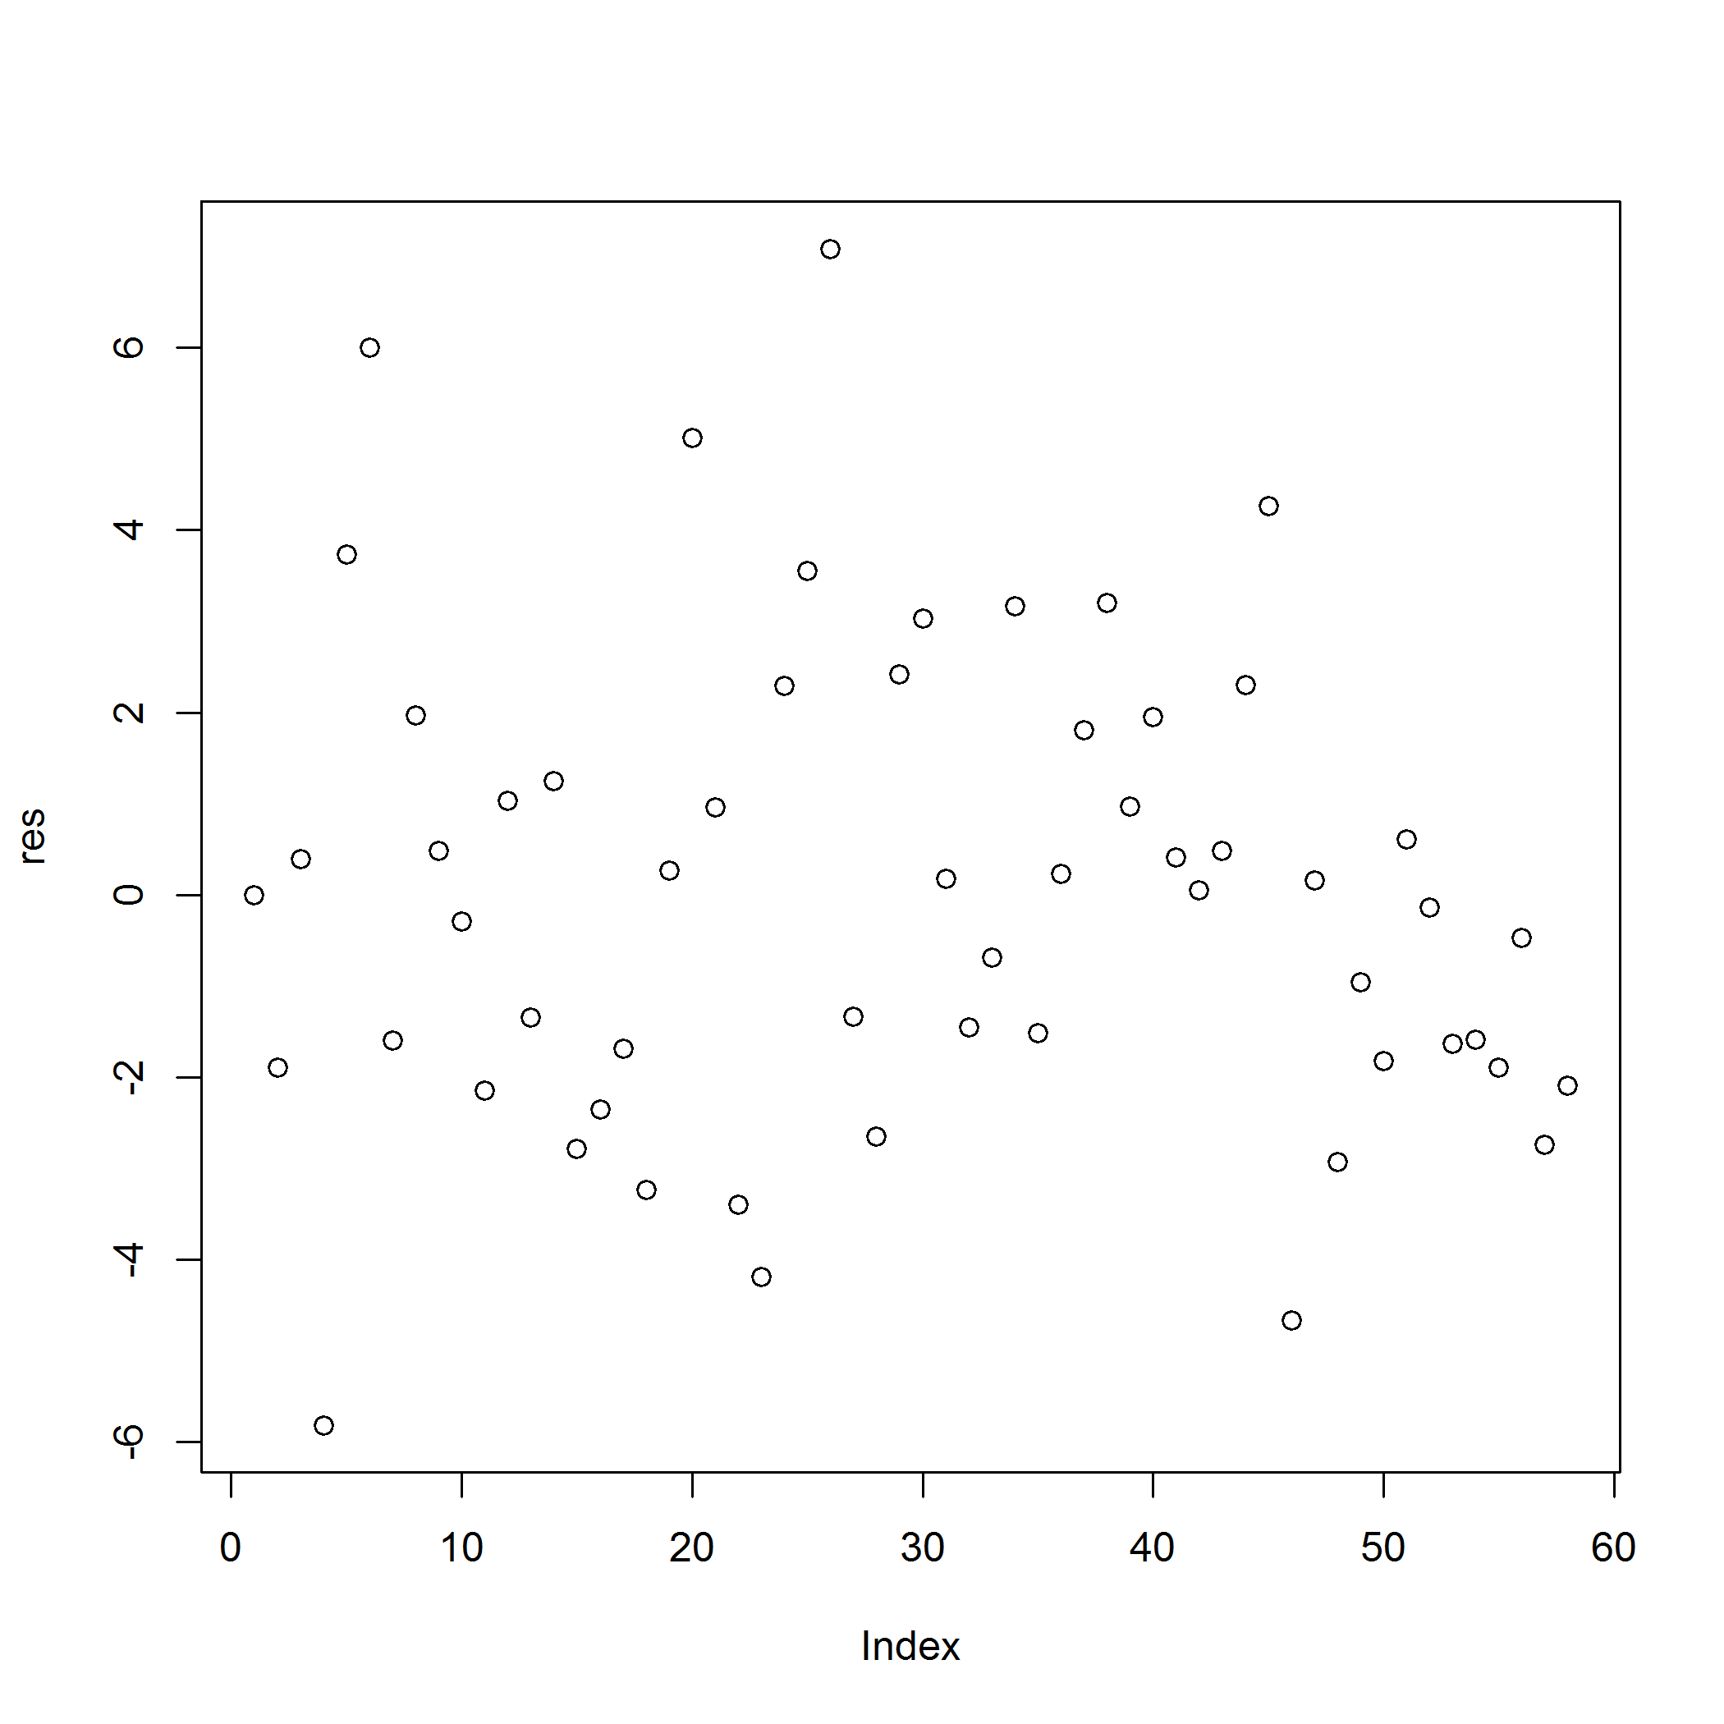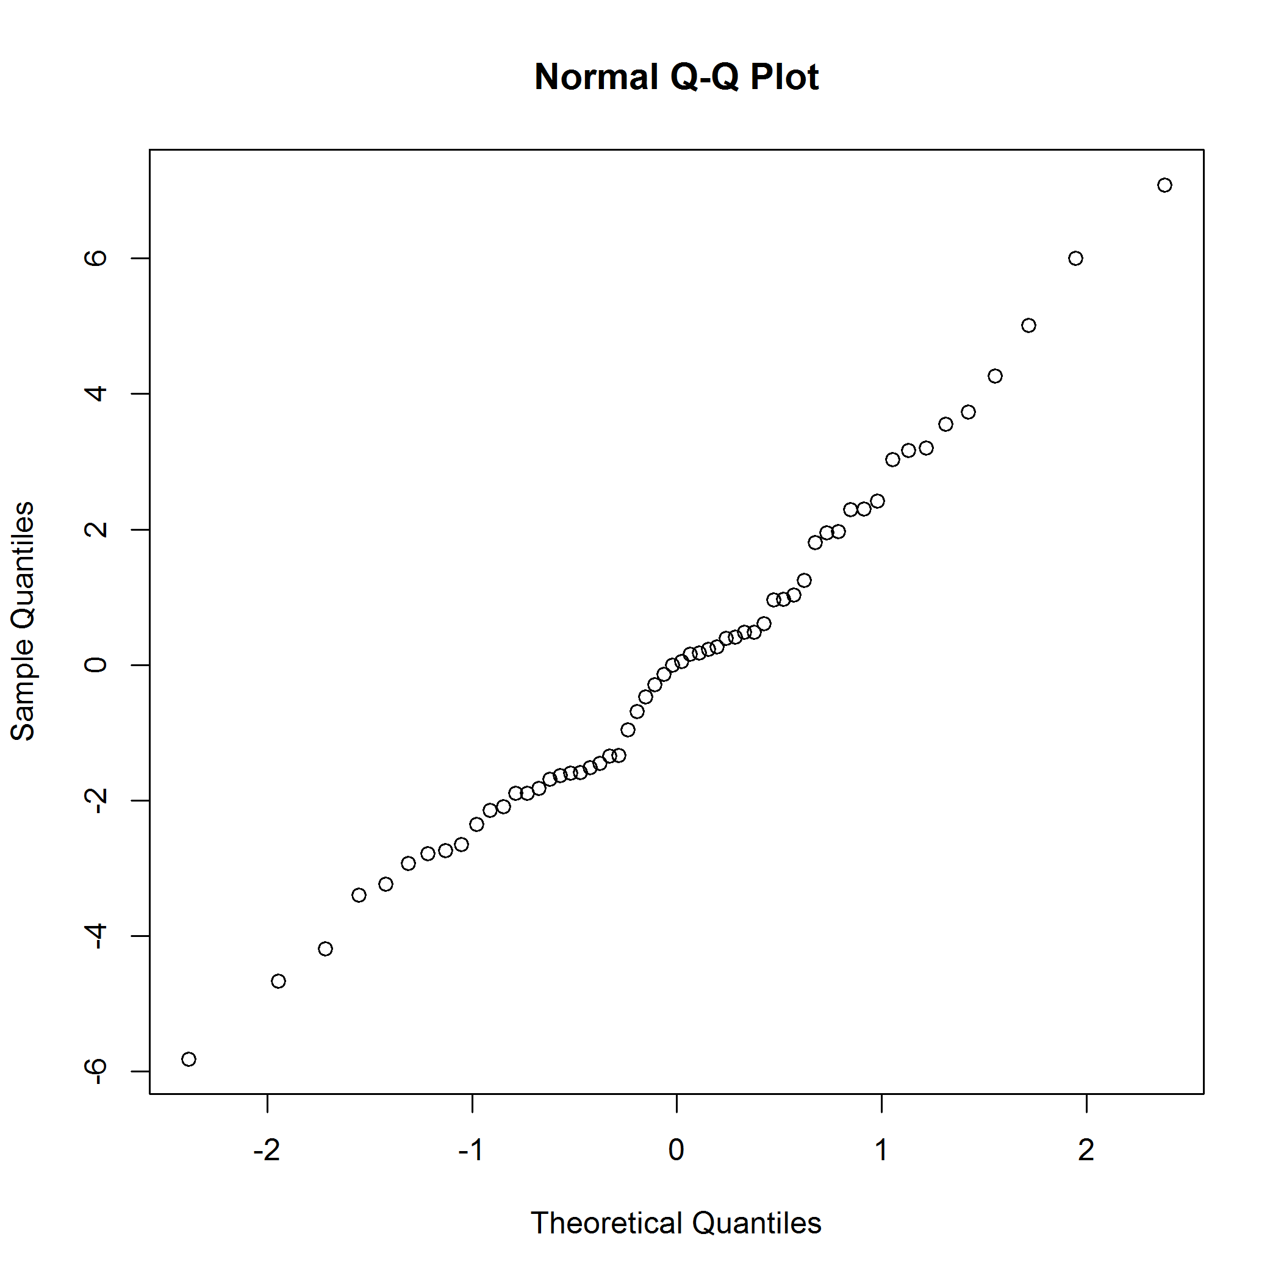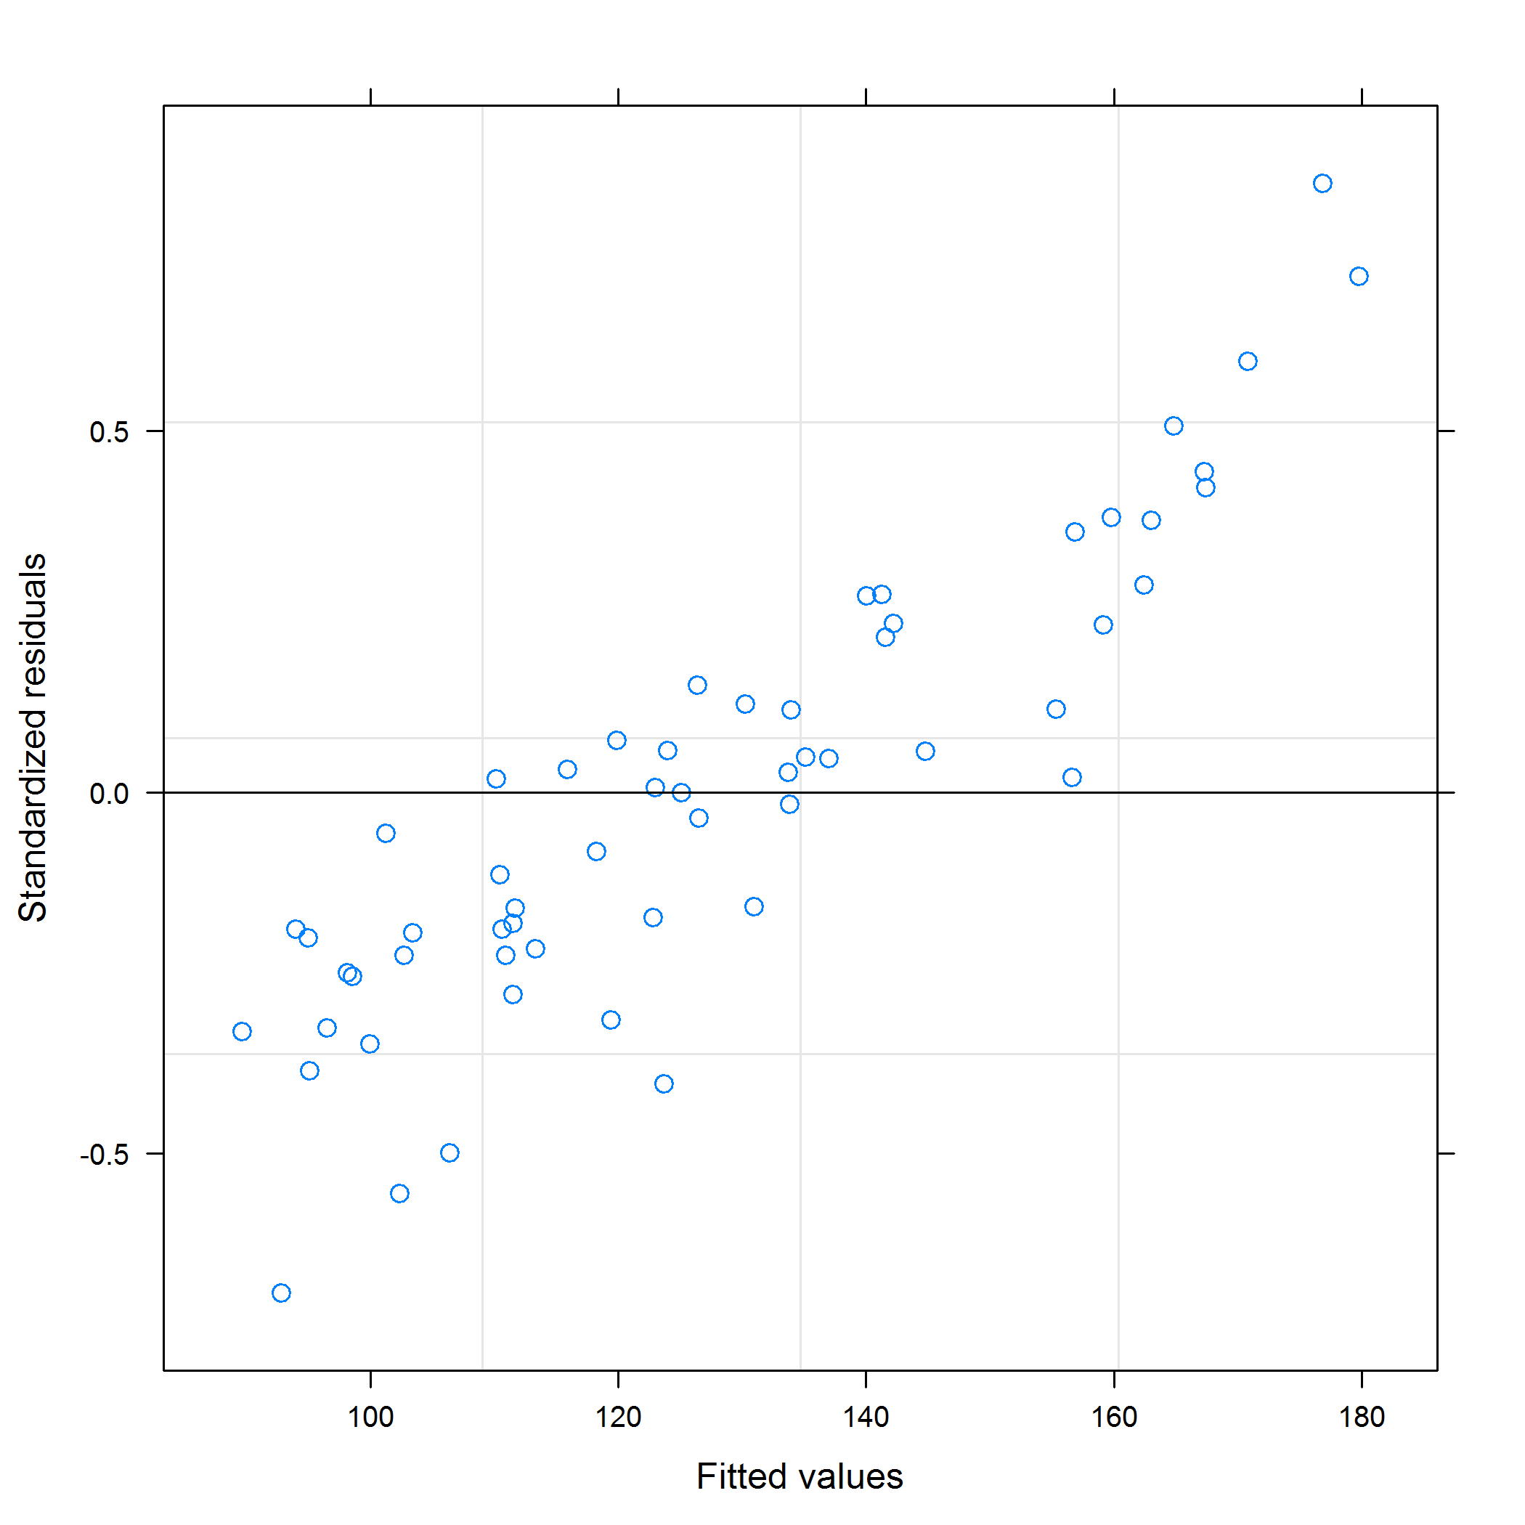

## Normalized concentration GSSG

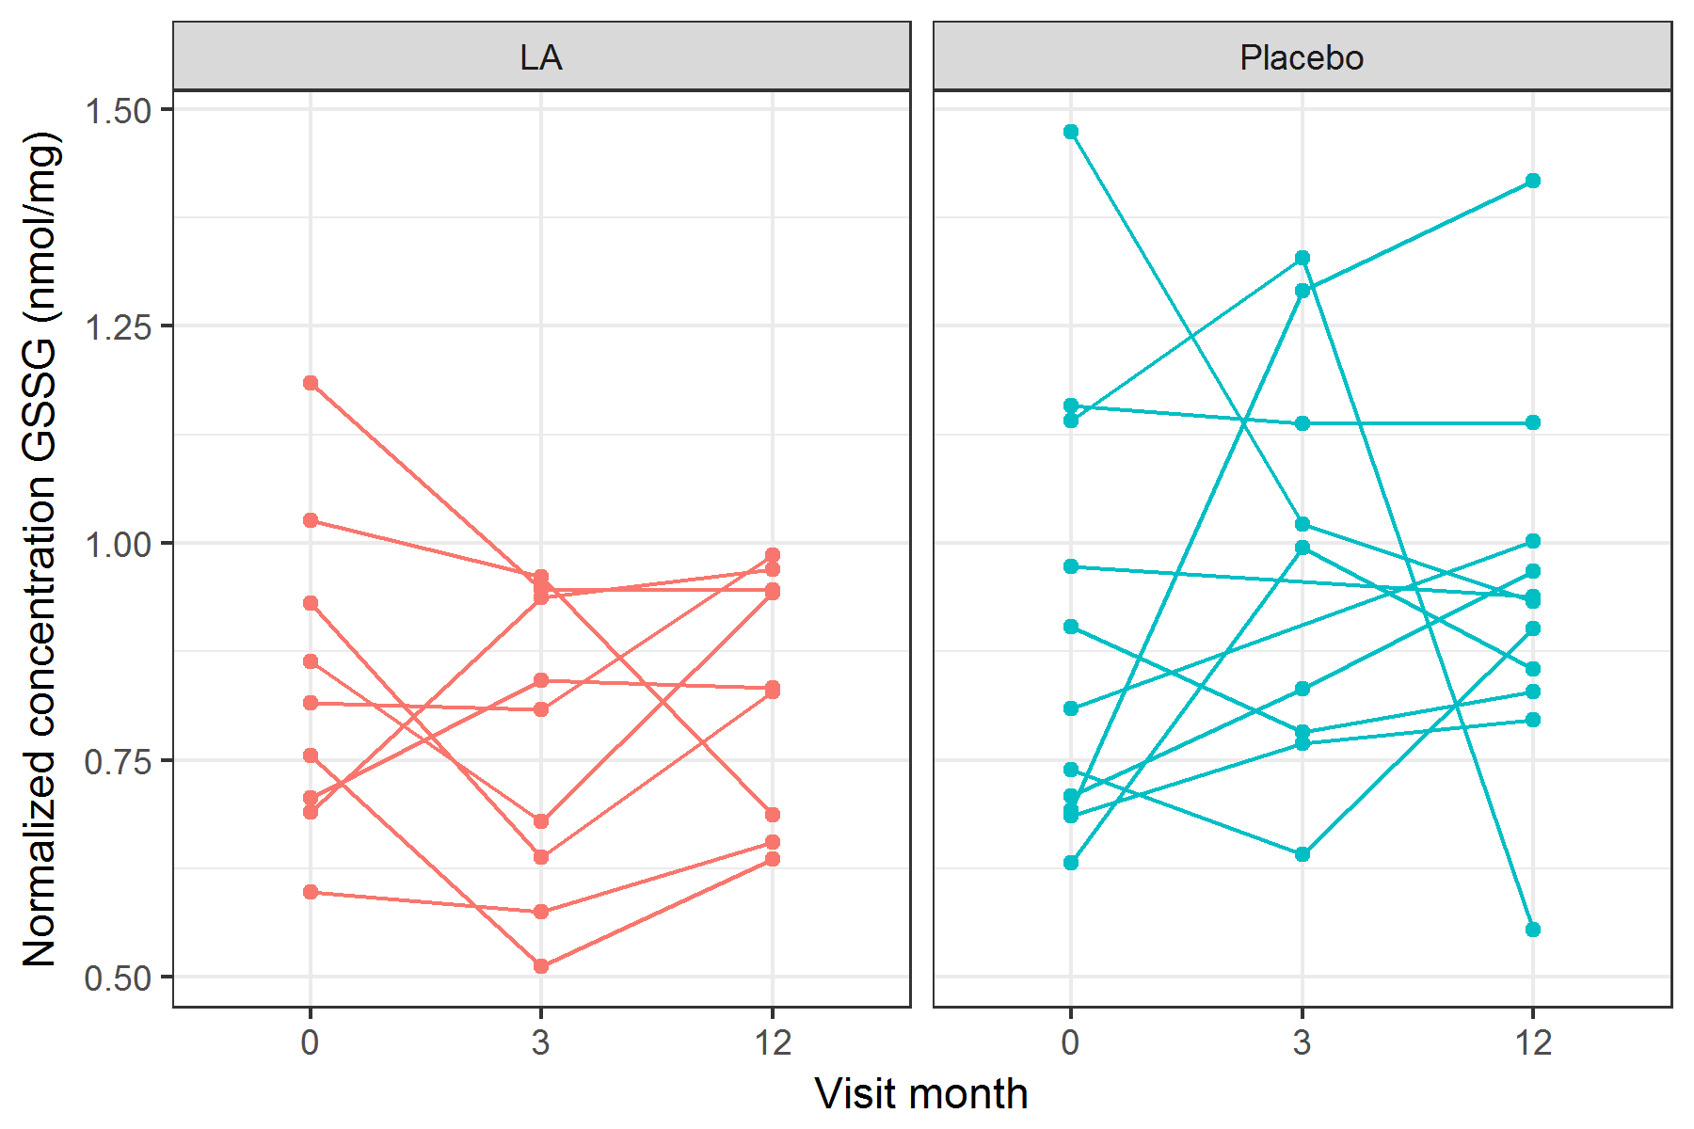

figures/lineplotNormalizedConcGSSG.png

Mixed effects model using the **lme4** package.

|  |  |  |  |  |
| --- | --- | --- | --- | --- |
| term | estimate | std.error | statistic | group |
| (Intercept) | 0.84 | 0.07 | 12.07 | fixed |
| studyArmPlacebo | 0.06 | 0.09 | 0.64 | fixed |
| visitMonth3 | -0.07 | 0.09 | -0.85 | fixed |
| visitMonth12 | -0.01 | 0.09 | -0.11 | fixed |
| studyArmPlacebo:visitMonth3 | 0.15 | 0.12 | 1.24 | fixed |
| studyArmPlacebo:visitMonth12 | 0.05 | 0.12 | 0.40 | fixed |
| sd_(Intercept).patientID | 0.09 | NA | NA | patientID |
| sd_Observation.Residual | 0.19 | NA | NA | Residual |

## Linear mixed model fit by REML ['lmerMod']  
## Formula: normalizedConcGSSG ~ studyArm * visitMonth + (1 | patientID)  
## Data: df1  
##   
## REML criterion at convergence: -3.5  
##   
## Scaled residuals:   
## Min 1Q Median 3Q Max   
## -2.22112 -0.61397 -0.01473 0.50159 2.59400   
##   
## Random effects:  
## Groups Name Variance Std.Dev.  
## patientID (Intercept) 0.008865 0.09415   
## Residual 0.034820 0.18660   
## Number of obs: 58, groups: patientID, 20  
##   
## Fixed effects:  
## Estimate Std. Error t value  
## (Intercept) 0.841158 0.069670 12.074  
## studyArmPlacebo 0.060342 0.093943 0.642  
## visitMonth3 -0.074450 0.087964 -0.846  
## visitMonth12 -0.009601 0.087964 -0.109  
## studyArmPlacebo:visitMonth3 0.151395 0.122027 1.241  
## studyArmPlacebo:visitMonth12 0.047468 0.118611 0.400  
##   
## Correlation of Fixed Effects:  
## (Intr) stdyAP vstMn3 vstM12 sAP:M3  
## stdyArmPlcb -0.742   
## visitMonth3 -0.631 0.468   
## visitMnth12 -0.631 0.468 0.500   
## stdyArmP:M3 0.455 -0.614 -0.721 -0.360   
## stdyArP:M12 0.468 -0.631 -0.371 -0.742 0.486

## $patientID

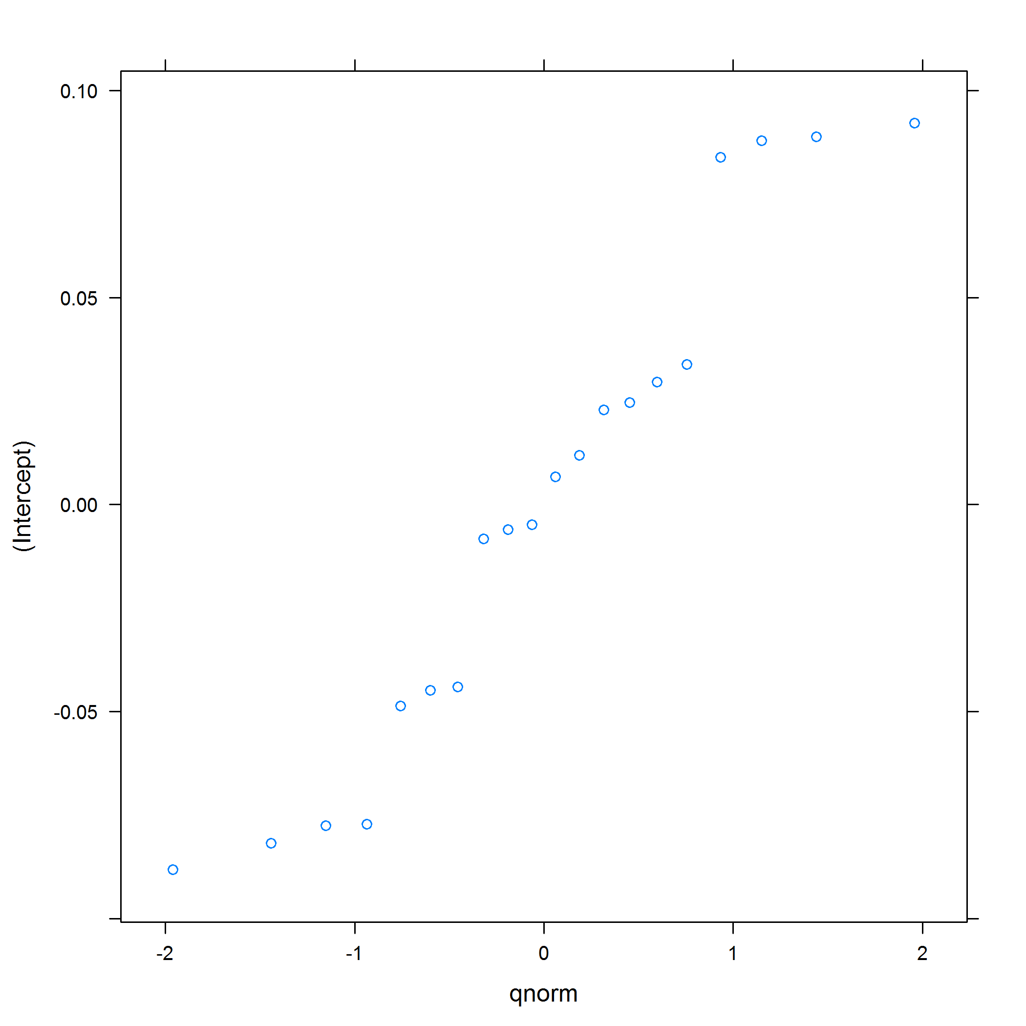 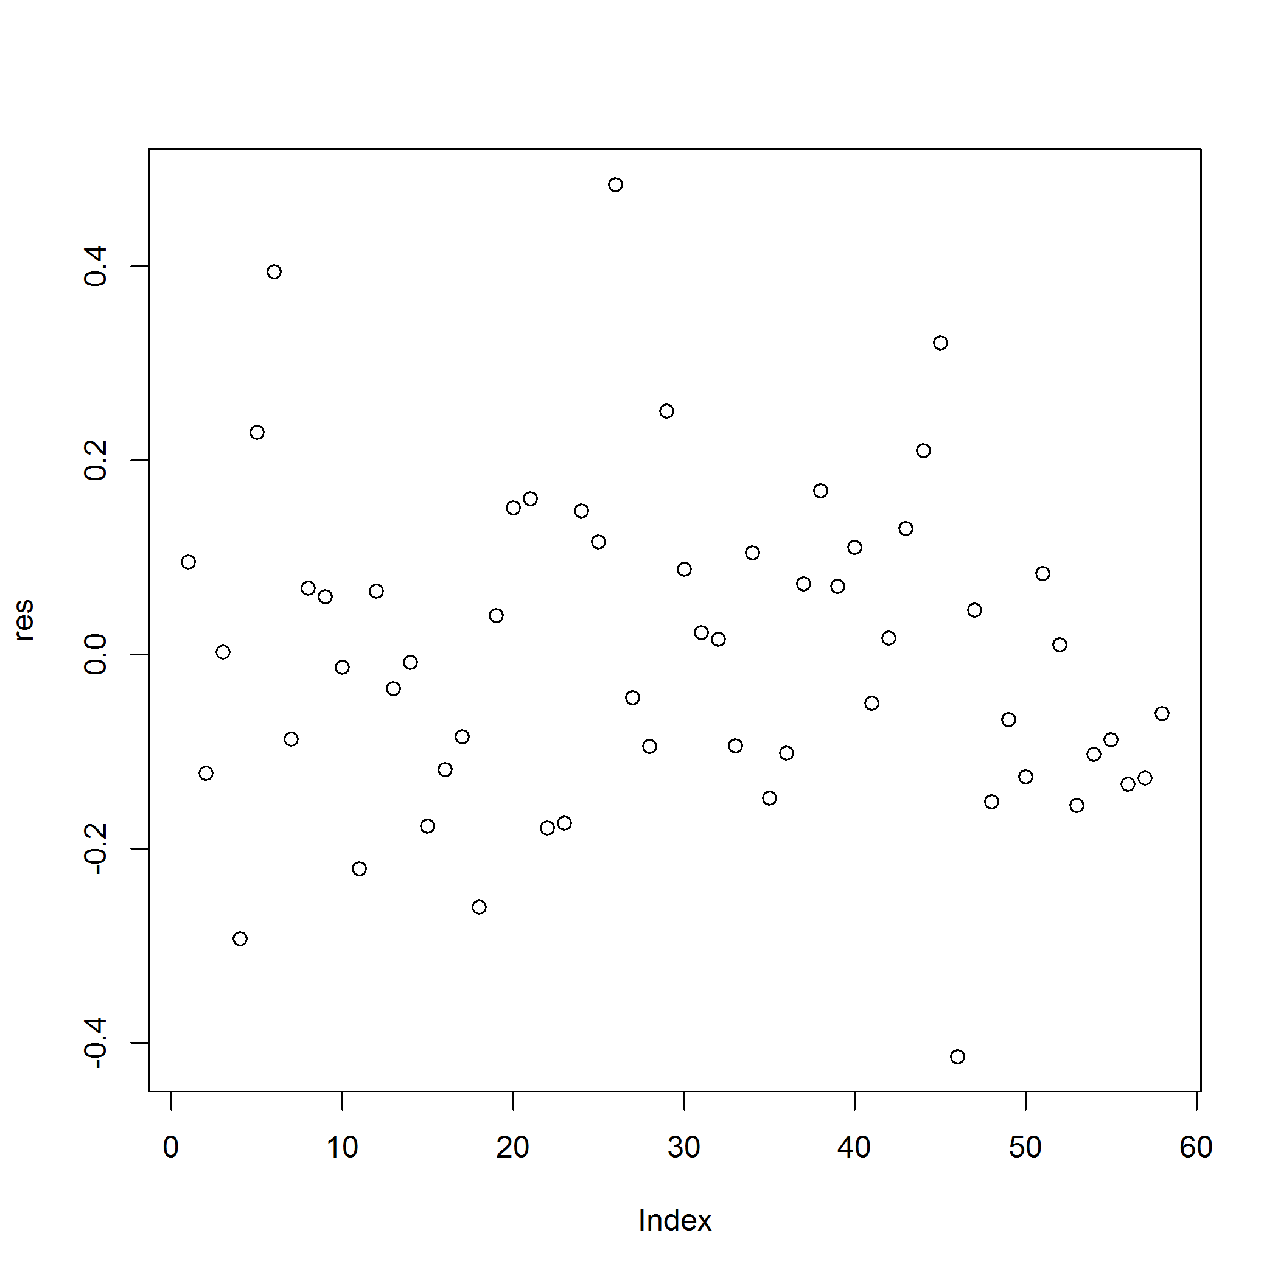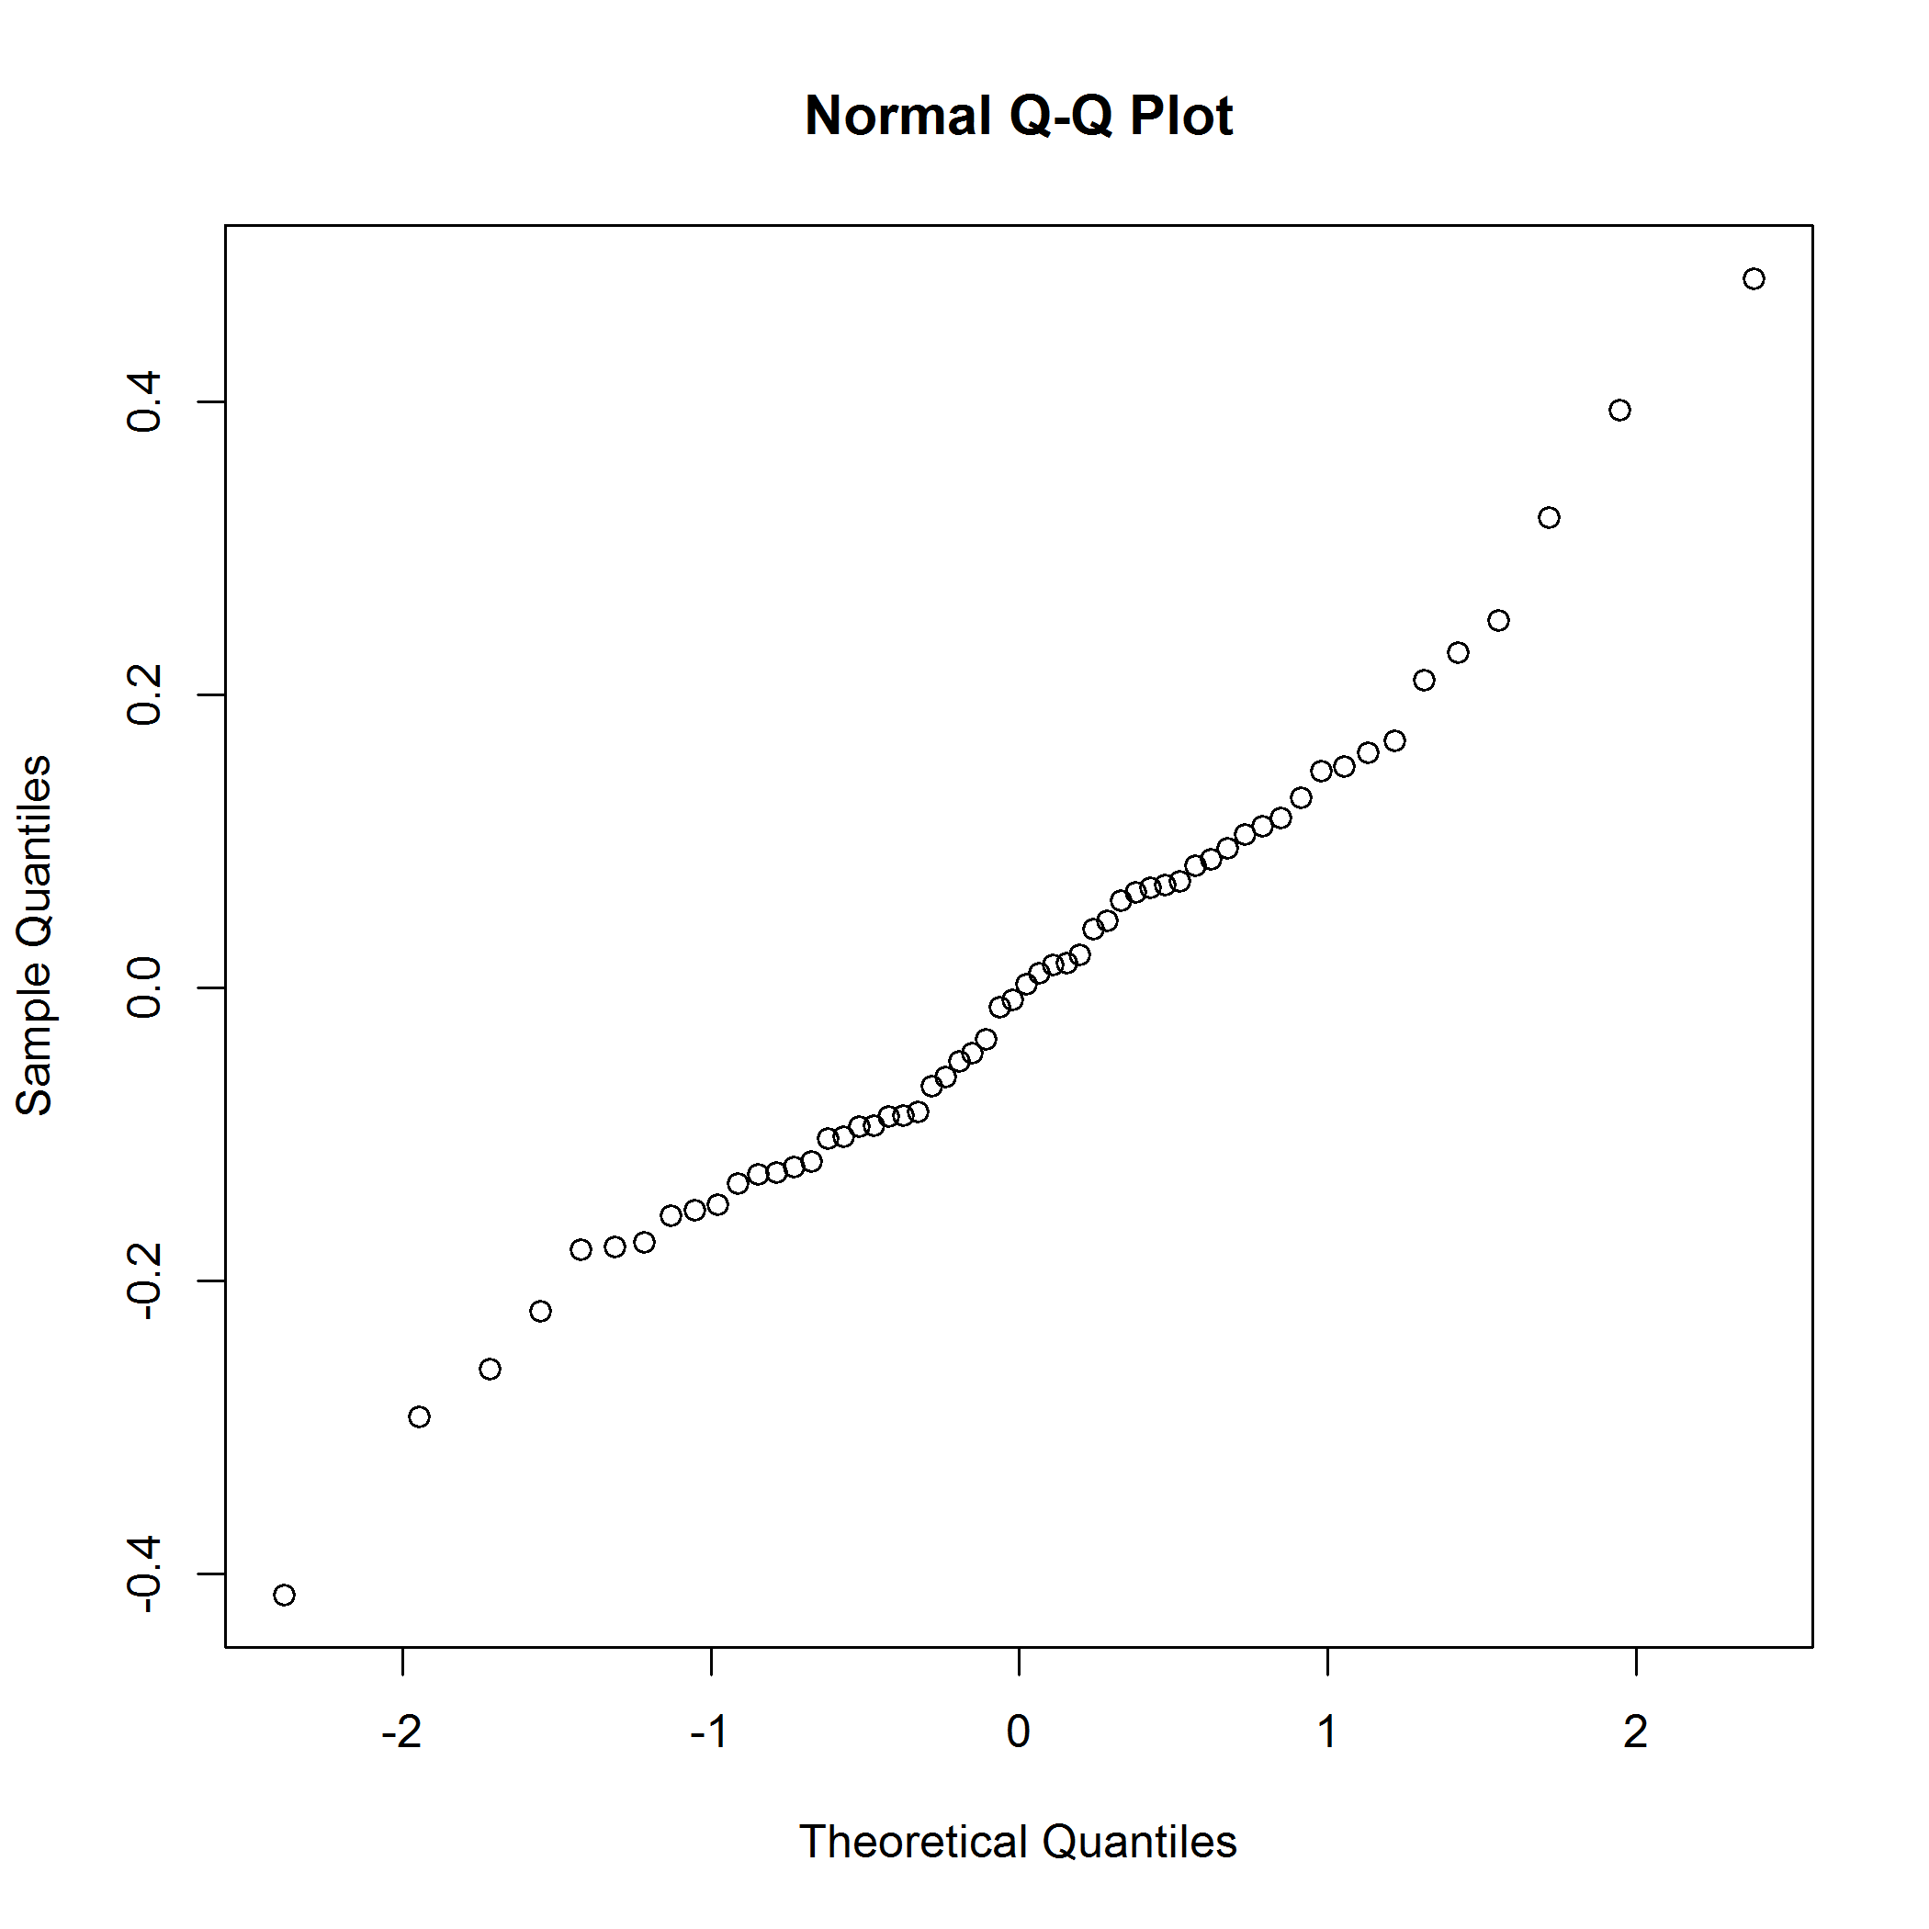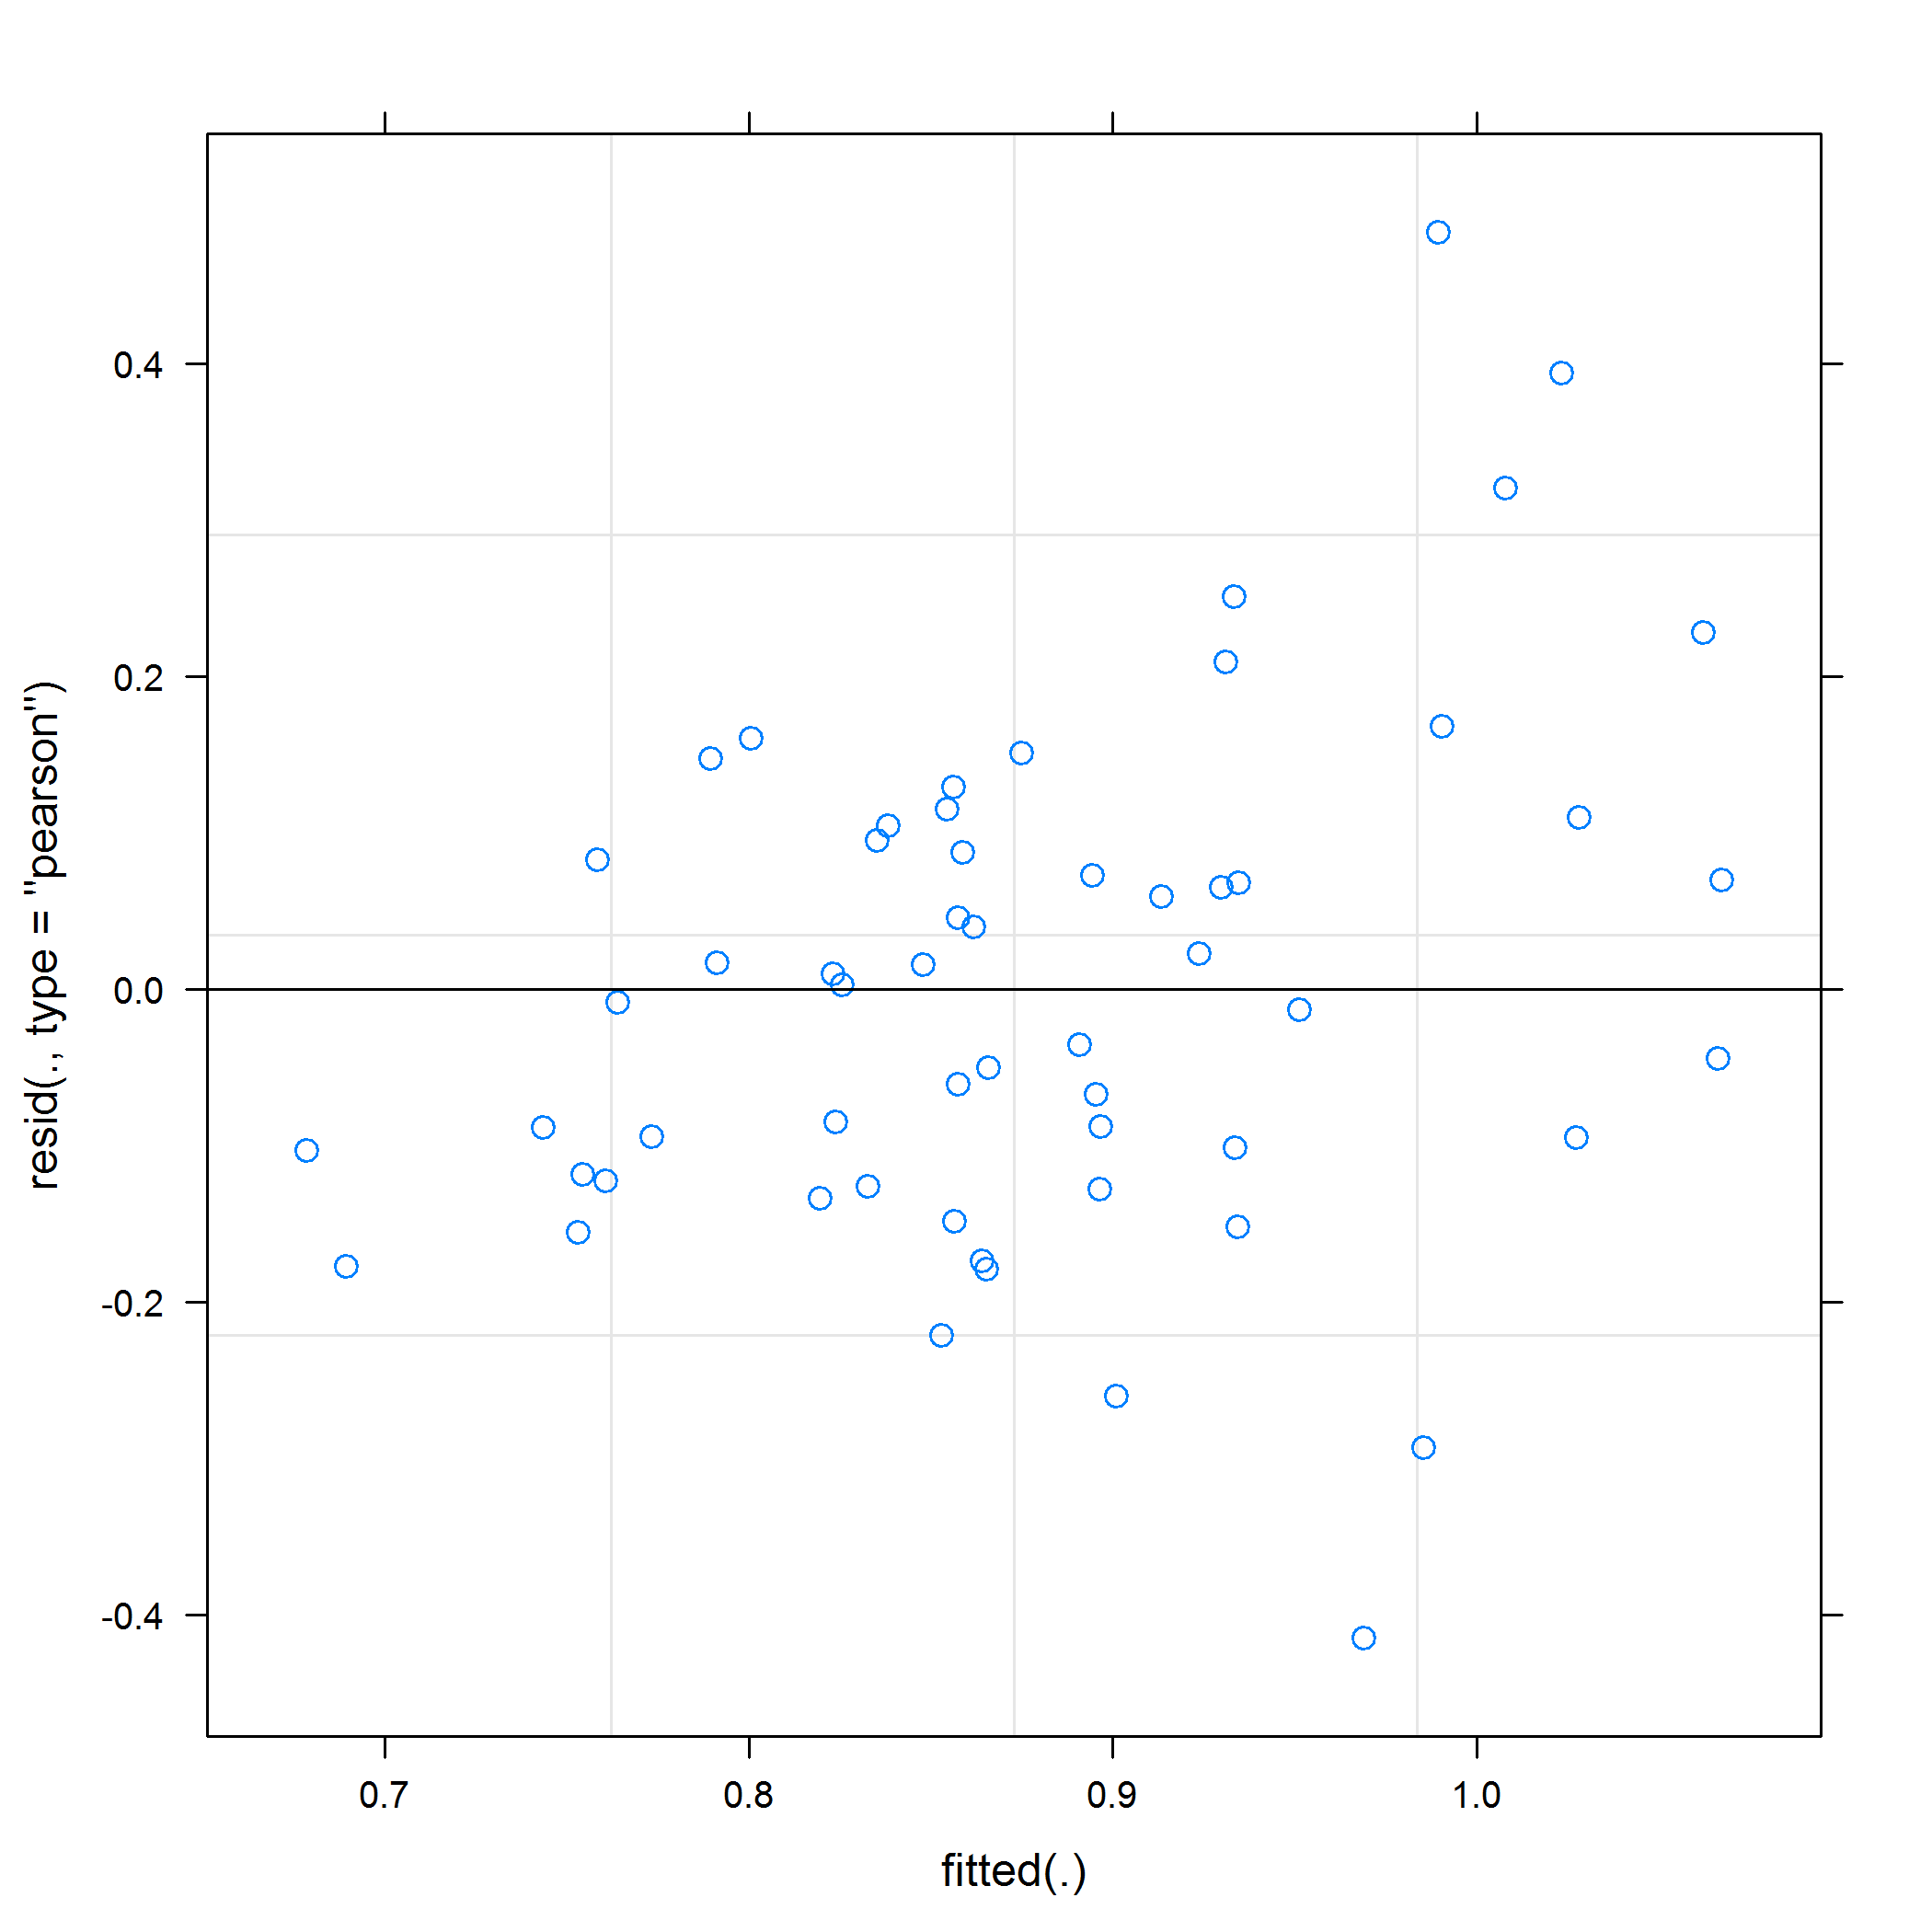

Mixed effects model using the **nlme** package.

|  |  |  |  |  |
| --- | --- | --- | --- | --- |
| term | estimate | std.error | statistic | p.value |
| (Intercept) | 0.84 | 0.07 | 12.07 | 0.0000 |
| studyArmPlacebo | 0.06 | 0.09 | 0.64 | 0.5288 |
| visitMonth3 | -0.07 | 0.09 | -0.85 | 0.4033 |
| visitMonth12 | -0.01 | 0.09 | -0.11 | 0.9137 |
| studyArmPlacebo:visitMonth3 | 0.15 | 0.12 | 1.24 | 0.2232 |
| studyArmPlacebo:visitMonth12 | 0.05 | 0.12 | 0.40 | 0.6915 |

## Linear mixed-effects model fit by REML  
## Data: df1   
## AIC BIC logLik  
## 16.46336 35.9758 1.768319  
##   
## Random effects:  
## Formula: ~1 | patientID  
## (Intercept)  
## StdDev: 0.09415466  
##   
## Formula: ~1 | visitMonth %in% patientID  
## (Intercept) Residual  
## StdDev: 0.175161 0.06433062  
##   
## Correlation Structure: AR(1)  
## Formula: ~1 | patientID/visitMonth   
## Parameter estimate(s):  
## Phi   
## 0   
## Fixed effects: normalizedConcGSSG ~ studyArm * visitMonth   
## Value Std.Error DF t-value p-value  
## (Intercept) 0.8411584 0.06966977 34 12.073506 0.0000  
## studyArmPlacebo 0.0603417 0.09394270 18 0.642324 0.5288  
## visitMonth3 -0.0744497 0.08796437 34 -0.846362 0.4033  
## visitMonth12 -0.0096006 0.08796437 34 -0.109142 0.9137  
## studyArmPlacebo:visitMonth3 0.1513947 0.12202746 34 1.240661 0.2232  
## studyArmPlacebo:visitMonth12 0.0474676 0.11861114 34 0.400196 0.6915  
## Correlation:   
## (Intr) stdyAP vstMn3 vstM12 sAP:M3  
## studyArmPlacebo -0.742   
## visitMonth3 -0.631 0.468   
## visitMonth12 -0.631 0.468 0.500   
## studyArmPlacebo:visitMonth3 0.455 -0.614 -0.721 -0.360   
## studyArmPlacebo:visitMonth12 0.468 -0.631 -0.371 -0.742 0.486  
##   
## Standardized Within-Group Residuals:  
## Min Q1 Med Q3 Max   
## -0.765731854 -0.211667787 -0.005078626 0.172921662 0.894283472   
##   
## Number of Observations: 58  
## Number of Groups:   
## patientID visitMonth %in% patientID   
## 20 58

