Psychiatric Symptoms of Veterans Surveyed Through Facebook Ads

Benjamin Chan (chanb@ohsu.edu)

2017-12-04 11:34:15

# Read data

**Most of this code was developed in Phase 1.** Results will be suppressed for brevity.

**Use only the REDCap survey data**

Notes on the REDCap identifier variables:

* If [consent] == 1, they started the eligibility survey;
* if == 0 or == NA, they didn't.
* If [consent_and_eligibility_complete] == 2, they finished the screener (whether eligible or ineligible);
* if == 0, they dropped out or never started.
* If [eligible] == 1, they completed the screener and were eligible;
* if == 0, they completed and were ineligible;
* if == NA , they dropped out or never started.
* If [veterans_and_social_media_use_co] == 2, they finished the survey;
* if == 0, they dropped out or never started (this includes people who were ineligible or didn't consent).
* If [analytic_sample] == 0, they completed the survey but were disqualified for data quality reasons;
* if == 1, they completed survey and was not disqualified for data quality reasons;
* if == NA, they didn't complete the survey.

|  |  |  |  |  |  |
| --- | --- | --- | --- | --- | --- |
| consent | consent_and_eligibility_complete | eligible | veterans_and_social_media_use_co | analytic_sample | n |
| 0 | 0 | NA | 0 | NA | 8 |
| 0 | 2 | 0 | 0 | NA | 7 |
| 1 | 0 | NA | 0 | NA | 84 |
| 1 | 2 | 0 | 0 | NA | 534 |
| 1 | 2 | 1 | 0 | NA | 106 |
| 1 | 2 | 1 | 2 | 0 | 18 |
| 1 | 2 | 1 | 2 | 1 | 587 |
| NA | 0 | NA | 0 | NA | 96 |

Inclusion criteria

* Completed survey and was not disqualified for data quality reasons; [analytic_sample] == 1

**Number included: n = 587**

Cleaning

* Parse out fba into 2 separate variables for image and text
* Assign indicator for survey participation, indSurveyParticipation
* analytic_sample == 1: Participant completed survey and was not disqualified for data quality reasons
* Assign indicator for eligibility screener participation, indScreenerParticipation
* eligible == 1: Participant completed eligibility screener and was eligible to participate in full survey

## Use of VA health services

Recoding logic

* Primary analysis will code 9 (not sure) as 0 (No)
* Sensitivity analysis will exclude the 9 values from the analysis
* If va_ever_enrolled == FALSE & is.na(va_use_12mo), then recode va_use_12mo to FALSE
* If va_use_12mo == TRUE & va_ever_enrolled == FALSE, then recode va_ever_enrolled to TRUE
* Code indicators indVANeverEnrolled and indVANotUse12mo as the logical opposites of va_ever_enrolled and va_use_12mo

## Independent variables

* Score the Modified Facebook Measure of Social Support (FMSS)
* Reverse-scored items are fmss_r7 through fmss_r10
* Standardize FMSS
* Prep FMSS items
* Combine categories due to small cell sizes

## fmss fmssZ   
## Min. :14.00 Min. :-2.29729   
## 1st Qu.:25.00 1st Qu.:-0.62179   
## Median :29.00 Median :-0.01252   
## Mean :29.08 Mean : 0.00000   
## 3rd Qu.:34.00 3rd Qu.: 0.74908   
## Max. :48.00 Max. : 2.88153   
## NA's :15 NA's :15

## fmss fmssZ  
## fmss 1 1  
## fmssZ 1 1

## fmss fmssZ  
## fmss 6.565197 2.562264  
## fmssZ 2.562264 1.000000

|  |  |  |  |
| --- | --- | --- | --- |
| fmssQuartile | n | min | max |
| Q1: [14,25] | 175 | 14 | 25 |
| Q2: (25,29] | 135 | 26 | 29 |
| Q3: (29,34] | 138 | 30 | 34 |
| Q4: (34,48] | 124 | 35 | 48 |
| NA | 15 | NA | NA |

Check.

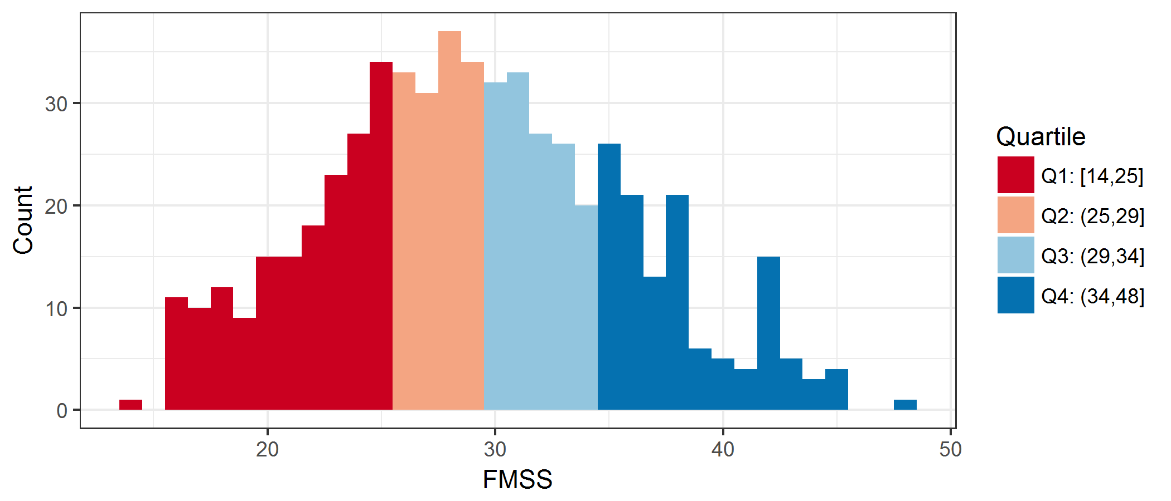

plot of chunk histogramFMSS

Cronbach's alpha for FMSS items 1-3.

##   
## Reliability analysis   
## Call: psych::alpha(x = .)  
##   
## raw_alpha std.alpha G6(smc) average_r S/N ase mean sd  
## 0.91 0.91 0.87 0.77 10 0.0065 1.1 0.9  
##   
## lower alpha upper 95% confidence boundaries  
## 0.9 0.91 0.92   
##   
## Reliability if an item is dropped:  
## raw_alpha std.alpha G6(smc) average_r S/N alpha se  
## fmss_r1 0.89 0.89 0.80 0.80 7.8 0.0094  
## fmss_r2 0.85 0.85 0.74 0.74 5.7 0.0124  
## fmss_r3 0.87 0.87 0.78 0.78 7.0 0.0104  
##   
## Item statistics   
## n raw.r std.r r.cor r.drop mean sd  
## fmss_r1 585 0.91 0.91 0.84 0.80 1.0 0.94  
## fmss_r2 584 0.93 0.93 0.89 0.84 1.1 0.97  
## fmss_r3 584 0.92 0.92 0.86 0.82 1.1 1.03  
##   
## Non missing response frequency for each item  
## 0 1 2 3 4 miss  
## fmss_r1 0.36 0.37 0.21 0.06 0.01 0.00  
## fmss_r2 0.33 0.38 0.21 0.08 0.01 0.01  
## fmss_r3 0.33 0.35 0.21 0.10 0.02 0.01

Cronbach's alpha for FMSS items 1-3 = Cronbach's alpha = 0.910.

Create FMSS subscore for items 1-3.

## Dependent variables

### Psychiatric symptoms (RQ1)

Code indicators for psychiatric disorder screening scales

* PTSD
* Name of scale: PC-PTSD
* Positive screen: ptsd_intrusive + ptsd_avoidant + ptsd_guarded + ptsd_numb + ptsd_guilty $≥$ 3
* Major depression
* Name of scale: PHQ-2
* Positive screen: phq_interest + phq_mood $≥$ 3
* Alcohol misuse
* Name of scale: AUDIT-C
* Positive screen: auditc_freq + auditc_amount + auditc_binge $≥$ 4 for men, $≥$ 3 for women

Presence of suicidality is defined as DSI-SS score $≥$ 2. This cut-off score was chosen based on recommendations for population-based samples noted in [von Glischinski M Clin Psychol Psychotherapy 2015](http://onlinelibrary.wiley.com/doi/10.1002/cpp.2007/full)

* Score the DSI-SS inventory
* See [Joiner 2002](http://www.sciencedirect.com/science/article/pii/S0005796701000171)
* *Scores on each item range from 0 to 3 and, for the inventory, from 0 to 12, with higher scores reflecting greater severity of suicidal ideation.*

Check.

|  |  |  |  |  |  |  |  |
| --- | --- | --- | --- | --- | --- | --- | --- |
| yvariable | indPTSD | mean | sd | min | max | n | freq |
| ptsd | FALSE | 0.9 | 0.9 | 0 | 2 | 236 | 47.0% |
| ptsd | TRUE | 4.2 | 0.8 | 3 | 5 | 266 | 53.0% |

|  |  |  |  |  |  |  |  |
| --- | --- | --- | --- | --- | --- | --- | --- |
| yvariable | indPHQ | mean | sd | min | max | n | freq |
| phq | FALSE | 1.0 | 0.9 | 0 | 2 | 422 | 72.0% |
| phq | TRUE | 4.5 | 1.2 | 3 | 6 | 164 | 28.0% |

|  |  |  |  |  |  |  |  |
| --- | --- | --- | --- | --- | --- | --- | --- |
| yvariable | indAuditC | mean | sd | min | max | n | freq |
| auditc | FALSE | 1.8 | 0.8 | 1 | 3 | 234 | 49.1% |
| auditc | TRUE | 5.9 | 2.1 | 3 | 12 | 243 | 50.9% |

|  |  |  |  |  |  |  |  |
| --- | --- | --- | --- | --- | --- | --- | --- |
| yvariable | indDSISS | mean | sd | min | max | n | freq |
| dsiss | FALSE | 0.1 | 0.3 | 0 | 1 | 453 | 77.4% |
| dsiss | TRUE | 3.9 | 1.6 | 2 | 9 | 132 | 22.6% |

Also create logical opposite for use in RQ3 modeling

### Social media use (RQ2)

* Spending more time on Facebook?
* Frequency of Facebook use: fb_freq
* Active use of Facebook: comm_facebook
* Sharing more personal or health-related information on social media?
* sm_emot_support
* sm_med_info
* sm_med_advice
* sm_med_questions
* sm_share_sympt
* sm_share_health
* sm_share_suicide

Mutate variables to factors.

## Covariates

* Social media platforms used: sm_used___1, ..., sm_used___7, sm_used___99, sm_used_other
* Recode the following sm_used_other values such that sm_used___99 = 0
  + I use Wikipedia to read about illnesses I don't have; it's a curiosity/hobby thing.
  + just in person
  + Just plain internet search
  + TV/phone conversations, veterans group meetings
  + google; bing
  + aol
  + e-mail
  + Web MD
  + webmd
* Offline social contact: comm_inperson
* History of suicidal ideation and suicide attempts
* suicide_considered_ever
* suicide_considered_12mo
* suicide_attempts

Check.

|  |  |  |
| --- | --- | --- |
| smOther | sm_used_other | n |
| FALSE |  | 552 |
| FALSE | aol | 1 |
| FALSE | e-mail | 1 |
| FALSE | google; bing | 1 |
| FALSE | I use Wikipedia to read about illnesses I don't have; it's a curiosity/hobby thing. | 1 |
| FALSE | just in person | 1 |
| FALSE | TV/phone conversations, veterans group meetings | 1 |
| FALSE | Web MD, | 1 |
| FALSE | webmd | 1 |
| TRUE | 4chan | 2 |
| TRUE | Gmail Hangouts; Reddit.com | 1 |
| TRUE | Google+ | 2 |
| TRUE | I used LiveJournal for the majority of my service as well as my deployment to Iraq | 1 |
| TRUE | Linked In | 1 |
| TRUE | LinkedIn, Snapchat | 1 |
| TRUE | LiveJournal | 1 |
| TRUE | MIL.MIL | 1 |
| TRUE | Ravelry Forums | 1 |
| TRUE | reddit | 3 |
| TRUE | Reddit | 5 |
| TRUE | Snao Chat | 1 |
| TRUE | snapchat | 3 |
| TRUE | Snapchat | 1 |
| TRUE | SnapChat | 1 |
| TRUE | webmd, mayoclinic,wikipedia, va | 1 |
| TRUE | www.coping-with-epilepsy.com | 1 |

Number of social media platforms used (excluding Facebook):

|  |  |
| --- | --- |
| countSocialMediaExclFB | n |
| 0 | 347 |
| 1 | 138 |
| 2 | 68 |
| 3 | 21 |
| 4 | 11 |
| 5 | 2 |

|  |  |
| --- | --- |
| comm_inperson | n |
| Every few weeks or less often | 169 |
| Once a week | 70 |
| A few times a week | 114 |
| Once a day | 58 |
| Several times a day | 175 |
| NA | 1 |

|  |  |  |  |  |
| --- | --- | --- | --- | --- |
| indSuicideConsideredEver | indSuicideConsidered12mo | indSuicideAttempt | countSuicideAttempts | n |
| FALSE | FALSE | FALSE | 0 | 330 |
| TRUE | FALSE | FALSE | 0 | 140 |
| TRUE | FALSE | TRUE | 1 | 31 |
| TRUE | TRUE | FALSE | 0 | 29 |
| TRUE | FALSE | TRUE | 2 | 16 |
| TRUE | TRUE | TRUE | 1 | 11 |
| TRUE | FALSE | TRUE | 3 | 9 |
| TRUE | TRUE | TRUE | 3 | 8 |
| TRUE | TRUE | TRUE | 2 | 7 |
| TRUE | FALSE | TRUE | 4 | 2 |
| TRUE | FALSE | TRUE | 5 | 2 |
| TRUE | TRUE | TRUE | 5 | 1 |
| NA | NA | NA | NaN | 1 |

# Research Question 1

**Is perceived social support received from Facebook (FMSS) associated with lower rates of**

* Positive screens for psychiatric disorders
* PC-PTSD
* PHQ-2
* AUDIT-C
* Positive screen for suicidality?
* DSI-SS

## Unadjusted comparisons

|  |  |  |  |  |  |  |  |
| --- | --- | --- | --- | --- | --- | --- | --- |
| yvariable | indPTSD | mean | sd | min | max | n | freq |
| fmss | FALSE | 29.3 | 6.4 | 14 | 45 | 228 | 46.6% |
| fmss | TRUE | 28.3 | 6.8 | 16 | 48 | 261 | 53.4% |

|  |  |  |  |  |  |  |  |
| --- | --- | --- | --- | --- | --- | --- | --- |
| yvariable | indPHQ | mean | sd | min | max | n | freq |
| fmss | FALSE | 29.5 | 6.4 | 16 | 48 | 412 | 72.2% |
| fmss | TRUE | 27.9 | 6.9 | 14 | 44 | 159 | 27.8% |

|  |  |  |  |  |  |  |  |
| --- | --- | --- | --- | --- | --- | --- | --- |
| yvariable | indAuditC | mean | sd | min | max | n | freq |
| fmss | FALSE | 29.7 | 6.6 | 14 | 48 | 230 | 49.6% |
| fmss | TRUE | 29.0 | 6.3 | 16 | 45 | 234 | 50.4% |

|  |  |  |  |  |  |  |  |
| --- | --- | --- | --- | --- | --- | --- | --- |
| yvariable | indDSISS | mean | sd | min | max | n | freq |
| fmss | FALSE | 29.5 | 6.6 | 16 | 48 | 442 | 77.5% |
| fmss | TRUE | 27.6 | 6.4 | 14 | 44 | 128 | 22.5% |

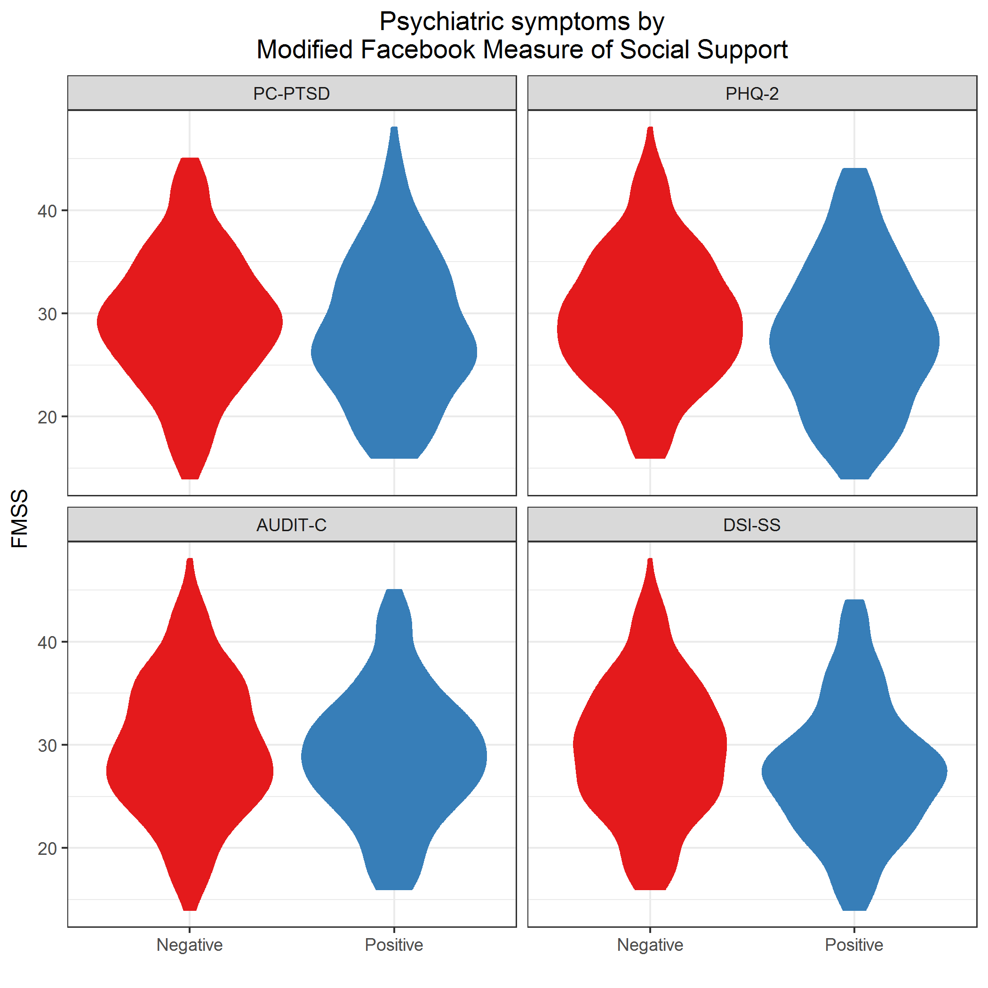

plot of chunk plot2GroupsRQ1

## Adjusted comparisons

## fmss fmssZ  
## fmss 6.565197 0  
## fmssZ 0.000000 1

Filter subjects with missing covariates.

### PC-PTSD

|  |  |  |  |  |  |
| --- | --- | --- | --- | --- | --- |
| model | term | oddsratio | std.error | statistic | p.value |
| Unadjusted | (Intercept) | 1.129 | 0.091 | 1.336 | 0.182 |
| Unadjusted | fmssZ | 0.866 | 0.090 | -1.600 | 0.110 |
| Adjusted | (Intercept) | 1.250 | 0.204 | 1.094 | 0.274 |
| Adjusted | fmssZ | 0.890 | 0.099 | -1.181 | 0.238 |
| Adjusted | countSocialMediaExclFB | 1.022 | 0.099 | 0.216 | 0.829 |
| Adjusted | comm_inpersonOnce a week | 0.653 | 0.340 | -1.252 | 0.211 |
| Adjusted | comm_inpersonA few times a week | 0.454 | 0.282 | -2.794 | 0.005 |
| Adjusted | comm_inpersonOnce a day | 0.558 | 0.359 | -1.625 | 0.104 |
| Adjusted | comm_inpersonSeveral times a day | 0.343 | 0.258 | -4.149 | 0.000 |
| Adjusted | indSuicideConsideredEverTRUE | 2.109 | 0.215 | 3.471 | 0.001 |
| Adjusted | countSuicideAttempts | 1.680 | 0.179 | 2.895 | 0.004 |

|  |  |  |  |  |  |  |  |
| --- | --- | --- | --- | --- | --- | --- | --- |
| model | null.deviance | df.null | logLik | AIC | BIC | deviance | df.residual |
| Unadjusted | 673.151 | 486 | -335.287 | 674.573 | 682.950 | 670.573 | 485 |
| Adjusted | 673.151 | 486 | -304.159 | 626.319 | 664.013 | 608.319 | 478 |

### PHQ-2

|  |  |  |  |  |  |
| --- | --- | --- | --- | --- | --- |
| model | term | oddsratio | std.error | statistic | p.value |
| Unadjusted | (Intercept) | 0.379 | 0.095 | -10.232 | 0.000 |
| Unadjusted | fmssZ | 0.770 | 0.096 | -2.713 | 0.007 |
| Adjusted | (Intercept) | 0.354 | 0.205 | -5.080 | 0.000 |
| Adjusted | fmssZ | 0.814 | 0.102 | -2.008 | 0.045 |
| Adjusted | countSocialMediaExclFB | 0.958 | 0.105 | -0.405 | 0.686 |
| Adjusted | comm_inpersonOnce a week | 0.738 | 0.314 | -0.967 | 0.333 |
| Adjusted | comm_inpersonA few times a week | 0.362 | 0.301 | -3.380 | 0.001 |
| Adjusted | comm_inpersonOnce a day | 0.420 | 0.401 | -2.165 | 0.030 |
| Adjusted | comm_inpersonSeveral times a day | 0.399 | 0.264 | -3.481 | 0.000 |
| Adjusted | indSuicideConsideredEverTRUE | 3.098 | 0.222 | 5.087 | 0.000 |
| Adjusted | countSuicideAttempts | 1.245 | 0.124 | 1.764 | 0.078 |

|  |  |  |  |  |  |  |  |
| --- | --- | --- | --- | --- | --- | --- | --- |
| model | null.deviance | df.null | logLik | AIC | BIC | deviance | df.residual |
| Unadjusted | 672.272 | 568 | -332.363 | 668.726 | 677.413 | 664.726 | 567 |
| Adjusted | 672.272 | 568 | -297.957 | 613.914 | 653.009 | 595.914 | 560 |

### AUDIT-C

|  |  |  |  |  |  |
| --- | --- | --- | --- | --- | --- |
| model | term | oddsratio | std.error | statistic | p.value |
| Unadjusted | (Intercept) | 1.031 | 0.093 | 0.323 | 0.746 |
| Unadjusted | fmssZ | 0.891 | 0.095 | -1.220 | 0.222 |
| Adjusted | (Intercept) | 1.105 | 0.201 | 0.496 | 0.620 |
| Adjusted | fmssZ | 0.912 | 0.098 | -0.939 | 0.348 |
| Adjusted | countSocialMediaExclFB | 1.045 | 0.097 | 0.450 | 0.652 |
| Adjusted | comm_inpersonOnce a week | 1.185 | 0.332 | 0.512 | 0.608 |
| Adjusted | comm_inpersonA few times a week | 0.694 | 0.269 | -1.359 | 0.174 |
| Adjusted | comm_inpersonOnce a day | 0.770 | 0.358 | -0.729 | 0.466 |
| Adjusted | comm_inpersonSeveral times a day | 0.615 | 0.253 | -1.926 | 0.054 |
| Adjusted | indSuicideConsideredEverTRUE | 1.463 | 0.214 | 1.781 | 0.075 |
| Adjusted | countSuicideAttempts | 0.864 | 0.132 | -1.108 | 0.268 |

|  |  |  |  |  |  |  |  |
| --- | --- | --- | --- | --- | --- | --- | --- |
| model | null.deviance | df.null | logLik | AIC | BIC | deviance | df.residual |
| Unadjusted | 640.39 | 461 | -319.447 | 642.894 | 651.165 | 638.894 | 460 |
| Adjusted | 640.39 | 461 | -314.297 | 646.593 | 683.813 | 628.593 | 453 |

### DSI-SS

|  |  |  |  |  |  |
| --- | --- | --- | --- | --- | --- |
| model | term | oddsratio | std.error | statistic | p.value |
| Unadjusted | (Intercept) | 0.280 | 0.103 | -12.364 | 0.000 |
| Unadjusted | fmssZ | 0.732 | 0.105 | -2.981 | 0.003 |
| Adjusted | (Intercept) | 0.124 | 0.256 | -8.161 | 0.000 |
| Adjusted | fmssZ | 0.751 | 0.114 | -2.514 | 0.012 |
| Adjusted | countSocialMediaExclFB | 1.047 | 0.110 | 0.414 | 0.679 |
| Adjusted | comm_inpersonOnce a week | 0.850 | 0.342 | -0.476 | 0.634 |
| Adjusted | comm_inpersonA few times a week | 0.668 | 0.319 | -1.266 | 0.205 |
| Adjusted | comm_inpersonOnce a day | 0.603 | 0.457 | -1.107 | 0.268 |
| Adjusted | comm_inpersonSeveral times a day | 0.595 | 0.295 | -1.757 | 0.079 |
| Adjusted | indSuicideConsideredEverTRUE | 5.491 | 0.256 | 6.664 | 0.000 |
| Adjusted | countSuicideAttempts | 1.295 | 0.123 | 2.102 | 0.036 |

|  |  |  |  |  |  |  |  |
| --- | --- | --- | --- | --- | --- | --- | --- |
| model | null.deviance | df.null | logLik | AIC | BIC | deviance | df.residual |
| Unadjusted | 604.194 | 568 | -297.503 | 599.006 | 607.694 | 595.006 | 567 |
| Adjusted | 604.194 | 568 | -254.388 | 526.776 | 565.871 | 508.776 | 560 |

## Additional questions

Some issues that additional analysis could clarify is whether people have a tendency to substitute social contact on social media for in-person social contact, and whether that substitution is bad for your emotional well-being. It would be interesting to look at:

* Do people who spend a lot of time (or frequently use) Facebook spend less time meeting up in-person (i.e., possibly substitute one form of social contact for another)? Variables: comm_facebook, fb_freq, comm_inperson
* Do people who spend a lot of time (or frequently use) Facebook and spend less time in-person have higher risk for psychiatric disorders?

## $table  
## fb_freq  
## comm_facebook Less than daily Daily or more Sum  
## Less than daily 59 170 229  
## Daily or more 2 354 356  
## Sum 61 524 585  
##   
## $expected  
## fb_freq  
## comm_facebook Less than daily Daily or more  
## Less than daily 23.87863 205.1214  
## Daily or more 37.12137 318.8786  
##   
## $chisq.test  
##   
## Pearson's Chi-squared test with Yates' continuity correction  
##   
## data: T  
## X-squared = 92.089, df = 1, p-value < 2.2e-16

## $table  
## comm_inperson  
## comm_facebook Less than daily Daily or more Sum  
## Less than daily 162 66 228  
## Daily or more 191 167 358  
## Sum 353 233 586  
##   
## $expected  
## comm_inperson  
## comm_facebook Less than daily Daily or more  
## Less than daily 137.3447 90.65529  
## Daily or more 215.6553 142.34471  
##   
## $chisq.test  
##   
## Pearson's Chi-squared test with Yates' continuity correction  
##   
## data: T  
## X-squared = 17.489, df = 1, p-value = 2.89e-05

## $table  
## comm_inperson  
## fb_freq Less than daily Daily or more Sum  
## Less than daily 37 23 60  
## Daily or more 314 210 524  
## Sum 351 233 584  
##   
## $expected  
## comm_inperson  
## fb_freq Less than daily Daily or more  
## Less than daily 36.06164 23.93836  
## Daily or more 314.93836 209.06164  
##   
## $chisq.test  
##   
## Pearson's Chi-squared test with Yates' continuity correction  
##   
## data: T  
## X-squared = 0.014885, df = 1, p-value = 0.9029

## FMSS items

Closely exam FMSS items 1, 2, 3, and 11

* fmss_r1 For you, how good is Facebook for getting real help or support?
* fmss_r2 For the support you get on Facebook, how much practical help is it?
* fmss_r3 How much does the support you get on Facebook make you feel better?
* fmss_r11 How close to people does Facebook make you feel?

## $table  
## fmss_r1  
## indPHQ Not at all A little Somewhat Very or Extremely Sum  
## FALSE 146 161 88 25 420  
## TRUE 61 55 33 15 164  
## Sum 207 216 121 40 584  
##   
## $expected  
## fmss_r1  
## indPHQ Not at all A little Somewhat Very or Extremely  
## FALSE 148.86986 155.34247 87.02055 28.76712  
## TRUE 58.13014 60.65753 33.97945 11.23288  
##   
## $chisq.test  
##   
## Pearson's Chi-squared test  
##   
## data: T  
## X-squared = 2.7267, df = 3, p-value = 0.4357

## $table  
## fmss_r2  
## indPHQ None A little Some Quite a bit or A lot Sum  
## FALSE 132 160 93 34 419  
## TRUE 59 58 27 20 164  
## Sum 191 218 120 54 583  
##   
## $expected  
## fmss_r2  
## indPHQ None A little Some Quite a bit or A lot  
## FALSE 137.27101 156.67581 86.24357 38.80961  
## TRUE 53.72899 61.32419 33.75643 15.19039  
##   
## $chisq.test  
##   
## Pearson's Chi-squared test  
##   
## data: T  
## X-squared = 4.9707, df = 3, p-value = 0.174

## $table  
## fmss_r3  
## indPHQ Not at all A little Somewhat Quite a bit or A lot Sum  
## FALSE 132 149 87 51 419  
## TRUE 58 57 33 16 164  
## Sum 190 206 120 67 583  
##   
## $expected  
## fmss_r3  
## indPHQ Not at all A little Somewhat Quite a bit or A lot  
## FALSE 136.55232 148.05146 86.24357 48.15266  
## TRUE 53.44768 57.94854 33.75643 18.84734  
##   
## $chisq.test  
##   
## Pearson's Chi-squared test  
##   
## data: T  
## X-squared = 1.1832, df = 3, p-value = 0.757

## $table  
## fmss_r11  
## indPHQ Not at all A little Somewhat Very or Extremely Sum  
## FALSE 77 192 126 26 421  
## TRUE 49 53 56 6 164  
## Sum 126 245 182 32 585  
##   
## $expected  
## fmss_r11  
## indPHQ Not at all A little Somewhat Very or Extremely  
## FALSE 90.67692 176.31624 130.97778 23.02906  
## TRUE 35.32308 68.68376 51.02222 8.97094  
##   
## $chisq.test  
##   
## Pearson's Chi-squared test  
##   
## data: T  
## X-squared = 14.377, df = 3, p-value = 0.002434

## $table  
## fmss_r1  
## indDSISS Not at all A little Somewhat Very or Extremely Sum  
## FALSE 157 164 98 33 452  
## TRUE 51 50 23 7 131  
## Sum 208 214 121 40 583  
##   
## $expected  
## fmss_r1  
## indDSISS Not at all A little Somewhat Very or Extremely  
## FALSE 161.26244 165.91424 93.81132 31.012007  
## TRUE 46.73756 48.08576 27.18868 8.987993  
##   
## $chisq.test  
##   
## Pearson's Chi-squared test  
##   
## data: T  
## X-squared = 1.9992, df = 3, p-value = 0.5726

## $table  
## fmss_r2  
## indDSISS None A little Some Quite a bit or A lot Sum  
## FALSE 148 159 101 43 451  
## TRUE 43 58 19 11 131  
## Sum 191 217 120 54 582  
##   
## $expected  
## fmss_r2  
## indDSISS None A little Some Quite a bit or A lot  
## FALSE 148.00859 168.15636 92.98969 41.84536  
## TRUE 42.99141 48.84364 27.01031 12.15464  
##   
## $chisq.test  
##   
## Pearson's Chi-squared test  
##   
## data: T  
## X-squared = 5.4222, df = 3, p-value = 0.1434

## $table  
## fmss_r3  
## indDSISS Not at all A little Somewhat Quite a bit or A lot Sum  
## FALSE 146 153 92 59 450  
## TRUE 44 53 27 8 132  
## Sum 190 206 119 67 582  
##   
## $expected  
## fmss_r3  
## indDSISS Not at all A little Somewhat Quite a bit or A lot  
## FALSE 146.90722 159.27835 92.01031 51.80412  
## TRUE 43.09278 46.72165 26.98969 15.19588  
##   
## $chisq.test  
##   
## Pearson's Chi-squared test  
##   
## data: T  
## X-squared = 5.5229, df = 3, p-value = 0.1373

## $table  
## fmss_r11  
## indDSISS Not at all A little Somewhat Very or Extremely Sum  
## FALSE 94 190 146 22 452  
## TRUE 33 53 36 10 132  
## Sum 127 243 182 32 584  
##   
## $expected  
## fmss_r11  
## indDSISS Not at all A little Somewhat Very or Extremely  
## FALSE 98.29452 188.07534 140.86301 24.767123  
## TRUE 28.70548 54.92466 41.13699 7.232877  
##   
## $chisq.test  
##   
## Pearson's Chi-squared test  
##   
## data: T  
## X-squared = 3.1139, df = 3, p-value = 0.3744

### PHQ-2

|  |  |  |  |  |  |
| --- | --- | --- | --- | --- | --- |
| model | term | oddsratio | std.error | statistic | p.value |
| Unadjusted | (Intercept) | 0.406 | 0.142 | -6.329 | 0.000 |
| Unadjusted | fmssSubscore | 0.988 | 0.034 | -0.355 | 0.722 |
| Adjusted | (Intercept) | 0.401 | 0.224 | -4.079 | 0.000 |
| Adjusted | fmssSubscore | 0.972 | 0.037 | -0.770 | 0.441 |
| Adjusted | countSocialMediaExclFB | 0.921 | 0.104 | -0.794 | 0.427 |
| Adjusted | comm_inpersonOnce a week | 0.795 | 0.309 | -0.741 | 0.459 |
| Adjusted | comm_inpersonA few times a week | 0.357 | 0.299 | -3.450 | 0.001 |
| Adjusted | comm_inpersonOnce a day | 0.453 | 0.387 | -2.044 | 0.041 |
| Adjusted | comm_inpersonSeveral times a day | 0.388 | 0.260 | -3.647 | 0.000 |
| Adjusted | indSuicideConsideredEverTRUE | 3.212 | 0.219 | 5.329 | 0.000 |
| Adjusted | countSuicideAttempts | 1.248 | 0.125 | 1.776 | 0.076 |

|  |  |  |  |  |  |  |  |
| --- | --- | --- | --- | --- | --- | --- | --- |
| model | null.deviance | df.null | logLik | AIC | BIC | deviance | df.residual |
| Unadjusted | 688.956 | 579 | -344.415 | 692.829 | 701.555 | 688.829 | 578 |
| Adjusted | 688.956 | 579 | -306.439 | 630.877 | 670.145 | 612.877 | 571 |

### DSI-SS

|  |  |  |  |  |  |
| --- | --- | --- | --- | --- | --- |
| model | term | oddsratio | std.error | statistic | p.value |
| Unadjusted | (Intercept) | 0.340 | 0.150 | -7.176 | 0.000 |
| Unadjusted | fmssSubscore | 0.949 | 0.038 | -1.391 | 0.164 |
| Adjusted | (Intercept) | 0.171 | 0.268 | -6.601 | 0.000 |
| Adjusted | fmssSubscore | 0.909 | 0.042 | -2.273 | 0.023 |
| Adjusted | countSocialMediaExclFB | 1.028 | 0.109 | 0.253 | 0.800 |
| Adjusted | comm_inpersonOnce a week | 0.803 | 0.339 | -0.645 | 0.519 |
| Adjusted | comm_inpersonA few times a week | 0.649 | 0.317 | -1.364 | 0.173 |
| Adjusted | comm_inpersonOnce a day | 0.567 | 0.454 | -1.251 | 0.211 |
| Adjusted | comm_inpersonSeveral times a day | 0.602 | 0.289 | -1.755 | 0.079 |
| Adjusted | indSuicideConsideredEverTRUE | 5.832 | 0.253 | 6.979 | 0.000 |
| Adjusted | countSuicideAttempts | 1.315 | 0.123 | 2.221 | 0.026 |

|  |  |  |  |  |  |  |  |
| --- | --- | --- | --- | --- | --- | --- | --- |
| model | null.deviance | df.null | logLik | AIC | BIC | deviance | df.residual |
| Unadjusted | 617.231 | 579 | -307.628 | 619.257 | 627.983 | 615.257 | 578 |
| Adjusted | 617.231 | 579 | -260.629 | 539.259 | 578.526 | 521.259 | 571 |

## FMSS quartiles

Stratify by FMSS quartile and compare Q1 vs Q4.

## $table  
## fmssQuartile  
## indPHQ Q1: [14,25] Q4: (34,48] Sum  
## FALSE 111 94 205  
## TRUE 63 30 93  
## Sum 174 124 298  
##   
## $expected  
## fmssQuartile  
## indPHQ Q1: [14,25] Q4: (34,48]  
## FALSE 119.69799 85.30201  
## TRUE 54.30201 38.69799  
##   
## $chisq.test  
##   
## Pearson's Chi-squared test with Yates' continuity correction  
##   
## data: T  
## X-squared = 4.3237, df = 1, p-value = 0.03759

## $table  
## fmssQuartile  
## indDSISS Q1: [14,25] Q4: (34,48] Sum  
## FALSE 127 104 231  
## TRUE 47 20 67  
## Sum 174 124 298  
##   
## $expected  
## fmssQuartile  
## indDSISS Q1: [14,25] Q4: (34,48]  
## FALSE 134.87919 96.12081  
## TRUE 39.12081 27.87919  
##   
## $chisq.test  
##   
## Pearson's Chi-squared test with Yates' continuity correction  
##   
## data: T  
## X-squared = 4.3153, df = 1, p-value = 0.03777

### PHQ-2

|  |  |  |  |  |  |
| --- | --- | --- | --- | --- | --- |
| model | term | oddsratio | std.error | statistic | p.value |
| Unadjusted | (Intercept) | 0.568 | 0.158 | -3.591 | 0.000 |
| Unadjusted | fmssQuartileQ4: (34,48] | 0.562 | 0.262 | -2.194 | 0.028 |
| Adjusted | (Intercept) | 0.419 | 0.287 | -3.032 | 0.002 |
| Adjusted | fmssQuartileQ4: (34,48] | 0.591 | 0.287 | -1.836 | 0.066 |
| Adjusted | countSocialMediaExclFB | 0.946 | 0.139 | -0.403 | 0.687 |
| Adjusted | comm_inpersonOnce a week | 1.269 | 0.419 | 0.568 | 0.570 |
| Adjusted | comm_inpersonA few times a week | 0.336 | 0.419 | -2.606 | 0.009 |
| Adjusted | comm_inpersonOnce a day | 0.576 | 0.537 | -1.028 | 0.304 |
| Adjusted | comm_inpersonSeveral times a day | 0.603 | 0.350 | -1.446 | 0.148 |
| Adjusted | indSuicideConsideredEverTRUE | 3.084 | 0.301 | 3.747 | 0.000 |
| Adjusted | countSuicideAttempts | 1.170 | 0.157 | 1.001 | 0.317 |

|  |  |  |  |  |  |  |  |
| --- | --- | --- | --- | --- | --- | --- | --- |
| model | null.deviance | df.null | logLik | AIC | BIC | deviance | df.residual |
| Unadjusted | 369.970 | 297 | -182.51 | 369.019 | 376.413 | 365.019 | 296 |
| Adjusted | 366.891 | 295 | -162.91 | 343.820 | 377.033 | 325.820 | 287 |

### DSI-SS

|  |  |  |  |  |  |
| --- | --- | --- | --- | --- | --- |
| model | term | oddsratio | std.error | statistic | p.value |
| Unadjusted | (Intercept) | 0.370 | 0.171 | -5.822 | 0.000 |
| Unadjusted | fmssQuartileQ4: (34,48] | 0.520 | 0.298 | -2.197 | 0.028 |
| Adjusted | (Intercept) | 0.158 | 0.366 | -5.047 | 0.000 |
| Adjusted | fmssQuartileQ4: (34,48] | 0.524 | 0.337 | -1.918 | 0.055 |
| Adjusted | countSocialMediaExclFB | 0.976 | 0.157 | -0.155 | 0.877 |
| Adjusted | comm_inpersonOnce a week | 0.716 | 0.465 | -0.718 | 0.473 |
| Adjusted | comm_inpersonA few times a week | 0.523 | 0.440 | -1.475 | 0.140 |
| Adjusted | comm_inpersonOnce a day | 0.736 | 0.609 | -0.503 | 0.615 |
| Adjusted | comm_inpersonSeveral times a day | 0.385 | 0.435 | -2.191 | 0.028 |
| Adjusted | indSuicideConsideredEverTRUE | 7.312 | 0.378 | 5.265 | 0.000 |
| Adjusted | countSuicideAttempts | 1.134 | 0.156 | 0.801 | 0.423 |

|  |  |  |  |  |  |  |  |
| --- | --- | --- | --- | --- | --- | --- | --- |
| model | null.deviance | df.null | logLik | AIC | BIC | deviance | df.residual |
| Unadjusted | 317.642 | 297 | -156.291 | 316.581 | 323.975 | 312.581 | 296 |
| Adjusted | 314.645 | 296 | -129.592 | 277.183 | 310.427 | 259.183 | 288 |

# Research Question 2

**Are certains features of social media use are associated with positive screens for psychiatric disorders or a positive screen for suicidality?**

* Spending more time on Facebook?
* Frequency of Facebook use: fb_freq
* Active use of Facebook: comm_facebook
* Sharing more personal or health-related information on social media?
* Get emotional support from others sm_emot_support
* Get information about health or medical topics sm_med_info
* Get advice about health or medical topics sm_med_advice
* Ask questions about health or medical issues sm_med_questions
* Share symptoms such as mood swings, depression, anxiety, or sleep problems sm_share_sympt
* Share information related to your health sm_share_health
* Share thoughts about suicide or hurting yourself in some way sm_share_suicide

## Association between frequency of Facebook use and active use of Facebook

Correlation (Spearman) between frequency of Facebook use and active use of Facebook is 0.457

## Unadjusted comparisons

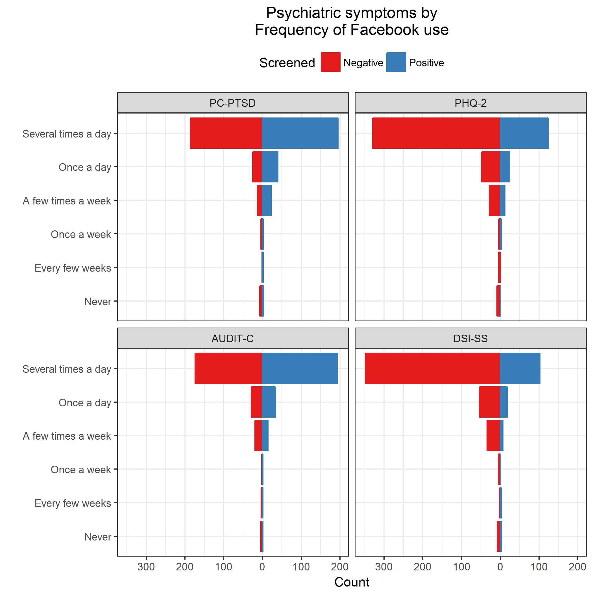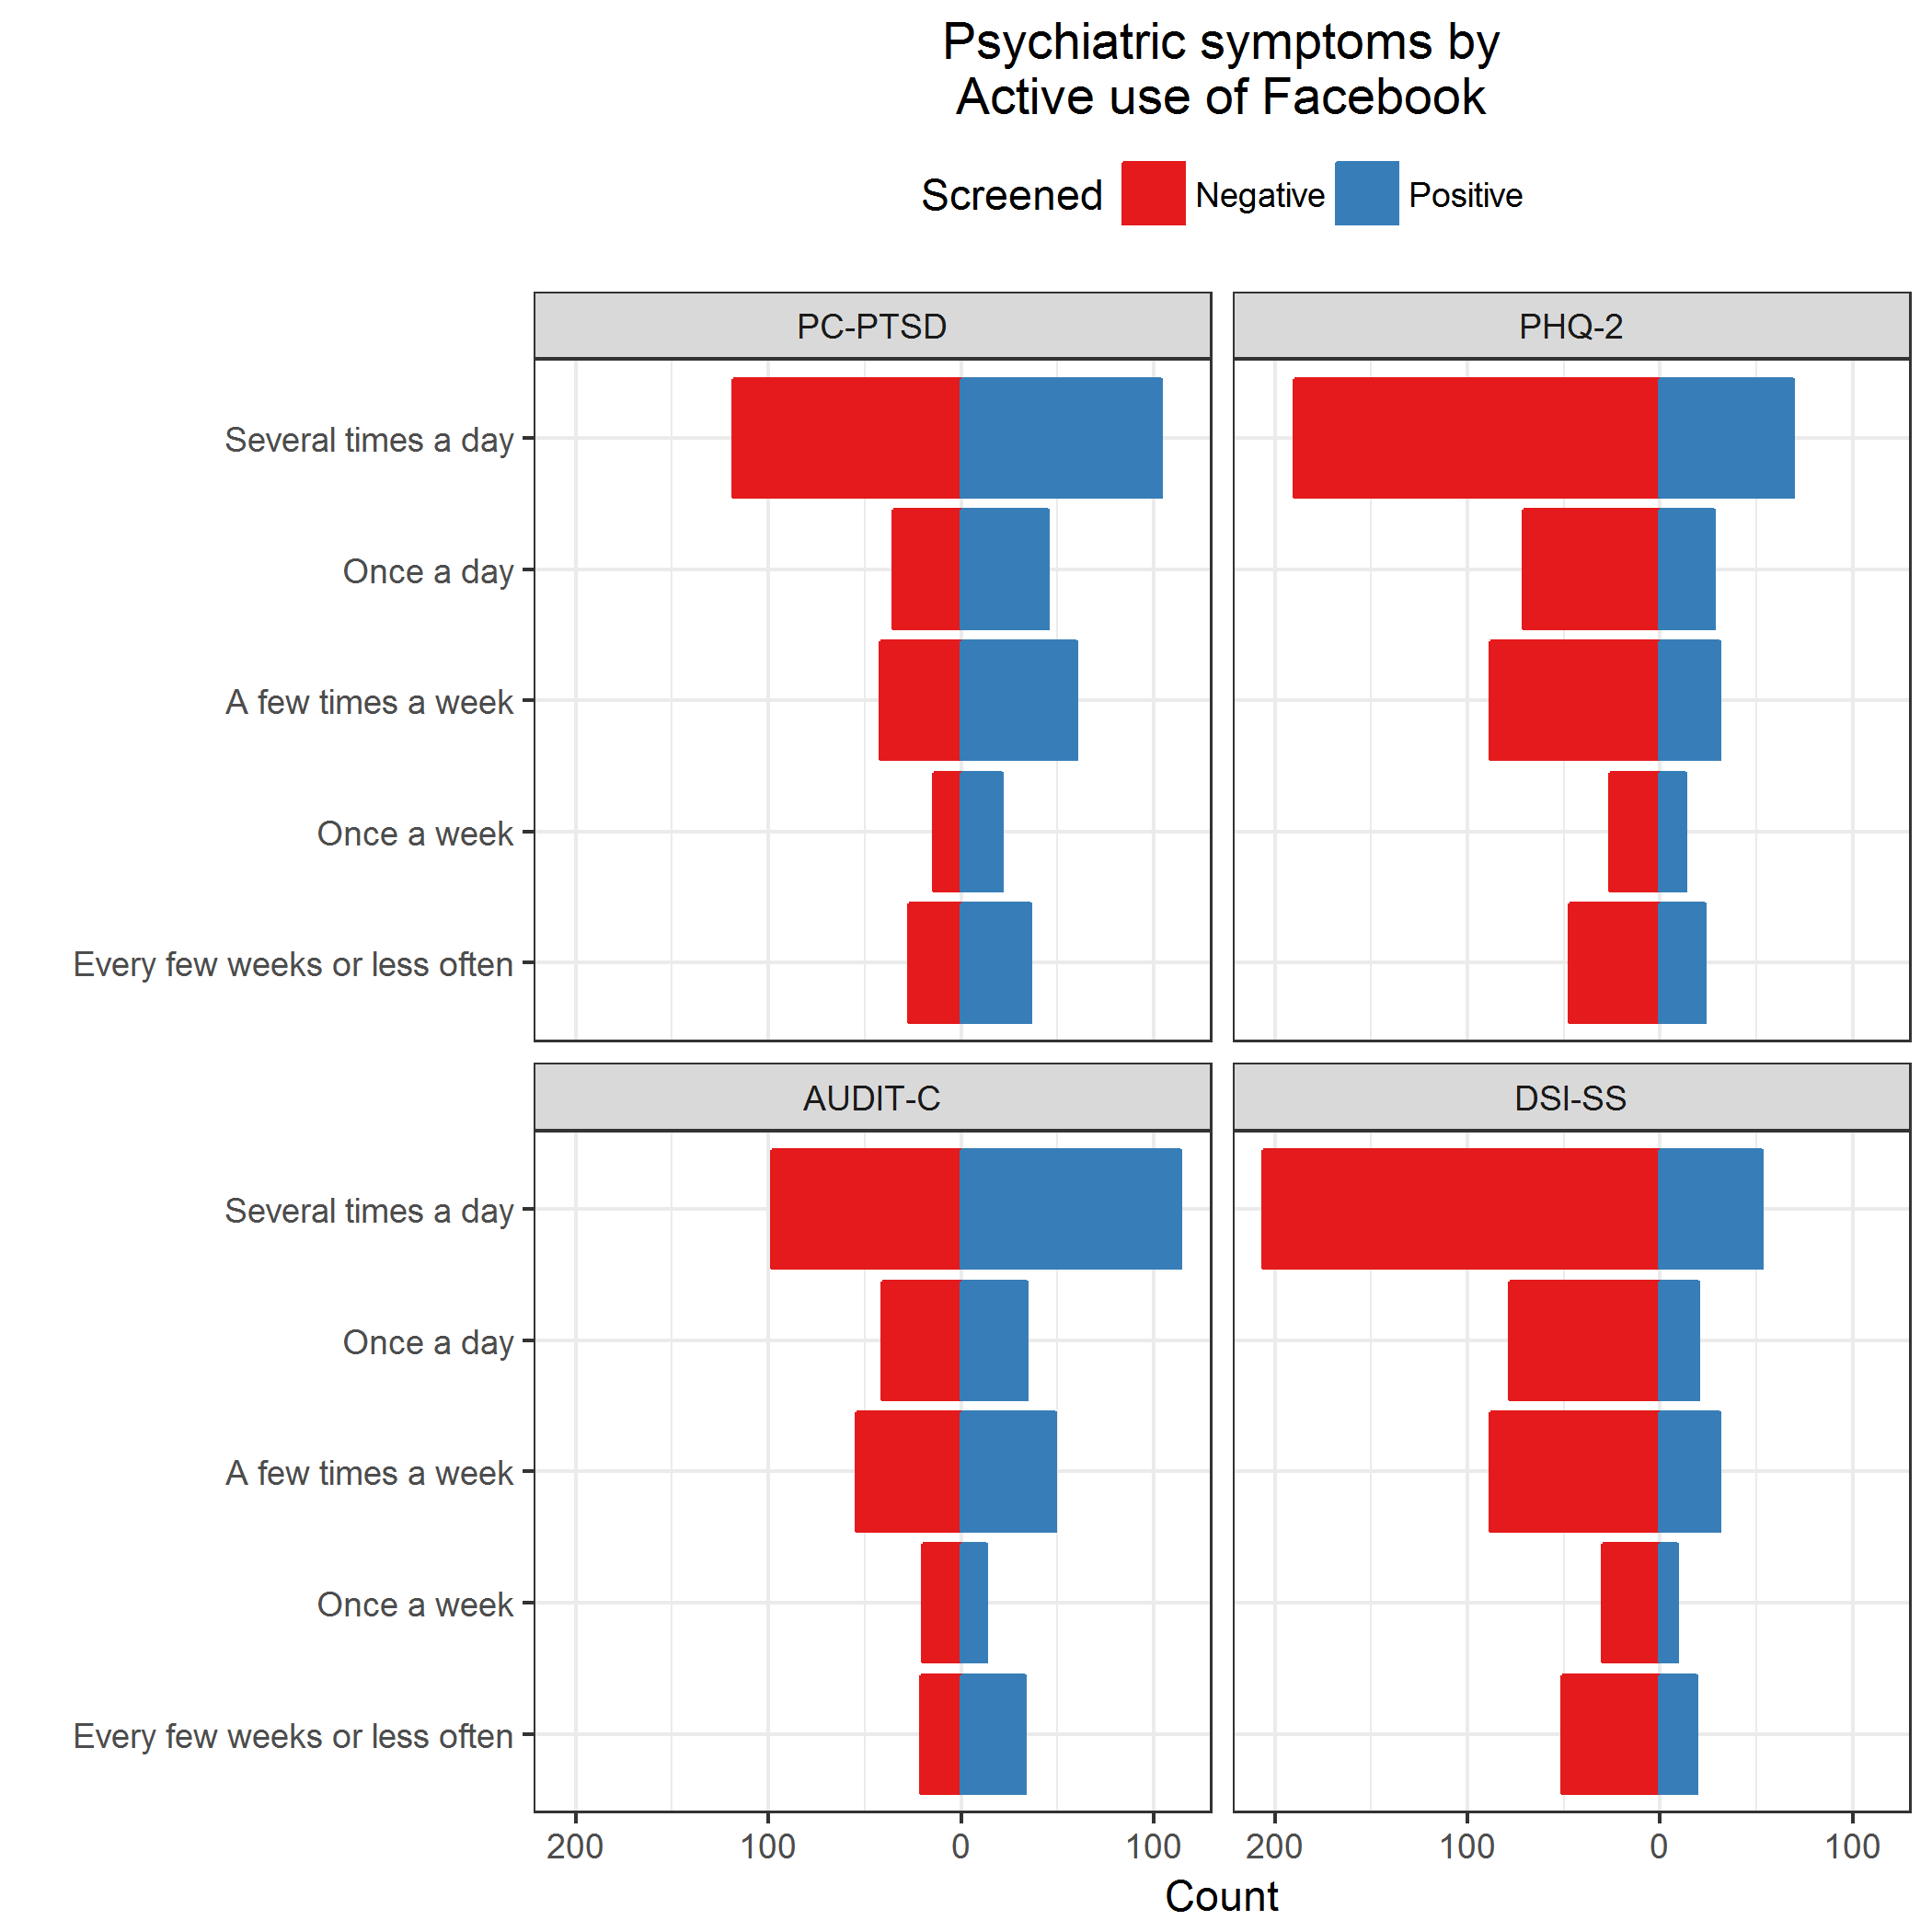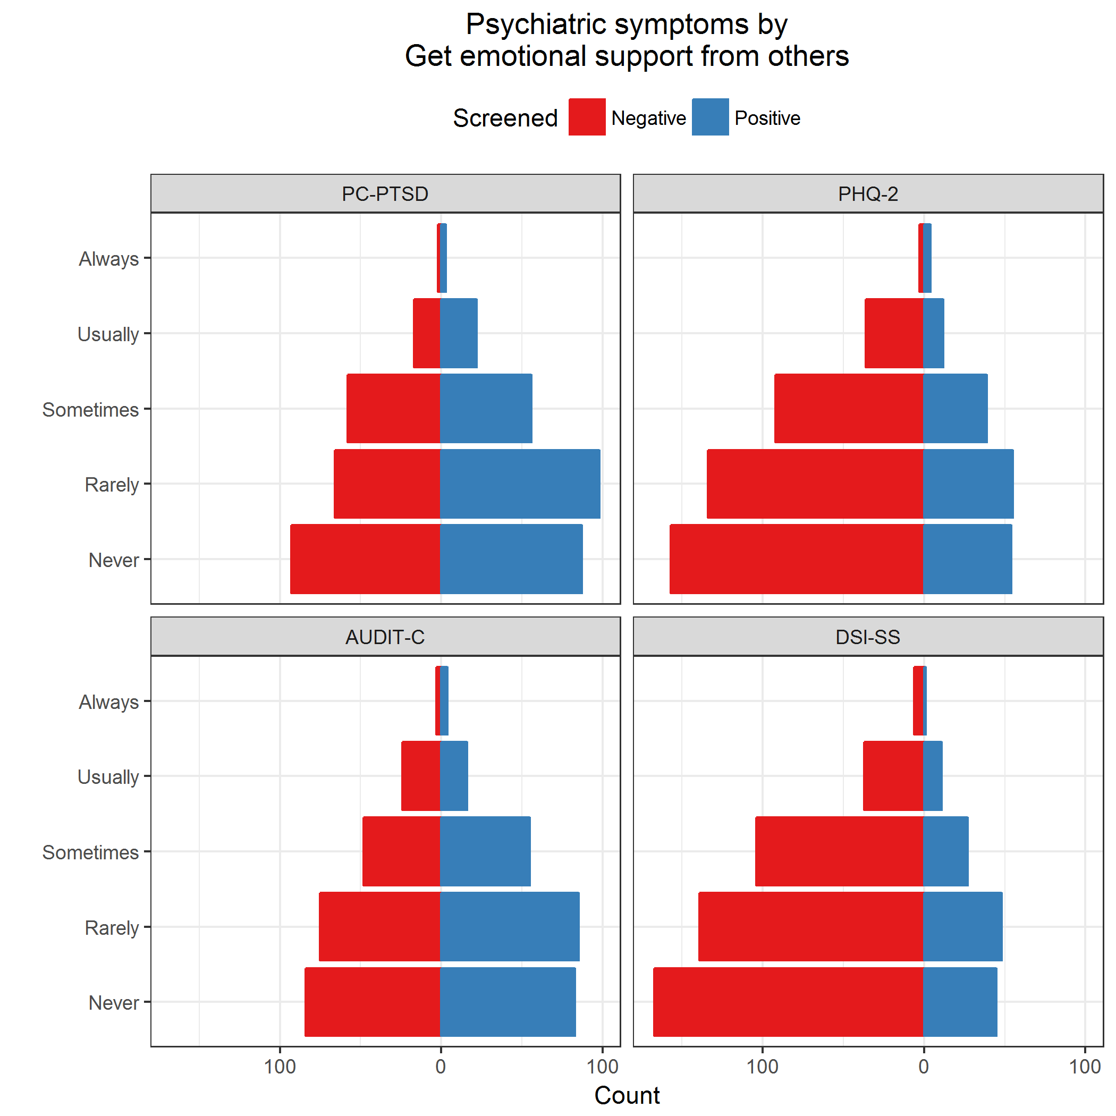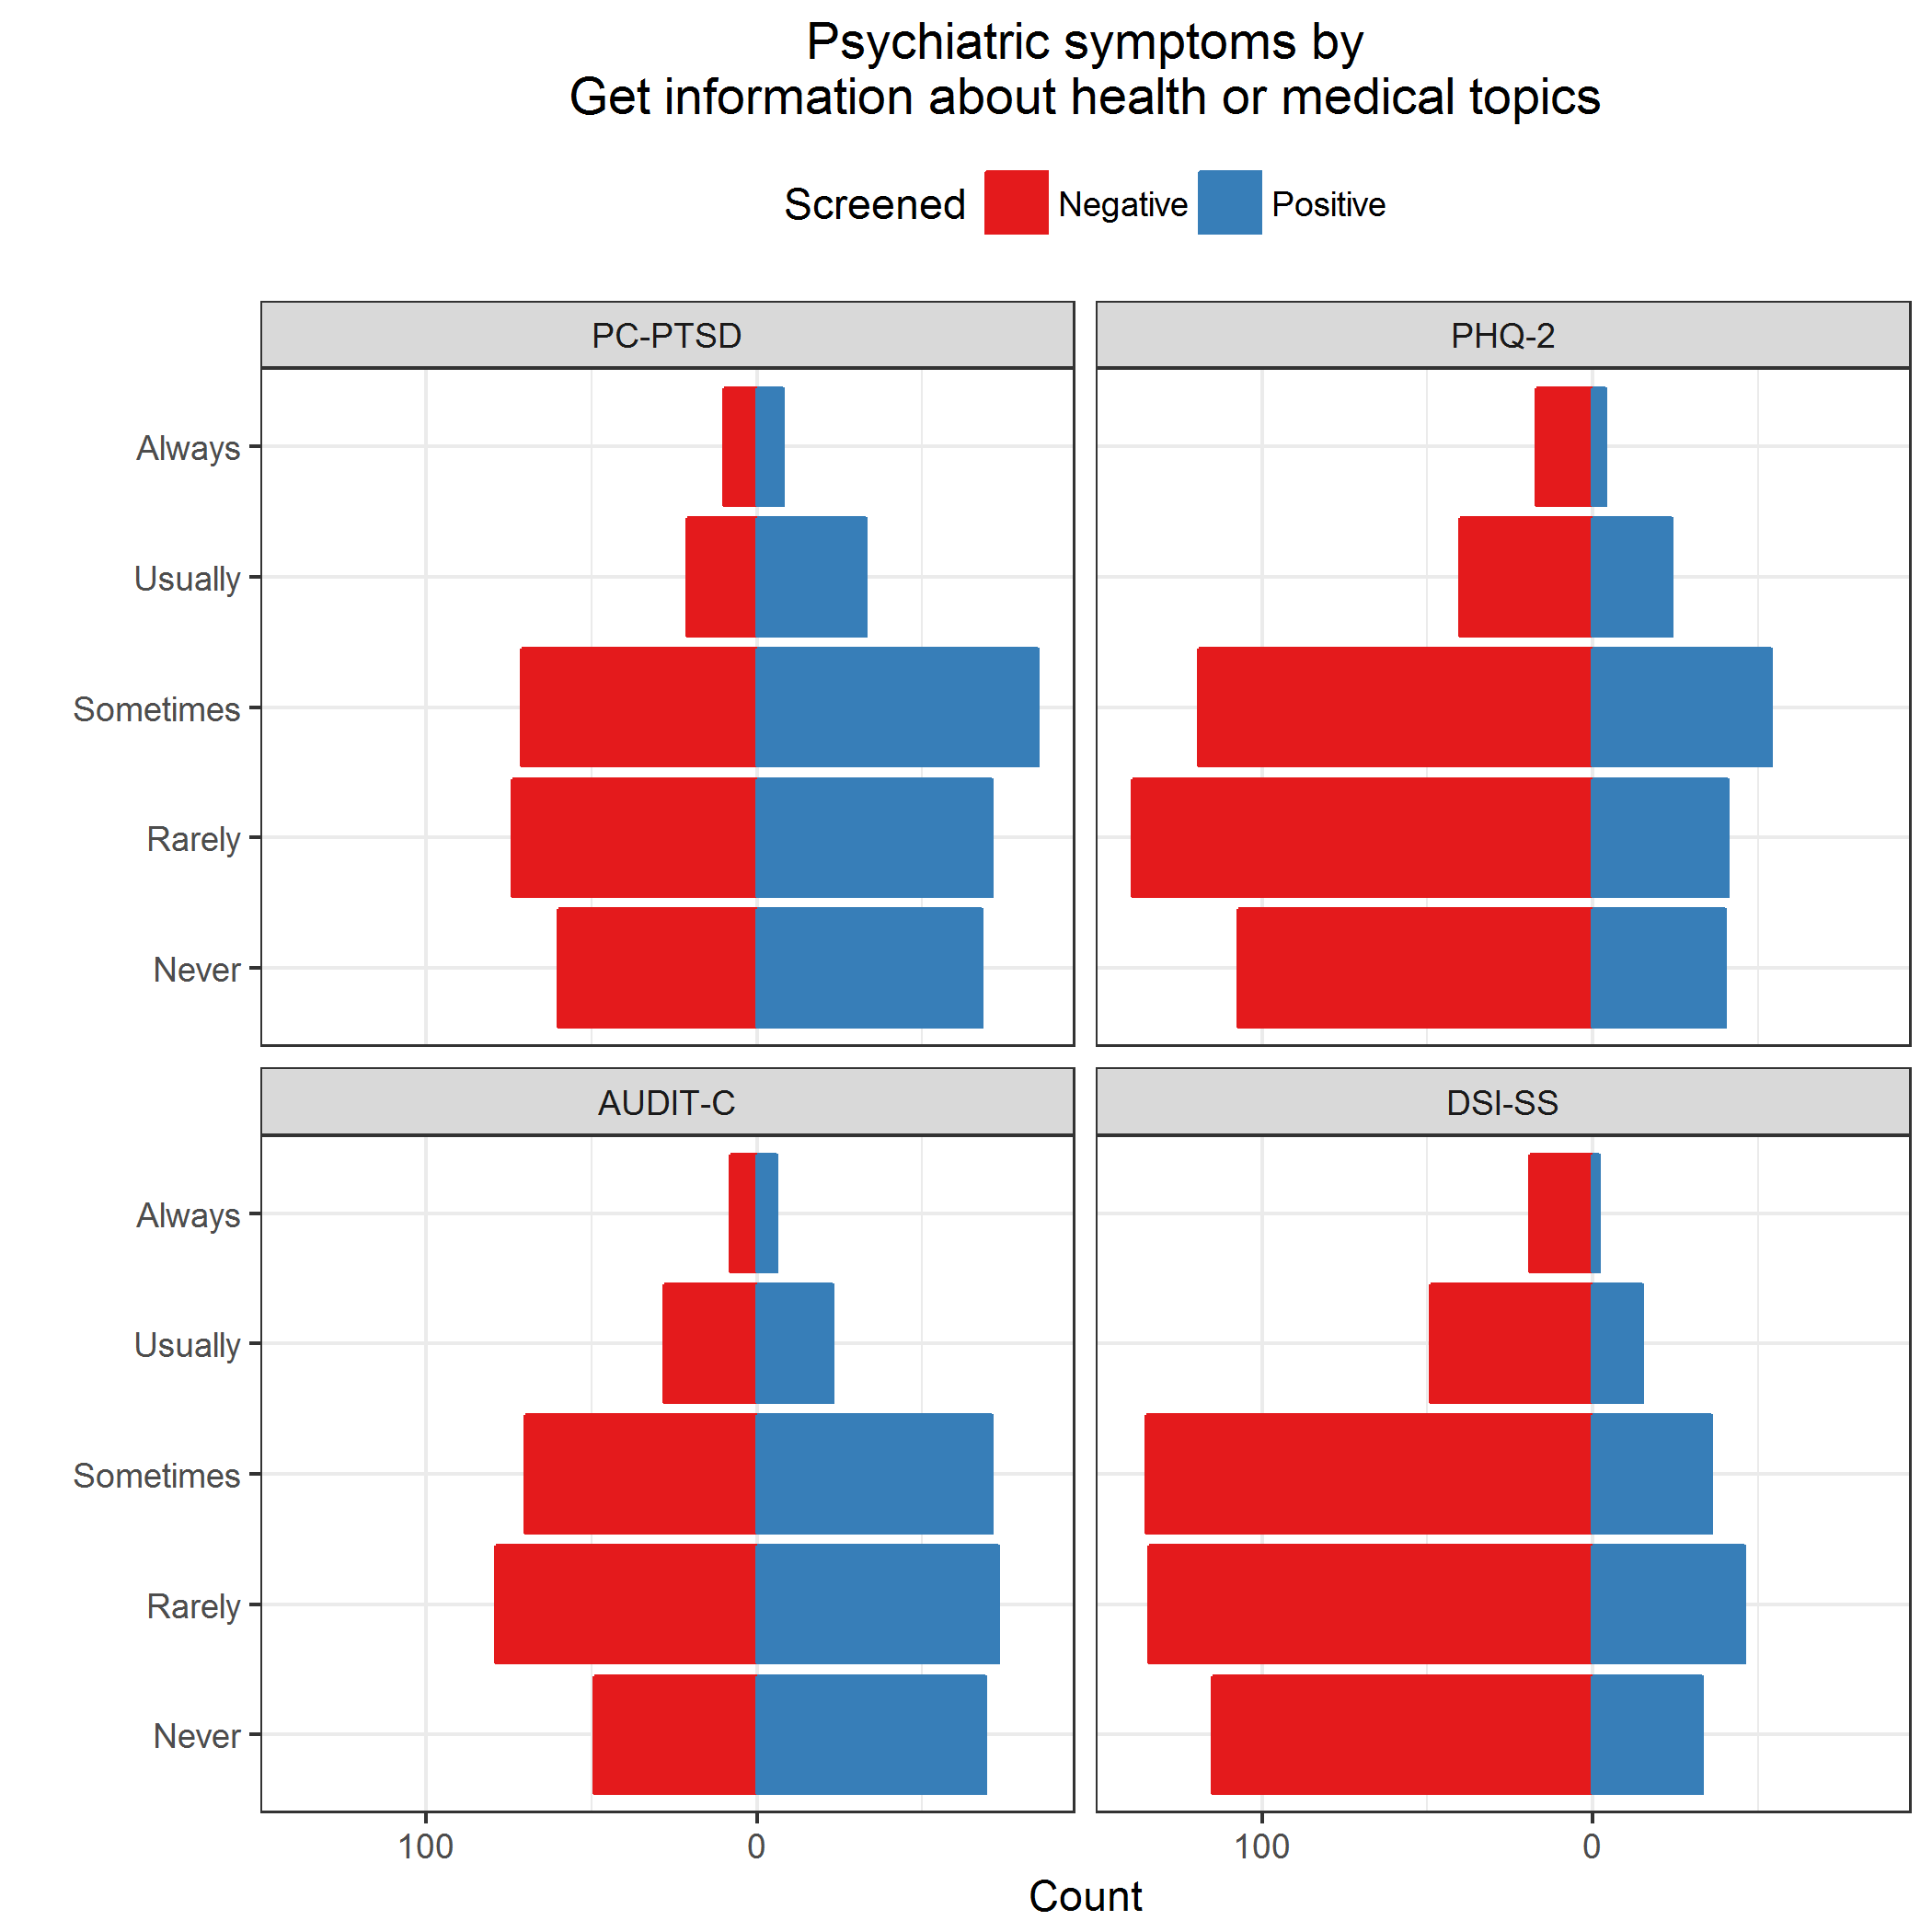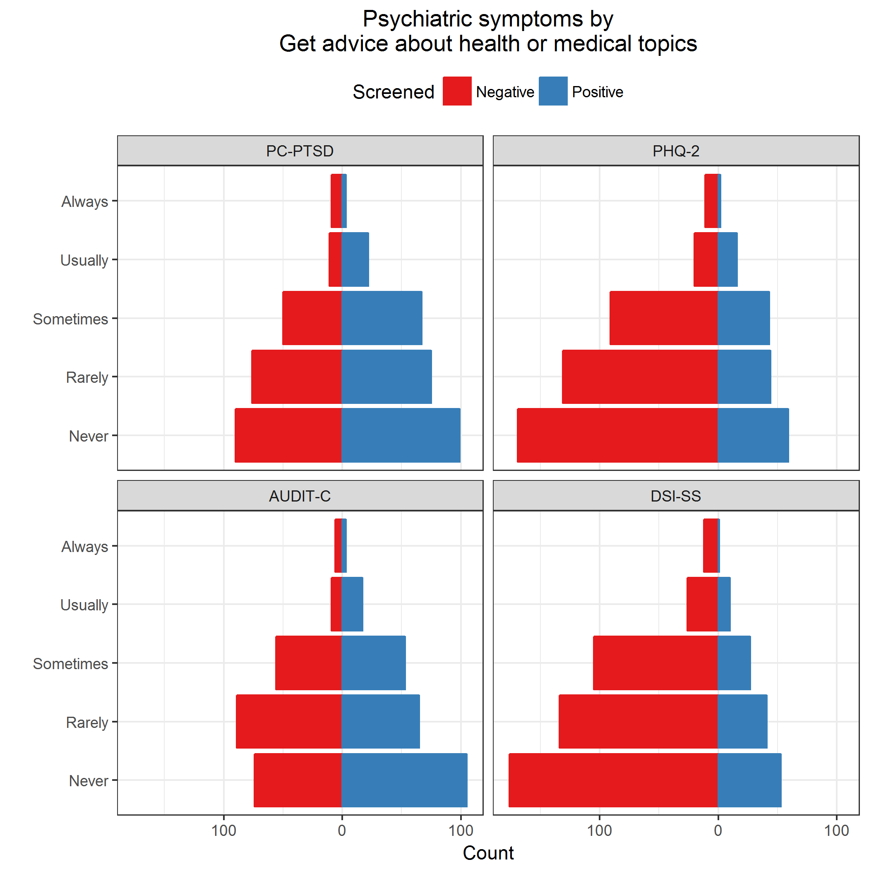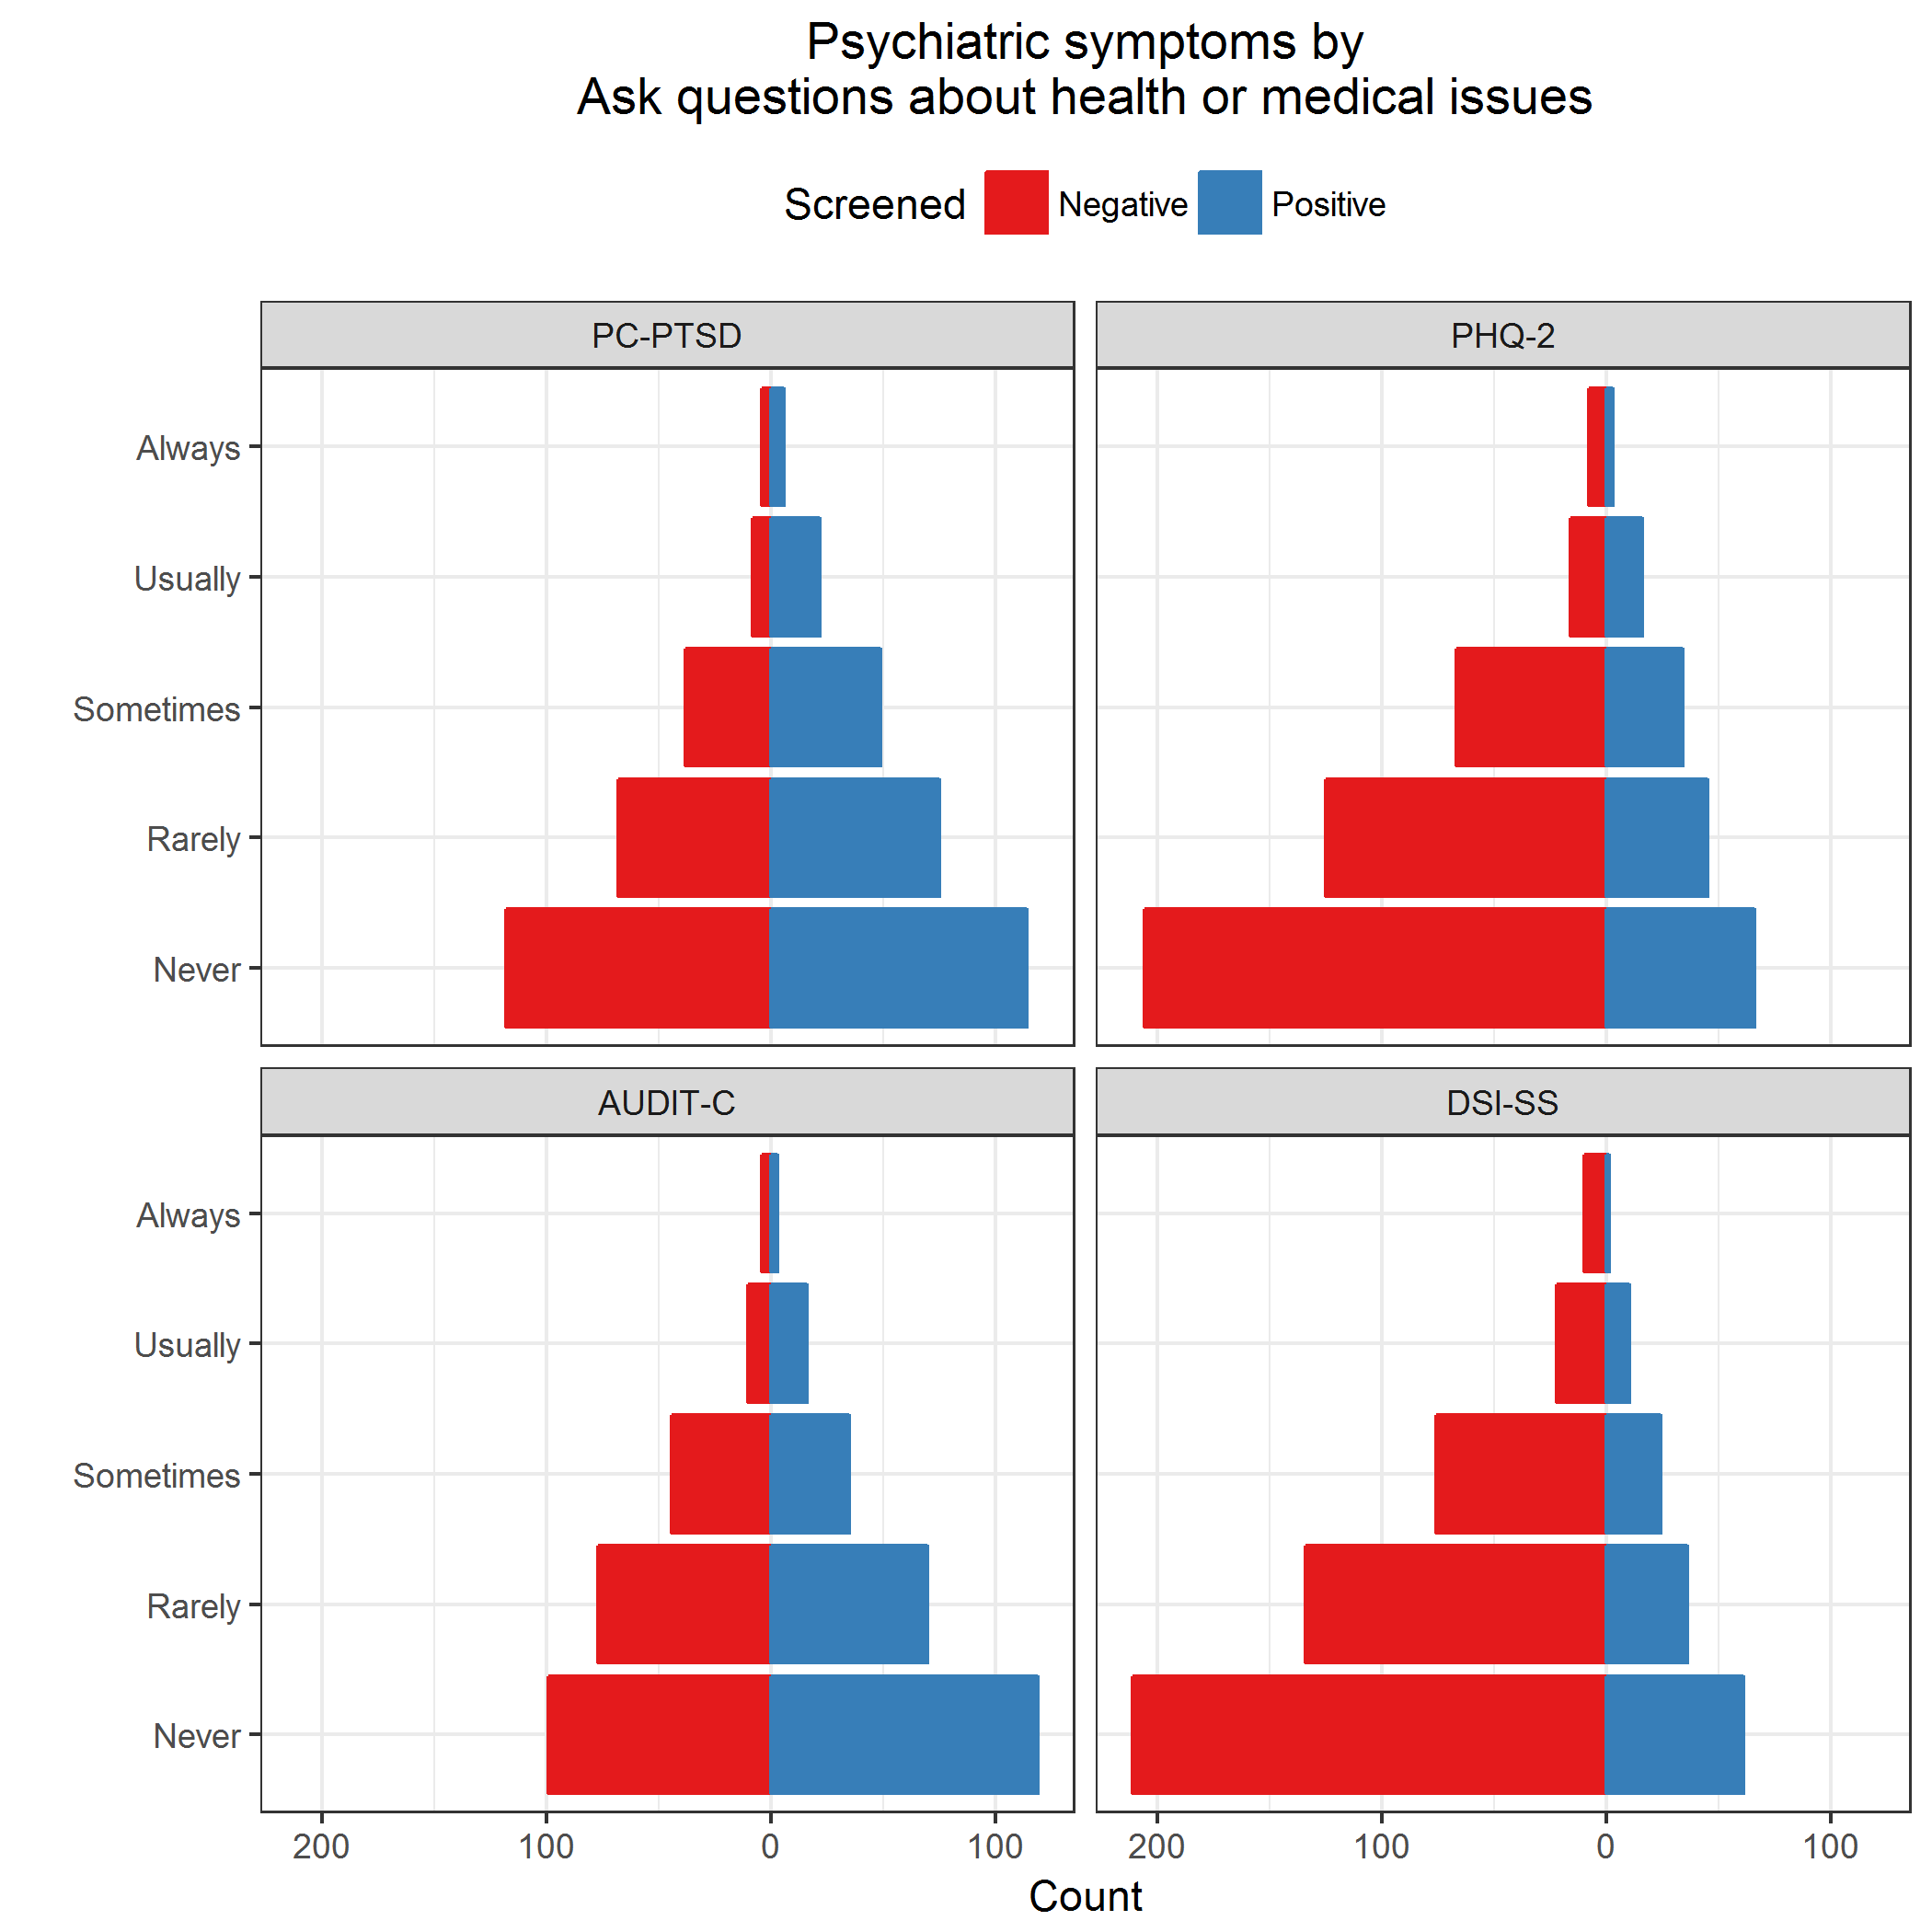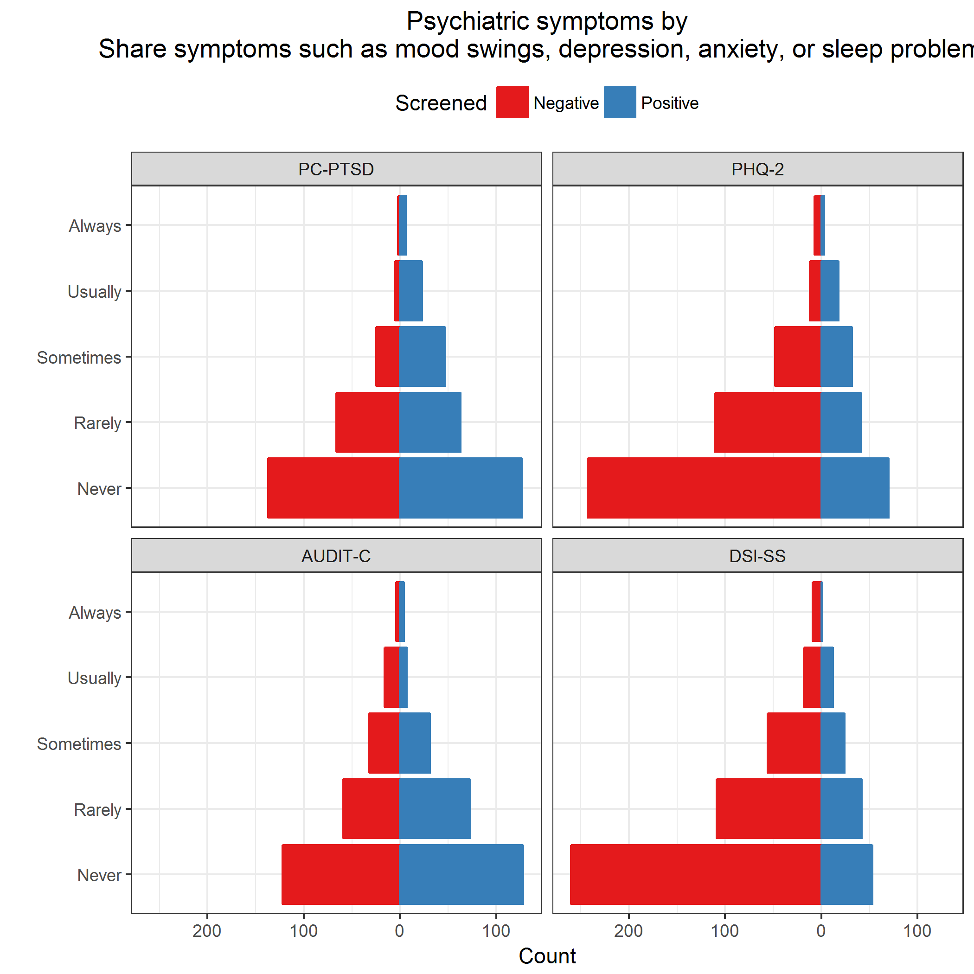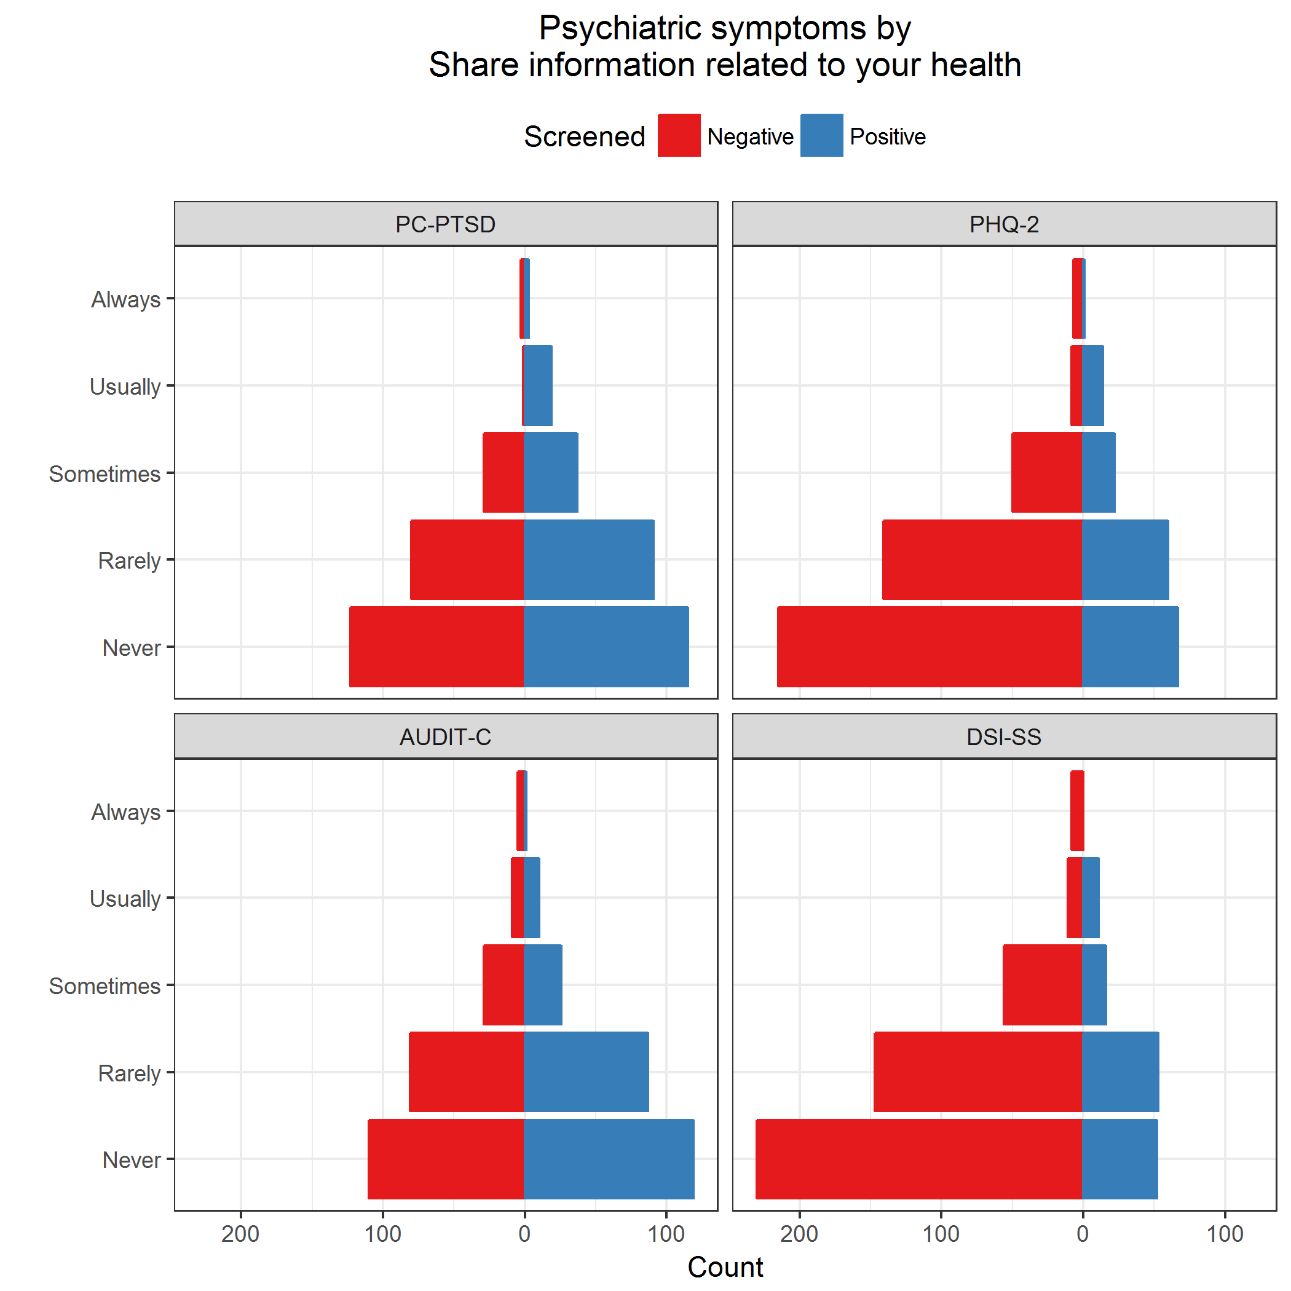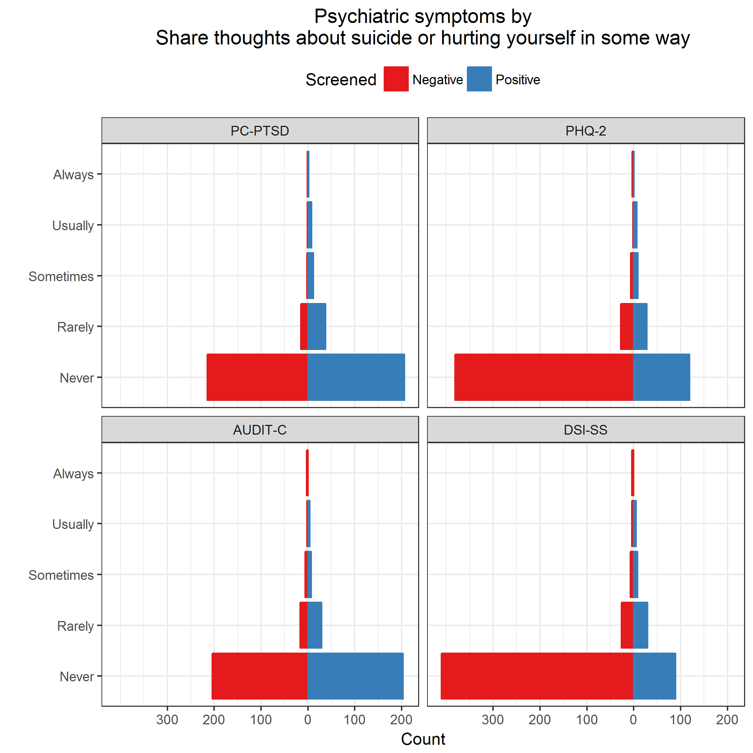

## Adjusted comparisons

Show the covariates used in the adjusted models.

covar <- c("countSocialMediaExclFB",  
 "comm_inperson",  
 "indSuicideConsideredEver",  
 "countSuicideAttempts")

Filter subjects with missing covariates.

Relabel factors; replace spaces with underscores.

### PC-PTSD vs Frequency of Facebook use

|  |  |  |  |  |
| --- | --- | --- | --- | --- |
| model | F | df1 | df2 | pValue |
| Unadjusted | 1.307 | 5 | 492 | 0.259 |
| Adjusted | 1.326 | 5 | 485 | 0.252 |

|  |  |  |  |  |  |
| --- | --- | --- | --- | --- | --- |
| model | term | oddsratio | std.error | statistic | p.value |
| Unadjusted | (Intercept) | 0.429 | 0.690 | -1.228 | 0.220 |
| Unadjusted | fb_freqEvery_few_weeks | 4.667 | 1.406 | 1.096 | 0.273 |
| Unadjusted | fb_freqOnce_a_week | 1.167 | 1.107 | 0.139 | 0.889 |
| Unadjusted | fb_freqA_few_times_a_week | 3.769 | 0.775 | 1.712 | 0.087 |
| Unadjusted | fb_freqOnce_a_day | 3.733 | 0.736 | 1.791 | 0.073 |
| Unadjusted | fb_freqSeveral_times_a_day | 2.434 | 0.698 | 1.275 | 0.202 |
| Adjusted | (Intercept) | 0.553 | 0.725 | -0.816 | 0.415 |
| Adjusted | fb_freqEvery_few_weeks | 3.447 | 1.486 | 0.833 | 0.405 |
| Adjusted | fb_freqOnce_a_week | 0.847 | 1.133 | -0.147 | 0.883 |
| Adjusted | fb_freqA_few_times_a_week | 3.894 | 0.797 | 1.705 | 0.088 |
| Adjusted | fb_freqOnce_a_day | 3.253 | 0.761 | 1.551 | 0.121 |
| Adjusted | fb_freqSeveral_times_a_day | 2.171 | 0.717 | 1.081 | 0.279 |
| Adjusted | countSocialMediaExclFB | 1.036 | 0.097 | 0.363 | 0.717 |
| Adjusted | comm_inpersonOnce a week | 0.653 | 0.339 | -1.257 | 0.209 |
| Adjusted | comm_inpersonA few times a week | 0.415 | 0.285 | -3.086 | 0.002 |
| Adjusted | comm_inpersonOnce a day | 0.476 | 0.353 | -2.102 | 0.036 |
| Adjusted | comm_inpersonSeveral times a day | 0.343 | 0.257 | -4.153 | 0.000 |
| Adjusted | indSuicideConsideredEverTRUE | 2.034 | 0.213 | 3.330 | 0.001 |
| Adjusted | countSuicideAttempts | 1.695 | 0.183 | 2.877 | 0.004 |

|  |  |  |  |  |  |  |  |
| --- | --- | --- | --- | --- | --- | --- | --- |
| model | null.deviance | df.null | logLik | AIC | BIC | deviance | df.residual |
| Unadjusted | 689.017 | 497 | -341.074 | 694.148 | 719.412 | 682.148 | 492 |
| Adjusted | 689.017 | 497 | -309.614 | 645.227 | 699.965 | 619.227 | 485 |

### PC-PTSD vs Active use of Facebook

|  |  |  |  |  |
| --- | --- | --- | --- | --- |
| model | F | df1 | df2 | pValue |
| Unadjusted | 1.451 | 4 | 495 | 0.216 |
| Adjusted | 1.176 | 4 | 488 | 0.321 |

|  |  |  |  |  |  |
| --- | --- | --- | --- | --- | --- |
| model | term | oddsratio | std.error | statistic | p.value |
| Unadjusted | (Intercept) | 1.333 | 0.255 | 1.130 | 0.258 |
| Unadjusted | comm_facebookOnce_a_week | 1.125 | 0.429 | 0.275 | 0.784 |
| Unadjusted | comm_facebookA_few_times_a_week | 1.036 | 0.325 | 0.108 | 0.914 |
| Unadjusted | comm_facebookOnce_a_day | 0.964 | 0.340 | -0.107 | 0.915 |
| Unadjusted | comm_facebookSeveral_times_a_day | 0.661 | 0.288 | -1.438 | 0.151 |
| Adjusted | (Intercept) | 1.328 | 0.302 | 0.940 | 0.347 |
| Adjusted | comm_facebookOnce_a_week | 1.166 | 0.461 | 0.333 | 0.739 |
| Adjusted | comm_facebookA_few_times_a_week | 1.088 | 0.348 | 0.243 | 0.808 |
| Adjusted | comm_facebookOnce_a_day | 1.167 | 0.366 | 0.422 | 0.673 |
| Adjusted | comm_facebookSeveral_times_a_day | 0.721 | 0.316 | -1.035 | 0.301 |
| Adjusted | countSocialMediaExclFB | 1.060 | 0.097 | 0.594 | 0.552 |
| Adjusted | comm_inpersonOnce a week | 0.645 | 0.337 | -1.301 | 0.193 |
| Adjusted | comm_inpersonA few times a week | 0.441 | 0.283 | -2.894 | 0.004 |
| Adjusted | comm_inpersonOnce a day | 0.485 | 0.355 | -2.038 | 0.042 |
| Adjusted | comm_inpersonSeveral times a day | 0.380 | 0.260 | -3.720 | 0.000 |
| Adjusted | indSuicideConsideredEverTRUE | 2.016 | 0.213 | 3.285 | 0.001 |
| Adjusted | countSuicideAttempts | 1.774 | 0.184 | 3.109 | 0.002 |

|  |  |  |  |  |  |  |  |
| --- | --- | --- | --- | --- | --- | --- | --- |
| model | null.deviance | df.null | logLik | AIC | BIC | deviance | df.residual |
| Unadjusted | 691.578 | 499 | -342.87 | 695.74 | 716.813 | 685.74 | 495 |
| Adjusted | 691.578 | 499 | -311.49 | 646.98 | 697.556 | 622.98 | 488 |

### PC-PTSD vs Get emotional support from others

|  |  |  |  |  |
| --- | --- | --- | --- | --- |
| model | F | df1 | df2 | pValue |
| Unadjusted | 1.367 | 4 | 495 | 0.244 |
| Adjusted | 1.415 | 4 | 488 | 0.228 |

|  |  |  |  |  |  |
| --- | --- | --- | --- | --- | --- |
| model | term | oddsratio | std.error | statistic | p.value |
| Unadjusted | (Intercept) | 0.925 | 0.150 | -0.523 | 0.601 |
| Unadjusted | sm_emot_supportRarely | 1.589 | 0.219 | 2.118 | 0.034 |
| Unadjusted | sm_emot_supportSometimes | 1.044 | 0.240 | 0.180 | 0.857 |
| Unadjusted | sm_emot_supportUsually | 1.399 | 0.356 | 0.944 | 0.345 |
| Unadjusted | sm_emot_supportAlways | 1.622 | 0.925 | 0.523 | 0.601 |
| Adjusted | (Intercept) | 1.124 | 0.221 | 0.528 | 0.598 |
| Adjusted | sm_emot_supportRarely | 1.571 | 0.238 | 1.900 | 0.057 |
| Adjusted | sm_emot_supportSometimes | 0.898 | 0.268 | -0.399 | 0.690 |
| Adjusted | sm_emot_supportUsually | 1.273 | 0.393 | 0.615 | 0.538 |
| Adjusted | sm_emot_supportAlways | 1.105 | 1.021 | 0.097 | 0.922 |
| Adjusted | countSocialMediaExclFB | 1.033 | 0.100 | 0.325 | 0.745 |
| Adjusted | comm_inpersonOnce a week | 0.654 | 0.339 | -1.255 | 0.210 |
| Adjusted | comm_inpersonA few times a week | 0.422 | 0.284 | -3.040 | 0.002 |
| Adjusted | comm_inpersonOnce a day | 0.491 | 0.354 | -2.011 | 0.044 |
| Adjusted | comm_inpersonSeveral times a day | 0.337 | 0.257 | -4.222 | 0.000 |
| Adjusted | indSuicideConsideredEverTRUE | 2.007 | 0.214 | 3.258 | 0.001 |
| Adjusted | countSuicideAttempts | 1.749 | 0.187 | 2.992 | 0.003 |

|  |  |  |  |  |  |  |  |
| --- | --- | --- | --- | --- | --- | --- | --- |
| model | null.deviance | df.null | logLik | AIC | BIC | deviance | df.residual |
| Unadjusted | 691.578 | 499 | -343.031 | 696.062 | 717.135 | 686.062 | 495 |
| Adjusted | 691.578 | 499 | -310.992 | 645.983 | 696.559 | 621.983 | 488 |

### PC-PTSD vs Get information about health or medical topics

|  |  |  |  |  |
| --- | --- | --- | --- | --- |
| model | F | df1 | df2 | pValue |
| Unadjusted | 0.779 | 4 | 494 | 0.539 |
| Adjusted | 0.726 | 4 | 487 | 0.574 |

|  |  |  |  |  |  |
| --- | --- | --- | --- | --- | --- |
| model | term | oddsratio | std.error | statistic | p.value |
| Unadjusted | (Intercept) | 1.133 | 0.177 | 0.707 | 0.480 |
| Unadjusted | sm_med_infoRarely | 0.835 | 0.243 | -0.743 | 0.457 |
| Unadjusted | sm_med_infoSometimes | 1.044 | 0.240 | 0.179 | 0.858 |
| Unadjusted | sm_med_infoUsually | 1.387 | 0.331 | 0.989 | 0.323 |
| Unadjusted | sm_med_infoAlways | 0.706 | 0.506 | -0.688 | 0.492 |
| Adjusted | (Intercept) | 1.361 | 0.254 | 1.216 | 0.224 |
| Adjusted | sm_med_infoRarely | 0.744 | 0.263 | -1.126 | 0.260 |
| Adjusted | sm_med_infoSometimes | 1.007 | 0.262 | 0.026 | 0.979 |
| Adjusted | sm_med_infoUsually | 1.223 | 0.361 | 0.557 | 0.577 |
| Adjusted | sm_med_infoAlways | 0.756 | 0.555 | -0.504 | 0.614 |
| Adjusted | countSocialMediaExclFB | 1.020 | 0.100 | 0.199 | 0.842 |
| Adjusted | comm_inpersonOnce a week | 0.677 | 0.336 | -1.163 | 0.245 |
| Adjusted | comm_inpersonA few times a week | 0.448 | 0.281 | -2.860 | 0.004 |
| Adjusted | comm_inpersonOnce a day | 0.501 | 0.353 | -1.954 | 0.051 |
| Adjusted | comm_inpersonSeveral times a day | 0.350 | 0.256 | -4.111 | 0.000 |
| Adjusted | indSuicideConsideredEverTRUE | 2.001 | 0.212 | 3.273 | 0.001 |
| Adjusted | countSuicideAttempts | 1.731 | 0.182 | 3.016 | 0.003 |

|  |  |  |  |  |  |  |  |
| --- | --- | --- | --- | --- | --- | --- | --- |
| model | null.deviance | df.null | logLik | AIC | BIC | deviance | df.residual |
| Unadjusted | 690.299 | 498 | -343.573 | 697.146 | 718.209 | 687.146 | 494 |
| Adjusted | 690.299 | 498 | -312.188 | 648.375 | 698.927 | 624.375 | 487 |

### PC-PTSD vs Get advice about health or medical topics

|  |  |  |  |  |
| --- | --- | --- | --- | --- |
| model | F | df1 | df2 | pValue |
| Unadjusted | 1.795 | 4 | 495 | 0.129 |
| Adjusted | 1.748 | 4 | 488 | 0.138 |

|  |  |  |  |  |  |
| --- | --- | --- | --- | --- | --- |
| model | term | oddsratio | std.error | statistic | p.value |
| Unadjusted | (Intercept) | 1.089 | 0.146 | 0.583 | 0.560 |
| Unadjusted | sm_med_adviceRarely | 0.906 | 0.219 | -0.450 | 0.653 |
| Unadjusted | sm_med_adviceSometimes | 1.212 | 0.238 | 0.810 | 0.418 |
| Unadjusted | sm_med_adviceUsually | 1.837 | 0.397 | 1.531 | 0.126 |
| Unadjusted | sm_med_adviceAlways | 0.306 | 0.682 | -1.735 | 0.083 |
| Adjusted | (Intercept) | 1.258 | 0.227 | 1.008 | 0.313 |
| Adjusted | sm_med_adviceRarely | 0.860 | 0.237 | -0.636 | 0.525 |
| Adjusted | sm_med_adviceSometimes | 1.238 | 0.257 | 0.831 | 0.406 |
| Adjusted | sm_med_adviceUsually | 1.620 | 0.426 | 1.131 | 0.258 |
| Adjusted | sm_med_adviceAlways | 0.243 | 0.769 | -1.842 | 0.065 |
| Adjusted | countSocialMediaExclFB | 1.025 | 0.099 | 0.248 | 0.804 |
| Adjusted | comm_inpersonOnce a week | 0.645 | 0.337 | -1.303 | 0.193 |
| Adjusted | comm_inpersonA few times a week | 0.433 | 0.284 | -2.946 | 0.003 |
| Adjusted | comm_inpersonOnce a day | 0.515 | 0.356 | -1.865 | 0.062 |
| Adjusted | comm_inpersonSeveral times a day | 0.353 | 0.256 | -4.060 | 0.000 |
| Adjusted | indSuicideConsideredEverTRUE | 2.044 | 0.213 | 3.358 | 0.001 |
| Adjusted | countSuicideAttempts | 1.731 | 0.180 | 3.053 | 0.002 |

|  |  |  |  |  |  |  |  |
| --- | --- | --- | --- | --- | --- | --- | --- |
| model | null.deviance | df.null | logLik | AIC | BIC | deviance | df.residual |
| Unadjusted | 691.578 | 499 | -341.854 | 693.709 | 714.782 | 683.709 | 495 |
| Adjusted | 691.578 | 499 | -309.941 | 643.882 | 694.457 | 619.882 | 488 |

### PC-PTSD vs Ask questions about health or medical issues

|  |  |  |  |  |
| --- | --- | --- | --- | --- |
| model | F | df1 | df2 | pValue |
| Unadjusted | 1.734 | 4 | 495 | 0.141 |
| Adjusted | 1.033 | 4 | 488 | 0.389 |

|  |  |  |  |  |  |
| --- | --- | --- | --- | --- | --- |
| model | term | oddsratio | std.error | statistic | p.value |
| Unadjusted | (Intercept) | 0.949 | 0.132 | -0.396 | 0.692 |
| Unadjusted | sm_med_questionsRarely | 1.162 | 0.213 | 0.704 | 0.481 |
| Unadjusted | sm_med_questionsSometimes | 1.359 | 0.253 | 1.210 | 0.226 |
| Unadjusted | sm_med_questionsUsually | 2.897 | 0.433 | 2.454 | 0.014 |
| Unadjusted | sm_med_questionsAlways | 1.580 | 0.659 | 0.695 | 0.487 |
| Adjusted | (Intercept) | 1.105 | 0.219 | 0.457 | 0.648 |
| Adjusted | sm_med_questionsRarely | 1.177 | 0.231 | 0.705 | 0.481 |
| Adjusted | sm_med_questionsSometimes | 1.375 | 0.270 | 1.182 | 0.237 |
| Adjusted | sm_med_questionsUsually | 2.319 | 0.465 | 1.810 | 0.070 |
| Adjusted | sm_med_questionsAlways | 1.389 | 0.716 | 0.458 | 0.647 |
| Adjusted | countSocialMediaExclFB | 0.993 | 0.099 | -0.076 | 0.940 |
| Adjusted | comm_inpersonOnce a week | 0.656 | 0.338 | -1.248 | 0.212 |
| Adjusted | comm_inpersonA few times a week | 0.445 | 0.282 | -2.870 | 0.004 |
| Adjusted | comm_inpersonOnce a day | 0.493 | 0.352 | -2.008 | 0.045 |
| Adjusted | comm_inpersonSeveral times a day | 0.361 | 0.255 | -3.994 | 0.000 |
| Adjusted | indSuicideConsideredEverTRUE | 2.011 | 0.213 | 3.288 | 0.001 |
| Adjusted | countSuicideAttempts | 1.718 | 0.184 | 2.941 | 0.003 |

|  |  |  |  |  |  |  |  |
| --- | --- | --- | --- | --- | --- | --- | --- |
| model | null.deviance | df.null | logLik | AIC | BIC | deviance | df.residual |
| Unadjusted | 691.578 | 499 | -342.028 | 694.057 | 715.130 | 684.057 | 495 |
| Adjusted | 691.578 | 499 | -311.705 | 647.410 | 697.986 | 623.410 | 488 |

### PC-PTSD vs Share symptoms such as mood swings, depression, anxiety, or sleep problems

|  |  |  |  |  |
| --- | --- | --- | --- | --- |
| model | F | df1 | df2 | pValue |
| Unadjusted | 4.384 | 4 | 494 | 0.002 |
| Adjusted | 1.890 | 4 | 487 | 0.111 |

|  |  |  |  |  |  |
| --- | --- | --- | --- | --- | --- |
| model | term | oddsratio | std.error | statistic | p.value |
| Unadjusted | (Intercept) | 0.912 | 0.124 | -0.741 | 0.459 |
| Unadjusted | sm_share_symptRarely | 1.046 | 0.215 | 0.210 | 0.834 |
| Unadjusted | sm_share_symptSometimes | 2.060 | 0.277 | 2.612 | 0.009 |
| Unadjusted | sm_share_symptUsually | 5.042 | 0.509 | 3.180 | 0.001 |
| Unadjusted | sm_share_symptAlways | 3.288 | 0.826 | 1.441 | 0.149 |
| Adjusted | (Intercept) | 1.130 | 0.211 | 0.579 | 0.563 |
| Adjusted | sm_share_symptRarely | 0.914 | 0.238 | -0.379 | 0.705 |
| Adjusted | sm_share_symptSometimes | 1.533 | 0.300 | 1.425 | 0.154 |
| Adjusted | sm_share_symptUsually | 3.051 | 0.531 | 2.100 | 0.036 |
| Adjusted | sm_share_symptAlways | 2.139 | 0.877 | 0.867 | 0.386 |
| Adjusted | countSocialMediaExclFB | 1.010 | 0.099 | 0.105 | 0.916 |
| Adjusted | comm_inpersonOnce a week | 0.710 | 0.345 | -0.992 | 0.321 |
| Adjusted | comm_inpersonA few times a week | 0.486 | 0.284 | -2.539 | 0.011 |
| Adjusted | comm_inpersonOnce a day | 0.522 | 0.354 | -1.840 | 0.066 |
| Adjusted | comm_inpersonSeveral times a day | 0.387 | 0.258 | -3.683 | 0.000 |
| Adjusted | indSuicideConsideredEverTRUE | 1.914 | 0.216 | 3.001 | 0.003 |
| Adjusted | countSuicideAttempts | 1.683 | 0.188 | 2.776 | 0.006 |

|  |  |  |  |  |  |  |  |
| --- | --- | --- | --- | --- | --- | --- | --- |
| model | null.deviance | df.null | logLik | AIC | BIC | deviance | df.residual |
| Unadjusted | 690.075 | 498 | -334.839 | 679.677 | 700.740 | 669.677 | 494 |
| Adjusted | 690.075 | 498 | -309.268 | 642.535 | 693.087 | 618.535 | 487 |

### PC-PTSD vs Share information related to your health

|  |  |  |  |  |
| --- | --- | --- | --- | --- |
| model | F | df1 | df2 | pValue |
| Unadjusted | 2.474 | 4 | 494 | 0.044 |
| Adjusted | 1.367 | 4 | 487 | 0.244 |

|  |  |  |  |  |  |
| --- | --- | --- | --- | --- | --- |
| model | term | oddsratio | std.error | statistic | p.value |
| Unadjusted | (Intercept) | 0.919 | 0.130 | -0.651 | 0.515 |
| Unadjusted | sm_share_healthRarely | 1.238 | 0.201 | 1.062 | 0.288 |
| Unadjusted | sm_share_healthSometimes | 1.389 | 0.280 | 1.172 | 0.241 |
| Unadjusted | sm_share_healthUsually | 20.681 | 1.034 | 2.929 | 0.003 |
| Unadjusted | sm_share_healthAlways | 1.088 | 0.827 | 0.103 | 0.918 |
| Adjusted | (Intercept) | 1.146 | 0.217 | 0.629 | 0.529 |
| Adjusted | sm_share_healthRarely | 0.998 | 0.217 | -0.010 | 0.992 |
| Adjusted | sm_share_healthSometimes | 1.017 | 0.308 | 0.053 | 0.957 |
| Adjusted | sm_share_healthUsually | 11.086 | 1.051 | 2.290 | 0.022 |
| Adjusted | sm_share_healthAlways | 0.680 | 0.978 | -0.395 | 0.693 |
| Adjusted | countSocialMediaExclFB | 1.015 | 0.099 | 0.152 | 0.879 |
| Adjusted | comm_inpersonOnce a week | 0.718 | 0.341 | -0.971 | 0.332 |
| Adjusted | comm_inpersonA few times a week | 0.490 | 0.283 | -2.516 | 0.012 |
| Adjusted | comm_inpersonOnce a day | 0.551 | 0.353 | -1.690 | 0.091 |
| Adjusted | comm_inpersonSeveral times a day | 0.380 | 0.258 | -3.742 | 0.000 |
| Adjusted | indSuicideConsideredEverTRUE | 1.946 | 0.216 | 3.087 | 0.002 |
| Adjusted | countSuicideAttempts | 1.746 | 0.189 | 2.952 | 0.003 |

|  |  |  |  |  |  |  |  |
| --- | --- | --- | --- | --- | --- | --- | --- |
| model | null.deviance | df.null | logLik | AIC | BIC | deviance | df.residual |
| Unadjusted | 690.299 | 498 | -334.936 | 679.872 | 700.935 | 669.872 | 494 |
| Adjusted | 690.299 | 498 | -307.549 | 639.099 | 689.650 | 615.099 | 487 |

### PC-PTSD vs Share thoughts about suicide or hurting yourself in some way

|  |  |  |  |  |
| --- | --- | --- | --- | --- |
| model | F | df1 | df2 | pValue |
| Unadjusted | 4.607 | 4 | 493 | 0.001 |
| Adjusted | 3.094 | 4 | 486 | 0.016 |

|  |  |  |  |  |  |
| --- | --- | --- | --- | --- | --- |
| model | term | oddsratio | std.error | statistic | p.value |
| Unadjusted | (Intercept) | 0.949 | 0.098 | -0.537 | 0.591 |
| Unadjusted | sm_share_suicideRarely | 2.670 | 0.320 | 3.067 | 0.002 |
| Unadjusted | sm_share_suicideSometimes | 6.324 | 0.770 | 2.395 | 0.017 |
| Unadjusted | sm_share_suicideUsually | 8.431 | 1.065 | 2.002 | 0.045 |
| Unadjusted | sm_share_suicideAlways | 2.108 | 1.229 | 0.607 | 0.544 |
| Adjusted | (Intercept) | 1.197 | 0.206 | 0.876 | 0.381 |
| Adjusted | sm_share_suicideRarely | 2.334 | 0.342 | 2.478 | 0.013 |
| Adjusted | sm_share_suicideSometimes | 4.356 | 0.803 | 1.831 | 0.067 |
| Adjusted | sm_share_suicideUsually | 7.922 | 1.087 | 1.904 | 0.057 |
| Adjusted | sm_share_suicideAlways | 1.168 | 1.486 | 0.104 | 0.917 |
| Adjusted | countSocialMediaExclFB | 1.023 | 0.098 | 0.229 | 0.819 |
| Adjusted | comm_inpersonOnce a week | 0.630 | 0.340 | -1.360 | 0.174 |
| Adjusted | comm_inpersonA few times a week | 0.415 | 0.286 | -3.072 | 0.002 |
| Adjusted | comm_inpersonOnce a day | 0.508 | 0.356 | -1.905 | 0.057 |
| Adjusted | comm_inpersonSeveral times a day | 0.339 | 0.259 | -4.178 | 0.000 |
| Adjusted | indSuicideConsideredEverTRUE | 1.804 | 0.216 | 2.731 | 0.006 |
| Adjusted | countSuicideAttempts | 1.744 | 0.187 | 2.974 | 0.003 |

|  |  |  |  |  |  |  |  |
| --- | --- | --- | --- | --- | --- | --- | --- |
| model | null.deviance | df.null | logLik | AIC | BIC | deviance | df.residual |
| Unadjusted | 688.566 | 497 | -332.651 | 675.303 | 696.356 | 665.303 | 493 |
| Adjusted | 688.566 | 497 | -305.016 | 634.031 | 684.558 | 610.031 | 486 |

### PHQ-2 vs Frequency of Facebook use

|  |  |  |  |  |
| --- | --- | --- | --- | --- |
| model | F | df1 | df2 | pValue |
| Unadjusted | 0.525 | 5 | 576 | 0.757 |
| Adjusted | 0.389 | 5 | 569 | 0.856 |

|  |  |  |  |  |  |
| --- | --- | --- | --- | --- | --- |
| model | term | oddsratio | std.error | statistic | p.value |
| Unadjusted | (Intercept) | 0.111 | 1.054 | -2.084 | 0.037 |
| Unadjusted | fb_freqEvery_few_weeks | 0.000 | 441.373 | -0.028 | 0.978 |
| Unadjusted | fb_freqOnce_a_week | 4.500 | 1.364 | 1.103 | 0.270 |
| Unadjusted | fb_freqA_few_times_a_week | 3.536 | 1.113 | 1.135 | 0.256 |
| Unadjusted | fb_freqOnce_a_day | 4.500 | 1.083 | 1.388 | 0.165 |
| Unadjusted | fb_freqSeveral_times_a_day | 3.375 | 1.059 | 1.148 | 0.251 |
| Adjusted | (Intercept) | 0.122 | 1.087 | -1.938 | 0.053 |
| Adjusted | fb_freqEvery_few_weeks | 0.000 | 650.476 | -0.021 | 0.983 |
| Adjusted | fb_freqOnce_a_week | 3.437 | 1.392 | 0.887 | 0.375 |
| Adjusted | fb_freqA_few_times_a_week | 3.692 | 1.139 | 1.147 | 0.251 |
| Adjusted | fb_freqOnce_a_day | 3.930 | 1.109 | 1.234 | 0.217 |
| Adjusted | fb_freqSeveral_times_a_day | 3.107 | 1.080 | 1.049 | 0.294 |
| Adjusted | countSocialMediaExclFB | 0.905 | 0.104 | -0.961 | 0.337 |
| Adjusted | comm_inpersonOnce a week | 0.781 | 0.312 | -0.791 | 0.429 |
| Adjusted | comm_inpersonA few times a week | 0.313 | 0.307 | -3.782 | 0.000 |
| Adjusted | comm_inpersonOnce a day | 0.437 | 0.387 | -2.136 | 0.033 |
| Adjusted | comm_inpersonSeveral times a day | 0.373 | 0.260 | -3.787 | 0.000 |
| Adjusted | indSuicideConsideredEverTRUE | 3.132 | 0.220 | 5.185 | 0.000 |
| Adjusted | countSuicideAttempts | 1.220 | 0.127 | 1.565 | 0.118 |

|  |  |  |  |  |  |  |  |
| --- | --- | --- | --- | --- | --- | --- | --- |
| model | null.deviance | df.null | logLik | AIC | BIC | deviance | df.residual |
| Unadjusted | 686.463 | 581 | -340.364 | 692.728 | 718.927 | 680.728 | 576 |
| Adjusted | 686.463 | 581 | -302.813 | 631.626 | 688.390 | 605.626 | 569 |

### PHQ-2 vs Active use of Facebook

|  |  |  |  |  |
| --- | --- | --- | --- | --- |
| model | F | df1 | df2 | pValue |
| Unadjusted | 0.482 | 4 | 579 | 0.749 |
| Adjusted | 0.471 | 4 | 572 | 0.757 |

|  |  |  |  |  |  |
| --- | --- | --- | --- | --- | --- |
| model | term | oddsratio | std.error | statistic | p.value |
| Unadjusted | (Intercept) | 0.489 | 0.254 | -2.808 | 0.005 |
| Unadjusted | comm_facebookOnce_a_week | 1.022 | 0.424 | 0.051 | 0.960 |
| Unadjusted | comm_facebookA_few_times_a_week | 0.705 | 0.331 | -1.057 | 0.290 |
| Unadjusted | comm_facebookOnce_a_day | 0.806 | 0.338 | -0.638 | 0.524 |
| Unadjusted | comm_facebookSeveral_times_a_day | 0.742 | 0.291 | -1.026 | 0.305 |
| Adjusted | (Intercept) | 0.431 | 0.305 | -2.754 | 0.006 |
| Adjusted | comm_facebookOnce_a_week | 1.063 | 0.465 | 0.131 | 0.896 |
| Adjusted | comm_facebookA_few_times_a_week | 0.679 | 0.360 | -1.074 | 0.283 |
| Adjusted | comm_facebookOnce_a_day | 0.929 | 0.372 | -0.199 | 0.842 |
| Adjusted | comm_facebookSeveral_times_a_day | 0.808 | 0.324 | -0.657 | 0.511 |
| Adjusted | countSocialMediaExclFB | 0.919 | 0.104 | -0.814 | 0.416 |
| Adjusted | comm_inpersonOnce a week | 0.794 | 0.311 | -0.740 | 0.459 |
| Adjusted | comm_inpersonA few times a week | 0.358 | 0.300 | -3.429 | 0.001 |
| Adjusted | comm_inpersonOnce a day | 0.429 | 0.387 | -2.187 | 0.029 |
| Adjusted | comm_inpersonSeveral times a day | 0.397 | 0.266 | -3.474 | 0.001 |
| Adjusted | indSuicideConsideredEverTRUE | 3.268 | 0.221 | 5.367 | 0.000 |
| Adjusted | countSuicideAttempts | 1.239 | 0.126 | 1.700 | 0.089 |

|  |  |  |  |  |  |  |  |
| --- | --- | --- | --- | --- | --- | --- | --- |
| model | null.deviance | df.null | logLik | AIC | BIC | deviance | df.residual |
| Unadjusted | 691.585 | 583 | -344.845 | 699.691 | 721.540 | 689.691 | 579 |
| Adjusted | 691.585 | 583 | -306.816 | 637.632 | 690.071 | 613.632 | 572 |

### PHQ-2 vs Get emotional support from others

|  |  |  |  |  |
| --- | --- | --- | --- | --- |
| model | F | df1 | df2 | pValue |
| Unadjusted | 0.990 | 4 | 579 | 0.412 |
| Adjusted | 0.789 | 4 | 572 | 0.533 |

|  |  |  |  |  |  |
| --- | --- | --- | --- | --- | --- |
| model | term | oddsratio | std.error | statistic | p.value |
| Unadjusted | (Intercept) | 0.338 | 0.159 | -6.836 | 0.000 |
| Unadjusted | sm_emot_supportRarely | 1.225 | 0.226 | 0.899 | 0.369 |
| Unadjusted | sm_emot_supportSometimes | 1.256 | 0.248 | 0.916 | 0.359 |
| Unadjusted | sm_emot_supportUsually | 0.987 | 0.369 | -0.034 | 0.973 |
| Unadjusted | sm_emot_supportAlways | 3.950 | 0.780 | 1.761 | 0.078 |
| Adjusted | (Intercept) | 0.344 | 0.224 | -4.771 | 0.000 |
| Adjusted | sm_emot_supportRarely | 1.193 | 0.249 | 0.709 | 0.478 |
| Adjusted | sm_emot_supportSometimes | 1.211 | 0.278 | 0.690 | 0.490 |
| Adjusted | sm_emot_supportUsually | 0.929 | 0.407 | -0.182 | 0.856 |
| Adjusted | sm_emot_supportAlways | 3.849 | 0.851 | 1.584 | 0.113 |
| Adjusted | countSocialMediaExclFB | 0.909 | 0.106 | -0.903 | 0.367 |
| Adjusted | comm_inpersonOnce a week | 0.781 | 0.313 | -0.791 | 0.429 |
| Adjusted | comm_inpersonA few times a week | 0.339 | 0.300 | -3.600 | 0.000 |
| Adjusted | comm_inpersonOnce a day | 0.415 | 0.391 | -2.253 | 0.024 |
| Adjusted | comm_inpersonSeveral times a day | 0.371 | 0.263 | -3.765 | 0.000 |
| Adjusted | indSuicideConsideredEverTRUE | 3.097 | 0.220 | 5.144 | 0.000 |
| Adjusted | countSuicideAttempts | 1.239 | 0.128 | 1.680 | 0.093 |

|  |  |  |  |  |  |  |  |
| --- | --- | --- | --- | --- | --- | --- | --- |
| model | null.deviance | df.null | logLik | AIC | BIC | deviance | df.residual |
| Unadjusted | 691.585 | 583 | -343.808 | 697.615 | 719.465 | 687.615 | 579 |
| Adjusted | 691.585 | 583 | -306.174 | 636.347 | 688.786 | 612.347 | 572 |

### PHQ-2 vs Get information about health or medical topics

|  |  |  |  |  |
| --- | --- | --- | --- | --- |
| model | F | df1 | df2 | pValue |
| Unadjusted | 1.870 | 4 | 578 | 0.114 |
| Adjusted | 2.022 | 4 | 571 | 0.090 |

|  |  |  |  |  |  |
| --- | --- | --- | --- | --- | --- |
| model | term | oddsratio | std.error | statistic | p.value |
| Unadjusted | (Intercept) | 0.374 | 0.185 | -5.309 | 0.000 |
| Unadjusted | sm_med_infoRarely | 0.770 | 0.258 | -1.014 | 0.310 |
| Unadjusted | sm_med_infoSometimes | 1.224 | 0.248 | 0.817 | 0.414 |
| Unadjusted | sm_med_infoUsually | 1.605 | 0.318 | 1.489 | 0.137 |
| Unadjusted | sm_med_infoAlways | 0.629 | 0.586 | -0.790 | 0.429 |
| Adjusted | (Intercept) | 0.374 | 0.259 | -3.798 | 0.000 |
| Adjusted | sm_med_infoRarely | 0.709 | 0.279 | -1.230 | 0.219 |
| Adjusted | sm_med_infoSometimes | 1.345 | 0.273 | 1.083 | 0.279 |
| Adjusted | sm_med_infoUsually | 1.539 | 0.355 | 1.216 | 0.224 |
| Adjusted | sm_med_infoAlways | 0.733 | 0.647 | -0.480 | 0.631 |
| Adjusted | countSocialMediaExclFB | 0.880 | 0.107 | -1.190 | 0.234 |
| Adjusted | comm_inpersonOnce a week | 0.776 | 0.313 | -0.809 | 0.419 |
| Adjusted | comm_inpersonA few times a week | 0.345 | 0.302 | -3.524 | 0.000 |
| Adjusted | comm_inpersonOnce a day | 0.446 | 0.391 | -2.061 | 0.039 |
| Adjusted | comm_inpersonSeveral times a day | 0.363 | 0.264 | -3.849 | 0.000 |
| Adjusted | indSuicideConsideredEverTRUE | 3.146 | 0.221 | 5.185 | 0.000 |
| Adjusted | countSuicideAttempts | 1.250 | 0.126 | 1.766 | 0.077 |

|  |  |  |  |  |  |  |  |
| --- | --- | --- | --- | --- | --- | --- | --- |
| model | null.deviance | df.null | logLik | AIC | BIC | deviance | df.residual |
| Unadjusted | 689.028 | 582 | -340.729 | 691.458 | 713.299 | 681.458 | 578 |
| Adjusted | 689.028 | 582 | -303.099 | 630.198 | 682.616 | 606.198 | 571 |

### PHQ-2 vs Get advice about health or medical topics

|  |  |  |  |  |
| --- | --- | --- | --- | --- |
| model | F | df1 | df2 | pValue |
| Unadjusted | 2.053 | 4 | 579 | 0.086 |
| Adjusted | 2.147 | 4 | 572 | 0.074 |

|  |  |  |  |  |  |
| --- | --- | --- | --- | --- | --- |
| model | term | oddsratio | std.error | statistic | p.value |
| Unadjusted | (Intercept) | 0.343 | 0.152 | -7.028 | 0.000 |
| Unadjusted | sm_med_adviceRarely | 0.979 | 0.231 | -0.093 | 0.926 |
| Unadjusted | sm_med_adviceSometimes | 1.392 | 0.240 | 1.379 | 0.168 |
| Unadjusted | sm_med_adviceUsually | 2.331 | 0.368 | 2.298 | 0.022 |
| Unadjusted | sm_med_adviceAlways | 0.530 | 0.784 | -0.811 | 0.418 |
| Adjusted | (Intercept) | 0.345 | 0.228 | -4.662 | 0.000 |
| Adjusted | sm_med_adviceRarely | 0.916 | 0.252 | -0.349 | 0.727 |
| Adjusted | sm_med_adviceSometimes | 1.519 | 0.263 | 1.589 | 0.112 |
| Adjusted | sm_med_adviceUsually | 2.205 | 0.407 | 1.942 | 0.052 |
| Adjusted | sm_med_adviceAlways | 0.419 | 0.857 | -1.015 | 0.310 |
| Adjusted | countSocialMediaExclFB | 0.888 | 0.106 | -1.124 | 0.261 |
| Adjusted | comm_inpersonOnce a week | 0.770 | 0.313 | -0.834 | 0.404 |
| Adjusted | comm_inpersonA few times a week | 0.339 | 0.303 | -3.571 | 0.000 |
| Adjusted | comm_inpersonOnce a day | 0.416 | 0.390 | -2.247 | 0.025 |
| Adjusted | comm_inpersonSeveral times a day | 0.374 | 0.262 | -3.748 | 0.000 |
| Adjusted | indSuicideConsideredEverTRUE | 3.144 | 0.221 | 5.189 | 0.000 |
| Adjusted | countSuicideAttempts | 1.260 | 0.125 | 1.842 | 0.065 |

|  |  |  |  |  |  |  |  |
| --- | --- | --- | --- | --- | --- | --- | --- |
| model | null.deviance | df.null | logLik | AIC | BIC | deviance | df.residual |
| Unadjusted | 691.585 | 583 | -341.701 | 693.402 | 715.252 | 683.402 | 579 |
| Adjusted | 691.585 | 583 | -303.356 | 630.712 | 683.151 | 606.712 | 572 |

### PHQ-2 vs Ask questions about health or medical issues

|  |  |  |  |  |
| --- | --- | --- | --- | --- |
| model | F | df1 | df2 | pValue |
| Unadjusted | 2.746 | 4 | 579 | 0.028 |
| Adjusted | 2.065 | 4 | 572 | 0.084 |

|  |  |  |  |  |  |
| --- | --- | --- | --- | --- | --- |
| model | term | oddsratio | std.error | statistic | p.value |
| Unadjusted | (Intercept) | 0.317 | 0.142 | -8.069 | 0.000 |
| Unadjusted | sm_med_questionsRarely | 1.135 | 0.225 | 0.565 | 0.572 |
| Unadjusted | sm_med_questionsSometimes | 1.600 | 0.254 | 1.850 | 0.064 |
| Unadjusted | sm_med_questionsUsually | 3.154 | 0.381 | 3.014 | 0.003 |
| Unadjusted | sm_med_questionsAlways | 1.183 | 0.692 | 0.243 | 0.808 |
| Adjusted | (Intercept) | 0.315 | 0.224 | -5.145 | 0.000 |
| Adjusted | sm_med_questionsRarely | 1.204 | 0.246 | 0.754 | 0.451 |
| Adjusted | sm_med_questionsSometimes | 1.697 | 0.275 | 1.925 | 0.054 |
| Adjusted | sm_med_questionsUsually | 2.702 | 0.422 | 2.358 | 0.018 |
| Adjusted | sm_med_questionsAlways | 0.762 | 0.764 | -0.356 | 0.722 |
| Adjusted | countSocialMediaExclFB | 0.881 | 0.106 | -1.194 | 0.233 |
| Adjusted | comm_inpersonOnce a week | 0.761 | 0.314 | -0.870 | 0.385 |
| Adjusted | comm_inpersonA few times a week | 0.344 | 0.302 | -3.533 | 0.000 |
| Adjusted | comm_inpersonOnce a day | 0.416 | 0.389 | -2.256 | 0.024 |
| Adjusted | comm_inpersonSeveral times a day | 0.382 | 0.262 | -3.671 | 0.000 |
| Adjusted | indSuicideConsideredEverTRUE | 3.134 | 0.220 | 5.181 | 0.000 |
| Adjusted | countSuicideAttempts | 1.240 | 0.126 | 1.710 | 0.087 |

|  |  |  |  |  |  |  |  |
| --- | --- | --- | --- | --- | --- | --- | --- |
| model | null.deviance | df.null | logLik | AIC | BIC | deviance | df.residual |
| Unadjusted | 691.585 | 583 | -340.411 | 690.822 | 712.672 | 680.822 | 579 |
| Adjusted | 691.585 | 583 | -303.640 | 631.279 | 683.718 | 607.279 | 572 |

### PHQ-2 vs Share symptoms such as mood swings, depression, anxiety, or sleep problems

|  |  |  |  |  |
| --- | --- | --- | --- | --- |
| model | F | df1 | df2 | pValue |
| Unadjusted | 5.983 | 4 | 578 | 0.000 |
| Adjusted | 2.574 | 4 | 571 | 0.037 |

|  |  |  |  |  |  |
| --- | --- | --- | --- | --- | --- |
| model | term | oddsratio | std.error | statistic | p.value |
| Unadjusted | (Intercept) | 0.285 | 0.136 | -9.195 | 0.000 |
| Unadjusted | sm_share_symptRarely | 1.295 | 0.228 | 1.135 | 0.256 |
| Unadjusted | sm_share_symptSometimes | 2.338 | 0.266 | 3.194 | 0.001 |
| Unadjusted | sm_share_symptUsually | 5.261 | 0.397 | 4.183 | 0.000 |
| Unadjusted | sm_share_symptAlways | 1.503 | 0.703 | 0.579 | 0.562 |
| Adjusted | (Intercept) | 0.327 | 0.213 | -5.247 | 0.000 |
| Adjusted | sm_share_symptRarely | 1.090 | 0.251 | 0.344 | 0.731 |
| Adjusted | sm_share_symptSometimes | 1.779 | 0.292 | 1.971 | 0.049 |
| Adjusted | sm_share_symptUsually | 3.128 | 0.425 | 2.681 | 0.007 |
| Adjusted | sm_share_symptAlways | 0.827 | 0.770 | -0.247 | 0.805 |
| Adjusted | countSocialMediaExclFB | 0.905 | 0.107 | -0.933 | 0.351 |
| Adjusted | comm_inpersonOnce a week | 0.794 | 0.318 | -0.726 | 0.468 |
| Adjusted | comm_inpersonA few times a week | 0.366 | 0.302 | -3.322 | 0.001 |
| Adjusted | comm_inpersonOnce a day | 0.434 | 0.391 | -2.137 | 0.033 |
| Adjusted | comm_inpersonSeveral times a day | 0.393 | 0.264 | -3.545 | 0.000 |
| Adjusted | indSuicideConsideredEverTRUE | 2.888 | 0.224 | 4.731 | 0.000 |
| Adjusted | countSuicideAttempts | 1.209 | 0.127 | 1.491 | 0.136 |

|  |  |  |  |  |  |  |  |
| --- | --- | --- | --- | --- | --- | --- | --- |
| model | null.deviance | df.null | logLik | AIC | BIC | deviance | df.residual |
| Unadjusted | 690.93 | 582 | -333.355 | 676.710 | 698.55 | 666.710 | 578 |
| Adjusted | 690.93 | 582 | -302.471 | 628.941 | 681.36 | 604.941 | 571 |

### PHQ-2 vs Share information related to your health

|  |  |  |  |  |
| --- | --- | --- | --- | --- |
| model | F | df1 | df2 | pValue |
| Unadjusted | 3.919 | 4 | 578 | 0.004 |
| Adjusted | 1.739 | 4 | 571 | 0.140 |

|  |  |  |  |  |  |
| --- | --- | --- | --- | --- | --- |
| model | term | oddsratio | std.error | statistic | p.value |
| Unadjusted | (Intercept) | 0.308 | 0.141 | -8.355 | 0.000 |
| Unadjusted | sm_share_healthRarely | 1.380 | 0.209 | 1.542 | 0.123 |
| Unadjusted | sm_share_healthSometimes | 1.427 | 0.292 | 1.217 | 0.224 |
| Unadjusted | sm_share_healthUsually | 5.674 | 0.465 | 3.733 | 0.000 |
| Unadjusted | sm_share_healthAlways | 0.463 | 1.078 | -0.714 | 0.475 |
| Adjusted | (Intercept) | 0.348 | 0.218 | -4.835 | 0.000 |
| Adjusted | sm_share_healthRarely | 1.088 | 0.227 | 0.370 | 0.711 |
| Adjusted | sm_share_healthSometimes | 1.070 | 0.324 | 0.208 | 0.836 |
| Adjusted | sm_share_healthUsually | 2.995 | 0.502 | 2.184 | 0.029 |
| Adjusted | sm_share_healthAlways | 0.203 | 1.182 | -1.349 | 0.177 |
| Adjusted | countSocialMediaExclFB | 0.908 | 0.105 | -0.914 | 0.361 |
| Adjusted | comm_inpersonOnce a week | 0.806 | 0.314 | -0.689 | 0.491 |
| Adjusted | comm_inpersonA few times a week | 0.368 | 0.302 | -3.313 | 0.001 |
| Adjusted | comm_inpersonOnce a day | 0.443 | 0.389 | -2.094 | 0.036 |
| Adjusted | comm_inpersonSeveral times a day | 0.401 | 0.263 | -3.481 | 0.000 |
| Adjusted | indSuicideConsideredEverTRUE | 2.979 | 0.223 | 4.903 | 0.000 |
| Adjusted | countSuicideAttempts | 1.280 | 0.130 | 1.901 | 0.057 |

|  |  |  |  |  |  |  |  |
| --- | --- | --- | --- | --- | --- | --- | --- |
| model | null.deviance | df.null | logLik | AIC | BIC | deviance | df.residual |
| Unadjusted | 690.93 | 582 | -337.184 | 684.368 | 706.209 | 674.368 | 578 |
| Adjusted | 690.93 | 582 | -303.710 | 631.420 | 683.839 | 607.420 | 571 |

### PHQ-2 vs Share thoughts about suicide or hurting yourself in some way

|  |  |  |  |  |
| --- | --- | --- | --- | --- |
| model | F | df1 | df2 | pValue |
| Unadjusted | 7.781 | 4 | 577 | 0 |
| Adjusted | 5.292 | 4 | 570 | 0 |

|  |  |  |  |  |  |
| --- | --- | --- | --- | --- | --- |
| model | term | oddsratio | std.error | statistic | p.value |
| Unadjusted | (Intercept) | 0.311 | 0.105 | -11.097 | 0.000 |
| Unadjusted | sm_share_suicideRarely | 3.220 | 0.287 | 4.071 | 0.000 |
| Unadjusted | sm_share_suicideSometimes | 4.831 | 0.537 | 2.930 | 0.003 |
| Unadjusted | sm_share_suicideUsually | 11.271 | 0.809 | 2.995 | 0.003 |
| Unadjusted | sm_share_suicideAlways | 1.073 | 1.159 | 0.061 | 0.951 |
| Adjusted | (Intercept) | 0.344 | 0.207 | -5.159 | 0.000 |
| Adjusted | sm_share_suicideRarely | 2.702 | 0.315 | 3.157 | 0.002 |
| Adjusted | sm_share_suicideSometimes | 3.347 | 0.568 | 2.126 | 0.034 |
| Adjusted | sm_share_suicideUsually | 10.870 | 0.870 | 2.743 | 0.006 |
| Adjusted | sm_share_suicideAlways | 0.313 | 1.257 | -0.925 | 0.355 |
| Adjusted | countSocialMediaExclFB | 0.887 | 0.108 | -1.108 | 0.268 |
| Adjusted | comm_inpersonOnce a week | 0.764 | 0.317 | -0.852 | 0.394 |
| Adjusted | comm_inpersonA few times a week | 0.322 | 0.308 | -3.675 | 0.000 |
| Adjusted | comm_inpersonOnce a day | 0.443 | 0.392 | -2.076 | 0.038 |
| Adjusted | comm_inpersonSeveral times a day | 0.368 | 0.267 | -3.741 | 0.000 |
| Adjusted | indSuicideConsideredEverTRUE | 2.825 | 0.224 | 4.634 | 0.000 |
| Adjusted | countSuicideAttempts | 1.263 | 0.132 | 1.768 | 0.077 |

|  |  |  |  |  |  |  |  |
| --- | --- | --- | --- | --- | --- | --- | --- |
| model | null.deviance | df.null | logLik | AIC | BIC | deviance | df.residual |
| Unadjusted | 690.273 | 581 | -328.601 | 667.202 | 689.035 | 657.202 | 577 |
| Adjusted | 690.273 | 581 | -295.884 | 615.767 | 668.165 | 591.767 | 570 |

### AUDIT-C vs Frequency of Facebook use

|  |  |  |  |  |
| --- | --- | --- | --- | --- |
| model | F | df1 | df2 | pValue |
| Unadjusted | 0.953 | 5 | 467 | 0.446 |
| Adjusted | 1.037 | 5 | 460 | 0.395 |

|  |  |  |  |  |  |
| --- | --- | --- | --- | --- | --- |
| model | term | oddsratio | std.error | statistic | p.value |
| Unadjusted | (Intercept) | 0.200 | 1.095 | -1.469 | 0.142 |
| Unadjusted | fb_freqEvery_few_weeks | 1.667 | 1.592 | 0.321 | 0.748 |
| Unadjusted | fb_freqOnce_a_week | 2.500 | 1.643 | 0.558 | 0.577 |
| Unadjusted | fb_freqA_few_times_a_week | 3.889 | 1.152 | 1.179 | 0.238 |
| Unadjusted | fb_freqOnce_a_day | 5.690 | 1.125 | 1.546 | 0.122 |
| Unadjusted | fb_freqSeveral_times_a_day | 5.578 | 1.100 | 1.562 | 0.118 |
| Adjusted | (Intercept) | 0.203 | 1.113 | -1.432 | 0.152 |
| Adjusted | fb_freqEvery_few_weeks | 1.802 | 1.609 | 0.366 | 0.714 |
| Adjusted | fb_freqOnce_a_week | 2.033 | 1.659 | 0.427 | 0.669 |
| Adjusted | fb_freqA_few_times_a_week | 4.342 | 1.165 | 1.260 | 0.208 |
| Adjusted | fb_freqOnce_a_day | 6.138 | 1.138 | 1.594 | 0.111 |
| Adjusted | fb_freqSeveral_times_a_day | 6.150 | 1.113 | 1.631 | 0.103 |
| Adjusted | countSocialMediaExclFB | 1.031 | 0.095 | 0.317 | 0.752 |
| Adjusted | comm_inpersonOnce a week | 1.072 | 0.329 | 0.212 | 0.832 |
| Adjusted | comm_inpersonA few times a week | 0.679 | 0.272 | -1.421 | 0.155 |
| Adjusted | comm_inpersonOnce a day | 0.720 | 0.355 | -0.926 | 0.354 |
| Adjusted | comm_inpersonSeveral times a day | 0.576 | 0.252 | -2.196 | 0.028 |
| Adjusted | indSuicideConsideredEverTRUE | 1.528 | 0.212 | 1.999 | 0.046 |
| Adjusted | countSuicideAttempts | 0.858 | 0.134 | -1.142 | 0.253 |

|  |  |  |  |  |  |  |  |
| --- | --- | --- | --- | --- | --- | --- | --- |
| model | null.deviance | df.null | logLik | AIC | BIC | deviance | df.residual |
| Unadjusted | 655.36 | 472 | -324.783 | 661.567 | 686.521 | 649.567 | 467 |
| Adjusted | 655.36 | 472 | -319.009 | 664.018 | 718.086 | 638.018 | 460 |

### AUDIT-C vs Active use of Facebook

|  |  |  |  |  |
| --- | --- | --- | --- | --- |
| model | F | df1 | df2 | pValue |
| Unadjusted | 1.445 | 4 | 470 | 0.218 |
| Adjusted | 1.557 | 4 | 463 | 0.185 |

|  |  |  |  |  |  |
| --- | --- | --- | --- | --- | --- |
| model | term | oddsratio | std.error | statistic | p.value |
| Unadjusted | (Intercept) | 1.571 | 0.279 | 1.619 | 0.105 |
| Unadjusted | comm_facebookOnce_a_week | 0.414 | 0.453 | -1.950 | 0.051 |
| Unadjusted | comm_facebookA_few_times_a_week | 0.600 | 0.343 | -1.492 | 0.136 |
| Unadjusted | comm_facebookOnce_a_day | 0.528 | 0.363 | -1.761 | 0.078 |
| Unadjusted | comm_facebookSeveral_times_a_day | 0.740 | 0.311 | -0.966 | 0.334 |
| Adjusted | (Intercept) | 1.636 | 0.314 | 1.568 | 0.117 |
| Adjusted | comm_facebookOnce_a_week | 0.435 | 0.459 | -1.813 | 0.070 |
| Adjusted | comm_facebookA_few_times_a_week | 0.575 | 0.352 | -1.569 | 0.117 |
| Adjusted | comm_facebookOnce_a_day | 0.531 | 0.374 | -1.688 | 0.091 |
| Adjusted | comm_facebookSeveral_times_a_day | 0.793 | 0.324 | -0.717 | 0.473 |
| Adjusted | countSocialMediaExclFB | 1.009 | 0.096 | 0.090 | 0.928 |
| Adjusted | comm_inpersonOnce a week | 1.167 | 0.330 | 0.467 | 0.640 |
| Adjusted | comm_inpersonA few times a week | 0.714 | 0.271 | -1.241 | 0.214 |
| Adjusted | comm_inpersonOnce a day | 0.800 | 0.357 | -0.625 | 0.532 |
| Adjusted | comm_inpersonSeveral times a day | 0.608 | 0.256 | -1.946 | 0.052 |
| Adjusted | indSuicideConsideredEverTRUE | 1.577 | 0.215 | 2.120 | 0.034 |
| Adjusted | countSuicideAttempts | 0.845 | 0.134 | -1.259 | 0.208 |

|  |  |  |  |  |  |  |  |
| --- | --- | --- | --- | --- | --- | --- | --- |
| model | null.deviance | df.null | logLik | AIC | BIC | deviance | df.residual |
| Unadjusted | 658.235 | 474 | -326.176 | 662.352 | 683.169 | 652.352 | 470 |
| Adjusted | 658.235 | 474 | -320.415 | 664.830 | 714.789 | 640.830 | 463 |

### AUDIT-C vs Get emotional support from others

|  |  |  |  |  |
| --- | --- | --- | --- | --- |
| model | F | df1 | df2 | pValue |
| Unadjusted | 0.673 | 4 | 470 | 0.611 |
| Adjusted | 0.436 | 4 | 463 | 0.782 |

|  |  |  |  |  |  |
| --- | --- | --- | --- | --- | --- |
| model | term | oddsratio | std.error | statistic | p.value |
| Unadjusted | (Intercept) | 1.000 | 0.155 | 0.000 | 1.000 |
| Unadjusted | sm_emot_supportRarely | 1.149 | 0.222 | 0.624 | 0.533 |
| Unadjusted | sm_emot_supportSometimes | 1.146 | 0.251 | 0.542 | 0.588 |
| Unadjusted | sm_emot_supportUsually | 0.667 | 0.358 | -1.132 | 0.258 |
| Unadjusted | sm_emot_supportAlways | 1.333 | 0.779 | 0.369 | 0.712 |
| Adjusted | (Intercept) | 1.105 | 0.220 | 0.455 | 0.649 |
| Adjusted | sm_emot_supportRarely | 1.111 | 0.230 | 0.459 | 0.646 |
| Adjusted | sm_emot_supportSometimes | 1.067 | 0.264 | 0.245 | 0.807 |
| Adjusted | sm_emot_supportUsually | 0.707 | 0.368 | -0.942 | 0.346 |
| Adjusted | sm_emot_supportAlways | 1.406 | 0.796 | 0.428 | 0.669 |
| Adjusted | countSocialMediaExclFB | 1.029 | 0.097 | 0.298 | 0.766 |
| Adjusted | comm_inpersonOnce a week | 1.138 | 0.330 | 0.391 | 0.696 |
| Adjusted | comm_inpersonA few times a week | 0.688 | 0.269 | -1.388 | 0.165 |
| Adjusted | comm_inpersonOnce a day | 0.775 | 0.355 | -0.719 | 0.472 |
| Adjusted | comm_inpersonSeveral times a day | 0.619 | 0.250 | -1.923 | 0.054 |
| Adjusted | indSuicideConsideredEverTRUE | 1.483 | 0.212 | 1.857 | 0.063 |
| Adjusted | countSuicideAttempts | 0.872 | 0.133 | -1.032 | 0.302 |

|  |  |  |  |  |  |  |  |
| --- | --- | --- | --- | --- | --- | --- | --- |
| model | null.deviance | df.null | logLik | AIC | BIC | deviance | df.residual |
| Unadjusted | 658.235 | 474 | -327.749 | 665.498 | 686.314 | 655.498 | 470 |
| Adjusted | 658.235 | 474 | -322.692 | 669.383 | 719.343 | 645.383 | 463 |

### AUDIT-C vs Get information about health or medical topics

|  |  |  |  |  |
| --- | --- | --- | --- | --- |
| model | F | df1 | df2 | pValue |
| Unadjusted | 1.031 | 4 | 469 | 0.391 |
| Adjusted | 1.244 | 4 | 462 | 0.292 |

|  |  |  |  |  |  |
| --- | --- | --- | --- | --- | --- |
| model | term | oddsratio | std.error | statistic | p.value |
| Unadjusted | (Intercept) | 1.408 | 0.187 | 1.832 | 0.067 |
| Unadjusted | sm_med_infoRarely | 0.665 | 0.248 | -1.648 | 0.099 |
| Unadjusted | sm_med_infoSometimes | 0.731 | 0.252 | -1.245 | 0.213 |
| Unadjusted | sm_med_infoUsually | 0.583 | 0.338 | -1.596 | 0.111 |
| Unadjusted | sm_med_infoAlways | 0.533 | 0.571 | -1.102 | 0.270 |
| Adjusted | (Intercept) | 1.548 | 0.254 | 1.720 | 0.085 |
| Adjusted | sm_med_infoRarely | 0.614 | 0.253 | -1.921 | 0.055 |
| Adjusted | sm_med_infoSometimes | 0.677 | 0.262 | -1.491 | 0.136 |
| Adjusted | sm_med_infoUsually | 0.538 | 0.350 | -1.775 | 0.076 |
| Adjusted | sm_med_infoAlways | 0.579 | 0.585 | -0.933 | 0.351 |
| Adjusted | countSocialMediaExclFB | 1.075 | 0.098 | 0.742 | 0.458 |
| Adjusted | comm_inpersonOnce a week | 1.160 | 0.329 | 0.450 | 0.653 |
| Adjusted | comm_inpersonA few times a week | 0.676 | 0.270 | -1.451 | 0.147 |
| Adjusted | comm_inpersonOnce a day | 0.779 | 0.356 | -0.703 | 0.482 |
| Adjusted | comm_inpersonSeveral times a day | 0.615 | 0.251 | -1.938 | 0.053 |
| Adjusted | indSuicideConsideredEverTRUE | 1.529 | 0.212 | 2.005 | 0.045 |
| Adjusted | countSuicideAttempts | 0.868 | 0.134 | -1.060 | 0.289 |

|  |  |  |  |  |  |  |  |
| --- | --- | --- | --- | --- | --- | --- | --- |
| model | null.deviance | df.null | logLik | AIC | BIC | deviance | df.residual |
| Unadjusted | 656.893 | 473 | -326.363 | 662.725 | 683.531 | 652.725 | 469 |
| Adjusted | 656.893 | 473 | -320.540 | 665.080 | 715.014 | 641.080 | 462 |

### AUDIT-C vs Get advice about health or medical topics

|  |  |  |  |  |
| --- | --- | --- | --- | --- |
| model | F | df1 | df2 | pValue |
| Unadjusted | 3.136 | 4 | 470 | 0.015 |
| Adjusted | 3.582 | 4 | 463 | 0.007 |

|  |  |  |  |  |  |
| --- | --- | --- | --- | --- | --- |
| model | term | oddsratio | std.error | statistic | p.value |
| Unadjusted | (Intercept) | 1.438 | 0.152 | 2.385 | 0.017 |
| Unadjusted | sm_med_adviceRarely | 0.508 | 0.223 | -3.036 | 0.002 |
| Unadjusted | sm_med_adviceSometimes | 0.670 | 0.246 | -1.632 | 0.103 |
| Unadjusted | sm_med_adviceUsually | 1.313 | 0.439 | 0.620 | 0.535 |
| Unadjusted | sm_med_adviceAlways | 0.348 | 0.723 | -1.461 | 0.144 |
| Adjusted | (Intercept) | 1.559 | 0.228 | 1.946 | 0.052 |
| Adjusted | sm_med_adviceRarely | 0.452 | 0.231 | -3.436 | 0.001 |
| Adjusted | sm_med_adviceSometimes | 0.648 | 0.252 | -1.724 | 0.085 |
| Adjusted | sm_med_adviceUsually | 1.160 | 0.452 | 0.328 | 0.743 |
| Adjusted | sm_med_adviceAlways | 0.363 | 0.737 | -1.376 | 0.169 |
| Adjusted | countSocialMediaExclFB | 1.075 | 0.097 | 0.745 | 0.456 |
| Adjusted | comm_inpersonOnce a week | 1.174 | 0.333 | 0.482 | 0.630 |
| Adjusted | comm_inpersonA few times a week | 0.679 | 0.273 | -1.418 | 0.156 |
| Adjusted | comm_inpersonOnce a day | 0.716 | 0.362 | -0.922 | 0.357 |
| Adjusted | comm_inpersonSeveral times a day | 0.615 | 0.253 | -1.922 | 0.055 |
| Adjusted | indSuicideConsideredEverTRUE | 1.620 | 0.214 | 2.251 | 0.024 |
| Adjusted | countSuicideAttempts | 0.841 | 0.135 | -1.280 | 0.201 |

|  |  |  |  |  |  |  |  |
| --- | --- | --- | --- | --- | --- | --- | --- |
| model | null.deviance | df.null | logLik | AIC | BIC | deviance | df.residual |
| Unadjusted | 658.235 | 474 | -322.696 | 655.392 | 676.208 | 645.392 | 470 |
| Adjusted | 658.235 | 474 | -316.220 | 656.440 | 706.399 | 632.440 | 463 |

### AUDIT-C vs Ask questions about health or medical issues

|  |  |  |  |  |
| --- | --- | --- | --- | --- |
| model | F | df1 | df2 | pValue |
| Unadjusted | 1.211 | 4 | 470 | 0.305 |
| Adjusted | 1.274 | 4 | 463 | 0.279 |

|  |  |  |  |  |  |
| --- | --- | --- | --- | --- | --- |
| model | term | oddsratio | std.error | statistic | p.value |
| Unadjusted | (Intercept) | 1.227 | 0.137 | 1.494 | 0.135 |
| Unadjusted | sm_med_questionsRarely | 0.741 | 0.214 | -1.398 | 0.162 |
| Unadjusted | sm_med_questionsSometimes | 0.648 | 0.265 | -1.637 | 0.102 |
| Unadjusted | sm_med_questionsUsually | 1.304 | 0.426 | 0.624 | 0.533 |
| Unadjusted | sm_med_questionsAlways | 0.611 | 0.776 | -0.634 | 0.526 |
| Adjusted | (Intercept) | 1.334 | 0.219 | 1.316 | 0.188 |
| Adjusted | sm_med_questionsRarely | 0.701 | 0.222 | -1.606 | 0.108 |
| Adjusted | sm_med_questionsSometimes | 0.620 | 0.269 | -1.778 | 0.075 |
| Adjusted | sm_med_questionsUsually | 1.126 | 0.438 | 0.270 | 0.787 |
| Adjusted | sm_med_questionsAlways | 0.596 | 0.789 | -0.655 | 0.513 |
| Adjusted | countSocialMediaExclFB | 1.054 | 0.097 | 0.549 | 0.583 |
| Adjusted | comm_inpersonOnce a week | 1.133 | 0.329 | 0.380 | 0.704 |
| Adjusted | comm_inpersonA few times a week | 0.690 | 0.269 | -1.376 | 0.169 |
| Adjusted | comm_inpersonOnce a day | 0.730 | 0.355 | -0.889 | 0.374 |
| Adjusted | comm_inpersonSeveral times a day | 0.626 | 0.250 | -1.878 | 0.060 |
| Adjusted | indSuicideConsideredEverTRUE | 1.564 | 0.212 | 2.114 | 0.035 |
| Adjusted | countSuicideAttempts | 0.845 | 0.134 | -1.256 | 0.209 |

|  |  |  |  |  |  |  |  |
| --- | --- | --- | --- | --- | --- | --- | --- |
| model | null.deviance | df.null | logLik | AIC | BIC | deviance | df.residual |
| Unadjusted | 658.235 | 474 | -326.672 | 663.344 | 684.160 | 653.344 | 470 |
| Adjusted | 658.235 | 474 | -321.007 | 666.014 | 715.973 | 642.014 | 463 |

### AUDIT-C vs Share symptoms such as mood swings, depression, anxiety, or sleep problems

|  |  |  |  |  |
| --- | --- | --- | --- | --- |
| model | F | df1 | df2 | pValue |
| Unadjusted | 1.182 | 4 | 469 | 0.318 |
| Adjusted | 1.547 | 4 | 462 | 0.188 |

|  |  |  |  |  |  |
| --- | --- | --- | --- | --- | --- |
| model | term | oddsratio | std.error | statistic | p.value |
| Unadjusted | (Intercept) | 1.067 | 0.127 | 0.508 | 0.612 |
| Unadjusted | sm_share_symptRarely | 1.160 | 0.216 | 0.686 | 0.493 |
| Unadjusted | sm_share_symptSometimes | 0.908 | 0.282 | -0.341 | 0.733 |
| Unadjusted | sm_share_symptUsually | 0.410 | 0.471 | -1.894 | 0.058 |
| Unadjusted | sm_share_symptAlways | 0.938 | 0.718 | -0.090 | 0.928 |
| Adjusted | (Intercept) | 1.224 | 0.209 | 0.967 | 0.333 |
| Adjusted | sm_share_symptRarely | 1.040 | 0.228 | 0.172 | 0.863 |
| Adjusted | sm_share_symptSometimes | 0.788 | 0.295 | -0.809 | 0.418 |
| Adjusted | sm_share_symptUsually | 0.323 | 0.489 | -2.314 | 0.021 |
| Adjusted | sm_share_symptAlways | 0.784 | 0.736 | -0.331 | 0.740 |
| Adjusted | countSocialMediaExclFB | 1.026 | 0.097 | 0.268 | 0.789 |
| Adjusted | comm_inpersonOnce a week | 1.127 | 0.333 | 0.359 | 0.719 |
| Adjusted | comm_inpersonA few times a week | 0.662 | 0.272 | -1.516 | 0.130 |
| Adjusted | comm_inpersonOnce a day | 0.699 | 0.353 | -1.013 | 0.311 |
| Adjusted | comm_inpersonSeveral times a day | 0.594 | 0.251 | -2.072 | 0.038 |
| Adjusted | indSuicideConsideredEverTRUE | 1.598 | 0.216 | 2.168 | 0.030 |
| Adjusted | countSuicideAttempts | 0.892 | 0.136 | -0.840 | 0.401 |

|  |  |  |  |  |  |  |  |
| --- | --- | --- | --- | --- | --- | --- | --- |
| model | null.deviance | df.null | logLik | AIC | BIC | deviance | df.residual |
| Unadjusted | 656.8 | 473 | -325.862 | 661.724 | 682.530 | 651.724 | 469 |
| Adjusted | 656.8 | 473 | -319.662 | 663.323 | 713.258 | 639.323 | 462 |

### AUDIT-C vs Share information related to your health

|  |  |  |  |  |
| --- | --- | --- | --- | --- |
| model | F | df1 | df2 | pValue |
| Unadjusted | 0.700 | 4 | 470 | 0.592 |
| Adjusted | 0.769 | 4 | 463 | 0.546 |

|  |  |  |  |  |  |
| --- | --- | --- | --- | --- | --- |
| model | term | oddsratio | std.error | statistic | p.value |
| Unadjusted | (Intercept) | 1.102 | 0.133 | 0.730 | 0.466 |
| Unadjusted | sm_share_healthRarely | 0.975 | 0.204 | -0.125 | 0.900 |
| Unadjusted | sm_share_healthSometimes | 0.814 | 0.301 | -0.685 | 0.493 |
| Unadjusted | sm_share_healthUsually | 1.008 | 0.478 | 0.017 | 0.986 |
| Unadjusted | sm_share_healthAlways | 0.182 | 1.103 | -1.546 | 0.122 |
| Adjusted | (Intercept) | 1.213 | 0.214 | 0.903 | 0.367 |
| Adjusted | sm_share_healthRarely | 0.880 | 0.211 | -0.608 | 0.543 |
| Adjusted | sm_share_healthSometimes | 0.742 | 0.314 | -0.951 | 0.342 |
| Adjusted | sm_share_healthUsually | 0.761 | 0.498 | -0.550 | 0.582 |
| Adjusted | sm_share_healthAlways | 0.191 | 1.116 | -1.481 | 0.139 |
| Adjusted | countSocialMediaExclFB | 1.049 | 0.096 | 0.498 | 0.618 |
| Adjusted | comm_inpersonOnce a week | 1.151 | 0.329 | 0.428 | 0.669 |
| Adjusted | comm_inpersonA few times a week | 0.681 | 0.271 | -1.422 | 0.155 |
| Adjusted | comm_inpersonOnce a day | 0.762 | 0.354 | -0.765 | 0.444 |
| Adjusted | comm_inpersonSeveral times a day | 0.624 | 0.251 | -1.880 | 0.060 |
| Adjusted | indSuicideConsideredEverTRUE | 1.553 | 0.214 | 2.060 | 0.039 |
| Adjusted | countSuicideAttempts | 0.897 | 0.135 | -0.807 | 0.420 |

|  |  |  |  |  |  |  |  |
| --- | --- | --- | --- | --- | --- | --- | --- |
| model | null.deviance | df.null | logLik | AIC | BIC | deviance | df.residual |
| Unadjusted | 658.235 | 474 | -327.307 | 664.615 | 685.431 | 654.615 | 470 |
| Adjusted | 658.235 | 474 | -321.722 | 667.444 | 717.404 | 643.444 | 463 |

### AUDIT-C vs Share thoughts about suicide or hurting yourself in some way

|  |  |  |  |  |
| --- | --- | --- | --- | --- |
| model | F | df1 | df2 | pValue |
| Unadjusted | 0.819 | 4 | 468 | 0.513 |
| Adjusted | 0.614 | 4 | 461 | 0.652 |

|  |  |  |  |  |  |
| --- | --- | --- | --- | --- | --- |
| model | term | oddsratio | std.error | statistic | p.value |
| Unadjusted | (Intercept) | 1.005 | 0.099 | 0.050 | 0.960 |
| Unadjusted | sm_share_suicideRarely | 1.697 | 0.321 | 1.647 | 0.099 |
| Unadjusted | sm_share_suicideSometimes | 1.161 | 0.565 | 0.264 | 0.792 |
| Unadjusted | sm_share_suicideUsually | 1.990 | 0.872 | 0.789 | 0.430 |
| Unadjusted | sm_share_suicideAlways | 0.000 | 509.652 | -0.029 | 0.977 |
| Adjusted | (Intercept) | 1.126 | 0.203 | 0.584 | 0.559 |
| Adjusted | sm_share_suicideRarely | 1.602 | 0.329 | 1.434 | 0.152 |
| Adjusted | sm_share_suicideSometimes | 1.088 | 0.583 | 0.145 | 0.885 |
| Adjusted | sm_share_suicideUsually | 1.827 | 0.885 | 0.681 | 0.496 |
| Adjusted | sm_share_suicideAlways | 0.000 | 495.355 | -0.029 | 0.976 |
| Adjusted | countSocialMediaExclFB | 1.026 | 0.096 | 0.272 | 0.786 |
| Adjusted | comm_inpersonOnce a week | 1.113 | 0.331 | 0.325 | 0.745 |
| Adjusted | comm_inpersonA few times a week | 0.656 | 0.270 | -1.563 | 0.118 |
| Adjusted | comm_inpersonOnce a day | 0.770 | 0.356 | -0.734 | 0.463 |
| Adjusted | comm_inpersonSeveral times a day | 0.606 | 0.251 | -1.998 | 0.046 |
| Adjusted | indSuicideConsideredEverTRUE | 1.467 | 0.213 | 1.799 | 0.072 |
| Adjusted | countSuicideAttempts | 0.874 | 0.140 | -0.961 | 0.337 |

|  |  |  |  |  |  |  |  |
| --- | --- | --- | --- | --- | --- | --- | --- |
| model | null.deviance | df.null | logLik | AIC | BIC | deviance | df.residual |
| Unadjusted | 655.36 | 472 | -323.816 | 657.632 | 678.428 | 647.632 | 468 |
| Adjusted | 655.36 | 472 | -318.653 | 661.306 | 711.216 | 637.306 | 461 |

### DSI-SS vs Frequency of Facebook use

|  |  |  |  |  |
| --- | --- | --- | --- | --- |
| model | F | df1 | df2 | pValue |
| Unadjusted | 0.641 | 5 | 576 | 0.669 |
| Adjusted | 0.692 | 5 | 569 | 0.630 |

|  |  |  |  |  |  |
| --- | --- | --- | --- | --- | --- |
| model | term | oddsratio | std.error | statistic | p.value |
| Unadjusted | (Intercept) | 0.250 | 0.791 | -1.754 | 0.080 |
| Unadjusted | fb_freqEvery_few_weeks | 4.000 | 1.275 | 1.087 | 0.277 |
| Unadjusted | fb_freqOnce_a_week | 0.800 | 1.351 | -0.165 | 0.869 |
| Unadjusted | fb_freqA_few_times_a_week | 0.706 | 0.906 | -0.384 | 0.701 |
| Unadjusted | fb_freqOnce_a_day | 1.333 | 0.836 | 0.344 | 0.731 |
| Unadjusted | fb_freqSeveral_times_a_day | 1.172 | 0.799 | 0.199 | 0.842 |
| Adjusted | (Intercept) | 0.170 | 0.864 | -2.050 | 0.040 |
| Adjusted | fb_freqEvery_few_weeks | 4.880 | 1.389 | 1.141 | 0.254 |
| Adjusted | fb_freqOnce_a_week | 0.486 | 1.416 | -0.510 | 0.610 |
| Adjusted | fb_freqA_few_times_a_week | 0.559 | 0.963 | -0.604 | 0.546 |
| Adjusted | fb_freqOnce_a_day | 0.817 | 0.893 | -0.227 | 0.821 |
| Adjusted | fb_freqSeveral_times_a_day | 0.788 | 0.850 | -0.281 | 0.779 |
| Adjusted | countSocialMediaExclFB | 0.993 | 0.108 | -0.065 | 0.948 |
| Adjusted | comm_inpersonOnce a week | 0.800 | 0.341 | -0.654 | 0.513 |
| Adjusted | comm_inpersonA few times a week | 0.669 | 0.316 | -1.273 | 0.203 |
| Adjusted | comm_inpersonOnce a day | 0.595 | 0.438 | -1.184 | 0.236 |
| Adjusted | comm_inpersonSeveral times a day | 0.610 | 0.288 | -1.712 | 0.087 |
| Adjusted | indSuicideConsideredEverTRUE | 5.612 | 0.251 | 6.878 | 0.000 |
| Adjusted | countSuicideAttempts | 1.295 | 0.125 | 2.068 | 0.039 |

|  |  |  |  |  |  |  |  |
| --- | --- | --- | --- | --- | --- | --- | --- |
| model | null.deviance | df.null | logLik | AIC | BIC | deviance | df.residual |
| Unadjusted | 620.726 | 581 | -308.724 | 629.448 | 655.647 | 617.448 | 576 |
| Adjusted | 620.726 | 581 | -264.010 | 554.021 | 610.785 | 528.021 | 569 |

### DSI-SS vs Active use of Facebook

|  |  |  |  |  |
| --- | --- | --- | --- | --- |
| model | F | df1 | df2 | pValue |
| Unadjusted | 0.577 | 4 | 579 | 0.680 |
| Adjusted | 0.722 | 4 | 572 | 0.577 |

|  |  |  |  |  |  |
| --- | --- | --- | --- | --- | --- |
| model | term | oddsratio | std.error | statistic | p.value |
| Unadjusted | (Intercept) | 0.373 | 0.269 | -3.674 | 0.000 |
| Unadjusted | comm_facebookOnce_a_week | 0.805 | 0.465 | -0.465 | 0.642 |
| Unadjusted | comm_facebookA_few_times_a_week | 0.915 | 0.342 | -0.260 | 0.795 |
| Unadjusted | comm_facebookOnce_a_day | 0.688 | 0.368 | -1.017 | 0.309 |
| Unadjusted | comm_facebookSeveral_times_a_day | 0.691 | 0.310 | -1.195 | 0.232 |
| Adjusted | (Intercept) | 0.193 | 0.344 | -4.785 | 0.000 |
| Adjusted | comm_facebookOnce_a_week | 0.728 | 0.521 | -0.610 | 0.542 |
| Adjusted | comm_facebookA_few_times_a_week | 0.741 | 0.383 | -0.782 | 0.434 |
| Adjusted | comm_facebookOnce_a_day | 0.630 | 0.411 | -1.127 | 0.260 |
| Adjusted | comm_facebookSeveral_times_a_day | 0.566 | 0.355 | -1.606 | 0.108 |
| Adjusted | countSocialMediaExclFB | 1.005 | 0.108 | 0.044 | 0.965 |
| Adjusted | comm_inpersonOnce a week | 0.800 | 0.341 | -0.655 | 0.513 |
| Adjusted | comm_inpersonA few times a week | 0.654 | 0.317 | -1.340 | 0.180 |
| Adjusted | comm_inpersonOnce a day | 0.648 | 0.435 | -0.998 | 0.318 |
| Adjusted | comm_inpersonSeveral times a day | 0.657 | 0.293 | -1.432 | 0.152 |
| Adjusted | indSuicideConsideredEverTRUE | 5.650 | 0.252 | 6.874 | 0.000 |
| Adjusted | countSuicideAttempts | 1.293 | 0.124 | 2.075 | 0.038 |

|  |  |  |  |  |  |  |  |
| --- | --- | --- | --- | --- | --- | --- | --- |
| model | null.deviance | df.null | logLik | AIC | BIC | deviance | df.residual |
| Unadjusted | 621.744 | 583 | -309.734 | 629.468 | 651.317 | 619.468 | 579 |
| Adjusted | 621.744 | 583 | -265.318 | 554.636 | 607.074 | 530.636 | 572 |

### DSI-SS vs Get emotional support from others

|  |  |  |  |  |
| --- | --- | --- | --- | --- |
| model | F | df1 | df2 | pValue |
| Unadjusted | 0.485 | 4 | 579 | 0.747 |
| Adjusted | 0.578 | 4 | 572 | 0.679 |

|  |  |  |  |  |  |
| --- | --- | --- | --- | --- | --- |
| model | term | oddsratio | std.error | statistic | p.value |
| Unadjusted | (Intercept) | 0.263 | 0.169 | -7.871 | 0.000 |
| Unadjusted | sm_emot_supportRarely | 1.311 | 0.238 | 1.136 | 0.256 |
| Unadjusted | sm_emot_supportSometimes | 0.985 | 0.275 | -0.054 | 0.957 |
| Unadjusted | sm_emot_supportUsually | 1.128 | 0.383 | 0.315 | 0.752 |
| Unadjusted | sm_emot_supportAlways | 0.633 | 1.093 | -0.419 | 0.675 |
| Adjusted | (Intercept) | 0.141 | 0.268 | -7.316 | 0.000 |
| Adjusted | sm_emot_supportRarely | 1.077 | 0.267 | 0.277 | 0.781 |
| Adjusted | sm_emot_supportSometimes | 0.746 | 0.313 | -0.935 | 0.350 |
| Adjusted | sm_emot_supportUsually | 0.914 | 0.432 | -0.208 | 0.836 |
| Adjusted | sm_emot_supportAlways | 0.348 | 1.177 | -0.897 | 0.370 |
| Adjusted | countSocialMediaExclFB | 1.002 | 0.111 | 0.016 | 0.987 |
| Adjusted | comm_inpersonOnce a week | 0.817 | 0.343 | -0.589 | 0.556 |
| Adjusted | comm_inpersonA few times a week | 0.632 | 0.317 | -1.444 | 0.149 |
| Adjusted | comm_inpersonOnce a day | 0.667 | 0.436 | -0.930 | 0.352 |
| Adjusted | comm_inpersonSeveral times a day | 0.607 | 0.289 | -1.728 | 0.084 |
| Adjusted | indSuicideConsideredEverTRUE | 5.511 | 0.250 | 6.823 | 0.000 |
| Adjusted | countSuicideAttempts | 1.308 | 0.125 | 2.145 | 0.032 |

|  |  |  |  |  |  |  |  |
| --- | --- | --- | --- | --- | --- | --- | --- |
| model | null.deviance | df.null | logLik | AIC | BIC | deviance | df.residual |
| Unadjusted | 621.744 | 583 | -309.895 | 629.790 | 651.639 | 619.790 | 579 |
| Adjusted | 621.744 | 583 | -265.502 | 555.003 | 607.442 | 531.003 | 572 |

### DSI-SS vs Get information about health or medical topics

|  |  |  |  |  |
| --- | --- | --- | --- | --- |
| model | F | df1 | df2 | pValue |
| Unadjusted | 0.702 | 4 | 578 | 0.591 |
| Adjusted | 0.768 | 4 | 571 | 0.546 |

|  |  |  |  |  |  |
| --- | --- | --- | --- | --- | --- |
| model | term | oddsratio | std.error | statistic | p.value |
| Unadjusted | (Intercept) | 0.287 | 0.197 | -6.322 | 0.000 |
| Unadjusted | sm_med_infoRarely | 1.170 | 0.262 | 0.600 | 0.549 |
| Unadjusted | sm_med_infoSometimes | 0.929 | 0.272 | -0.269 | 0.788 |
| Unadjusted | sm_med_infoUsually | 1.067 | 0.355 | 0.182 | 0.856 |
| Unadjusted | sm_med_infoAlways | 0.367 | 0.769 | -1.304 | 0.192 |
| Adjusted | (Intercept) | 0.141 | 0.305 | -6.439 | 0.000 |
| Adjusted | sm_med_infoRarely | 1.137 | 0.290 | 0.443 | 0.657 |
| Adjusted | sm_med_infoSometimes | 0.878 | 0.304 | -0.428 | 0.669 |
| Adjusted | sm_med_infoUsually | 0.812 | 0.399 | -0.523 | 0.601 |
| Adjusted | sm_med_infoAlways | 0.314 | 0.850 | -1.364 | 0.173 |
| Adjusted | countSocialMediaExclFB | 1.007 | 0.112 | 0.063 | 0.950 |
| Adjusted | comm_inpersonOnce a week | 0.798 | 0.339 | -0.666 | 0.506 |
| Adjusted | comm_inpersonA few times a week | 0.633 | 0.317 | -1.444 | 0.149 |
| Adjusted | comm_inpersonOnce a day | 0.634 | 0.438 | -1.040 | 0.298 |
| Adjusted | comm_inpersonSeveral times a day | 0.618 | 0.289 | -1.661 | 0.097 |
| Adjusted | indSuicideConsideredEverTRUE | 5.413 | 0.249 | 6.772 | 0.000 |
| Adjusted | countSuicideAttempts | 1.336 | 0.126 | 2.298 | 0.022 |

|  |  |  |  |  |  |  |  |
| --- | --- | --- | --- | --- | --- | --- | --- |
| model | null.deviance | df.null | logLik | AIC | BIC | deviance | df.residual |
| Unadjusted | 621.236 | 582 | -308.926 | 627.852 | 649.693 | 617.852 | 578 |
| Adjusted | 621.236 | 582 | -264.307 | 552.614 | 605.033 | 528.614 | 571 |

### DSI-SS vs Get advice about health or medical topics

|  |  |  |  |  |
| --- | --- | --- | --- | --- |
| model | F | df1 | df2 | pValue |
| Unadjusted | 0.606 | 4 | 579 | 0.659 |
| Adjusted | 0.806 | 4 | 572 | 0.521 |

|  |  |  |  |  |  |
| --- | --- | --- | --- | --- | --- |
| model | term | oddsratio | std.error | statistic | p.value |
| Unadjusted | (Intercept) | 0.295 | 0.158 | -7.725 | 0.000 |
| Unadjusted | sm_med_adviceRarely | 1.036 | 0.238 | 0.147 | 0.883 |
| Unadjusted | sm_med_adviceSometimes | 0.870 | 0.267 | -0.519 | 0.603 |
| Unadjusted | sm_med_adviceUsually | 1.302 | 0.404 | 0.652 | 0.514 |
| Unadjusted | sm_med_adviceAlways | 0.282 | 1.052 | -1.203 | 0.229 |
| Adjusted | (Intercept) | 0.151 | 0.269 | -7.041 | 0.000 |
| Adjusted | sm_med_adviceRarely | 0.892 | 0.264 | -0.431 | 0.666 |
| Adjusted | sm_med_adviceSometimes | 0.750 | 0.297 | -0.966 | 0.334 |
| Adjusted | sm_med_adviceUsually | 0.996 | 0.450 | -0.008 | 0.993 |
| Adjusted | sm_med_adviceAlways | 0.170 | 1.128 | -1.570 | 0.116 |
| Adjusted | countSocialMediaExclFB | 1.009 | 0.110 | 0.086 | 0.932 |
| Adjusted | comm_inpersonOnce a week | 0.806 | 0.341 | -0.634 | 0.526 |
| Adjusted | comm_inpersonA few times a week | 0.635 | 0.316 | -1.434 | 0.151 |
| Adjusted | comm_inpersonOnce a day | 0.639 | 0.437 | -1.026 | 0.305 |
| Adjusted | comm_inpersonSeveral times a day | 0.613 | 0.288 | -1.700 | 0.089 |
| Adjusted | indSuicideConsideredEverTRUE | 5.452 | 0.249 | 6.801 | 0.000 |
| Adjusted | countSuicideAttempts | 1.326 | 0.125 | 2.253 | 0.024 |

|  |  |  |  |  |  |  |  |
| --- | --- | --- | --- | --- | --- | --- | --- |
| model | null.deviance | df.null | logLik | AIC | BIC | deviance | df.residual |
| Unadjusted | 621.744 | 583 | -309.364 | 628.727 | 650.577 | 618.727 | 579 |
| Adjusted | 621.744 | 583 | -264.664 | 553.327 | 605.766 | 529.327 | 572 |

### DSI-SS vs Ask questions about health or medical issues

|  |  |  |  |  |
| --- | --- | --- | --- | --- |
| model | F | df1 | df2 | pValue |
| Unadjusted | 0.683 | 4 | 579 | 0.604 |
| Adjusted | 0.717 | 4 | 572 | 0.581 |

|  |  |  |  |  |  |
| --- | --- | --- | --- | --- | --- |
| model | term | oddsratio | std.error | statistic | p.value |
| Unadjusted | (Intercept) | 0.284 | 0.146 | -8.595 | 0.000 |
| Unadjusted | sm_med_questionsRarely | 0.945 | 0.238 | -0.239 | 0.811 |
| Unadjusted | sm_med_questionsSometimes | 1.111 | 0.276 | 0.380 | 0.704 |
| Unadjusted | sm_med_questionsUsually | 1.598 | 0.408 | 1.148 | 0.251 |
| Unadjusted | sm_med_questionsAlways | 0.352 | 1.059 | -0.987 | 0.324 |
| Adjusted | (Intercept) | 0.144 | 0.265 | -7.322 | 0.000 |
| Adjusted | sm_med_questionsRarely | 0.893 | 0.268 | -0.424 | 0.672 |
| Adjusted | sm_med_questionsSometimes | 1.013 | 0.303 | 0.042 | 0.966 |
| Adjusted | sm_med_questionsUsually | 1.061 | 0.459 | 0.129 | 0.897 |
| Adjusted | sm_med_questionsAlways | 0.163 | 1.117 | -1.622 | 0.105 |
| Adjusted | countSocialMediaExclFB | 0.996 | 0.111 | -0.034 | 0.973 |
| Adjusted | comm_inpersonOnce a week | 0.794 | 0.341 | -0.678 | 0.498 |
| Adjusted | comm_inpersonA few times a week | 0.617 | 0.317 | -1.524 | 0.128 |
| Adjusted | comm_inpersonOnce a day | 0.621 | 0.435 | -1.096 | 0.273 |
| Adjusted | comm_inpersonSeveral times a day | 0.593 | 0.288 | -1.814 | 0.070 |
| Adjusted | indSuicideConsideredEverTRUE | 5.487 | 0.249 | 6.831 | 0.000 |
| Adjusted | countSuicideAttempts | 1.319 | 0.125 | 2.209 | 0.027 |

|  |  |  |  |  |  |  |  |
| --- | --- | --- | --- | --- | --- | --- | --- |
| model | null.deviance | df.null | logLik | AIC | BIC | deviance | df.residual |
| Unadjusted | 621.744 | 583 | -309.374 | 628.747 | 650.597 | 618.747 | 579 |
| Adjusted | 621.744 | 583 | -264.738 | 553.477 | 605.915 | 529.477 | 572 |

### DSI-SS vs Share symptoms such as mood swings, depression, anxiety, or sleep problems

|  |  |  |  |  |
| --- | --- | --- | --- | --- |
| model | F | df1 | df2 | pValue |
| Unadjusted | 4.158 | 4 | 578 | 0.002 |
| Adjusted | 1.348 | 4 | 571 | 0.251 |

|  |  |  |  |  |  |
| --- | --- | --- | --- | --- | --- |
| model | term | oddsratio | std.error | statistic | p.value |
| Unadjusted | (Intercept) | 0.200 | 0.152 | -10.595 | 0.000 |
| Unadjusted | sm_share_symptRarely | 1.927 | 0.237 | 2.770 | 0.006 |
| Unadjusted | sm_share_symptSometimes | 2.143 | 0.287 | 2.652 | 0.008 |
| Unadjusted | sm_share_symptUsually | 3.333 | 0.402 | 2.992 | 0.003 |
| Unadjusted | sm_share_symptAlways | 0.556 | 1.065 | -0.552 | 0.581 |
| Adjusted | (Intercept) | 0.126 | 0.260 | -7.985 | 0.000 |
| Adjusted | sm_share_symptRarely | 1.476 | 0.264 | 1.475 | 0.140 |
| Adjusted | sm_share_symptSometimes | 1.345 | 0.322 | 0.920 | 0.358 |
| Adjusted | sm_share_symptUsually | 1.649 | 0.438 | 1.143 | 0.253 |
| Adjusted | sm_share_symptAlways | 0.218 | 1.133 | -1.342 | 0.179 |
| Adjusted | countSocialMediaExclFB | 0.988 | 0.110 | -0.106 | 0.916 |
| Adjusted | comm_inpersonOnce a week | 0.725 | 0.346 | -0.930 | 0.352 |
| Adjusted | comm_inpersonA few times a week | 0.602 | 0.320 | -1.590 | 0.112 |
| Adjusted | comm_inpersonOnce a day | 0.592 | 0.438 | -1.197 | 0.231 |
| Adjusted | comm_inpersonSeveral times a day | 0.580 | 0.289 | -1.885 | 0.059 |
| Adjusted | indSuicideConsideredEverTRUE | 5.016 | 0.252 | 6.387 | 0.000 |
| Adjusted | countSuicideAttempts | 1.323 | 0.127 | 2.196 | 0.028 |

|  |  |  |  |  |  |  |  |
| --- | --- | --- | --- | --- | --- | --- | --- |
| model | null.deviance | df.null | logLik | AIC | BIC | deviance | df.residual |
| Unadjusted | 621.236 | 582 | -302.156 | 614.311 | 636.152 | 604.311 | 578 |
| Adjusted | 621.236 | 582 | -263.491 | 550.983 | 603.401 | 526.983 | 571 |

### DSI-SS vs Share information related to your health

|  |  |  |  |  |
| --- | --- | --- | --- | --- |
| model | F | df1 | df2 | pValue |
| Unadjusted | 3.283 | 4 | 578 | 0.011 |
| Adjusted | 1.063 | 4 | 571 | 0.374 |

|  |  |  |  |  |  |
| --- | --- | --- | --- | --- | --- |
| model | term | oddsratio | std.error | statistic | p.value |
| Unadjusted | (Intercept) | 0.222 | 0.155 | -9.732 | 0.000 |
| Unadjusted | sm_share_healthRarely | 1.626 | 0.223 | 2.182 | 0.029 |
| Unadjusted | sm_share_healthSometimes | 1.289 | 0.323 | 0.785 | 0.433 |
| Unadjusted | sm_share_healthUsually | 4.510 | 0.454 | 3.320 | 0.001 |
| Unadjusted | sm_share_healthAlways | 0.000 | 514.561 | -0.027 | 0.978 |
| Adjusted | (Intercept) | 0.130 | 0.266 | -7.673 | 0.000 |
| Adjusted | sm_share_healthRarely | 1.167 | 0.247 | 0.625 | 0.532 |
| Adjusted | sm_share_healthSometimes | 0.712 | 0.363 | -0.935 | 0.350 |
| Adjusted | sm_share_healthUsually | 2.127 | 0.506 | 1.493 | 0.136 |
| Adjusted | sm_share_healthAlways | 0.000 | 722.393 | -0.022 | 0.982 |
| Adjusted | countSocialMediaExclFB | 1.009 | 0.110 | 0.077 | 0.938 |
| Adjusted | comm_inpersonOnce a week | 0.796 | 0.346 | -0.660 | 0.509 |
| Adjusted | comm_inpersonA few times a week | 0.649 | 0.320 | -1.349 | 0.177 |
| Adjusted | comm_inpersonOnce a day | 0.631 | 0.438 | -1.052 | 0.293 |
| Adjusted | comm_inpersonSeveral times a day | 0.629 | 0.291 | -1.588 | 0.112 |
| Adjusted | indSuicideConsideredEverTRUE | 5.233 | 0.253 | 6.549 | 0.000 |
| Adjusted | countSuicideAttempts | 1.387 | 0.132 | 2.488 | 0.013 |

|  |  |  |  |  |  |  |  |
| --- | --- | --- | --- | --- | --- | --- | --- |
| model | null.deviance | df.null | logLik | AIC | BIC | deviance | df.residual |
| Unadjusted | 621.236 | 582 | -302.129 | 614.258 | 636.099 | 604.258 | 578 |
| Adjusted | 621.236 | 582 | -260.905 | 545.810 | 598.228 | 521.810 | 571 |

### DSI-SS vs Share thoughts about suicide or hurting yourself in some way

|  |  |  |  |  |
| --- | --- | --- | --- | --- |
| model | F | df1 | df2 | pValue |
| Unadjusted | 11.132 | 4 | 577 | 0 |
| Adjusted | 6.657 | 4 | 570 | 0 |

|  |  |  |  |  |  |
| --- | --- | --- | --- | --- | --- |
| model | term | oddsratio | std.error | statistic | p.value |
| Unadjusted | (Intercept) | 0.215 | 0.117 | -13.098 | 0.000 |
| Unadjusted | sm_share_suicideRarely | 5.376 | 0.293 | 5.749 | 0.000 |
| Unadjusted | sm_share_suicideSometimes | 5.325 | 0.531 | 3.151 | 0.002 |
| Unadjusted | sm_share_suicideUsually | 5.824 | 0.681 | 2.587 | 0.010 |
| Unadjusted | sm_share_suicideAlways | 0.000 | 727.699 | -0.019 | 0.985 |
| Adjusted | (Intercept) | 0.122 | 0.257 | -8.184 | 0.000 |
| Adjusted | sm_share_suicideRarely | 4.466 | 0.326 | 4.584 | 0.000 |
| Adjusted | sm_share_suicideSometimes | 3.064 | 0.575 | 1.948 | 0.051 |
| Adjusted | sm_share_suicideUsually | 4.781 | 0.750 | 2.087 | 0.037 |
| Adjusted | sm_share_suicideAlways | 0.000 | 639.363 | -0.024 | 0.981 |
| Adjusted | countSocialMediaExclFB | 0.954 | 0.113 | -0.416 | 0.678 |
| Adjusted | comm_inpersonOnce a week | 0.733 | 0.357 | -0.872 | 0.383 |
| Adjusted | comm_inpersonA few times a week | 0.573 | 0.328 | -1.697 | 0.090 |
| Adjusted | comm_inpersonOnce a day | 0.633 | 0.446 | -1.025 | 0.305 |
| Adjusted | comm_inpersonSeveral times a day | 0.564 | 0.298 | -1.924 | 0.054 |
| Adjusted | indSuicideConsideredEverTRUE | 4.893 | 0.256 | 6.207 | 0.000 |
| Adjusted | countSuicideAttempts | 1.334 | 0.136 | 2.122 | 0.034 |

|  |  |  |  |  |  |  |  |
| --- | --- | --- | --- | --- | --- | --- | --- |
| model | null.deviance | df.null | logLik | AIC | BIC | deviance | df.residual |
| Unadjusted | 620.726 | 581 | -287.469 | 584.937 | 606.769 | 574.937 | 577 |
| Adjusted | 620.726 | 581 | -250.517 | 525.033 | 577.431 | 501.033 | 570 |

## F-tests

|  |  |  |  |  |  |  |  |
| --- | --- | --- | --- | --- | --- | --- | --- |
| depvar | indepvar | model | F | df1 | df2 | pValue | indSig |
| indPTSD | fb_freq | Unadjusted | 1.307 | 5 | 492 | 0.259 | . |
| indPTSD | fb_freq | Adjusted | 1.326 | 5 | 485 | 0.252 | . |
| indPTSD | comm_facebook | Unadjusted | 1.451 | 4 | 495 | 0.216 | . |
| indPTSD | comm_facebook | Adjusted | 1.176 | 4 | 488 | 0.321 | . |
| indPTSD | sm_emot_support | Unadjusted | 1.367 | 4 | 495 | 0.244 | . |
| indPTSD | sm_emot_support | Adjusted | 1.415 | 4 | 488 | 0.228 | . |
| indPTSD | sm_med_info | Unadjusted | 0.779 | 4 | 494 | 0.539 | . |
| indPTSD | sm_med_info | Adjusted | 0.726 | 4 | 487 | 0.574 | . |
| indPTSD | sm_med_advice | Unadjusted | 1.795 | 4 | 495 | 0.129 | . |
| indPTSD | sm_med_advice | Adjusted | 1.748 | 4 | 488 | 0.138 | . |
| indPTSD | sm_med_questions | Unadjusted | 1.734 | 4 | 495 | 0.141 | . |
| indPTSD | sm_med_questions | Adjusted | 1.033 | 4 | 488 | 0.389 | . |
| indPTSD | sm_share_sympt | Unadjusted | 4.384 | 4 | 494 | 0.002 | ** |
| indPTSD | sm_share_sympt | Adjusted | 1.890 | 4 | 487 | 0.111 | . |
| indPTSD | sm_share_health | Unadjusted | 2.474 | 4 | 494 | 0.044 | * |
| indPTSD | sm_share_health | Adjusted | 1.367 | 4 | 487 | 0.244 | . |
| indPTSD | sm_share_suicide | Unadjusted | 4.607 | 4 | 493 | 0.001 | ** |
| indPTSD | sm_share_suicide | Adjusted | 3.094 | 4 | 486 | 0.016 | * |
| indPHQ | fb_freq | Unadjusted | 0.525 | 5 | 576 | 0.757 | . |
| indPHQ | fb_freq | Adjusted | 0.389 | 5 | 569 | 0.856 | . |
| indPHQ | comm_facebook | Unadjusted | 0.482 | 4 | 579 | 0.749 | . |
| indPHQ | comm_facebook | Adjusted | 0.471 | 4 | 572 | 0.757 | . |
| indPHQ | sm_emot_support | Unadjusted | 0.990 | 4 | 579 | 0.412 | . |
| indPHQ | sm_emot_support | Adjusted | 0.789 | 4 | 572 | 0.533 | . |
| indPHQ | sm_med_info | Unadjusted | 1.870 | 4 | 578 | 0.114 | . |
| indPHQ | sm_med_info | Adjusted | 2.022 | 4 | 571 | 0.090 | . |
| indPHQ | sm_med_advice | Unadjusted | 2.053 | 4 | 579 | 0.086 | . |
| indPHQ | sm_med_advice | Adjusted | 2.147 | 4 | 572 | 0.074 | . |
| indPHQ | sm_med_questions | Unadjusted | 2.746 | 4 | 579 | 0.028 | * |
| indPHQ | sm_med_questions | Adjusted | 2.065 | 4 | 572 | 0.084 | . |
| indPHQ | sm_share_sympt | Unadjusted | 5.983 | 4 | 578 | 0.000 | *** |
| indPHQ | sm_share_sympt | Adjusted | 2.574 | 4 | 571 | 0.037 | * |
| indPHQ | sm_share_health | Unadjusted | 3.919 | 4 | 578 | 0.004 | ** |
| indPHQ | sm_share_health | Adjusted | 1.739 | 4 | 571 | 0.140 | . |
| indPHQ | sm_share_suicide | Unadjusted | 7.781 | 4 | 577 | 0.000 | *** |
| indPHQ | sm_share_suicide | Adjusted | 5.292 | 4 | 570 | 0.000 | *** |
| indAuditC | fb_freq | Unadjusted | 0.953 | 5 | 467 | 0.446 | . |
| indAuditC | fb_freq | Adjusted | 1.037 | 5 | 460 | 0.395 | . |
| indAuditC | comm_facebook | Unadjusted | 1.445 | 4 | 470 | 0.218 | . |
| indAuditC | comm_facebook | Adjusted | 1.557 | 4 | 463 | 0.185 | . |
| indAuditC | sm_emot_support | Unadjusted | 0.673 | 4 | 470 | 0.611 | . |
| indAuditC | sm_emot_support | Adjusted | 0.436 | 4 | 463 | 0.782 | . |
| indAuditC | sm_med_info | Unadjusted | 1.031 | 4 | 469 | 0.391 | . |
| indAuditC | sm_med_info | Adjusted | 1.244 | 4 | 462 | 0.292 | . |
| indAuditC | sm_med_advice | Unadjusted | 3.136 | 4 | 470 | 0.015 | * |
| indAuditC | sm_med_advice | Adjusted | 3.582 | 4 | 463 | 0.007 | ** |
| indAuditC | sm_med_questions | Unadjusted | 1.211 | 4 | 470 | 0.305 | . |
| indAuditC | sm_med_questions | Adjusted | 1.274 | 4 | 463 | 0.279 | . |
| indAuditC | sm_share_sympt | Unadjusted | 1.182 | 4 | 469 | 0.318 | . |
| indAuditC | sm_share_sympt | Adjusted | 1.547 | 4 | 462 | 0.188 | . |
| indAuditC | sm_share_health | Unadjusted | 0.700 | 4 | 470 | 0.592 | . |
| indAuditC | sm_share_health | Adjusted | 0.769 | 4 | 463 | 0.546 | . |
| indAuditC | sm_share_suicide | Unadjusted | 0.819 | 4 | 468 | 0.513 | . |
| indAuditC | sm_share_suicide | Adjusted | 0.614 | 4 | 461 | 0.652 | . |
| indDSISS | fb_freq | Unadjusted | 0.641 | 5 | 576 | 0.669 | . |
| indDSISS | fb_freq | Adjusted | 0.692 | 5 | 569 | 0.630 | . |
| indDSISS | comm_facebook | Unadjusted | 0.577 | 4 | 579 | 0.680 | . |
| indDSISS | comm_facebook | Adjusted | 0.722 | 4 | 572 | 0.577 | . |
| indDSISS | sm_emot_support | Unadjusted | 0.485 | 4 | 579 | 0.747 | . |
| indDSISS | sm_emot_support | Adjusted | 0.578 | 4 | 572 | 0.679 | . |
| indDSISS | sm_med_info | Unadjusted | 0.702 | 4 | 578 | 0.591 | . |
| indDSISS | sm_med_info | Adjusted | 0.768 | 4 | 571 | 0.546 | . |
| indDSISS | sm_med_advice | Unadjusted | 0.606 | 4 | 579 | 0.659 | . |
| indDSISS | sm_med_advice | Adjusted | 0.806 | 4 | 572 | 0.521 | . |
| indDSISS | sm_med_questions | Unadjusted | 0.683 | 4 | 579 | 0.604 | . |
| indDSISS | sm_med_questions | Adjusted | 0.717 | 4 | 572 | 0.581 | . |
| indDSISS | sm_share_sympt | Unadjusted | 4.158 | 4 | 578 | 0.002 | ** |
| indDSISS | sm_share_sympt | Adjusted | 1.348 | 4 | 571 | 0.251 | . |
| indDSISS | sm_share_health | Unadjusted | 3.283 | 4 | 578 | 0.011 | * |
| indDSISS | sm_share_health | Adjusted | 1.063 | 4 | 571 | 0.374 | . |
| indDSISS | sm_share_suicide | Unadjusted | 11.132 | 4 | 577 | 0.000 | *** |
| indDSISS | sm_share_suicide | Adjusted | 6.657 | 4 | 570 | 0.000 | *** |

## Additional questions

An issue that additional data analysis could clarify is whether veterans who are actively experiencing psychiatric problems are using social media for health-related purposes. If so, this would suggest potential for an intervention that aims to increase the likelihood of veterans using social media to initiate help-seeking or take a screener for psychiatric problems after developing psychiatric symptoms. It would be interest to see if:

* Of those who screen positive for PTSD, alcohol misuse, depression, and suicidal ideation, how often do they use a social media platform for health- related concerns?
* Anything else???

# Research Question 3

**Is perceived social support received from Facebook (fmssSubscore) associated with health service utilization?**

* Among participants with positive screens for psychiatric disorders or suicidal ideation?
* Among all participants?

Use interaction terms to examine effect modification by positive screens for psychiatric disorders or suicidal ideation. **Look at the unadjusted and adjusted odds ratio for the fmssSubscore term.**

## Unadjusted comparisons

|  |  |  |  |  |  |  |  |
| --- | --- | --- | --- | --- | --- | --- | --- |
| yvariable | indVANeverEnrolled | mean | sd | min | max | n | freq |
| fmssSubscore | FALSE | 3.4 | 2.7 | 0 | 12 | 392 | 67.2% |
| fmssSubscore | TRUE | 2.9 | 2.6 | 0 | 10 | 191 | 32.8% |

|  |  |  |  |  |  |  |  |
| --- | --- | --- | --- | --- | --- | --- | --- |
| yvariable | indVANotUse12mo | mean | sd | min | max | n | freq |
| fmssSubscore | FALSE | 3.5 | 2.8 | 0 | 12 | 262 | 45.0% |
| fmssSubscore | TRUE | 3.0 | 2.6 | 0 | 12 | 320 | 55.0% |

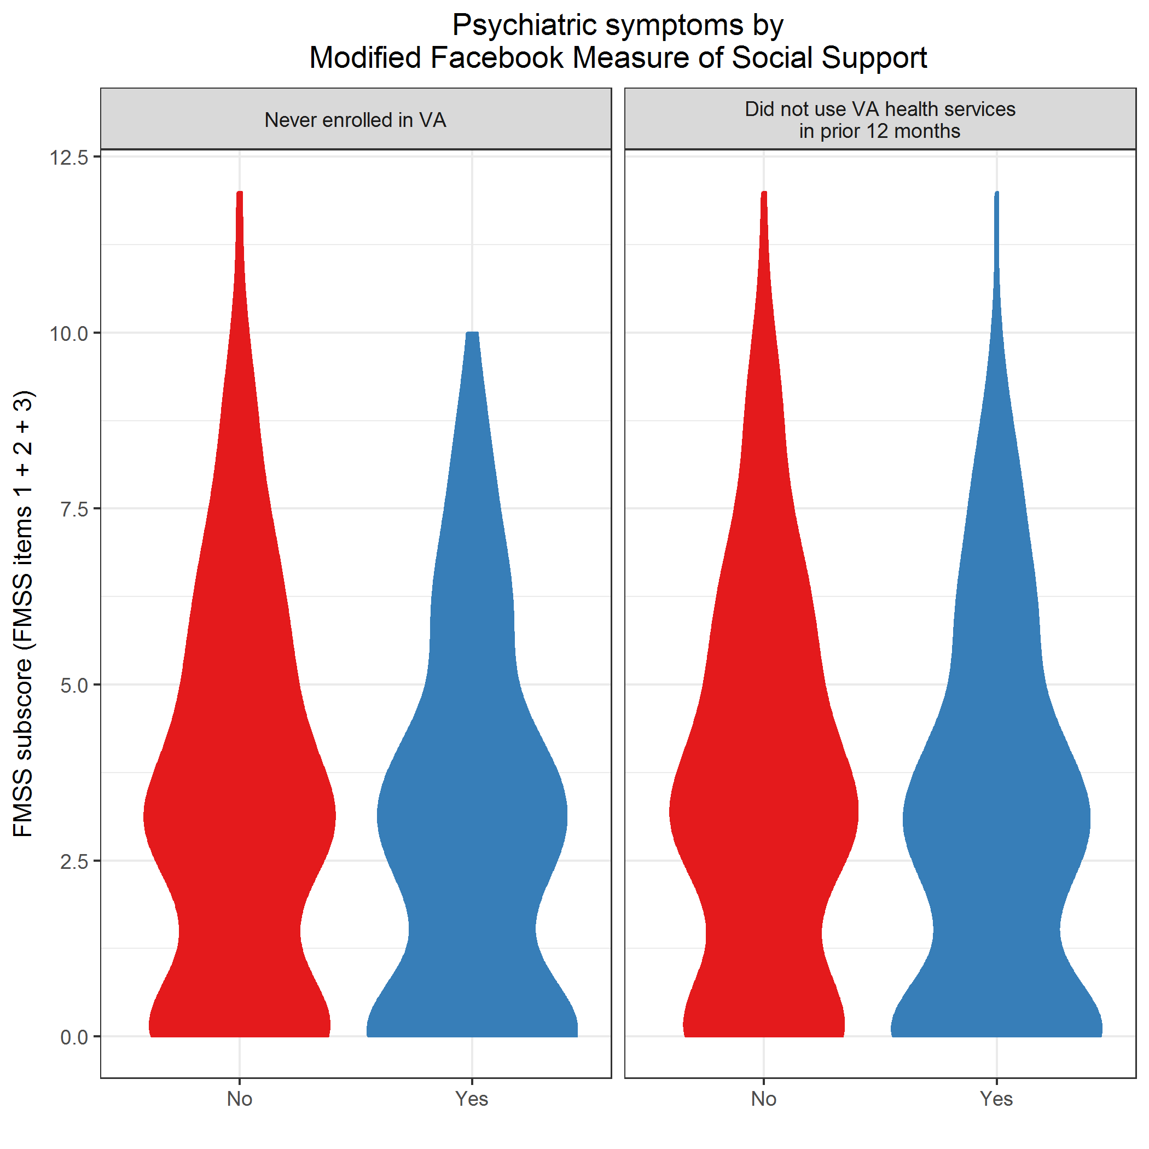

plot of chunk plot2GroupsRQ3

## Adjusted comparisons

Filter subjects with missing covariates.

### Never enrolled in VA

**PC-PTSD**

|  |  |  |  |  |  |
| --- | --- | --- | --- | --- | --- |
| model | term | oddsratio | std.error | statistic | p.value |
| Unadjusted | (Intercept) | 0.345 | 0.224 | -4.750 | 0.000 |
| Unadjusted | fmssSubscore | 0.922 | 0.057 | -1.407 | 0.159 |
| Unadjusted | indNotPTSDTRUE | 2.852 | 0.299 | 3.502 | 0.000 |
| Unadjusted | fmssSubscore:indNotPTSDTRUE | 0.960 | 0.077 | -0.530 | 0.596 |
| Adjusted | (Intercept) | 0.386 | 0.300 | -3.169 | 0.002 |
| Adjusted | fmssSubscore | 0.938 | 0.058 | -1.091 | 0.275 |
| Adjusted | countSocialMediaExclFB | 0.874 | 0.110 | -1.221 | 0.222 |
| Adjusted | comm_inpersonOnce a week | 0.883 | 0.369 | -0.336 | 0.737 |
| Adjusted | comm_inpersonA few times a week | 0.864 | 0.312 | -0.471 | 0.638 |
| Adjusted | comm_inpersonOnce a day | 1.286 | 0.376 | 0.669 | 0.504 |
| Adjusted | comm_inpersonSeveral times a day | 1.297 | 0.269 | 0.964 | 0.335 |
| Adjusted | indSuicideConsideredEverTRUE | 1.156 | 0.230 | 0.631 | 0.528 |
| Adjusted | countSuicideAttempts | 0.544 | 0.235 | -2.588 | 0.010 |
| Adjusted | indNotPTSDTRUE | 2.473 | 0.311 | 2.910 | 0.004 |
| Adjusted | fmssSubscore:indNotPTSDTRUE | 0.956 | 0.079 | -0.575 | 0.565 |

|  |  |  |  |  |  |  |  |
| --- | --- | --- | --- | --- | --- | --- | --- |
| model | null.deviance | df.null | logLik | AIC | BIC | deviance | df.residual |
| Unadjusted | 610.384 | 496 | -289.972 | 587.943 | 604.778 | 579.943 | 493 |
| Adjusted | 610.384 | 496 | -282.618 | 587.236 | 633.530 | 565.236 | 486 |

**PHQ-2**

|  |  |  |  |  |  |
| --- | --- | --- | --- | --- | --- |
| model | term | oddsratio | std.error | statistic | p.value |
| Unadjusted | (Intercept) | 0.463 | 0.264 | -2.916 | 0.004 |
| Unadjusted | fmssSubscore | 0.862 | 0.073 | -2.030 | 0.042 |
| Unadjusted | indNotPHQTRUE | 1.461 | 0.308 | 1.232 | 0.218 |
| Unadjusted | fmssSubscore:indNotPHQTRUE | 1.106 | 0.083 | 1.209 | 0.226 |
| Adjusted | (Intercept) | 0.536 | 0.319 | -1.951 | 0.051 |
| Adjusted | fmssSubscore | 0.871 | 0.072 | -1.908 | 0.056 |
| Adjusted | countSocialMediaExclFB | 0.827 | 0.102 | -1.869 | 0.062 |
| Adjusted | comm_inpersonOnce a week | 0.994 | 0.333 | -0.018 | 0.985 |
| Adjusted | comm_inpersonA few times a week | 0.928 | 0.278 | -0.267 | 0.789 |
| Adjusted | comm_inpersonOnce a day | 1.638 | 0.330 | 1.497 | 0.134 |
| Adjusted | comm_inpersonSeveral times a day | 1.348 | 0.241 | 1.241 | 0.215 |
| Adjusted | indSuicideConsideredEverTRUE | 1.156 | 0.207 | 0.699 | 0.485 |
| Adjusted | countSuicideAttempts | 0.501 | 0.223 | -3.096 | 0.002 |
| Adjusted | indNotPHQTRUE | 1.209 | 0.318 | 0.595 | 0.552 |
| Adjusted | fmssSubscore:indNotPHQTRUE | 1.115 | 0.083 | 1.316 | 0.188 |

|  |  |  |  |  |  |  |  |
| --- | --- | --- | --- | --- | --- | --- | --- |
| model | null.deviance | df.null | logLik | AIC | BIC | deviance | df.residual |
| Unadjusted | 735.079 | 579 | -359.548 | 727.097 | 744.549 | 719.097 | 576 |
| Adjusted | 735.079 | 579 | -347.374 | 716.748 | 764.741 | 694.748 | 569 |

**AUDIT-C**

|  |  |  |  |  |  |
| --- | --- | --- | --- | --- | --- |
| model | term | oddsratio | std.error | statistic | p.value |
| Unadjusted | (Intercept) | 0.800 | 0.209 | -1.067 | 0.286 |
| Unadjusted | fmssSubscore | 0.890 | 0.055 | -2.107 | 0.035 |
| Unadjusted | indNotAuditCTRUE | 0.747 | 0.299 | -0.974 | 0.330 |
| Unadjusted | fmssSubscore:indNotAuditCTRUE | 1.101 | 0.073 | 1.309 | 0.190 |
| Adjusted | (Intercept) | 0.873 | 0.275 | -0.495 | 0.621 |
| Adjusted | fmssSubscore | 0.898 | 0.057 | -1.877 | 0.061 |
| Adjusted | countSocialMediaExclFB | 0.823 | 0.107 | -1.818 | 0.069 |
| Adjusted | comm_inpersonOnce a week | 1.098 | 0.352 | 0.266 | 0.790 |
| Adjusted | comm_inpersonA few times a week | 1.012 | 0.290 | 0.041 | 0.967 |
| Adjusted | comm_inpersonOnce a day | 1.786 | 0.364 | 1.592 | 0.111 |
| Adjusted | comm_inpersonSeveral times a day | 1.278 | 0.262 | 0.937 | 0.349 |
| Adjusted | indSuicideConsideredEverTRUE | 1.033 | 0.221 | 0.145 | 0.885 |
| Adjusted | countSuicideAttempts | 0.503 | 0.231 | -2.978 | 0.003 |
| Adjusted | indNotAuditCTRUE | 0.711 | 0.309 | -1.105 | 0.269 |
| Adjusted | fmssSubscore:indNotAuditCTRUE | 1.108 | 0.076 | 1.353 | 0.176 |

|  |  |  |  |  |  |  |  |
| --- | --- | --- | --- | --- | --- | --- | --- |
| model | null.deviance | df.null | logLik | AIC | BIC | deviance | df.residual |
| Unadjusted | 617.811 | 472 | -306.497 | 620.994 | 637.631 | 612.994 | 469 |
| Adjusted | 617.811 | 472 | -294.651 | 611.302 | 657.052 | 589.302 | 462 |

**DSI-SS**

|  |  |  |  |  |  |
| --- | --- | --- | --- | --- | --- |
| model | term | oddsratio | std.error | statistic | p.value |
| Unadjusted | (Intercept) | 0.365 | 0.297 | -3.386 | 0.001 |
| Unadjusted | fmssSubscore | 1.068 | 0.075 | 0.881 | 0.378 |
| Unadjusted | indNotDSISSTRUE | 1.904 | 0.334 | 1.928 | 0.054 |
| Unadjusted | fmssSubscore:indNotDSISSTRUE | 0.846 | 0.084 | -2.000 | 0.046 |
| Adjusted | (Intercept) | 0.484 | 0.367 | -1.976 | 0.048 |
| Adjusted | fmssSubscore | 1.080 | 0.077 | 1.003 | 0.316 |
| Adjusted | countSocialMediaExclFB | 0.838 | 0.101 | -1.757 | 0.079 |
| Adjusted | comm_inpersonOnce a week | 1.056 | 0.331 | 0.165 | 0.869 |
| Adjusted | comm_inpersonA few times a week | 1.037 | 0.275 | 0.132 | 0.895 |
| Adjusted | comm_inpersonOnce a day | 1.771 | 0.328 | 1.740 | 0.082 |
| Adjusted | comm_inpersonSeveral times a day | 1.503 | 0.238 | 1.709 | 0.087 |
| Adjusted | indSuicideConsideredEverTRUE | 0.998 | 0.212 | -0.009 | 0.993 |
| Adjusted | countSuicideAttempts | 0.479 | 0.222 | -3.316 | 0.001 |
| Adjusted | indNotDSISSTRUE | 1.329 | 0.357 | 0.797 | 0.426 |
| Adjusted | fmssSubscore:indNotDSISSTRUE | 0.852 | 0.086 | -1.865 | 0.062 |

|  |  |  |  |  |  |  |  |
| --- | --- | --- | --- | --- | --- | --- | --- |
| model | null.deviance | df.null | logLik | AIC | BIC | deviance | df.residual |
| Unadjusted | 735.079 | 579 | -363.228 | 734.456 | 751.908 | 726.456 | 576 |
| Adjusted | 735.079 | 579 | -348.516 | 719.032 | 767.026 | 697.032 | 569 |

### Did not use VA health services in prior 12 months

**PC-PTSD**

|  |  |  |  |  |  |
| --- | --- | --- | --- | --- | --- |
| model | term | oddsratio | std.error | statistic | p.value |
| Unadjusted | (Intercept) | 0.777 | 0.192 | -1.312 | 0.190 |
| Unadjusted | fmssSubscore | 0.950 | 0.046 | -1.102 | 0.271 |
| Unadjusted | indNotPTSDTRUE | 3.520 | 0.289 | 4.353 | 0.000 |
| Unadjusted | fmssSubscore:indNotPTSDTRUE | 0.948 | 0.069 | -0.778 | 0.437 |
| Adjusted | (Intercept) | 0.767 | 0.266 | -0.994 | 0.320 |
| Adjusted | fmssSubscore | 0.961 | 0.048 | -0.847 | 0.397 |
| Adjusted | countSocialMediaExclFB | 1.038 | 0.097 | 0.387 | 0.698 |
| Adjusted | comm_inpersonOnce a week | 1.115 | 0.325 | 0.335 | 0.738 |
| Adjusted | comm_inpersonA few times a week | 1.210 | 0.280 | 0.681 | 0.496 |
| Adjusted | comm_inpersonOnce a day | 1.554 | 0.366 | 1.205 | 0.228 |
| Adjusted | comm_inpersonSeveral times a day | 1.291 | 0.253 | 1.010 | 0.313 |
| Adjusted | indSuicideConsideredEverTRUE | 0.954 | 0.214 | -0.218 | 0.827 |
| Adjusted | countSuicideAttempts | 0.674 | 0.153 | -2.575 | 0.010 |
| Adjusted | indNotPTSDTRUE | 3.000 | 0.299 | 3.672 | 0.000 |
| Adjusted | fmssSubscore:indNotPTSDTRUE | 0.943 | 0.070 | -0.841 | 0.400 |

|  |  |  |  |  |  |  |  |
| --- | --- | --- | --- | --- | --- | --- | --- |
| model | null.deviance | df.null | logLik | AIC | BIC | deviance | df.residual |
| Unadjusted | 686.626 | 495 | -322.818 | 653.636 | 670.462 | 645.636 | 492 |
| Adjusted | 686.626 | 495 | -316.580 | 655.161 | 701.433 | 633.161 | 485 |

**PHQ-2**

|  |  |  |  |  |  |
| --- | --- | --- | --- | --- | --- |
| model | term | oddsratio | std.error | statistic | p.value |
| Unadjusted | (Intercept) | 0.830 | 0.240 | -0.776 | 0.438 |
| Unadjusted | fmssSubscore | 0.897 | 0.060 | -1.798 | 0.072 |
| Unadjusted | indNotPHQTRUE | 2.320 | 0.288 | 2.919 | 0.004 |
| Unadjusted | fmssSubscore:indNotPHQTRUE | 1.056 | 0.071 | 0.769 | 0.442 |
| Adjusted | (Intercept) | 0.855 | 0.294 | -0.532 | 0.595 |
| Adjusted | fmssSubscore | 0.905 | 0.061 | -1.649 | 0.099 |
| Adjusted | countSocialMediaExclFB | 0.955 | 0.091 | -0.502 | 0.615 |
| Adjusted | comm_inpersonOnce a week | 1.052 | 0.303 | 0.168 | 0.867 |
| Adjusted | comm_inpersonA few times a week | 1.150 | 0.258 | 0.543 | 0.587 |
| Adjusted | comm_inpersonOnce a day | 1.822 | 0.337 | 1.780 | 0.075 |
| Adjusted | comm_inpersonSeveral times a day | 1.301 | 0.231 | 1.141 | 0.254 |
| Adjusted | indSuicideConsideredEverTRUE | 1.074 | 0.200 | 0.357 | 0.721 |
| Adjusted | countSuicideAttempts | 0.646 | 0.146 | -2.987 | 0.003 |
| Adjusted | indNotPHQTRUE | 1.964 | 0.298 | 2.267 | 0.023 |
| Adjusted | fmssSubscore:indNotPHQTRUE | 1.059 | 0.072 | 0.803 | 0.422 |

|  |  |  |  |  |  |  |  |
| --- | --- | --- | --- | --- | --- | --- | --- |
| model | null.deviance | df.null | logLik | AIC | BIC | deviance | df.residual |
| Unadjusted | 797.044 | 578 | -381.761 | 771.523 | 788.968 | 763.523 | 575 |
| Adjusted | 797.044 | 578 | -373.244 | 768.488 | 816.462 | 746.488 | 568 |

**AUDIT-C**

|  |  |  |  |  |  |
| --- | --- | --- | --- | --- | --- |
| model | term | oddsratio | std.error | statistic | p.value |
| Unadjusted | (Intercept) | 1.876 | 0.211 | 2.983 | 0.003 |
| Unadjusted | fmssSubscore | 0.910 | 0.052 | -1.799 | 0.072 |
| Unadjusted | indNotAuditCTRUE | 0.830 | 0.298 | -0.624 | 0.533 |
| Unadjusted | fmssSubscore:indNotAuditCTRUE | 1.080 | 0.070 | 1.097 | 0.273 |
| Adjusted | (Intercept) | 1.824 | 0.271 | 2.216 | 0.027 |
| Adjusted | fmssSubscore | 0.912 | 0.054 | -1.715 | 0.086 |
| Adjusted | countSocialMediaExclFB | 0.939 | 0.099 | -0.640 | 0.522 |
| Adjusted | comm_inpersonOnce a week | 1.286 | 0.334 | 0.755 | 0.451 |
| Adjusted | comm_inpersonA few times a week | 1.402 | 0.278 | 1.218 | 0.223 |
| Adjusted | comm_inpersonOnce a day | 2.470 | 0.398 | 2.270 | 0.023 |
| Adjusted | comm_inpersonSeveral times a day | 1.346 | 0.255 | 1.165 | 0.244 |
| Adjusted | indSuicideConsideredEverTRUE | 0.910 | 0.217 | -0.432 | 0.666 |
| Adjusted | countSuicideAttempts | 0.586 | 0.160 | -3.341 | 0.001 |
| Adjusted | indNotAuditCTRUE | 0.752 | 0.308 | -0.925 | 0.355 |
| Adjusted | fmssSubscore:indNotAuditCTRUE | 1.099 | 0.072 | 1.304 | 0.192 |

|  |  |  |  |  |  |  |  |
| --- | --- | --- | --- | --- | --- | --- | --- |
| model | null.deviance | df.null | logLik | AIC | BIC | deviance | df.residual |
| Unadjusted | 639.302 | 471 | -317.912 | 643.825 | 660.452 | 635.825 | 468 |
| Adjusted | 639.302 | 471 | -304.274 | 630.548 | 676.275 | 608.548 | 461 |

**DSI-SS**

|  |  |  |  |  |  |
| --- | --- | --- | --- | --- | --- |
| model | term | oddsratio | std.error | statistic | p.value |
| Unadjusted | (Intercept) | 0.952 | 0.270 | -0.181 | 0.856 |
| Unadjusted | fmssSubscore | 0.933 | 0.072 | -0.963 | 0.336 |
| Unadjusted | indNotDSISSTRUE | 1.863 | 0.310 | 2.010 | 0.044 |
| Unadjusted | fmssSubscore:indNotDSISSTRUE | 0.998 | 0.080 | -0.028 | 0.978 |
| Adjusted | (Intercept) | 1.033 | 0.336 | 0.096 | 0.923 |
| Adjusted | fmssSubscore | 0.936 | 0.073 | -0.910 | 0.363 |
| Adjusted | countSocialMediaExclFB | 0.969 | 0.090 | -0.347 | 0.728 |
| Adjusted | comm_inpersonOnce a week | 1.083 | 0.297 | 0.267 | 0.789 |
| Adjusted | comm_inpersonA few times a week | 1.361 | 0.251 | 1.227 | 0.220 |
| Adjusted | comm_inpersonOnce a day | 1.994 | 0.332 | 2.080 | 0.037 |
| Adjusted | comm_inpersonSeveral times a day | 1.506 | 0.226 | 1.816 | 0.069 |
| Adjusted | indSuicideConsideredEverTRUE | 0.981 | 0.201 | -0.093 | 0.926 |
| Adjusted | countSuicideAttempts | 0.638 | 0.144 | -3.108 | 0.002 |
| Adjusted | indNotDSISSTRUE | 1.386 | 0.331 | 0.984 | 0.325 |
| Adjusted | fmssSubscore:indNotDSISSTRUE | 1.009 | 0.081 | 0.114 | 0.909 |

|  |  |  |  |  |  |  |  |
| --- | --- | --- | --- | --- | --- | --- | --- |
| model | null.deviance | df.null | logLik | AIC | BIC | deviance | df.residual |
| Unadjusted | 796.642 | 578 | -391.470 | 790.939 | 808.384 | 782.939 | 575 |
| Adjusted | 796.642 | 578 | -380.441 | 782.882 | 830.856 | 760.882 | 568 |