View Factor for a Square Area – Case 1

Problem: Use Monte Carlo method to determine view factor for and as shown below.
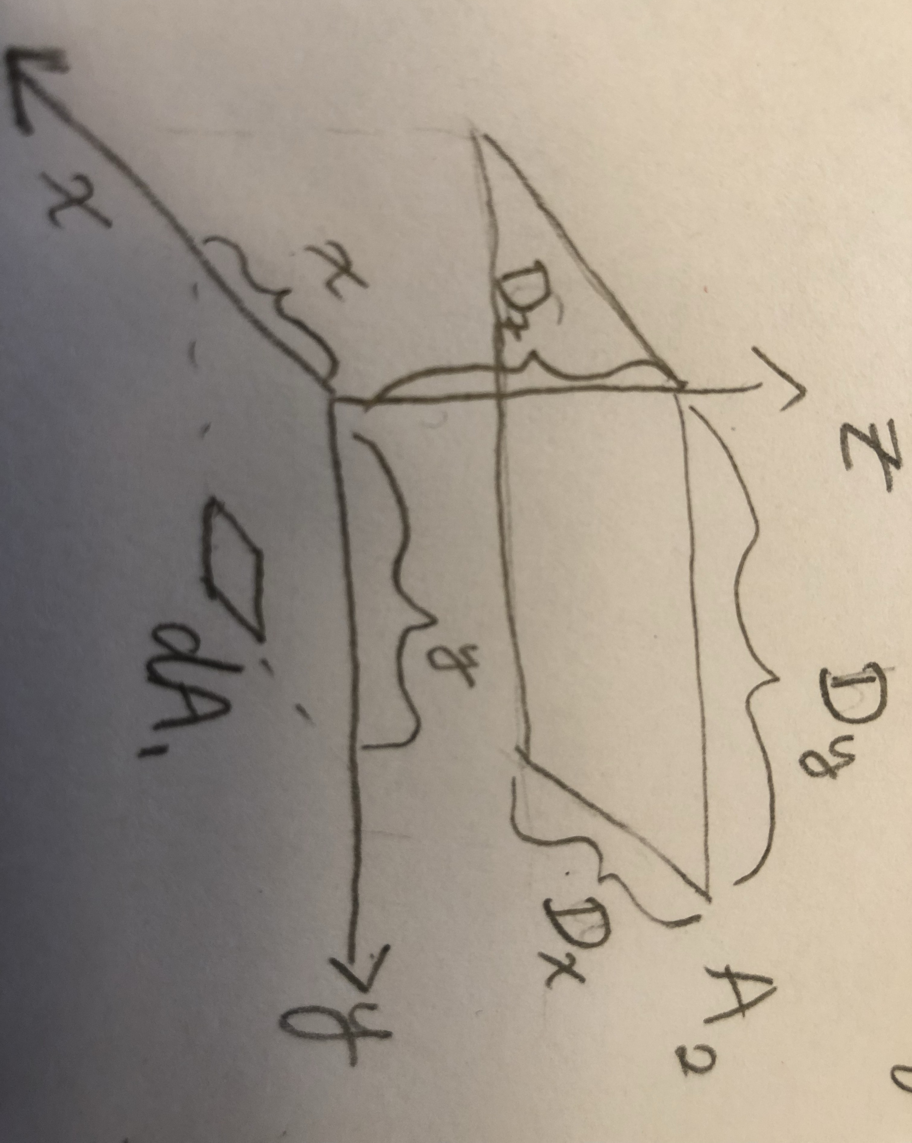

Solution: Sample the polar and azimuthal angles for a pair of random variables.
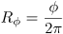
Since the bundle lands at , we can find the displacement vector by converting from polar coordinates.
And add the vectors to get the final position .
If and , then the bundle hits .

To calculate the view factor , launch bundles and count the number of them that land on .

