**Benjamin Darçot CM2003**

**Project report**

1. **Goal of the project**

This project is based on the dataset: [*Ischemic Stroke Lesion Segmentation Challenge - ISLES'22*](https://isles22.grand-challenge.org/home/). This dataset consists of 250 MRI scans of brains with ischemic strokes. The brain images are in three different modalities: ADC, FLAIR and diffusion. In addition to that, the masks of the strokes are given beside.

The goal of this project is to build a neural network capable of segmenting the ischemic stroke mask using the three different modalities.

1. **3D study**

As the task to be performed is a segmentation, the architecture used is the U-net architecture. However, it had to be slightly modified compared to the architecture used in the practical work. Indeed, the main difference with the practical work comes from the fact that the images used in this project are in 3 dimensions as they are MRIs of the brain. Thus, the different convolutions used in the encoder blocks have been changed to 3D convolution and not 2D, as well as the pooling and the convolutional transpose layers. It seems indeed logical to use 3D convolutions so that a neuron can have information from its neighbors in the 3 directions surrounding it.

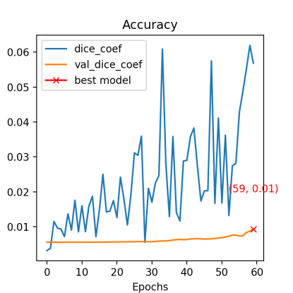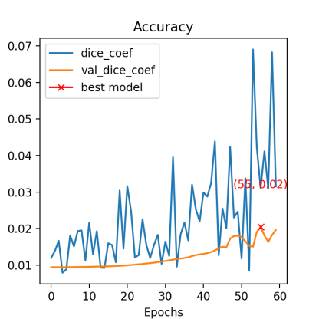This model should work quite efficiently in theory, however due to memory problems, it was impossible to use it with all three modalities at the same time. It was therefore tested with each modality separately. The curves showing the dice coefficient in each modality (left: ADC, middle: Diffusion, right: flair) are presented below.

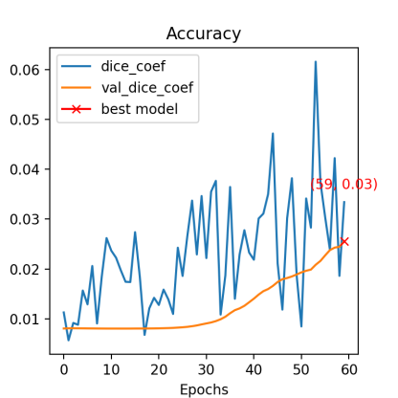

So we can see that the model is not efficient at all and that even the fitting is not done correctly. These problems can come from different factors:

- the modalities are used separately which is not optimal and reduces the amount of information available for the model

- the number of subjects is 250 which does not represent a very voluminous dataset and therefore once again reduces the amount of information available for the model

- the different parameters to be adjusted such as the learning rate, the batch size or the number of neurons in the first layer are perhaps not optimal and could lead to a more convincing result if they were better adjusted

To counter the first problem, a solution was considered: reduce the size of the images to be able to use the three different modalities at the same time. Unfortunately, the memory problem remains and it was impossible to use them all at the same time. Another solution would be to have access to a more powerful computer.

To counter the second problem, a data augmentation technique could be considered to enrich the dataset. However, because of memory problems, it could not be implemented.

Finally, about the last problem, different models should be tested with different parameters in order to find the best possible parameters. However, in spite of several tests no model was conclusive and all results gave the same order of accuracy.

1. **2D study**

As the 3D model used a lot of memory, it was very slow to train and this made it particularly difficult to improve the model. So, to get around this memory problem, it was chosen to transform the dataset into a 2D image. To do this, a 2D U-net model (as seen in the lab) was trained using only certain layers of the different images. The layers were chosen to all contain at least one piece of the stroke.

Thus, once this model was trained, by running the MRIs in different modalities layer by layer, it was possible to reconstruct the stroke mask layer by layer as well. This technique has the advantage of greatly limiting the memory required and therefore all three modalities can be used at the same time. However, the main problem is that a lot of information is lost, especially information about the neighboring pixels in the orthogonal direction to the selected layer.

To train this model, in a first step, the layer containing the largest part of the ischemic stroke was used in each participant and a data augmentation technique was applied. The results of the fitting on the selected layers are displayed below.

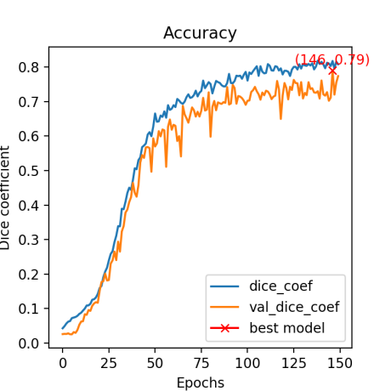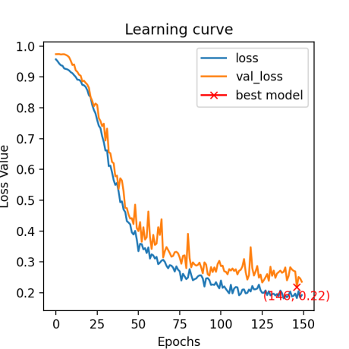

So we can see that the model performs quite well on the selected slices. However, as the goal is to obtain the mask in 3D, it is necessary to pass the data of a subject layer by layer to reconstruct the mask in its entirety. And although the model performs well on the layers containing a large part of the ischemic stroke, the performance is poor on the layers containing few, making the accuracy of the mask in its entirety rather average. The average dice coefficient on the whole mask for all subjects is 0.40.

To increase the efficiency on all layers, the model was trained again on 5 different layers (but containing a part of the stroke) per subject. The results of the fitting on the selected layers are shown below.

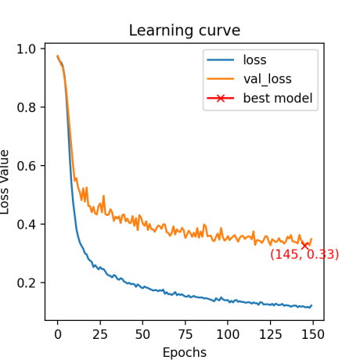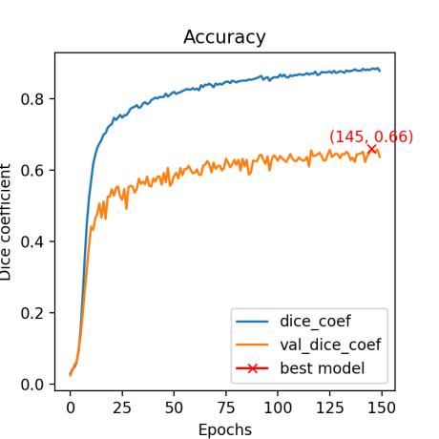

The fitting is less efficient than before, but the generalization is actually better, because when we use this new model layer by layer to reconstruct the mask, the average dice coefficient over the whole mask for all subjects increases to 0.52.

Thus, this model has an average dice coefficient of 0.52 on the whole dataset. As a comparison, the results of the challenge are between 0.82 and 0.40. This model could be improved by using more layers per subject. However the 3D model should be the most efficient since it does not lose any information.