EDA HD Charges and LOS

Michael Samuel

September 11, 2019

## Descriptive Statistics   
## oshpd16   
## N: 115278   
##   
## charge los los_adj  
## ----------------- ------------- ----------- -----------  
## Mean 65673.31 4.97 4.99  
## Std.Dev 283359.65 21.67 21.66  
## Min 0.00 0.00 1.00  
## Q1 9804.00 2.00 2.00  
## Median 31527.50 3.00 3.00  
## Q3 70036.00 5.00 5.00  
## Max 64917266.00 3795.00 3795.00  
## MAD 38463.09 1.48 1.48  
## IQR 60231.75 3.00 3.00  
## CV 4.31 4.36 4.34  
## Skewness 144.52 86.51 86.56  
## SE.Skewness 0.01 0.01 0.01  
## Kurtosis 29509.08 11152.66 11161.36  
## N.Valid 115278.00 115278.00 115278.00  
## Pct.Valid 100.00 100.00 100.00

## CHARGES

## charges  
## 0 1 7 40 48 83 91   
## 12.262531 0.026024 0.000867 0.000867 0.000867 0.000867 0.000867   
## 102 107 111 119 125 127 147   
## 0.001735 0.007807 0.006940 0.004337 0.002602 0.000867 0.000867   
## 150 160 182 213 240 290 316   
## 0.000867 0.000867 0.000867 0.003470 0.000867 0.000867 0.000867   
## 335 342 346 357 361 364 369   
## 0.000867 0.000867 0.000867 0.000867 0.000867 0.042506 0.002602   
## 381 427   
## 0.001735 0.000867

## charges  
## 0 1 7 40 48 83 91 102 107 111 119 125   
## 14136 30 1 1 1 1 1 2 9 8 5 3   
## 127 147 150 160 182 213 240 290 316 335 342 346   
## 1 1 1 1 1 4 1 1 1 1 1 1   
## 357 361 364 369 381 427   
## 1 1 49 3 2 1

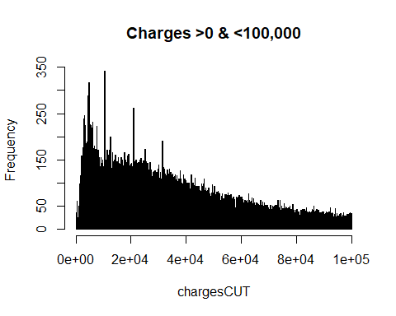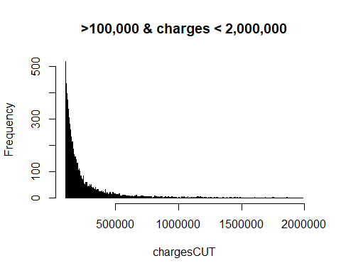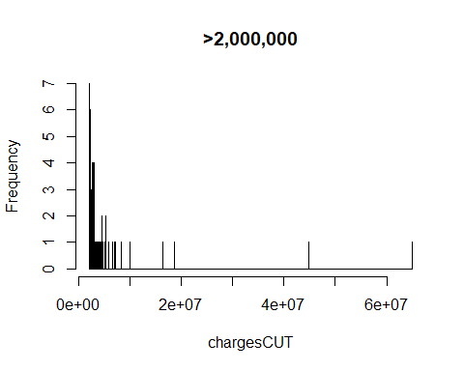

## charges  
## 3091233 3176847 3218981 3300883 3386416 3484666 3510548 3569596   
## 1 1 1 1 1 1 1 1   
## 3662966 3725890 3844003 3949894 4113346 4275627 4423432 4492040   
## 1 1 1 1 1 1 1 1   
## 4567500 4578298 4684636 5111367 5314730 5324090 5891891 6617602   
## 1 1 1 1 1 1 1 1   
## 7082287 8205721 9999999 16320049 18684930 44858667 64917266   
## 1 1 1 1 1 1 1

## LOS

## los  
## 0 1 2 3 4 5 6 7 8 9 10 11   
## 2.12 17.55 25.98 17.33 10.06 6.11 4.36 3.18 2.25 1.62 1.28 1.05   
## 12 13 14 15 16 17 18 19 20 21 22 23   
## 0.82 0.72 0.67 0.53 0.42 0.37 0.32 0.28 0.28 0.27 0.20 0.16   
## 24 25 26 27 28 29 30 31 32 33 34   
## 0.15 0.13 0.12 0.11 0.13 0.09 0.09 0.07 0.06 0.05 0.06

