**The challenge of mapping Alaska’s salmon streams [DRAFT]**  
January 28, 2023  
Benjamin Meyer (benjamin.meyer.ak@gmail.com)

*\*Note: this is the first in a series of essays addressing the state of freshwater salmon habitat mapping efforts in Alaska. This first article is for a more general audience, and the second is for a more technical audience and may be accessed here: ____________*

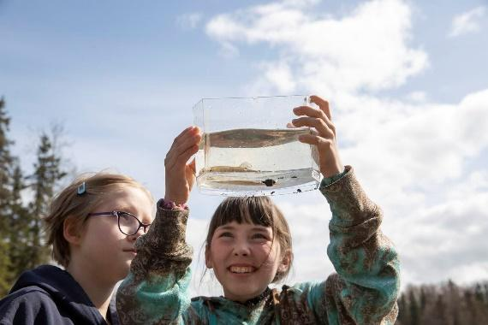  
*A student holds up a juvenile salmon near the Kenai River*

90% of Alaskans will tell you that wild salmon are either “important” or “very important”, according to a 2013 poll1. It’s easy to imagine this sentiment in the form of a fly fisherman casting on a glimmering river, or a filet in our freezer, not to mention a grizzly fishing atop a waterfall.

But wild salmon rely on more than just picturesque wilderness settings. A small trickle of water seeping from a bluff behind a paved parking lot, an impenetrable swamp, and a stagnant puddle are all places that I have found to be teeming with salmon and other fish in my work as a biologist. It is in these headwaters that many of them grow and feed, preparing for a long journey out to the ocean and back.

It can be easy to overlook these humbler places even for those of us who study them. Frequently, smaller salmon streams do not appear on even our best maps that land managers use to understand their habitat. These everyday “backyard” streams that are part of our landscape in much of coastal Alaska may be individually small, but together they are the nursery grounds for millions of fish. In other words, fish need land too.

Our best-intended, best-designed regulations are only as good as our best information, and too often we’re using incomplete details to make irreversible decisions. As a result, Alaska has a regulatory gap that can inadvertently let even the most fish-minded among us stumble into damaging salmon habitat. How can we take care of our “wild infrastructure” when we don’t yet know where exactly it exists?

The Alaska Department of Fish and Game website describes this gap in its overview of the Anadromous Waters Catalog, the map which serves as the official inventory for Alaskan salmon habitat. (“Anadromous” means any fish that is born and spawns in freshwater, but migrates to the ocean to grow into an adult, as do salmon):

“The Catalog […] currently lists almost 20,000 streams, rivers or lakes around the state which have been specified as being important for the spawning, rearing or migration of anadromous fish. However […] it is believed that this number represents a fraction of the streams, rivers, and lakes actually used by anadromous species. Until these habitats are inventoried, they will not be protected under State of Alaska law…”2

Put in other words: rivers and lakes in Alaska are presumed to *not* be salmon habitat unless otherwise proven. Unless someone, usually a trained biologist, has taken the time to visit a potential salmon stream in person and unambiguously document the presence of juvenile or adult salmon, disturbing the waterbody does not require a fish habitat permit from the Alaska Department of Fish and Game.

As a result, if a road is to be built across an unidentified salmon stream on privately held property, it may not necessarily require the fish-friendliest culvert. If land clearing is planned, local riparian buffer ordinances might not apply. A manager deciding where to focus on rebuilding road culverts to fish-friendly standards is likely operating with a big information handicap, as their decisions are partially based on looking at maps to estimate the amount of upstream salmon habitat.

Consider a case I encountered a few summers ago of a recently bulldozed creek tributary. A landowner had started a major construction project, excavating a small stream that we later discovered was home to thousands of juvenile silver salmon and dolly varden. The stream did not appear in the anadromous waters catalog; nor was it even on the map of any streams at all. Even a conservation-minded landowner could struggle to take responsible actions around this stream if they don’t know it exists.

In a higher-profile example, consider that over a hundred miles of salmon stream were identified within the proposed Pebble mine claim area in southwest Alaska by a team of researchers working with The Nature Conservancy in 2008-20103. Without their work, the developer might have been obligated to consider impacts to only the small fraction of salmon streams that had already been identified there.

Identifying a salmon stream post-hoc after it has been bulldozed is a situation no one wants to see. Arguably not every single wild salmon stream is destined for perfect preservation as we balance the needs of growing communities and wild fish habitat in our backyards. But we owe it to ourselves to have good information about where wild salmon live to make informed decisions.

Every summer a small but dedicated cadre of biologists from state, federal, tribal, and nonprofit groups work to expand the map of Alaska salmon streams. They are to be commended for their yeoman’s labor. But their task is gargantuan, not unlike attempting to build a towering tree out of twigs and twine. It can be done, slowly and with difficulty, but not soon enough.

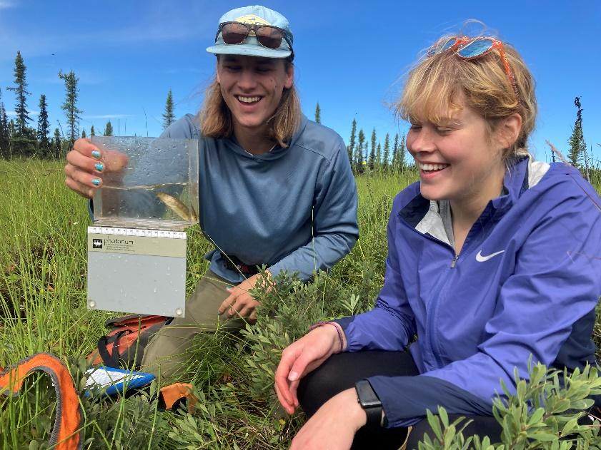  
*Researchers Burke Haywood and Erin Blum examine a juvenile coho salmon*

*What are our options?*

So, what are the alternatives to our current situation? There are a spectrum of options, and somewhere in the middle is the best approach to mapping Alaska’s salmon streams. The good news is that the tools to address the challenge are ready at hand and some researchers are already changing the game as we speak.

*Option 1: Change our assumptions*

Given how widespread salmon habitat is throughout Alaska, the presumption that waters are *not* salmon habitat unless otherwise proven is a kind of “guilty until proven innocent approach.” At the most progressive end of the spectrum, we could *reverse* our current assumption that waters are not salmon-bearing until proven otherwise. But this option may prove too challenging to execute.

Such a shift was proposed as part of Ballot Measure 1, also known as the “Stand for Salmon” campaign in 2018[1]. The shift could have placed the responsibility on landowners and developers to assess the status of streams, lakes, and wetlands that may be disturbed by their proposed activities. Today, in many cases such proactive steps are voluntary for private landowners. While such a vision may be well intentioned, enforcing it could be complex and would represent a sea change at a scale that Alaska may not be ready to accept, and pursuing this path could be politically ineffective.

*Option 2: Status quo*

At the other end of the spectrum is our current approach to mapping salmon habitat. Today, we rely on a dedicated but small array of state and federal agencies, nonprofits, tribal entities, and a few volunteer citizens to do the important work of documenting salmon habitat. Each summer, scientists pore over maps searching for rivers, streams, and lakes not yet registered in the

Anadromous Waters Catalog. They travel to where they estimate are the uppermost headwaters in a stream that salmon may be found, sometimes a high mountain stream or sometimes a swampy rivulet. They use tools to survey for presence or absence of salmon, then submit their data to be assessed by the Alaska Department of Fish and Game each fall.

Our current approach, while straightforward, is slow, labor-intensive, and will never document every salmon stream. As our communities grow, more streams and wetlands that serve as salmon habitat are likely to be inadvertently disturbed in our expanding footprint.

*Option 3: Use better maps to make better maps*

There may be more efficient ways to inventory Alaska’s salmon streams, and some researchers are already using them.

For biologists preparing to head out to the field to map and ground-truth salmon habitat, guessing the “uppermost point of anadromy” is a critical but challenging task. Our methods for choosing where to go range from interviewing local people, squinting at topo lines, or checking computer databases. In my own experience, it’s usually a semi-informed shot in the dark as to whether or not many miles of additional salmon habitat lie upstream from a field survey site reached after an arduous journey.

Over the last decade, scientists have begun to develop detailed watershed maps using high-resolution imagery and computer models that do a much better job of predicting where salmon habitat may lay. These maps are being applied in southeast Alaska by the U.S. Forest Service in recent fish habitat survey efforts. The results so far are promising: models can predict with approximately 98% accuracy the “uppermost point of anadromy” of a stream, within ±67 meters5,6. Such efforts can help us identify dozens or hundreds of miles of previously undocumented salmon streams.

In most of Alaska, these mapping techniques have yet to be applied. This approach is still labor-intensive, but at least it is informed by our best information.

A map that can so accurately predict the extent of salmon habitat suggests that someday perhaps we could change our “guilty until proven innocent” salmon habitat approach. One day, perhaps managers could use these predictive maps to help understand their full habitat range without having to have someone physically set foot in every single headwater. Such a change would be a major shift from current policy and would require more experience and evidence, but it could be a powerful choice in the long term.

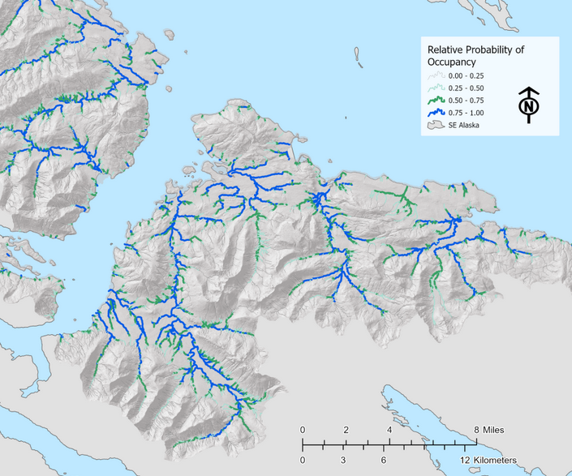  
*Map of streams in southeast Alaska, with blue lines as known salmon streams and green lines as probable salmon streams6*

*Ongoing efforts*

Everyday Alaskans have expressed a strong interest in helping with the work of mapping salmon streams. A hands-on experience to seek and find "baby salmon" in surprising places is an explorer’s joy. Recently, Trout Unlimited Alaska has supported these efforts both in the Juneau area, as well as on the Kenai Peninsula in partnership with Kenai Watershed Forum7–9. The “Fish Map App” for smartphones recently released by the nonprofit Indigenous Sentinels Network also aims to support such citizen science efforts10.

Technical and logistical challenges lay ahead on our road towards improving anadromous waters mapping in Alaska. But the work will not wait for us. As a society where 90% of us say that we value wild salmon in our lives, doing our best to learn where they live is a start to learning how to live together.

The second essay of this series will outline some questions that have unfolded as I learn more about this topic.

*For ways to get involved with mapping salmon streams on the Kenai Peninsula, contact Kenai Watershed Forum (hydrology@kenaiwatershed.org).*

References

1. The Salmon Project. *What Alaskans are thinking about salmon: Alaskan connections to the wild salmon resource*. https://salmonproject.wpenginepowered.com/wp-content/uploads/2016/01/Salmon-Project-Statewide-Research-Executive-Report.pdf (2013).

2. Alaska Department of Fish and Game. Anadromous Waters Catalog Overview. https://www.adfg.alaska.gov/sf/sarr/awc/ (2022).

3. Woody, C. A. & O’Neal, S. L. *Fish Surveys in Headwater Streams of the Nushagak and Kvichak River Drainages, Bristol Bay, Alaska 2008-2010*. https://www.nature.org/media/alaska/awc_dec_2010.pdf (2010).

4. Ballotopedia. Alaska Ballot Measure 1, Salmon Habitat Protections and Permits Initiative (2018). *Ballotpedia* https://ballotpedia.org/Alaska_Ballot_Measure_1,_Salmon_Habitat_Protections_and_Permits_Initiative_(2018) (2018).

5. Romey, B. & Martin, D. *Landscape-Level Extent of Resident Fish Occupancy in the Alexander Archipelago*. (2022).

6. Romey Fisheries & Aquatic Science. Southeast Alaska Fish-Habitat. *Landscape-level ecosystem assessment using best-available science paired with remote sensing to support aquatic conservation.* https://storymaps.arcgis.com/stories/6b3949e1ebcd44c6a531d13f038807c5 (2021).

7. Trout Unlimited Staff. Trout Unlimited expands Alaska’s knowledge of fish habitat. https://www.tu.org/magazine/science/trout-unlimited-expands-alaskas-knowledge-of-fish-habitat/?utm_source=rss&utm_medium=rss&utm_campaign=trout-unlimited-expands-alaskas-knowledge-of-fish-habitat (2021).

8. Poux, S. & KDLL-Soldotna. Stream by stream, volunteers map the Kenai Peninsula’s anadromous waters. https://alaskapublic.org/2022/09/07/stream-by-stream-volunteers-map-the-kenai-peninsulas-anadromous-waters/ (2022).

9. Meyer, B. Kenai Peninsula Chapter of Trout Unlimited Embrace-a-Stream Project: Expanding Knowledge of Fish Habitat in Alaska’s Kenai Peninsula. https://bookdown.org/kwfwqx/tu_awc_expansion/ (2022).

10. Indigenous Sentinels Network. Alaska fish habitat mapping “Fish map app.” https://alaskafishmapping.org/ (2022).

1. The statewide initiative failed by a significant margin. The “Stand for Alaska” campaign opposed the initiative, and was able to outspend the “Stand for Salmon” campaign by a margin of six to one4.