**Using better maps to make better maps for Alaska’s salmon streams [DRAFT]**February 12, 2023  
Benjamin Meyer (benjamin.meyer.ak@gmail.com)

*This is the second essay in a series addressing the state of freshwater salmon habitat mapping efforts in Alaska. The first introductory article is for a more general audience and may be accessed here ____________:, while this second article below is for a more technical audience.*

In a previous essay I made the case for using a more systematic approach to mapping Alaska’s salmon streams and lakes, also known as “anadromous waters.” In this second article I will explore how we may do so, and how some researchers already are.

As part of developing a project to expand the anadromous waters catalog (AWC) in the Kenai Borough region I’ve encountered a series of questions on how to best proceed. Here my intention is to provide a narrative to the evolving set of ideas for how we can predict the locations of yet-unidentified salmon streams in Alaska. By examining different approaches to the challenge, I hope to learn methods that will help us put more anadromous waters on the map statewide.

*The need for a systematic approach*

To search for yet-unidentified salmon streams and lakes, biologists first must choose which field survey sites to visit. Sometimes we rely on word of mouth, on local databases, or on our visual assessments of maps. The lack of a systematic approach is inefficient, as frequently we are uncertain of on-the-ground geography before we travel: perhaps a natural downstream barrier prevents fish passage, or perhaps many miles of additional salmon habitat lay upstream from our selected survey location.

As an example, in summer 2022 we surveyed a small tributary of the Moose River near the community of Sterling. Figure 1 shows that not only was this tributary not yet included in the AWC, but the anadromous stream section continued well beyond where the currently mapped flow channel lay. Until we submitted the (pending) AWC nomination, a land manager would have little reason to think a salmon stream existed there.

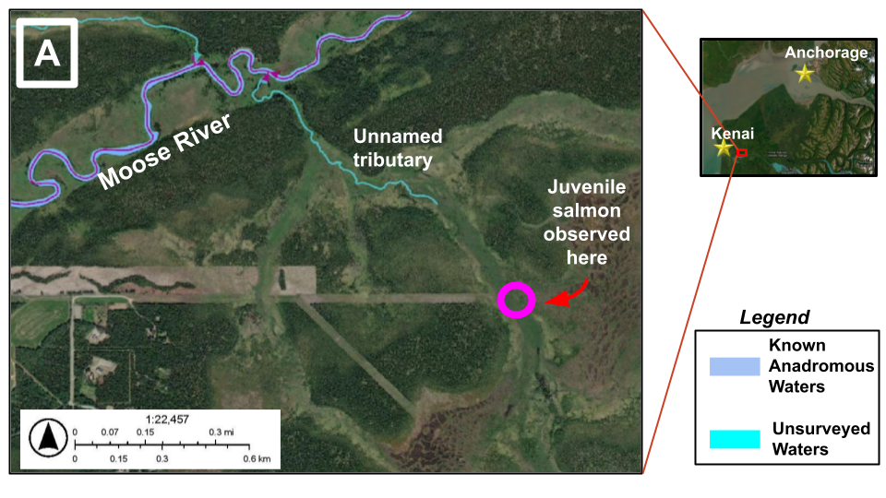

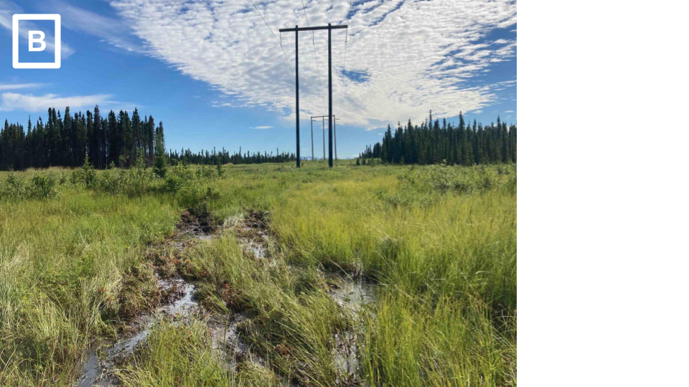

*Figure 1. A.) A previously unidentified anadromous tributary of the Moose River near Sterling, Alaska. Juvenile salmon were observed approximately 0.3 miles upstream of where the mapped tributary ended. B.) An on-the-ground view of the site circled in figure 1A. The anadromous extent likely continues further upstream, but we were unable to access the area in 2022. Read more about this story from KDLL Public Radio at* [*https://alaskapublic.org/2022/09/07/stream-by-stream-volunteers-map-the-kenai-peninsulas-anadromous-waters/*](https://alaskapublic.org/2022/09/07/stream-by-stream-volunteers-map-the-kenai-peninsulas-anadromous-waters/)*.*

There are countless additional examples like the tributary in figure 1, often at the current margins of our development footprint. These are the types of salmon streams that today are too often overlooked.

After a few similar fieldwork experiences, I began looking for better ways to approach the challenge of choosing where to survey for more yet-unidentified salmon streams.

*Option 1: Applying a slope gradient threshold*

In fall 2022 at the Mat-Su Salmon Science Symposium I met other researchers tackling the same challenges. Habitat biologists from the Alaska Department of Fish and Game had applied the publicly available stream network map known as the National Hydrography Database plus (NHD+) towards identifying the likely most-upstream anadromous extent. They used a gradient threshold approach, identifying stream reaches with 12% slope gradients and assumed these to be barriers to adult salmon migration. When superimposed with the existing AWC map, this reveals many miles of likely salmon streams and lakes not yet included in the AWC.

Upon further reading, the gradient threshold method has pros and cons. On the pro side, the simple threshold can be applied without complex, time-consuming modeling. Others emphasize that this approach creates an incomplete picture of probable salmon habitat and should be recognized as only a partial solution. Attempting to infer probable upstream limit of fish occupancy from simple thresholds such as gradient, channel width, or channel type can lead to inaccurate results due to oversimplification of the many other factors that affect fish distribution (Romey and Martin 2022). Using a threshold-only approach is a start, but no one would use the results as the final word on fish distribution.

*Option 2: Predictive stream network models*

Another researcher at the 2022 Mat-Su Symposium from Alaska Center for Conservation Science shared a short introduction on work in progress that will apply the NHD+ in a more complex model of juvenile salmon occupancy (Figure 2). The work is part of an ongoing doctoral project with University of Alaska Fairbanks, and I am excited to see how it may apply to AWC mapping prioritization in the future.

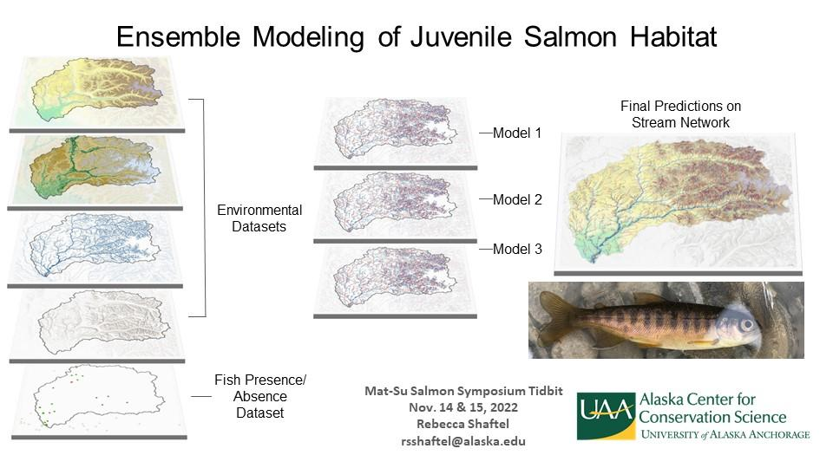

*Figure 2. Ensemble modeling approach to mapping anadromous waters. Figure courtesy of Rebecca Shaftel, Alaska Center for Conservation Science.*

Past researchers in Alaska have also used predictive modeling to map anadromous waters. A decade ago, scientists with Kachemak Bay Research Reserve and Baylor University developed a stream network model for several watersheds in the southern Kenai Peninsula near Homer. Their work applied a suite of GIS datasets along with hydrological and biological observations, and found that flow-weighted slope (an indicator of water residence time and gradient) was the best correlate of fish community structure (King et al. 2012). Their work assisted with the addition of many dozens of new miles added to the AWC in the southern Kenai Peninsula region.

The Chena River near Fairbanks has also been the subject of similarly themed research efforts. A graduate project in 2014-2015 developed a predictive stream network model of habitat intrinsic potential (IP) for juvenile Chinook salmon, and assessed the efficacy of several ground-truthing methods, including environmental DNA and visual observation (e.g. snorkeling surveys) (Matter et al. 2018). This work applied a stream network model distinct from the NHD or NHD+ called NetMap, which will be discussed in further detail below.

The academic work in predictive modeling has helped lay a path for what I anticipate will be an approach reproducible in other areas of the state. Ongoing work in the Tongass National Forest shows promise to be just such an approach.

*Option 3: Other predictive models based on NetMap*

In Fall 2022 I stumbled across reports from a project in southeast Alaska that seems to synthesize some of the previously described mapping approaches.

As part of the Hoonah Native Forest Partnership, researchers developed intrinsic potential models for pink, chum, and coho salmon for select watersheds in the region (HNFP 2019). Habitat IP was determined using a variety of watershed characteristics, such as stream gradient or slope, mean annual streamflow, and valley width, in combination with species-specific habitat and life history needs. Biologists used these data along with hundreds of “end of anadromy surveys” from the upper reaches of watersheds to develop predictive models of high, medium, and low habitat values for salmon habitat.

The map predicted *presence* of fish correctly at the most-upstream reach in 86.7% of cases, and correctly predicted *absence* in 98.7% of cases, within ± 67 m (Romey and Martin 2022). These numbers suggest enormous potential to be of help to field biologists looking to add new miles to the AWC.

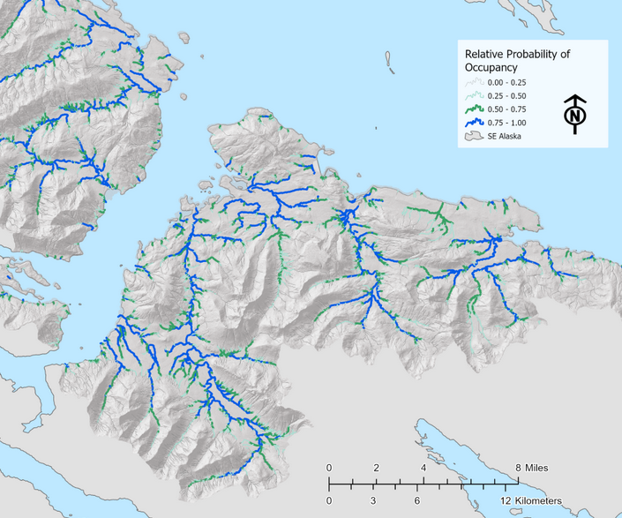

*Figure 3. Figure from ‘Southeast Alaska Fish Habitat’ story map, Romey Fisheries and Aquatic Sciences 2021. Probability of salmon occupancy is color coded from high to low based on a predictive model.*

The impressive predictive power is not achieved without investment in time and resources. Along with extensive fieldwork, the approach applied in both the HNFP and Chena River projects requires access to a geospatial product called NetMap, produced by the consulting group Terrainworks (Romey 2019).

In my discussions with some local GIS colleagues, I discovered that some of them were uncertain about the value of investing in NetMap for the Kenai region. As I am not an advanced GIS user, I am unable to give due justice to the merits of their concerns but a few of them included:

* NetMap is a pricey, proprietary data product that requires an annual subscription to fully apply, and it would be better to use data products and tools fully accessible in the public domain, such as the NHD and NHD+
* NetMap may generate results slightly different than what the NHD+ would produce. When it comes to mapping stream flow paths it would be preferable to work together towards a single “source of truth” for public reference, rather than diverging research needs producing multiple versions of watershed maps.

To investigate these concerns, I inquired to half adozen colleagues with experience in watershed mapping. From our conversations, it seems like while the above observations were not unfounded, the concerns over cost and access do not outweigh the potential benefits of commissioning and applying NetMap. The answers I received included:

* NetMap may use proprietary tools, but the product fills an important niche that no other entity has rushed to fill.
* The NHD+ does not contain the data characteristics needed to generate the kind of successful predictive models discussed earlier, as it does not contain physical channel or watershed characteristics, except for segment length

As I mentioned, I am not an advanced GIS user and am unable to evaluate the details of this discussion. However I did find that according to a [USGS availability map](https://usgs.maps.arcgis.com/apps/MapTools/index.html?appid=41a5c2ca49bd4a83b239450e61022d53) (USGS 2022), a beta version of the National Hydrography Dataset Plus High Resolution map is available for most of southcentral Alaska, including the Kenai region. And NetMap has already been developed for part of the Kenai Peninsula (within the Chugach National Forest) as part of a 2017 U.S. Forest Service planning effort.

*Future pursuits*

Overall, the impressions I’m left with are as follows:

* Using a threshold gradient to estimate the upper limits of salmon distribution is a better approach than nothing, but is likely to still miss identifying many places where salmon habitat is found.
* A model that applies NetMap and extensive field data appears to be the “state-of-the-art” option, but it is potentially the most expensive and “data-hungry” option.
* There is great value in prioritizing the locations we choose to survey for AWC nominations based on local conservation needs and interests.

I am currently in the process of developing a grant proposal that would tackle the challenge of expanding the AWC for the Kenai Peninsula Borough region. It seems like if we have the option (and the funding) to pursue a “state-of-the-art” option such as applying a predictive model based on NetMap, then the choice is clear. But, could this approach prove too complex and expensive to apply at a state-wide scale? It is unclear to me now, which is the reason I’ve tried to elucidate my thoughts here.

My vision for the future of anadromous waters mapping in Alaska is something such as this: with whatever approach we (researchers and managers) evolve towards, we would work together to create a statewide “treasure map” of predicted end-of-anadromy headwater sites. Such a map might have thousands or tens of thousands of sites within the Kenai Peninsula Borough alone. Ultimately, I hope the model will prove successful enough to negate the need for ground-truth surveys in every single headwater of every single watershed, an unrealistic expectation in our vast landscape. My vision is that land managers would be confident in using the more detailed predictive map to assess impacts and make decisions and take into consideration a map where not every “known” anadromous water has been confirmed by on-the-ground observations.

Such an approach would be different from our current management system, but with enough experience and evidence we could move towards this model. The more we can apply our collective knowledge in mapping Alaska’s salmon streams, the better job we can do sharing our backyard with them.

*For ways to get involved with mapping salmon streams on the Kenai Peninsula, contact Kenai Watershed Forum (hydrology@kenaiwatershed.org).*

References

HNFP. 2019. “The Hoonah Native Forest Partnership: An Interdisciplinary, Collaborative Approach to Watershed Assessment and Resource Planning.” https://www.hia-env.org/wp-content/uploads/2019/10/19_ELE_Hoonah_ForestReport_3F_WEB-1.pdf.

King, Ryan S., Coowe M. Walker, Dennis F. Whigham, Steven J. Baird, and Jeffrey A. Back. 2012. “Catchment Topography and Wetland Geomorphology Drive Macroinvertebrate Community Structure and Juvenile Salmonid Distributions in South-Central Alaska Headwater Streams.” *Freshwater Science*  31 (2): 341–64.

Matter, Allison N., Jeffrey A. Falke, J. Andrés López, and James W. Savereide. 2018. “A Rapid-Assessment Method to Estimate the Distribution of Juvenile Chinook Salmon in Tributary Habitats Using EDNA and Occupancy Estimation.” *North American Journal of Fisheries Management* 38 (1): 223–36.

Romey, Bernard. 2019. “Landscape-Level Model for Predicting Juvenile Coho Salmon Rearing Habitat in Southeast Alaska.” presented at the Alaska Section of the American Water Resources Association Annual Conference, Juneau, ALaska.

Romey, Bernard, and Douglas Martin. 2022. “Landscape-Level Extent of Resident Fish Occupancy in the Alexander Archipelago.” 21–03. Romey Fisheries & Aquatic Sciences.

USGS. 2022. “National Hydrography Dataset Plus High Resolution (NHDPlus HR) Availability Map.” 2022. https://usgs.maps.arcgis.com/apps/MapTools/index.html?appid=41a5c2ca49bd4a83b239450e61022d53.

**Intended initial readers**

**J falke  
B romey  
B shaftel  
B bornemann  
M Harings  
N cathcart  
E Tucker  
M Mazzacavallo  
B haywood, j buban  
L Flynn  
t troll  
s o’neal**