Alaska Sustainable Salmon Fund
2023 Call for Proposals
Project Proposal Form

- Project Title: Juvenile Salmon Body Condition and Freshwater Prey Availability in Cook Inlet, Prince William Sound, and Copper River

- Principal Investigator
Erin Larson, Ph.D., Research Assistant Professor
University of Alaska Center for Conservation Science
3211 Providence Dr., BMH 103
Anchorage, Alaska 99508
907-786-6392
elarson15@alaska.edu

Co-Principal Investigator(s)
Rebecca Shaftel, M.S., Lead Aquatic Ecologist
University of Alaska Center for Conservation Science
3211 Providence Dr., BMH 103
Anchorage, Alaska 99508
907-786-4965
rsshaftel@alaska.edu

Erik Schoen, Ph.D., Research Assistant Professor
International Arctic Research Center, University of Alaska Fairbanks
PO Box 757340
Fairbanks, AK 99775-7340
907-474-7735
eschoen@alaska.edu

Kate Morse, M.P.A., Program Director
Copper River Watershed Project
P.O. Box 1560
Cordova, AK 99574
kate@copperriver.org
907-424-3334

Ben Meyer, M.S., Water Quality Coordinator
Kenai Watershed Forum
44129 Sterling Hwy
Soldotna, AK 99669
907-232-0280
ben@kenaiwatershed.org

Dan Rinella, Ph.D., Fisheries Biologist
Southern Alaska Fish and Wildlife Field Office, U.S. Fish & Wildlife Service
4700 BLM Road
Anchorage, AK 99507
907-271-2871
daniel_rinella@fws.gov

- Project Period: 3/1/24-11/30/26

- AKSSF Objective: Conduct climate impact assessments to guide the selection of future AKSSF projects.

- Project Description
- Synopsis
This work will synthesize available freshwater temperature and biological data to characterize climate-related effects on juvenile salmon in the Cook Inlet, Copper River, and Prince William Sound regions. This project will compile available information and create novel datasets to assess temperature relationships with food quality and quantity and juvenile salmon body condition and growth. This work builds on prior thermal sensitivity modeling work in the region to assess how the changing freshwater thermal template could affect food availability and growth in the juvenile life stages of Pacific salmon.

- Introduction
Southcentral Alaska includes a confluence of the fastest growing population centers in the state, crucial salmon populations for subsistence, commercial, and personal use, and a wide range of documented climate and habitat threats to salmon-bearing watersheds. To maximize restoration, conservation, and monitoring efforts in this region, there is a need to understand how climate change will affect productivity of different types of watersheds in the future. Cook Inlet, Prince William Sound, and the Copper River have a mix of very warm, currently productive systems, and colder systems that are likely to experience an expansion of salmon habitat and productivity in the future as glaciers recede and freshwater temperatures increase (Pitman et al., 2021). These changes to freshwater habitat will affect all freshwater life stages of all species of Pacific salmon.

Climate change has the potential to affect salmon-bearing watersheds in multiple ways. First, warming water temperatures can influence freshwater life stages of Pacific salmon by causing pre-spawning mortality, changing emergence timing (Adelfio et al., 2019; Campbell et al., 2020), influencing juvenile growth rates, and altering outmigration timing (Wilson et al., 2023). Second, climate can alter the freshwater habitat template of different types of watersheds. For example, climate-driven glacial recession could result in an increase in available salmon habitat in highly-glaciated watersheds, while an increase in extreme streamflow events (Lader et al., 2017) could cause scouring and mortality of incubating eggs and also impact juvenile rearing stages in other watersheds (Gendaszek et al., 2018; Sloat et al., 2017). Finally, changes to temperature and flow regimes in freshwater habitat will affect freshwater prey availability and nutritional quality. For example, in large river systems, juvenile Chinook salmon relied on aquatic-riparian insects during flooding and zooplankton during drought (Goertler et al., 2018).

Watershed characteristics have a strong, but complex influence on multiple phases of Pacific salmon life cycles. For example, stream temperature differentially predicts population productivity, depending on the watershed (Jones et al., 2020). As water temperatures warm, bioenergetics models predict that feeding rates and food quality become increasingly important for determining fish growth (Railsback, 2022), with these results confirmed by in situ experiments (Lusardi et al., 2020). Thus, to understand how climate change will affect salmon populations, it is critical to understand how prey resources respond to changing thermal regimes (Meyer et al., 2023). Yet these relationships are poorly understood in Alaska. Recent research in the Kenai River watershed suggests that warming will not uniformly lead to an increase in juvenile salmon growth (Meyer et al., 2023). More information about prey availability during the freshwater rearing phase will be key to assessing climate impacts on salmon populations in Alaska.

In Pacific salmon, juvenile growth rates may be especially sensitive to shifts in freshwater thermal regimes due to their longer freshwater residency times. In Alaska, these fish typically reside in streams for 1 year (Chinook Salmon) or 1– 2 years (Coho Salmon) or lakes for 1-3 years (Sockeye Salmon) before migrating to sea (Quinn, 2005). Freshwater growth rate is relevant because larger smolt size can influence age at marine entry, which in turn drives age structure and population stability (Cline et al., 2019), and growth is often positively correlated with marine survival (Henderson & Cass, 1991; Ruggerone et al., 2009). In addition, in sub-arctic regions of interior and western Alaska, warmer stream temperatures have been associated with increased juvenile growth of both Chinook Salmon (Falke et al., 2019) and Coho Salmon (Armstrong et al., 2010). However, it is unclear whether this pattern holds in more temperate regions with historically warmer thermal regimes, such as the Gulf of Alaska region, or how long it will persist before further warming leads to reduced growth (Mauger et al., 2017; Shaftel et al., 2020). The effects of warming vary across geomorphically diverse watersheds, adding further complexity to how juvenile salmon growth responds to climate warming (Lisi et al., 2015).

Juvenile salmon growth follows a hump-shaped curve, where growth increases with temperature up to a threshold. Past that thermal threshold, growth rates decrease as salmon become more thermally challenged. The availability of abundant and high quality food resources can increase the thermal optimum for growth of juvenile salmon up to a tolerance threshold that rarely exceeds 20C (von Biela et al., 2020; Zillig et al., 2021). In tandem with temperature, prey availability and nutritional quality determine juvenile growth rates and survival. These forces act in concert to drive salmon population dynamics. Aquatic insects comprise a large proportion of the diet of juvenile Pacific salmon (Grunblatt et al., 2019). Aquatic insects themselves are also sensitive to changes in thermal regime and physical habitat, with shifts in community composition predicted under different climate change scenarios.

Previous AKSSF-funded efforts in this region focused on mapping thermal sensitivities of salmon-bearing watersheds. The proposed project builds on that prior work to collate and synthesize information about freshwater prey resources, juvenile salmon body size and condition, and stream temperature with data on habitat threats and stream thermal sensitivities. That synthesis will identify critical watersheds in the Cook Inlet, Prince William Sound, and Copper River regions for future restoration, conservation, and monitoring efforts.

- Location(s)

The proposed work will include watersheds in the Cook Inlet and Prince William Sound regions, along with the Copper River watershed. These locations were selected because of potential data availability and their importance for numerous subsistence and personal-use fisheries near population centers in the state. Cook Inlet in particular contains multiple fisheries that support food security for a large number of Alaskans (Harrison & Loring, 2016). Overall, the Chugach National Forest supports runs of all five Pacific salmon species, with particularly large runs of sockeye, pinks, and cohos (Johnson et al., 2019). The Upper Copper River and Upper Susitna River Management Area supports three subsistence fisheries (Somerville & Hansen, 2021). In both Cook Inlet and Copper River, Chinook salmon have experienced severe declines over the past decade, resulting in fishery closures and emergency orders and introducing the possibility of increased restrictions on subsistence fisheries in the future (Somerville & Hansen, 2021).

- Strategic Importance

This project addresses the 2023 AKSSF objective under “Habitat Resiliency” to conduct climate impact assessments to guide the selection of future AKSSF projects. This project will result in a holistic webmapper highlighting both areas threatened by climate change and development pressure, as well as areas where adequate information about juvenile salmon body condition and freshwater prey availability are lacking to make informed management decisions. To our knowledge, this project would be the first regional effort to pull together data on freshwater prey availability for juvenile salmon in southcentral Alaska and would leverage and build on existing efforts to collate freshwater temperature data and juvenile body condition data across the state. The outcomes of this project could be used to 1) identify high-value habitats that are particularly crucial at present for juvenile salmon growth and outmigration; 2) highlight watersheds that have experienced changes in the quality and quantity of freshwater prey resources for juvenile salmon; 3) assess which habitats are likely to become more productive for juvenile salmon production in the future; and 4) inform data gaps, restoration and conservation priorities, and monitoring needs for future AKSSF-funded work.

- Local Engagement

This proposed work will build on connections from other funded work, including the Salmon Watershed Stewardship project hosted by ACCS, which focuses on building networks focused on understanding and monitoring salmon watersheds around Cook Inlet. This project includes place-based nonprofit organizations (Kenai Watershed Forum and Copper River Watershed Project) focused on watershed stewardship as funded project partners and will leverage their networks to identify and collaborate with interested parties in the region.

- Habitat Conservation in Subsistence Areas

Cook Inlet has five stocks of concern for Chinook salmon, including in McNeil River, Chuitna River, Theodore River, Alexander Creek, and East Susitna River. Cook Inlet, Prince William Sound and the Copper River all host important personal-use and subsistence fisheries. Cook Inlet has a federal subsistence fishery for residents of Hope, Cooper Landing, and Ninilchik, and state subsistence fisheries for Port Chatham, Windy Bay, Port Graham, Nanwalek, and Seldovia. In Prince William Sound, the Tatitlek and Chenega Areas both have state subsistence fisheries, and there are other subsistence fisheries in the general fishing districts around Prince WIlliam Sound, including the Copper River and Bering River. In Copper River, there are federal subsistence fisheries on the Upper and Lower Copper River and a state subsistence fishery in the Glennallen Subdistrict.

The Cook Inlet region in particular holds some of the fastest-growing towns in the state, highlighting the need to understand the intersection of climate threats with development pressure. All three areas have watersheds that span a range of glacial cover, which will drastically alter watershed characteristics under climate change. These changes could influence the freshwater growth phase of juvenile salmon, both directly through temperature effects on growth rates and indirectly through changes in prey availability and nutritional quality.

- Monitoring and Assessing Populations Utilized for Subsistence

This section does not apply to this project.

- Objectives
- Objective 1: Create a freshwater macroinvertebrate database to assess data gaps and trends over space and time in freshwater prey sampling efforts.
- Objective 2: Build on an existing juvenile salmon body condition database to identify high value rearing habitats and fill and identify data gaps.
- Objective 3: Leverage newly launched and publicly available statewide freshwater temperature database (AKTEMP) to assess juvenile salmon body condition and prey availability across different thermal regimes and geomorphic settings.
- Objective 4: Synthesize biological data with development threat data in a public mapper to identify overlaps between uncovered data gaps and potential threats to freshwater habitat.

- Methods

Objective 1: Freshwater macroinvertebrate database
This first objective will pull together data from multiple sources to create a freshwater macroinvertebrate database that can be used to assess the quantity and quality of freshwater prey availability for juvenile salmon across the region. This effort will be the first to create a harmonized database of freshwater prey availability in the region and will set the foundation for potential future statewide efforts to understand freshwater prey availability. Similar efforts have been made to collate information on marine food availability for Pacific salmon, and an enhanced understanding of importance of nutrition during the freshwater portion of their life cycle would aid in management efforts (Graham et al., 2020). Some watersheds in the study region have been sampled at multiple time points over the past several decades and can be used to analyze changes in freshwater prey availability and sampling efforts over that time period. This database could be leveraged for future statewide work and to build a database that could ingest and serve freshwater prey data statewide.

Task 1.1 Outreach to partners and possible data providers about data availability

Multiple entities across the state collect macroinvertebrate data, either explicitly to assess freshwater prey availability or for other monitoring purposes (Figure 1). In the case of federal and state agencies, these data are made publicly available, either through web-based data portals or upon request. As a first step, the project team will create a list of possible data providers and reach out to request their participation in this work. The project team also has collected freshwater macroinvertebrate data across the region and will contribute these data to the database. Some members of the project team (e.g. CRWP) are interested in building capacity in macroinvertebrate monitoring, so as part of this task, the project team will also facilitate conversations about best practices and protocols for macroinvertebrate monitoring to support salmon conservation and restoration efforts.

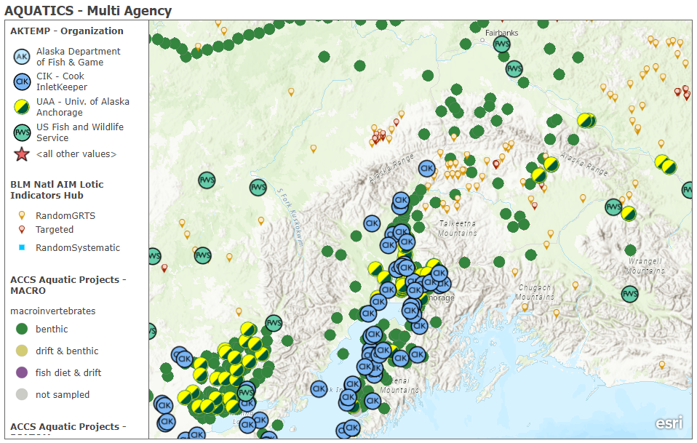
Figure 1. Initial survey of existing temperature and macroinvertebrate sampling locations and metadata from ACCS, BLM, and ADEC sampling efforts.
Task 1.2 Establish and carry out workflow for data ingestion and quality control

A data workflow will be created to bring together disparate macroinvertebrate datasets from data contributors. This workflow will check for data completeness, including information on data collection methodology, sampling time period, and locality information. This process will be documented to ensure replicability and transparency for end-users and to inform potential future efforts in other regions.

Task 1.3 Create a metadata webmapper

Similar to prior efforts to build a statewide freshwater temperature database, this project will start with mapping metadata about who is collecting what types of macroinvertebrate data in which locations and during which time periods. Depending on the comparability of efforts, this project may also be able to collate the datasets into a harmonized database, but based on prior experience of the leadership team with creating macroinvertebrate databases in other settings, that could be a time-intensive task. At minimum, this task will result in a mapper that shares information about data collection of freshwater prey resources across the region, providing a foundation for future efforts to build a database that can ingest and serve data about juvenile salmon food resources.

Task 1.4 Publish database on ACCS data catalog
To maximize utility of the freshwater macroinvertebrate database, the data will be published on the ACCS data catalog. This entry will include the webmapper created in Task 1.3, as well as supporting documentation to inform users about the provenance of information in the database and how to use the database for their purposes.

Objective 2: Juvenile salmon body condition database
The statewide juvenile salmon body condition database currently contains 109,000 juvenile salmon length measurements and over 39,000 weight measurements from across the state. These data were collated from 15 different research projects across the state. However, due to the statewide focus of this effort and the limited funds that supported its creation, an opportunity exists to expand on this effort to make this database even more useful in the future. By focusing on a specific region and conducting targeted outreach to potential data providers, the proposed work could be leveraged in the future in other regions across the state.

Task 2.1 Evaluate data gaps in existing database

While the existing database is extensive and covers the state, it still is lacking resolution and coverage in key areas for subsistence and personal use fisheries. Mapping locations of existing data will inform the next steps for targeted outreach to partners and potential data providers to build on this existing database. By also using coarse habitat filters (e.g. glaciated vs. non-glaciated watersheds), this project will also identify important habitat types that are currently underrepresented (Bidlack et al., 2014).

Task 2.2 Outreach to partners and potential data providers to supplement existing data

The outcome of Task 2.1 will inform targeted outreach to potential data providers in areas where salmon-bearing watersheds are located but where juvenile salmon data are missing from the existing database. For example, the Susitna basin is currently well-represented in the database, while information about the Copper River is missing, but likely available from project partners. As part of this proposed work, the Copper River Watershed Project will convene their existing network of partners working on a coordinated temperature monitoring effort in order to identify existing data. They will also expand their juvenile salmon sampling and temperature monitoring in partnership with the Ahtna Intertribal Resource Commission into the headwaters of Tanada Creek and Copper Lake to add novel data to both the juvenile salmon database and the AKTEMP freshwater temperature database. A more focused and targeted effort to secure data for Southcentral Alaska could also be leveraged in future work in other regions across the state.

Task 2.3 QA/QC final database and make spatially available on a webmapper

The current structure of the database is not spatially explicit, although the database contains locality data associated with body condition information. Turning this database into a webmapper will allow more users to interact with the data and to filter the database according to their geographic area of interest. The webmapper will include other filtering functionality so that users can, for example, select data from particular salmon species, sampling time periods, or data providers.

Task 2.4 Publish database to ACCS data catalog

The database is currently planned to be archived in a public data repository like the Knowledge Network for Biocomplexity database as a collection of .csv files and R scripts. By including a linked record to that public repository and a functional webmapper on the ACCS data catalog, the database will be more visible and accessible to practitioners across the state. The data catalog entry will include information about data curation and associated metadata.

Objective 3: Prey resource availability and juvenile salmon body condition across different thermal and geomorphic settings
AKTEMP is a publicly accessible database recently launched by ACCS in collaboration with Walker Environmental Research that takes in and distributes freshwater temperature data from across the state. The new launch of this database creates a unique opportunity to combine empirical data on water temperature, juvenile body condition, and prey availability to understand how thermal regimes and watershed geomorphic setting influence the freshwater juvenile life stage of Pacific salmon.

Task 3.1 Assess spatial and temporal overlaps between available temperature, prey availability, and juvenile salmon data
While AKTEMP builds on an existing metadata mapper, AKOATS (Alaska Online Aquatic Temperature Site), the database is still being populated by data contributors (Figure 2), with continued and funded efforts planned to bring in more data. As part of AKSSF Project 51012 to assess stream thermal sensitivities, ACCS has collaborated with partners in the same study area (Cook Inlet, Prince William Sound, and Copper River regions) to aggregate historical stream temperature datasets and perform quality control on summertime data. Data uploads to AKTEMP are performed by data collectors and ACCS will provide support to upload and review complete stream temperature time series for the study area so that these important datasets can be leveraged for this project and future research needs. AKTEMP can also store continuous and discrete lake temperature datasets and the project team will contact lake data collectors to facilitate importing these datasets into the database so that they can used to compare and contrast growth conditions for juvenile sockeye in the study area. Thus, this portion of the proposed work will focus on leveraging the AKTEMP database to identify watersheds where juvenile salmon body condition, prey resource, and freshwater temperature data have all been collected during comparable time periods.

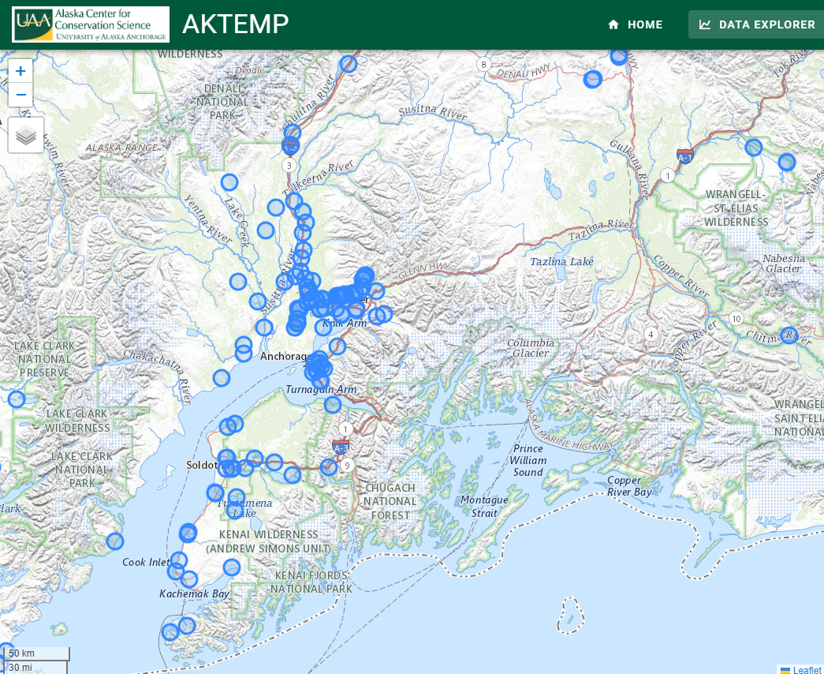
Figure 2. Sites with temperature data uploaded to the AKTEMP database. Note the concentration of sites in the northern and eastern Cook Inlet basin, compared with Prince William Sound and the Copper River basin.

Task 3.2 Analyze juvenile body condition and freshwater prey availability by thermal regime and geomorphic setting

Using watersheds identified as having overlapping data availability during Task 3.1, this project will assess how juvenile salmon body condition and freshwater prey availability vary with freshwater temperature and watershed characteristics (e.g. watershed glaciation) across the study area. A large set of geomorphic attributes have already been created for a spatially balanced set of stream reaches across the proposed study area (Cook Inlet, Prince William Sound, and Copper River regions) as part of AKSSF Project 51012. These include stream slope, mean catchment elevation, mean catchment slope, mean watershed slope, percent of the watershed with a north aspect, watershed area, distance to the coast, and percent of the watershed covered by glaciers, lakes, or wetlands.

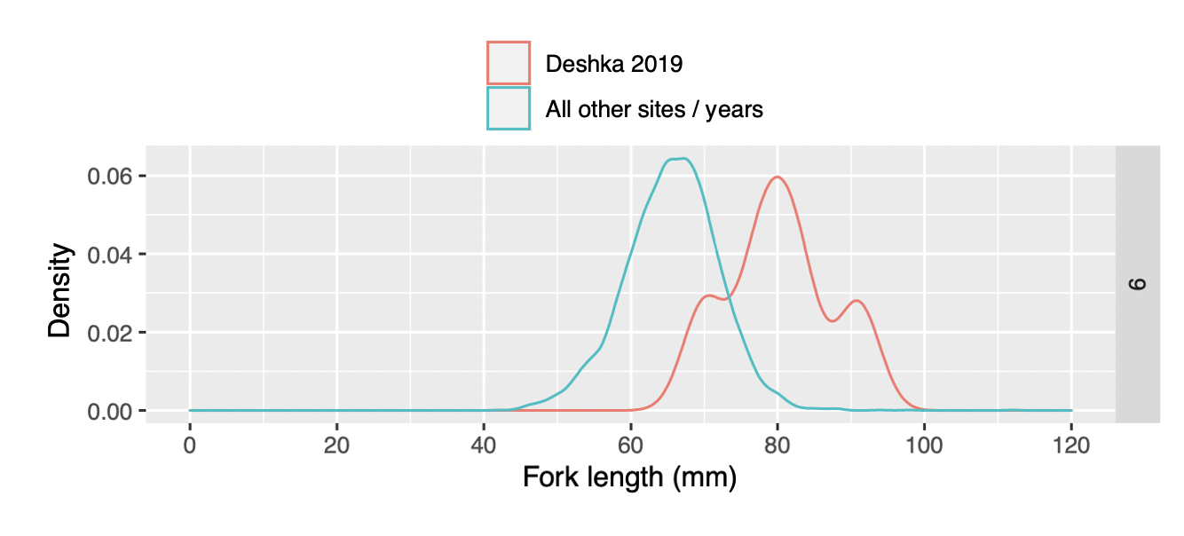
Figure 3. The distribution of length data from the juvenile salmon database for September, with the Deshka River in 2019 highlighted as a separate distribution from the remainder of the available data.

As an example, preliminary analysis of the juvenile salmon database (Figure 3) suggests that warmer freshwater systems and warmer years, like the Deshka River in 2019, will result in populations of juvenile salmon that reach longer lengths and potentially out-migrate sooner than cooler systems. However, this earlier maturity and outmigration timing could result in phenological mismatches between smolts and their marine food resources, with consequences for returning adult spawners in the future (Wilson et al., 2023). Better understanding of the juvenile freshwater portion of salmon life cycles across the region will help to identify these thermally sensitive habitats, as well as to predict which habitats might be more productive in the future.

Additional work that could leverage this joined database include efforts to: 1) compare end of summer juvenile salmon size as a proxy for watershed productivity across streams of different geomorphic settings; 2) model juvenile salmon bioenergetics across the landscape including empirical data about freshwater prey availability; 3) predict freshwater prey quality and quantity under different climate change scenarios; 4) compare juvenile salmon productivity to adult return data across different thermal regimes; and 5) target future sampling and monitoring in areas with little temporal and spatial overlap in temperature, prey, and juvenile salmon data.

Objective 4: Data synthesis

This final objective will synthesize the datasets compiled in the prior three objectives with additional data about watershed thermal sensitivities and current and future habitat threats to inform future AKSSF project selection.

Task 4.1 Create webmapper combining AKTEMP, juvenile salmon data, and freshwater prey data with thermal sensitivities from prior AKSSF work and current and future habitat threats.

Leveraging prior AKSSF-funded work on thermal sensitivities of salmon habitats (Figure 4), this proposed work will create a synthesis webmapper that brings together freshwater temperature data, juvenile salmon data, and freshwater prey data with thermal sensitivity data and current and proposed development threats to salmon habitat.

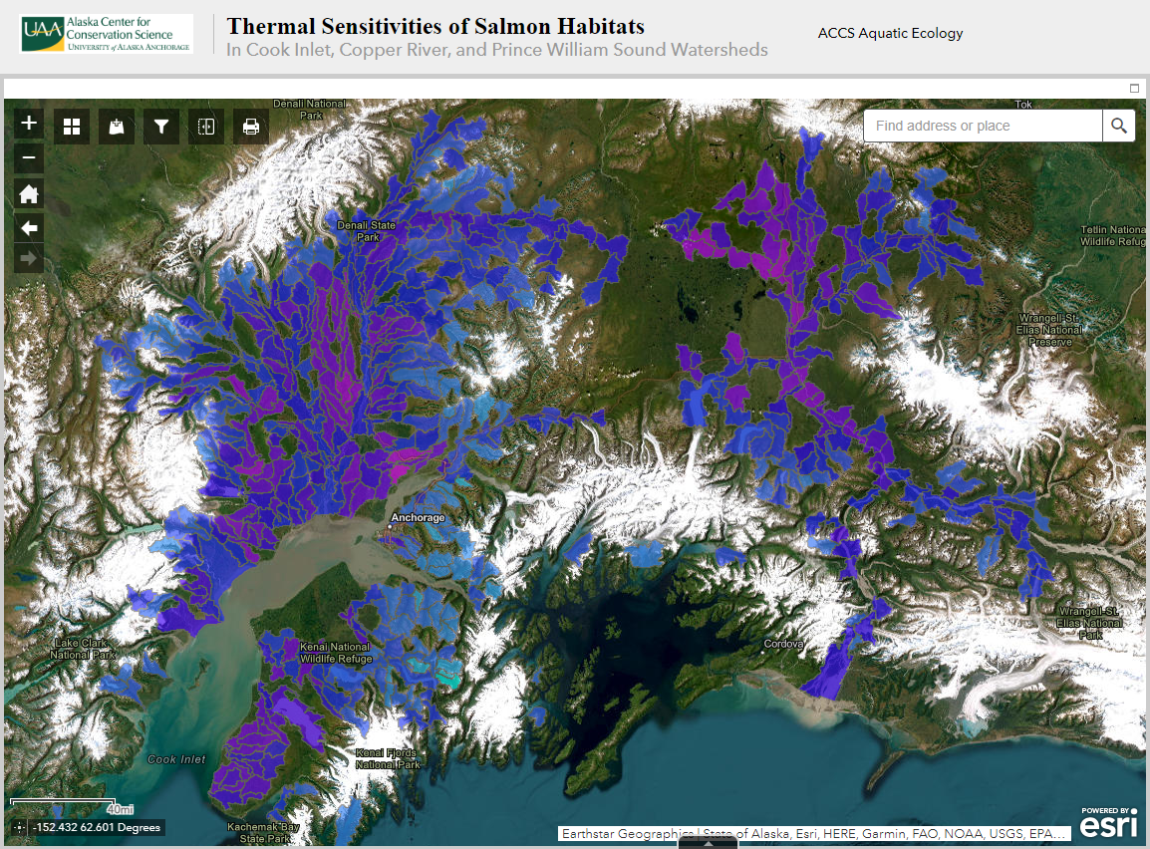
Figure 4. Webmapper of thermal sensitivities across the study region, from previously funded AKSSF work. Watersheds shown are at the HUC12 level.

Task 4.2 Assess overlaps between data gaps and sensitive watersheds to inform future AKSSF projects

The combined webmapper will be used to rank watersheds that are both sensitive to climate change and development threats and that are currently lacking data availability to monitor these changes. Based on prior work on thermal sensitivities in the region, all three study areas (Cook Inlet, Copper River, and Prince William Sound) have watersheds that span a range of thermal sensitivities (Figure 5). It is anticipated that some of the most thermally sensitive watersheds (e.g. the Deshka River and the Gulkana River) will have the most available data. However, the less thermally sensitive areas, such as those found at high elevations or in highly glacierized watersheds (Figure 4), might represent habitat that could become more productive for juvenile salmon in the future, which would motivate expanding restoration, conservation, and monitoring efforts in those watersheds. As an outcome of this task, this project will create a watershed prioritization based on value for juvenile rearing under current and future climatic conditions.

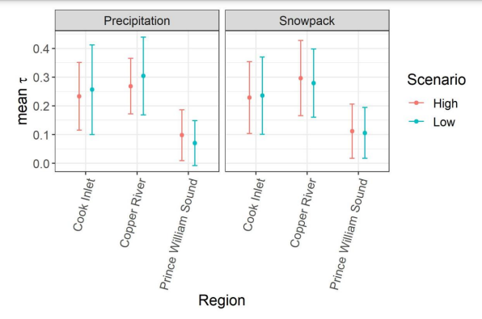
Figure 5. Average thermal sensitivities from the different subregions within the proposed study area, from previously funded AKSSF work. Scenarios shown include high and low temperature change scenarios, across changes in both spring snowpack and summer precipitation.

- Benefits

The outcomes of the proposed work will identify watersheds that are both threatened by climate change and current and proposed development and that lack sufficient data to assess those potential impacts. Those watersheds could then be targeted for enhanced monitoring, restoration, and conservation efforts by future AKSSF projects. This work will also highlight watersheds that are currently productive for juvenile salmon or that might experience an increase in productivity in the future as water temperatures rise. Those watersheds could then be prioritized for AKSSF-funded conservation and restoration efforts.

- Products, Milestones, and Timelines
- Project Milestones

Activity | 2024 |  | 2025 |  |  |  | 2026
 | Summer | Fall | Winter | Spring | Summer | Fall | Winter | Spring | Summer | Fall
Objective 1
Task 1.1
Task 1.2
Task 1.3
Task 1.4
Objective 2
Task 2.1
Task 2.2
Task 2.3
Task 2.4
Objective 3
Task 3.1
Task 3.2
Objective 4
Task 4.1
Task 4.2
Preparation of Final Report

Product Completion Dates:
- Objective 1: Freshwater macroinvertebrate database - Estimated completion date - December 2025
- Objective 2: Juvenile salmon body condition webmapper - Estimated completion date - March 2026
- Objective 3: Analysis of juvenile salmon body condition and prey availability across different thermal regimes and geomorphic settings - May 2026
- Objective 4: Biological data synthesis development threat data in a public mapper - November 2026
- Presentation of overall project to Alaska Chapter of the American Fisheries Society Annual Meeting - March 2026

- Project Communication

The project will hold semi-annual meetings with project partners and interested parties to provide updates and collect feedback to inform future direction, in addition to more frequent meetings among the project leadership team. Project team members, who are primarily located in the Cook Inlet region, will travel to Cordova to meet with project partners in the Copper River watershed and strengthen those relationships in the early stages of the proposed work. Similar meetings will take place in the Cook Inlet and Prince William Sound regions. Project results will be disseminated through multiple venues towards the end of the project, including sharing results at the annual meeting of the Alaska Chapter of the American Fisheries Society, local Fish Habitat Partnership meetings in the Matanuska-Susitna and Kenai Peninsula Boroughs, and through an informational webinar targeted towards interested parties and open to the public. All project reports and data products will be made publicly available and hosted through the ACCS data catalog.

- Experience and Qualifications
- Experience and qualifications of the principal investigator and key project personnel
Erin Larson has worked as a faculty member and aquatic ecologist in Alaska for 4 years. She has a B.A. in Biology from Dartmouth College and a Ph.D. in Ecology and Evolutionary Biology from Cornell University and has organized and led numerous field campaigns in remote areas of the U.S and Ecuador. Her research expertise encompasses community and ecosystem ecology of aquatic systems (e.g. Larson et al., 2021), including freshwater food web dynamics (Larson et al., 2018) and habitat effects on biological communities (e.g. Poff et al., 2018). Larson has over 18 published scientific peer-reviewed publications, mainly focusing on aquatic ecology. Larson has managed day-to-day project implementation and budgets, and completed deliverables on six grants totaling over $1,230,000, including three administered as PI. Larson has experience leading and participating in several complex projects with collaborators at universities, resource management agencies, consulting firms, and non-governmental organizations.
Rebecca Shaftel is an aquatic ecologist at the Alaska Center for Conservation Science. She has a B.S. in Earth Systems from Stanford University and M.S. in Biology from Baylor University. Rebecca co-authored the Stream Temperature Data Collection Standards for Alaska (Mauger et al., 2015) and has been involved in several research projects utilizing empirical stream temperature data, including a regional analysis of stream temperatures in Cook Inlet (Mauger et al., 2017) and a classification of stream thermal regimes for the Matanuska-Susitna Basin (Shaftel et al., 2020). She has scripted R code for calculating thermal regime metrics associated with water quality standards of salmon life histories.
Erik Schoen is an aquatic ecologist who studies population and community responses to environmental drivers. He recently served as joint lead author on a study of environmental drivers of Chinook salmon productivity in the Cook Inlet basin (Jones et al., 2020). Schoen led an interdisciplinary synthesis of climatic and landscape changes affecting salmon populations and fisheries in the Gulf of Alaska drainage basin, with a focus on the Kenai River (Schoen et al., 2017). He has also studied the influence of temperature on growth potential of juvenile Chinook salmon in the Chena River (Falke et al., 2019) and freshwater food resource use effects on juvenile coho and Chinook salmon in the Susitna River drainage (Rine et al., 2016).

Benjamin Meyer is an environmental scientist with Kenai Watershed Forum in Soldotna, Alaska, and has worked in ecology research and natural resource management throughout Alaska for fifteen years. He holds a B.S. in Biology and M.S. in Fisheries form University of Alaska Fairbanks. Meyer has six published peer-reviewed publications, including a recent manuscript focused on climate change's influence on growth of juvenile salmon in the Kenai River watershed (Meyer et al., 2023).
Dan Rinella, senior fisheries biologist with the U.S. Fish and Wildlife Service’s Southern Alaska Fish and Wildlife Field Office, has a Ph.D. in Biological Sciences from the University of Alaska Fairbanks and has conducted research on Alaska’s fish and their habitats for 23 years. He’s contributed to research focused on understanding changing thermal regimes and their drivers (Mauger et al., 2017; Shaftel et al., 2020) and on fish and fishery responses to environmental change (Leppi et al., 2014; Schoen et al., 2017; Jones et al., 2020; Meyer et al., 2023; Leppi et al., in press). He is currently leading watershed-scale temperature monitoring programs in the Deshka and Gulkana rivers focused on understanding watershed-scale thermal changes and their consequences for salmon.

Kate Morse, Program Director for the CRWP, will help with engagement of Copper River partners. Kate has 20 years of experience implementing partnership projects in the Copper River/Prince William Sound region, helping to coordinate communication and information dissemination between a wide range of partners. Since 2008 she has worked with the CRWP to help prioritize fish passage improvement projects in the region, and starting in 2022 convened partners to focus on filling freshwater temperature data gaps in the Copper River region.

- Experience and qualifications of the organization(s)

University of Alaska
The University of Alaska has well-developed administrative capabilities at both the UAF and UAA campuses, and PI Larson and Co-PIs Schoen and Shaftel have experience managing substantial research grants and the associated responsibilities. The University provides extensive support services for project administration and grant management as well as technical expertise for serving data to publicly available repositories. The College of Fisheries and Ocean Sciences shares a focus in research and education at the nexus of fisheries, oceanography, and marine biology, with faculty and students engaged in both applied research related to fisheries management and basic research in the areas of fish ecology and biology. The International Arctic Research Center fosters research to help the nation and the world to understand, prepare for, and adapt to the pan-Arctic impacts of climate change. The Alaska Center for Conservation Science (ACCS) is a center for research committed to providing the public, industry, and agency partners with information to facilitate effective biological conservation and management of the state’s natural resources by hosting an open source data portal.

ACCS Administrative experience and expertise (including training, facilities, existing programs, and administrative resources and personnel) in managing grants:

The Alaska Center for Conservation Science is a center for research, education, and scholarship at the University of Alaska Anchorage that is committed to providing the public, industry, and agency partners with information to facilitate effective biological conservation and management of the state’s natural resources. Our faculty and staff conduct basic and applied research, serve a wide range of data to the public, offer professional services, and provide educational opportunities.

ACCS was formed within UAA’s College of Arts and Sciences as the Alaska Natural Heritage Program, the Kachemak Bay National Estuarine Research Reserve (KBNERR), and the Landscape Ecology and Conservation Planning units in 2014. The primary administrative offices, staff, faculty, and students associated with the Alaska Natural Heritage Program and Landscape Ecology are housed on UAA’s main campus in Anchorage. ACCS maintains offices, an aquatic ecology lab, and the UAA herbarium on the main campus. In addition to these facilities, KBNERR offices, a marine lab, and a bunkhouse are located in Homer, Alaska. Management and serving of data is an integral element of the center and we use database services internally as well as from Information Technology Services at the university, private companies, and agency partners.

ACCS is primarily funded by grants, contracts, and cooperative agreements from a range of sources. Funding to support ACCS activities is derived from a wide diversity of federal agencies such as NOAA, BLM, USFWS, USFS, NPS, USGS, EPA, and DoD; state agencies such as ADF&G and DEC; as well as receiving support from municipalities, Tribes, NSF, and private sources. ACCS has a strong track record of managing these awards and maintains a grant management office that works closely with additional administrative personnel within the College of Arts and Sciences and UAA’s Office of Sponsored Programs. Additionally, in order to reach project objectives, our staff work closely with the university’s procurement, travel, facilities, human resources, and risk management offices. The fiscal professionals at ACCS and CAS have decades of experience and are trained in the laws, regulations, financial assistance mechanisms, uniform guidance administrative requirements, cost principles and risk management.
______________________
Additional specifics:
$2.5 - $3.0 M awarded in extramural funds. (ca. $250K in base funds from UAA)
Typically, 40+ awards are active at any time.
Administrative Personnel:
- 1 Fiscal Professional with 12+ years of experience in grant management and proposal administration at UAA. (Currently training for grant management certification)
- (½ time Fiscal Technician position to be filled.)
- 1 Director with 15+ years of experience in research, teaching, grant management and proposal administration at UAA.
- 1 KBNERR Manager (of reserve activities, ¼ support) with ca. 20 years of experience in research and grant management at the reserve.
- Additional grant management support from College of Arts and Sciences (2 fiscal professionals).

Kenai Watershed Forum
Founded in 1997 by a group of concerned citizens, the Kenai Watershed Forum (KWF) has grown from a small grassroots collective focusing on the Kenai River Watershed (2,200 square miles) to a regionally recognized 501(c)3 non-profit organization whose mission now encompasses the entire Kenai Peninsula (16,000 square miles).
With seven permanent employees and 5-7 seasonal employees, KWF utilizes a non-adversarial approach, focusing on solutions through high quality research, education, and restoration programs to meet the evolving needs of the region. This can be seen on the water and at the conference table. KWF facilitates hard conversations on natural resource issues, as evidenced by its role in facilitating the formation of the Kenai Peninsula Fish Habitat Partnership, which has brought varying entities to the table and has received national recognition through the National Fish Habitat Partnership. KWF is proud of its nationally recognized programs including the Stream Watch program. With an annual budget of over $1M, KWF typically holds more than 40 active grants and contracts from a variety of sources including local, state, and federal governments. The organization’s mission is “working together for healthy watersheds on the Kenai Peninsula,” and KWF is proud to be a recognized leader among watershed organizations in Alaska and beyond.
KWF is experienced in working with administrative and financial personnel with University of Alaska, which funded partner projects from 2014-2017 through the Alaska EPSCoR program. KWF has also received funding for multiple past projects through the Alaska Sustainable Salmon Fund.

U.S. Fish and Wildlife Service
The Southern Alaska Fish and Wildlife Field Office works with partners towards a connected network of lands and waters that support diverse, self-sustaining populations of wild, native fish that exhibit their natural variability in abundance, genetics, and life history. The staff specialize in fish management, ecology, biology, hydrology, fish passage, engineering, statistics, genetics, project management, habitat assessment and restoration, outreach, and administration. Through the delegated federal in-season fishery management authority, USFWS partners with the National Wildlife Refuge Program and other Service program, as well as State, Tribal, and Canadian entities (Yukon River only) to manage interjurisdictional fisheries on the Yukon, Kenai/Kasilof, Kuskokwim Rivers and river systems of the Alaska Peninsula. USFWS works with others to monitor long-term trends of anadromous fish populations, monitor for and manage aquatic invasive species, protect fish habitats, restore degraded habitats, remove barriers to fish passage, and use a variety of outreach tools to promote conservation and enjoyment of aquatic resources. USFWS provides technical and financial assistance to, and/or work cooperatively with Refuges, other government agencies, Alaska Tribes and Native organizations, private landowners and other interested groups to advance mutual conservation goals. These coordinated efforts and strategically placed staff help to ensure the vitality of our native aquatic resources and provide fish for subsistence and other uses now and for future generations.

Copper River Watershed Project
The mission of the Copper River Watershed Project (CRWP) is to “promote a salmon-rich, intact watershed and culturally diverse communities by forming partnerships for watershed-scale planning and projects.” The CRWP represents 23 communities across the 26,500 square mile watershed of the Copper River Basin. CRWP participates in and leads multiple habitat restoration and monitoring projects throughout the watershed to improve fish passage, re-vegetate and stabilize habitats for spawning and rearing salmon, assess water quality and identify salmon habitat for listing in the Alaska Department of Fish & Game’s Anadromous Waters Catalog.

CRWP has worked previously with researchers and financial administrators with University of Alaska and has previously received funding through the Alaska Sustainable Salmon Fund. The Copper River Watershed Project has considerable experience in project and grant management. In its 24-year history, the CRWP has regularly managed grants of $100,000 to multi-million-dollar awards. Sources from which the CRWP has received competitive funding in the past four years include the U.S. Fish & Wildlife Service, the National Fish & Wildlife Foundation, U.S. Forest Service, BLM, and Exxon Valdez Oil Spill Trustee Council, and the CRWP raises approximately $65,000 of general membership support annually. CRWP has an accounting staff who manages an accounting system capable of tracking expenditures by grant source. Staff track hours charged to active projects through time sheets, which are used to charge payroll expenses to the appropriate project grant. The CRWP uses profit and loss statements by grant source to show that only budgeted, allowable expenses are charged to grant accounts. The CRWP contracts annually for preparation of its IRS Form 990 by a CPA, conducted Single Audits in Fiscal Years 2010, 2011, 2020, 2021, and 2022. The CRWP has an approved indirect cost rate from USDA (included with proposal).
CRWP has a long history of facilitating successful partnerships, and has been recognized by BLM (2011) and USFWS (2021) as an outstanding partner for our role convening partners in a watershed-approach to sustaining the health of the region. Our fish passage partnership received the 2020 U.S. Forest Service’s Chief’s Honor Award for Region 10 in recognition of our outstanding achievements to improve aquatic organism passage on the Copper River delta.
- Leveraging Resources
The proposed work will benefit from previously awarded AKSSF funds and funds from other sources, detailed below:
● AKSSF-funded projects led by Shaftel (Projects 51012 and 53011) to assess thermal sensitivities of salmon habitats in the Cook Inlet, Copper River, Prince William Sound, and Bristol Bay regions. Results from these projects will help inform the analyses and synthesis outlined in Objectives 3 and 4.
● EPA-funded project led by Shaftel to develop a statewide portal of water temperature data for Alaska (AK TEMP). This work builds on previous temperature data discoverability and synthesis efforts including the State of Alaska Salmon and People project and AKOATS, a data portal of stream temperature monitoring metadata. This project will leverage the large amount of data that has been QAQC’d and made publicly available.
● EPA-funded project led by Shaftel to monitor macroinvertebrate communities in streams around Cook Inlet. This project will use this compiled dataset to jumpstart the prey availability database.
- Congressionally-directed funds led by Larson to engage communities around Cook Inlet in salmon watershed stewardship. This project will utilize the network created by this project to solicit data sharing and feedback on the proposed work.

- Project Budget

University of Alaska Anchorage
Line 100: Personnel
- Erin Larson will lead the project as PI and will oversee all of the project objectives and tasks. She will lead the creation of the prey availability database. Salary costs for Larson include 2.5% COLA annually as negotiated by UNAC, 12.5% leave rate, and have a 28.3% fringe benefit rate added to them.
  - Year 1: 200 hours at $9,767 ($43.41/hour)
  - Year 2: 257 hours at $12,865 ($44.50/hour)
  - Year 3: 175 hours at $8,979 ($45.61/hour)
- Rebecca Shaftel will provide statistical and analytical expertise, and as an expert in stream temperature modeling, will help with analyses of data for Objectives 3 and 4. Salary costs for Shaftel include 16.5% leave rate, 2.5% COLA annually, and have an added 38.5% fringe benefit rate.
  - Year 1: 175 hours at $8,314 ($40.78/hour)
  - Year 2: 257 hours at $12,418 ($41.80/hour)
  - Year 3: 175 hours at $4,618 ($42.84/hour)
- Dustin Merrigan will help with data QA/QC and with creation of spatial layers and datasets. Salary costs for Merrigan include 17.8% leave rate, 2.5% COLA annually, and have an added 48.6% fringe benefit rate.
  - Year 1: 175 hours at $5,702 ($27.66/hour)
  - Year 2: 255 hours at $8,517 ($28.35/hour)
  - Year 3: 80 hours at $2,739 ($29.06/hour)
Line 200: Travel
Travel rates follow per diem and lodging rates set for the state of Alaska by the federal government.
- Travel is requested for two people to travel to Cordova to meet with the Copper River Watershed Project and their partners
  - Airfare is estimated at $310 roundtrip, for a total of $620
  - Lodging for one night is estimated at $174, for a total of $348
  - Per Diem is estimated at $170 for two days for a total of $340
- Travel is requested for two people to attend the Alaska Chapter of the American Fisheries Society conference in late March 2026.
  - Airfare is estimated at $350 roundtrip, for a total of $700
  - Lodging for four nights is estimated at $522, for a total of $1,044
  - Per Diem is estimated at $52 for four days for a total of $255
Line 300: Contractual
- Registration costs for two people is requested for the Alaska AFS conference: $350/registration = $700 total
Line 400: Supplies
Line 500: Equipment
Line 600: Indirect
- $28,152 is requested for indirect costs

UAA’s federally negotiated indirect rate is 53.1% excluding tuition, equipment, and contractual costs in excess of $25,000. UAA is voluntarily reducing its indirect rate to 25% for this proposal.

University of Alaska Fairbanks
Line 100: Personnel
- Erik Schoen will compile salmon body size data, analyze patterns and trends in body size in relation to temperature and food, and contribute to deliverables. Salary costs include 2.5% COLA as negotiated by UNAC, 12.5% leave rate, and 28.3% fringe benefit rate..
    - Year 1: 174 hours at $11,847 ($47.17/hour), including COLA, leave rate, and fringe benefit rate
    - Year 2: 261 hours at $18,215 ($48.35/hour), including COLA, leave rate, and fringe benefit rate
    - Year 3: 87 hours at $6,224 ($49.56/hour), including COLA, leave rate, and fringe benefit rate
Salaries are listed at the current FY23 rate and include a leave reserve of 12.5% for faculty. Salaries also include an annual inflation increase of 2.5%. The FY24 increase for UNAC-represented faculty salaries is budgeted at 5.8% per the tentative agreement for contract renewal announced November 1, 2022. A copy of the announcement can be found at: https://alaska.edu/hr/labor/labor-relations/bargaining.php.
Staff benefits are applied according to UAF’s FY23 fixed fringe benefit rates. Rates are 28.3% for faculty salaries. A copy of the rate agreement is available at http://www.alaska.edu/cost-analysis/negotiation-agreements/.
Line 200: Travel
- None
Line 300: Contractual
- None
Line 400: Supplies
- None
Line 500: Equipment
- None
Line 600: Indirect
- $19,958 is requested for indirect costs
Facilities and Administrative (F&A) Costs are negotiated with the Office of Naval Research. The rate for sponsored research at UAF is calculated at 55.0% (FY23-FY26 predetermined agreement) of Modified Total Direct Costs (MTDC). MTDC includes Total Direct Costs minus tuition and associated fees, scholarships, participant support costs, rental/lease costs, subaward amounts over $25,000, and equipment. A copy of the rate agreement is available at: http://www.alaska.edu/cost-analysis/negotiation-agreements/.

Copper River Watershed Project
Line 100: Personnel
- Kirsti Jurica, CRWP Hydro- Biologist, will assist AITRC with temperature logger site assessments in the 2024 field season: 2 weeks @ $1791 = $3582
- Kate Morse, CRWP Program Director, will coordinate with current Copper River watershed temperature monitoring partnership: 2 week @ $1929/weeks = $3858
- Ashley Taylor, CRWP GIS and Data Specialist, will help communicate Copper River watershed temperature monitoring partnership efforts: 2 weeks @ $1378 = $2756
Line 200: Travel
- None
Line 300: Contractual
- Dan Gorze, AITRC Biologist, will oversee temperature logger deployment and retrieval, juvenile fish sampling, and macroinvertebrate evaluation in the 2024 field season: 2 weeks @ $1494/week = $2988
- AITRC Technician, will assist with temperature logger deployment and retrieval, juvenile fish sampling, and macroinvertebrate evaluation in the 2024 field season: 2 weeks @$1243/week = $2486
- Dan Gorze, AITRC Biologist and an AITRC Technician will travel from Glennallen to Klutina Lake field site overnight roundtrip 4 times in the 2024 field season:
  - Ground vehicle travel 200 miles @ $.66/mile = $132
  - Boat fuel 6 days @ $60/day (12 gal @ $5/gal) = $360
  - Meals and incidentals per diem: 8 days @ $80/day (first and last days) + 2 days at $121/day (non-travel days) x 2 people = $1764
Line 400: Supplies
- CRWP will purchase 10 HOBO loggers @ $150/unit = $1500
- CRWP will purchase a HOBO U23 Pro v2 Temperature/Relative Humidity Data Logger, solar radiation shield, and housing and mounting hardware = $482
Line 500: Equipment
- None
Line 600: Indirect
- Copper River Watershed Project's federally negotiated indirect rate through December 31, 2023, is 30% excluding capital expenditures, and the portion of subawards in excess of $25,000.

Kenai Watershed Forum
Line 100: Personnel
- Benjamin Meyer, Water Quality Coordinator, Kenai Watershed Forum, will assist project PIs with data management and project development tasks described throughout the methodology. He will assist in reaching out to partners and coordinating efforts to assess availability of freshwater prey availability data, juvenile salmon body condition data, and water temperature data. He will assist in communicating results from this project to regional partners including tribes, nonprofits, and government agencies. 500 hours at $36.51/hour = $18,255.00
Line 200: Travel
- Benjamin Meyer, Water Quality Coordinator, Kenai Watershed Forum, will travel to Juneau, Alaska for the spring 2026 Alaska Chapter of the American Fisheries Society meeting (dates TBD)
  - Airfare: 1 ticket Kenai - Juneau @ $658/ticket = $658
  - Lodging: 3 nights @ $249/night = $747
  - Meals per diem: 2 days @ $56/day (first and last days) + 2 days at $95/day (non-travel days) = $302
Line 300: Contractual
● None
Line 400: Supplies
● None
Line 500: Equipment
● None
Line 600: Indirect
● Kenai Watershed Forum’s federally negotiated indirect rate through December 31, 2023, is 25.40% excluding capital expenditures, pass through funds, equipment depreciation, and contractual expenses in excess of the first $25,000.

- Match Budget

University of Alaska Anchorage
Line 100: Personnel
- Erin Larson will provide a total of 88 hours of matched salary. Salary costs for Larson include 2.5% COLA annually as negotiated by UNAC, 12.5% leave rate, and have a 28.3% fringe benefit rate added to them.
  - Year 1: 40 hours at $1,953 ($43.41/hour)
  - Year 2: 30 hours at $1,502 ($44.50/hour)
  - Year 3: 18 hours at $924 ($45.61/hour)
- Rebecca Shaftel will provide a total of 88 hours of matched salary. Salary costs for Shaftel include 16.5% leave rate, 2.5% COLA annually, and have an added 38.5% fringe benefit rate.
  - Year 1: 40 hours at $8,314 ($40.78/hour)
  - Year 2: 30 hours at $12,418 ($41.80/hour)
  - Year 3: 18 hours at $4,618 ($42.84/hour)
Line 200: Travel
- None
Line 300: Contractual
- None
Line 400: Supplies
- None
Line 500: Equipment
Unrecovered indirect costs on sponsor budget are calculated as follows: 53.1% (full negotiated F&A rate for organized research) – 25.0% (reduced F&A rate) = 28.1% unrecovered F&A rate. 28.1% x sponsor budget of $140,828 = $31658 unrecovered indirect costs. Per AKSSF administrative guidance, unrecovered indirect costs are included in the “Equipment” line of the AKSSF budget spreadsheet.
Line 600: Indirect
UAA’s federally negotiated indirect rate is 53.1% excluding tuition, equipment, and contractual costs in excess of $25,000. UAA is voluntarily reducing its indirect rate to 25% for this proposal.

University of Alaska Fairbanks
Line 100: Personnel
- Erik Schoen will provide match of 60.91 hours (0.35 mos.) in Year 1, 91.36 hours (0.53 mos.) in Year 2, and 30.44 hours (0.17 mos.) in Year 3 (at $46.02 /hour). Additionally, a total match of $2,801 in benefits will be provided.
Salaries are listed at the current FY23 rate and include a leave reserve of 12.5% for faculty. Salaries also include an annual inflation increase of 2.5%. The FY24 increase for UNAC-represented faculty salaries is budgeted at 5.8% per the tentative agreement for contract renewal announced November 1, 2022. A copy of the announcement can be found at: https://alaska.edu/hr/labor/labor-relations/bargaining.php.
Staff benefits are applied according to UAF’s FY23 fixed fringe benefit rates. Rates are 28.3% for faculty salaries. A copy of the rate agreement is available at http://www.alaska.edu/cost-analysis/negotiation-agreements/.

Line 200: Travel
- None
Line 300: Contractual
- None
Line 400: Supplies
- None
Line 500: Equipment
- None
Line 600: Indirect
- Facilities and Administrative (F&A) Costs are negotiated with the Office of Naval Research. The rate for sponsored research at UAF is calculated at 55.0% (FY23-FY26 predetermined agreement) of Modified Total Direct Costs (MTDC). MTDC includes Total Direct Costs minus tuition and associated fees, scholarships, participant support costs, rental/lease costs, subaward amounts over $25,000, and equipment. A copy of the rate agreement is available at: http://www.alaska.edu/cost-analysis/negotiation-agreements/.

Copper River Watershed Project
Line 100: Personnel
- Kirsti Jurica, CRWP Hydro- Biologist, will provide match: 50 hours @ $45/hour = $2239
- Kate Morse, CRWP Program Director, will provide match: 60 hours @ $48/hour = $2894
- Ashley Taylor, CRWP GIS and Data Specialist, will provide match: 53 hours @ $34/hour = $1826
Line 200: Travel
- None
Line 300: Contractual
- None
Line 400: Supplies
- None
Line 500: Equipment
- None
Line 600: Indirect
- Copper River Watershed Project's federally negotiated indirect rate through December 31, 2023, is 30% excluding capital expenditures, and the portion of subawards in excess of $25,000.
Kenai Watershed Forum
Line 100: Personnel
- KWF Employee Benjamin Meyer personnel time: 122.5 hours @ $36.51/hour = $6389.25.

Line 200: Travel
● None
Line 300: Contractual
● None
Line 400: Supplies
● None
Line 500: Equipment
● None
Line 600: Indirect
● Kenai Watershed Forum’s federally negotiated indirect rate through December 31, 2023, is 25.40% excluding capital expenditures, pass through funds, equipment depreciation, and contractual expenses in excess of the first $25,000.
Ahtna Intertribal Resource Commission
Line 100: Personnel
- None
Line 200: Travel
- AITRC solar jet boat: 6 days @ $350/day = $2,100
Line 300: Contractual
- None
Line 400: Supplies
- None
Line 500: Equipment
- None
Line 600: Indirect
- None

- References
Adelfio, L. A., Wondzell, S. M., Mantua, N. J., & Reeves, G. H. (2019). Warm winters reduce landscape-scale variability in the duration of egg incubation for coho salmon (Oncorhynchus kisutch) on the Copper River Delta, Alaska. Canadian Journal of Fisheries and Aquatic Sciences, 76(8), 1362–1375. https://doi.org/10.1139/cjfas-2018-0152
Armstrong, J. B., Schindler, D. E., Omori, K. L., Ruff, C. P., & Quinn, T. P. (2010). Thermal heterogeneity mediates the effects of pulsed subsidies across a landscape. Ecology, 91(5), 1445–1454. https://doi.org/10.1890/09-0790.1
Bidlack, A. L., Benda, L. E., Miewald, T., Reeves, G. H., & McMahan, G. (2014). Identifying Suitable Habitat for Chinook Salmon across a Large, Glaciated Watershed. Transactions of the American Fisheries Society, 143(3), 689–699. https://doi.org/10.1080/00028487.2014.880739
Campbell, E. Y., Dunham, J. B., & Reeves, G. H. (2020). Linkages between temperature, macroinvertebrates, and young-of-year Coho Salmon growth in surface-water and groundwater streams. Freshwater Science, 39(3), 447–460. https://doi.org/10.1086/710042
Cline, T. J., Ohlberger, J., & Schindler, D. E. (2019). Effects of warming climate and competition in the ocean for life-histories of Pacific salmon. Nature Ecology & Evolution, 3(6), 935–942. https://doi.org/10.1038/s41559-019-0901-7
Falke, J. A., Huntsman, B. M., & Schoen, E. R. (2019). Advances in Understanding Landscape Influences on Freshwater Habitats and Biological Assemblages. In Advances in Understanding Landscape Influences on Freshwater Habitats and Biological Assemblages. American Fisheries Society. https://doi.org/10.47886/9781934874561.ch4
Gendaszek, A. S., Burton, K., Magirl, C. S., & Konrad, C. P. (2018). Streambed scour of salmon spawning habitat in a regulated river influenced by management of peak discharge. Freshwater Biology, 63(8), 917–927. https://doi.org/10.1111/fwb.12987
Goertler, P., Jones, K., Cordell, J., Schreier, B., & Sommer, T. (2018). Effects of Extreme Hydrologic Regimes on Juvenile Chinook Salmon Prey Resources and Diet Composition in a Large River Floodplain. Transactions of the American Fisheries Society, 147(2), 287–299. https://doi.org/10.1002/tafs.10028
Graham, C., Pakhomov, E. A., & Hunt, B. P. V. (2020). A salmon diet database for the North Pacific Ocean. Scientific Data, 7, 332. https://doi.org/10.1038/s41597-020-00676-y
Grunblatt, J., Meyer, B. E., & Wipfli, M. S. (2019). Invertebrate prey contributions to juvenile Coho Salmon diet from riparian habitats along three Alaska streams: Implications for environmental change. Journal of Freshwater Ecology, 34(1), 617–631. https://doi.org/10.1080/02705060.2019.1642243
Harrison, H. L., & Loring, P. A. (2016). Urban harvests: Food security and local fish and shellfish in Southcentral Alaska. Agriculture & Food Security, 5(1), 16. https://doi.org/10.1186/s40066-016-0065-5
Henderson, M. A., & Cass, A. J. (1991). Effect of Smolt Size on Smolt-to-Adult Survival for Chilko Lake Sockeye Salmon ( Oncorhynchus nerka ). Canadian Journal of Fisheries and Aquatic Sciences, 48(6), 988–994. https://doi.org/10.1139/f91-115
Johnson, A. C., Bellmore, J. R., Haught, S., & Medel, R. (2019). Quantifying the Monetary Value of Alaska National Forests to Commercial Pacific Salmon Fisheries. North American Journal of Fisheries Management, 39(6), 1119–1131. https://doi.org/10.1002/nafm.10364
Jones, L. A., Schoen, E. R., Shaftel, R., Cunningham, C. J., Mauger, S., Rinella, D. J., & St. Saviour, A. (2020). Watershed-scale climate influences productivity of Chinook salmon populations across southcentral Alaska. Global Change Biology, 26(9), 4919–4936. https://doi.org/10.1111/gcb.15155
Lader, R., Walsh, J. E., Bhatt, U. S., & Bieniek, P. A. (2017). Projections of Twenty-First-Century Climate Extremes for Alaska via Dynamical Downscaling and Quantile Mapping. Journal of Applied Meteorology and Climatology, 56(9), 2393–2409. https://doi.org/10.1175/JAMC-D-16-0415.1
Larson, E. I., Poff, N. L., Atkinson, C. L., & Flecker, A. S. (2018). Extreme flooding decreases stream consumer autochthony by increasing detrital resource availability. Freshwater Biology. https://doi.org/10.1111/fwb.13177
Larson, E. I., Poff, N. L., Funk, W. C., Harrington, R. A., Kondratieff, B. C., Morton, S. G., & Flecker, A. S. (2021). A unifying framework for analyzing temporal changes in functional and taxonomic diversity along disturbance gradients. Ecology, 102(11), e03503. https://doi.org/10.1002/ecy.3503
Leppi, J. C., Rinella, D. J., Wilson, R. R., & Loya, W. M. (2014). Linking climate change projections for an Alaskan watershed to future coho salmon production. Global Change Biology, 20(6), 1808–1820. https://doi.org/10.1111/gcb.12492
Lisi, P. J., Schindler, D. E., Cline, T. J., Scheuerell, M. D., & Walsh, P. B. (2015). Watershed geomorphology and snowmelt control stream thermal sensitivity to air temperature. Geophysical Research Letters, 42(9), 3380–3388. https://doi.org/10.1002/2015GL064083
Lusardi, R. A., Hammock, B. G., Jeffres, C. A., Dahlgren, R. A., & Kiernan, J. D. (2020). Oversummer growth and survival of juvenile coho salmon (Oncorhynchus kisutch) across a natural gradient of stream water temperature and prey availability: An in situ enclosure experiment. Canadian Journal of Fisheries and Aquatic Sciences, 77(2), 413–424. https://doi.org/10.1139/cjfas-2018-0484
Mauger, S., Shaftel, R., Leppi, J. C., & Rinella, D. J. (2017). Summer temperature regimes in southcentral Alaska streams: Watershed drivers of variation and potential implications for Pacific salmon. Canadian Journal of Fisheries and Aquatic Sciences, 74(5), 702–715. https://doi.org/10.1139/cjfas-2016-0076
Mauger, S., Shaftel, R., Trammell, E. J., Geist, M., & Bogan, D. (2015). Stream temperature data collection standards for Alaska: Minimum standards to generate data useful for regional-scale analyses. Journal of Hydrology: Regional Studies, 4, 431–438. https://doi.org/10.1016/j.ejrh.2015.07.008
Meyer, B. E., Wipfli, M. S., Schoen, E. R., Rinella, D. J., & Falke, J. A. (2023). Landscape characteristics influence projected growth rates of stream-resident juvenile salmon in the face of climate change in the Kenai River watershed, south-central Alaska. Transactions of the American Fisheries Society, 152(2), 169–186. https://doi.org/10.1002/tafs.10397
Pitman, K. J., Moore, J. W., Huss, M., Sloat, M. R., Whited, D. C., Beechie, T. J., Brenner, R., Hood, E. W., Milner, A. M., Pess, G. R., Reeves, G. H., & Schindler, D. E. (2021). Glacier retreat creating new Pacific salmon habitat in western North America. Nature Communications, 12(1), Article 1. https://doi.org/10.1038/s41467-021-26897-2
Poff, L. N., Larson, E. I., Salerno, P. E., Morton, S. G., Kondratieff, B. C., Flecker, A. S., Zamudio, K. R., & Funk, C. W. (2018). Extreme streams: Species persistence and genomic change in montane insect populations across a flooding gradient. Ecology Letters, 21(4), 525–535. https://doi.org/10.1111/ele.12918
Quinn, T. P. (2005). The Behavior and Ecology of Pacific Salmon and Trout (First Paperback edition). University of Washington Press.
Railsback, S. F. (2022). What We Don’t Know About the Effects of Temperature on Salmonid Growth. Transactions of the American Fisheries Society, 151(1), 3–12. https://doi.org/10.1002/tafs.10338
Rine, K. M., Wipfli, M. S., Schoen, E. R., Nightengale, T. L., & Stricker, C. A. (2016). Trophic pathways supporting juvenile Chinook and coho salmon in the glacial Susitna River, Alaska: Patterns of freshwater, marine, and terrestrial food resource use across a seasonally dynamic habitat mosaic. Canadian Journal of Fisheries and Aquatic Sciences, 73(11), 1626–1641. https://doi.org/10.1139/cjfas-2015-0555
Ruggerone, G. T., Nielsen, J. L., & Agler, B. A. (2009). Linking marine and freshwater growth in western Alaska Chinook salmon Oncorhynchus tshawytscha. Journal of Fish Biology, 75(6), 1287–1301. https://doi.org/10.1111/j.1095-8649.2009.02364.x
Schoen, E. R., Wipfli, M. S., Trammell, E. J., Rinella, D. J., Floyd, A. L., Grunblatt, J., McCarthy, M. D., Meyer, B. E., Morton, J. M., Powell, J. E., Prakash, A., Reimer, M. N., Stuefer, S. L., Toniolo, H., Wells, B. M., & Witmer, F. D. W. (2017). Future of Pacific Salmon in the Face of Environmental Change: Lessons from One of the World’s Remaining Productive Salmon Regions. Fisheries, 42(10), 538–553. https://doi.org/10.1080/03632415.2017.1374251
Shaftel, R., Mauger, S., Falke, J., Rinella, D., Davis, J., & Jones, L. (2020). Thermal Diversity of Salmon Streams in the Matanuska-Susitna Basin, Alaska. JAWRA Journal of the American Water Resources Association, 56(4), 630–646. https://doi.org/10.1111/1752-1688.12839
Sloat, M. R., Reeves, G. H., & Christiansen, K. R. (2017). Stream network geomorphology mediates predicted vulnerability of anadromous fish habitat to hydrologic change in southeast Alaska. Global Change Biology, 23(2), 604–620. https://doi.org/10.1111/gcb.13466
Somerville, M. A., & Hansen, T. (2021). Fishery management report for the recreational, personal use, and subsistence fisheries of the Upper Copper/Upper Susitna Management Area, 2019 (Fishery Management Report No. 21–07). Alaska Department of Fish and Game.
von Biela, V. R., Bowen, L., McCormick, S. D., Carey, M. P., Donnelly, D. S., Waters, S., Regish, A. M., Laske, S. M., Brown, R. J., Larson, S., Zuray, S., & Zimmerman, C. E. (2020). Evidence of prevalent heat stress in Yukon River Chinook salmon. Canadian Journal of Fisheries and Aquatic Sciences, 77(12), 1878–1892. https://doi.org/10.1139/cjfas-2020-0209
Wilson, S. M., Moore, J. W., Ward, E. J., Kinsel, C. W., Anderson, J. H., Buehrens, T. W., Carr-Harris, C. N., Cochran, P. C., Davies, T. D., Downen, M. R., Godbout, L., Lisi, P. J., Litz, M. N. C., Patterson, D. A., Selbie, D. T., Sloat, M. R., Suring, E. J., Tattam, I. A., & Wyatt, G. J. (2023). Phenological shifts and mismatch with marine productivity vary among Pacific salmon species and populations. Nature Ecology & Evolution, 1–10. https://doi.org/10.1038/s41559-023-02057-1
Zillig, K. W., Lusardi, R. A., Moyle, P. B., & Fangue, N. A. (2021). One size does not fit all: Variation in thermal eco-physiology among Pacific salmonids. Reviews in Fish Biology and Fisheries, 31(1), 95–114. https://doi.org/10.1007/s11160-020-09632-w

