kenai_salmon_data

Benjamin Meyer

2024-05-15

Table of contents

# Northern Kenai Peninsula Salmon: Who’s Catching What?

In Alaska’s Northern Kenai Peninsula region, wild salmon fisheries exemplify the high social, economic, and ecological value of wild salmon and the complex changes they face in the Gulf of Alaska region. Wild salmon harvest is central to the region’s food sovereignty, allowing tens of thousands of Alaskans to harvest a sustainable, wild, and local protein. Whether it is to fill the family freezer in the personal use fishery, take home a paycheck from commercial fishing, or sustain cultural traditions in customary and additional harvest, people of southcentral Alaska count on the millions of salmon that return each year to the Kenai and Kasilof rivers.

As the population and economy of southcentral Alaska has evolved in the 21st century, the magnitude of harvest of wild salmon by the region’s distinct user groups has shifted dramatically. Since 1970’s, combined harvest by sport and personal use fisheries have grown from under 10% prior to 1995 to 44% in year 2022. The shift signals a strong growth in demand for the opportunity to independently harvest the region’s salmon both for local consumption as well as tourism. The degree to which this shift has affected the region’s commercial salmon fishing industry is highly contentious. The region is also home to several active tribal entities who have stewarded the region’s fisheries for millennia, and continue to do so today.

Additional content TKA here

# 1. Data Sources

# 2. Data Sources

## 2.1 Geographical Areas

Note on data sources for Northern Kenai Peninsula Fisheries Harvest, adapted from (Schoen et al. 2017) supplemental materials:

Harvest and effort data are reported differently for the commercial, recreational, and personal-use fisheries in Upper Cook Inlet, such that it is not possible to calculate the harvest and effort of salmon produced specifically by the Kenai or Kasilof Rivers (including their tributaries) by each fishing sector. To make comparisons within a common geographic area, we aggregated harvest and effort data from the northern Kenai Peninsula, ranging from the Kasilof River in the south to Ingram Creek in the north. The Kenai River is the predominant salmon-producing river in this area.

We aggregated harvest and effort data from the following fisheries:

* Commercial: Central District drift gill net and east-side set gill net (Shields and Dupuis 2016);
* Recreational: Northern Kenai Peninsula Management Area (Begich et al. 2013);
* Personal-use: Kenai River dip net, Kasilof River dip net, and Kasilof River set net (Fall et al. 2015; Shields and Dupuis 2016). ADF&G also reports harvest and effort for an “unknown” personal-use fishery in Upper Cook Inlet. This harvest and effort was reported on permits on which the fishery was left blank. We allocated this harvest and effort to each known fishery based on the proportions of accurately reported harvest and effort in each year.

## 2.2 Plots

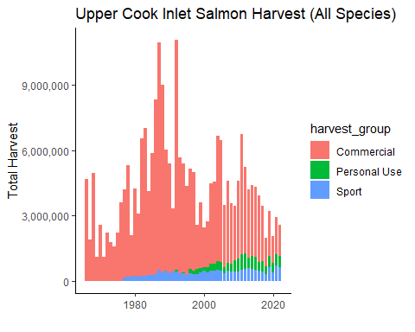

`summarise()` has grouped output by 'harvest_group'. You can override using the  
`.groups` argument.

## 2.3 Commercial Harvest

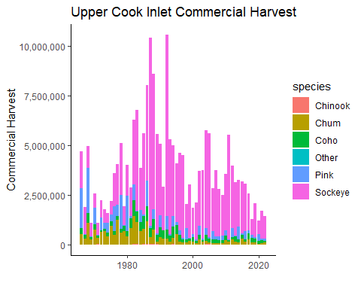

## 2.4 Personal Use Harvest

Warning: Removed 61 rows containing missing values or values outside the scale range  
(`geom_bar()`).

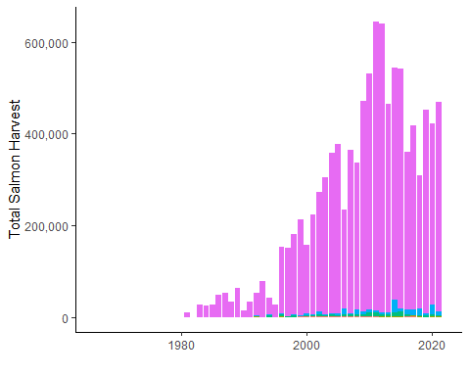

Joining with `by = join_by(year, harvest_group)`

Warning: Using `size` aesthetic for lines was deprecated in ggplot2 3.4.0.  
ℹ Please use `linewidth` instead.  
Removed 61 rows containing missing values or values outside the scale range  
(`geom_bar()`).

Warning: Removed 80 rows containing missing values or values outside the scale range  
(`geom_line()`).

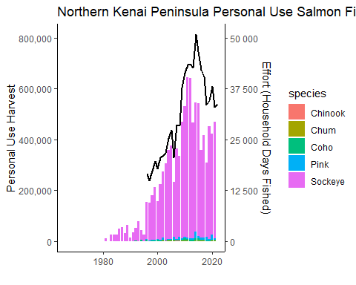

Warning: Removed 16 rows containing missing values or values outside the scale range  
(`geom_line()`).

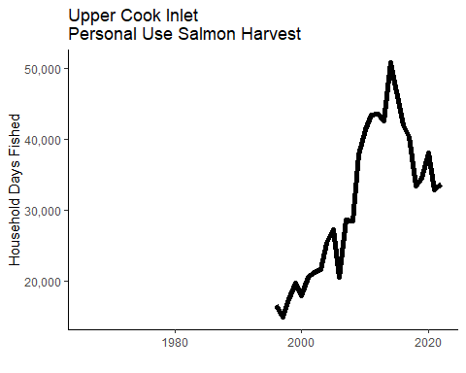

Warning: Removed 16 rows containing missing values or values outside the scale range  
(`geom_line()`).

Warning: Removed 61 rows containing missing values or values outside the scale range  
(`geom_bar()`).

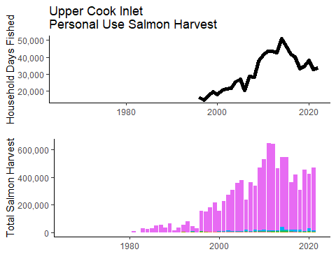

## 2.5 Sport Harvest

Scale for y is already present.  
Adding another scale for y, which will replace the existing scale.  
Joining with `by = join_by(year)`  
Scale for y is already present.  
Adding another scale for y, which will replace the existing scale.

Warning: Removed 6 rows containing missing values or values outside the scale range  
(`geom_bar()`).

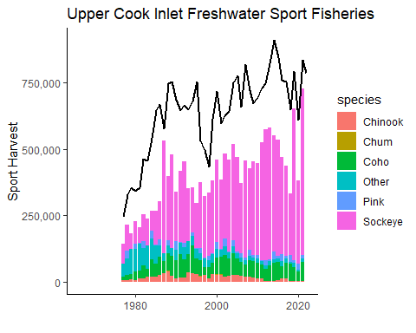

Next:

* find commercial effort data
* map fig(s) to indicate where data is sourced from
* match stack colors to original fig
* match stack order to legend order
* explanatory text (comm has longest time series, etc)
* diff colors for fig 1 than any other used
* representative pictures of each fishery

Idea for NEW overall fig - stacked bar plot of harvest by fishery (& sub stack by species?) superimposed with total harvest … can visualize remaining escapement in context of harvest. –> might be hard to do becuase the above figures do not include solely kenai fish

* place citations/sources for data below each plot

See p 91 in lipka & stumpf 2024, all uci sockeye harvests combined

plan - draft for sport and pu; send to anna, as for effort data for comm

# 3. Summary

In summary, this book has no content whatsoever.

1 + 1

[1] 2

# References

Schoen, Erik R, Mark S Wipfli, E Jamie Trammell, Daniel J Rinella, Angelica L Floyd, Jess Grunblatt, Molly D McCarthy, et al. 2017. “Future of Pacific Salmon in the Face of Environmental Change: Lessons from One of the World’s Remaining Productive Salmon Regions.” *Fisheries* 42 (10): 538–53. <https://doi.org/10.1080/03632415.2017.1374251>.