The Role of Emotional Attachment in Crowdfunding Energy Initiatives
Abstract
Achieving the European Union’s ambitious climate change targets will require substantial additional investment, particularly from private citizens. Despite the considerable potential for citizens to participate in sustainable initiatives, there is a significant gap between their expressed interest and actual investment behaviour. Crowdfunding has emerged as a promising method to reduce barriers to citizen participation, but the persistent attitude-behaviour gap remains a critical obstacle. We analyse how emotional attachment can bridge this gap and enhance the success of crowdfunding in community energy projects through an experimental design involving a representative sample of 3,562 European citizens. Participants were randomly assigned to one of two sustainable crowdfunding conditions. In the football condition, they were exposed to a campaign aimed at reducing the carbon footprint of a football stadium, while the control group viewed a campaign for a neutral building (school or library). Participants were then asked to indicate both their likelihood to participate (LTP) and their willingness to pay (WTP) for the campaign. Our results show that the interaction between emotional attachment and the football condition significantly increases LTP by around ten percentage points and leads to a higher WTP among fans. Consistent with the Theory of Planned Behaviour, prior knowledge of crowdfunding, environmental awareness, and social norms significantly influence investment decisions. Overall, the findings suggest that communities of interest—formed around shared passions rather than geography—are more effective motivators than communities of place, offering a novel pathway to mobilize citizen finance for the energy transition.
Keywords: Crowdfunding, Renewable Energy, Emotional Attachment, Football, Green Finance

Introduction
In the context of sustainable investment, two observations present a compelling paradox. On the one hand, there is a pronounced investment gap in renewable energy (RE) and energy efficiency (EE) initiatives. Achieving the 2030 climate goals will require an additional annual investment of €275 billion (1). On the other hand, the investment potential among citizens for renewable energy projects is significant, with estimates suggesting that they could contribute €176 billion to the energy transition (2). This gap indicates a disparity between the general interest in sustainable investments and actual investment behaviour (3,4). Several factors contribute to this gap, which include a lack of technical expertise, perceived risks, constraints on individual financial capacity, and a lack of financial products tailored to smaller investments (3). Additionally, the well-documented attitude-behaviour gap, where pro-environmental values do not translate into green behaviours, exacerbates the issue (5,6,7).
Crowdfunding has emerged as a potential solution to reduce these barriers (8,9,10,11). By pooling small amounts of capital from a large pool of funders, crowdfunding lowers the entry threshold for individual investors and reduces perceived risks (12). Despite these advantages, a critical gap remains unaddressed: the attitude-behaviour gap.
We address this gap and study whether sustainable community energy projects have a higher chance to be funded via a crowdfunding campaign when they are integrated into existing communities with shared values, emotional attachment and a sense of group belonging. Thereby, we test whether crowdfunding can overcome financial and motivational barriers when RE and EE solutions are integrated into an existing community with strong identification. In addition to economic incentives and informational drivers, we argue that social identity and emotional attachment can act as powerful catalysts of investment behaviour. When individuals identify with a social group, such as football fans, they may experience a sense of belonging and collective purpose, which increases their motivation to act in accordance with group norms (14,15,16,17). Empirical evidence shows that identity-based alignment enhances cooperation and collective action (18) and that community identification fosters sustained engagement in online and environmental contexts (19,20,21). Similarly, in prosocial lending and crowdfunding, a shared identity among backers has been shown to increase trust, reciprocity, and the intention to participate (22,23). Building on these insights, our study examines whether emotional attachment to a community of interest, such as football fans, can increase participation in and contributions to sustainable crowdfunding campaigns.
Building on the Theory of Planned Behaviour (24), we propose that three key factors influence individuals' likelihood to participate (LTP) and willingness to pay (WTP). First, emotional attachment is expected to strengthen participation intentions: individuals who identify as football fans are predicted to be more likely to participate in a football-specific crowdfunding campaign and willingness to pay than non-fans or fans who saw a neutral campaign (Hypothesis 1a & 1b). Second, environmental consciousness is expected to positively influence LTP (WTP), regardless of the campaign type (Hypothesis 2). Third, familiarity with crowdfunding and related financial tools is expected to enhance perceived behavioural control and thereby increase LTP and WTP intentions (Hypothesis 3).
To test these hypotheses, we conducted a survey-based experiment with a representative sample of 3,562 citizens from four countries, France, Ireland, Azerbaijan and Sweden. The first part of the survey collected detailed information on respondents’ environmental and energy-related attitudes, values and behavioural intention In addition, we included items measuring participants’ interest in football as a proxy for emotional attachment and community identification.
In the second part of the survey, participants were randomly distributed into two groups. Each group was introduced to a crowdfunding campaign with a shared objective: to reduce carbon emissions in a building in their area. However, the context of this goal differed for each group. The first group, the ’neutral group’, was presented with a campaign that focused on implementing RE and EE measures in a public building, such as a school or library. The second group, referred to as the ’football group’, was introduced to a similar campaign, but the building in question was a local football building, such as a stadium or training facility.
The random allocation of participants allowed us to divide the responses into four groups: i) football fans in the football group, ii) non-fans in the football group, iii) fans in the neutral group, and iv) non-fans in the neutral group. By comparing the responses across these four groups, we assess the impact of emotional attachment on the participants’ likelihood to participate (LTP) in a crowdfunding campaign.
Finally, in the last part of the survey, only participants in the football group (N=1780) were presented with a more specific crowdfunding scenario. They were introduced to a campaign designed to renovate and reduce the carbon footprint of national football infrastructure. Participants were asked to imagine that they had invested €1,000 (converted to their local currency) in the project and could then choose among several possible reward options. Afterwards respondents again indicated how likely they would be to participate in the campaign given the selected reward and considering their personal circumstances. In the final step, they specified the amount they would be willing to contribute: their WTP for the proposed football-related renewable energy initiative.
Two key findings emerge from our experiment. First, within the football group, emotional attachment showed a significant relationship with investment intention (LTP), which in turn strongly predicts WTP, underscoring its importance in driving investment decisions, even when the campaign goal was not directly linked to the football club’s performance on the field but focused on reducing the building’s carbon footprint. Second, our findings suggest that crowdfunding can effectively drive the energy transition when integrated into existing communities. This sequential link between LTP and WTP indicates that emotional attachment primarily increases participation motivation, which then translates into higher financial commitment. Using emotional attachment, barriers related to motivation and geography can be overcome, leading to the formation of energy communities that share a common interest..
The main contribution of this paper is threefold. First, by analysing the main motivators that shape individual crowdfunding participation and contribution, we add to the growing literature that focuses on the psychological, social, and economic factors that influence individual engagement in crowdfunding campaigns. Prior research on citizen investment in renewable energy has primarily examined financial incentives, information provision, and environmental attitudes (25). However, the social and emotional drivers of participation remain largely unknown. Recent studies on environmental and prosocial behaviour emphasize that social identity and emotional attachment can significantly impact individuals' willingness to support collective goals (20,21). Similarly, studies on crowdfunding demonstrate that a shared identity among backers can foster trust, a sense of belonging, and intentions to participate (19,23). By identifying these key motivators, our study aims to provide deeper insight into how crowdfunding can be effectively used to leverage the high potential of private investments in the energy transition. By shifting the focus from communities of place to communities of interest, we propose a new behavioural approach to mobilizing private investment for the energy transition.
Second, by building on the Theory of Planned Behaviour, we contribute to a better understanding of investment intentions in sustainable crowdfunding. And third, by providing new evidence on the role of identification and emotional attachment on the support for sustainable actions and policies, we not only shed light on effective designs of crowdfunding campaigns and the development of energy-related projects. Moreover, actions and policies requiring a critical mass to be effective and that have multiple pathways for their implementation may benefit from our results on how to design their campaigns to maximise support, e.g. initiatives having to decide whether to aim for supporters from a geographical or intentional community, say, citizens of a (federal) region or employees from a specific sector.
This article is organized as follows: Section 2 presents the related literature that motivates this article and develops the three main hypotheses, Section 3 details the methodology, describes the survey design and the econometric model specification, Section 4 provides and discusses the results of the econometric model, and Section 5 concludes.

Related Literature
Investing in a crowdfunding campaign is complex and involves a series of decisions, including choosing which project to participate in and how much to contribute. Despite the importance of emotions in economic decisions (26,27,28), crowdfunding research has focused primarily on analysing the characteristics of different types of crowdfunding (29,30), factors contributing to the success of entrepreneurs in raising capital (31) or the performance of different crowdfunding platforms (32,33,34,35,36,37). Relatively less attention has been paid to the other side of the equation: the factors influencing investor participation and contribution to sustainable crowdfunding (11,38).
Existing research has identified several factors that influence sustainable investment decisions, including self-interest, pro-social motivation, and the desire for recognition (10,36,39,40,41). However, there is no consensus on the relative importance of different motives in influencing financial behaviour. Although some studies suggest that prosocial motivation has a dominant effect (42,43), others consider economic incentives as the primary driving factor (39). In contrast, other studies do not find a positive relationship between pro-environmental orientation and crowdfunding success (44,45). This attitude-behaviour ga is well documented in literature and reflects the fact that ”environmental knowledge and strongly held pro-environmental values, attitudes, and intentions often do not translate into green purchasing and other pro-environmental behaviours in practice” (5,7).
An important limitation of these studies is that they mainly analyse data from previous campaigns without collecting detailed information on investors’ preferences, attitudes, values, and behavioural intentions (10). As a result, most studies do not provide information on the impact of environmental awareness and other attitudes, norms, and beliefs on an individual’s LTP or WTP in or contribute to sustainable crowdfunding. Rather, they have examined whether sustainability-oriented crowdfunding campaigns attract more investors in general.
While previous research on sustainable crowdfunding has primarily focused on economic and informational factors, recent work in behavioural and environmental sciences emphasizes the importance of social identity and community attachment in explaining collective engagement. When individuals identify with a group, their behaviour is shaped by personal benefit, perceived group norms, and shared goals (15). Previous research has shown that real-world groups, such as military platoons (15) or lending communities (22) can increase prosocial behaviour when group identity is made salient. In sustainability contexts, identification and belonging have been shown to enhance collective efficacy: the belief that coordinated group action can make a meaningful difference, which predicts pro-environmental and cooperative behaviour (20,21,47,48,49). Emotional attachment further reinforces this mechanism by motivating individuals to act consistently with community values and to contribute to shared outcomes. Evidence from online and prosocial crowdfunding likewise indicates that shared identity among participants fosters engagement, trust, reciprocity, and investment intentions (22,23). These insights suggest that a sense of belonging and shared purpose may represent underutilized behavioural levers for mobilizing citizen investment in renewable energy projects.
Beyond crowdfunding, identification with different political levels can influence support for sustainable projects. Many sustainable actions and policies involve the decision at what administrative and political sphere a measure is best implemented to gain citizens’ support. As one example thereof, (50) investigated citizens’ support for the transformation of a local energy supply system into a 100% renewable system. In a survey experiment, they derived local citizens’ WTP for such a transformation and randomly varied the level of policy-making to publicly recommend the project, i.e. participants were told that their mayor, their national government, or EU leaders were in favour of the respective project. Among the investigated countries, Austria, Germany, Italy and Switzerland, citizens of two countries were highly sensitive to following the recommendation of a specific policy level. The EU country Italy had the highest WTP when EU leaders recommended a specific project in contrast to national or local leaders, while the non-EU country Switzerland showed altered support only in case of the local mayor recommending the project. However, their research could not identify where the differences in the most effective level of recommendation came from; namely whether these differences were rooted in experience based on their geographical affiliation about the quality of decision-making of the respective level, i.e. more fact-oriented reasons, or if identification and emotional reasons were drivers of the citizens’ preferences.
  - Key drivers of crowdfunding behaviour
To synthesize these insights, we draw on the Theory of Planned Behaviour (TPB), which presents a tool to understand which factors influence individual investment decisions (24) and has been widely used to predict sustainable investment (SI) and crowdfunding behaviour (35,51,52,53,54). According to TPB, behavioural intention is the primary antecedent to behaviour and is determined by three factors: subjective norms, attitudes, and perceived behavioural control.
Subjective norms represent an individual’s beliefs regarding the expectations and opinions of significant others, such as their community, family, or friends, regarding the behaviour in question. In the context of investment behaviour, subjective norms are reliable predictors for behavioural intention (55,56,57). For instance, (58) found that crowdfunding investors are motivated to engage in social interactions, such as providing feedback to project creators, fostering a stronger commitment to the idea, and building connections with other investors who share similar interests. However, expectations of significant others can also lead to herding effects (43,59). (60)found that investors respond favourably to projects presented as opportunities to make a difference rather than purely business-oriented narratives . In line with this, (44)found that sustainable crowdfunding is perceived as more attractive to non-professional investors as they follow a community-driven investment strategy triggered by a sense of “community-belonging”, a commitment to community values, beliefs, trust, and reciprocity. From the analysis of prior literature, we derive three hypotheses:
Hypothesis 1a) Emotional attachment significantly predicts crowdfunding intention. Football fans show a higher LTP if presented with a football-specific crowdfunding campaign (football group) compared to non-fans or fans from the neutral group.
Hypothesis 1b) Football fans show a higher LTP and WTP in the national crowdfunding campaign compared to non-fans.
Attitudes represent an individual’s overall evaluation of the behaviour in question, indicating the degree to which they view the behaviour favourably or unfavourably. For instance, (61)identified a ”warm-glow” effect, which refers to the positive emotions and sense of satisfaction experienced by funders when they contribute to projects aligned with their values and beliefs. Several studies show that pro-environmental attitudes increase the intention to invest in sustainable projects (35,55,56,62,63) Thus, our second hypothesis is derived as follows:
Hypothesis 2) Environmental consciousness is significantly and positively associated with LTP and WTP, independent of the crowdfunding conditions.
Finally, perceived behavioural control refers to an individual’s perception of how easy or difficult it is to perform a specific behaviour. It encompasses their belief in their capacity and resources to engage in the behaviour. Regarding crowdfunding, a certain level of financial literacy is necessary to manage these financial tools. Moreover, (64)find that crowdfunding experience, as well as income and education, are positively correlated with crowdfunding participation . Thus, hypothesis 3 is derived as follows:
Hypothesis 3) Crowdfunding literacy is significantly and positively associated with LTP and WTP, independent of the crowdfunding conditions.
Based on these insights, our empirical analysis tests whether emotional attachment and community identification lead to stronger intentions to participate in sustainable crowdfunding through a survey experiment. This approach allows us to link the social identity and planned behaviour theoretical frameworks to the experimental design presented in the following section.

Methodology
  - Data
The professional survey company Efficience 3 administered the survey online and recruited participants through its national panels in July and August of 2021. In total 3,562 people from Azerbaijan (N = 509), France (N = 1,038), Ireland (N=1,002) and Sweden (N = 1,013) participated.
The minimum age to participate in the survey was 18 years. All monetary values were converted from euros to the equivalent in the local currency. To ensure a representative sample, quotas were established for age, gender, and income categories. In addition to sociodemographic variables, the survey collected detailed information on respondents’ environmental and energy-related values and behaviours, interest in sports in general and football in particular, and knowledge of crowdfunding. Table 1 presents the actual distribution of these variables.
Table 1: Stratified sample by country.
 | France | Ireland | Sweden | Azerbaijan
N | 1,038 | 1,002 | 1,013 | 509
Age Group (%)
18 - 24 years | 8.7 | 10.6 | 8.6 | 14.5
25 - 34 years | 14.1 | 18.5 | 17.7 | 25.0
35 - 44 years | 16.6 | 22.7 | 14.7 | 19.6
45 - 54 years | 17.6 | 19.5 | 16.2 | 16.5
55 - 64 years | 17.2 | 14.4 | 15.5 | 14.7
65 - 74 years | 14.7 | 11.6 | 14.7 | 6.5
75 years and older | 11.1 | 2.9 | 12.6 | 3.1
Gender (%)
Female | 47.6 | 44.6 | 46.6 | 46.8
Annual Net Income (%)  Under 30,000 € | 26.3 | 27.8 | 22.7 | 52.3
Between 30,000 and 40,000 € | 24.0 | 25.7 | 23.8 | 34.8
Between 40,000 and 55,000 € | 23.6 | 22.7 | 26.5 | 9.4
More than 55,000 € | 26.1 | 23.8 | 27.0 | 3.5

  - Survey Design
The survey consisted of three parts. The first part collected socio-demographic characteristics and attitudes of participants. The second part consisted of a survey experiment analysing interest in crowdfunding in football (football group) versus a socially framed crowdfunding campaign (neutral group). Part three, which only participants in the football condition completed, presented another crowdfunding campaign and assessed: i) reward preferences, ii) LTP for the new campaign and iii) WTP. Figure 1 shows the design of the online survey experiment.
Figure 1: Flowchart of the online survey experiment.
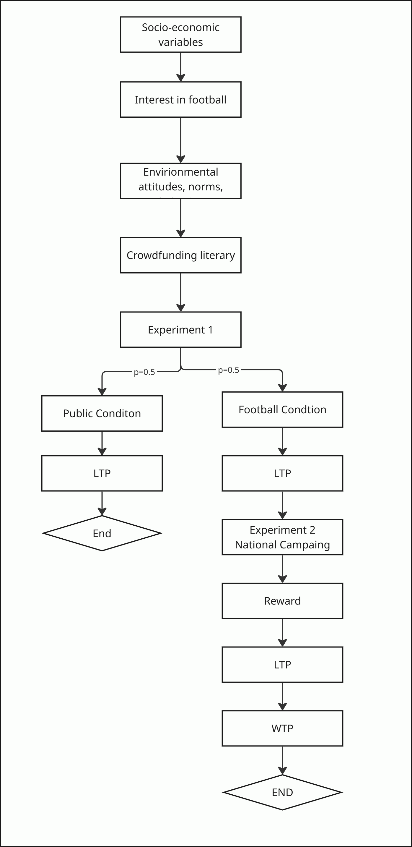
To identify potential differences between socially framed and football-specific crowdfunding campaigns, we randomly divided the sample into two groups. Randomization was implemented automatically by Efficience 3’s survey software. Participants were assigned to either the community-based football campaign or the socially-framed neutral campaign. All participants viewed the same survey structure, layout, and wording.
All participants were asked to imagine that they were offered the opportunity to participate in a crowdfunding campaign that would use the money raised to carry out energy-efficiency renovations to a building to significantly reduce its carbon emissions. The investment required to participate in the campaign was €50. The only difference between the two groups was the building described (see Figure 2). In the football group, a football stadium or training center in the participant’s local area was presented, while in the neutral group, a school or library was presented. The full survey is included in the Appendix.
Figure 2: Experimental setting used in the survey to describe both hypothetical crowdfunding campaigns
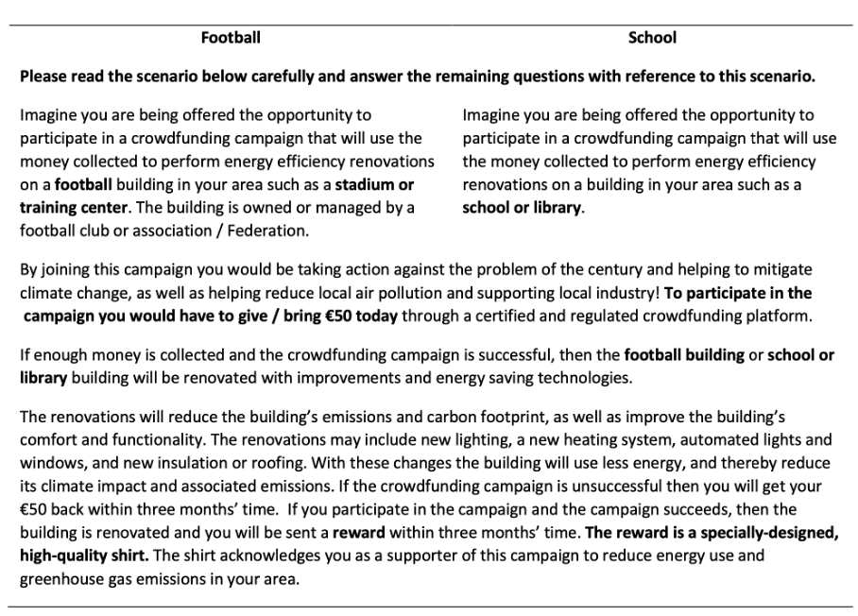
Note: This table shows the exact implementation of both groups. The text that was constant between both groups is shown only once. The only difference is the description of the respective buildings.
Finally, in the last part of the survey, only participants assigned to the football condition (N=1780) continued to a more specific crowdfunding scenario (Table 2). They were introduced to a campaign designed to renovate and reduce the carbon footprint of national football infrastructure —either the national stadium (in Azerbaijan, Ireland, and Sweden) or the national team’s training facilities (in France). Participants were asked to imagine that they had invested €1,000 (converted to their local currency) in the project. They could then choose among several possible reward options, including pure financial returns (pay back plus interest) or other benefits (such as discount for solar or electricity, team jerseys etc.), or a combination of both.
After selecting their preferred reward, respondents again indicated how likely they would be to participate in the campaign given the selected reward and considering their personal circumstances. In the final step, they specified the amount they would be willing to contribute: their willingness to pay (WTP) for the proposed football-related renewable energy initiative.
  - Variables
Dependent Variable
The first dependent variable is LTP in the crowdfunding campaign. In the survey, participants first saw the crowdfunding campaign and were then asked to indicate their likelihood of participating using a 5-point Likert scale ranging from 1 = very unlikely to 5 = very likely. By comparing the responses of the two groups, we can determine how a crowdfunding campaign is perceived in the specific context of football. Furthermore, by interacting the football group with emotional attachment - identified by the respondents indicating their interest in football on a 5-point Likert scale from 1 = not at all interested to 5 = very interested, we can estimate how emotional attachment affects crowdfunding. Table 3 shows the responses for all four groups. Figure A9 from the Appendix shows the distribution of fans vs. non-fans for each country.
Table 3: This table shows the shares of response for the dependent variables for both conditions among fans and non-fans.
 | Football Condition |  | Neutral Condition
LTP | Fan  (N = 739) | Non-Fan  (N = 1,041) | Fan  (N= 787) | Non-Fan  (N = 995)
Very unlikely | 14% | 38% | 13% | 19%
Unlikely | 17% | 19% | 11% | 15%
Indifferent | 26% | 27% | 28% | 30%
Likely | 32% | 13% | 35% | 27%
Very likely | 12% | 3% | 14% | 9%

The second dependent variable is WTP, measured in monetary terms (see Table 4, Column 2). Since currencies and purchasing power differ across countries, we transformed the variable into five ordered categories to ensure comparability. Participants who indicated no contribution (0 €) were coded as “no contribution”, contributions between 30–75 € as “low”, 200–400 € as “medium”, 750–3,000 € as “high”, and 7,500 € or more as “very high.”
Table 4: This table shows the shares of response for the dependent variable WTP for both conditions among fans and non-fans.
WTP Category | Monetary Range* | Non-Fan  (N = 1,041) | Fan  (N = 739)
No contribution | 0 € | 315 (30.3%) | 86 (11.6%)
Low | 30–75 € | 338 (32.5%) | 224 (30.3%)
Medium | 200–400 € | 192 (18.4%) | 201 (27.2%)
High | 750–3,000 € | 137 (13.2%) | 168 (22.7%)
Very high | 7,500–15,000 € | 59 (5.7%) | 60 (8.1%)
Total (N) |  | 1,041 | 739
Note: This table reports the distribution of respondents’ Willingness to Pay (WTP) stratified by fan status. Participants selected one of nine predefined contribution amounts (0, 30, 75, 200, 400, 750, 3,000, 7,500, or 15,000 €), which were subsequently grouped into five ordered WTP categories: No contribution (0 €), Low (30–75 €), Medium (200–400 €), High (750–3,000 €), and Very high (7,500–15,000 €). Values are reported as frequencies and column percentages. *Amounts were converted into national currency.

Independent Variables
Building on TPB, we cluster our control variables into four categories: related to i) social norms, ii) attitudes, iii) behavioural control, and iv) sociodemographic variables, which serve as additional control variables.
The primary indicator of emotional attachment is represented by the variable ”interest in football”. This dummy variable is assigned a value of 1 for participants who reported being interested or very interested in football and 0 for all others. Because fan status is a key predictor, it was crucial to ensure fans and non-fans were evenly distributed between the two conditions. Balanced groups reduce the risk of confounding variables, ensuring that observed differences in LTP or WTP in crowdfunding initiatives can be attributed to the fan status themselves rather than pre-existing differences between the groups (65). Table A7 from the Appendix shows the distribution of demographic variables, environmental attitudes and crowdfunding preferences among fans and non-fans.
Figure 3 shows the percentage of fans and non-fans for both conditions (building types) including the 95% confidence intervals. To determine if there is a significant association between being a fan and the treatment condition (Neutral vs. Football), we performed a Pearson’s Chi-squared test. The test statistic was χ² = 2.4411 with a p-value of 0.1182.

Figure 3: Distribution of fans and non-fans among both building types (conditions). Whiskers show 95% confidence intervals.
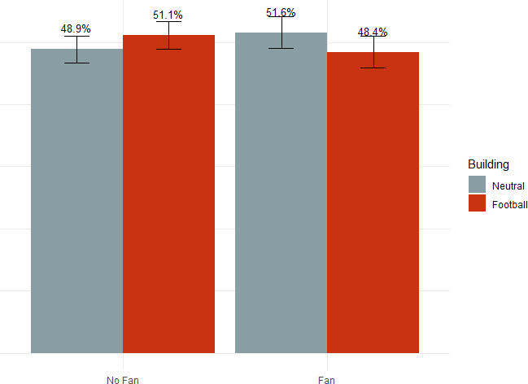
To assess the relationship between environmental attitudes and the likelihood of crowdfunding participation, our survey included questions focused on participants’ concerns about climate change, the importance they place on environmental factors when making energy-related decisions, and any recent lifestyle changes they have made to reduce their carbon footprint. For our regression analysis, we converted responses to the climate change concern question into a binary variable, assigning a value of 1 to responses indicating ”very concerned” and ”extremely concerned” and 0 for all others. In addition, we created specific dummy variables to reflect whether participants had made lifestyle changes to reduce their carbon footprint. These changes included making efforts to reduce electricity consumption, choosing more sustainable travel methods, adopting a diet with less energy-intensive foods, or making other various lifestyle adjustments.
As we assume that environmental attitudes affect crowdfunding participation independent of treatment conditions, we have to ensure that beliefs about climate change are equally distributed among fans and non-fans and between both conditions. Figure 4 indicates high climate-change concern across all groups. An ANOVA finds some differences between groups, but the effects are very small. (see Figure 4).
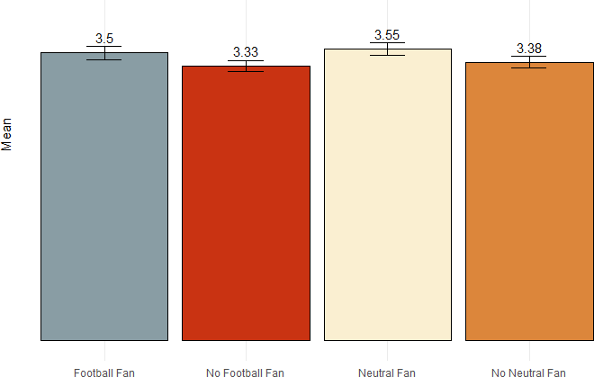
Figure 4: Average climate concerns across treatments between fans and non-fans with 95% CI.

To assess perceived behavioural control, we asked participants about their familiarity with crowdfunding, financial habits, preferences for returns on crowdfunding investments, and motivations for participating in crowdfunding campaigns previously. Familiarity with crowdfunding emerged as the key predictor, represented by a dummy variable set to 1 for participants who were familiar with or had participated in crowdfunding campaigns. In addition, we included a measure of financial literacy, which indicates whether participants have traditional savings accounts or invest in stocks, bonds, and other financial assets. Table 4 shows that there are statistically significant differences between crowdfunding familiarity between treatments. Especially in the football condition participants who indicated to not be interested in football (non-fans) have on average a higher experience with crowdfunding. However, as Figure 5 shows the mean responses are very similar among the four groups.
We also examine cross-country differences in crowdfunding literacy, as the maturity of national financial systems and regulatory frameworks can substantially shape individuals’ familiarity and confidence with crowdfunding (66). Overall, familiarity with crowdfunding remains limited in our sample, as 46.2% of respondents indicated “No” when asked whether they were familiar with the concept prior to the survey. The lowest levels of awareness were found in Azerbaijan (60%), followed by France (50%), Sweden (45%), and Ireland (35%). Conversely, the Irish sample shows the highest level of familiarity: 47.5% reported having heard about crowdfunding before, and 13.3% stated that they had already participated in a crowdfunding campaign. These cross-country differences likely reflect variations in national regulatory frameworks, market maturity, and exposure to digital financial services.
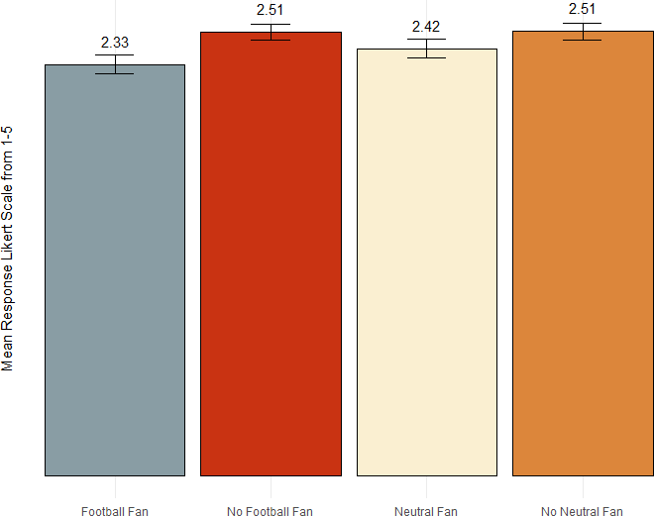
Figure 5: Average crowdfunding familiarity across treatments between fans and non-fans with 95% CI.

In addition to social norms, attitudes and perceived behavioural control, we control for socio-economic variables such as age, gender, employment status, education level, income, and household composition of the respondents. Household net income was measured using four categories based on quartiles and the 90% quantile of national household income statistics.¹
Table 4: Group Differences: Climate Change Concern and Crowdfunding Familiarity
Variable | Diff | Lwr | Upr | P-value
Climate Change Concern
Neutral-Fan vs. Football-Fan | 0.048 | -0.099 | 0.196 | 0.834
Neutral-Non Fan vs. Football-Non Fan | 0.051 | -0.077 | 0.179 | 0.740
Football-Non Fan vs. Football-Fan | -0.163 | -0.302 | -0.024 | 0.013
Neutral-Non Fan vs. Neutral-Fan | -0.161 | -0.299 | -0.024 | 0.014
Crowdfunding Familiarity
Neutral-Fan vs. Football-Fan | 0.088 | -0.013 | 0.189 | 0.111
Neutral-Fan vs. Football-Non Fan | -0.094 | -0.187 | -0.001 | 0.047
Football-Non Fan vs. Football-Fan | 0.182 | 0.087 | 0.276 | 0.000
Neutral-Non Fan vs. Neutral-Fan | 0.098 | 0.004 | 0.192 | 0.036
Note: The table shows the differences in the means for Climate Change Concern and Crowdfunding Familiarity. We also show the lower and upper bounds of the confidence intervals and the adjusted p-values from Tukey’s HSD test.
  - Econometric model
Our analysis is based on two experimental stages. Stage 1 compares a football-related campaign with a socially neutral campaign (school or library). Given the ordinal nature of the outcome, we estimate an ordered logit model to explain LTP in either campaign. Stage 2 then focuses exclusively on participants from the football condition, where respondents were presented with reward options and asked again about their likelihood to contribute to the same campaign before stating their WTP. This within-campaign LTP differs from the general participation intention elicited in Stage 1. Because these two within-campaign decisions—whether to participate and how much to contribute—are likely interdependent, we estimate a recursive bivariate ordered probit model using the conditional mixed process (CMP) estimator (67), which allows for correlated unobservables across both stages.
Stage 1
LTP in the crowdfunding campaign is measured on an ordered 5-point Likert scale, ranging from “very unlikely” (1) to “very likely” (5). To analyse such ordinal responses, we employ an ordered logit model, the standard approach for modelling ordered categorical outcomes due to its intuitive structure and straightforward interpretation of results (68).
In this context, the decision to participate can be interpreted as a latent (unobserved) indirect utility $y_{i}^{*}$that individual $i$derives from participating in or funding the campaign. Higher values of $y_{i}^{*}$correspond to higher levels of well-being or satisfaction associated with participation. The observed response $y_{i}$takes on discrete values depending on whether $y_{i}^{*}$falls between certain threshold values ($ν_{1},ν_{2},ν_{3},ν_{4}$):
$y_{i}^{*}=X_{i}β+ϵ_{i}, ϵ_{i}∼Logistic\left(0,1\right)$ (1)
$$y_{i}=\left\{\begin{matrix}1 & \text{if }y_{i}^{*}≤ν_{1} \\ 2 & \text{if }ν_{1}<y_{i}^{*}≤ν_{2} \\ 3 & \text{if }ν_{2}<y_{i}^{*}≤ν_{3} \\ 4 & \text{if }ν_{3}<y_{i}^{*}≤ν_{4} \\ 5 & \text{if }y_{i}^{*}>ν_{4}\end{matrix}\right.$$
Whereby $X_i$ represents the vector of explanatory variables and $ß$ the vector of corresponding slope coefficients, and ν1 to ν4 are the thresholds estimated along with β.
The vector $X_{i}$includes the following sets of variables: i) treatment variables are indicators for the football condition, football fandom, and their interaction term (football condition × fan); ii) attitudinal and behavioural variables are climate change concerns and crowdfunding literacy; iii) sociodemographic controls are age, gender, employment Status, and income and iv) country-fixed effects to capture unobserved heterogeneity across countries (France serves as the reference category).
The coefficients $β$ from the ordered logit model capture how a change in each explanatory variable affects the latent utility $y_{i}^{*}$. To facilitate interpretation, we report average marginal effects, which express how a one-unit change in an explanatory variable alters the predicted probability that the outcome falls into a given response category $m$ (e.g., “very likely”), holding all other variables constant at their mean values:
$$\frac{Δprob\left(y=m∣X\right)}{ΔX}=prob\left(y=m∣X_{ϵ}\right)-prob\left(y=m∣X_{s}\right) (2)$$
This approach allows for an intuitive understanding of how individual characteristics and experimental conditions influence respondents’ stated likelihood to participate in the crowdfunding campaign.
Stage 2
To extend the analysis, we examine respondents’ WTP, the amount they would be prepared to invest in the football-related renewable energy project. WTP is also measured on an ordered 5-point categorical scale ranging from “no contribution” (1) to “very high contribution” (5).
Given the sequential nature of the decision process, first deciding which rewards they would prefer, then how likely they would be to participate in the national campaign, to then how much to contribute, we estimate a recursive bivariate ordered probit model using the CMP estimator (67). This structure captures the potential endogeneity of participation intentions in shaping contribution levels:
$$\begin{matrix}LTP_{2i}^{*} & =α_{1}+β_{1}{\text{Fan}}_{i}+β_{2}X_{i}+ε_{1i}, \\ WTP_{i}^{*} & =γ_{1}LT{P2}_{i}+γ_{2}{\text{Fan}}_{i}+γ_{3}X_{i}+ε_{2i},\end{matrix} (3)$$
where both $LTP_{2i}$ and $WTP_{i}$ are observed as ordered categories, and the disturbances $\left(ε_{1i},ε_{2i}\right)$ are assumed to be jointly normal with correlation $ρ_{12}$. This specification allows for unobserved factors, such as general altruism or optimism, to affect both the intention and contribution stages.
Control variables $X_{i}$ again include sociodemographic characteristics, behavioural attitudes, country-fixed effects, and respondents’ preferred reward type (monetary, environmental, or experiential), which they could select prior to the WTP elicitation.

Results
Our empirical analysis proceeds in two stages. Stage 1 tests whether emotional attachment, environmental concern, and crowdfunding literacy predict LTP in a sustainable crowdfunding campaign. Stage 2 then focuses on the football condition only and examines how participation intentions translate into actual willingness to pay (WTP) for different reward options.

Stage 1: Likelihood to Participate (LTP)
We begin the discussion of our results by testing Hypothesis 1a, which states that football fans are more likely to participate in a crowdfunding campaign when it targets the renovation of a football stadium. We then turn to Hypothesis 2, which posits that stronger environmental concern increases participation intentions, independent of the framing. Finally, we examine whether prior crowdfunding familiarity predicts higher participation likelihood, controlling for demographic and country-specific characteristics.
Table 5 presents the marginal effects of key predictors on LTP across the five Likert-scale categories, while Table 6 reports the underlying regression coefficients. All our models use fixed effects for gender, age, employment status and income.
Participants exposed to the football-framed campaign are, on average, less likely to report high participation intentions. Being in the football condition increases the probability of indicating “very unlikely” participation (LTP = 1) by 17 percentage points. However, this effect reverses among football fans, thus Hypothesis 1 holds true in the expected way.
The interaction between the football condition and football fan status shows that participants who are fans and saw the football building are 9.7% more likely to be in the second highest participation category (LTP=4) and 7.7% more likely to be in the highest participation category (LTP=5). This supports the idea that emotional attachment amplifies participation when the project aligns with group identity and shared purpose. While these effects are statistically robust, they are moderate in size and should be interpreted as shifts in stated intentions rather than actual financial behaviour, given the hypothetical setting.
Figure 6 shows the marginal effects from the regression model for all LTP categories. This indicates the importance of emotional attachment in influencing crowdfunding participation. Despite varying specifications of emotional attachment to football, including general fan status, monetary support, and support for different types of football clubs, the core findings remain robust. The interaction effect remains positive and significant across models (see Table A8 from the Appendix).
Turning to Hypothesis 2, we find that participants who are concerned or very concerned about climate change are less likely to be in the lower participation categories, but more likely to be in the higher categories. Pro-environmental attitudes are positively associated with crowdfunding participation likelihood, independent of treatment. Consistent with previous findings, the results show that participants who join the campaign for environmental reasons have a higher LTP than those who join for other reasons. Environmental concerns increase the probability of falling into the highest category by about 5 percentage points and the probability of falling into the likely category by about 3% points. Thus, hypothesis 2 is supported. As a robustness check, we include additional controls for general and energy-specific environmental concerns, as well as questions related to direct lifestyle changes.
Another important variable that influences investment decisions is financial literacy (69). In our study, crowdfunding literacy is captured by crowdfunding knowledge and/or prior experience. Consistent with Hypothesis 3, we find a positive and significant coefficient of crowdfunding literacy, indicating that a higher level of familiarity predicts LTP. Subjects who have at least heard of crowdfunding are about 3% points more likely to fall into the second-highest category, and 2% points more likely to fall into the highest category.
Table 5: Marginal Effects for the Likelihood to Participate (LTP) by Football Fan Status and Condition.
Predictor |  | LTP = 1 |  | LTP = 2 | LTP = 3 |  | LTP = 4 |  | LTP = 5
Football Condition |  | 0.1713***  (0.0129) |  | 0.0534***  (0.0043) | −0.0092**  (0.0033) |  | −0.1318***  (0.0092) |  | −0.0837***  (0.0072)
Football Condition× Football Fan |  | −0.1161***  (0.0149) |  | −0.0460***  (0.0070) | −0.0119***  (0.0046) |  | 0.0969***  (0.0124) |  | 0.0771***  (0.0137)
Football Fan |  | −0.0733***  (0.0130) |  | −0.0261***  (0.0051) | 0.0009  (0.0015) |  | 0.0619***  (0.0115) |  | 0.0367***  (0.0068)
Very concerned about climate change |  | −0.0760***  (0.0096) |  | −0.0250***  (0.0034) | 0.0016  (0.0014) |  | 0.0622***  (0.0080) |  | 0.0372***  (0.0053)
Crowdfunding familiarity | −0.0353***  (0.0096) |  | −0.0115***  (0.0032) |  |  | 0.0006  (0.0007) |  | 0.0286***  (0.0079) |  | 0.0176***  (0.0048)
Note. t statistics in parentheses. p < .1; p < .05; p < .01.

To assess whether the proportional odds assumption holds in our ordered logit model, we conducted a Brant (Wald) test (Table A9). While a few variables showed local deviations, the overall test result (χ²(39) = 35.04, p = 0.65) was not significant, indicating that the proportional odds assumption holds for the model as a whole. For robustness, we also estimated a generalized ordered logit model, which relaxes this assumption by allowing coefficients to vary across outcome categories. The results were highly consistent with those from the ordered logit model in terms of both sign and significance of coefficients (Table A8), confirming the stability of our findings.
Figure 6: Marginal Effect of Treated Fans on LTP
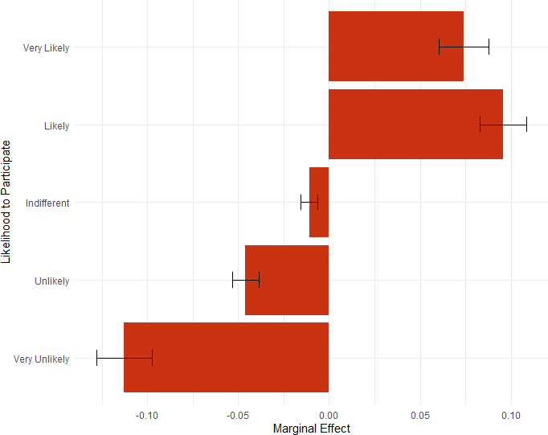
This figure shows the marginal effect from the regression including standard errors of treated fans vs. non treated subjects (fans and non-fans) while keeping all other variables at the mean.
Table 5: Regression Results for Likelihood to Participate (LTP) by Football Fan Status and Treatment
Predictor | Overall | France | Ireland | Sweden | Azerbaijan
Football Condition | −1.115***  (0.082) | −0.930***  (0.159) | −1.533***  (0.164) | −0.901***  (0.154) | −1.178***  (0.195)
Football Fan | 0.490***  (0.088) | 0.473***  (0.163) | 0.569***  (0.161) | 0.416***  (0.166) | 0.321  (0.272)
Very Concerned (Climate) | 0.502***  (0.063) | 0.458***  (0.118) | 0.621***  (0.119) | 0.580***  (0.122) | 0.309*  (0.173)
Crowdfunding Familiarity | 0.234***  (0.064) | 0.421***  (0.122) | 0.133  (0.121) | 0.131  (0.122) | 0.090  (0.174)
Football Condition × Football Fan | 0.857***  (0.125) | 0.955***  (0.231) | 0.941***  (0.231) | 0.755***  (0.236) | 0.781**  (0.384)
Controls
Country | yes | – | – | – | –
Age | yes | yes | yes | yes | yes
Gender | yes | yes | yes | yes | yes
Employment | yes | yes | yes | yes | yes
Income | yes | yes | yes | yes | yes
Cut Points
Cut 1 | −1.100 | −1.287 | −1.933 | −0.721 | −2.309
Cut 2 | −0.233 | −0.403 | −1.044 | 0.061 | −1.225
Cut 3 | 1.100 | 1.087 | 0.235 | 1.522 | −0.139
Cut 4 | 3.004 | 3.229 | 2.040 | 3.539 | 1.816
Model Fit
Wald χ² | 710.26 | 180.23 | 228.53 | 197.26 | 70.36
Log pseudolikelihood | −5101.70 | −1441.59 | −1439.63 | −1409.71 | −750.62
Pseudo R² | 0.0710 | 0.0684 | 0.0744 | 0.0662 | 0.0425
Observations | 3,562 | 1,038 | 1,002 | 1,013 | 509
Note. p < .1; p < .05; p < .01. All coefficients use robust standard errors.

Stage 2: Willingness to Pay (WTP)
We begin the analysis of WTP with a descriptive comparison of participation likelihood and reward preferences. Figure 7 illustrates that LTP in the second crowdfunding campaign targeting the renovation of national football infrastructure is higher among respondents who reported an interest in football. This pattern is consistent with the findings from the first part of the study, suggesting that social identity and emotional attachment to football increase the likelihood to participate in related sustainability initiatives. Furthermore, respondents interested in football were significantly more likely to select a football-related reward, such as a €1,100 payback plus World Cup jersey or training tickets at the national team’s facility. A chi-squared test confirms that this difference is statistically significant (χ²(1) = 14.34, p < 0.001). Table A10 from the Appendix shwos the share of financial rewards selected in the second crowdfunding campaign for fans and non-fans.
Figure 7: Likelihood to participate for fans and non-fans
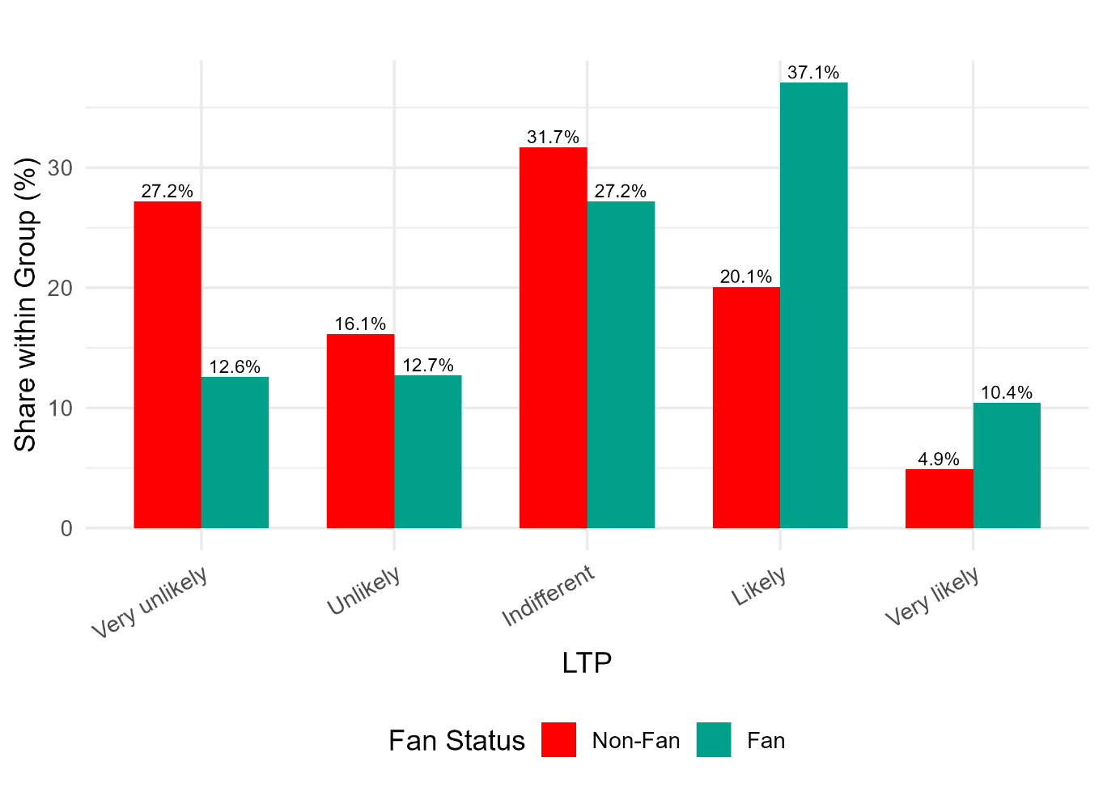
This pattern is mirrored in the WTP results (see Figure 8): fans have a higher average willingness to contribute compared to non-fans. However, fans tend to choose different types of rewards, which in turn affect both their LTP and their eventual WTP. To capture the sequential nature of the decision process, first, how likely respondents are to participate (LTP), and second, how much they are willing to contribute (WTP), we estimated a recursive bivariate ordered probit model using the cmp estimator (67).
In this specification, LTP is modelled as a function of respondents’ fan status, chosen reward, and individual characteristics. The second equation models WTP as an ordered outcome depending on LTP, fan status, reward, and the same covariates. The model allows the error terms of both equations to be correlated, thereby accounting for unobserved individual traits, such as altruism, optimism, or social identification, which may jointly influence participation and contribution decisions.
The results show a strong positive association between fan identity and the likelihood to participate (β = 0.53, p < 0.001). However, fan status does not have a direct significant effect on WTP once LTP is controlled for. Instead, LTP itself strongly predicts WTP (β = 0.68, p < 0.001), suggesting that the intention to participate is the primary driver of financial commitment.
Reward preferences also matter: choosing football-related rewards, such as training tickets or World Cup jerseys, is associated with higher LTP, while purely financial rewards (e.g., “free electricity”) do not increase willingness to pay. The estimated correlation between unobserved factors in the two equations (ρ = -0.35, p < 0.01) indicates that individuals with unobserved traits reducing participation propensity also tend to contribute less, confirming the endogeneity between participation and contribution decisions.
Figure 8: Willingness to pay for fans and non-fans
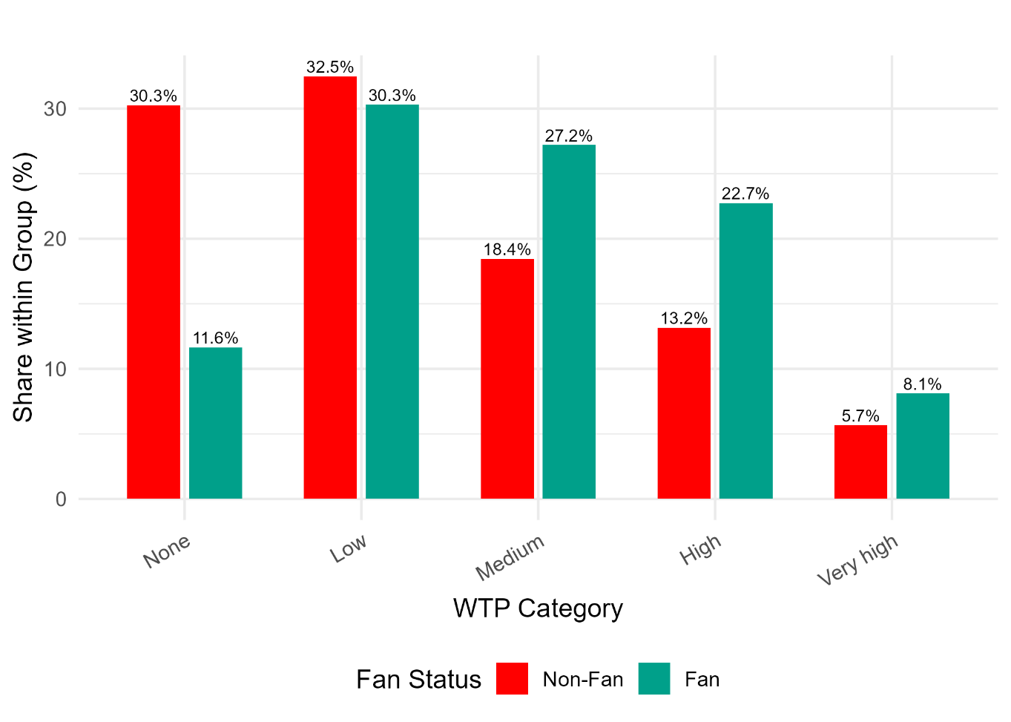

Table 6: Recursive Bivariate Ordered Probit Results
 | LTP (Eq. 1) | WTP (Eq. 2)
Fan (1=yes) | 0.53*** (0.06) | 0.08 (0.07)
Likelihood to Participate (LTP) | — | 0.68*** (0.04)
Reward: €1100 + World Cup jersey | 0.23** (0.10) | 0.04 (0.11)
Reward: €1000 + Tesla lottery entry | 0.30*** (0.09) | 0.03 (0.10)
Reward: Free electricity (1 year) | 0.14** (0.06) | -0.16** (0.07)
Reward: 20% discount solar roof | 0.27*** (0.10) | -0.05 (0.11)
Reward: 4 training tickets (facility) | 0.40*** (0.11) | 0.08 (0.12)
Male | -0.13** (0.05) | 0.04 (0.05)
Employed | 0.23*** (0.05) | 0.13** (0.06)
Environmental concern | 0.18*** (0.05) | -0.05 (0.06)
Crowdfunding literacy | 0.07 (0.05) | 0.17*** (0.06)
Ireland (ref: France) | 0.23*** (0.07) | 0.09 (0.08)
Sweden | 0.04 (0.07) | 0.38*** (0.08)
Azerbaijan | 0.31*** (0.08) | 0.27*** (0.10)
ρ (correlation of errors) |  | -0.35* (0.07)
N |  | 1,780
Log-likelihood |  | -5003.7
Pseudo R² |  | 0.107
Note: Standard errors in parentheses. ***p < 0.01, **p < 0.05, *p < 0.1.

Conclusion
This study highlights the potential of crowdfunding to bridge the investment gap in renewable energy (RE) and energy efficiency (EE) initiatives. Despite significant interest among citizens in sustainable investments, several barriers hinder actual investment activities. Crowdfunding offers a mechanism to mitigate these barriers by pooling small amounts of capital from a large pool of backers, lowering individual investors’ entry threshold and reducing perceived risks.
Our research goes beyond crowdfunding to explore the broader implications of identification and emotional attachment in supporting sustainable actions and policies. Through a representative survey of 3,562 citizens, we examined two crowdfunding campaigns - one aimed at reducing the carbon emissions of a football stadium and another aimed at a neutral building and differentiating between football fans and non-fans, we assessed how emotional attachment affects crowdfunding participation.
The results from Stage 1 show that emotional attachment significantly increases investment intentions by around 10 percentage points, particularly among football fans, highlighting its crucial role in influencing investment decisions. Participants exposed to the football-framed campaign were, on average, less likely to participate than those in the neutral condition, but this effect reversed for fans, demonstrating that emotional identification can offset the lower appeal of a themed campaign. Environmental concern and crowdfunding literacy further increased participation likelihood, consistent with the Theory of Planned Behaviour.
Results from Stage 2 extend these findings by showing how emotional attachment translates into financial engagement. Among participants in the football condition, fan identity strongly predicted LTP in the national football campaign, which in turn was the main driver of WTP. Once participation intention was controlled for, fan status no longer had a direct effect on WTP indicating that emotional attachment influences financial commitment primarily through the formation of intention. In addition, reward preferences mattered: experiential or identity-related rewards (such as training tickets or team jerseys) were associated with higher participation and WTP, whereas purely financial rewards (e.g., free electricity) did not increase contribution levels. These findings underline that emotional and social factors, not only economic incentives, shape citizens’ readiness to invest in sustainable initiatives.
While our findings are based on a hypothetical and non-incentivised setting and thus can only assess the likelihood to participate and willingness to pay rather than actual behaviour, evidence from real-world football crowdfunding campaigns focusing on both environmental and community aspects suggests that emotional attachment can translate into tangible financial engagement when channelled through trusted and well-governed platforms.
Two main conclusions can be drawn from our findings. First, emotional attachment could effectively drive the energy transition by integrating renewable energy and energy-efficiency projects into existing communities. Second, crowdfunding can overcome motivational and geographical barriers, facilitating the formation of energy communities around shared values, emotional attachment, and a sense of group belonging. These findings are valuable for designing effective crowdfunding campaigns and developing energy-related projects that require broad support to be successful.
Nevertheless, several limitations should be acknowledged. Firstly, the study relied on a non-incentivised survey experiment, so future research should test our hypotheses using either a field experiment involving a real crowdfunding campaign or an incentivised laboratory setting. Consequently, while the reported effects are statistically robust, they may not directly translate into realised investment outcomes. Moreover, actual investment behaviour in crowdfunding contexts is shaped by a wider range of factors beyond emotional attachment. Perceived financial risk, trust in the intermediary platform, and individual liquidity constraints are critical determinants of real investment decisions (13). Future studies should therefore integrate these dimensions, ideally within field or incentivized experimental designs, to strengthen the validity and practical relevance of the findings. Secondly, emotional attachment was not directly manipulated, so the experiment does not allow for strict causal inference. Thirdly, emotional attachment was operationalised solely through football fan identity. While this measure was appropriate for our purposes, it represents a specific form of community identification. Future research should therefore explore alternative domains of attachment, such as local community ties, cultural events or social movements, to assess whether similar mechanisms apply in other emotionally salient contexts. Finally, subsequent field experiments or incentivised surveys could test whether the observed intention patterns persist when real financial incentives and time dynamics are introduced.
In addition, our research provides insights into the wider implications of identification and emotional attachment in supporting sustainable actions and policies. Strategic decisions about the most effective administrative and political levels for gaining citizen support can benefit from our findings. We contribute to the growing literature on the psychological, social and economic factors that influence individual engagement in crowdfunding campaigns and provide insights into how to effectively leverage private investment in the energy transition.

References
1. European Commission. Renovation Wave Strategy: A European Green Deal Initiative. European Commission. 2020;
2. De Brauwer CPS, Cohen J. Analysing the potential of citizen-financed community renewable energy to drive Europe’s low-carbon energy transition. Renewable and Sustainable Energy Reviews. 2020;133:110300.
3. Paetzold F, Busch T. Unleashing the powerful few: Sustainable investing behaviour of wealthy private investors. Organization & Environment. 2014;27(4):347–67.
4. Brunner T, Axhausen KW. The gap between intentions and actions in building renovation: A conceptual framework. Journal of Environmental Psychology. 2015 Mar;43:107–16.
5. Peattie K. Green Consumption: Behavior and Norms. Annual Review of Environment and Resources. 2010;35(1):195–228.
6. Ceglia D, Claro J, Neto M. The Personal Norms of Sustainability: Exploring the Attitudes, Intentions, and Behaviors of Pro-Environmental Consumers. Journal of Cleaner Production. 2015;107:1–12.
7. Hanss D, Bohm G, Doran R, Homburg A. The Influence of Attitudes and Norms on Household Energy Consumption: The Role of Knowledge and Perceived Behavioral Control. Energy Policy. 2016;98:213–22.
8. Calic G, Mosakowski E. Kicking off social entrepreneurship: How a sustainability orientation influences crowdfunding success. Journal of Management Studies. 2016;53(5):738–67.
9. Dinh J, Isaak AJ, Wehner MC. Sustainability-oriented crowdfunding: An integrative literature review. Journal of Cleaner Production. 2024;141579.
10. Bourcet C, Bovari E. Exploring citizens’ decision to crowdfund renewable energy projects: Quantitative evidence from France. Energy Economics. 2020;88:104754.
11. Li G, Wang J. Threshold effects on backer motivations in reward-based crowdfunding. Journal of Management Information Systems. 2019;36(2):546–73.
12. Short JC, Ketchen Jr DJ, McKenny AF, Allison TH, Ireland RD. Research on crowdfunding: Reviewing the (very recent) past and celebrating the present. Entrepreneurship Theory and Practice. 2017;41(2):149–60.
13. Coakley J, Lazos A. New Developments in Equity Crowdfunding: A Review. RCF. 2021;1(3–4):341–405.
14. Fehr E, Fischbacher U. Social norms and human cooperation. Trends in cognitive sciences. 2004;8(4):185–90.
15. Goette L, Huffman D, Meier S. The impact of social ties on group interactions: Evidence from minimal groups and randomly assigned real groups. American Economic Journal: Microeconomics. 2012;4(1):101–15.
16. Fillis I, Mackay C. Moving beyond fan typologies: The impact of social integration on team loyalty in football. Journal of Marketing Management. 2014;30(3–4):334–63.
17. Thomas WE, Brown R, Easterbrook MJ, Vignoles VL, Manzi C, D’Angelo C, et al. Social identification in sports teams: The role of personal, social, and collective identity motives. Personality and Social Psychology Bulletin. 2017;43(4):508–23.
18. Andre P, Boneva T, Chopra F, Falk A. Globally representative evidence on the actual and perceived support for climate action. Nature Climate Change. 2024;14(3):253–9.
19. Gao X, Yee CL, Choo WC. How Attachment and Community Identification Affect User Stickiness in Social Commerce: A Consumer Engagement Experience Perspective. Sustainability. 2022 Oct 21;14(20):13633.
20. Wild S, Schulze Heuling L. Exploring the role of identity in pro-environmental behavior: cultural and educational influences on younger generations. Front Psychol. 2024 Oct 9;15:1459165.
21. Neves C, Oliveira T, Karatzas S. Citizen participation in local energy communities: A social identity and pro-environmental behaviour joint perspective. Energy and Climate Change. 2025 Dec;6:100212.
22. Ai W, Chen R, Chen Y, Mei Q, Phillips W. Recommending teams promotes prosocial lending in online microfinance. Proc Natl Acad Sci USA. 2016 Dec 27;113(52):14944–8.
23. Monik A, Parzuchowski M. Mind the Like-Minded. The Role of Social Identity in Prosocial Crowdfunding. Social Science Computer Review. 2024 Feb;42(1):103–21.
24. Ajzen I. The Theory of Planned Behavior. Organizational Behavior and Human Decision Processes. 1991;50(2):179–211.
25. Cumming DJ, Leboeuf G, Schwienbacher A. Crowdfunding cleantech. Energy Economics. 2017;65:292–303.
26. Shiv B, Loewenstein G, Bechara A, Damasio H, Damasio AR. Investment behavior and the negative side of emotion. Psychological Science. 2005;16(6):435–9.
27. Kahneman D, Riepe MW. Aspects of investor psychology. Journal of Portfolio Management. 1998;24(4).
28. Loewenstein G. Emotions in economic theory and economic behavior. American Economic Review. 2000;90(2):426–32.
29. Chang JW. The economics of crowdfunding. American Economic Journal: Microeconomics. 2020;12(2):257–80.
30. Cumming D, Hornuf L. The economics of crowdfunding. Springer; 2018.
31. Colombo MG, Franzoni C, Rossi–Lamastra C. Internal social capital and the attraction of early contributions in crowdfunding. Entrepreneurship Theory and Practice. 2015;39(1):75–100.
32. Belleflamme P, Omrani N, Peitz M. The economics of crowdfunding platforms. Information Economics and Policy. 2015;33:11–28.
33. Kaminski JC, Hopp C. Predicting outcomes in crowdfunding campaigns with textual, visual, and linguistic signals. Small Business Economics. 2020;55:627–49.
34. Mollick E. The dynamics of crowdfunding: An exploratory study. Journal of Business Venturing. 2014;29(1):1–16.
35. Shneor R, Munim ZH. Reward crowdfunding contribution as planned behaviour: An extended framework. Journal of Business Research. 2019;103:56–70.
36. Bonzanini D, Giudici G, Patrucco A. The crowdfunding of renewable energy projects. In: Handbook of Environmental and Sustainable Finance. Elsevier; 2016. p. 429–44.
37. Cumming DJ, Leboeuf G, Schwienbacher A. Crowdfunding cleantech. Energy Economics. 2017;65:292–303.
38. Vasileiadou E, Huijben J, Raven R. Three is a crowd? Exploring the potential of crowdfunding for renewable energy in the Netherlands. Journal of Cleaner Production. 2016;128:142–55.
39. Cholakova M, Clarysse B. Does the possibility to make equity investments in crowdfunding projects crowd out reward–based investments? Entrepreneurship Theory and Practice. 2015;39(1):145–72.
40. Giudici G, Guerini M, Rossi-Lamastra C. Reward-based crowdfunding of entrepreneurial projects: the effect of local altruism and localized social capital on proponents’ success. Small Business Economics. 2018;50(2):307–24.
41. Greenberg J, Mollick E. Activist Choice Homophily and the Crowdfunding of Female Founders. Administrative Science Quarterly. 2017 June;62(2):341–74.
42. Berglin H, Strandberg C. Leveraging customers as investors: The driving forces behind crowdfunding. Thesis, Uppsala University. 2013;
43. Bretschneider U, Leimeister JM. Not just an ego-trip: Exploring backers’ motivation for funding in incentive-based crowdfunding. The Journal of Strategic Information Systems. 2017;26(4):246–60.
44. Vismara S. Sustainability in equity crowdfunding. Technological Forecasting and Social Change. 2019;141:98–106.
45. Hörisch J. Crowdfunding for environmental ventures: an empirical analysis of the influence of environmental orientation on the success of crowdfunding initiatives. Journal of Cleaner Production. 2015;107:636–45.
46. Turner JC, Brown RJ, Tajfel H. Social comparison and group interest in ingroup favouritism. European journal of social psychology. 1979;9(2):187–204.
47. Reese G, Proch J, Finn C. Identification with all humanity: The role of self‐definition and self‐investment. European Journal of Social Psychology. 2015;45(4):426–40.
48. Pong V, Tam KP. Relationship between global identity and pro-environmental behavior and environmental concern: a systematic review. Frontiers in Psychology. 2023;14:1033564.
49. Dono J, Webb J, Richardson B. The relationship between environmental activism, pro-environmental behaviour and social identity. Journal of Environmental Psychology. 2010 June;30(2):178–86.
50. Azarova V, Cohen J, Friedl C, Reichl J. Designing Local Renewable Energy Communities to Increase Social Acceptance: Evidence from a Choice Experiment in Austria, Germany, Italy, and Switzerland. Energy Policy. 2019;132:1176–83.
51. Cordano M, Frieze IH. Pollution reduction preferences of US environmental managers: Applying Ajzen’s theory of planned behavior. Academy of Management Journal. 2000;43(4):627–41.
52. Lülfs R, Hahn R. Sustainable behavior in the business sphere: A comprehensive overview of the explanatory power of psychological models. Organization & Environment. 2014;27(1):43–64.
53. Chen Y, Dai R, Yao J, Li Y. Donate time or money? The determinants of donation intention in online crowdfunding. Sustainability. 2019;11(16):4269.
54. Kazaure MA, Abdullah A, Jantan A, Zawawi D. Influences of TPB variable on SMEs intention to adopt online crowdfunding services in Nigeria. International Journal of Advanced Science and Technology. 2020;29(4):981–93.
55. Korcaj L, Hahnel UJ, Spada H. Intentions to adopt photovoltaic systems depend on homeowners’ expected personal gains and behavior of peers. Renewable Energy. 2015;75:407–15.
56. Gamel J, Bauer A, Decker T, Menrad K. Financing wind energy projects: An extended theory of planned behavior approach to explain private households’ wind energy investment intentions in Germany. Renewable Energy. 2022;182:592–601.
57. Hong Y, Hu Y, Burtch G. Embeddedness, pro-sociality, and social influence: Evidence from online crowdfunding. MIS Quarterly, Forthcoming. 2018;
58. Gerber EM, Hui JS, Kuo PY, others. Crowdfunding: Why people are motivated to post and fund projects on crowdfunding platforms. In: Proceedings of the International Workshop on Design, Influence, and Social Technologies: Techniques, Impacts and Ethics. 2012. p. 10.
59. Renwick MJ, Mossialos E. Crowdfunding our health: economic risks and benefits. Social Science & Medicine. 2017;191:48–56.
60. Allison TH, Davis BC, Webb JW, Short JC. Persuasion in crowdfunding: An elaboration likelihood model of crowdfunding performance. Journal of Business Venturing. 2017;32(6):707–25.
61. Cecere G, Le Guel F, Rochelandet F. Crowdfunding and social influence: an empirical investigation. Applied Economics. 2017;49(57):5802–13.
62. Cohen J, Azarova V, Kollmann A, Reichl J. Preferences for community renewable energy investments in Europe. Energy Economics. 2021;100:105386.
63. Kim MJ, Hall CM. Do value-attitude-behavior and personality affect sustainability crowdfunding initiatives? Journal of Environmental Management. 2021;280:111827.
64. Tenner I, Hörisch J. Crowdfunding sustainable entrepreneurship: What are the characteristics of crowdfunding investors? Journal of Cleaner Production. 2021;290:125667.
65. Cook TD, Campbell DT, Shadish W. Experimental and quasi-experimental designs for generalized causal inference. Vol. 1195. Houghton Mifflin Boston, MA; 2002.
66. Bianchini R, Croce A. The Role of Environmental Policies in Promoting Venture Capital Investments in Cleantech Companies. RCF. 2022;2(3):587–616.
67. Roodman D. Fitting fully observed recursive mixed-process models with cmp. The Stata Journal. 2011;11(2):159–206.
68. Cohen J, Moeltner K, Reichl J, Schmidthaler M. An empirical analysis of local opposition to new transmission lines across the EU-27. The Energy Journal. 2016;37(3).
69. Meoli M, Rossi A, Vismara S. Financial literacy and security-based crowdfunding. Corporate Governance: An International Review. 2020;
70. Andrade C. Mean Difference, Standardized Mean Difference (SMD), and Their Use in Meta-Analysis: As Simple as It Gets. J Clin Psychiatry [Internet]. 2020 Sept 22 [cited 2025 Oct 30];81(5). Available from: https://www.psychiatrist.com/jcp/mean-difference-standardized-mean-difference-smd-and-their-use-in-meta-analysis

Appendix:
Figure A9: Distribution of fans and non-fans among treatments for each country with CI (1=France, 2=Ireland, 3=Sweden, 4=Azerbaijan).
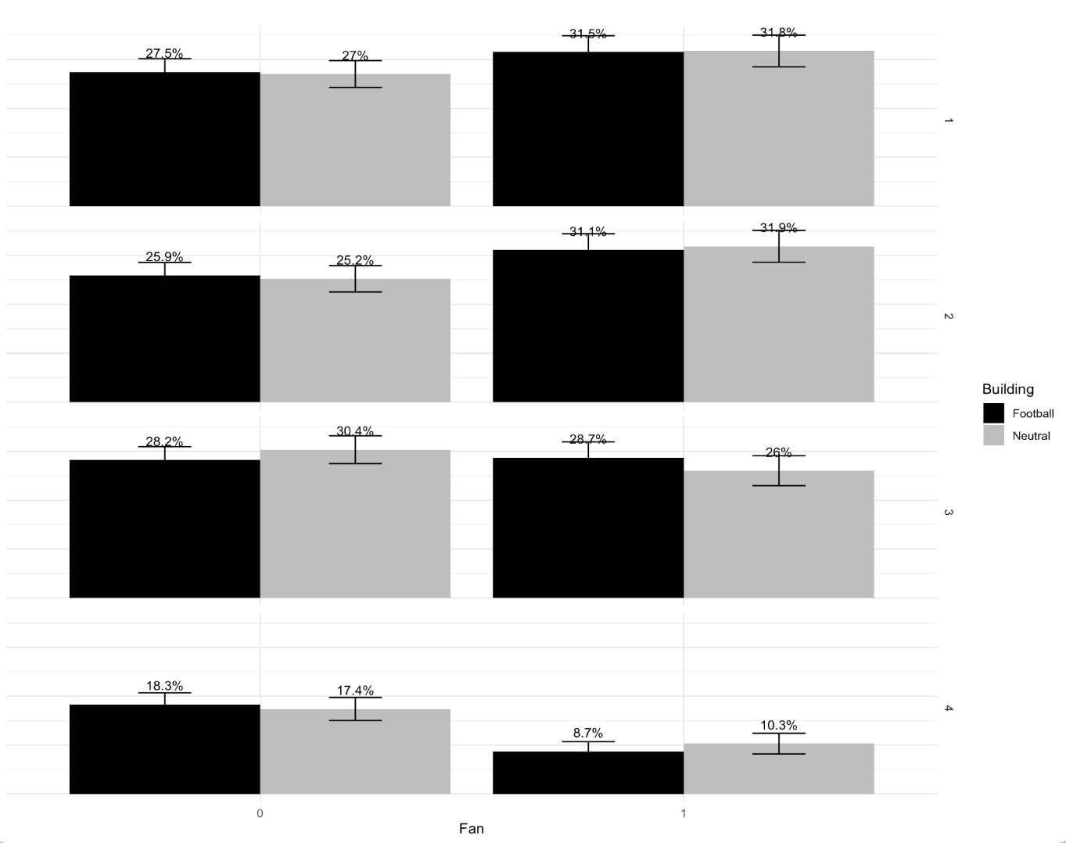
Table A7: Balance Check: Demographics, Environmental Attitudes, and Crowdfunding Motives
Stratified by Group | Football Fan | Football Non Fan | Neutral Fan | Neutral Non Fan | SMD
n | 739 | 1041 | 787 | 995
Age Group (%) |  |  |  |  | 0.200
18–24 years | 91 (12.3) | 98 (9.4) | 81 (10.3) | 87 (8.7)
25–34 years | 162 (21.9) | 188 (18.1) | 147 (18.7) | 140 (14.1)
35–44 years | 145 (19.6) | 194 (18.6) | 147 (18.7) | 162 (16.3)
45–54 years | 120 (16.2) | 181 (17.4) | 143 (18.2) | 182 (18.3)
55–64 years | 100 (13.5) | 171 (16.4) | 115 (14.6) | 169 (17.0)
65–74 years | 81 (11.0) | 114 (11.0) | 105 (13.3) | 151 (15.2)
75+ years | 40 (5.4) | 95 (9.1) | 49 (6.2) | 104 (10.5)
Gender = Male (%) | 468 (63.3) | 346 (33.2) | 478 (60.7) | 359 (36.1) | 0.399
Employment Status (%) |  |  |  |  | 0.252
Full time | 378 (51.2) | 396 (38.0) | 390 (49.6) | 373 (37.5)
Part time | 79 (10.7) | 122 (11.7) | 85 (10.8) | 102 (10.3)
Self-employed | 49 (6.6) | 76 (7.3) | 41 (5.2) | 44 (4.4)
Retired | 117 (15.8) | 221 (21.2) | 147 (18.7) | 256 (25.7)
Unemployed | 63 (8.5) | 128 (12.3) | 70 (8.9) | 117 (11.8)
Student | 36 (4.9) | 52 (5.0) | 40 (5.1) | 53 (5.3)
Other | 17 (2.3) | 46 (4.4) | 14 (1.8) | 50 (5.0)
Annual Net Income (%) |  |  |  |  | 0.206
< €30,000 | 181 (24.5) | 367 (35.3) | 168 (21.3) | 332 (33.4)
€30,000–40,000 | 193 (26.1) | 273 (26.2) | 211 (26.8) | 248 (24.9)
€40,000–55,000 | 179 (24.2) | 191 (18.3) | 204 (25.9) | 214 (21.5)
> €55,000 | 186 (25.2) | 210 (20.2) | 204 (25.9) | 201 (20.2)
Env. concern energy choices (mean, SD) | 3.54 (0.95) | 3.31 (0.99) | 3.54 (0.93) | 3.34 (0.96) | 0.158
Reduced electricity use (mean, SD) | 0.55 (0.50) | 0.53 (0.50) | 0.57 (0.50) | 0.52 (0.50) | 0.057
Crowdfunding return preference (%) |  |  |  |  | 0.296
Financial return | 244 (33.0) | 250 (24.0) | 265 (33.7) | 238 (23.9)
Reward | 83 (11.2) | 71 (6.8) | 81 (10.3) | 76 (7.6)
Return + decision rights | 110 (14.9) | 118 (11.3) | 100 (12.7) | 90 (9.0)
No return | 67 (9.1) | 80 (7.7) | 64 (8.1) | 70 (7.0)
Not interested | 84 (11.4) | 208 (20.0) | 111 (14.1) | 211 (21.2)
Mixed motives | 56 (7.6) | 78 (7.5) | 61 (7.8) | 85 (8.5)
Unsure | 95 (12.9) | 236 (22.7) | 105 (13.3) | 225 (22.6)
Main participation reason (%) |  |  |  |  | 0.288
Support community | 82 (11.1) | 93 (8.9) | 82 (10.4) | 94 (9.4)
Support favourite club | 45 (6.1) | 32 (3.1) | 41 (5.2) | 23 (2.3)
Innovative idea | 123 (16.6) | 150 (14.4) | 119 (15.1) | 142 (14.3)
Support friend | 70 (9.5) | 88 (8.5) | 71 (9.0) | 54 (5.4)
Protect environment | 178 (24.1) | 234 (22.5) | 199 (25.3) | 240 (24.1)
Financial return | 160 (21.7) | 211 (20.3) | 187 (23.8) | 188 (18.9)
Other | 81 (11.0) | 233 (22.4) | 88 (11.2) | 254 (25.5)
Note: The table reports group distributions and standardized mean differences (SMD). SMDs of 0.2, 0.5, and 0.8 are considered small, medium, and large, respectively (70).

Table A8: Robustness Check for Different Model Specifications
 | Ordered Logit | Generalized Ordered Logit
 | LTP combined | LTP=1 | LTP=2 | LTP=3 | LTP=4
Football Condition | -1.1152 *** (0.0825) | -1.1077 *** (0.0825) | -1.1077 *** (0.0825) | -1.1077 *** (0.0825) | -1.1077 *** (0.0825)
Football Fan | 0.4895 *** (0.0878) | 0.5000 *** (0.0893) | 0.5000 *** (0.0893) | 0.5000 *** (0.0893) | 0.5000 *** (0.0893)
Football Condition × Fan | 0.8569 *** (0.1246) | 0.9307 *** (0.1538) | 0.6561 *** (0.1357) | 0.9059 *** (0.1327) | 0.9450 *** (0.1697)
Very Concerned (Climate) | 0.5020 *** (0.0630) | 0.5007 *** (0.0629) | 0.5007 *** (0.0629) | 0.5007 *** (0.0629) | 0.5007 *** (0.0629)
Crowdfunding Literacy | 0.2342 *** (0.0640) | 0.2361 *** (0.0886) | 0.1052 (0.0769) | 0.3251 *** (0.0773) | 0.3252 * (0.1288)
Controls
Age | yes | yes | yes | yes | yes
Gender | yes | yes | yes | yes | yes
Employment | yes | yes | yes | yes | yes
Income | yes | yes | yes | yes | yes
Country | yes | yes | yes | yes | yes
Cut 1 | -1.0995 *** (0.1382) | -1.0995 *** (0.1382) | -1.0995 *** (0.1382) | -1.0995 *** (0.1382) | -1.0995 *** (0.1382)
Cut 2 | -0.2331 *** (0.1362) | -0.2331 *** (0.1362) | -0.2331 *** (0.1362) | -0.2331 *** (0.1362) | -0.2331 *** (0.1362)
Cut 3 | 1.1003 *** (0.1364) | 1.1003 *** (0.1364) | 1.1003 *** (0.1364) | 1.1003 *** (0.1364) | 1.1003 *** (0.1364)
Cut 4 | 3.0040 *** (0.1468) | 3.0040 *** (0.1468) | 3.0040 *** (0.1468) | 3.0040 *** (0.1468) | 3.0040 *** (0.1468)
Observations | 3562 | 3562 | 3562 | 3562 | 3562
Table A9: Test of the Proportional Odds Assumption
Variable | Category | p-value | Constraint Imposed
Fan Yes | 1 | 0.9685 | Yes
Treated General Fan | 1 | 0.0019 | No
Treated | 1 | 0.4696 | Yes
Crowdfunding Familiarity | 1 | 0.0123 | No
Very Concerned (Climate) | 1 | 0.1467 | Yes
Male | 1 | 0.7225 | Yes
Age 25–34 | 1 | 0.1412 | Yes
Age 35–44 | 1 | 0.4606 | Yes
Age 45–54 | 1 | 0.3693 | Yes
Age 55–64 | 1 | 0.4653 | Yes
Age 65–74 | 1 | 0.0273 | No
Age > 75 | 1 | 0.9311 | Yes
Income €30k–40k | 1 | 0.7723 | Yes
Income €40k–55k | 1 | 0.1856 | Yes
Income > €55k | 1 | 0.0129 | No
Employed | 1 | 0.5988 | Yes
Country 2 | 1 | 0.0044 | No
Country 3 | 1 | 0.4354 | Yes
Country 4 | 1 | 0.0001 | No
Note: The table reports results from the Brant (Wald) test for the proportional odds assumption. The null hypothesis states that coefficients are equal across response categories. While some variables (e.g., Treated General Fan, Crowdfunding Familiarity, Income > €55k, and Country 4) show local violations, the overall Wald test (χ² = 35.04, p = 0.65) indicates that the proportional odds assumption holds for the model as a whole.

Table A10: Share of financial rewards selected in the second crowdfunding campaign for fans and non fans.
Reward | Non-Fan (N=1,041) | Fan (N=739)
N | 1,041 | 739
Reward selected
€1,000 payback + Tesla lottery entry | 92 (8.8%) | 85 (11.5%)
€1,100 payback + World Cup jersey | 72 (6.9%) | 73 (9.9%)
€1,200 payback after 5 years | 299 (28.7%) | 192 (26.0%)
20% discount on solar roof | 84 (8.1%) | 69 (9.3%)
4 training tickets at respective Stadium | 55 (5.3%) | 66 (8.9%)
Free electricity for one year | 439 (42.2%) | 254 (34.4%)
Note: Percentages indicate the share of respondents within each fan group selecting a given reward option. Differences in reward distributions between fans and non-fans are statistically significant (χ²(5) = 21.7, p < 0.001).

Governance and regulatory design also influence participation, as differences in transparency requirements, investor protection, and platform certification shape perceived trust and risk (13). In our survey, all hypothetical campaigns were described as having been implemented through a certified and regulated crowdfunding platform.
The selection of countries France, Ireland, Sweden, and Azerbaijan was based on the participating pilot regions of the Horizon 2020 GREENFOOT project (GA-Nr- 893858) in the course of which this experiment was conducted.

