THe First signs of knowing: sign language translation

Princess Irabor, Benjamin Sullins

Georgia Tech. Graduate Distance Learner Students – ECE 6258-Q
irabor.princess1@gmail.com
bensullins1@gmail.com

Abstract

The classification of alphabetical sign language characters and their translation to readable text is addressed in this paper. The system utilizes a single set of training images and a multitude of extracted feature vectors to aid in classifying a user-defined input sign language character. The extracted feature vectors include length, width, orientation, eccentricity, Fourier domain qualities, and fingertip segmentations. These feature vectors are coupled with a K-Means clustering algorithm to improve the efficiency and accuracy of the system. Each feature vector aids in narrowing down the classification possibilities to improve the overall character estimation results.

Index Terms— Sign Language, Image Classification, K-Means, Feature Vector

1. Introduction

Sign language provides a means of communicating with others through a set of hand motions. Large portions of the population know little or none of the language, making communicating between two individuals cumbersome. A method of translating the sign language characters to readable text aids in bridging the communication gap between those individuals.

The significant obstacle in developing a system which can perform the language translation lies in the discrimination between multitudes of sign language characters. Previously designed systems focus on an element of the sign language character to help identify what character is being displayed. These elements translate into a feature vector which is pervasive across a number of sign language characters and can aid in discrimination. Some sign language character feature vectors are similar, if not the same, as other characters in the given set. This introduces error into the discrimination process and can lead to false results. The designer is often forced to find another feature vector which can improve the results, sometimes at the expense of overcomplicating the existing system.

Instead of finding alternative feature vectors through complicated design methods, a number of easily computed feature vectors can be used in unison to achieve similar results. This paper focuses on computing those simple feature vectors and showing their effectiveness in discriminating between sign language characters when used collectively.

Sign Language includes a vast number of characters. To reduce the complexity of the overall system, focus is given to the letters of the alphabet (A – Z). Figure 1.1 shows an example set of the alphabet data set. Extensions to the existing design can be made to include larger data sets that expand past the alphabet to something much larger.
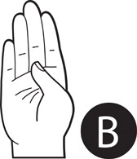
Figure 1.1 Alphabet Examples

Figure 1.2 shows the system implementation. The image set is processed to produce a binary image tracing around the edges of the contour. The key image features are generated and used to train the classification algorithm. This forms the basis for discriminating between the different signs.

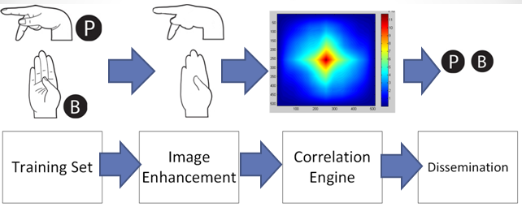
Figure 1.2 System Diagram

2. Length / Width Feature Vectors

An initial look at the alphabet set will show distinct discrepancies between large collections of sign language characters. Some signs will be elongated in the horizontal, vertical, or neither direction. An easy computation to make upon these characters is to find the length and width. These results can provide knowledge about the generic ratio of the length and width. Figure 2.1 shows three characters which exhibit the features the first feature vector found within the system.
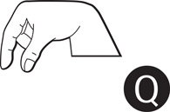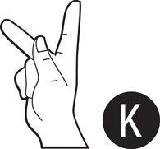
Figure 2.1 Dissimilar Length/Width Examples

This feature vector is easily computed yet doesn’t effectively disseminate between every character. Figure 2.2 shows an example of two signs which exhibit similar length/width feature vector results. This limitation prompts the use of additional feature vectors as described in the remainder of this paper.


Figure 2.2 Similar Length/Width Examples

3. inertial moments

Inertial moments can provide a collection of feature vectors for sign language discrimination. Each order of the moments provides different data points about the underlying image. The zeroth order depicts the area. The first moment focuses on the centroid of the object. The second order specifies the orientation and eccentricity. The third moment begins describing the skewness and kurtosis. Each one of these moment orders is easily computed as shown in the Figure 3.1 equations.

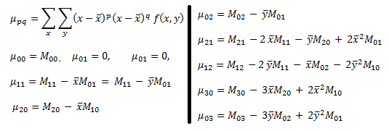
Figure 3.1 Moment Equations

The area (zeroth order moment) provides an effective data point in discriminating between the characters, but is susceptible to depth/orientation errors which might be introduced by the input sign. Therefore, the area is not used as a feature vector within the system.

The centroid (first moment) provides the center of the character. During our analysis, we use the central moment calculations to remove translation errors in the estimation results. These central moments translates the character, thus making the centroids of all our signs at the same location and unusable.

The orientation and eccentricity (second order moment) are used as feature vectors. The orientation provides directional information on the overall character. This is important in characters which are oriented at different angles. Figure 3.2 shows an example of two signs whose orientation feature vector provides good discrimination points. The eccentricity of the image provides information on the elongation or how oval-like the character is. This is excellent for discriminating between characters that are generically round in appearance to those that are elongated. The difference between the length/width feature vectors lies in the discrepancy between determining the characters elongation to that of its physical length vs. width in pixels. Figure 3.3 shows an example of excellent discrimination qualities for eccentricity between two signs.
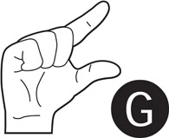

Figure 3.2 Orientation Discrimination Examples



Figure 3.3 Eccentricity Discrimination Examples

The skewness and kurtosis (third moment) of the characters is not used as it is susceptible to noise and introduces significant error into the estimation results.

4. fourier domain feature vectors

The Fourier Expansion of the input character contains frequency information which can be used to describe the image. Geometrically, the coefficients can be represented as rotating vectors tracing the boundary contour [5]. The boundary is approximated as a set of discrete samples in a complex plane for expansion in the frequency domain. Figure 4.1 illustrates the representation of the curve in complex form.
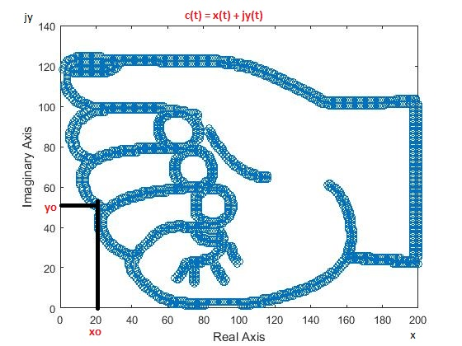
Figure 4.1 Complex Contour Representations

The Discrete Fourier Transform provides the zero frequency component and higher order harmonics. The transform forms an orthonormal basis and can therefore be exploited in representing decoupled features. The Fourier feature vectors are selected by using a combination of properties derived from the coefficients of expansion in the vertical and horizontal dimension. Equation 4.1 describes the Discrete Fourier Transform.
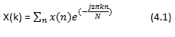
Although the total collection of all the coefficients will form an optimal feature vector for the image, this will be computationally expensive. The Fourier feature vectors are tested in combination with other descriptors for the image to enable satisfactory classification with fewer coefficients. The coefficients of the first, highest and least harmonics and also the zero frequency were selected as the frequency domain descriptors for the image. These features provided better discrimination between the signs compared to other derived properties such as the mean and the variance.

The zero frequency components contain information about the image in terms of its location (center of gravity) and are less susceptible to noise. This makes it desirable as a feature vector. The first harmonic coefficient gives an indication of the locus of the shape formed by slow changing portions of the boundary. The higher order harmonics, though susceptible to noise, describe the finer details of the image contour. It is assumed that the trace contributed by the first and highest frequency as well as the minimum radial traces are significant descriptors.

The coefficients of the transform are normalized for scale invariance. This ensures invariance of these properties regardless of the image size.

5. finger segmentation feature vectors

The fingers within sign language characters play large roles in conveying certain characters. Some signs have their fingers extended or protruding outward while others have their fingers clenched or covered. Understanding the location and number of fingertips provides useful information in discriminating between signs.

There are several methods in identifying fingertips, yet the one used in this system focuses on relating the curvature of the hand’s boundary to the expected curvature of a fingertip. The results from the method can be seen in Figure 5.1. This figure includes the fingertip locations (red triangles) and the normal lines to each boundary location used in the curvature equations.

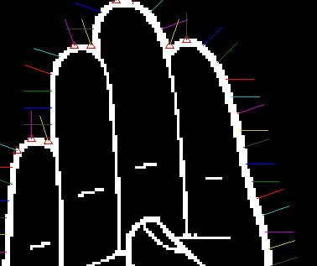
Figure 5.1 Fingertip Algorithm Results

The algorithm begins tracing around the hand, selecting sampling points with enough displacement to generate sufficient curvature statistics. Selecting appropriate sampling distances between data points is significant as it allows for the fingertips to be better described by sharp changes instead of small variations. Selecting too small a sampling point reduces the displacements to that close to the noise floor of the calculations. See Figure 5.2 for an example of the curvature computation with correct sampling distance between data points.

With the appropriate displacements to generate relatable curvature statistics to expected fingertips, identification of the number of fingertips becomes much easier. Appropriately sized thresholds are needed on the curvature results to prevent noise from bleeding into the final estimation results. Additional removal of the wrist locations is needed for the synthetic images due to their large false curvature results.

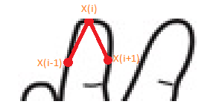
Figure 5.2 Fingertip Curvature Computations

6. Experimental results

A collection of 26 alphabetized training images was used to set the initial expected feature vector values. Each image has their individual features extracted and saved into a table for future reference. Once complete, the user is able to select a character from a table of images. This new character’s feature vectors are individually computed. With the completion of all feature vector extractions, the data points are inputs to a K-Means clustering algorithm which identifies the closest training image feature vector that each feature vector aligns with. The maximum correlation amongst the estimated feature vectors to that of the training images determines the probable sign that was originally selected. An example execution of the system is shown in Figure 6.1.

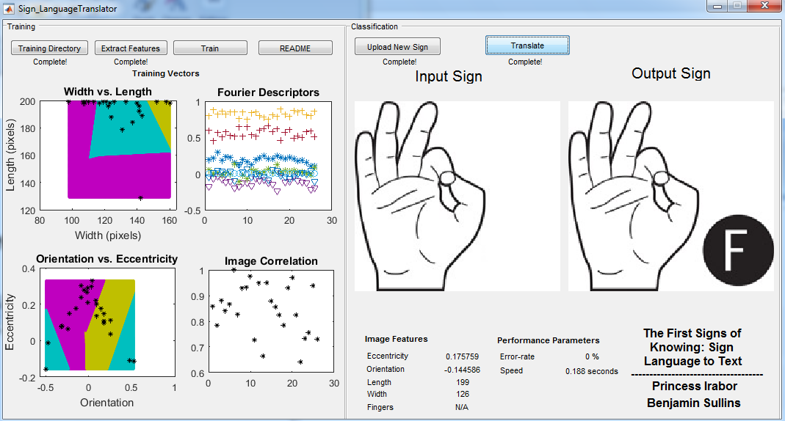
Figure 6.1 Example Test Run

The system is capable of estimating all 26 alphabetical characters. Introduction of orientation/depth errors or real-world inputs degrades the performance due to the non-compensated algorithm modifcations needed to support such changes.

7. improvements

The Length/Width feature vector used in the design utilizes the maximum displacement points within the image to describe the length and width. For a number of sign language characters, selecting the length and width results from the centroid often produces better results. Although the maximum method generates viable results, the centroid method can produce a feature vector with more variation amongst characters.

The fingertip feature vector computes as strong classifying that is able to disseminate amongst the characters well. Unfortunately, the underlying method for computing the curvature requires tuning in order to select the correct sampling distances and threshold limits. Without proper tuning, the fingertip results can be dampened or highly sensitive to curvature regions and generate improper conclusion about the character. A more optimal curvature computation which dynamically tunes the fingertip parameters would generate feature vectors that could be used in the final estimation results. Further work includes injecting real-world inputs in place of the synthetic images, compensation for orientation/angle errors on input images, and the addition of more feature vectors to aid in improving the discrimination estimation made by the overall system.

8. conclusion

This paper focused on the use of multiple feature vector selection and their use for discriminating between sign language characters. The feature vectors were not computationally challenging and could be used in unison to narrow down the selection process to greatly increase the estimation results of the system. The results show that using a multitude of easily computed vectors over a single, computationally-challenging feature vector is both viable and practical.

9. References

[1] Johannes Kilian, "Simple Image Analysis By Moments,". [Online]. Available: http://breckon.eu/toby/teaching/dip/opencv/
SimpleImageAnalysisbyMoments.pdf. Accessed: Nov. 27, 2016.

[2] Ruslan Kurdyumov and Phillip Ho Justin Ng, "Sign Language Classification Using Webcam Images. [Online]. Available: http://cs229.stanford.edu/proj 2011/KurdyumovHoNgSign
LanguageClassificationUsing WebcamImages.pdf. Accessed: Nov. 22, 2016.

[3] Erdem Yörük, Ender Konukoglu, and Bülent Sankur, "Shape-Based Hand Recognition. [Online]. Available: http://www.busim
.ee.boun.edu.tr/~sankur/SankurFolder/Shape-Based_Hand
_Recognition.pdf. Accessed: Nov. 24, 2016.

[4] Thiago R. Trigo and Sergio Roberto M. Pellegrino, "An Analysis of Features for Hand-Gesture Classification,". [Online]. Available: http://www2.ic.uff.br/iwssip2010/Proceedings/nav/
papers/paper_128.pdf. Accessed: Nov. 25, 2016.

[5] N. Mark, A. Alberto, Feature Extraction & Image Processing, Elsevier Linacre House, London, pp. 304, 12/1/2016.

