**To write code for a new SPI device you need to note a few things:**

* What is the maximum SPI speed your device can use? This is controlled by the first parameter in SPISettings. If you are using a chip rated at 15 MHz, use 15000000. Arduino will automatically use the best speed that is equal to or less than the number you use with SPISettings.
* Is data shifted in Most Significant Bit (MSB) or Least Significant Bit (LSB) first? This is controlled by second SPISettings parameter, either MSBFIRST or LSBFIRST. Most SPI chips use MSB first data order.
* Is the data clock idle when high or low? Are samples on the rising or falling edge of clock pulses? These modes are controlled by the third parameter in SPISettings.

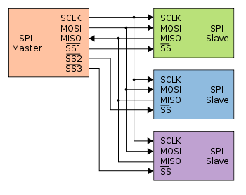

**Arduino:**

**Pins:**

* D13 = CLK
* D12 = MISO
* D11 = MOSI
* D10 = SS (not restricted, could be any D-pin)

SS pin (slave select – CS chip select) must be set to low, in order to start communicating with the slave chip. **RTC_init()** – function would be useful for this purpose

Void RTC_init () {

pinMode(SS, OUTPUT);

SPI.begin();

SPI.setBitOrder(MSBFIRST);

SPI.setDataMode(SPI_MODE1);

digitalWrite(SS, LOW); //Start Communication

SPI.transfer(0x8E);

}