Evidence for the PDA in software development

A & D - Analysis and Design Unit

Benjamin Bowen

Cohort E17

A.D. 1

A Use Case Diagram

Put database inside the system.

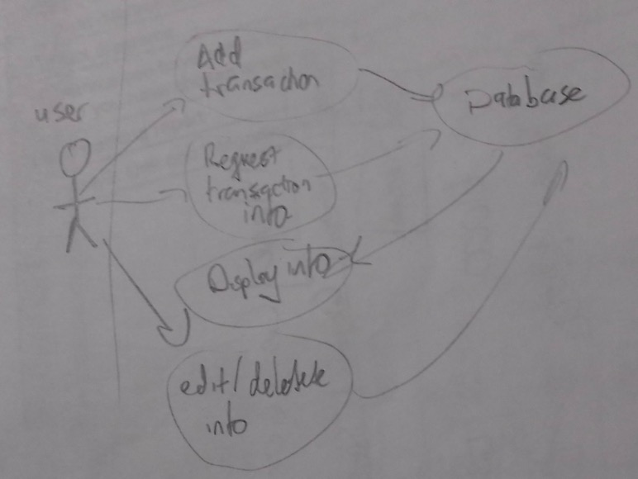

A.D. 2

A Class Diagram

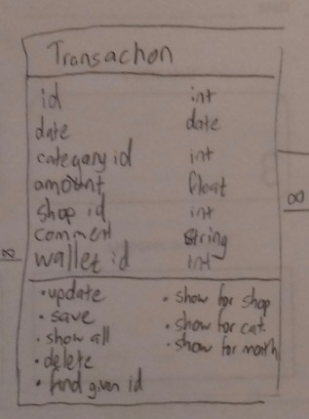

A.D. 3

A Object Diagram

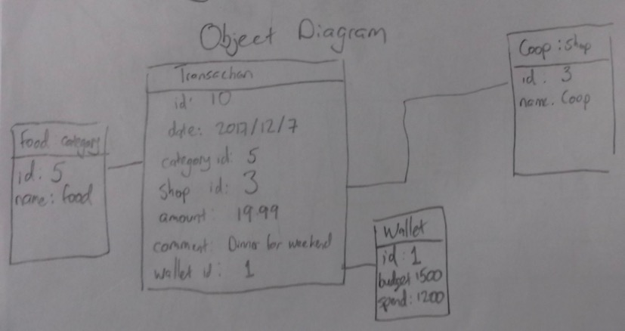

A.D. 4

An Activity Diagram

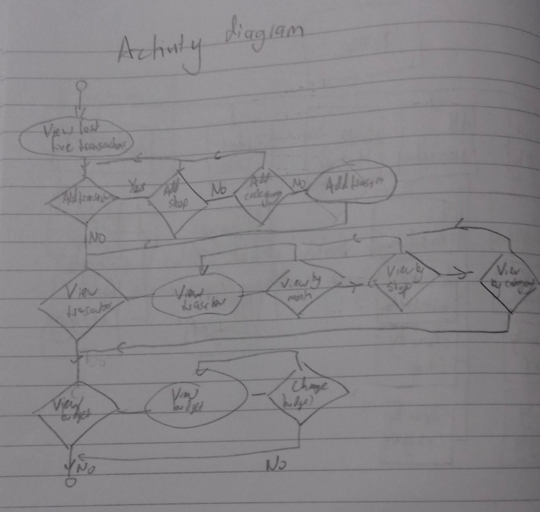

A.D. 6

Produce an Implementations Constraints plan detailing the following factors:

* Hardware and software platforms
* Performance requirements
* Persistent storage and transactions
* Usability
* Budgets
* Time

|  |  |  |
| --- | --- | --- |
| **Topic** | **Constraint** | **Solution** |
| Hardware and software | App to be run on computer screen not for mobile phone. | Use media queries in css to change layout if width/height is less than a set value. |
| Performance requirements | Has to run in all commonly used browsers. | Check e.g. with <https://caniuse.com/> if unsure about recent css/html. |
| Persistent storage and transactions | Data needs to persist when app is closed and also can be reset. | Using PostgreSQL to store data in a database. Have a function that will delete all data from the table. |
| Usability | User needs to be able to quickly recognize and log a transaction. | Different colour of ‘Add a transaction’ button. Large font and clear spacing on input data page. |
| Budget | Cannot buy new software. | Use software already installed on computer. |
| Time | Project to be completed in a week. | Limit the amount of functionality. |