Evidence for the PDA in software development

I&T Implementation and Testing Unit

Benjamin Bowen

Cohort E17

IT 5

An array in a function

A function that uses the array

The result of the function running

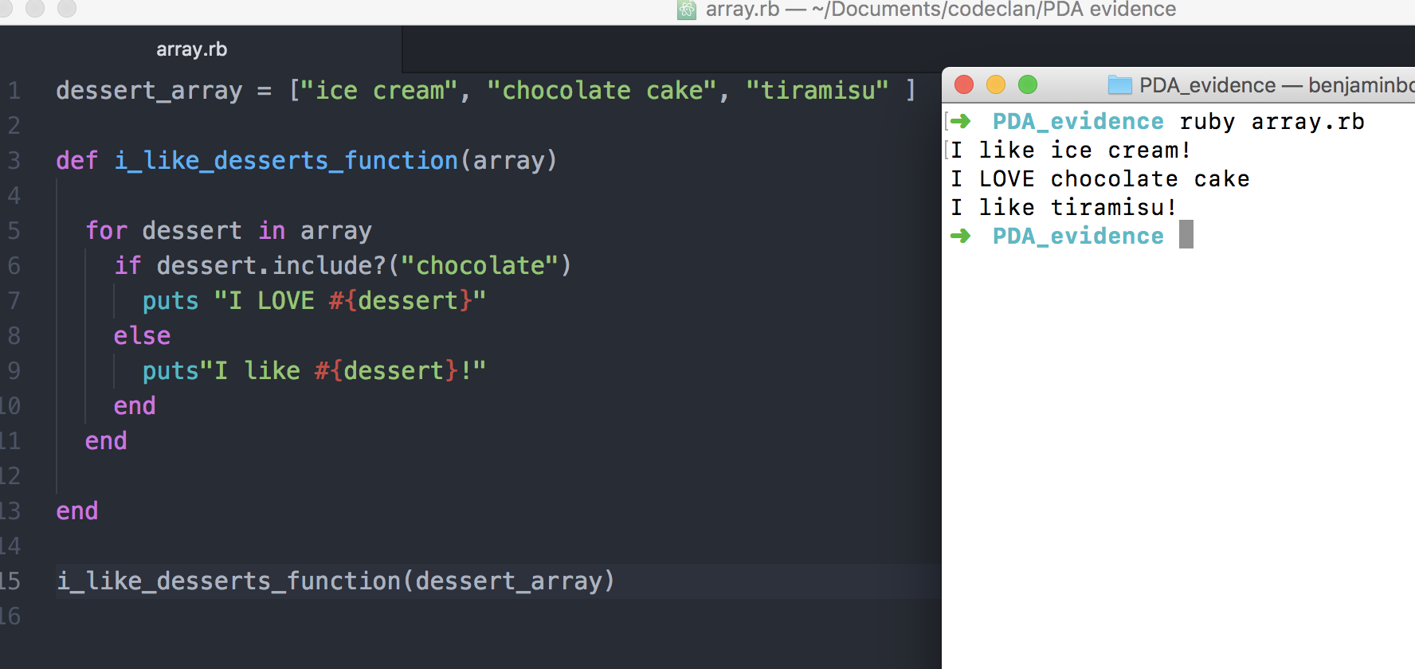

IT 6

A hash in a program

A function that uses a hash

The result of the function running

