ADMIN CAN

* Log In and Log Out
* Create table for the judges
* Add/edit/delete judges record add email address for certificates
* Create Competition Name
* Customize competition with customizable criteria or criterion
* View summary results of each competition
* Automatically calculate rating and generate ranking results
* Print summary results in PDF
* Send Certificate of Appreciation and Certificate of Appearance

JUDGES

* Log in and Log out
* View the lists of competitions
* Rate contestants
* View summary results each competition

DATABASE is created first

Database name:cultural2024

Admin table name:admin2024

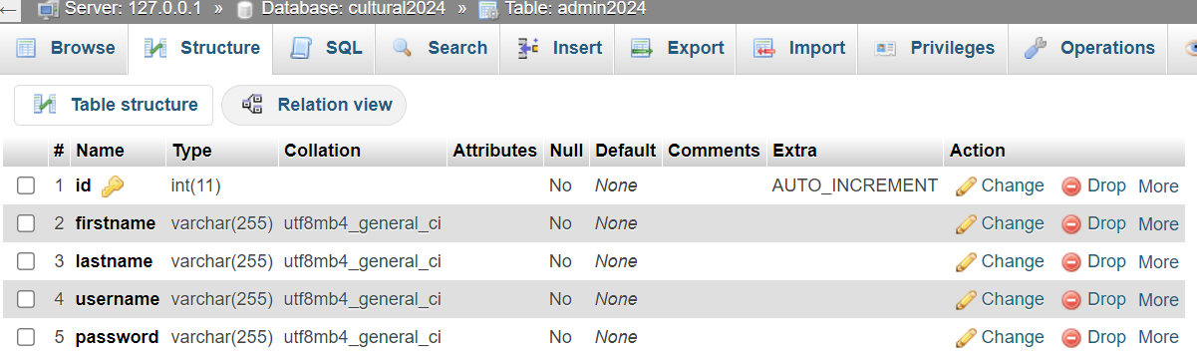

Log In page

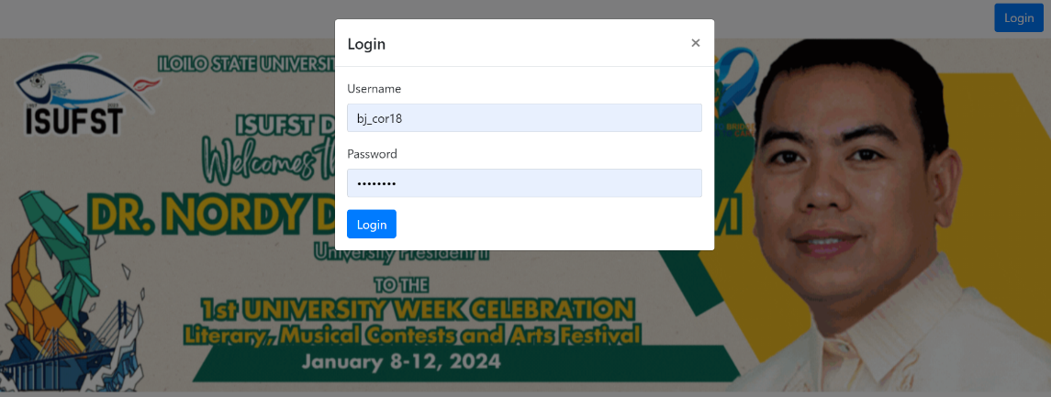

ADMIN page This is the Judges Table. If the Judges Table is not existing. Please click Create Judge Table before creating or adding a judge

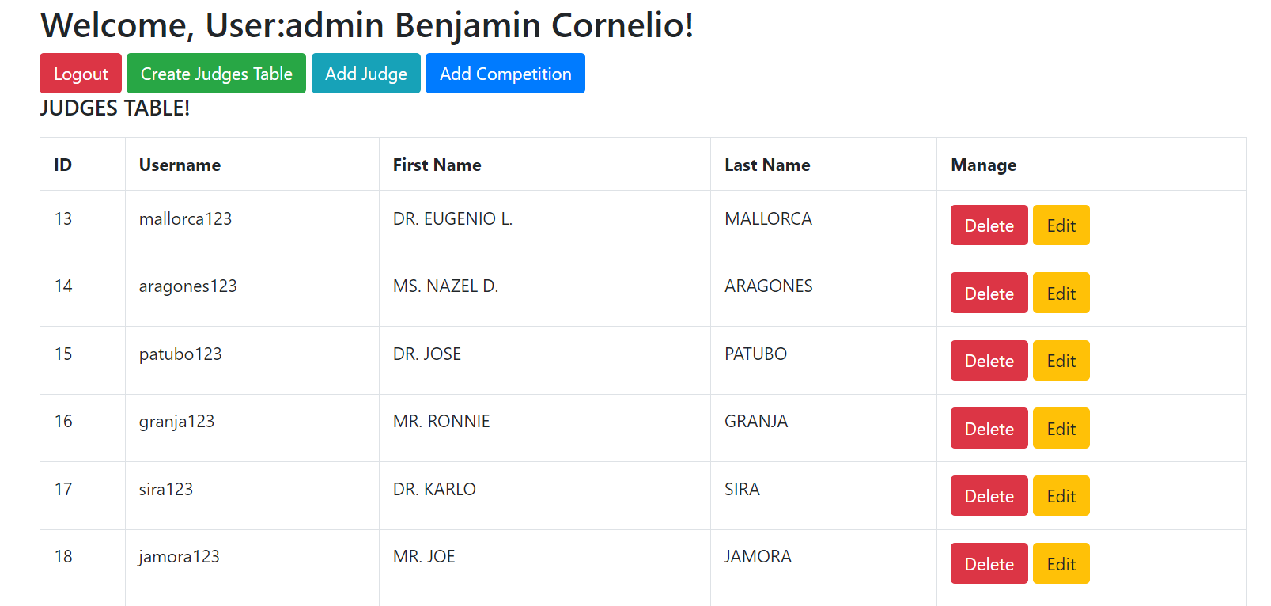

ADMIN page This is the Judges Table. If the Judges Table is not existing. Please click Create Judge Table before creating or adding a judge

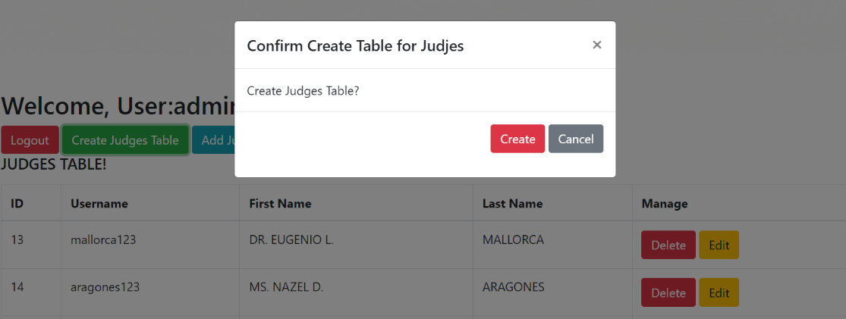

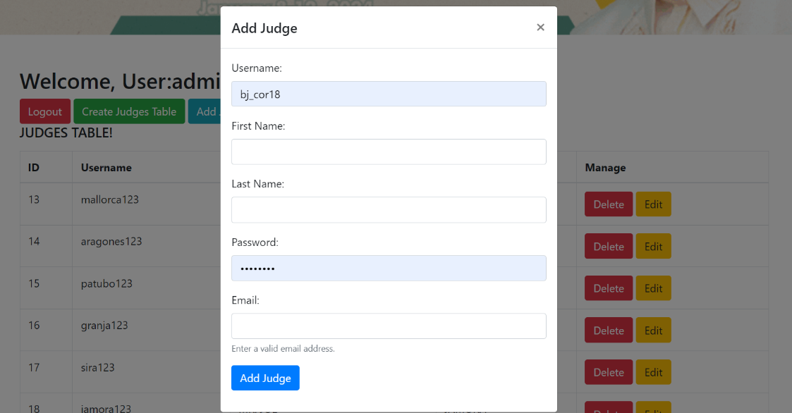After creating the table, you can add Judge, add and edit

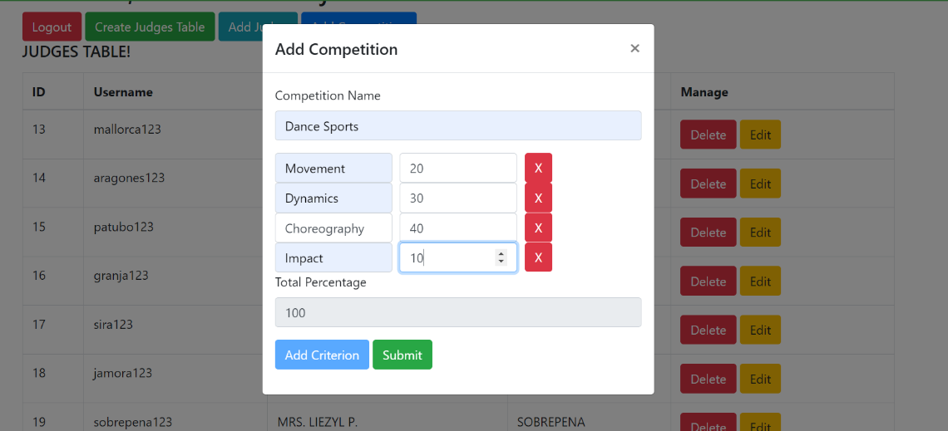Then you can add competition, set and customizable Criteria and competition name

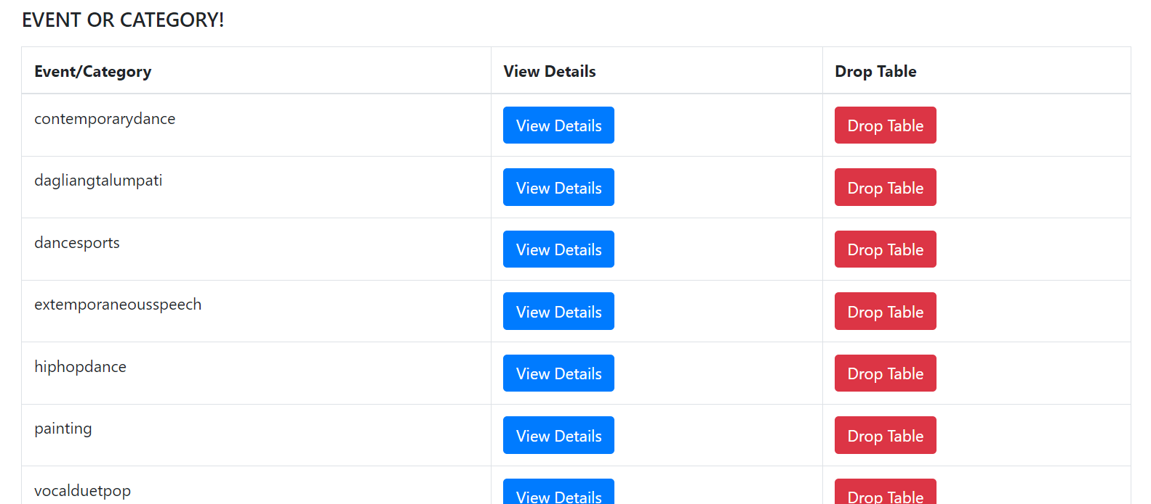Then you can view and drop the table or competition

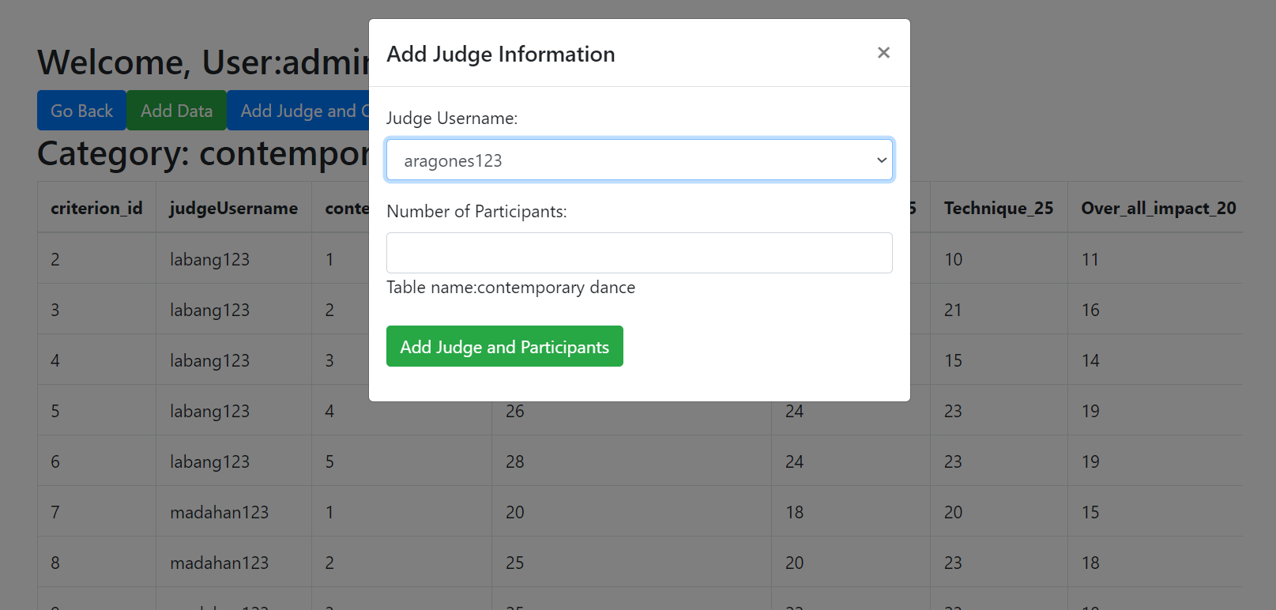You can view the details of the competition to add a particular judge in that event, using the username

The admin can see the scores for each judges for monitoring purposes

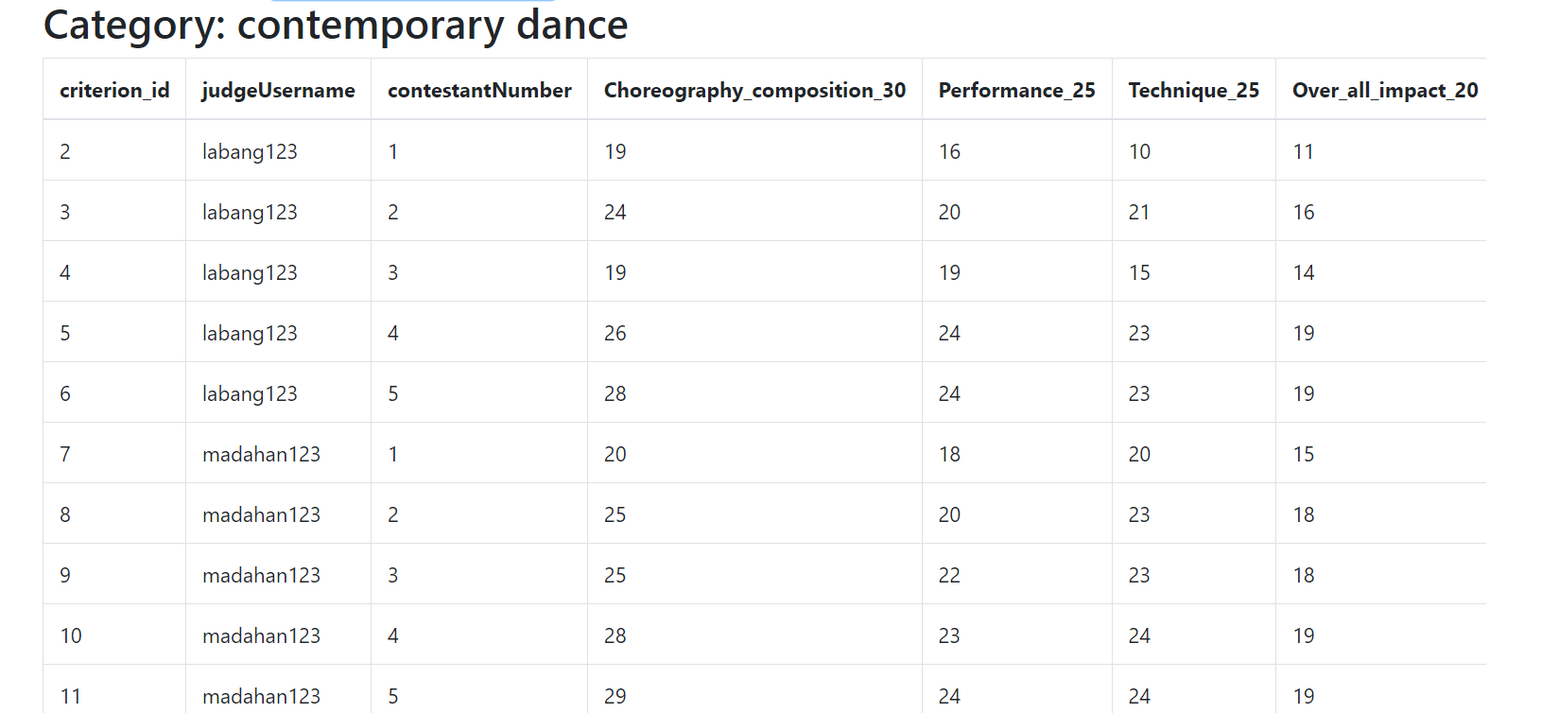

And can also view the summary results. It has an option to export results in pdf form, it can send certificate of recognition or appreciation and certificate of appearance as an attachment to each judges based on their email addresses.

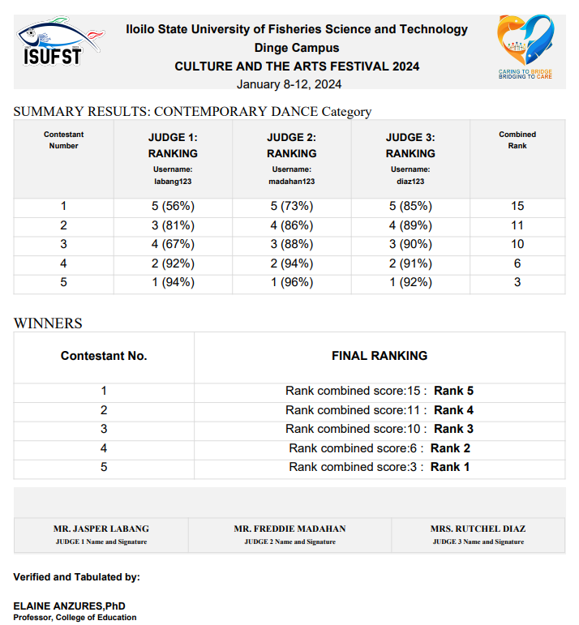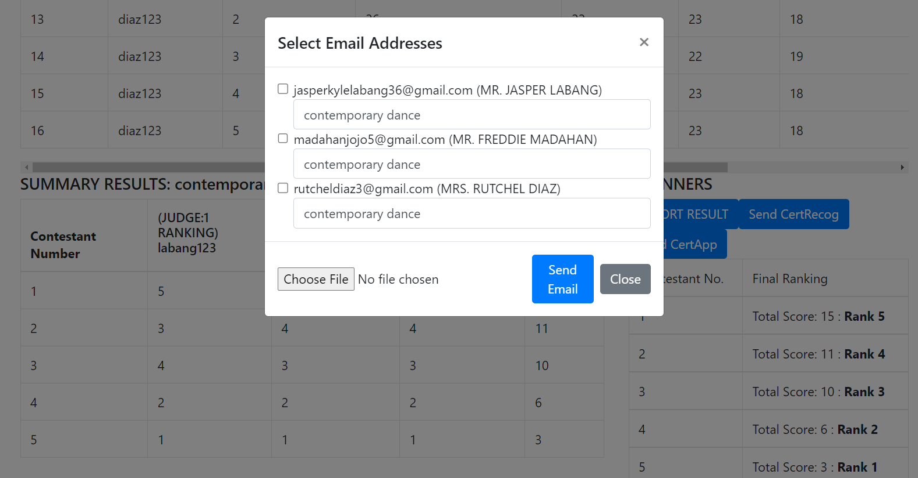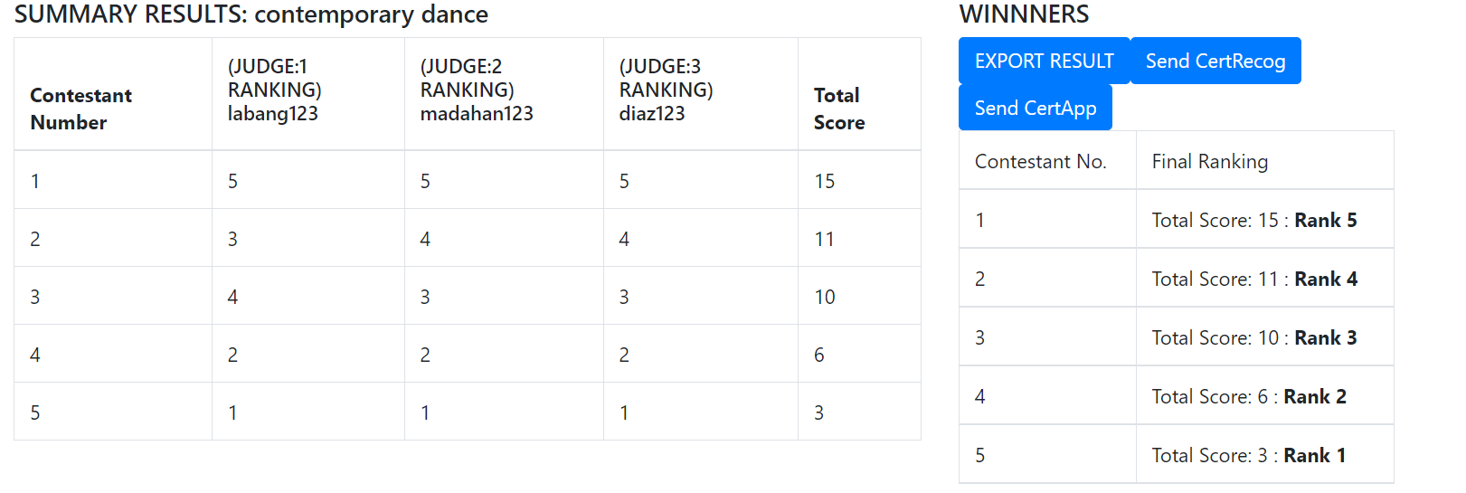This is the sample exported PDF summary result file. And it can send email.

This is the email sent to each judges after the competition.

**JUDGES HOMEPAGE**

It show the lists of table that the judges is registered or added

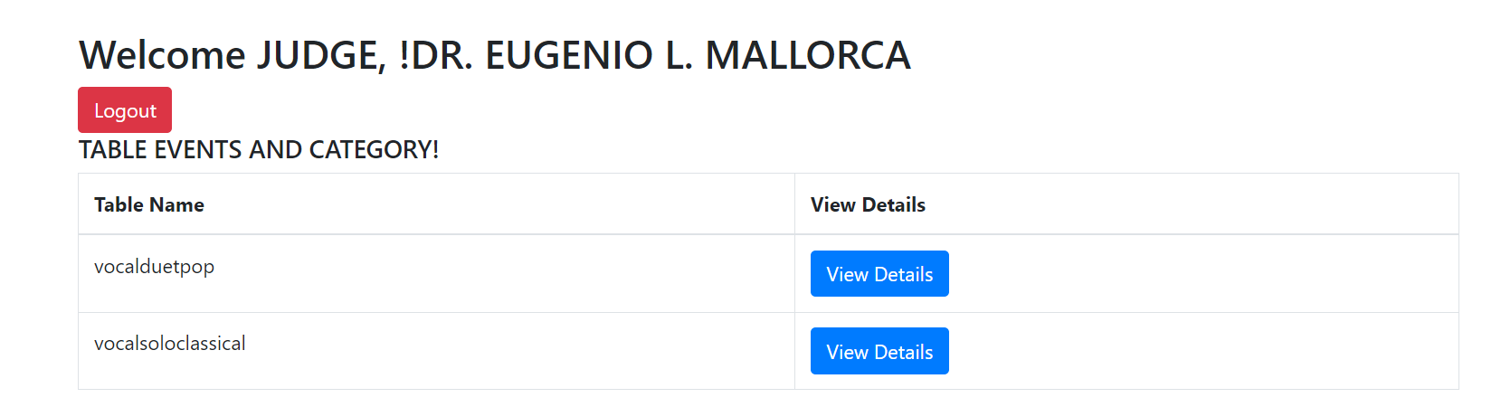

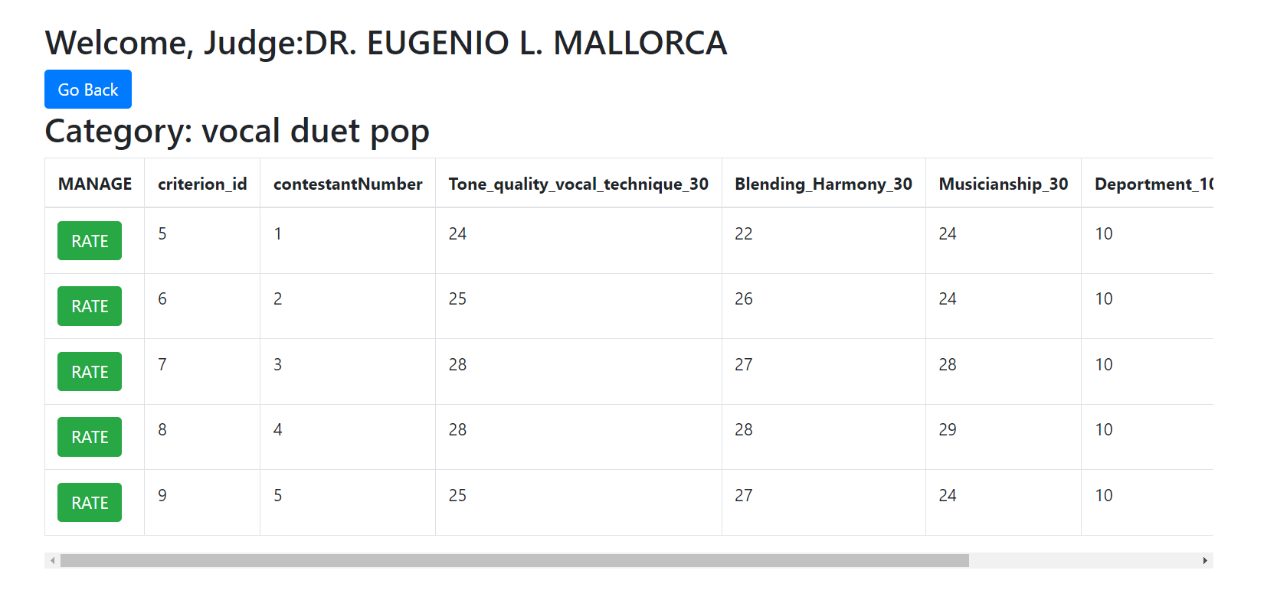Inside each table competition

JUDGES can click each rate button to add scores for each contestants

