- What is the value of each variable after the if statement?
  - n = 1, k = 2, r = 1
  - n = 1, k = 2, r = 2
  - n = 1, k = 1, r = 2,
  - n = 1, k = 6, r = 3
- Explain the difference
  - In the first block of code, it is possible that s could be incremented twice, and in the second block it could only possibly be incremented once
- Find the errors in the following if statements.
  - “then” is not valid syntax
  - it is missing a closing parentheses
  - = is used instead of == and the curly braces are misaligned
  - ?
  - Since they are not if-else statements, every time the grade is >= 60, the letter grade will be a D
- What do these code fragments print?
  - -1
  - 1
  - 1.0
  - 2
- Suppose x and y are variables of type double. Write a code fragment that sets y to x if x is positive and to 0 otherwise.
  - if(x > 0){
y = x
} else {
y = 0;
}
- Suppose x and y are variables of type double. Write a code fragment that sets y to the absolute value of x without calling the Math.abs method. Use an if statement.
  - if(x < 0){
y = -x;
} else {
y = x;
}
- Explain why it is more difficult to compare floating-point numbers than integers. Write Java code to test whether an integer n equals 10 and whether a floating-point number x is approximately equal to 10.
  - floating point numbers have limited precision so there are often errors in mathematical operations
  - if(n == 10){
System.out.println(“N is 10”);
} else {
System.out.println(“N is not 10”);
}
  - int tolerance = 0.001;
if(Math.abs(x – 10) <= tolerance){
System.out.println(“x is approximately 10”);
} else {
System.out.println(“x is not approximately 10”);
}
- Given two pixels on a computer screen with integer coordinates (x1, y1) and (x2, y2), write conditions to test whether they are
  - if(x1 == x2 && y1 == y2){
System.out.println(“same pixel”);
} else {
System.out.println(“not the same”);
}
  - if(Math.sqrt(Math.pow(x2 - x1, 2) + Math.pow(y2 – y1, 2)) <= 5)
System.out.println(“distance less than 5”);
} else {
System.out.println(“distance greater than 5”);
}
- It is easy to confuse the = and == operators.
  - error: incompatible types: int cannot be converted to boolean
  - error: ';' expected
- Each square on a chess board can be described by a letter and number, such as g5 in this example:
Letter is g
Number is odd
Color = black:
End program
- Give a set of four test cases for the algorithm of Exercise •• R3.10 that covers all branches.
  - A1
  - a2
  - b1
  - b2
- In a scheduling program, we want to check whether two appointments overlap. For simplicity, appointments start at a full hour, and we use military time (with hours 0–24). The following pseudocode describes an algorithm that determines whether the appointment with start time start1 and end time end1 overlaps with the appointment with start time start2 and end time end2.
Start1 | Start2 | End1 | end2 | s | e
10 | 11 | 12 | 13
 |  |  |  | 11
 |  |  |  |  | 12
S < e, so they overlap
Start1 | Start2 | End1 | end2 | s | e
10 | 12 | 11 | 13
 |  |  |  | 12
 |  |  |  |  | 11
S > e so they don’t overlap
- Draw a flowchart for the algorithm in Exercise •• R3.12.
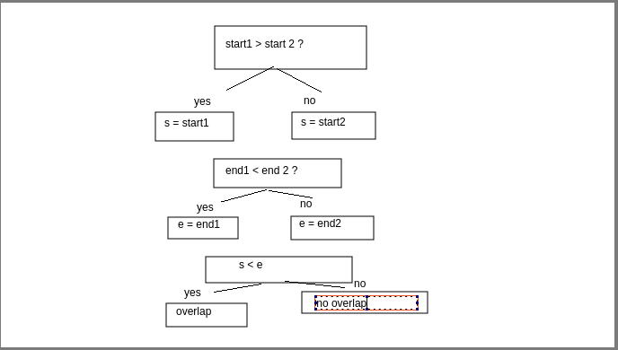
- Draw a flowchart for the algorithm in Exercise •• E3.13.
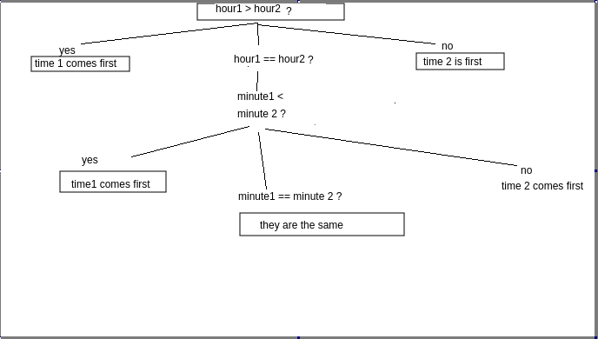
- Draw a flowchart for the algorithm in Exercise •• E3.14.
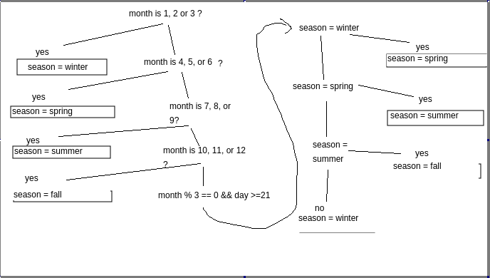
- Develop a set of test cases for the algorithm in Exercise •• R3.12.
  - 12-3, 10-4
  - 12-3, 1-2
  - 12-3, 1-4
  - 12-3. 10-1
- Develop a set of test cases for the algorithm in Exercise •• E3.14.
  - Month = 3, day = 22
  - month = 3, day = 20
  - month = 6, day = 22
  - month = 6, day = 20
  - month = 9, day = 22
  - Month = 9, day = 20
  - Month = 12, day = 22
  - month = 12, day = 20
- Write pseudocode for a program that prompts the user for a month and day and prints out whether it is one of the following four holidays:
if month is jan and day is 1
day is new year’s
otherwise, if month is jul and day is 4
day is independence day
otherwise, if month is nov and day is 11
day is veterans day
otherwise, if month is dec and day is 25
day is christmas
- Write pseudocode for a program that assigns letter grades for a quiz, according to the following table:
if score is 90 to 100
grade is A
otherwise, if score is 80 to 89
grade is B
otherwise, if score is 70 to 79
grade is C
otherwise, if score is 60 to 69
grade is D
otherwise if score is less than 60
grade is F

- Explain the difference between an if/else if/else sequence and nested if statements. Give an example of each.
  - in an if/else sequence, it checks if one condition is true, and if it’s true it'll execute one block of code but if it’s false, it will execute the else block. In nested if statements, if one condition is true, it executes a block of code that contains another if statement, and if this statement of code, it will execute the block under the nested if statement.
  - if/else sequence:
if(age >= 18){
adult = true;
} else {
adult = false
}
  - nested if statement:
if(age <18){
if(age > 12){
teenager = true;
}
}
- Rewrite the condition in Section 3.3 to use < operators instead of >= operators. What is the impact on the order of the comparisons?
if(richter <4.5){
System.out.println("No destruction of buildings");
} else if(richter < 6.0){
System.out.println("Damage to poorly constructed buildings");
} else if(richter < 7.0){
System.out.println("Many buildings considerably damaged, some collapse");
} else if(richter < 8.0){
System.out.println("Many buildings destroyed");
} else {
System.out.println("Most structures fall");
}
- Give a set of test cases for the tax program in Exercise ••• P3.8. Manually compute the expected results.
  - Single, $5000: tax = $500
  - Single, $10000: tax = $1100
  - Single, $35000: tax = $5150
  - Married, $10000: tax = $1000
  - Married, $50,000: tax = $6700
  - Married, $70, 000: tax = $10, 300

- Make up a Java code example that shows the dangling else problem using the following statement: A student with a GPA of at least 1.5, but less than 2, is on probation. With less than 1.5, the student is failing.
  - if(gpa >= 1.5 && gpa < 2){
onProbation = true;
} else {
failing = true;
}

- True
- .
- Suppose the value of b is false and the value of x is 0. What is the value of each of the following expressions?
  - False
  - true
  - true
  - true
  - false
  - false
  - false
  - true
- Simplify the following expressions. Here, b is a variable of type boolean.
  - B
  - !B
  - !B
  - B
- Simplify the following statements. Here, b is a variable of type boolean and n is a variable of type int.
  - b = (n == 0 );
  - b = !(n == 0);
  - b = (n > 1 && n < 2);
  - b = (n < 1 | | n > 2);
- What is wrong with the following program?
  - They should check if stdin has another in before they try to take an in input

