Activity Diagrams

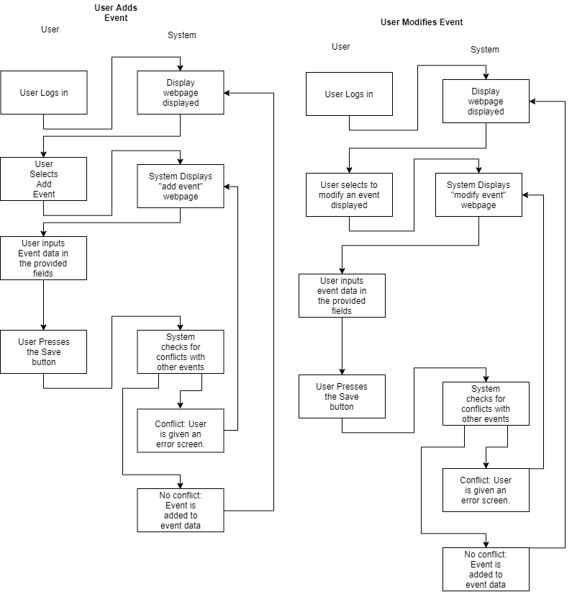 Models Use Case “Add Event” Models Use Case “Modify Event”

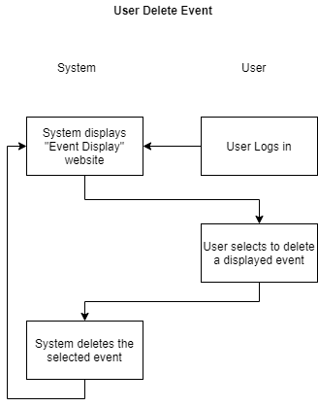

Models Use Case “Delete Event”

Class Diagram

State Diagram

