Manual steps to fix mkv2vob affected file

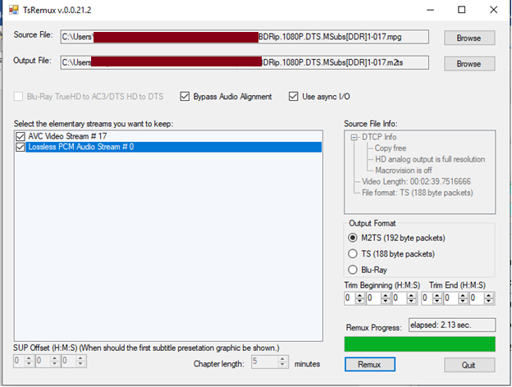

Step1: Select these options and click “remux”. It will create a m2ts file

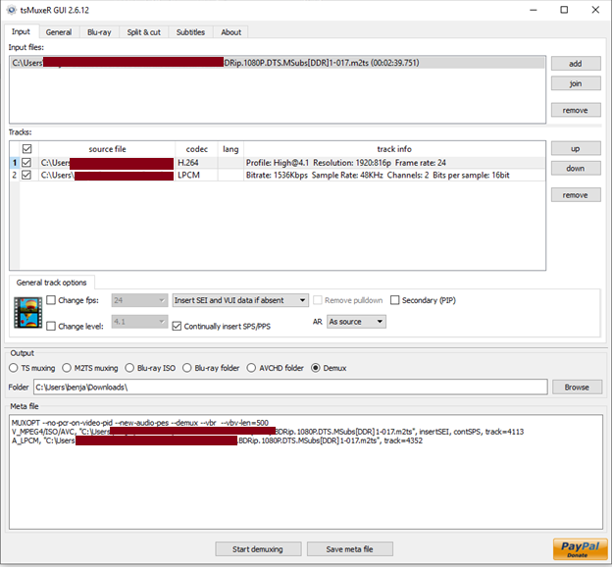step 2: select the m2ts file and then split into H.264 and LPCM wav tracks

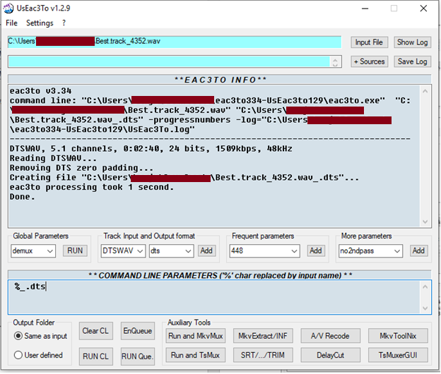Step 3: Convert LPCM wav track into DTS

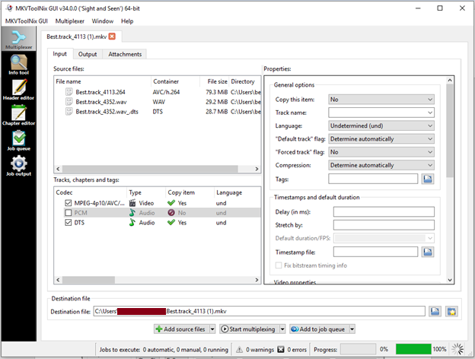Step 4: Use MKVmerge to merge the H.264 and the DTS file to final fixed mkv file