DTC-OSTI-MatlabCancerModelling-A

**Benjamin Frot, Oakley Cox, Pedro Esperanca, Annekathrin Meiburg & Sam Demharter**



<http://creativecommons.org/licenses/by/3.0/>

**Main reference:**

[K. Smallbone, R.A. Gatenby, R.J. Gillies, P.K. Maini, D.J. Gavaghan. Metabolic changes during carcinogenesis: potential impact on invasiveness. *J. Theor. Biol.* **244**, 703-713 (**2007**)](http://eprints.maths.ox.ac.uk/566/1/223.pdf)

**Abstract [authored by Oakley, Benjamin, Sam, Pedro & Annekathrin]**

Based upon the work of Smallbone et al. we have developed a hybrid cellular automaton to model the adaptation of cancer cells to its microenvironment. Our aim is to replicate Smallbone’s results with our own MatLab code. The code is a mathematical model based upon a theoretical model proposed by Gatenby and Gillies (2004). Gatenby and Gillies hypothesised that cancerous growth starts with hyper-plasticity (increased proliferation) in cells. Initially, cell survival and proliferation is limited by oxygen levels, as dictated by the oxygen diffusion limit away from blood vessels. Any adaptations by cells that reduce the reliance on oxygen for ATP production are promoted and result in cell proliferation towards the glucose diffusion limit. Reduced oxygen reliance is associated with an up-regulation in glycolysis and an increase in anaerobic metabolism. As a by-product of glycolysis, acidification of the local environment is observed (increased levels in lactic acid), that now acts as the proliferation limit by inducing cell death (both necrotic and apoptotic). Low pH promotes the next stage in cellular evolution with the emergence of acid-resistance (i.e. resistance to acid-induced toxicity). The cellular phenotype has a significant proliferation advantage because it will acidify the surroundings in a way that is toxic to its competitors but harmless to itself. By using mathematical methods to examine cellular evolution of premalignant cells within anatomical constraints, Smallbone suggests Gatenby and Gillies’ sequence is integral in the formation of invasive cancer tissue. He goes on to predict that the transition from self-limited premalignant growth to invasive cancer could be delayed or prevented by interrupting the hypoxia-glycolysis-acidosis cycle. The results produced by our model are coherent with Smallbone’s argument.

**Introduction [authored by Oakley, Benjamin, Sam, Pedro & Annekathrin]**

Cancer-related diseases cause 7 million deaths worldwide every year (The World Health Report 2006) despite significant improvements in understanding, diagnosing and treatment of the disease. The use of mathematical and computation models may be central to the next step in understanding cancer progression and dynamics in patients (L. Preziosi et al. & E. Y. Rodin et al.).

Numerous studies have demonstrated that linear, intuitive word-models cannot explain the complex dynamics in multi-scale systems (such as carcinogenesis) (Gatenby et al. 2002; Gatenby and Maini, 2003; Komarova, 2005). Instead a detailed mathematical model is required. In Smallbone’s study, he uses evolutionary models of carcinogenesis with explicit spatial parameters to accommodate the geometry of early tumour development. The method uses a hybrid cellular automaton (Anderson, 2005; Patel et al, 2001). The advantage of an automaton model is that each cell can be treated as discrete individuals such that cellular processes (proliferation, death, adaptation and metabolite consumption/production) can be modelled for each cell individually. The automaton is described as hybrid because metabolite distribution (oxygen, glucose and H+ concentrations) are allowed to form a continuous field across the cells.

Smallbone’s model is designed to test the theoretical model proposed by Gatenby and Gillies in 2004. They hypothesised that cancerous growth starts with a hyper-plastic mutation of cells. Initially, cell proliferation is limited by oxygen levels, as dictated by the oxygen diffusion limit away from blood vessels. A mutation by a cell that results in up-regulation of glycolysis (i.e. anaerobic respiration) is favoured because of a reduced reliance upon oxygen. Glycolytic cells proliferate towards the glucose diffusion limit. Reduced oxygen reliance is associated with an up-regulation in glycolysis and an increase in anaerobic metabolism. As a by-product of glycolysis, acidification of the local environment is observed (increased levels in lactic acid), that now acts as the proliferation limit by inducing cell death (both necrotic and apoptotic). Low pH promotes the next stage in cellular evolution with the emergence of acid-resistance (i.e. resistance to acid-induced toxicity). The cellular phenotype has a significant proliferation advantage because it will acidify the surroundings in a way that is toxic to its competitors but harmless to itself.

The proposed sequence can be observed graphically in [figure 1](http://www.nature.com/nrc/journal/v4/n11/fig_tab/nrc1478_F6.html) of Smallbone’s paper (originally sourced from MacMillan Magazines).

**Materials and Methods [authored by Benjamin, Oakley, Pedro, Annekathrin & Sam]**

Our hybrid automaton was designed using the guidelines and parameters outlined by Smallbone et al. The conditions of the automaton are stored in 5 matrices of size height x width. Each one holds information on one of the five variables: cell state, ATP, glucose, hydrogen (pH) or oxygen. The first matrix contains information of the state of the cell in each element. An element can be empty, contain healthy cell, or contain a tumour cell in one of seven states. A tumour cell can be hyperplastic, glycolytic, acid-resistant or any combination of the three. Each mutation allows a cell to behave in a different manner:

*Normal* – Undergoes aerobic respiration to survive. Apoptosis will occur if the cell is not adjacent to the base of the matrix.

*Hyperplastic* – Allows survival in element within the matrix.

*Glycolytic* – Glucose consumption is increased by a factor of *k* to demonstrate an increase in anaerobic metabolism and a lower reliance on oxygen.

*Acid-resistant* – Higher threshold to pH dependant death (i.e. survives longer in acidic conditions).

Our model can be run using RunSimulation.m in MatLab. The automaton is initialised using InitialiseProblem.m and updated according to the following structure:

**A – Initialise conditions (InitialiseProblem.m)**

Set up 5 matrices of size height x width:

1. State: all elements ‘empty’ except the bottom row, which are marked as 1 (or normal cells).
2. ATP: All non-empty elements marked as ATP=1. Otherwise ATP=0.
3. Glucose: All non-empty elements marked as Glucose=1. Otherwise Glucose=0.
4. Oxygen: All non-empty marked as Oxygen=1. Otherwise Oxygen=0.
5. Hydrogen: All elements marked as Hydrogen=0.

*Input:* params.

*Output:* Matrices(state,ATP,glucose,oxygen,hydrogen).

**B – Cellular Automata (StateUpdate.m, DivideStatus.m, Mutate.m, Pdeath.m)**

Implement changes in cell state (cell division, metabolism, death and evolution).

*Inputs:* ATP, hydrogen, state, oxygen, params.

*Outputs:* state.

**C – Update ATP matrix (ATPUpdate.m)**

Calculate new ATP levels for each element depending on the new states of each element.

*Inputs:* glucose, oxygen, state.

*Outputs:* ATP.

**D – Update X matrix, where X = glucose, oxygen or hydrogen (Diffusion.m, Protons.m)**

Calculate new X levels for each elements depending upon the new state of each element and the diffusion boundary conditions.

*Inputs:* state, boundary conditions

*Outputs:* X

**E – Plot results (Visualisation.m)**

Graphical display of each matrix to represent the distribution of cells and metabolites.

The input parameters (params) were selected such that they could be changed upon each running of the model. They can be checked and edited in the file setParams.m. Below are all important variables listed in alphabetical order for reference:

a0 : Minimum ATP for a cell to survive.

ATP : Matrix containing cellular ATP levels.

c : Oxygen level.

dc : Diffusion coefficient for oxygen.

vec_delta : Used to describe eq.(16), used in the paper by Smallbone et al.

dg : Diffusion coefficient for glucose.

Glucose : Matrix containing cellular glucose levels.

height : Height of the grid.

hypl : Cells in hyperplastic state.

hyplgly : Cells in hyperplastic and glycolytic state.

hyplglyar : Cells in hyperplastic, glycolytic and acid-resistant state.

hn : Normal cell acidity threshold.

ht : Tumour (acid-resistant) cell acidity threshold.

Hydrogen : Matrix containing cellular acidity levels.

k : Glycolytic rate constant.

na : Number of ATP molecules produced during complete oxidation.

Niter : Number of iterations.

Oxygen : Matrix containing cellular oxygen levels.

pa : Adaptation rate.

phiOxygen : Rate of oxygen uptake by cells.

phiGlucose : Rate of glucose uptake by cells.

u : Random number generated to determine any probabilistic change of state (cell division or cell death).

width : Width of the grid.

y : Matrix of 0s and 1s to describe any changes of state (cell division or cell death).

Our code utilises the equations outlined by Smallbone et al. to determine changes to cell state and metabolite levels. During each time-step, a cell may divide or die. The probability of cell death due to acidity levels, *p*dea, is proportional to hn (or *h*n) in normal cells, and ht (or *h*t) in acid-resistant cells. The probability of dividing, *p*div, is proportional to a0, or a0. The probabilities are defined below:

Hydrogeni,j/*h*n in a normal cell, if Hydrogen<*h*n,

*p*dea = Hydrogeni,j/*h*t in an acid-resistant cell, if Hydrogen<*h*t,

1 otherwise. (1)

(ATPi,j – a0)/(1 – a0) a0<ATP<1,

*p*div=

1. ATP≥1. (2)

These are equivalent to equations (3) and (4) in Smallbone et al.’s paper.

If division is to occur, the new cell will appear in an empty neighbouring element. If there are no empty neighbouring elements then no division occurs. If there is more than one empty space the new cell goes to the element with the largest oxygen concentration. The two daughter cells have a probability of inheriting one of the three mutations (hyperplasmia, glycolysis or acid-resistance). This probability is proportional to pa.

ATP is updated each time-step according to glucose and oxygen levels. In our model *n*a = 36 because 36 molecules of ATP are generated per glucose molecule during aerobic respiration (see equation (1) in the Smallbone et al. paper). We used an equivalent to equation (11) from the Smallbone et al. paper to determine cellular ATP levels:

ATP = Oxygeni,j + (2/*n*a)(phiGlucosei,j – Oxygeni,j). (3)

The levels of oxygen, glucose and hydrogen are updated each time-step using a non-dimensionalised diffusion equation. The equation is based upon the steady-state approximation such that glucose levels can be assumed to be in diffusive equilibrium at all times. The equation uses the diffusion coefficient of the relevant metabolite, dg (or *d*g) for glucose and dc (or *d*c) for oxygen:

(*d*g2 ∇ξ2)*x – phiX = 0, where x = Glucosei,j or Oxygeni,j,

and phiX = phiGlucosei,j or phiOxygeni,j. (4)

Note that:

phiGlucosei,j = Glucose i,j for normal cells, (5)

phiGlucosei,j = k * Glucose i,j for glycolytic cells, (6)

phiOxygeni,j = c = Oxygen i,j for all cells. (7)

Equation (4) can be solved for Glucosei,j using a finite-difference approximation:

Glucosei+1,j + Glucosei-1,j + Glucosei,j+1 + Glucosei,j-1 – (4 + δi,j)*Glucosei,j = 0. (8)

Where,

0 in a vacant cell,

δi,j  = 1/ *d*g2  in a normal cell,

k/ *d*g2 in a glycolytic cell. (9)

Further details of these equations can be seen with equations (16) and (17) in the Smallbone et al. paper.

Hydrogen concentration does not follow simple (Fickian) diffusion, as this would lead to charge separation. Movement can be approximated using an approximation of the diffusion coefficient:

(∇ξ2)*Hydrogen + phiGlucose - Oxygen = 0, (10)

and can again be solved using a finite-difference approximation, with the difference being that Hydrogen = 0 is the normal level at the basement membrane.

**Results [authored by Benjamin, Oakley, Pedro, Annekathrin & Sam]**

Cells in the basement layer are termed normal cells. They are unable to divide into the upper layers as they lack the hyperplastic mutation. Other mutations are seen but these are also incapable of dividing upwards in our cellular automata model (Figure 1a). Only when the hyperplastic mutation arises are the cells able to proliferate and take over the free space above the basement layer (Figure 1b). As they approach the O2 survival threshold, more and more of these cells begin to die as they face a lack of ATP production due to O2 starvation. This “equilibrium” state continues until a second mutation arises which enables the cells to use glucose to make up for low O2 concentrations to produce ATP, the so called “glycolytic” phenotype (Figure 1c). These new cells can replicate and grow beyond the previous barrier that was faced by the merely hyperplastic cells and grow in the upper regions until a second threshold is encountered. Initially they can proliferate past this threshold but after some time they are killed due to the high concentrations of protons resulting from their own anaerobic glycolysis, which produces a toxic, acidic environment, that promotes their death (Figure 1c & appendix).

However, they begin to outcompete the merely hyperplastic cells and take over the lower layers because of their increased fitness due to higher ATP production, which leads to higher probability of division.

Eventually acid-resistance will develop in the glycolytic-hyperplastic mutant that enables them to grow into the acidic environment (Figure 1e). Because these cells are acid resistant they have a higher likelihood of surviving their own acid production pushing the non-resistant phenotype back towards the basement membrane. While this new “super” cell population is growing, more hydrogen is produced and more glucose is consumed (appendix). Eventually most non-acid-resistant cells have died and the invasive species predominates and invades the basement membrane (Figure 1f). Once in a while new mutations develop, although these are short lived and die within a few iterations.

Even the invasive species faces a restriction, however, which is the lack of glucose in the higher regions (appendix).

**Conclusions [authored by Benjamin, Oakley, Pedro, Annekathrin & Sam]**

We are able to reproduce the results seen in the original paper. We saw a fixed order in which the cells mutated, due to the order in which the limiting environmental conditions occurred. Future work could be aimed at implementing faster algorithm (e.g., convolutions that replace for loops). It may also be interesting to see what effects a simulated glucose depletion drug would have on the glycolytic mutants or similar experiments.

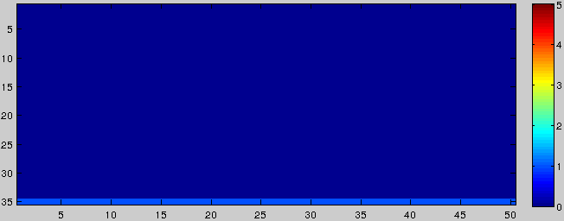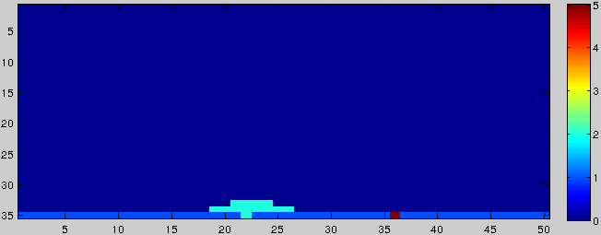

a)

b)

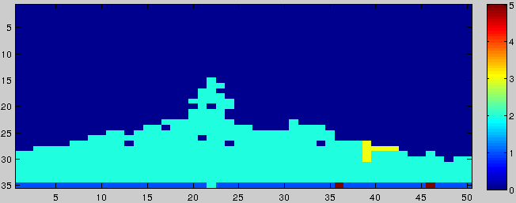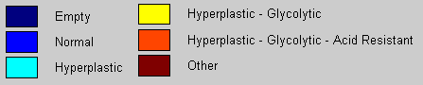

c)

**Figure 1 Evolution of cellular automata model for cancer invasiveness.**

1. Iteration 1, initial state;
2. Iteration 32, hyperplastic mutation arises
3. Iteration 58, hyperplastic cells proliferate, glycolytic mutation arises

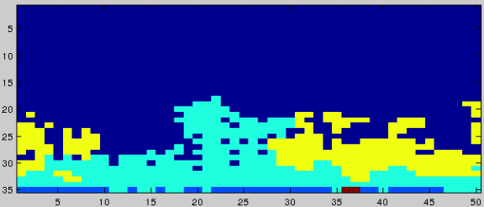

d)

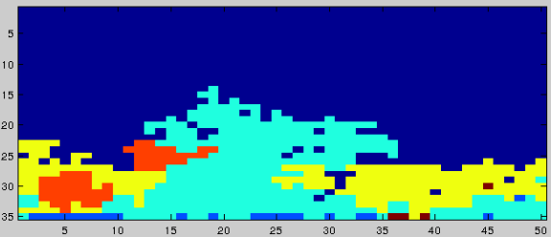

e)

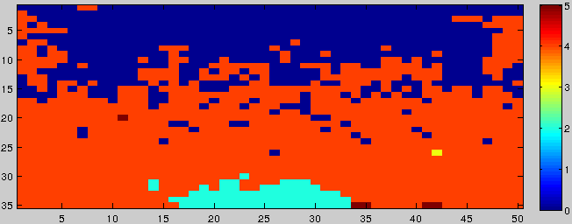

f

Figure 1 (continued)

1. Iteration 101, glycolytic outcompetes hyperplastic phenotype
2. Iteration 128, acid resistance arises
3. Iteration 247, invasive species takes over