Literature Review

Introduction

This literature review aims to provide an overview of past research related to my project. The main area of focus will be Correlation Matrix Memories and I will be considering the various encoding methods for CMMs which have been researched in the past. The second area of focus will be Self Organizing Maps. Finally I will be presenting an overview of existing research into the interaction between these two data structures.

Associative Memories
Storing information is one of the vital functions of a computer. Typically computer memories are associative memories, meaning that every stored datum consists of both a key and a value, where the value can be retrieved using only the key.

Implementations of associative memories can exist on various levels. At the lowest level is the idea of a logical address space, which the vast majority of computer architectures are based on. The idea is that the memory space is separated into many cells capable of holding a single numerical value. Each cell also has a ‘address’ which is usually its index within the memory space.

Memory Address | Contents
0x00 | 01101000
0x01 | 01100101
0x02 | 01101100
0x03 | 01101100
0x04 | 01101111

However this simple model suffers from the fact that each cell may only hold one value. Real world data tends to consist of various fields with different values, and we tend to want to perform storage and recall on the entire record rather than individual fields.

So higher level data structures tend to be implemented on top of a logical address space. One such example is an SQL database, which in essence is just a set of tables consisting of rows and columns. Each row represents one item of data to be stored, and each column is one attribute. Most of the time every row is also given a numerical key by which it is indexed and can be retrieved.

Primary Key | Name | Age
1 | Alice | 24
2 | Bob | 17
3 | Charlie | 42

This type of associative memory can be constructed on top of a simple logical address space, and handles grouped data much more effectively.

However, one downside of database-style memories is that their size grows in proportion to the number of rows in the database. Large databases can be hundreds of gigabytes in size. In addition search and lookup operations can become slower as more rows are added.

Correlation Matrix Memories
A Correlation Matrix Memory (henceforth CMM) is another type of high level associative memory which was first proposed by Teuvo Kohonen in 1972 [1]. This data structure has two main advantages over a database-style associative memory. Firstly, a CMM has a fixed size which does not grow as more data items are added. Secondly, it allows for fuzzy key lookup, meaning that an incomplete or noisy key may be supplied and the corresponding value may still be retrieved.

However these strengths are also weaknesses. The fixed size means that as items are added to the CMM it becomes increasingly saturated meaning that recall is increasingly less accurate.

In Kohonen’s seminal paper he was able to present a mathematical model of exactly how quickly saturation would occur as more and more items were inserted, and thus what the corresponding recall error would look like. Since their conception CMMs have been applied to various problems including the development of a novel search engine [2], spell-checking [3] and the monitoring of high-volume sensor data [4]. Much research has also gone into improving their performance and capacity for generalisation [5].

A CMM uses mathematical operations on matrices in order to store data. When a key/value pair is presented to it, both the key and value are first converted into numerical vectors. These vectors are then multiplied to create a matrix. The sum of all such matrices form the CMM as a whole.

Diagram of CMM key/value insertion here

The encoding of the key and value into vectors is a problem of vital importance, and is my project’s focus.

A good encoding seeks to maximize the recall accuracy of the CMM and must have several properties. Firstly it must not be lossy: The original record needs to be able to be encoded and then decoded back into its original form without loss of information. Secondly, a suitable encoding must generate vectors which have a fixed magnitude (and thus lie on the surface of a hypersphere). Thirdly, there should be minimal overlap in the encodings, meaning that ideally no two records should have the same encoding.

Various encoding schemes exist which meet these criteria. One such encoding scheme which was found to be fairly effective was suggested by Stephen Hobson and Jim Austin [6] and makes use of Baum codes [7]. Baum codes are binary codes which have a fixed length and number of bits. The length of the encoding is split into several groups of bits in which only one bit in each group is set. The lengths of each group of bits are co-prime meaning that duplicate codes cannot exist. This turns out to be a good encoding for use in a CMM since the fixed number of bits in the code allows a fixed size vector to be constructed. In addition, when encoding a complex record each field within the record can be represented by one group of bits within the code.
Diagram of Baum code construction here

The aim of my project is to develop a similar scheme which makes use of Self-Organizing Maps in order to encode the input data to the CMM.

Self Organizing Maps
Self Organizing Maps are a type of Artificial Neural Network. Artificial Neural Networks are computing systems which attempt to imitate the function of an animal brain. They consist of a set of virtual neurons and synapses which connect those neurons. The output from each neuron is usually a non-linear function of it’s inputs. Useful outputs can be obtained by feeding input data into carefully structured networks.

The idea of a logical calculus for neural networks was first suggested by Warren McCulloch and Walter Pitts in 1943 in their paper “A Logical Calculus of the Ideas Immanent In Nervous Activity”[10]. Their thought was that neural events and the relations between them could be treated as statements of propositional logic. In the late 1940s Donald Hebb expanded on this idea in his book “The Organization of Behaviour”[11], suggesting a theory for learning which was well summarized by another as “Cells that fire together, wire together”[12]. His theory became known as Hebbian Learning, a form of unsupervised learning.

The concept of supervised vs. unsupervised learning is one that often appears in the literature. In supervised learning, the learning agent is presented with both an input pattern and the ‘correct’ output pattern. It thus learns, by example, how to associate inputs with correct outputs. This could be for example, a spoken word as input and the correct spelling of that word as output.

On the other hand, in unsupervised learning the agent is never shown the ‘correct’ output. The agent must attempt to calculate the optimal output pattern without guidance.

Both methods have their advantages. Supervised learning excels when a large body of input/output examples are available. The agent can be trained using a set of these examples, in the hope that it may then respond well to previously unseen ‘real-world’ examples. However in some cases this body of data may not be available. Or alternatively, it may not be possible to know what an optimal output pattern even looks like.

Self Organizing Maps fall into the second category since they make use of unsupervised learning. They were, like CMMs, a conception of Teuvo Kohonen. In 1982 Kohonen published a paper titled “Self-organized formation of topologically correct feature maps”[14] in which he first presented the idea of the SOM. He later refined his ideas and published a thorough book, simply titled “The Self-Organizing Map”[15].

SOMs consists of a lattice of connected neurons. Common structures include a 1 dimensional ‘chain’ of neurons, or a 2 dimensional square or hexagonal grid.
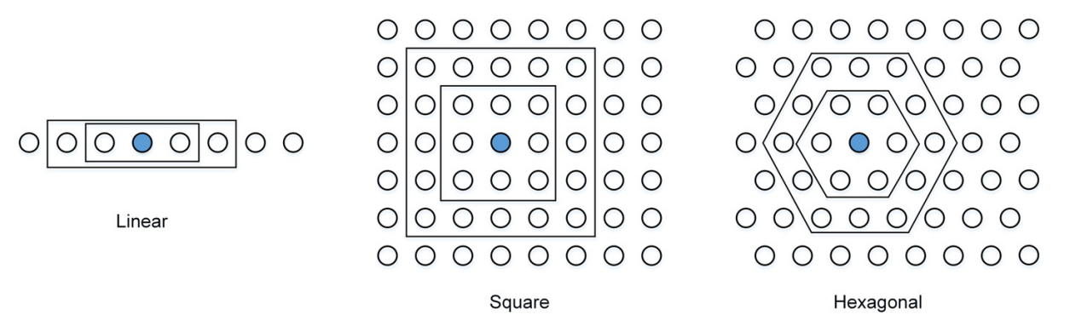
Common SOM topologies [16]

Each neuron holds a vector of weights which has the same dimensions as the input data. These weight vectors are usually initialized with random values. When an input datum is presented to the network, the neuron with the weight vector that best matches the input vector is found. This best matching neuron is often called the ‘best-matching unit’ or BMU for short. The best match is usually calculated by computing the Euclidean distance from the neuron’s weight vector to the input vector, and then finding the neuron that minimizes this function.

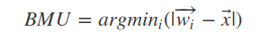

Once the BMU has been found, the weight vector of this neuron is adapted slightly to ‘pull’ it closer to the input that was matched. Additionally, the weight vectors of all neurons in the neighbourhood surrounding the BMU are also adapted, but by smaller amounts depending on the distance of those neurons from the BMU. The effect is comparable to pulling on a piece of cloth or net – the point that is being pulled is moved the most, but all surrounding points are also along with that point. Over time the topology of the weight vectors becomes similar to the topology of the input space. This is why the term ‘self-organizing’ is applicable.

Once the training process is complete a SOM becomes useful for categorizing input examples. The output of the SOM is the co-ordinates of the BMU. So for example if a 2D lattice is used, the output consists of a (row, column) pair. There are many applications for this technology; one of the most prevalent however is it’s usefulness for creating visualizations of complex data sets. The figure below was constructed using a SOM, and attempts to categorize a number of countries according to their level of poverty. Constructing such a visualization is not a simple task since ‘level of poverty’ is rather an abstract, immeasurable term. However by using various other statistics about the countries, such as life expectancy and average income, we can estimate poverty levels reasonably well. The SOM solves this problem excellently. In this case the weight matrix of each neuron refers to 39 indicators taken from World Bank statistics relating to each country.

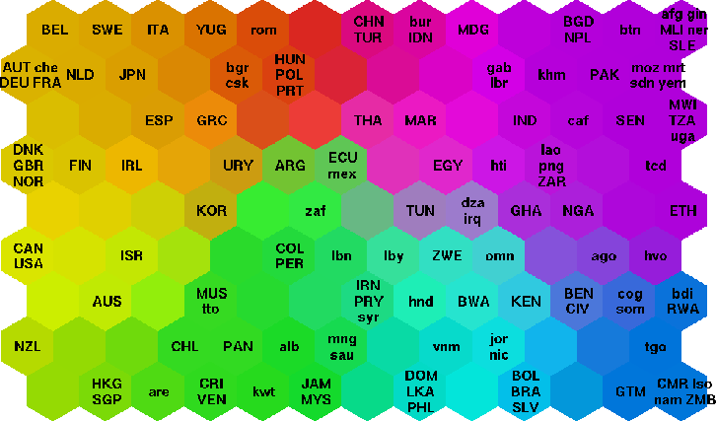
World poverty map based on 39 indicators from World Bank Statistics [17]

SOM based methods have also proven effective in oceanography and meteorology. Liu and Weisberg[18] note that the SOM’s ability to handle high-dimensional data is extremely useful in these domains, which often require predictions to be made based on large numbers of variables, which may have unknown significance and co-variability.

SOM Based CMM Encodings
An important question remains; why do we predict a SOM-based encoding to a CMM might be effective?

One weakness of other encoding schemes, such as Baum codes, is that the encoding for two very similar items of input data may be very different. This may lead to reduced recall accuracy in the CMM. The self-organizing property of the SOM addresses this issue well. Given two very similar items of input data, the BMU’s for each are likely to be very close in terms of distance, if not the same. Thus the encodings given to each item are likely to be very similar.

However as we note earlier, there are other important factors in creating a good encoding for a CMM. One of these is the need for encodings with a fixed number of bits. Another is the need to be able to link a given encoding back to the original datum. Whether or not a SOM-encoder can deal with these other issues is the question of this project.

References
[1] Teuvo Kohonen, “Correlation Matrix Memories” IEEE Transactions on Computers, vol. c-21, no. 4, April 1972.
[2] J. Austin, K. Lees, “A search engine based on neural correlation matrix memories”, Neurocomputing, vol. 35 (2000), pp. 55-72, Elsevier, April 2000.
[3] Victoria J. Hodge, Jim Austin, “A Novel Binary Spell Checker”, 2001. [Online]. Available: https://link.springer.com/content/pdf/10.1007/3-540-44668-0_167.pdf. [Accessed: 26- Nov- 2017]
[4] Jim Austin, Grant Brewer, Tom Jackson, Victoria J. Hodge “AURA-Alert: The use of Binary Associative Memories for Condition Monitoring Applications”. [Online]. Available: https://www.researchgate.net/profile/Victoria_Hodge/publication/228522738_AURA-Alert_The_use_of_Binary_Associative_Memories_for_Condition_Monitoring_Applications/links/0912f50990a2710451000000/AURA-Alert-The-use-of-Binary-Associative-Memories-for-Condition-Monitoring-Applications.pdf. [Accessed: 26- Nov- 2017].
[5] Stephen Hobson, “Correlation Matrix Memories: Improving Performance for Capacity and Generalisation” September 2011. [Online]. Available: https://pdfs.semanticscholar.org/1dc8/04171b5f65baee8148597ff0a55bf19813e7.pdf. [Accessed: 26- Nov- 2017]
[6] Stephen Hobson, Jim Austin “Improved Storage Capacity in Correlation Matrix Memories Storing Fixed Weight Codes” Artificial Neural Networks - ICANN 2009, pp. 728-736.
[7] E. B. Baum, J. Moody, F. Wilczek, “Internal Representations for Associative Memory” in Biological Cybernetics, Volume 59, Issue 4-5, pp. 217-228, September 1988.
[8] T. Kohonen, “The self-organizing map”, Proc. IEEE 78(9), September 1990.
[9] Sung Woo Park, “Implementation of Kohonen Self-Organising Feature Map Using AURA Systems”, March 2004. [Online]. Available: https://www.cs.york.ac.uk/library/proj_files/2004/3rdyr/swp101/swp101_project.pdf. [Accessed: 26- Nov- 2017].
[10] Warren S. McCulloch, Walter H. Pitts, “A Logical Calculus of the Ideas Immanent In Nervous Activity” Bulletin of Mathematical Biology, Volume 52, Issues 1-2, 1990, Pages 99-115.
[11] D. O. Hebb, “The Organization of Behaviour”, London: Chapman & Hall Ltd., 1949.
[12] S. Löwel, W. Singer, “Selection of Intrinsic Horizontal Connections in the Visual Cortex by Correlated Neuronal Activity”. Science 255 - American Association for the Advancement of Science, 1992, pp. 209-212.
[13]@inproceedings{citeulike:794012,
address = {Los Alamitos, CA},
annote = {Description of the phonotopic maps and the application to speech recognition.},
author = {Kohonen, Teuvo and M{\"{a}}kisara, Kai and Saram{\"{a}}ki, Tapio},
booktitle = {Proc. 7ICPR, Int. Conf.on Pattern Recognition},
citeulike-article-id = {794012},
keywords = {lsb},
pages = {182--185},
posted-at = {2006-08-10 13:53:55},
priority = {2},
publisher = {IEEE Computer Soc. Press},
title = {Phonotopic Maps - Insightful Representation of Phonological Features for Speech Recognition},
year = {1984}
}
[14]@Article{Kohonen1982,
author="Kohonen, Teuvo",
title="Self-organized formation of topologically correct feature maps",
journal="Biological Cybernetics",
year="1982",
month="Jan",
day="01",
volume="43",
number="1",
pages="59--69",
issn="1432-0770",
doi="10.1007/BF00337288",
url="https://doi.org/10.1007/BF00337288"
}
[15] @ARTICLE{58325,
author={T. Kohonen},
journal={Proceedings of the IEEE},
title={The self-organizing map},
year={1990},
volume={78},
number={9},
pages={1464-1480},
keywords={learning systems;neural nets;self-adjusting systems;speech recognition;clustering;competitive learning;learning vector;neural networks;self-organizing map;semantic maps;speech recognition;Animals;Artificial neural networks;Biological neural networks;Computer networks;Organizing;Pattern recognition;Process control;Signal processing;Signal processing algorithms;Speech recognition},
doi={10.1109/5.58325},
ISSN={0018-9219},
month={Sep},}
[16] @unknown{unknown,
author = {Miljković, Dubravko},
year = {2017},
month = {05},
pages = {},
title = {Brief Review of Self-Organizing Maps}
}

[17] Samuel Kaski, “SOM Research Page”, University of Helsinki. [Online]. Available: http://www.cis.hut.fi/research/som-research/worldmap.html. Accessed: [10- Jan- 2018].

[18] Liu, Yonggang, and Robert H. Weisberg. "A review of self-organizing map applications in meteorology and oceanography." Self Organizing Maps-Applications and Novel Algorithm Design. InTech, 2011.

