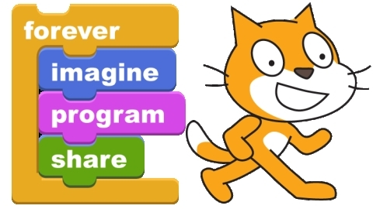**Lesson 5: Advanced Game Design**

**Description:**

Today we will continue to use Scratch. We will learn how to find games that others have created and borrow their code for use in our own programs.

**Discussion:**

1. What is code?
2. What is the advantage of using other people’s code?
3. Why would you want to share your code?
4. When is it unfair or illegal to borrow code?

**Tips:**

We’ve already learned shortcuts for copy (ctrl+c), paste (ctrl+v), find (ctrl+f), close (alt +F4), switch windows (alt + tab), undo (ctrl+z), new Tab (ctrl + T), new Window (Ctrl + N), and run (windows + r) now we can learn three more very useful shortcuts.

1. Print Screen (Prnt Scrn)
2. Select a document (Ctrl + A)
3. Save your work (Ctrl + S)

**Look at other Games:**

1. Open the internet
2. Go to scratch.mit.edu
3. Login
   1. Click Login
   2. Username: kippstudent
   3. Password: mygames
4. Check out all the programs on the front page, try a few out
5. Now, search for “Basketball ***(demo)***”
6. Click on the top result
7. Try playing for a minute
8. Now Download the project
   1. Click on the blue link titled "[**Basketball ***(demo)…**](http://scratch.mit.edu/projects/golfer3/494126/download)"

Cool! So now you have seen the other work that people have put together with Scratch and learned how to download the code from a program that you like. Next let’s try editing the program.

**Edit Basketball (demo):**

1. Click on the basketball
2. Whoa, there is a ton going on here, but we don’t need to understand all of it to make some changes. Let’s just change the look of the basketball without changing its behavior
3. Click on costumes
4. Click Edit
5. Now paint a new picture in the basketball
   1. First off, let’s work inside the basketball, because if we change its shape we might change its behavior
   2. Try painting a smiley face, adding lines to it, or some other creative idea
   3. When you are done click OK
6. Now try playing the Basketball game with your edited code
   1. Click on the green flag
   2. Play around

Awesome! Now you have taken a cool game and made a small improvement. Think of all of the other changes you could make to this game. You could improve its background or add a second basketball. But remember changing looks is pretty easy and changing the behavior (scripts) requires that you understand the program. Now you can borrow elements from all sorts of games, feel free to play around.