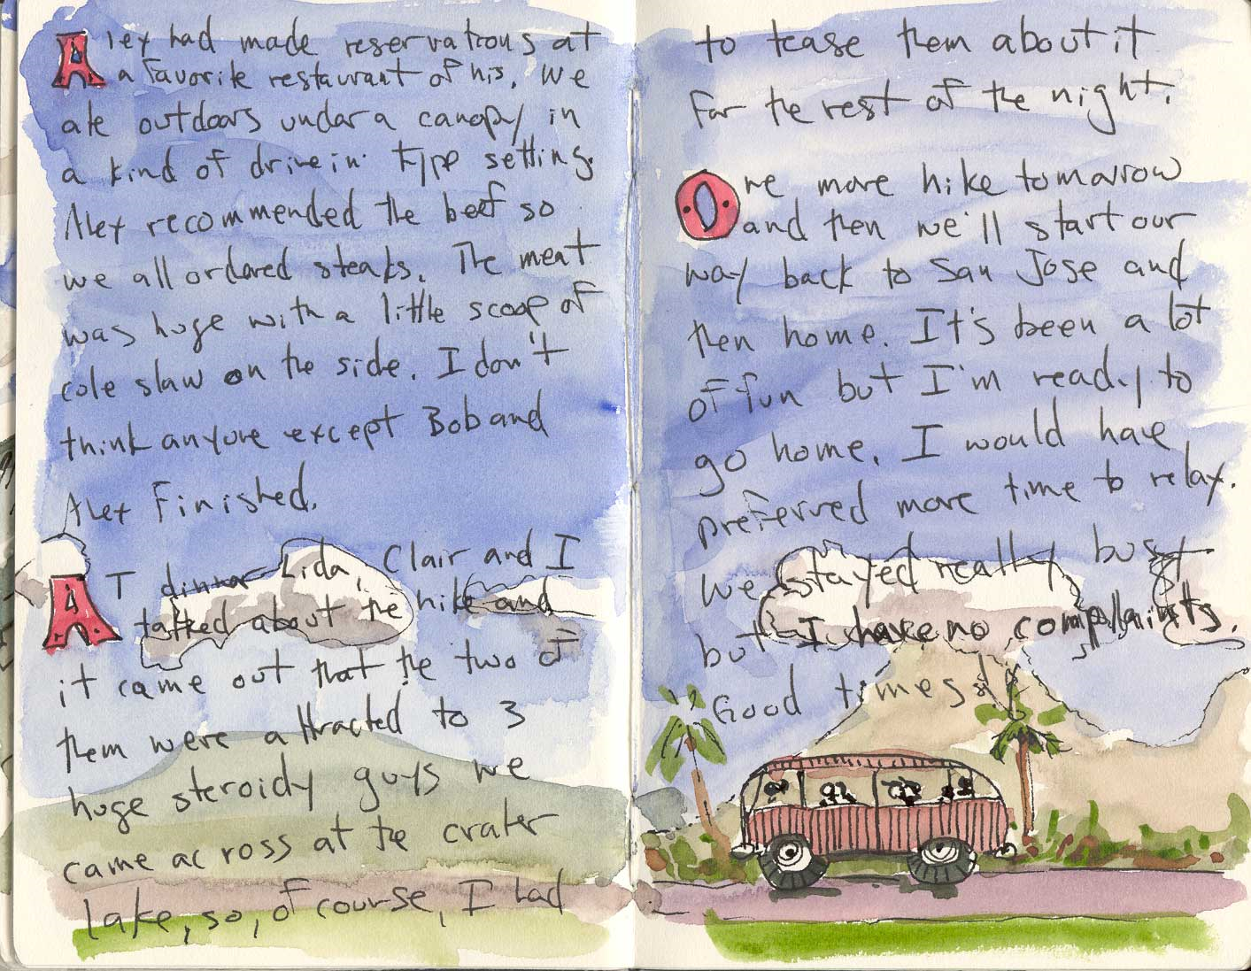
Lesson 4: Blogs
Description:
Today we will create a blog and link its content to your website.

Discussion:

- What is a blog?
- What could you write in a blog?
- What would you write?
- What is a Feed?
- What is the blogosphere?

Tips:
Shortcuts make you faster on the computer. We’ve already learned shortcuts for copy (ctrl+z), paste (ctrl+v), and find (ctrl+f) now we can learn three more very useful shortcuts.
- To close a window press Alt + F4
- To switch between windows press Alt + tab
- To undo your last step press Ctrl+Z

Try out these helpful tips during the lesson.

Start your blog

- Go to the Blogger website
- sign in using your google information
  - email: kipp.student1
  - password: mywebsite
- click “create a blog” (on the right side of the page near ‘help’)
- Fill out the form
  - Give your blog a title
  - Give it a unique address ( be sure to check availability )
  - Enter the squiggly characters ( ask for help if you need it )
  - Press continue
- Choose your layout press continue
- Click Start Blogging
- Give your post a title (like “hello world” )
- Write a few sentences or a paragraph about who you are and what you want to blog about
- Click “Publish Post”
- Click View blog

Congratulations! You have just made your first blog post. If you want to write more click new post and keep writing. Otherwise go on to the next part of the lesson.

Feed your blog to your website

- Go to Google Sites
- Login (the password is above if you don’t remember)
- Choose your site and click edit
- Click “insert” then click “more”
- Search for “RSS”
- Choose “Custom RSS”
- Now find the blog feed and copy it into the “Feed URL”
  - Go back to your blog
  - Click “Posts (Atom)” at the bottom of your page
  - Copy the address
  - Go back to your website
  - Paste the address into the “FEED URL” box
- Adjust the size (make the width:1000 and height:500)
- Click OK
- Click Save

Great! Now you have a blog and a feed to your website. Feel free to spend the rest of class working on your site or writing in your blog.

