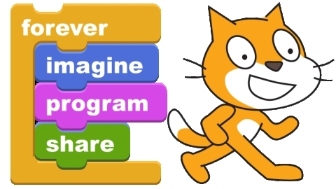
Lesson 4: Game Design
Description:

Today we are going to use the “Scratch” software to make our first videogame.

Discussion:

- What are your favorite games?
- Where can you find awesome games?
- Who makes video games?
- Can you get paid for making video games? How?

Tips:
We’ve already learned shortcuts for copy (ctrl+c), paste (ctrl+v), find (ctrl+f), close (alt +F4), switch windows (alt + tab) and undo (ctrl+z) now we can learn three more very useful shortcuts.

- To open a new tab Ctrl + T
- To open a new window Ctrl + N
- To run a program by typing its name windows + r

Write your Program:
- Open Scratch
  - Click on my computer
  - Open the “S:” drive
  - Open the “Scratch” folder
  - Open Scratch
- Add some Controls
  - Click Control
  - Drag the “When… Clicked” condition with the flag into the Scripts section in the middle
  - Drag the Forever loop under the “When… Clicked” button so they are connected
- Add a motion
  - Click on Motion
  - Drag the “Turn 15 Degrees” command into the Forever loop into the script
- Add a look
  - Click Looks
  - Drag the “Change Color Effect by 25” command into the Forever loop in the script
- Try it out
  - Click the green flag on the top and watch your sprite spin
- Save it
  - Click Save
  - Choose a name
  - Click OK
- Share it with the world
  - Click Share
  - Username: kippstudent
  - Password: mygames
  - Then add a project name and notes if you like
  - Click OK

Congratulations! You have just made your first game and shared it with the world. It is a simple game and you could add all sorts of things to it. To get inspired try checking out the website and see your own game along side all the other games that have been made

Look at Scratch Online:
- Go to Scratch online
- Login
  - Click Login
  - Username: kippstudent
  - Password: mygames
- Click on and look at your project
- Look through the other projects
  - Click on “Scratch” to go back to the homepage
  - Click on projects and see what they are like
- Leave some comments
  - If you like a project or have a suggestion write them a comment in the comment box
  - Click add to share the comment
- Look at their Code
  - If you like a part of a project you can see their code
  - Click on the title of the game in the box that says “Download this project”
  - Click “OK” to Open with Scratch Project

Awesome! Now you can share games with the world and look at the code. Feel free to play more with Scratch or to work more on your website.

