Middle School Math Challenges
from Columbus State University

Problem 1.
You are given a three-digit positive number abc. When abc is reversed, cba, and multiplied by abc, the resulting product is 100147 (abc x cba = 100147). Find the value of abc and cba. Hint: the key to this problem is in the product.

Problem 2.
Observe the triangle BDE formed by line segments AE, CD, and DE. If angle ABC = 80 degrees, and angle BDE = 60 degrees, find the sum of the measures of angles CBE and BED. Remember, you are finding angle CBE + angle BED.

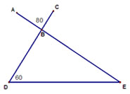

Problem 3.
Observe the cube with vertices A, B, C, D, E, F, G and H. Find the solution to question 3.

1. What is the minimum number of vertices you must cross if you start at vertex A and travel to vertex G if you may only travel along a straight edge? For example, if you travel path ABCDHG, you cross 4 vertices B, C, D, and H to get to G.

2. How many different paths can be traveled using this minimum number of vertices?

  - What is the product of question1 and question 2?

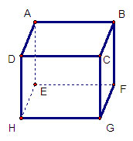

Problem 4.
If it is 7 o’clock a.m. on March 1st in Portland, Oregon, what day and time will it be in 7777 hours in Washington, DC?

