1. General

The project is executed by the NODE platform as JS application. Run of the drill is to be carried out from project downloaded folder with the following command: **node index.js** , and to access the computer local server indicated port:

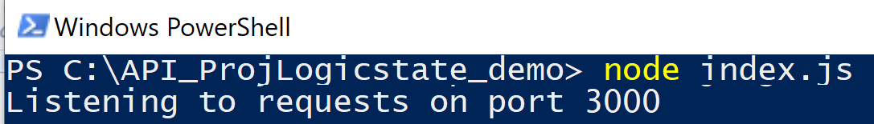

1. Background

The purpose of the document is to define the logics operation of a naval platform control & surveillance positions. Each position logic state specifies the characteristics of the dedicate state performance and the logic conditions to enable the position system function. A logical state will be defined by a number associated with a group of numbers that defines a main policy state and states realized in that particular policy.

שמירת התרגום

1. Details of the information to be displayed

Details are displayed by click on the DETAIL button in each logic state title row. The form of data is then displayed unique for each state