1. General

The project is executed by the NODE platform as JS application. Run of the drill is to be carried out from project downloaded folder with the following command: **node index.js** , and to access the computer local server indicated port:

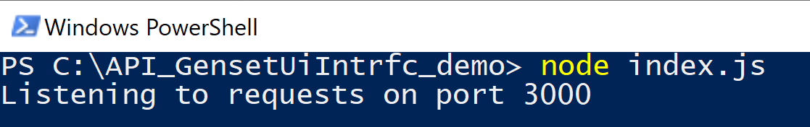

1. Background

Remote controlled systems operated by command consoles includes applications of power supply status display of the generators. The display is extremely essential since the state of the power supply is a basic condition for the proper operation of the remote system.

שמירת התרגום

1. Details of the information to be displayed

As a general rule, the information is laid out on applications where the fields will be displayed at the top of the form and additional 3 tabs for numerical displays.

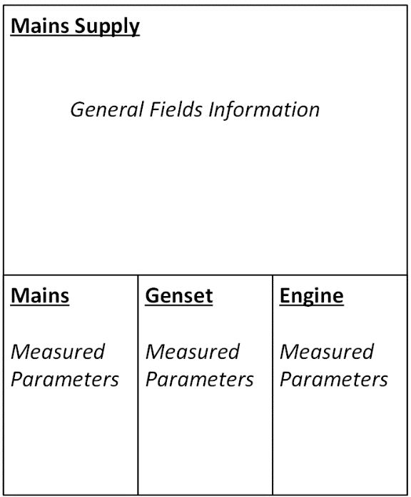

1. The display specification for layout in the form.

*Mains Supply*

|  |  |  |
| --- | --- | --- |
| **Field Name** | **Object:**  **Led Ind.**  **[color]** | **Notes** |
| ***Mains*** | Green | Mains Contactor control in RUN mode |
| ***Genset*** | Yellow | Genset Contactor control in RUN mode |
| ***Auto Ready*** | Green | The genset ready to run when necessary |
| ***Test*** | Yellow | The genset runs in TEST state |
| ***Alarm*** | Red | Turns on when a shutdown alarm exists |
| ***Warning*** | Red | Turns on when a warning condition exists |
| ***Service*** | Red | Turns on when at least one of service counters has expired |
|  |  |  |

*Mains – Tab Script*

|  |  |  |
| --- | --- | --- |
| **Field Name** | **Object:**  **Label** | **Notes** |
| ***L1 Volt*** | Num. [V] | voltage phase L1 to neutral |
| ***L2 Volt*** | Num. [V] | voltage phase L2 to neutral |
| ***L3 Volt*** | Num. [V] | voltage phase L3 to neutral |
| ***L1 Amps*** | Num. [A] | current phase L1 |
| ***L2 Amps*** | Num. [A] | current phase L2 |
| ***L3 Amps*** | Num. [A] | current phase L3 |
| ***Frequency*** | Num. [Hz] |  |
| ***Total kW*** | Num. [kw] |  |

*Genset – Tab Script*

|  |  |  |
| --- | --- | --- |
| **Field Name** | **Object:**  **Label** | **Notes** |
| ***L1 Volt*** | Num. [V] | voltage phase L1 to neutral |
| ***L2 Volt*** | Num. [V] | voltage phase L2 to neutral |
| ***L3 Volt*** | Num. [V] | voltage phase L3 to neutral |
| ***L1 Amps*** | Num. [A] | current phase L1 |
| ***L2 Amps*** | Num. [A] | current phase L2 |
| ***L3 Amps*** | Num. [A] | current phase L3 |
| ***Frequency*** | Num. [Hz] |  |
| ***Total kW*** | Num. [kw] |  |

*Engine – Tab Script*

|  |  |  |
| --- | --- | --- |
| **Field Name** | **Object:**  **Label** | **Notes** |
| ***Speed*** | Num. [Rpm] | Engine RPM |
| ***Run Hours*** | Num. [h] | Engine Run Hours Counter |
| ***Fuel Level*** | Num. [%] | Fuel tank filling level |
| ***Battery*** | Num. [Vdc] | Battery voltage |
| ***Oil Press*** | Num. [Bar] | Oil pressure |
| ***Oil Temp*** | Num. [C] | Temperature (°C) |
| ***Engine Temp*** | Num. [C] | Temperature (°C) |
| ***Canopy Temp*** | Num. [C] | Temperature (°C) |
|  |  |  |