import java.util.Scanner;

public class Palindrome {

public static void main(String[] args) {

Scanner sc = new Scanner(System.in);

String str;

System.out.println("Enter a string: ");

str = sc.nextLine();

str=str.toLowerCase();

String rev="";

for(int i=0; i<str.length(); ++i)

{

char ch = str.charAt(i);

rev = ch+rev;

}

System.out.println(rev);

if(str.equals(rev))

System.out.println("The string you have entered is a palindrome");

else

System.out.println("The string you have entered is not a palindrome");

sc.close();

}

}

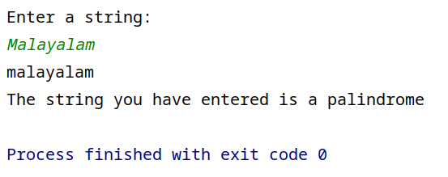

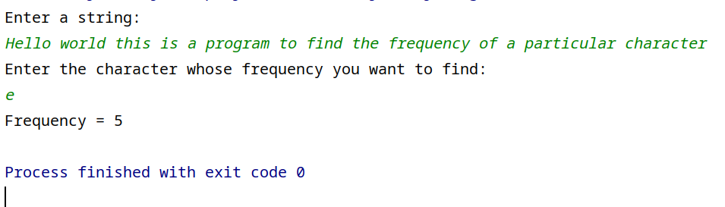

import java.util.Scanner;

public class CharFreq {

public static void main(String[] args) {

Scanner sc = new Scanner(System.in);

String str;

System.out.println("Enter a string: ");

str = sc.nextLine();

System.out.println("Enter the character whose frequency you want to find:");

char ch = sc.next().charAt(0);

int frequency=0;

for(int i=0; i<str.length(); ++i)

{

if(ch == str.charAt(i))

frequency++;

}

System.out.println("Frequency = "+frequency);

sc.close();

}

}

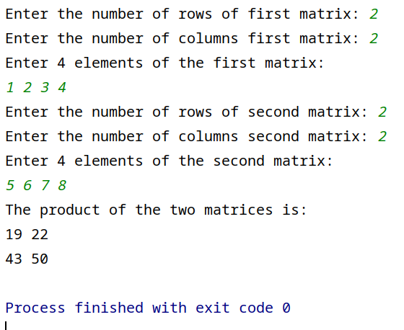

import java.util.Scanner;

public class Matrix {

public static void main(String[] args) {

Scanner sc = new Scanner(System.in);

//First Matrix

int row1,col1;

System.out.print("Enter the number of rows of first matrix: ");

row1 = sc.nextInt();

System.out.print("Enter the number of columns first matrix: ");

col1 = sc.nextInt();

int[][] matrix1 = new int[row1][col1];

System.out.println("Enter "+(row1\*col1)+" elements of the first matrix:");

matrix1 = MatrixInput(row1,col1,matrix1);

//Second Matrix

int row2,col2;

System.out.print("Enter the number of rows of second matrix: ");

row2 = sc.nextInt();

System.out.print("Enter the number of columns second matrix: ");

col2 = sc.nextInt();

System.out.println("Enter "+(row2\*col2)+" elements of the second matrix:");

int [][] matrix2 = new int[row2][col2];

matrix2 = MatrixInput(row2,col2,matrix2);

//Matrix Multiplication Algorithm

if(col1 == row2)

{

int[][] matrix3 = new int[row1][col2];

for(int i=0; i<row1; ++i)

{

for(int j=0; j<col2; ++j)

{

for(int k=0; k<col1; ++k)

{

matrix3[i][j] += matrix1[i][k] \* matrix2[k][j];

}

}

}

//Printing the product matrix

System.out.println("The product of the two matrices is:");

MatrixDisplay(row1,col2,matrix3);

}

sc.close();

}

public static int[][] MatrixInput(int row, int col, int[][] mat) {

Scanner sc = new Scanner(System.in);

for(int i=0; i<row; ++i)

{

for(int j=0; j<col; ++j)

{

mat[i][j] = sc.nextInt();

}

}

return mat;

}

//Function for printing the matrices

public static void MatrixDisplay(int row, int col, int[][] mat) {

for(int i=0; i<row; ++i)

{

for(int j=0; j<col; ++j)

{

System.out.print(mat[i][j]+" ");

}

System.out.println();

}

}

}

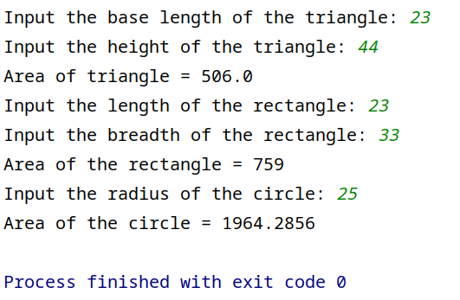

import java.util.Scanner;

public class Area {

public static void main(String[] args) {

Scanner sc = new Scanner(System.in);

int length,breadth;

float base,height,radius;

//Triangle

System.out.print("Input the base length of the triangle: ");

base = sc.nextFloat();

System.out.print("Input the height of the triangle: ");

height = sc.nextFloat();

System.out.println("Area of triangle = "+(area(base,height)));

//Rectangle

System.out.print("Input the length of the rectangle: ");

length = sc.nextInt();

System.out.print("Input the breadth of the rectangle: ");

breadth = sc.nextInt();

System.out.println("Area of the rectangle = "+(area(length, breadth)));

//Circle

System.out.print("Input the radius of the circle: ");

radius = sc.nextFloat();

System.out.println("Area of the circle = "+(area(radius)));

sc.close();

}

static float area(float base, float height) {

return ((base\*height)/2);

}

static int area(int length, int breadth) {

return (length\*breadth);

}

static float area(float radius) {

return ((22f/7f)\*radius\*radius);

}

}

import java.util.Scanner;

class Employee{

String name;

short age;

long phone;

String address;

int salary;

public void printSalary() {

System.out.println("Salary: "+salary);

}

}

class Officer extends Employee{

String specialization;

}

class Manager extends Employee{

String department;

}

public class Inheritance {

public static void main(String[] args) {

Scanner sc = new Scanner(System.in);

Officer off = new Officer();

Manager man = new Manager();

System.out.print("Enter the name of the officer: ");

off.name = sc.nextLine();

System.out.print("Enter the age of the officer: ");

off.age = sc.nextShort();

System.out.print("Enter the phone number of the officer: ");

off.phone = sc.nextLong();

System.out.print("Enter the address of the officer: ");

sc.nextLine();

off.address = sc.nextLine();

System.out.print("Enter the salary of the officer: ");

off.salary = sc.nextInt();

System.out.print("Enter the specialization of the officer: ");

sc.nextLine();

off.specialization = sc.nextLine();

System.out.println();

System.out.print("Enter the name of the manager: ");

man.name = sc.nextLine();

System.out.print("Enter the age of the manager: ");

man.age = sc.nextShort();

System.out.print("Enter the phone number of the manager: ");

man.phone = sc.nextLong();

System.out.print("Enter the address of the manager: ");

sc.nextLine();

man.address = sc.nextLine();

System.out.print("Enter the salary of the manager: ");

man.salary = sc.nextInt();

System.out.print("Enter the department of the manager: ");

sc.nextLine();

man.department = sc.nextLine();

System.out.println();

System.out.println("Details of the Officer");

System.out.println("Name: "+off.name);

System.out.println("Age: "+off.age);

System.out.println("Phone Number: "+off.phone);

System.out.println("Address: "+off.address);

off.printSalary();

System.out.println("Specialization: "+off.specialization);

System.out.println();

System.out.println("Details of Manager");

System.out.println("Name: "+man.name);

System.out.println("Age: "+man.age);

System.out.println("Phone Number: "+man.phone);

System.out.println("Address: "+man.address);

man.printSalary();

System.out.println("Department: "+man.department);

sc.close();

}

}

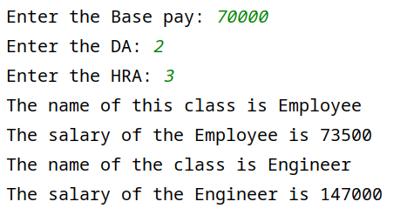

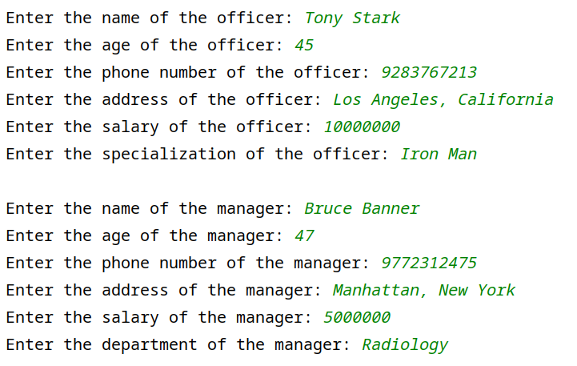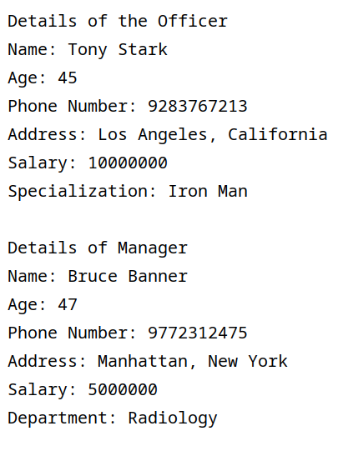

import java.util.Scanner;

class Employees {

int basePay,da,hra,grossPay;

void display() {

System.out.println("The name of this class is Employee");

}

void calcSalary() {

System.out.println("The salary of the Employee is "+grossPay);

}

}

class Engineer extends Employees {

Engineer(int bp, int da, int hra) {

this.basePay = bp;

this.da = da;

this.hra = hra;

this.grossPay = bp + (bp\*da/100) + (bp\*hra/100);

}

void display() {

System.out.println("The name of the class is Engineer");

}

void calcSalary() {

super.display();

super.calcSalary();

this.display();

System.out.println("The salary of the Engineer is "+(grossPay\*2));

}

}

public class Salary {

public static void main(String[] args) {

Scanner sc = new Scanner(System.in);

int bp,da,hra,gp;

System.out.print("Enter the Base pay: ");

bp = sc.nextInt();

System.out.print("Enter the DA: ");

da = sc.nextInt();

System.out.print("Enter the HRA: ");

hra =sc.nextInt();

Engineer engineer = new Engineer(bp,da,hra);

engineer.calcSalary();

}

}

abstract class Shape{

abstract void numberOfSides();

}

class Rectangle extends Shape{

void numberOfSides() {

System.out.println("I am a Rectangle, I have 4 sides");

}

}

class Triangle extends Shape{

void numberOfSides(){

System.out.println("I am a Triangle, I have 3 sides");

}

}

class Hexagon{

void numberOfSides() {

System.out.println("I am a Hexagon, I have 6 sides");

}

}

public class Abstract {

public static void main(String[] args) {

Rectangle rectangle = new Rectangle();

Triangle triangle = new Triangle();

Hexagon hexagon = new Hexagon();

rectangle.numberOfSides();

triangle.numberOfSides();

hexagon.numberOfSides();

}

}

