Introduction

This document explains how to use BXACK. You will learn how to:

* Install prerequisites.
* How to use the tool

Prerequisites

The following python library are required for the tool to run:

* PyFPDF
* paramiko
* Datetime

Using pip install:

pip install fpdf

pip install Datetime

pip install paramiko

Running the tool

python program.py

Using BXAC

Main Menu:

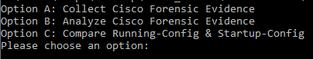

Option A: Collect Cisco Forensic Evidence

**Step 1:** After choosing option “A”, you will be required to enter the Cisco device’s IP address, Username, Password and enable password.

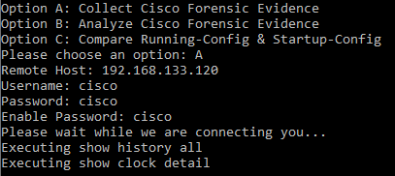

**Step 2:** BXAC will now run a list of “show” commands. A txt file for each command will be created in the same directory as the tool. After all commands are executed a pdf file containing all the output will be created.

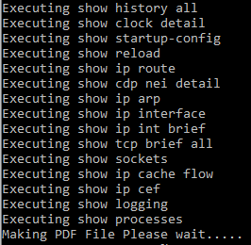

Option B: Analyze Cisco Forensic Evidence

**Step 1:** 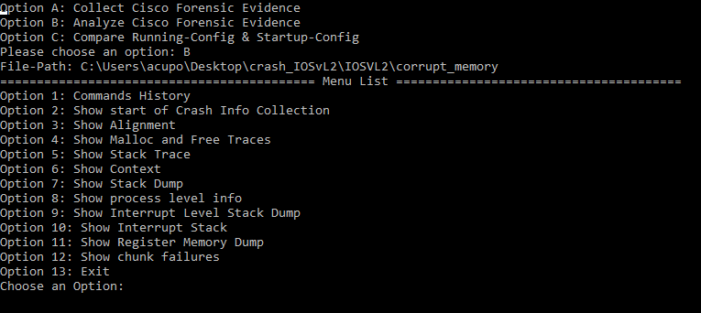After choosing option “B”, you will be required to enter the path of the crashinfo file.

**Step 2:** A menu list will appear and you are able to select the option.

Option C: Compare Running-Config & Startup-Config

**Step 1:** After choosing option “C”, you will be required to enter the Cisco device’s IP address, Username, Password and enable password.

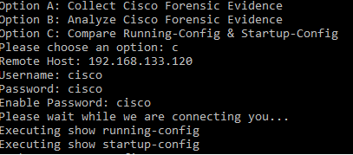

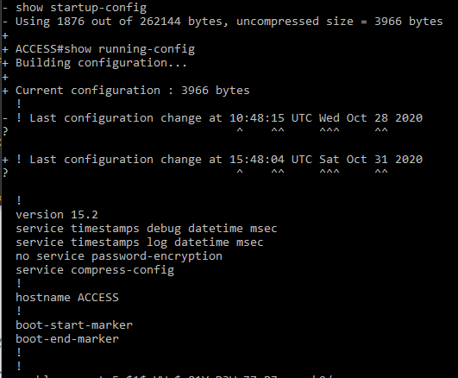**Step 2:** The output and the legends will be displayed.

