DOTE 2030 Midterm — condensed sheet to copy by hand (Lectures 2–5)
Copy in priority order: ① sections first, then ②, then ③ if you have space. Blue = formula, grey = example, orange = trap. Sketch the graphs roughly, only the shape and labels matter.

① Flow time, capacity, bottleneck (L2)
parallel ⇒ longest route
shared activity ⇒ add to BOTH
= bottleneck
- Find bottleneck: list every resource (people + machines) → add its activity times → 60 ÷ load → ×pool size → smallest wins.
- Pooled activity counted once in flow time. Never capacity = 1 ÷ flow time.
- Help bottleneck: pool it, or cut its unit load. Stop when it ties the next bottleneck.
Burger ∥ fries: 1 + max(7, 4) + 1 = 9 min (not 13).
HW1 Q4: saw 30, Emp1 40+10 = 50, crane 10, Emp2 60 ⇒ capacities 2, 1.2, 6, 1/hr ⇒ bottleneck Emp2.
① Throughput & utilization (L2)
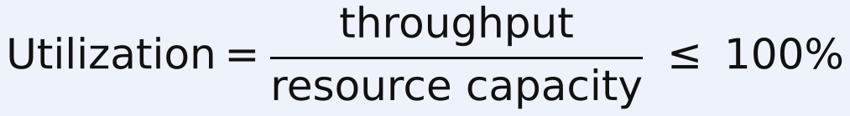 uses throughput
uses input
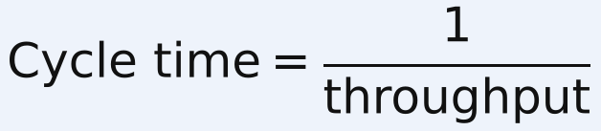
- Profit: new capacity (= new min) × $ per unit − hourly costs; compare with now.
SA1(e): A 10, B 20, C 15 min ⇒ 6, 3, 4/hr: $30/hr. Rent 2nd B ($14) ⇒ C limits at 4/hr: $40 − 14 = $26 ⇒ don't rent.
① Inventory build-up (L3)
discrete
continuous
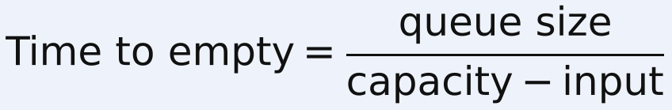

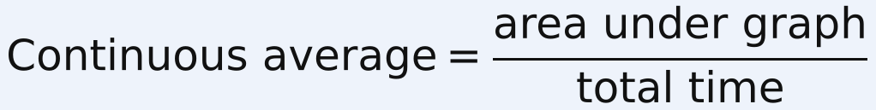
- Stable: long-run average input ≤ capacity. Short bursts above capacity still make temporary queues.
- Areas: triangle ½·b·h, rectangle b·h. Divide by the whole time window.
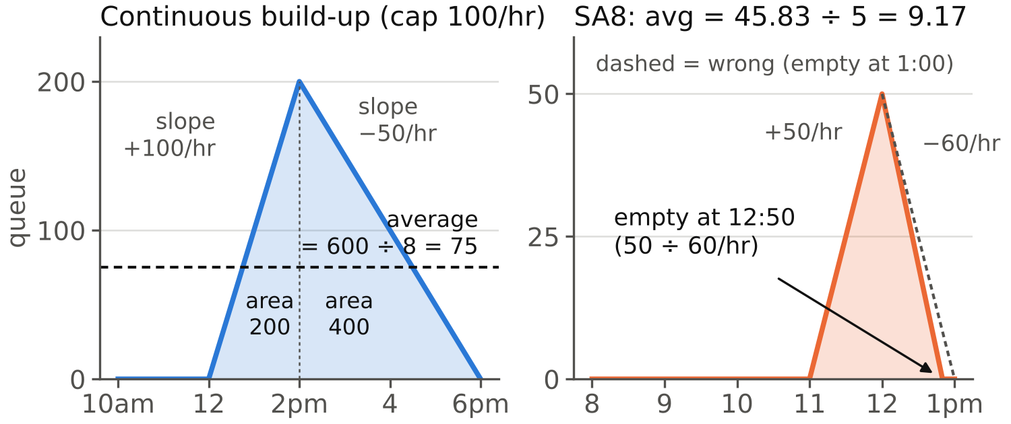
Lecture: 0 → 200 (+100/hr, 12–2) → 0 (−50/hr, 2–6) ⇒ area 600 ÷ 8 hr = 75.
Review SA8: queue empties at 12:50 (slope −60/hr), not 1:00 ⇒ avg 9.17, not 10.
① Little's Law (L3)
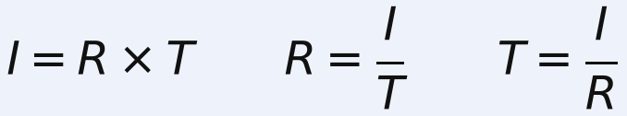
- Same part of the process (queue only: I_{q} = R·T_{q}) and same time units.
Rocks: 12/hr × 10 min (1/6 hr) = 2. I = 4 waiting + 1 crushing = 5, T = 20 min ⇒ R = 0.25/min.
① Scheduling: SPT & WSPT (L4)
- C_{i} = running total of the real p_{i}. ΣW = ΣC − Σp. Weighted: Σw_{i}W_{i} = Σw_{i}C_{i} − Σw_{i}p_{i}.
p = 6, 5, 8, 15 ⇒ order 2, 1, 3, 4 ⇒ C = 5, 11, 19, 34 ⇒ ΣC 69, ΣW 35. Weights 4, 1, 2, 1 ⇒ p/w 1.5, 5, 4, 15 ⇒ order 1, 3, 2, 4.
① Probability (L4)
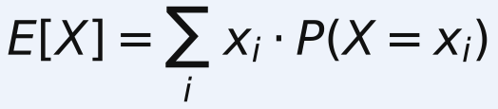
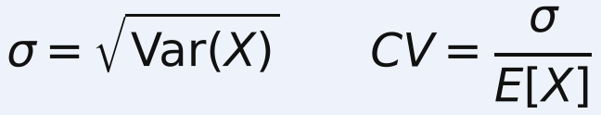
 | Poisson (count) | Exponential (time) | Constant
Mean | m | 1/λ | value
Std dev | √m | 1/λ (= mean) | 0
CV | 1/√m | 1 | 0
- Poisson arrivals ⇔ exponential gaps. Mean = std dev alone does not prove exponential.
① Single-server queue (L4)
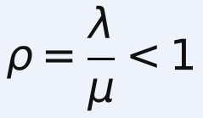
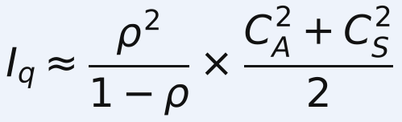 people WAITING
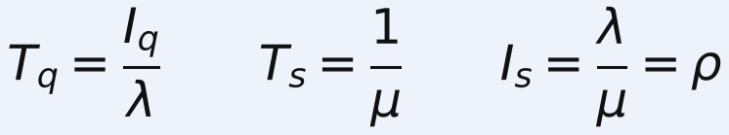
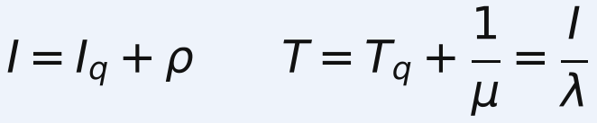 incl. being served
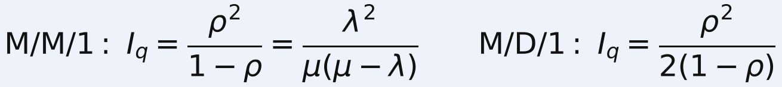
- CV: "exponential" ⇒ 1; "exactly / constant" ⇒ 0; else std dev ÷ mean of the TIME. Names X/Y/c: M = exponential, D = constant, G = general.
- Steps: one time unit → ρ (check < 1) → C_{A}, C_{S} → I_{q} → T_{q} = I_{q}/λ (× 60 for min) → add ρ or 1/μ if "in system".
λ = 4/hr, 10 min service (μ = 6), exponential: ρ = 2/3 ⇒ I_{q} = 4/3, T_{q} = 20 min. Constant service: I_{q} = 2/3, T_{q} = 10 min.
Drive-through λ 20, μ 30: I_{q} 4/3, I = 2, T_{q} 4 min, T 6 min.
① Multi-server queue, ONE shared line (L5)
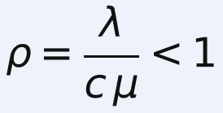
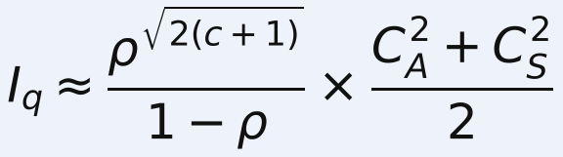
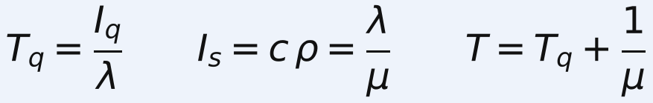 I_{s} = busy servers
c | 1 | 2 | 3 | 4 | 5
√(2(c+1)) | 2 | 2.449 | 2.828 | 3.162 | 3.464
- Pooling: one shared line always beats c separate lines with the same total demand and capacity.
Card office λ 90, μ 20, c 5: ρ 0.9 ⇒ I_{q} = 0.9^{3.464}/0.1 = 6.94, T_{q} = 4.63 min.
Bank: separate (5/10, 15/20) ⇒ ½ + 9/4 = 2.75; shared M/M/2 (λ 20, μ 15) ⇒ ρ 2/3 ⇒ 1.11.
① True/False traps (review)
F: flow time = every unit's time (it's the minimum). F: shorten ANY task ⇒ capacity ↑ (only bottleneck's).
F: input > capacity ⇒ utilization > 100% (that's IMPLIED). F: throughput = capacity ⇒ must build inventory.
F: activities have capacity (only resources). Handsaw trap: the person doing 2 + 1 hr is the bottleneck.
F: ρ ↑ ⇒ I_{q} ↓. T: D/D/1 ⇒ I_{q} = 0. F: double λ and μ ⇒ I_{q} × 2 (it's × 4).
T: implied utilization > 100% ⇒ inventory builds. T: Poisson 15/hr ⇒ gap std dev 4 min.
② Utilization vs variability · OM triangle
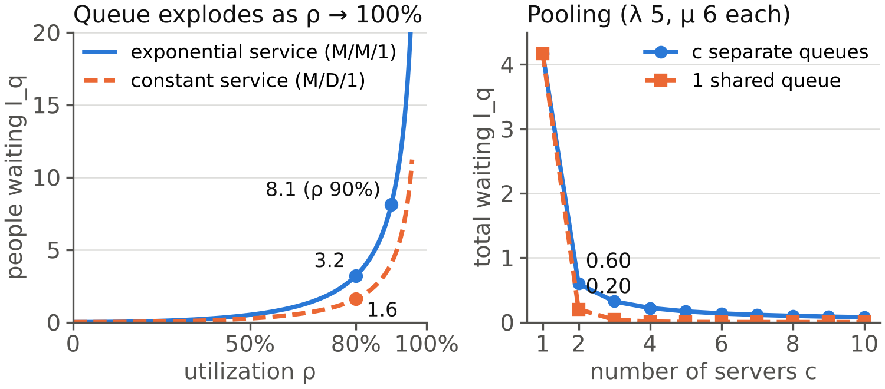
- M/M/1 I_{q} at ρ 50 / 80 / 90 / 95%: 0.5 / 3.2 / 8.1 / 18.05. High utilization + variability ⇒ long queues.
- OM triangle: capacity (add servers) · inventory (let queue form) · information (cut variability, e.g. scheduling).
- λ 8: 6 min exp ⇒ 24 min wait; 5 min exp ⇒ 10 min; 6 min constant ⇒ 12 min.
② More examples worth copying
Bank SA11(c): W1 4+2 = 6 min, W2 3+7 = 10 min ⇒ 6/hr: 6×$10 − $40 = $20. Hire W3 for act 3 or 4 ⇒ 8.57/hr: $85.7 − $60 = $25.7 ⇒ hire.
HW1 Q4(c): 2 cars/hr ⇒ every load ≤ 30 min ⇒ QA −30 min ($300) + assemble −20 min ($200) = $500.
Discrete POS: in 15, 32, 39, 10 vs cap 30 ⇒ queues 0, 2, 11, 0 ⇒ 13/4 = 3.25.
Airport separate lines 3, 6, 30 min ⇒ weighted 17.07 min; merged M/M/3 ρ 58/90 ⇒ 2.84 min.
② Review answer-key slips
SA8 avg = 9.17 (not 10). SA1(a) bottleneck is B. SA1(b) cycle time = 1/3 hr = 20 min. SA12(f) std dev = 1/48 day.
③ Shouldice (L3)
- Weekly: beds 210, surgeons 240, ORs 200 (bottleneck; ≤ 40 ops/day). Now 150/wk, I = 150 × 3/7 ≈ 64. Best weekday plan 40, 40, 10, 40, 40 = 170 max (40 + 90 + 40).
③ Matching (L5)
- Platform picks when and whom to match. Suspense + surprise ⇒ match similar skill. Trade-off: better matches vs longer waits.

