Mediating the Mediation Debate:

Conflict Resolution and the Local State in China

Published in: Journal of Conflict Resolution
Vol. 52, No. 5 (October 2008), pp. 737-764

 | Benjamin L. Read  Politics Department  Merrill Academic Building  University of California  Santa Cruz, CA 95064  blread@ucsc.edu  http://benread.net  831-459-4469 |  | Ethan Michelson  Department of Sociology  Ballantine Hall 744  Indiana University  1020 E. Kirkwood Ave.  Bloomington, IN 47405-7103  emichels@indiana.edu  812-856-1521

Full Tables and Figures

Due to space limitations, several tables had to be abridged or omitted in the published version of this article. Here we provide the unabridged tables and figures. See “readme.txt” and “ReplicationOverview.xls”.

November 7, 2008

Table A: Incidence of Requests for Mediation: Various Types, Measures
 |  |  | Indicated having sought mediation?
 |  |  | Yes | No | Missing
Urban | Closed-ended: Asked specifically about having sought RC during a ... | Neighbor dispute, ever | 7.8% | 91.0% | 1.2%
Urban |  | Family dispute, ever (e.g. mother-in-law/daughter-in-law, marital) | 3.2% | 95.4% | 1.4%
Urban |  | Either of the above | 8.6% | 90.3% | 1.1%
Urban | Open-ended: Volunteered an answer of having sought RC in response to questions about ... | Any of 15 types of disputes, past five years | 1.8% | 98.2% | n/a
Urban |  | For any in either closed-ended or open-ended questions | 9.3% | 90.8% | n/a
 |  | Total n of urban respondents: 1,124
Rural | Closed-ended: Asked specifically about having sought VC during a ... | Neighbor dispute, ever | 14.2% | 82.9% | 3.0%
Rural |  | Family dispute, ever (e.g. mother-in-law/daughter-in-law, marital) | 10.2% | 87.1% | 2.7%
Rural |  | Either of the above | 18.8% | 79.0% | 2.2%
Rural | Open-ended: Volunteered an answer of having sought VC in response to questions about ... | Any of 12 types of disputes, past five years | 7.8% | 92.2% | n/a
Rural |  | For any in either closed-ended or open-ended questions | 22.9% | 77.1% | n/a
 |  | Total n of rural respondents: 2,877

Note: Open-ended questions have no missing values, thus this column is not applicable to those questions. Due to rounding error, not all rows sum to 100.0%.

Table B: Requests for Mediation, by Gender
 |  |  | Male | Female
Urban | Ever sought RC for neighbor dispute? | Yes | 6.2% | 9.4%
Urban | Ever sought RC for neighbor dispute? | No | 93.8% | 90.6%
Urban | Chi-squared=3.769, p=0.052 |  | n=514 | n=597
Urban | Ever sought RC for within-family dispute? | Yes | 1.8% | 4.5%
Urban | Ever sought RC for within-family dispute? | No | 98.2% | 95.5%
Urban | Chi-squared=6.790, p=0.009 |  | n=513 | n=595
Rural | Ever sought VC for neighbor dispute? | Yes | 14.2% | 15.1%
Rural | Ever sought VC for neighbor dispute? | No | 85.8% | 84.9%
Rural | Chi-squared=0.499, p=0.480 |  | n=1,533 | n=1,258
Rural | Ever sought VC for within-family dispute? | Yes | 9.4% | 11.8%
Rural | Ever sought VC for within-family dispute? | No | 90.6% | 88.2%
Rural | Chi-squared=4.561, p=0.033 |  | n=1,540 | n=1,259

Table 1: Logistic Regression on Having Sought Mediation (Beijing)
 | Sought RC due to dispute with neighbor | Sought RC due to dispute within own family
Age | -0.016 | 0.007
 | (0.014) | (0.019)
Female | 0.177 | 0.508
 | (0.259) | (0.414)
Communist Party Member | 0.216 | -0.707
 | (0.307) | (0.484)
Household income (log) | -0.048 | -0.489
 | (0.251) | (0.320)
Education (years) | -0.002 | 0.005
 | (0.044) | (0.055)
Time in neighborhood (years) | -0.002 | -0.012
 | (0.010) | (0.014)
Sociability (index) | -0.008 | 0.073
 | (0.192) | (0.290)
Household registration is correct | 0.491 | 0.298
 | (0.419) | (0.654)
Lives in high-rise apartment | -0.042 | -0.015
 | (0.541) | (0.730)
Neighborhood’s avg. income (1000s yuan) | -0.156 | -0.139
 | (0.336) | (0.549)
Trust in police and courts (index) | 0.753*** | 0.525
 | (0.213) | (0.341)
Instances of contact with RC (log) | 0.310*** | 0.191
 | (0.072) | (0.121)
Satisfaction with RC (index) | 0.045 | 0.186
 | (0.164) | (0.288)
Participation in RC activities | 1.485*** | 1.276***
 | (0.292) | (0.468)
[Constant] | -3.509 | -2.285
 | (2.171) | (2.818)
Observations | 986 | 984
Pseudo R-squared | 0.200 | 0.150
Robust standard errors in parentheses
* p<0.1 ** p<.05 *** p<0.01

Table 2: Logistic Regression on Having Sought Mediation (Rural)
 | Sought VC due to dispute with neighbor | Sought VC due to dispute within own family
Age | 0.001 | -0.011**
 | (0.005) | (0.006)
Female | 0.263** | 0.403***
 | (0.124) | (0.142)
Household income (log) | -0.021 | -0.064
 | (0.078) | (0.082)
Education (years) | -0.046** | -0.043
 | (0.023) | (0.026)
Sociability (index) | -0.015 | -0.084
 | (0.083) | (0.100)
Trust in police and courts (index) | 0.020 | 0.082
 | (0.089) | (0.097)
Participation in village affairs (index) | 0.523*** | 0.406***
 | (0.067) | (0.076)
Village average income (1000s yuan) | -0.002 | 0.000
 | (0.013) | (0.014)
Instances of contact with VC (log) | 0.250*** | 0.146**
 | (0.053) | (0.062)
Satisfaction with VC (index) | -0.084 | -0.023
 | (0.064) | (0.072)
[Constant] | -2.957*** | -2.098***
 | (0.707) | (0.763)
Observations | 2,567 | 2,575
Pseudo R-squared | 0.062 | 0.032
Robust standard errors in parentheses. The rural survey did not contain a question about Communist Party membership.
* p<0.1 ** p<.05 *** p<0.01

Table 3: Types of Dispute by Channel Pursued (Beijing)
 |  |  |  |  | Breakdown of Those Seeking Third-Party Help
Type of Dispute | Cases | "Lumping It" | Direct Response | Seeking Third-Party Help | Informal Third Party | Residents' Committee | Work Unit | Misc. Gov't Office | Police | Lawyer or Court | Other
Neighbor | 46 | 43.5% | 4.3% | 52.2% | 12.5% | 54.2% | 4.2% | 4.2% | 20.8% | 4.2% | 0.0%
Consumer | 32 | 68.8% | 18.8% | 12.5% | 50.0% | 25.0% | 0.0% | 0.0% | 0.0% | 0.0% | 25.0%
Other | 11 | 27.3% | 0.0% | 72.7% | 12.5% | 25.0% | 0.0% | 25.0% | 0.0% | 37.5% | 0.0%
Property Damage, Loss | 81 | 50.6% | 1.2% | 48.1% | 2.6% | 12.8% | 7.7% | 2.6% | 71.8% | 0.0% | 2.6%
Home Renovation | 27 | 33.3% | 25.9% | 40.7% | 45.5% | 9.1% | 0.0% | 27.3% | 0.0% | 0.0% | 18.2%
Hiring Discrimination | 34 | 64.7% | 0.0% | 35.3% | 33.3% | 8.3% | 16.7% | 0.0% | 0.0% | 8.3% | 33.3%
Personal Injury | 21 | 38.1% | 0.0% | 61.9% | 7.7% | 7.7% | 15.4% | 15.4% | 38.5% | 7.7% | 7.7%
Property Title or Deed | 51 | 47.1% | 0.0% | 52.9% | 7.4% | 7.4% | 7.4% | 14.8% | 0.0% | 51.9% | 11.1%
Accused of PI or Theft | 1 | 0.0% | 0.0% | 100.0% | 100.0% | 0.0% | 0.0% | 0.0% | 0.0% | 0.0% | 0.0%
Collecting Salary | 39 | 76.9% | 0.0% | 23.1% | 55.6% | 0.0% | 22.2% | 22.2% | 0.0% | 0.0% | 0.0%
Landlord | 6 | 16.7% | 16.7% | 66.7% | 25.0% | 0.0% | 25.0% | 25.0% | 0.0% | 25.0% | 0.0%
Eviction | 19 | 52.6% | 15.8% | 31.6% | 16.7% | 0.0% | 33.3% | 33.3% | 0.0% | 16.7% | 0.0%
Collecting Salary (Spouse) | 29 | 79.3% | 3.4% | 17.2% | 0.0% | 0.0% | 60.0% | 20.0% | 0.0% | 20.0% | 0.0%
Hiring Discrim. (Spouse) | 21 | 85.7% | 0.0% | 14.3% | 0.0% | 0.0% | 33.3% | 33.3% | 0.0% | 0.0% | 33.3%
Will or Inheritance | 9 | 33.3% | 0.0% | 66.7% | 0.0% | 0.0% | 0.0% | 0.0% | 16.7% | 66.7% | 16.7%
Divorce | 5 | 60.0% | 40.0% | 0.0% | 0.0% | 0.0% | 0.0% | 0.0% | 0.0% | 0.0% | 0.0%
Total | 432 | 54.9% | 5.3% | 39.8% | 15.7% | 15.1% | 11.0% | 11.6% | 22.7% | 15.7% | 8.1%
Note: Due to rounding error, not all rows sum to 100.0%. Table is sorted by the percentage of those who sought third parties who went to the Residents’ Committee.

Table 4: Types of Dispute by Channel Pursued (Rural)
 |  |  |  |  | Breakdown of Those Seeking Third-Party Help
Type of Dispute | Cases | "Lumping It" | Direct Response | Seeking Third-Party Help | Informal Third Party | Villagers' Committee | Higher Gov't Office | Police | Lawyer or Court
Neighbor | 850 | 32.7% | 47.5% | 19.8% | 21.4% | 68.5% | 2.4% | 3.0% | 4.8%
Water Use | 495 | 41.0% | 52.1% | 6.9% | 20.6% | 61.8% | 11.8% | 2.9% | 2.9%
Property Title or Deed | 335 | 30.1% | 36.4% | 33.4% | 14.3% | 42.9% | 38.4% | 0.9% | 3.6%
Other | 72 | 34.7% | 31.9% | 33.3% | 20.8% | 33.3% | 20.8% | 0.0% | 25.0%
Divorce | 43 | 18.6% | 25.6% | 55.8% | 20.8% | 29.2% | 4.2% | 0.0% | 45.8%
Debt Collection | 229 | 26.6% | 59.4% | 14.0% | 40.6% | 28.1% | 9.4% | 0.0% | 21.9%
Property Damage or Loss | 251 | 34.3% | 46.2% | 19.5% | 6.1% | 26.5% | 10.2% | 40.8% | 16.3%
Personal Injury | 130 | 28.5% | 33.1% | 38.5% | 10.0% | 26.0% | 12.0% | 22.0% | 30.0%
Collecting Salary | 250 | 41.6% | 46.8% | 11.6% | 41.1% | 13.8% | 24.1% | 6.9% | 13.8%
Accused of PI or Theft | 37 | 16.2% | 32.4% | 51.4% | 31.6% | 10.5% | 10.5% | 10.5% | 36.8%
Within Own Family | 440 | 45.5% | 38.6% | 15.9% | 85.7% | 10.0% | 2.9% | 0.0% | 1.4%
Consumer | 338 | 26.6% | 60.4% | 13.0% | 56.8% | 2.3% | 40.9% | 0.0% | 0.0%
Total | 3470 | 34.6% | 46.6% | 18.9% | 29.5% | 37.9% | 15.3% | 6.4% | 11.0%
Note: Due to rounding error, not all rows sum to 100.0%. Table is sorted by the percentage of those who sought third parties who went to the Villagers’ Committee.

Table C: Categorization of Dispute Types (Rural)
Original Dispute Types | Categorization
Property Title or Deed | Ownership
Personal Injury | Liability
Accused of PI or Theft | Liability
Property Damage or Loss | Liability
Consumer | Business
Collecting Salary | Business
Divorce | Divorce
Within Own Family | Within Own Family
Neighbor | Neighbor
Water Use | Water Use
Debt Collection | Debt
Other (dropped)

Table 5: Multinomial Logistic Regression Results on Channels Through Which Help was Sought (Rural)
 | Direct Resolution  Vs. Lumping It |  | Informal Third Party  Vs. Lumping It |  | Village  Vs. Lumping It |  | Spillover  Vs. Lumping It
Age (mean of household adults) | -.005 |  | -.001 |  | -.002 |  | .014
 | (.005) |  | (.011) |  | (.009) |  | (.011)
Education (mean of hh adults, years) | -.060 | *** | -.128 | ** | -.093 | ** | .002
 | (.023) |  | (.051) |  | (.044) |  | (.053)
Household income (log) | .150 | *** | .649 | *** | .332 | *** | .320 | ***
 | (.051) |  | (.091) |  | (.097) |  | (.113)
Instances of contact with VC (log) | .023 |  | .262 | *** | .217 | *** | .337 | ***
 | (.041) |  | (.073) |  | (.076) |  | (.080)
Village income (log) | -.036 |  | -1.148 | *** | -.655 | *** | -.536 | **
 | (.106) |  | (.203) |  | (.224) |  | (.226)
Dispute category: Ownership | .279 |  | -.672 | ** | 2.616 | *** | 3.890 | ***
 | (.173) |  | (.322) |  | (.426) |  | (.735)
Dispute category: Liability | .387 | ** | -1.122 | *** | 1.709 | *** | 3.926 | ***
 | (.158) |  | .323 |  | (.441) |  | (.726)
Dispute category: Business | .587 | *** | -.584 | ** | -.399 |  | 2.614 | ***
 | (.140) |  | (.238) |  | (.594) |  | (.736)
Dispute category: Divorce | .434 |  | .822 |  | 3.080 | *** | 4.875 | ***
 | (.484) |  | (.620) |  | (.679) |  | (.874)
Dispute category: Neighbor | .523 | *** | -.818 | *** | 2.474 | *** | 1.809 | **
 | (.132) |  | (.235) |  | (.402) |  | (.752)
Dispute category: Water | .401 | *** | -2.157 | *** | 1.046 | ** | 1.102
 | (.143) |  | (.417) |  | (.454) |  | (.821)
Dispute category: Debt | .908 | *** | -.552 |  | 1.360 | ** | 2.658 | ***
 | (.189) |  | (.360) |  | (.529) |  | (.787)
Dispute category: Intra-Family (omitted reference group)
[Constant] | -.815 | * | -4.622 | *** | -4.912 | *** | -7.829 | ***
 | (.461) |  | (.961) |  | (.900) |  | (1.200)
Observations | 3,311
Pseudo R-squared | 0.073
Robust standard errors in parentheses
* p<0.1 ** p<.05 *** p<0.01

Table 6: Predicted Probability of Responses to Disputes, by Category (Rural)
Probability of seeking village mediation compared to four other responses
 | Lump It | Direct | Informal | Village | Spillover
Divorce | 0.194 | 0.270 | 0.128 | 0.153 | 0.255
Property ownership | 0.300 | 0.357 | 0.044 | 0.149 | 0.150
Neighbor | 0.319 | 0.484 | 0.041 | 0.137 | 0.020
Liability | 0.319 | 0.422 | 0.030 | 0.064 | 0.165
Water | 0.398 | 0.535 | 0.013 | 0.041 | 0.012
Debt | 0.272 | 0.605 | 0.045 | 0.038 | 0.040
Within Own Family | 0.448 | 0.403 | 0.129 | 0.016 | 0.005
Business | 0.340 | 0.550 | 0.055 | 0.008 | 0.047
Note: Predicted probabilities are calculated with all other variables set at their means. Due to rounding error, not all rows sum to 100.0%. Dispute categories are ordered by probability of seeking village mediation. “Spillover” refers to any response involving higher levels of authority such as the township, county or police.

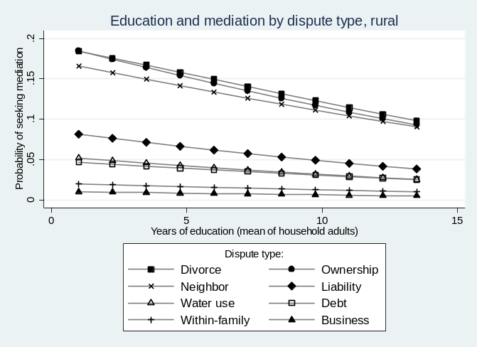
Figure 1. Predicted Probability of Seeking Mediation by Several Variables (Rural)

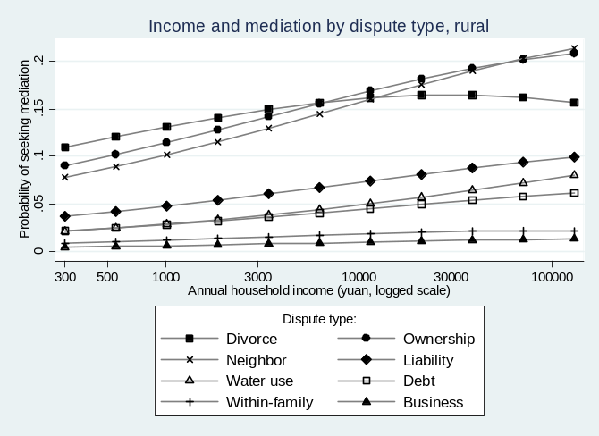
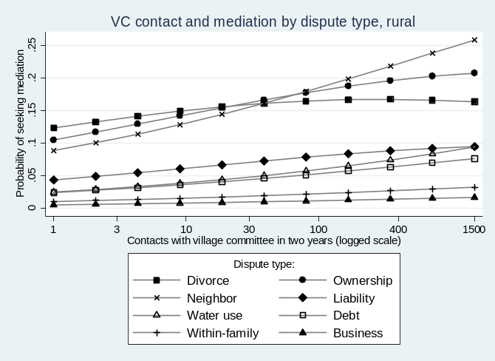
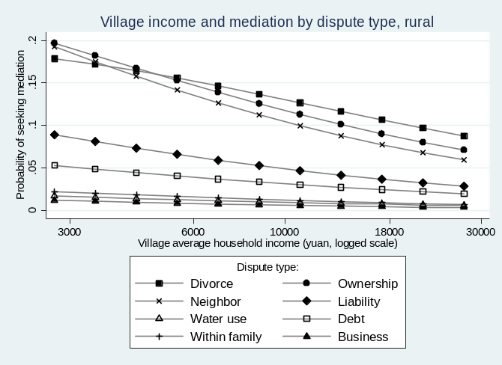

Table 7: Respondents’ Assessment of How Their Dispute Was Handled, by Third Party
Beijing |  | Rural
Third Party | Met or Exceeded Expectations | Third Party | Met or Exceeded Expectations
Residents' Committee | 47.8% | Higher government | 73.6%
Informal | 45.0% | Informal | 72.6%
Lawyer or court | 40.0% | Village Committee | 68.9%
Misc. government | 35.7% | Legal system | 47.1%
Work unit | 30.8% | Police | 44.7%
Police | 25.8%
Total disputes: 126 |  | Total disputes: 606
Note: Third parties are ranked in order of assessment.

