How to use SQLiteExporter.exe

1. Download the zip from the discord forum (in the modding section)

2. Unzip the file in any folder and type ‘cmd’ in the adress bar
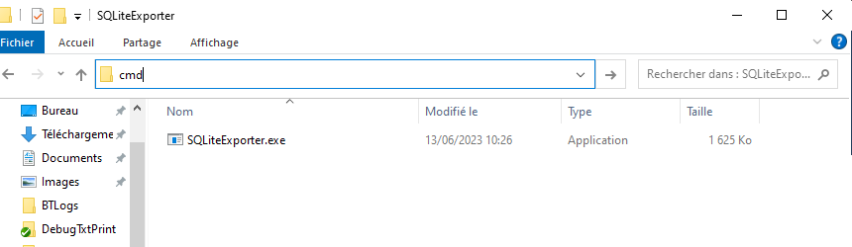

cmd will open a command prompt where you can type ‘SQLiteExporter.exe’ to show the usage
Note : It is possible that you need to be administrator to use the exporter.

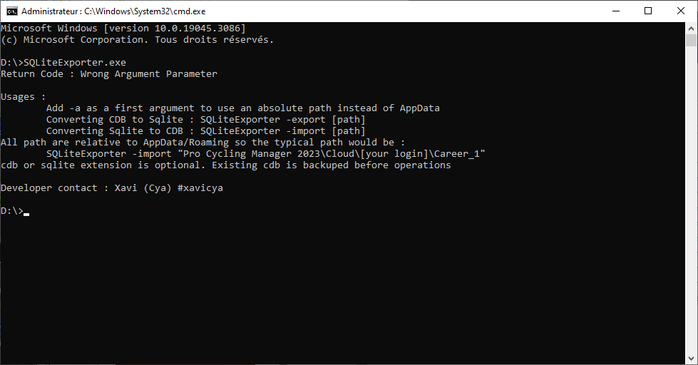

3. Locate your PCM Save folder by combining Windows Key + R and entering %appdata %
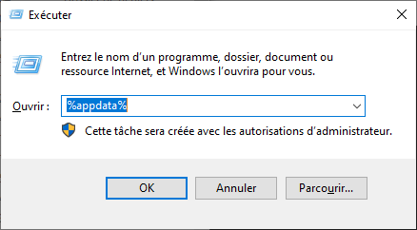

It is supposed to bring you to C:\Users\[your windows user]\AppData\Roaming and then you can browse to Pro Cycling Manager 2025\Cloud\[your steam ID]

You may copy Pro Cycling Manager 2025\Cloud\[your steam ID] to your clipboard to reuse it later.

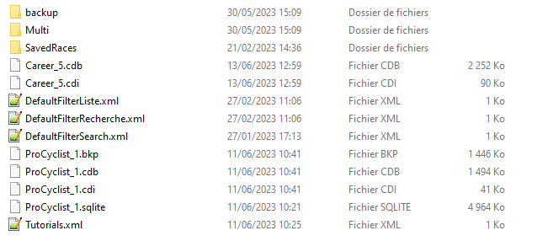
You may want to use absolute paths instead of path relative to Appdata. In this case use the argument parameter ‘-a’ before export/import command, e.g :

SQLiteExporter.exe -a -export "D:\MyWorkspace\Career_5"

4. Back to your command prompt, you can try to export a cdb. For example, let’s export Career_5 from the previous screenshot :

SQLiteExporter.exe -export "Pro Cycling Manager 2025\Cloud\CyaXavi\Career_5"

If every thing went fine it should prompt you info ending with Return Code : Success. You can notice a new Career_5.sqlite in your folder.

5. Now that you have a SQLite file, you may edit it on any SQLite client software. There are various SQLite UI software that you can use : HeidiSQL, Dbeaver, DB Browser for SQLite, SQLiteStudio, there is a lot of possibilities (https://dbmstools.com/categories/gui-tools/sqlite)

Example with DB Browser :

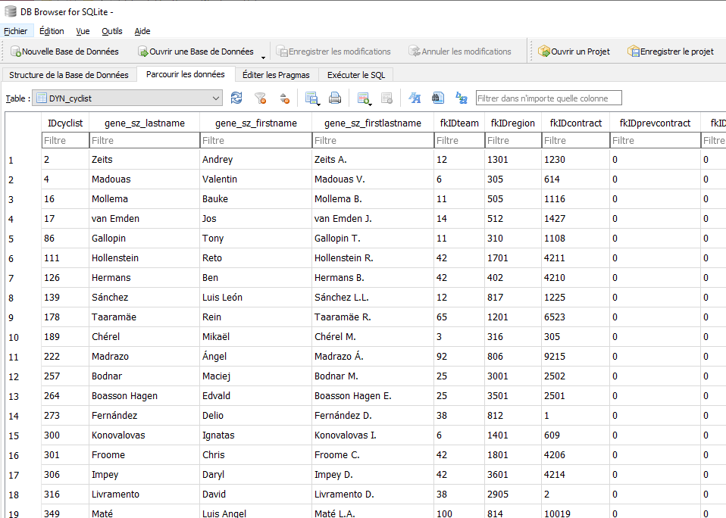
Now you can edit, add, delete cells as you want. Don’t forget to save modifications once you are done. You can also make SQL queries on the content if you want.

6. Now you edited the db, you can import it back to a modified cdb by the very similar command as in part 4/ :

SQLiteExporter.exe -import "Pro Cycling Manager 2024\Cloud\CyaXavi\Career_5"

Important : do not put the extension .sqlite on the command line, otherwise the command will fail.

If it succeeds, you should observe that Career_5.cdb is now updated and that a backup of the former cdb has been made to make sure you don’t corrupt your save with your modification.

I still suggest to make your own backups before making modifications.

7. You can now load Career_5 again in PCM and play with your modified data.

You can report problems on the discord modding forum to get support. (https://discord.gg/JaxZhqDSB7)

