🌟 ENGLISH TEST 🌟
1st Grade • Primero Básico
Name: ________________________________ | Date: _________________________

1. School Supplies 🎒
✏️ Look and read the words.

✏️  PENCIL | 🧹  ERASER | 📏  RULER | 📚  BOOK | 🎒  BAG | ✂️  SCISSORS

2. Long or Short? 📏
✏️ Circle the correct word.

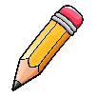  LONG / SHORT | 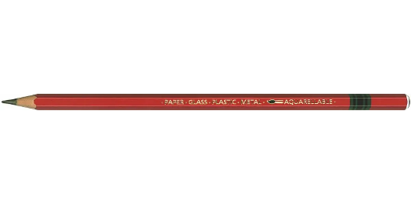  LONG / SHORT
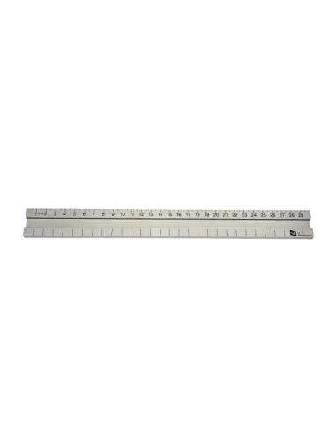  LONG / SHORT |   LONG / SHORT

3. Colours 🎨
✏️ Read the colour and write it on the line.

Color | Word in English | Write it! ✏️
 | RED | Write:
 | BLUE | Write:
 | GREEN | Write:
 | YELLOW | Write:
 | ORANGE | Write:
 | PINK | Write:

4. Numbers 🔢
✏️ Read the number and write it on the line.

Number | In English | Write it! ✏️
1 | ONE | Write:
2 | TWO | Write:
3 | THREE | Write:
4 | FOUR | Write:
5 | FIVE | Write:
6 | SIX | Write:
7 | SEVEN | Write:
8 | EIGHT | Write:
9 | NINE | Write:
10 | TEN | Write:

5. How many? 🔢
✏️ Count and write the number.

🍎🍎🍎 | How many? ___________
⭐⭐ | How many? ___________
🐶🐶🐶🐶🐶 | How many? ___________
🌸🌸🌸🌸 | How many? ___________
🎈🎈🎈🎈🎈🎈🎈 | How many? ___________
🦋🦋🦋🦋🦋🦋🦋🦋🦋🦋 | How many? ___________

🌟 Great job! You did it! 🌟

