**UI Evaluation Report**

# Introductio**n**

Steve Jobs said “Design is not just what it looks like and feels like. Design is how it works.”. This is quite an important theory because if something looks pretty and doesn’t work well then it is of no use to anybody, and that is no more important than of something that is used for a small amount of time every single day, such as a public transport system. The terminals can look as pretty as you like, but when it comes down to brass tacks, if it takes 2 minutes for each user to get a ticket or the user is not sure what to press next, the system is failing.

In an attempt to combat against this happening, we have done some evaluation on the usability and UI of our system. This evaluation contains two stages, a task-oriented evaluation where a user is asked to complete a list of tasks and then a cognitive walkthrough where users are given free reign to see if they can understand a never seen before system. After each of these stages, there will be changes made on user feedback.

# How We are going to evaluate

There are many ways to evaluate a system, but it was decided to use two different approaches, one that is researcher led and another which is user led.

## Task-oriented evaluation

Due to this system been a short, daily interaction between members of the public and a computer performing a necessary task, this system does not need to be fancy, it just needs to work. Due to this, it was decided that user interface is more important than user experience, meaning the system should be as easy to use as possible at the sacrifice of feeling rewarding or enjoyable.

The system can be reduced down to a small set of tasks, each with its own functionality and importance within the system, if any of them add unnecessary complications, they should be removed. To ensure this is the case, users were asked to complete the task list, Appendix 1, while under observation by researchers noting the success on each task, the time the task took and the necessity of the task. A meeting was then held between user and researchers to discuss the tasks and receive user feedback.

## Cognitive Walkthrough

A cognitive walkthrough is going to be used, this is where a user is asked to use their free will to operate the system with actions been recorded by researchers. If the actions cannot be reasoned about, then their must be a flaw in the system as the user is doing something unexpected. The aim of this type of evaluation is to see if the system had a simple and easy user journey for a user who has just approached it for the first time, which is often the case in this type of system.

# What came out of evaluation

## Task-oriented evaluation and Usability testing

During development, potential users were approached and asked to test the system by following a set of pre-determined tasks and comment on the design and ease of use. These were all taken into consideration and changes were made to try and make the system more intuitive and easier to use. Some of the things that came out of this were as follows.

### Have validation on login form

Validation was added to the login form so the system tells alerts when the username or password is incorrect.

### Hit enter to login after typing in user credentials

Due to the admin section been aimed for user on a computer, tablet or phone, occasionally some keyboard shortcuts may come in handy. We added the use of the ‘enter’ key to advance through the system at certain points, such as logging in.

### Have a log out button

Users found that there was no way to exit the system when doing things such as adding fares and they would have to just close the program to exit. Due to this, a visible log out button was added to allow the user to get back to the login screen.

### Make buttons look better

Where appropriate, buttons were colored so it was more intuitive to use. As show in figure 1 below, buttons that allowed the user to advanced through the system, such as save or update balance, were made to be green and buttons that allowed the user to exit out of the current section were colored red.

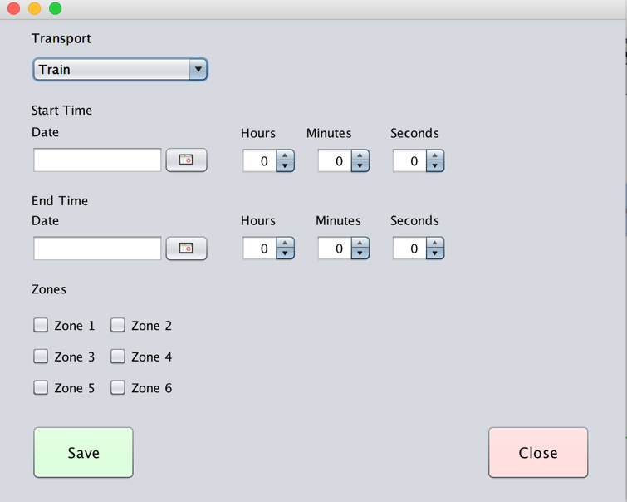

Figure : Adding a fare, example of button colors

### Have validation on some input fields

When entering data, such as adding a fare, users were entering invalid data. To combat against this, validation was added some some fields. An example of where validation was added is while choosing a date and time for the fare to be available from. The time is a set of three spinners and now the hours can only go from 1 – 23, minutes and seconds can go from 0 -59. Due to this, It’s now be impossible for a user to add an incorrect time.

## Cognitive Walkthroughs

With the fixed made from the task-oriented evaluation, cognitive walkthroughs were performed, giving users free reign over the system. Some more feedback was given and again, changes were made. The changes are as follows.

### Make the form clearer

Some users found navigating the forms, such as adding a fare, quite time consuming as it was initially split up into several sections. To combat against this, the design was made more linear with the page running top to bottom with the fields that need to be added, as shown in Figure 1 on page 2.

# Conclusion

Software Engineering is hard. Building software that is intended to be used by the general public is even harder. It is impossible to get a full evaluation without testing against hundreds of different users, from different background and with different life skills. There is then 3 different user interfaces that have to be tested against, which all have to be as friendly as possible but in different ways.

The reality of a system like this, is a sprawling mass of class diagrams way more extensive than the one we received. It would need to be extensible and pluggable with very little effort and designing a system like that would take years, with hundreds of hours of professional input. Systems like this never really change once the infrastructure is built as they are so complex and difficult to get right.

However, the user testing that we have proves that we have managed to get a high quality implementation out of the design we started with and it is both intuitive and visually enjoyable to use.

# Appendix 1 : Task List for Task-oriented evaluation

Please follow through the tasks below, making a note on the success of each task and how easy you found it to complete on a scale of 1 – 5, where 1 is impossible and 5 is intuitive.

### Management UI

|  |  |  |
| --- | --- | --- |
| TASK | SUCCESS | DIFFICULTY |
| Try to enter a correct username |  |  |
| Try to enter a password |  |  |
| Try to enter an incorrect username and a correct password |  |  |
| Try to enter a correct username and an incorrect password |  |  |
| Try to enter both an incorrect username and password |  |  |
| Try to enter both a correct username and password |  |  |
| View the fare list (Requires successful login) |  |  |
| Click the new fare button |  |  |
| Fill out the new fare form with invalid details |  |  |
| Fill out the new fare form with valid details |  |  |
| Save and close the fare form |  |  |
| View the updated list |  |  |

### Add money

|  |  |  |
| --- | --- | --- |
| TASK | SUCCESS | DIFFICULTY |
| Insert a card with invalid token |  |  |
| Remove card |  |  |
| Insert a card with valid token |  |  |
| View your current balance |  |  |
| Update your balance to be £10 |  |  |
| View your new balance |  |  |
| Update your balance to be £13.70 (add £3.70) |  |  |
| View your new balance |  |  |
| Ask the machine to return your card |  |  |
| Insert your card again |  |  |
| View your balance |  |  |
| Go to add some money to your card, but cancel instead of confirming |  |  |
| View your balance |  |  |
| Return your card forcefully (using the remove card button at the bottom) |  |  |

Thank you for testing this software, please return this evaluation sheet to the observer.