We plan to address the problem in 2 steps :

Step 1 : Use FASSEG dataset (more than 200 labeled faces in multiples poses) to build a model performing two tasks :

* Face segmentation (detect hair, skin, nose, eyes, mouth)
* Pose estimation (head orientation from -90° to +90°)

The desired output would look like this :

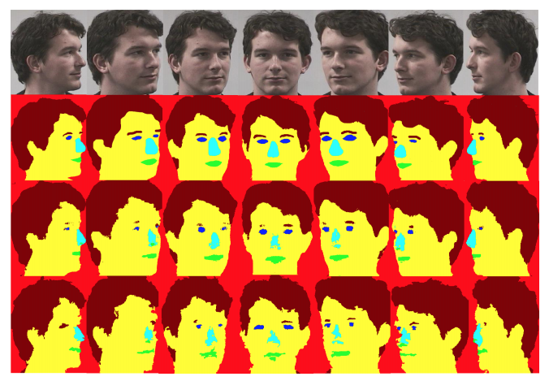

Step 2 : Use the output of this model to develop a use case among the following :

* Expression analysis
* Gender recognition
* Age prediction
* Face similarities
* Deepfake detection

Our methodology for step 1 will be based on the one developed by Khalil Khan, Massimo Mauro and Riccardo Leonardi (cf « References » section). For step 2, we plan to extract features from the color maps produced at step 1 as predictors for one of the use cases mentioned above.