Creating a Plugin for Janus CLI

This document walks through how to create a custom plugin for the Janus Command Line Interface (CLI), which can extend the functionality of the CLI by adding new commands. Each plugin must implement the ICommand interface, which defines the structure and behaviour of each command.

# What you will need

.NET SDK installation

C#

# Creating a Plugin

## Setup your project

### **Create a new class library project.**

dotnet new classlib -n MyPlugin

### **Add reference to Janus.Plugin**



## **Implement your command**

### Create a class for your command

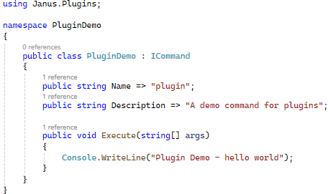

### Build your Plugin

dotnet build

### Get DLL file

## Put DLL in the .Plugins Directory

## Run and test