Coursework

# 1A)

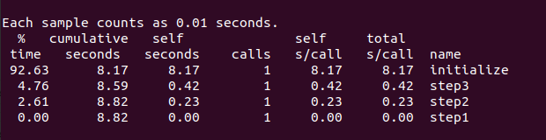

Most computationally expensive

^

|

| Initialize -> 92.63%

| Step3 -> 4.76%

| Step2 -> 2.61%

| Step1 -> 0.00%

|

Least computationally expensive

The most computationally expensive are Initialize, Step3 and Step2.

# 1B)

### a)

Below are screenshots of the FLOPs values given. The average FLOPs value will be calculated based on these.

Fig.1

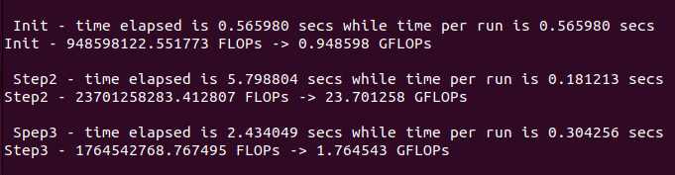

Fig.2

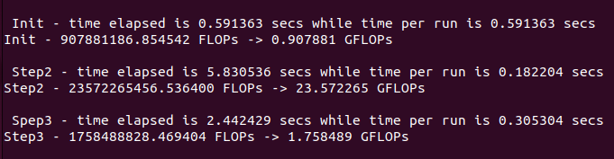

Fig.3

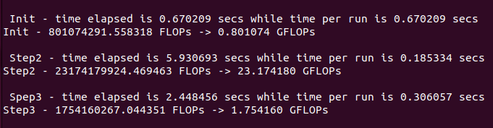

Most computationally expensive routines are Initialize, Step3 & Step2.

**Finding the average FLOPs for Initialization (to 2 decimal places):**

$$\frac{\left(0.948598+ 0.907881+ 0.801074\right)}{3}=0.89 Giga FLOPs$$

**Finding the average FLOPs for Step2 (to 2 decimal places):**

$$\frac{\left(23.701258+ 23.572265+ 23.174180\right)}{3}=23.48 Giga FLOPs$$

**Finding the average FLOPs for step 3 (to 2 decimal places):**

$$\frac{\left(1.764543+ 1.758489 + 1.754160\right)}{3}=1.76 Giga FLOPs$$

### b)

#define BILLION 1000000000

double flop, flops, timeper;

**For Initialization:**

start=omp_get_wtime();

for (i=0;i<1;i++){

initialize();

}

end=omp_get_wtime();

printf("\n Init - time elapsed is %f secs while time per run is %f secs\n",end-start, (end-start)/1);

flop = N + 2 * N * N;

timeper = (end-start)/1;

flops = flop/timeper;

printf("Init - %f FLOPs -> %f GFLOPs\n",flops, flops/BILLION);

**For Step2:**

start=omp_get_wtime();

for (i=0;i<32;i++){

step2();

}

end=omp_get_wtime();

printf("\n Step2 - time elapsed is %f secs while time per run is %f secs\n",end-start, (end-start)/32);

flop = 16.0f * N * N; // ((8*8) * N / 4) * N

timeper = (end-start)/32;

flops = flop/timeper;

printf("Step2 - %f FLOPs -> %f GFLOPs\n",flops, flops/BILLION);

**For Step3:**

start=omp_get_wtime();

for (i=0;i<8;i++){

reduction=step3();

}

end=omp_get_wtime();

printf("\n Spep3 - time elapsed is %f secs while time per run is %f secs\n",end-start, (end-start)/8);

flop = 2 * N * N + 1 * N / 8;

timeper = (end-start)/8;

flops = flop/timeper;

printf("Step3 - %f FLOPs -> %f GFLOPs\n",flops, flops/BILLION);

### c)

|  |  |  |
| --- | --- | --- |
|  | Windows Machine | Virtual Machine (running on windows machine) |
| CPU | Intel Core i7 8750H 2.20GHz (Turbo 4.10 GHz) | Intel Core i7 8750H 2.20GHz (Turbo 4.10 GHz) |
| Cores | 6 | 2 |
| Memory | DDR4 16GB 1200GHz | DDR4 8GB 1200GHz |
| OS | Windows 11 Home (64-bit) | Ubuntu 22.04 LTS (Jammy Jellyfish) (64-bit) |

# 1C)

**Theoretical peak FLOPs (capable on the virtual machine):**

$$Peak.FLOPs =num.CPU.cores* CPU.freq*\frac{simd.length.in.bits}{32}*num.FMA.units*2$$

$$=2* 4.10*\frac{256}{32}*1*2$$

$$Peak.FLOPs=131.2 Giga FLOPs$$

The results in step B demonstrate that Step2 obtains significantly more FLOPs than the other methods, as Step 2 utilises SIMD to perform 4 floating point operations at once. This increases the FLOPs value obtained as less memory calls and loops occur, due to this parallelisation less time is needed for operations as they can be performed simultaneously. Despite this none of the methods approach the theoretical peak as the program is not utilising all of the resources effectively. Each method is memory bound, meaning they are limited by the speed at which data can be transferred from the memory to be used in calculations. In order to increase the FLOPs value obtained by each method some optimisations can be implemented. These include loop tiling, parallelisation and utilising AVX vectors. Loop tiling involves dividing the data into smaller tiles which can fit inside of the cache, reducing cache misses and improving data locality. This would improve performance as data is reused within the cache. Another optimisation is parallelisation as at the moment the process runs on a single core but by splitting the work across multiple cores it allows different parts to be processed simultaneously, increasing the throughput and performance. Finally, I would utilise AVX vectors as currently, SSE vectors are used in Step2, while Step3 and the Initialisation are not vectorised. By utilising AVX vectors, which are a wider than SSE vectors, more floating-point operations can be run each cycle, significantly improving the FLOPs that can be obtained.

# 1D)

Fig.4

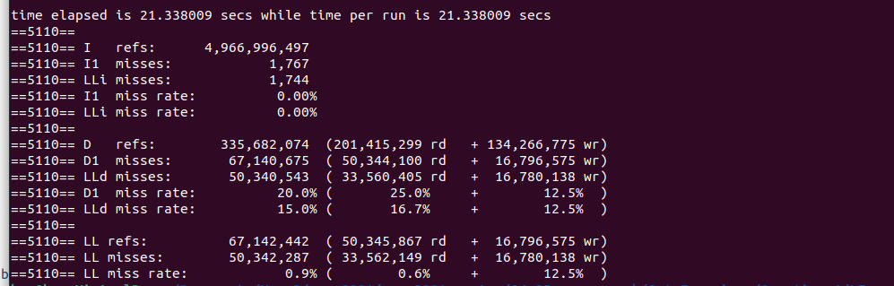

Fig.4 shows the Cachegrind output for the program with the LL misses being the number of L3 cache misses.

The Cachegrind output shows that 50,342,287 total L3 cache misses occurred, with 33,562,149 read misses and 16,780,138 write misses. The number of misses can be explained by looking at the memory and how it is accessed.

**Memory**

Given that N is large (at 16384), it can be seen that the 2D array A with dimensions N * N will have a large number of elements when compared to the other arrays, meaning it have a significant impact on the number of L3 cache misses observed. This results in there being a total of 268,435,456 elements in A. Since each element is a float value taking up 4 bytes

The total size of A is:

$$N * N * 4 bytes = 1,073,741,824 bytes$$

$$≈ 1,07 GB$$

This is much too big to fit inside the L3 cache (which is 9.0 MB for this machine), meaning that only a small part of A can be inside the cache at a given moment. The result of this is such that whenever a new part of A is accessed it will almost always not be in the L3 cache, giving a cache miss.

In contrast the 1D arrays X and Y can both easily fit within the cache. With each arrays size being:

$$N * 4 bytes = 65536 bytes$$

$$≈ 0.066 MB$$

Because of this array A will have the greatest contribution to the L3 cache misses.

**Estimating Cache Read Misses**

Array A is used in Step2 and Step3 and is accessed through row by row.

Given that a cache line is 64 bytes long and each float is 4 bytes, each cache line holds 16 float values.

Therefore, as there will be little if not any spatial locality significant cache thrashing will occur resulting in a L3 cache miss every 16 elements the are required from A. So, for each row of A accessed there is:

$$\frac{N}{16}=1024 L3 cache read misses$$

For the whole array there are:

$$\frac{N}{16}*N=16,777,216 L3 cache read misses$$

For both step2 and step3 the total cache misses when accessing A would be:

$$16,777,216*2= 33,554,432 L3 cache misses$$

The estimated total cache misses are close to the value of 33,562,149 given by Cachegrind.

**Estimating Cache Write Misses**

The biggest impact on write misses would be during the initialization of array A as it cannot all fit into the L3 cache. Therefore, like with the cache read misses a cache write miss will occur every 16 elements.

$$\frac{N}{16}*N=16,777,216 L3 cache write misses$$

This is close to the value given by Cachegrind of 16,780,138.

**Total Estimate**

Combining the read and write misses the estimated value is:

$$33,554,432 +16,777,216=50,331,648 L3 cache misses$$

As the estimates are very close to the observed misses, they justify the large number of L3 cache misses occurring.

# Q2)

## Before Optimisation:

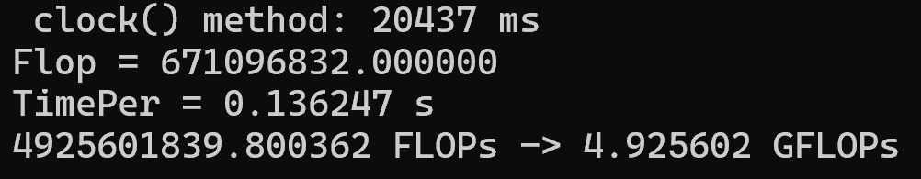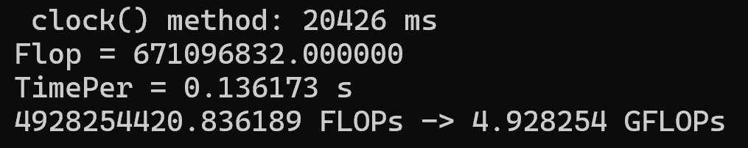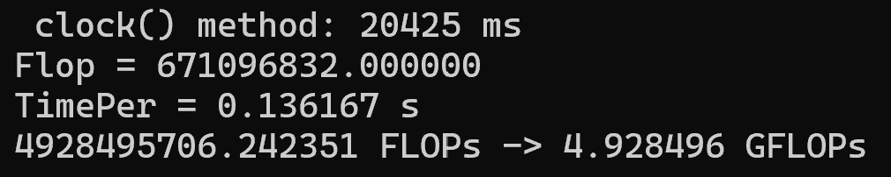

**Finding the average FLOPs before optimisation (to 2 decimal places):**

$$\frac{\left(4.925602+ 4.928254+ 4.928496\right)}{3}=4.93 Giga FLOPs$$

## After Optimisation:

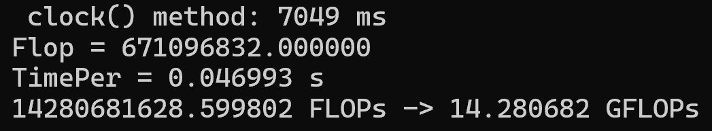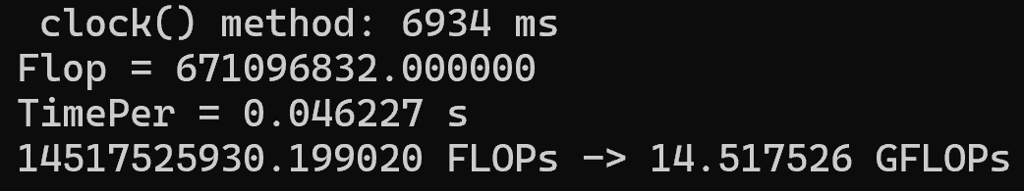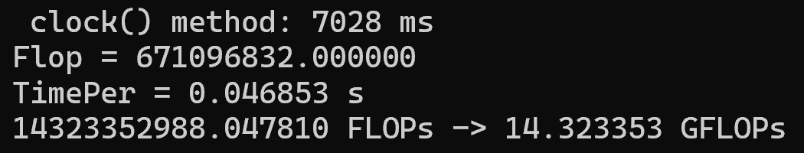

**Finding the average FLOPs after optimisation (to 2 decimal places):**

$$\frac{\left(14.280682+ 14.517526+ 14.323353\right)}{3}=14.37 Giga FLOPs$$