

**CECS 460 – UART Chip Specification with TSI**

Benjamin Santos

May 1, 2018

­­­­­

*This page intentionally left blank*

**Table of Contents**

I. Introduction……………………………………………………………………………… 5  
II. Documents………………………………………………………………………………. 5  
III. Requirements …………………………………………………………………………. 6  
IV. Top Level ……………………………………………………………………………… 7  
 a. Description ……………………………………………………………………… 7  
 b. Block Diagram …………………………………………………………………. 8  
 c. Data Flow Description .…………………………………………………………. 10  
 d. I/O ………………………………………………………………………..……... 10  
 e. Clocks ………………………………………………………………………….. 10  
 f. Resets …………………………………………………………………………… 10  
 g. Software ………………………………………………………………………… 10  
V. Externally Developed Blocks ………………………………………………………….. 11  
 a. Description ……………………………………………………………….……... 11  
 b. Block Diagram …………………………………………………………………. 12  
 c. I/O ………………………………………………………………………………. 13  
 d. Register Map ……………………………………………………………..……... 13  
VI. Internally Developed Blocks ………………………………………………………….. 14  
 1. UART  
 a. Description ……………………………………………………………… 14  
 b. Block Diagram ………………………………………………………….. 15  
 c. I/O ………………………………………………………………………. 16  
 d. State Machines …………………………………………………………. 16  
 e. Register Map ……………………………………………………………. 17  
 f. Verification ……………………………………………………………… 17  
 2. TX  
 a. Description ……………………………………………………………… 19  
 b. Block Diagram ………………………………………………………….. 19  
 c. I/O ………………………………………………………………………. 20  
 d. State Machines …………………………………………………………. 20  
 e. Register Map ……………………………………………………………. 21  
 f. Verification ……………………………………………………………… 22  
 3. RX  
 a. Description ……………………………………………………………… 23  
 b. Block Diagram ………………………………………………………….. 24  
 c. I/O ………………………………………………………………………. 25  
 d. State Machines …………………………………………………………. 25  
 e. Register Map ……………………………………………………………. 26  
 f. Verification ……………………………………………………………… 27  
VII. Chip Level Verification ……………………………………………………………… 27  
VIII. Chip Level Test ……………………………………………………………………… 28  
VIV. Tramelblaze Instruction Set …………………………………………………………. 31  
X. All Verilog Files ………………………………………………………………………. 39

**1 Introduction**

This project creates a UART chip has the RX and TX engine that receives and transmits serial data, respectively, alongside the 16-bit Tramelblaze Microcontroller written by John Tramel. The Transmit Engine provides the bit to be output onto the serial capture program according to the instruction set from the assembly code programmed into the Tramelblaze.

**II Documents**

1. External Documents
2. Customer Specifications
3. Industry Standards
4. References
5. Internal Documents
6. Internally generated specifications
7. Applicable methodology documents
8. Chip Test Plan
9. Analyses or trade studies

**III Requirements**

* The Chip should not start transmitting data when the TXRDY signal is not active and the TXRDY should stay active while it is in the middle of transmitting data.
* The Chip should not receive any data while the RXRDY signal is not active and the RXRDY should stay active while it is in the middle of receiving data.
* All modules in the program should use Asynchronous reset.
* The Receiver (Serial Capture Program) and the UART should be in the same BAUD rate in order to have the same data transmitted and received. For each BAUD rate it counts to the following integer count:

|  |  |  |  |
| --- | --- | --- | --- |
| **Baud[3:0] (switches)** | **Rate** | **Bit Time** | **Count** |
| 0000 | 300 | 0.003333333 | 333,333 |
| 0001 | 1200 | 0.000833333 | 83,333 |
| 0010 | 2400 | 0.000416667 | 41,667 |
| 0011 | 4800 | 0.000208333 | 20,833 |
| 0100 | 9600 | 0.000104167 | 10,417 |
| 0101 | 19200 | 5.20833E-05 | 5,208 |
| 0110 | 38400 | 2.60417E-05 | 2,604 |
| 0111 | 57600 | 1.73611E-05 | 1,736 |
| 1000 | 115200 | 8.68056E-06 | 868 |
| 1001 | 230400 | 4.34028E-06 | 434 |
| 1010 | 460800 | 2.17014E-06 | 217 |
| 1011 | 921600 | 1.08507E-06 | 109 |

**IV Top Level**

A. Description

The Top Level module of this project connects the CORE logic module and the Technology Specific Instantiations module to the Nexys4DDR board in order to communicate with the serial capture program (i.e Realterm). The CORE logic module has the UART chip and the Tramelblaze, while the Technology Specific Instantiations (TSI) module allocates each I/O of the chip to meet the electrical and timing requirements of the external interface to avoid any shorting on the hardware aspect of the chip.

Moreover, the CORE logic of this project echoes the user’s input from the keyboard onto the serial capture program with some preset functions such as:

@ - Prints out the current character written on screen.

* - Prints out my Hometown which is “Naga City”

BACKSPACE – Removes the current character the pointer is pointing to.

B. Block Diagram

1. Connection of TSI and Core

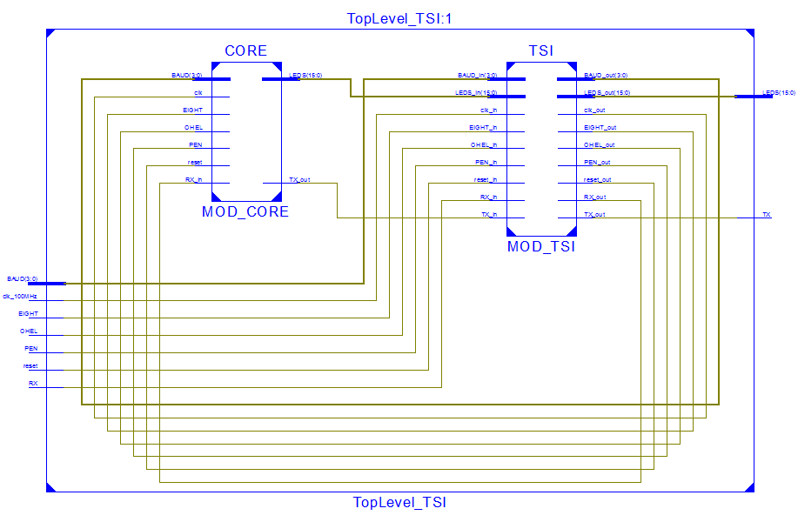

2. CORE

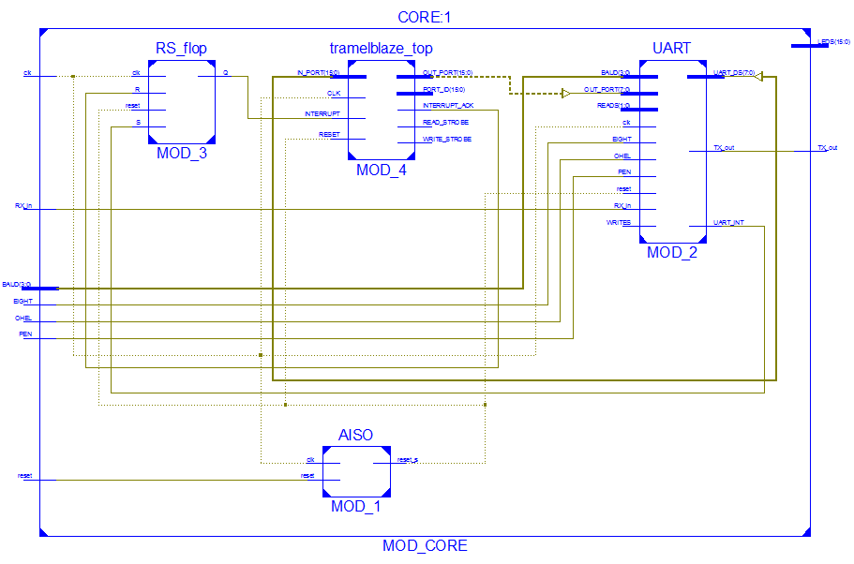

C. Data Flow Description

- The UART chip accepts the RX signal and leads it to the RX engine and generates the   
 8 bit data with the TX engine to be sent to the Tramelblaze.

- The TX engine also generates the TX signal to be sent to the serial capture program (Realterm) in accordance to the WRITES and OUT_PORT signal coming from the Tramelblaze.

D. I/O

|  |  |  |  |
| --- | --- | --- | --- |
| **Name** | **Bits** | **Type** | **Description** |
| clk_100MHz | 1 | Input | 100MHz clock provided by the Nexys4 board |
| reset | 1 | Input | Main reset of the program set to a button |
| BAUD | 4 | Input | Determines Baud rate of the Transmit Engine using 4 switches |
| EIGHT | 1 | Input | EIGHT flag if data being transmitted or received  is 8 bits. |
| PEN | 1 | Input | Parity Enable flag |
| OHEL | 1 | Input | Odd high or Even Low parity bit flag |
| RX_in | 1 | Input | The 1 bit serial input to the UART generated by the serial capture program along with the Tramelblaze |
| TX_out | 1 | Output | The 1 bit serial output of the UART to be received by the serial capture program (i.e Realterm) |
| LEDS | 16 | Output | Running LEDs on the Nexys4DDR board |
| anode | 8 | Output | Anodes on the Nexys4DDR board |

E. Clocks

The Top Level uses the default 100MHz clock of the Nexys4DDR board.

F. Resets

The Reset for the Top Level is provided by a user input from the Nexys4DDR board (btnu). The Top Level generates an Asynchronous Reset with the AISO.v and uses it for all other modules.

G. Software

The project was written in Verilog using the XILINX ISE

**V. Externally Developed Blocks**

A. Description

Tramelblaze is the 16-bit Picoblaze microcontroller written by John Tramel. Tramelblaze utilizes two volatile memories, Stack (128 x 16) and Scratch (512 x 16) RAMs and one Instruction ROM (4096 x 16) where the user can generate the Block Memory for the instructions from an assembly code.

B. Block Diagram

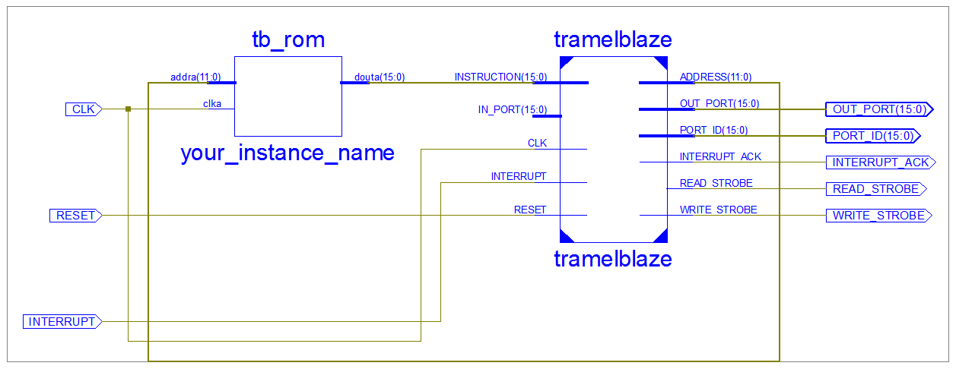

C. I/O

|  |  |  |  |
| --- | --- | --- | --- |
| **Name** | **Bits** | **Type** | **Description** |
| Clock | 1 | Input | Clock of the Tramelblaze |
| Reset | 1 | Input | Reset of the Tramelblaze |
| IN_PORT | 16 | Input | Data coming from the UART |
| INTERRUPT | 1 | Input | 1 clock cycle Interrupt flag |
| OUT_PORT | 16 | Output | Data to be sent to the UART |
| PORT_ID | 16 | Output | Address to be used by the Address Decoder |
| READ_STROBE | 1 | Output | Flag generated when the Chip is currently reading data in. |
| WRITE_SROBE | 1 | Output | Flag generated when the Chip is currently writing data out. |
| INTERRUPT_ACK | 1 | Output | Flag that is high for 1 clock cycle when it just received an Interrupt. |

D. Register Map

|  |  |
| --- | --- |
| **Type** | **Definition** |
| R | Read only |
| W | Write only |
| RW | Read and Write |
| RC | Read and Clear |

|  |  |  |  |
| --- | --- | --- | --- |
| **Name** | **Type** | **Bits** | **Description** |
| INSTRUCTION | RW | 16 | Instruction Set traversing through the Tramelblaze |
| ADDRESS | RW | 12 | Address of where the Instruction Set is being written or read |

**VI. Internally Developed Blocks**

**1. Universal Asynchronous Receiver-Transmitter (UART)**

1. A. Description

The UART chip communicates with the Tramelblaze, the Nexys4DDR board and the serial capture program (Realterm).

- The UART chip accepts the RX signal and leads it to the RX engine and generates the   
 8 bit data with the TX engine to be sent to the Tramelblaze.

- The TX engine also generates the TX signal to be sent to the serial capture program (Realterm) in accordance to the WRITES and OUT_PORT signal coming from the Tramelblaze.

1. B. Block Diagram

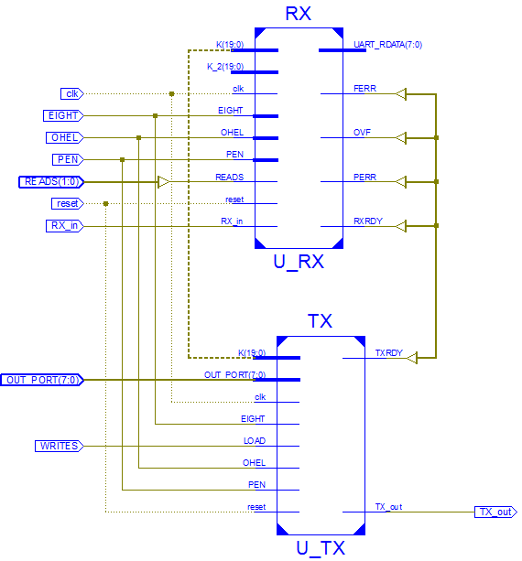

1. C. I/O

|  |  |  |  |
| --- | --- | --- | --- |
| **Name** | **Bits** | **Type** | **Description** |
| Clk | 1 | Input | Clock of the UART |
| Reset | 1 | Input | Reset of the UART |
| BAUD | 20 | Input | BAUD rate according to the Nexys4DDR board. |
| WRITES | 1 | Input | WRITES[0] flag from the Address Decoder |
| READS | 2 | Input | READS from the Address Decoder to determine whether the data being output (UART_DS) is the status or the data. |
| OUT_PORT | 8 | Input | OUT_PORT from the Tramelblaze |
| EIGHT | 1 | Input | EIGHT flag if data being transmitted or received  is 8 bits. |
| PEN | 1 | Input | Parity Enable flag |
| OHEL | 1 | Input | Odd high or Even Low parity bit flag |
| RX_in | 1 | Input | The 1 bit serial input to the UART generated by the serial capture program along with the Tramelblaze |
| TX_out | 1 | Output | 1 bit serial output of the TX engine to be received by the Tramelblaze |
| UART_DS | 8 | Output | Data to be sent to the Tramelblaze |
| UART_INT | 1 | Output | Interrupt generated if either TXRDY or RXRDY is active for 1 clock cycle |

1. D State Machines

1. E Register Map

|  |  |
| --- | --- |
| **Type** | **Definition** |
| R | Read only |
| W | Write only |
| RW | Read and Write |
| RC | Read and Clear |

|  |  |  |  |
| --- | --- | --- | --- |
| **Name** | **Type** | **Bits** | **Description** |
| K | RW | 1 | BAUD rate in integer |
| K_2 | RW | 1 | Half of the BAUD rate in integer |
| TXRDY | RW | 1 | 1 Clock delay of input LOAD for the shift register |
| RXRDY | RW | 1 | Flag produced by Bit Time Counter that is active for one clock when the counter counts up to 1 bit time according to the BAUD rate. |
| UART_STATUS | RW | 8 | Output of the loadable register from the input. |
| UART_RDATA | RW | 1 | 10th bit to be input to the shift register |
| UART_RXRDY | RW | 1 | 9th bit to be input to the shift register |
| UART_TXRDY | RW | 1 | BAUD rate in integer |

1. F Verification

The following waveform has the RX_out connected to the TX_in in order to simulate an ECHO command from the Tramelblaze. Moreover the UART is given the input OUT_PORT = 0x65 or 0110_0101 while the BAUD rate is set on the fastest speed

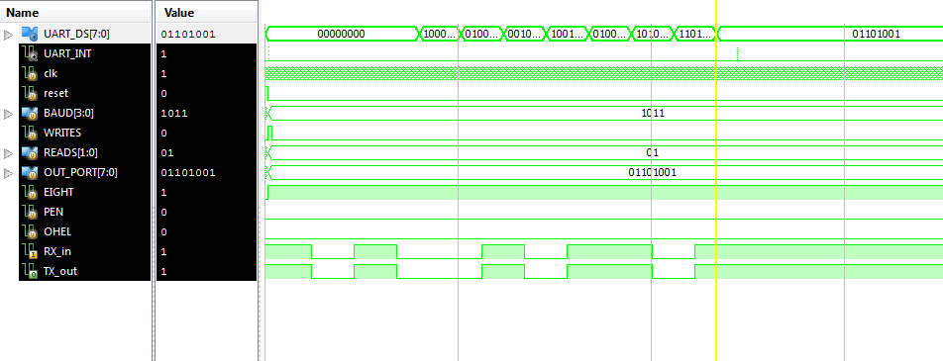

As what can be seen, the TX_out along with the RX_in, has the start bit(0) and starts changing the data from the Least Significant Bit to the Most Significant Bit (1010_0110) and finally the stop bit(1).

**2. Transmit Engine (TX)**

2. A. Description

The Transmit Engine generates a 1 bit output for the serial capture device to display on the screen from the instruction set from the Tramelblaze

2. B. Block Diagram

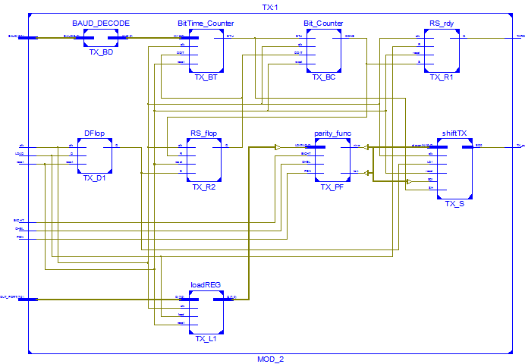

2. C. I/O

|  |  |  |  |
| --- | --- | --- | --- |
| **Name** | **Bits** | **Type** | **Description** |
| Clk | 1 | Input | Clock of the TX engine |
| Reset | 1 | Input | Reset of the TX engine |
| K | 20 | Input | BAUD rate in integer form. |
| LOAD | 1 | Input | LOAD flag that is high when WRITES[0] from the Address Decoder is high |
| OUT_PORT | 8 | Input | Data received by the Shift Register of the TX when LOAD is high. |
| EIGHT | 1 | Input | EIGHT flag if data being transmitted or received  is 8 bits. |
| PEN | 1 | Input | Parity Enable flag |
| OHEL | 1 | Input | Odd high or Even Low parity bit flag |
| TXRDY | 1 | Output | TXRDY flag if the TX engine is ready to transmit data. |
| TX_out | 1 | Output | 1 bit serial output of the TX engine to be received by the Tramelblaze |

2. D. State Machines

2. E. Register Map

|  |  |
| --- | --- |
| **Type** | **Definition** |
| R | Read only |
| W | Write only |
| RW | Read and Write |
| RC | Read and Clear |

|  |  |  |  |
| --- | --- | --- | --- |
| **Name** | **Type** | **Bits** | **Description** |
| DOIT | RW | 1 | Flag used for the Bit Time Counter and Bit Counter |
| DONE | RW | 1 | Flag produced by Bit Counter that is active for one clock when the TX is done transmitting data |
| LOADD1 | RW | 1 | 1 Clock delay of input LOAD for the shift register |
| BTU | RW | 1 | Flag produced by Bit Time Counter that is active for one clock when the counter counts up to 1 bit time according to the BAUD rate. |
| LDATA | RW | 8 | Output of the loadable register from the input. |
| Ten | RW | 1 | 10th bit to be input to the shift register |
| Nine | RW | 1 | 9th bit to be input to the shift register |
| K | RW | 20 | BAUD rate in integer |

2. F. Verification

The following waveform is given the input OUT_PORT = 0x65 or 0110_0101 while the BAUD rate is set on the fastest speed

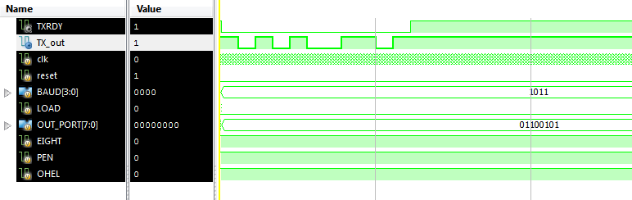

As what can be seen, the TX_out outputs the start bit(0) and starts transmitting the data from the Least Significant Bit to the Most Significant Bit (1010_0110) and finally the stop bit(1).

**3. Receive Engine (RX)**

3. A. Description

The Receive Engine receives a 1 bit input from the serial capture device and synchronizes the data collection with the TX communication. The Receive Engine is always polling the RX line looking for a high to low transition indicating the arrival of the START bit and a simple Moore state machine ensures that the START bit remains active until the Bit Time Counter is done counting (BTU is up) and it goes to the data collection part. Finally, the state machine lets the receive engine continue to receive data until the DONE flag from the Bit Counter is active.

3. B. Block Diagram

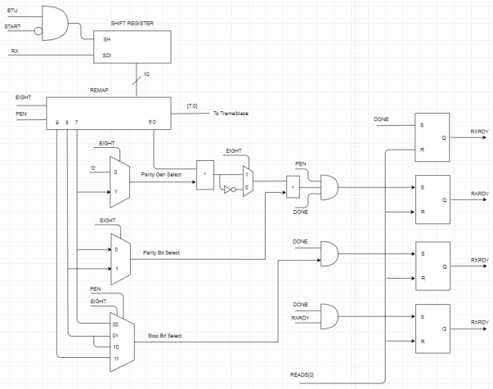

3. C. I/O

|  |  |  |  |
| --- | --- | --- | --- |
| **Name** | **Bits** | **Type** | **Description** |
| Clk | 1 | Input | Clock of the RX |
| Reset | 1 | Input | Reset of the RX |
| K | 20 | Input | BAUD rate in integer form |
| K_2 | 20 | Input | Half of the BAUD rate in integer form |
| RX_in | 1 | Input | The 1 bit serial input to the UART generated by the serial capture program along with the Tramelblaze |
| EIGHT | 1 | Input | EIGHT flag if data being transmitted or received  is 8 bits. |
| PEN | 1 | Input | Parity Enable flag |
| OHEL | 1 | Input | Odd high or Even Low parity bit flag |
| READS | 1 | Input | The READS[0] bit from the Address Decoder and Tramelblaze for the UART_STATUS flags |
| UART_RDATA | 8 | Output | Data to be sent to the Tramelblaze directly from the Remapped Shift Register |
| OVF | 1 | Output | Overflow Error flag |
| FERR | 1 | Output | Framing Error flag |
| PERR | 1 | Output | Parity Error flag |
| RXRDY | 1 | Output | RXRDY flag |

3. D. State Machines

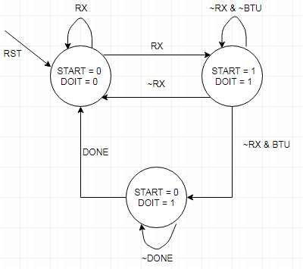

3. E. Register Map

|  |  |
| --- | --- |
| **Type** | **Definition** |
| R | Read only |
| W | Write only |
| RW | Read and Write |
| RC | Read and Clear |

|  |  |  |  |
| --- | --- | --- | --- |
| **Name** | **Type** | **Bits** | **Description** |
| START | RW | 1 | Flag is high when RX is on the START bit |
| DOIT | RW | 1 | Flag used for the Bit Time Counter and Bit Counter |
| DONE | RW | 1 | Flag produced by Bit Counter that is active for one clock when the RX is done receiving data |
| BTU | RW | 1 | Flag produced by Bit Time Counter that is active for one clock when the counter counts up to 1 bit time according to the BAUD rate. |
| K_in | RW | 20 | BAUD rate in integer according to the START bit |
| SH | RW | 1 | Flag for the Shift Register (BTU && ~START) |
| SR | RW | 10 | Shift Register |
| RMP | RW | 10 | Remapped Shift Register to send [6:0] to the Tramelblaze |
| parr2 | RW | 1 | Higher priority of the PERR RS flop. |
| SBS | RW | 1 | Stop Bit Select used for the FERR (DONE && ~SBS) |

3. F. Verification

The RX engine is fed the signals 0x5B = 0101_1011 and as what can be seen, the UART_RDATA signal gets the same bits sent from the testbench.

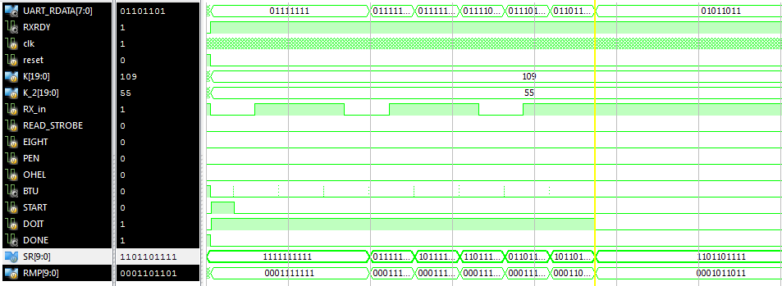

**VII. Chip Level Verification**

UART Verification shown above.

**VIII. Chip Level Test**

The CORE logic of this project echoes the user’s input from the keyboard onto the serial capture program with some preset functions such as:

@ - Prints out the current character written on screen.

* - Prints out my Hometown which is “Naga City”

BACKSPACE – Removes the current character the pointer is pointing to.

On launch:

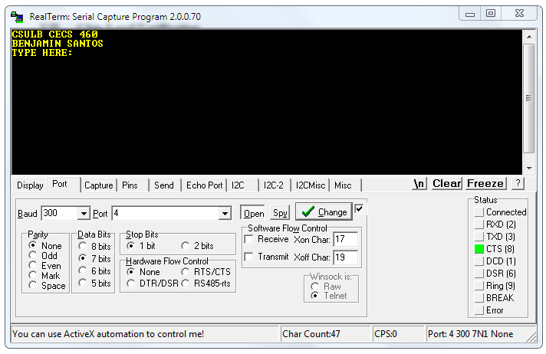

Verification of @ function:

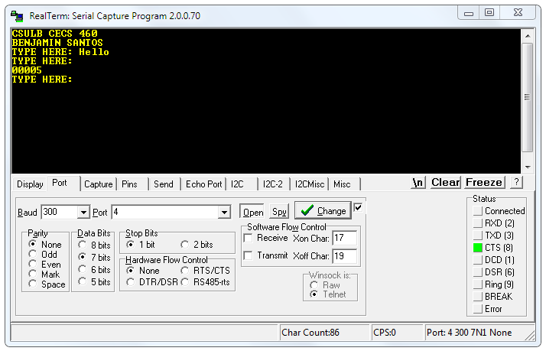

Verification of * function:

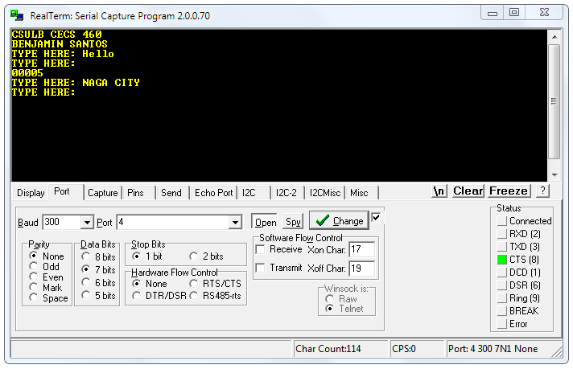

Tramelblaze Instruction Set (Using Assembly Language) :

; Benjamin Santos

; CECS 460 - UART

; April 28, 2018

; declare constants for coding

ONE EQU 1000

ZERO EQU 0000

asc_0 EQU 0030

asc_1 EQU 0031

asc_2 EQU 0032

asc_3 EQU 0033

asc_4 EQU 0034

asc_5 EQU 0035

asc_6 EQU 0036

asc_7 EQU 0037

asc_8 EQU 0038

asc_9 EQU 0039

asc_A EQU 0041

asc_B EQU 0042

asc_C EQU 0043

asc_D EQU 0044

asc_E EQU 0045

asc_F EQU 0046

asc_G EQU 0047

asc_H EQU 0048

asc_I EQU 0049

asc_J EQU 004A

asc_K EQU 004B

asc_L EQU 004C

asc_M EQU 004D

asc_N EQU 004E

asc_O EQU 004F

asc_P EQU 0050

asc_Q EQU 0051

asc_R EQU 0052

asc_S EQU 0053

asc_T EQU 0054

asc_U EQU 0055

asc_V EQU 0056

asc_W EQU 0057

asc_X EQU 0058

asc_Y EQU 0059

asc_Z EQU 005A

asc_Sp EQU 0020

asc_CR EQU 000D

asc_CR_7 EQU 008D

asc_LF EQU 000A

asc_BS EQU 0008

asc_BS_7 EQU 0088

asc_ST EQU 002A

asc_ST_7 EQU 00AA

asc_AT EQU 0040

asc_AT_7 EQU 00C0

asc_PS EQU 0025

asc_AR EQU 003E

asc_FF EQU 000C

asc_NULL EQU 0000

TENTHOUSANDS EQU 0103

THOUSANDS EQU 0104

HUNDREDS EQU 0105

TENS EQU 0106

ONES EQU 0107

; WALKING ONES

WALKING EQU R0

WALK_COUNT EQU R1

; ISR

TEMP EQU R2

COUNTER EQU R3

DATA EQU R4

CHAR_FLAG EQU R5

NEW_FLAG EQU R6

BACK_FLAG EQU R7

HOME_FLAG EQU R8

NEW_POINTER EQU R9

BACK_POINTER EQU RA

HOME_POINTER EQU RB

CHAR_COUNT EQU RC

BORDER_COUNT EQU RD

TXOK EQU RE

CHAR_POINTER EQU RF

; begin

START ENINT

; banner

LOAD TEMP, asc_FF

STORE TEMP, 0000

LOAD TEMP, asc_C

STORE TEMP, 0001

LOAD TEMP, asc_S

STORE TEMP, 0002

LOAD TEMP, asc_U

STORE TEMP, 0003

LOAD TEMP, asc_L

STORE TEMP, 0004

LOAD TEMP, asc_B

STORE TEMP, 0005

LOAD TEMP, asc_Sp

STORE TEMP, 0006

LOAD TEMP, asc_C

STORE TEMP, 0007

LOAD TEMP, asc_E

STORE TEMP, 0008

LOAD TEMP, asc_C

STORE TEMP, 0009

LOAD TEMP, asc_S

STORE TEMP, 000A

LOAD TEMP, asc_Sp

STORE TEMP, 000B

LOAD TEMP, asc_4

STORE TEMP, 000C

LOAD TEMP, asc_6

STORE TEMP, 000D

LOAD TEMP, asc_0

STORE TEMP, 000E

LOAD TEMP, asc_Sp

STORE TEMP, 000F

LOAD TEMP, asc_CR

STORE TEMP, 0010

LOAD TEMP, asc_LF

STORE TEMP, 0011

; Name

; 0012

LOAD TEMP, asc_B ;B

STORE TEMP, 0012

LOAD TEMP, asc_E ;E

STORE TEMP, 0013

LOAD TEMP, asc_N ;N

STORE TEMP, 0014

LOAD TEMP, asc_J ;J

STORE TEMP, 0015

LOAD TEMP, asc_A ;A

STORE TEMP, 0016

LOAD TEMP, asc_M ;M

STORE TEMP, 0017

LOAD TEMP, asc_I ;I

STORE TEMP, 0018

LOAD TEMP, asc_N ;N

STORE TEMP, 0019

LOAD TEMP, asc_Sp ;

STORE TEMP, 001A

LOAD TEMP, asc_S ;S

STORE TEMP, 001B

LOAD TEMP, asc_A ;A

STORE TEMP, 001C

LOAD TEMP, asc_N ;N

STORE TEMP, 001D

LOAD TEMP, asc_T ;T

STORE TEMP, 001E

LOAD TEMP, asc_O ;O

STORE TEMP, 001F

LOAD TEMP, asc_S ;S

STORE TEMP, 0020

; prompt and new line

; 0021

LOAD TEMP, asc_CR

STORE TEMP, 0021

STORE TEMP, 0101

LOAD TEMP, asc_LF

STORE TEMP, 0022

STORE TEMP, 0102

LOAD TEMP, asc_T

STORE TEMP, 0023

LOAD TEMP, asc_Y

STORE TEMP, 0024

LOAD TEMP, asc_P

STORE TEMP, 0025

LOAD TEMP, asc_E

STORE TEMP, 0026

LOAD TEMP, asc_Sp

STORE TEMP, 0027

LOAD TEMP, asc_H

STORE TEMP, 0028

LOAD TEMP, asc_E

STORE TEMP, 0029

LOAD TEMP, asc_R

STORE TEMP, 002A

LOAD TEMP, asc_E

STORE TEMP, 002B

LOAD TEMP, 003A ;:

STORE TEMP, 002C

LOAD TEMP, asc_Sp

STORE TEMP, 002D

; backspace

; 002E

LOAD TEMP, asc_BS

STORE TEMP, 002E

LOAD TEMP, asc_Sp

STORE TEMP, 002F

LOAD TEMP, asc_BS

STORE TEMP, 0030

; hometown

; 0031

LOAD TEMP, asc_N

STORE TEMP, 0031

LOAD TEMP, asc_A

STORE TEMP, 0032

LOAD TEMP, asc_G

STORE TEMP, 0033

LOAD TEMP, asc_A

STORE TEMP, 0034

LOAD TEMP, asc_Sp

STORE TEMP, 0035

LOAD TEMP, asc_C

STORE TEMP, 0036

LOAD TEMP, asc_I

STORE TEMP, 0037

LOAD TEMP, asc_T

STORE TEMP, 0038

LOAD TEMP, asc_Y

STORE TEMP, 0039

; initializing registers

LOAD COUNTER, ZERO

LOAD WALKING, ONE

LOAD NEW_POINTER, 0021

LOAD BACK_POINTER, 002E

LOAD HOME_POINTER, 0031

LOAD CHAR_COUNT, 0000

LOAD NEW_FLAG, 0000

LOAD BACK_FLAG, 0000

LOAD HOME_FLAG, 0000

LOAD CHAR_POINTER, 0101

; main loop, walking ones

FIRST LOAD WALK_COUNT, FFFF

OUTPUT WALKING, 0001

RR WALKING

JUMP DELAY

DELAY SUB WALK_COUNT, 0001

COMP WALK_COUNT, 0000

JUMPZ FIRST

JUMP DELAY

; address for interrupt service routine

ADDRESS 0500

; set up for in isr

ISR COMP NEW_FLAG, FFFF ;right

JUMPZ NEWLINE

COMP BACK_FLAG, FFFF

JUMPZ BACKSPACE

COMP HOME_FLAG, FFFF

JUMPZ HOMETOWN

COMP CHAR_FLAG, FFFF

JUMPZ CHARACTERS

COMP COUNTER, 002E

JUMPZ USERINPUT

FETCH TEMP, COUNTER

OUTPUT TEMP, 0000

ADD COUNTER, 0001

RETEN

USERINPUT INPUT TEMP, 0001

STORE TEMP, 0100

AND TEMP, 0001

COMP TEMP, 0001

JUMPZ RECEIVE

FETCH TEMP, 0100

AND TEMP, 0002

COMP TEMP, 0002

JUMPZ TXBLOCK

RETEN

TXBLOCK LOAD TXOK, FFFF

RETEN

RECEIVE INPUT DATA, 0000

COMP TXOK, FFFF

JUMPZ TRANSMIT

RETEN

TRANSMIT LOAD TXOK, 0000

COMP DATA, asc_CR

JUMPZ NEWLINE

COMP DATA, asc_CR_7

JUMPZ NEWLINE

COMP DATA, asc_BS

JUMPZ BACKCHECK

COMP DATA, asc_BS_7

JUMPZ BACKCHECK

COMP DATA, asc_ST

JUMPZ HOMETOWN

COMP DATA, asc_ST_7

JUMPZ HOMETOWN

COMP DATA, asc_AT

JUMPZ PRETENTHOUSAND

COMP DATA, asc_AT_7

JUMPZ PRETENTHOUSAND

ADD CHAR_COUNT, 0001

STORE CHAR_COUNT, 0200

OUTPUT CHAR_COUNT, 0003

ADD BORDER_COUNT, 0001

OUTPUT DATA, 0000

COMP BORDER_COUNT, 0021

JUMPZ PRENEWLINE

RETEN

PRENEWLINE LOAD NEW_FLAG, FFFF

RETEN

NEWLINE LOAD NEW_FLAG, FFFF

FETCH TEMP, NEW_POINTER

OUTPUT TEMP, 0000

ADD NEW_POINTER, 0001

COMP NEW_POINTER, 002E

JUMPZ NEWRESET

RETEN

NEWRESET LOAD NEW_FLAG, 0000

LOAD NEW_POINTER, 0021

LOAD BORDER_COUNT, 0000

RETEN

BACKCHECK COMP BORDER_COUNT, 0000

JUMPNZ BACKSPACE

LOAD DATA, asc_NULL

OUTPUT DATA, 0000

RETEN

BACKSPACE LOAD BACK_FLAG, FFFF

FETCH TEMP, BACK_POINTER

OUTPUT TEMP, 0000

ADD BACK_POINTER, 0001

COMP BACK_POINTER, 0031

JUMPZ BACKRESET

RETEN

BACKRESET LOAD BACK_FLAG, 0000

LOAD BACK_POINTER, 002E

SUB BORDER_COUNT, 0001

RETEN

HOMETOWN LOAD HOME_FLAG, FFFF

FETCH TEMP, HOME_POINTER

OUTPUT TEMP, 0000

ADD HOME_POINTER, 0001

COMP HOME_POINTER, 0040

JUMPZ HOMERESET

RETEN

HOMERESET LOAD HOME_FLAG, 0000

LOAD HOME_POINTER, 0031

JUMP PRENEWLINE

PRETENTHOUSAND LOAD TEMP, 0000

COMP CHAR_COUNT, 0000

JUMPNZ TENTHOUSAND

LOAD DATA, asc_NULL

OUTPUT DATA, 0000

RETEN

TENTHOUSAND SUB CHAR_COUNT, 2710

JUMPC PRETHOUSAND

ADD TEMP, 0001

JUMP TENTHOUSAND

PRETHOUSAND STORE TEMP, TENTHOUSANDS

LOAD TEMP, 0000

ADD CHAR_COUNT, 2710

COMP CHAR_COUNT, 2710

JUMPZ CHARACTERS

JUMP THOUSAND

THOUSAND SUB CHAR_COUNT, 03E8

JUMPC PREHUNDRED

ADD TEMP, 0001

JUMP THOUSAND

PREHUNDRED STORE TEMP, THOUSANDS

LOAD TEMP, 0000

ADD CHAR_COUNT, 03E8

COMP CHAR_COUNT, 03E8

JUMPZ CHARACTERS

JUMP HUNDRED

HUNDRED SUB CHAR_COUNT, 0064

JUMPC PRETEN

ADD TEMP, 0001

JUMP HUNDRED

PRETEN STORE TEMP, HUNDREDS

LOAD TEMP, 0000

ADD CHAR_COUNT, 0064

COMP CHAR_COUNT, 0064

JUMPZ CHARACTERS

JUMP TEN

TEN SUB CHAR_COUNT, 000A

JUMPC PREONE

ADD TEMP, 0001

JUMP TEN

PREONE STORE TEMP, TENS

LOAD TEMP, 0000

ADD CHAR_COUNT, 000A

COMP CHAR_COUNT, 000A

JUMPZ CHARACTERS

JUMP ONE_1

ONE_1 STORE CHAR_COUNT, ONES

JUMP CHARACTERS

CHARACTERS LOAD CHAR_FLAG, FFFF

COMP CHAR_POINTER, 0108

JUMPZ CHARRESET

FETCH TEMP, CHAR_POINTER

ADD CHAR_POINTER, 0001

COMP TEMP, 0000

JUMPZ LOADZERO

COMP TEMP, 0001

JUMPZ LOADONE

COMP TEMP, 0002

JUMPZ LOADTWO

COMP TEMP, 0003

JUMPZ LOADTHREE

COMP TEMP, 0004

JUMPZ LOADFOUR

COMP TEMP, 0005

JUMPZ LOADFIVE

COMP TEMP, 0006

JUMPZ LOADSIX

COMP TEMP, 0007

JUMPZ LOADSEVEN

COMP TEMP, 0008

JUMPZ LOADEIGHT

COMP TEMP, 0009

JUMPZ LOADNINE

OUTPUT TEMP, 0000

RETEN

LOADZERO LOAD DATA, asc_0

OUTPUT DATA, 0000

RETEN

LOADONE LOAD DATA, asc_1

OUTPUT DATA, 0000

RETEN

LOADTWO LOAD DATA, asc_2

OUTPUT DATA, 0000

RETEN

LOADTHREE LOAD DATA, asc_3

OUTPUT DATA, 0000

RETEN

LOADFOUR LOAD DATA, asc_4

OUTPUT DATA, 0000

RETEN

LOADFIVE LOAD DATA, asc_5

OUTPUT DATA, 0000

RETEN

LOADSIX LOAD DATA, asc_6

OUTPUT DATA, 0000

RETEN

LOADSEVEN LOAD DATA, asc_7

OUTPUT DATA, 0000

RETEN

LOADEIGHT LOAD DATA, asc_8

OUTPUT DATA, 0000

RETEN

LOADNINE LOAD DATA, asc_9

OUTPUT DATA, 0000

RETEN

CHARRESET LOAD CHAR_FLAG, 0000

LOAD CHAR_POINTER, 0101

FETCH CHAR_COUNT, 0200

LOAD DATA, asc_NULL

OUTPUT DATA, 0000

JUMP PRENEWLINE

; ISR vectored through 0FFE

ADDRESS 0FFE

ENDIT JUMP ISR

END

**X. All Verilog Files**

The following are all the Verilog files used for this project.