NAIJA PRIME SCHOOL
School Management Portal
User Manual
For system administrators, head teachers, teachers, bursars, storekeepers, parents and pupils
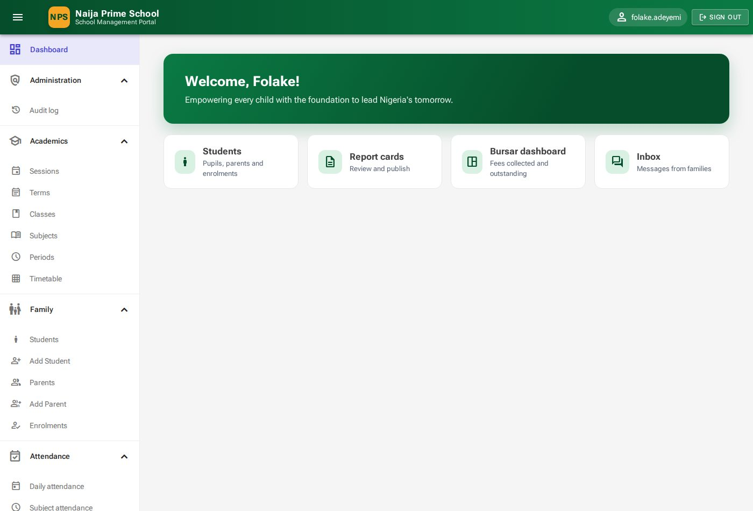
Version 1.0 · September 2026
Produced by Benjamin Fadina for HepziBen Technologies Ltd.

Document information
Title | Naija Prime School Management Portal — User Manual
Version | 1.0
Date | September 2026
Author | Benjamin Fadina
Produced for | HepziBen Technologies Ltd.
Covers | Portal release with Sprints 1–16 (user accounts to audit log)
Audience | All users: SuperAdmin, HeadTeacher, Teacher, SchoolBursar, SchoolStoreKeeper, Parent, Student
© 2026 HepziBen Technologies Ltd. All rights reserved. This manual was produced by Benjamin Fadina for HepziBen Technologies Ltd. It describes the Naija Prime School Management Portal; screenshots show demonstration data only.

Contents

If the contents list is empty, right-click it in Word and choose Update Field.

1. Introduction
The Naija Prime School Management Portal is a web application that runs the day-to-day work of the school in one place: pupil and parent records, class timetables, attendance, assessments and report cards, fees and payments (including online payment), the school store, announcements, private messages between families and the school office, and a full audit trail of every change.
This manual explains, step by step and with pictures, how every type of user carries out their tasks. You do not need to read it from cover to cover — use the table below to find the chapters for your role.

1.1 Who should read what
Your role | What you do in the portal | Read chapters
SuperAdmin (system administrator) | Creates staff accounts, assigns roles, resets passwords; can use every feature. | 2, 3, 4 and any other
HeadTeacher | Sets up the academic year, manages pupils and parents, publishes results and report cards, communicates with families, reviews finance, store and the audit log. | 2, 3, 5–13
Teacher | Takes attendance, records assessment scores, views the class timetable. | 2, 3, 5.6, 7, 8.1
SchoolBursar | Sets fees, issues invoices, records payments and refunds, monitors online payments. | 2, 3, 9
SchoolStoreKeeper | Maintains the store catalogue, records purchases and issues, manages suppliers. | 2, 3, 10
Parent | Follows each child's attendance, results and fees, pays fees online, reads announcements and messages the school. | 2, 3, 14
Student | Sees today's timetable, results, attendance and fees; reads announcements; messages the school. | 2, 3, 15

1.2 Conventions used in this manual
- Names of buttons, menus, fields and tabs are shown in bold, for example Save changes.
- A menu path such as Family → Students means: open the Family section in the menu on the left, then click Students.
- The pictures come from the demonstration school "Naija Prime School". Names, amounts and dates on your screen will be your own school's.
- Boxes labelled Tip, Note and Important give extra advice. Read the Important ones carefully — they protect records and money.

1.3 What you need
- A computer, tablet or phone with an up-to-date web browser (Chrome, Edge, Firefox or Safari).
- The portal address given to you by the school (for example https://portal.naijaprimeschool.ng).
- Your username (or email address) and password. Staff receive these from the system administrator; parents and pupils receive them from the school office when the pupil is admitted.

2. Getting started

2.1 Signing in
- Open the portal address in your browser. The Welcome back sign-in page appears.
- In Email or username type your username (for example folake.adeyemi) or your email address.
- Type your Password. Tick Remember me only on a private device.
- Click Sign in. You arrive at your Dashboard.

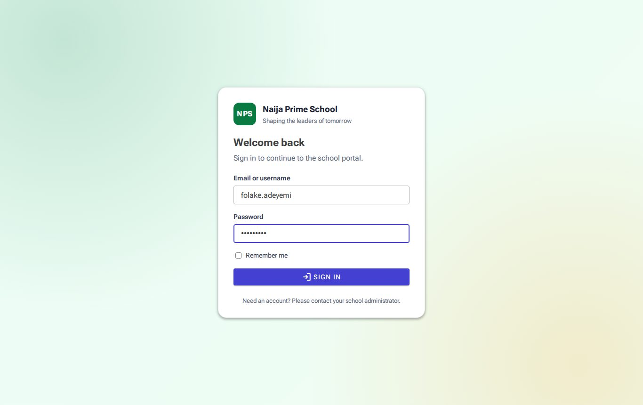
Figure 1: The sign-in page
Important: Five wrong passwords in a row lock the account for 15 minutes. If you have forgotten your password, ask the system administrator (staff) or the school office (parents and pupils) to reset it — see section 4.4.

2.2 The dashboard
The dashboard is the first page after signing in. It greets you by name and shows shortcut cards to the parts of the portal you use most. The shortcuts depend on your role: a teacher sees Daily attendance, Assessments and Timetable; a parent sees My wards, Announcements and Messages. The system administrator also sees account statistics (number of users, active and deactivated accounts, roles).
Figure 2: Dashboard for the head teacher, with shortcut cards
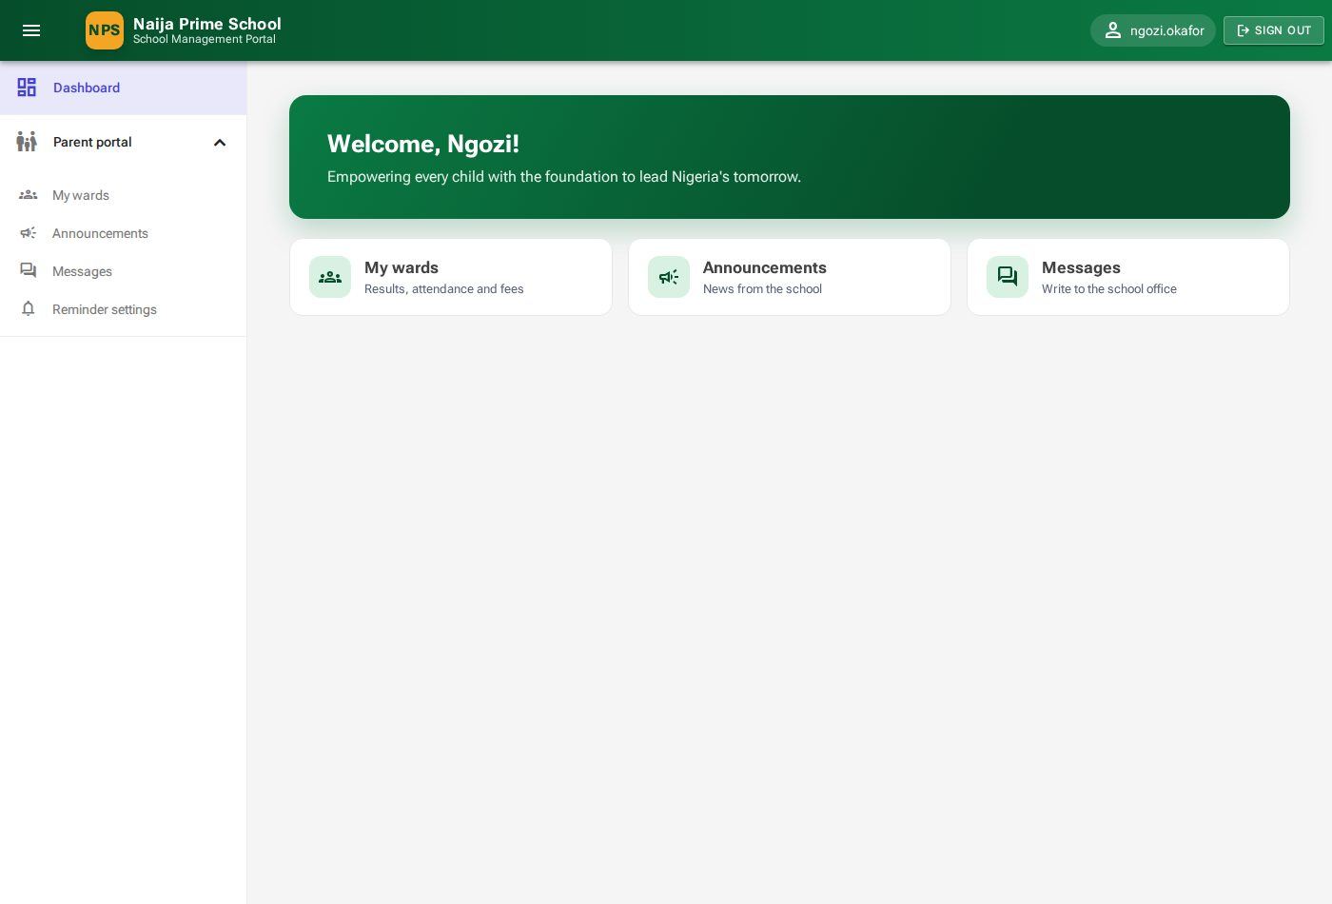
Figure 3: Dashboard for a parent

2.3 Finding your way around
Every page has the same frame:
- Header (green bar): the menu button (☰) shows or hides the menu; your username is on the right with the Sign out button.
- Menu (left): the sections you are allowed to use. Click a section heading to open or close it. You only ever see the parts of the portal your role permits.
- Page area: the page title and a short description at the top, action buttons on the right (for example New class), then filters and the page content.

Lists (grids)
- Most lists have Search and filter boxes above them. Results update as soon as you change a filter or press Tab after typing.
- Long lists are split into pages; use the page numbers at the bottom and choose how many rows to show per page.
- Click a column heading to sort by it (where sorting is available).
- Small icon buttons at the end of each row perform actions: ✏ edit, 🗑 delete, 👁 open/view. Hover over an icon to see what it does.

Forms, messages and confirmations
- Fields marked with an asterisk (*) are required. If something is missing or invalid, the field is outlined in red with a short explanation.
- After you save, a message appears briefly in the corner of the screen: green for success (for example "Saved"), red for a problem with the reason.
- Actions that cannot easily be undone — deleting, withdrawing, publishing, refunding — ask you to confirm in a pop-up first.

2.4 When a page says "Access denied"
If you follow a link or type an address for a page your role may not use, the portal shows Access denied. Click Back to home. If you believe you should have access, ask the system administrator to review your roles.
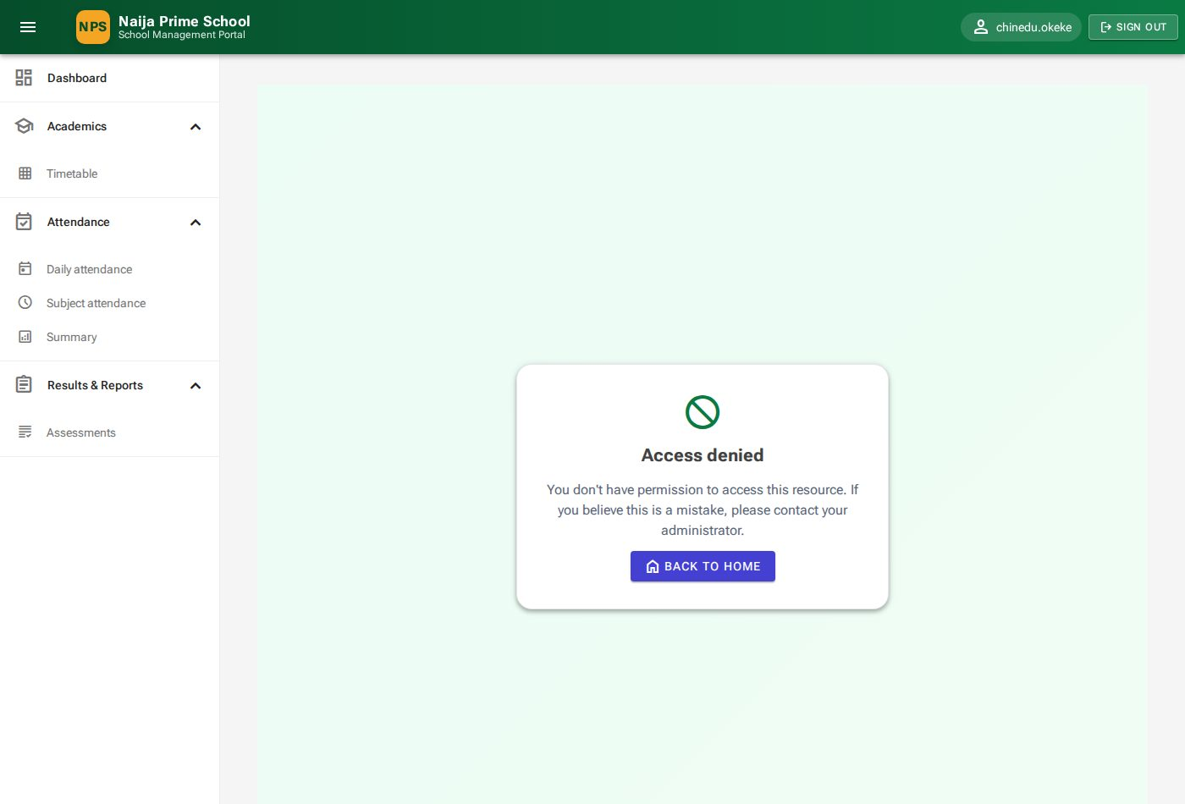
Figure 4: Access denied

2.5 Signing out
Click Sign out in the top-right corner. Always sign out on shared computers. For your security the portal also ends sessions when an administrator deactivates your account or resets your password.

3. Roles and permissions
Access is controlled by roles. A person can hold more than one role (for example a teacher who is also the bursar). The seven roles are fixed by the system:
Role | Purpose
SuperAdmin | System administrator with access to every feature, including user accounts.
HeadTeacher | Runs the school: academics, pupils and parents, results, communications, audit log; can also use finance and store.
Teacher | Timetable, attendance and assessments.
SchoolBursar | Fees, invoices, payments, online payments.
SchoolStoreKeeper | Store catalogue, stock movements, suppliers.
Parent | Parent portal for their own children only.
Student | Student portal for their own records only.

Parent and Student accounts are created automatically when the office registers a parent or admits a pupil (chapter 6). Staff accounts are created by the system administrator (chapter 4). Appendix A lists exactly which pages each role can open.

4. User management (SuperAdmin)
Menu: User Management. Only the SuperAdmin role sees this section.

4.1 Viewing users
User Management → All Users lists every account — staff, parents and pupils — with name, email, username, role badges and status (Active or Inactive).
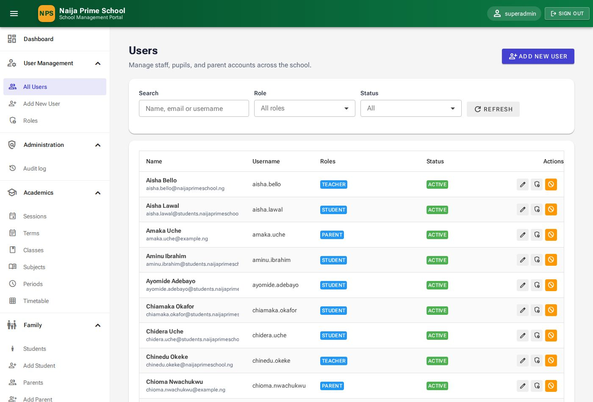
Figure 5: All Users
- Search finds users by name, email or username.
- Role shows only users with a given role, for example all Teachers.
- Status shows only Active or only Inactive accounts.

4.2 Adding a staff member
- Click Add new user (or User Management → Add New User).
- Under Personal details enter title, first and last name (required), gender, date of birth and address.
- Under Account enter a Username (for example kemi.adewale), Email, phone, and a Password typed twice. Passwords must be at least 8 characters with upper- and lower-case letters, a number and a symbol.
- Under Roles tick at least one role.
- Click Create user. The new person can sign in immediately with the username and password you set — give these to them privately.

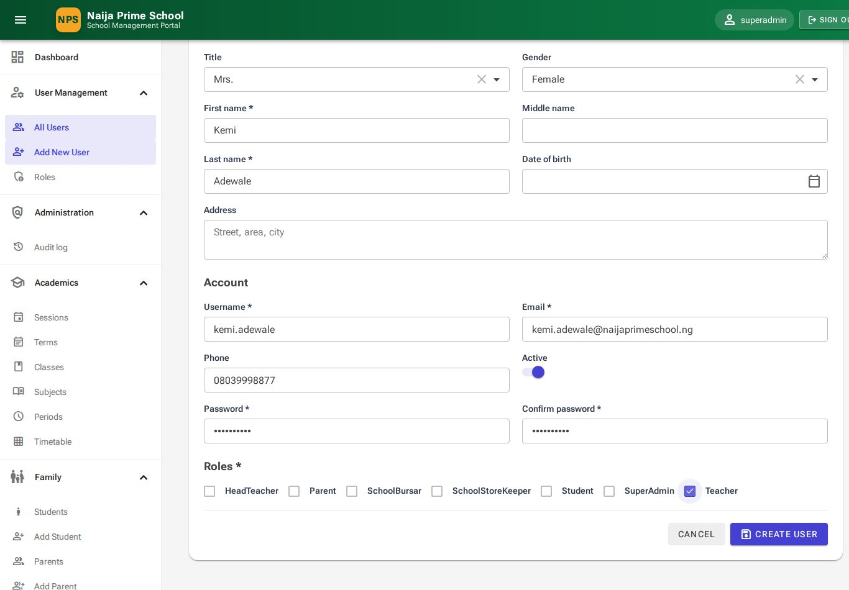
Figure 6: Adding a new user
Note: Parents and pupils are not added here — register them from Family (chapter 6) so their portal account is linked to the right record.

4.3 Editing a user
Click the ✏ Edit icon on the user's row. Change the details and click Save changes. From this page you can also Assign roles, Reset password, and Deactivate or Activate the account.
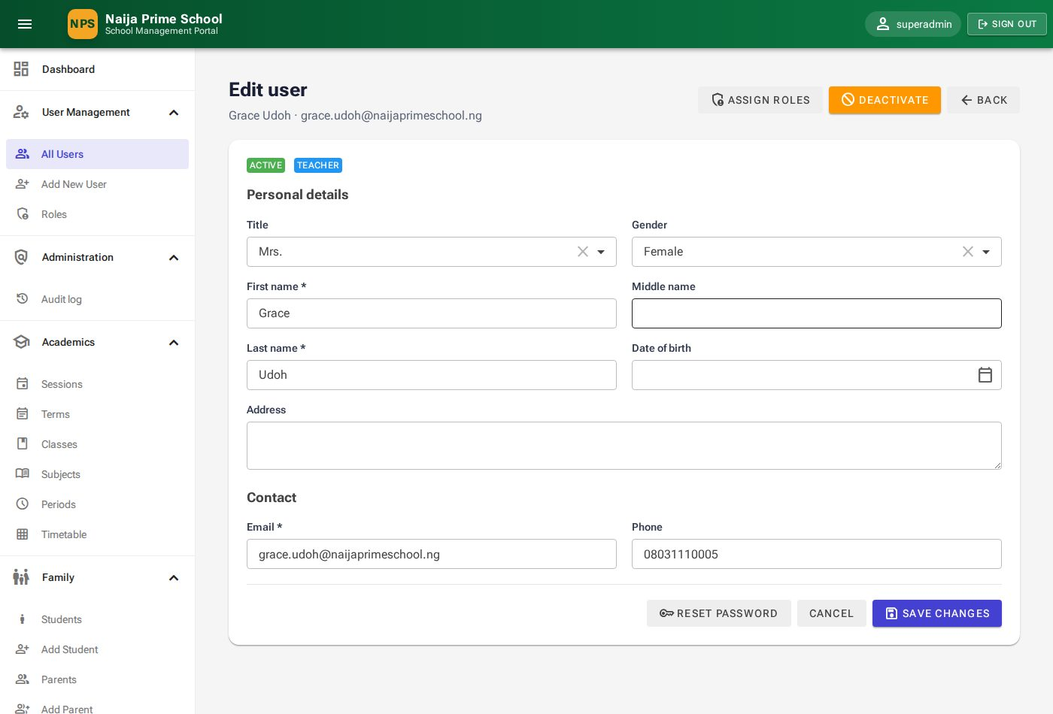
Figure 7: Edit user

4.4 Resetting a password
- Open the user (✏ Edit) and click Reset password.
- Type the new password in New password and Confirm password (at least 8 characters).
- Click Update password and tell the person their new password privately. They are signed out of any open sessions.

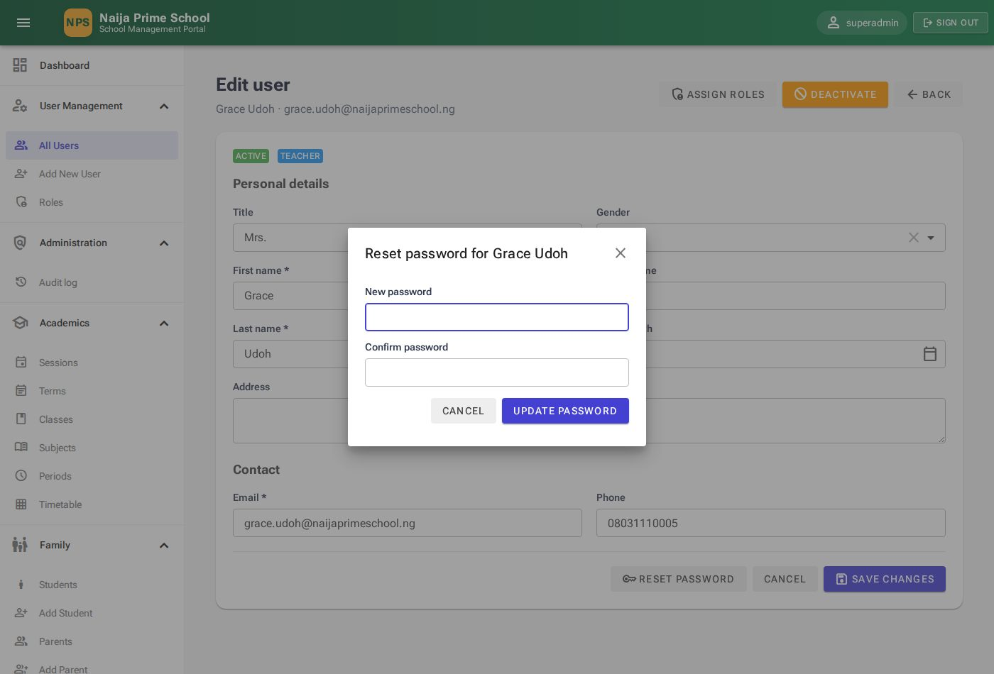
Figure 8: Resetting a password

4.5 Assigning roles
Click the 🛡 Assign roles icon on the user's row (or Assign roles on the edit page), tick or untick roles and click Save roles. The menu the person sees changes the next time they open a page.
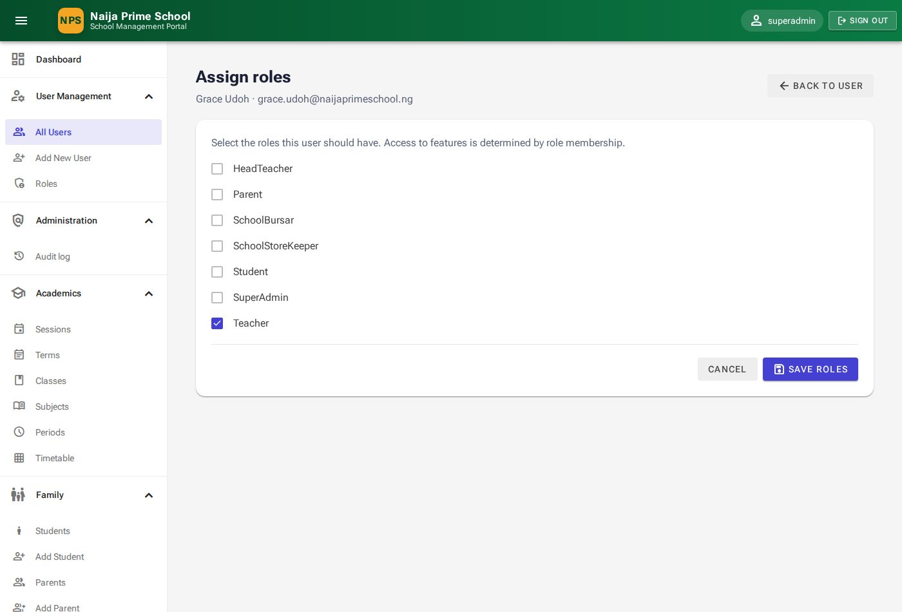
Figure 9: Assigning roles

4.6 Deactivating and reactivating accounts
When someone leaves, click the ⛔ Deactivate icon and confirm. The account is kept (with its history) but the person can no longer sign in. Click Activate to restore access. Deactivating is always preferable to deleting.

4.7 Roles page
User Management → Roles lists the seven system roles and their descriptions for reference.
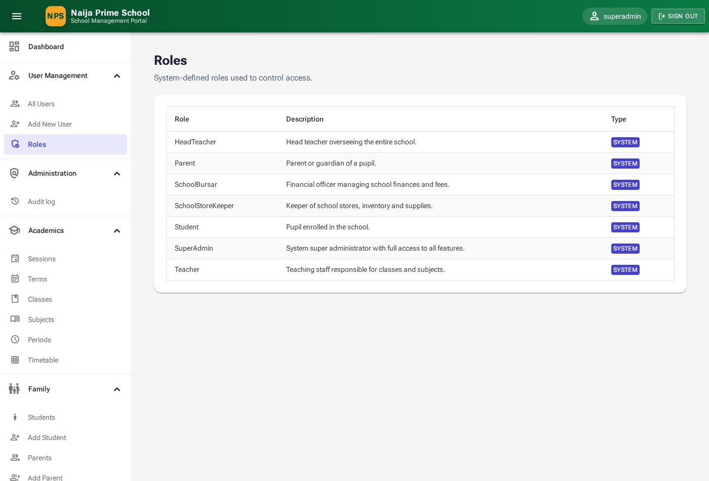
Figure 10: Roles

5. Academic set-up (HeadTeacher)
Menu: Academics. Set these up at the start of each academic year, in this order: session → terms → classes → subjects → periods → timetable.

5.1 Academic sessions
A session is an academic year such as 2026/2027. Exactly one session is marked Current; most pages open on the current session automatically.
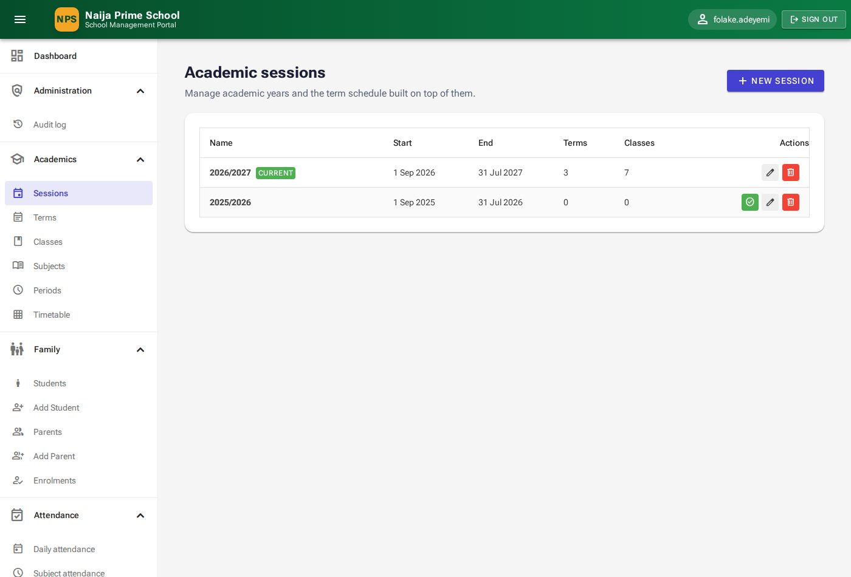
Figure 11: Academic sessions
- Click New session.
- Enter the Name (for example 2027/2028), Start date and End date. Turn on Mark current only when the new year begins.
- Click Save.

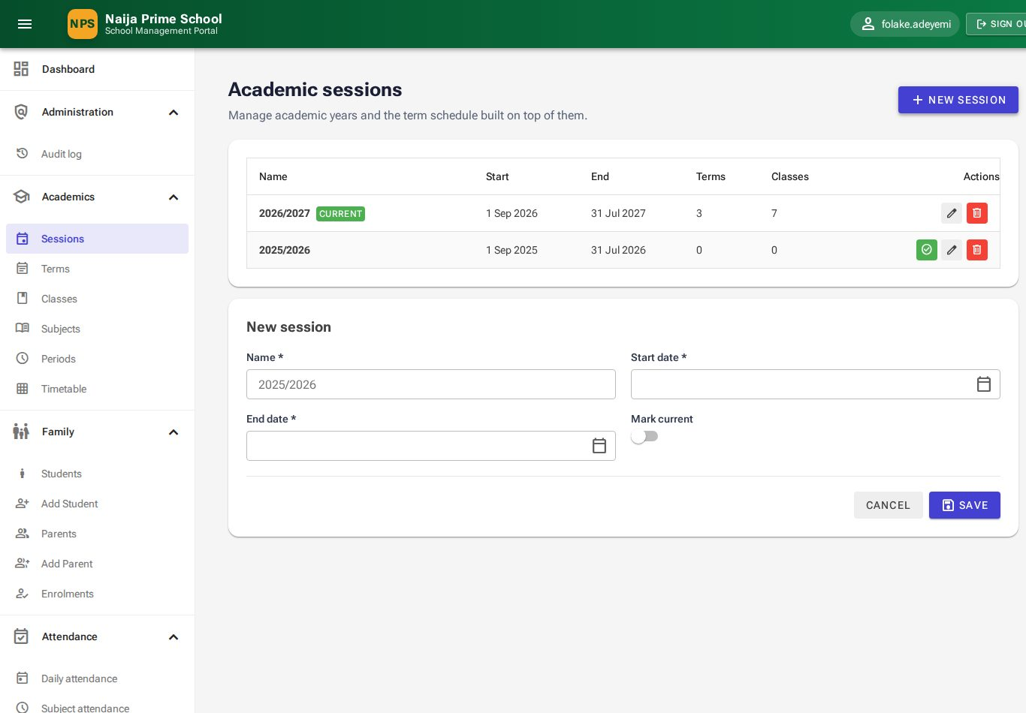
Figure 12: Creating a session
- To make another session current, click the ✔ Mark current icon on its row.
- A session can only be deleted while it has no terms or classes.
- The end date must be after the start date, and names must be unique.

5.2 Terms
Academics → Terms lists the First, Second and Third Term of each session with their dates. Click New term, choose the Session and Term, enter the dates and Save. Mark the running term as Current with the ✔ icon. A term that already has timetable lessons cannot be deleted.
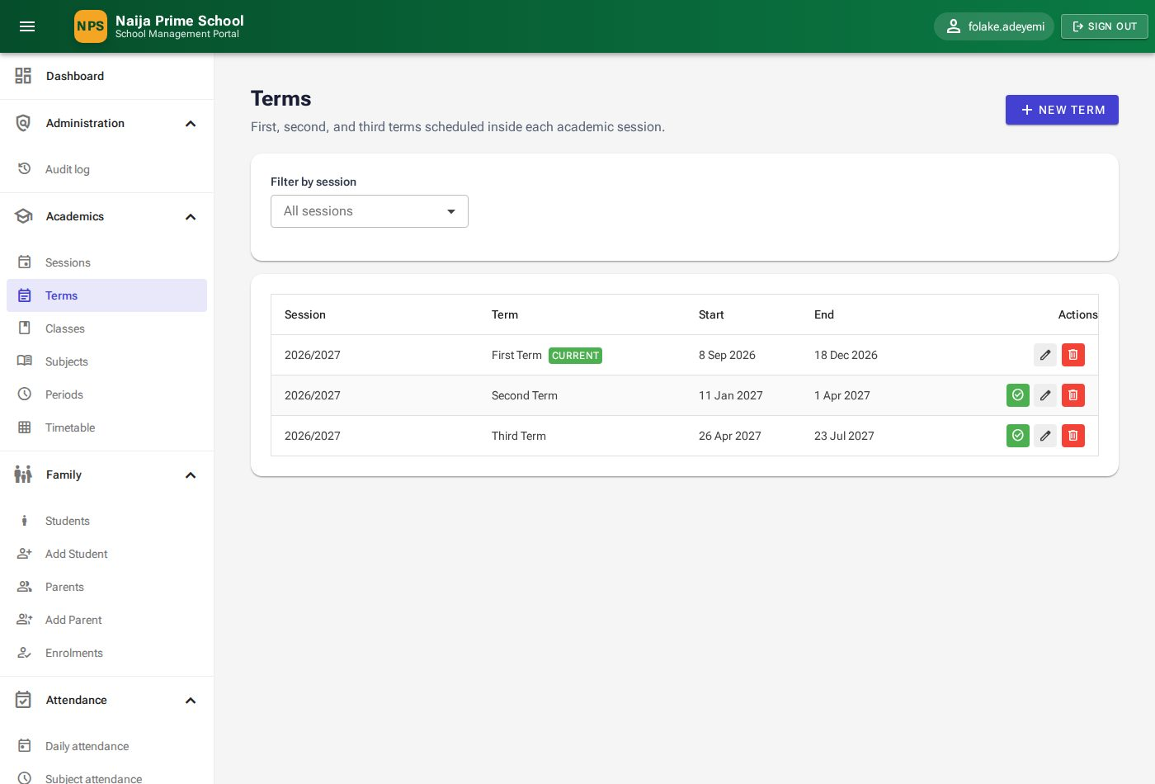
Figure 13: Terms

5.3 Classes
Classes (class arms) belong to a session — for example Primary 5A in 2026/2027. Each class has a level (Creche to Primary 6) and optionally a class teacher.
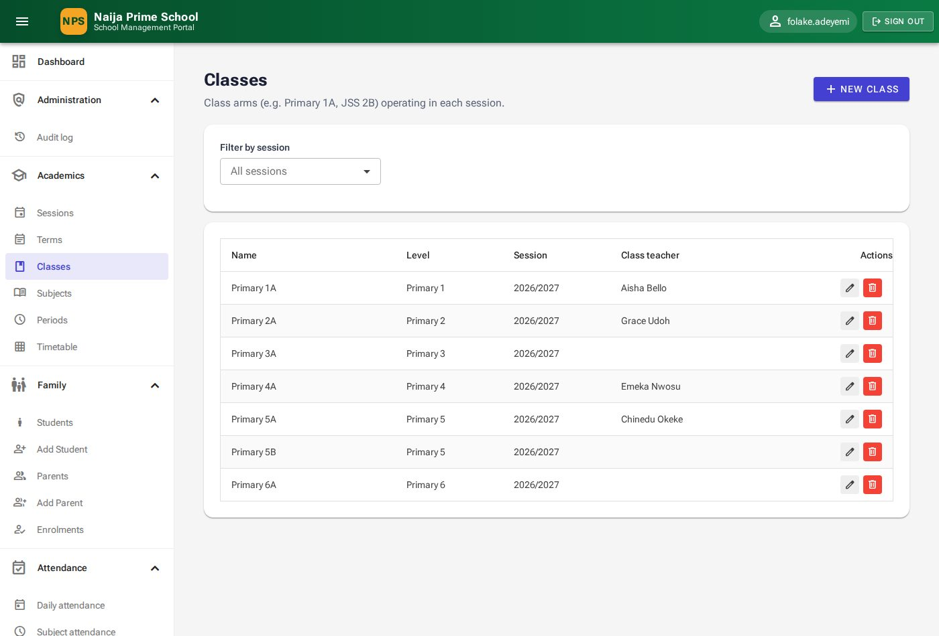
Figure 14: Classes
- Click New class.
- Enter the Name (for example Primary 3B), pick the Class level and Session, and optionally the Class teacher.
- Click Save. Class names must be unique within a session.

5.4 Subjects
Academics → Subjects holds the subjects taught, each with a short Code (for example MTH) that appears on timetables and result sheets. Click New subject, enter name and code, and Save. A subject on a timetable cannot be deleted.
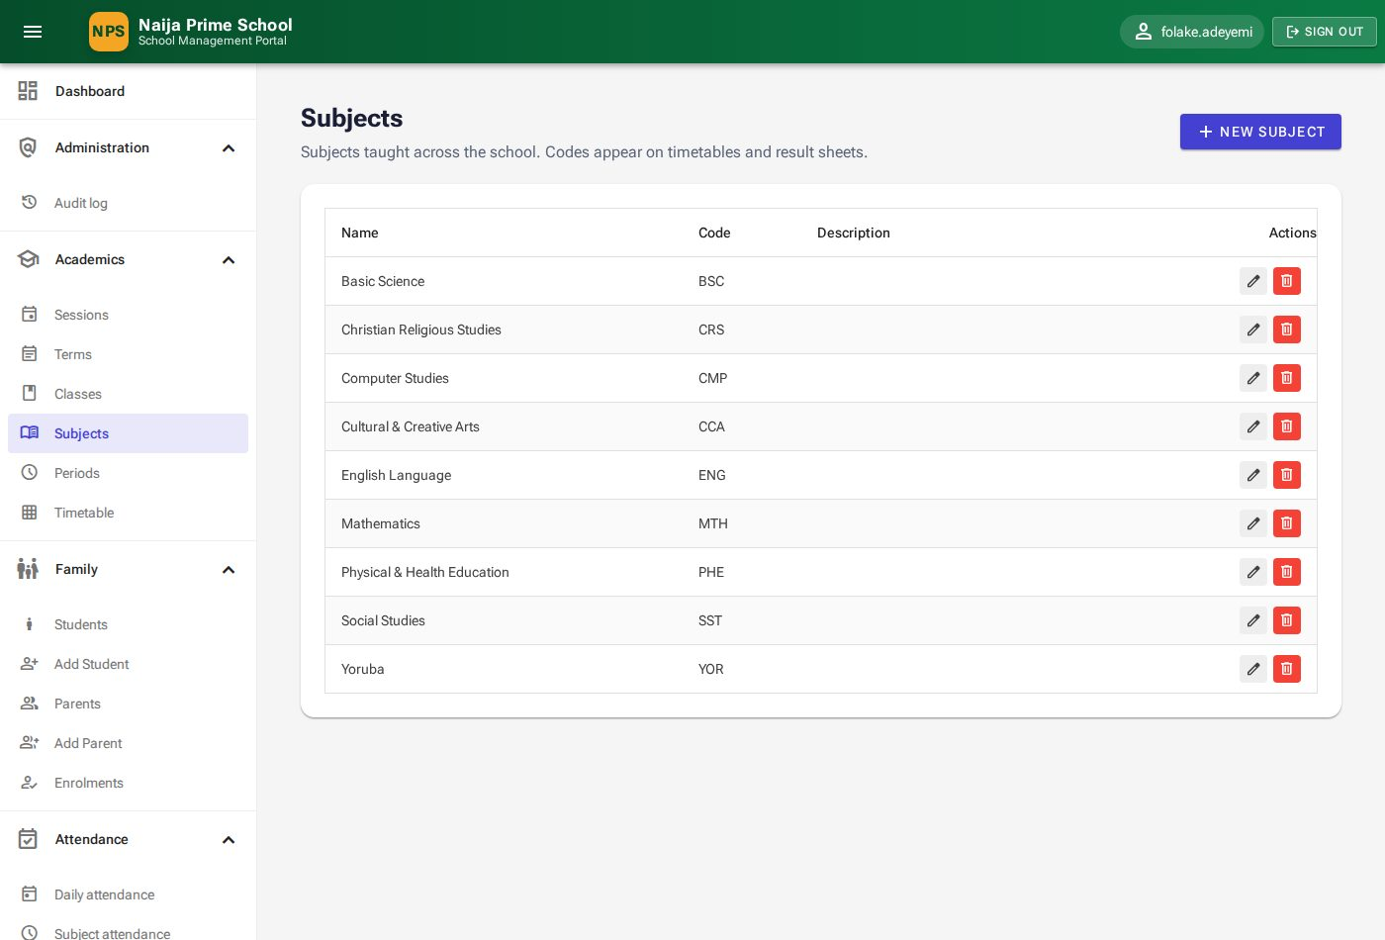
Figure 15: Subjects

5.5 Timetable periods
Periods are the time slots of the school day, including breaks. Click New period, enter the name, display order, start and end time, and turn on Break period for breaks and lunch.
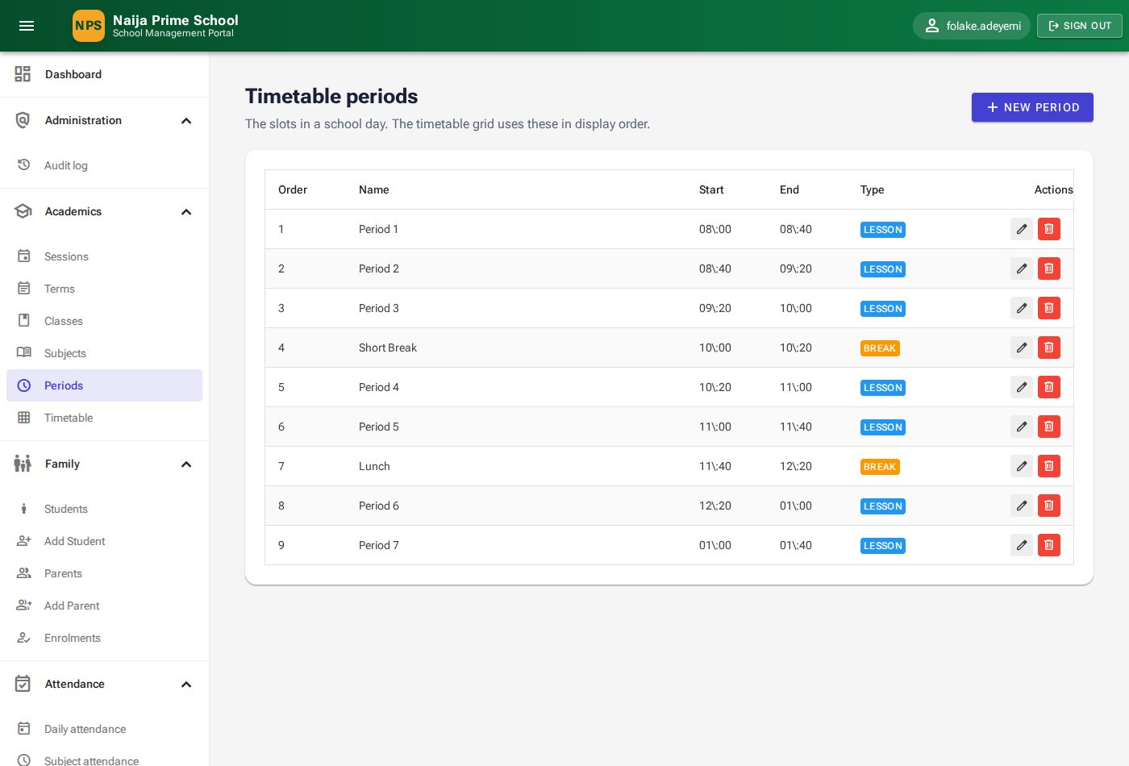
Figure 16: Timetable periods

5.6 Class timetable
Menu: Academics → Timetable (HeadTeacher and Teachers). Choose a Term and a Class to see the week: days across the top, periods down the side, break rows shaded.
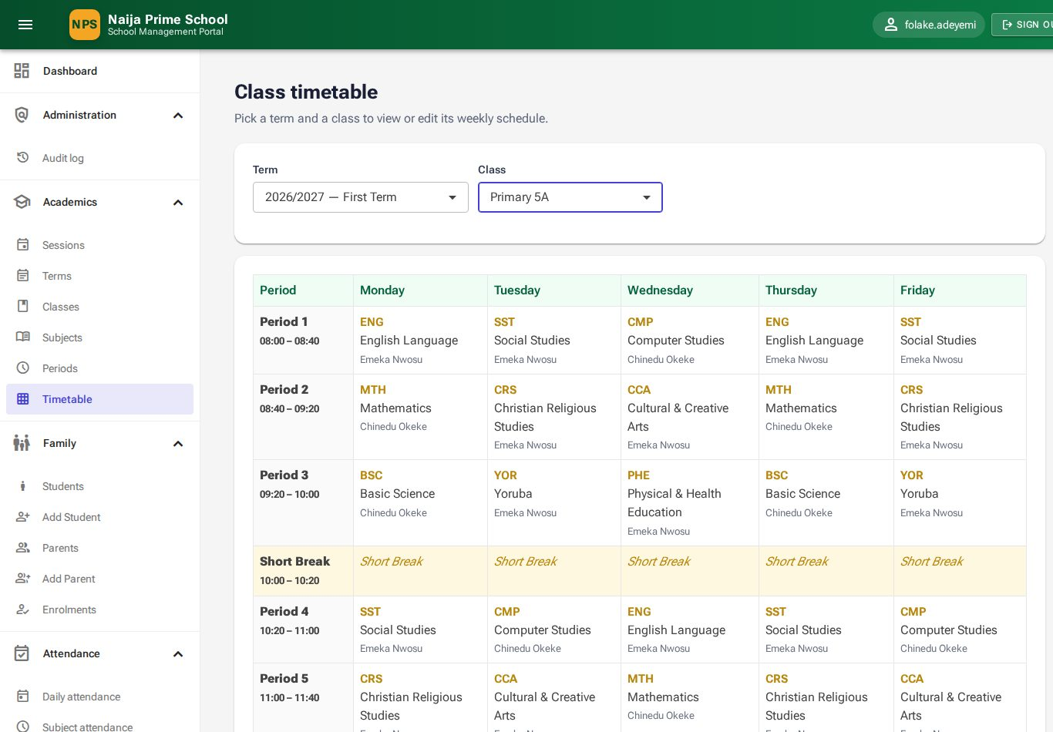
Figure 17: The weekly timetable for Primary 5A
- Click an empty cell ("+ assign") or an existing lesson.
- Choose the Subject, the Teacher, and optionally a Room and notes.
- Click Save. To clear a slot, open it and click Remove.

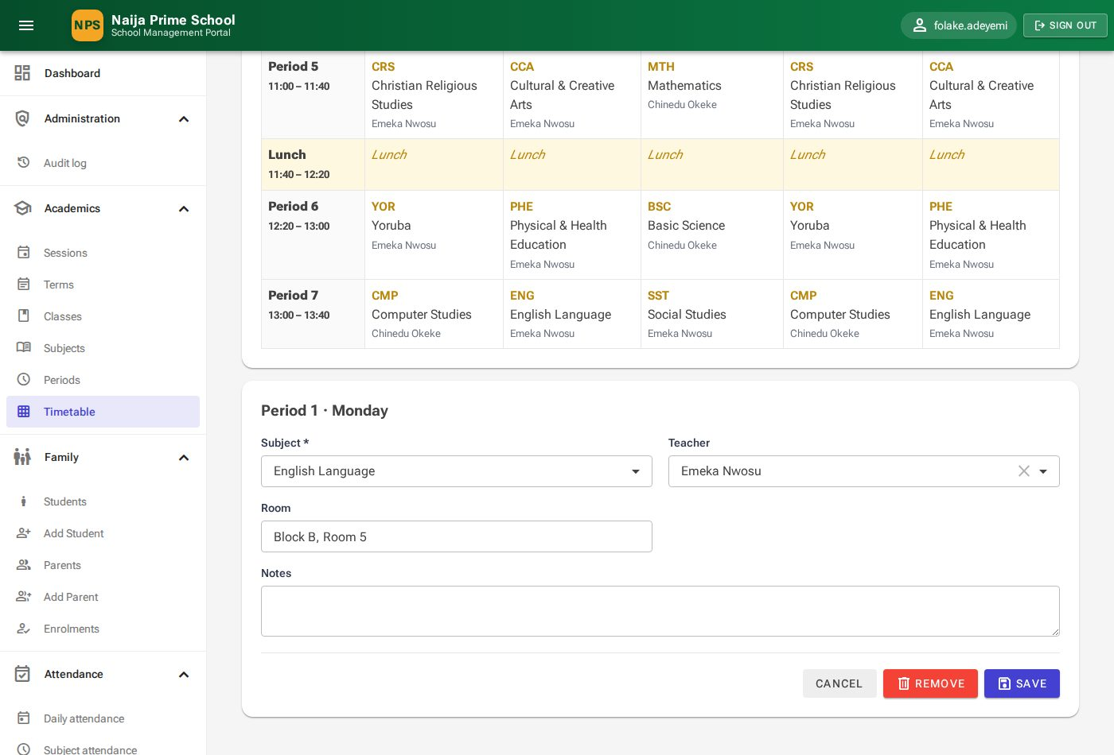
Figure 18: Assigning a lesson to a period
Important: A teacher cannot be timetabled in two classes in the same period. If you try, the portal refuses and names the class the teacher is already teaching.

6. Pupils and parents (HeadTeacher)
Menu: Family. These pages hold every pupil and parent record, how they are linked, and which class each pupil is in.

6.1 The pupils list
Family → Students shows every pupil with photo (or initials), admission number, current class, date of birth, primary contact and status. Use Search (name or admission number), Session, Class and Status to narrow the list.
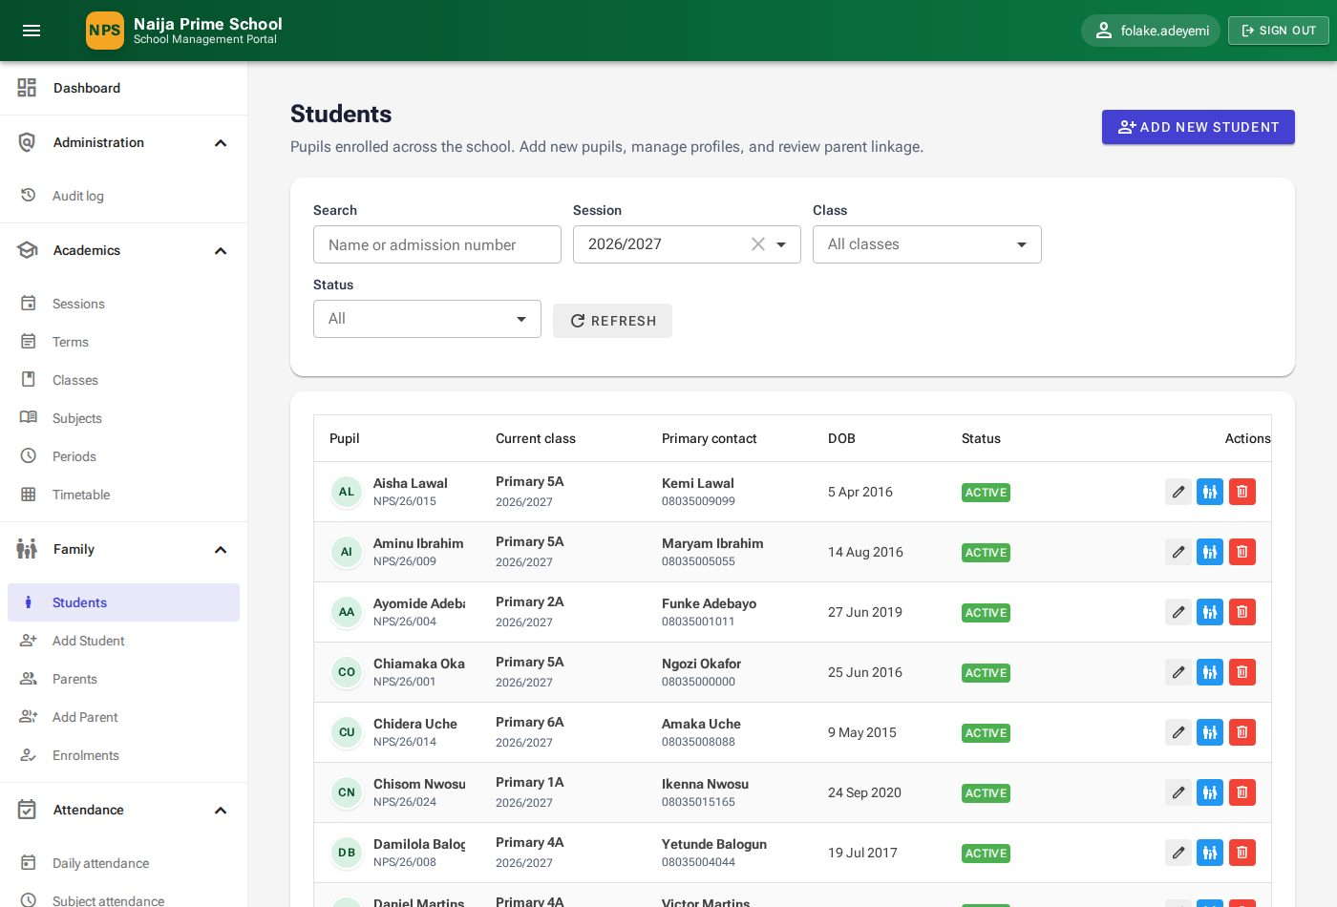
Figure 19: Students

6.2 Admitting a new pupil
- Click Add new student (or Family → Add Student).
- Under Identity enter the Admission number, Admission date, names, Date of birth, gender, blood group, state of origin and address.
- Under Health record any Allergies and Medical notes staff should know about.
- Under Initial enrolment (optional) pick the pupil's Class to enrol them straight away.
- Under Portal sign-in enter a Username, Email and Initial password for the pupil's own portal account.
- Click Save student. The pupil's record opens.

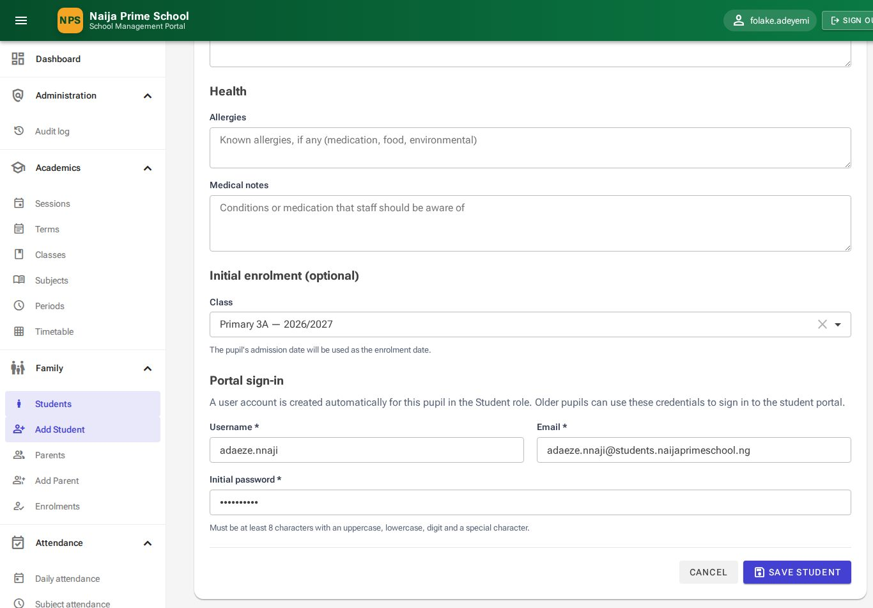
Figure 20: Admitting a pupil (lower half of the form)
Note: Admission numbers must be unique, and the date of birth must be earlier than the admission date. The pupil can sign in to the Student portal immediately with the username and password you set.

6.3 The pupil's record
Open a pupil with the ✏ Edit icon. The record has tabs:
- Profile — edit personal and health details, then Save changes.
- Photo — Choose new photo to upload a JPEG or PNG (up to 2 MB); Remove photo to go back to initials. The photo appears on registers, score sheets and report cards.
- Parents — the parents and guardians linked to the pupil.
- Enrolment history — every class the pupil has been in.
- Reminders — the pupil's email/SMS reminder preferences (see 11.4).

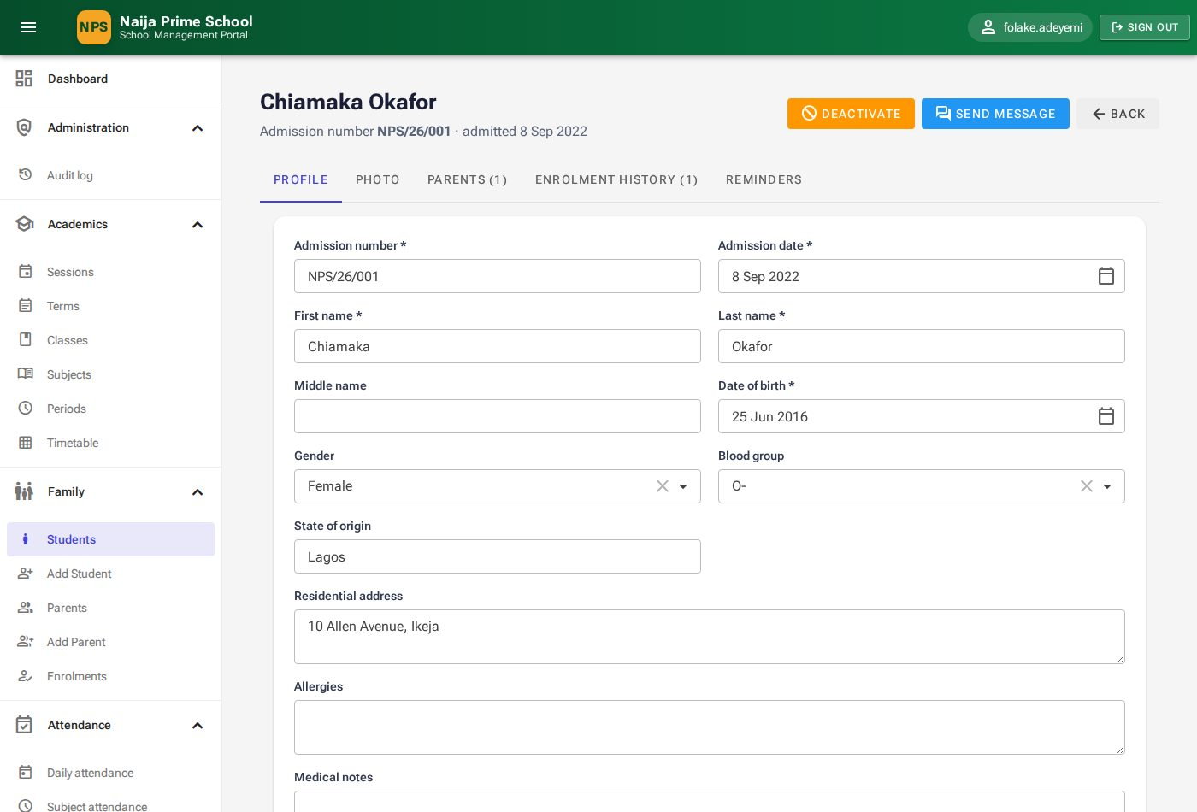
Figure 21: A pupil's record — Profile tab
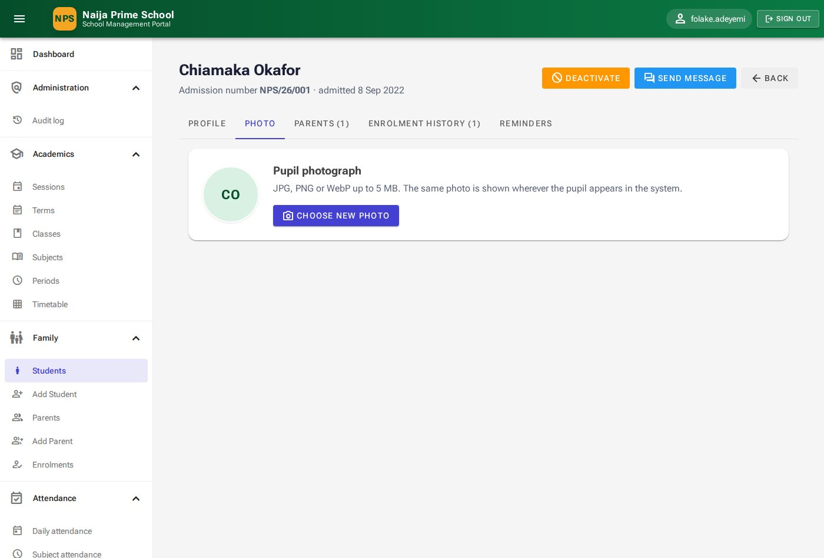
Figure 22: Photo tab
Buttons at the top: Deactivate / Activate (a deactivated pupil also cannot sign in to the portal), Send message (start a private conversation with the pupil, chapter 12) and Back.

6.4 Linking parents and guardians
- On the pupil's Parents tab click Link a parent.
- In Parent start typing the parent's name and pick them. (Register the parent first if they are not in the list — 6.6.)
- Choose the Relationship (Father, Mother, Guardian …).
- Turn on Primary contact for the main contact; leave Authorised to collect on unless this person must not collect the child. Add Notes if needed.
- Click Save link.

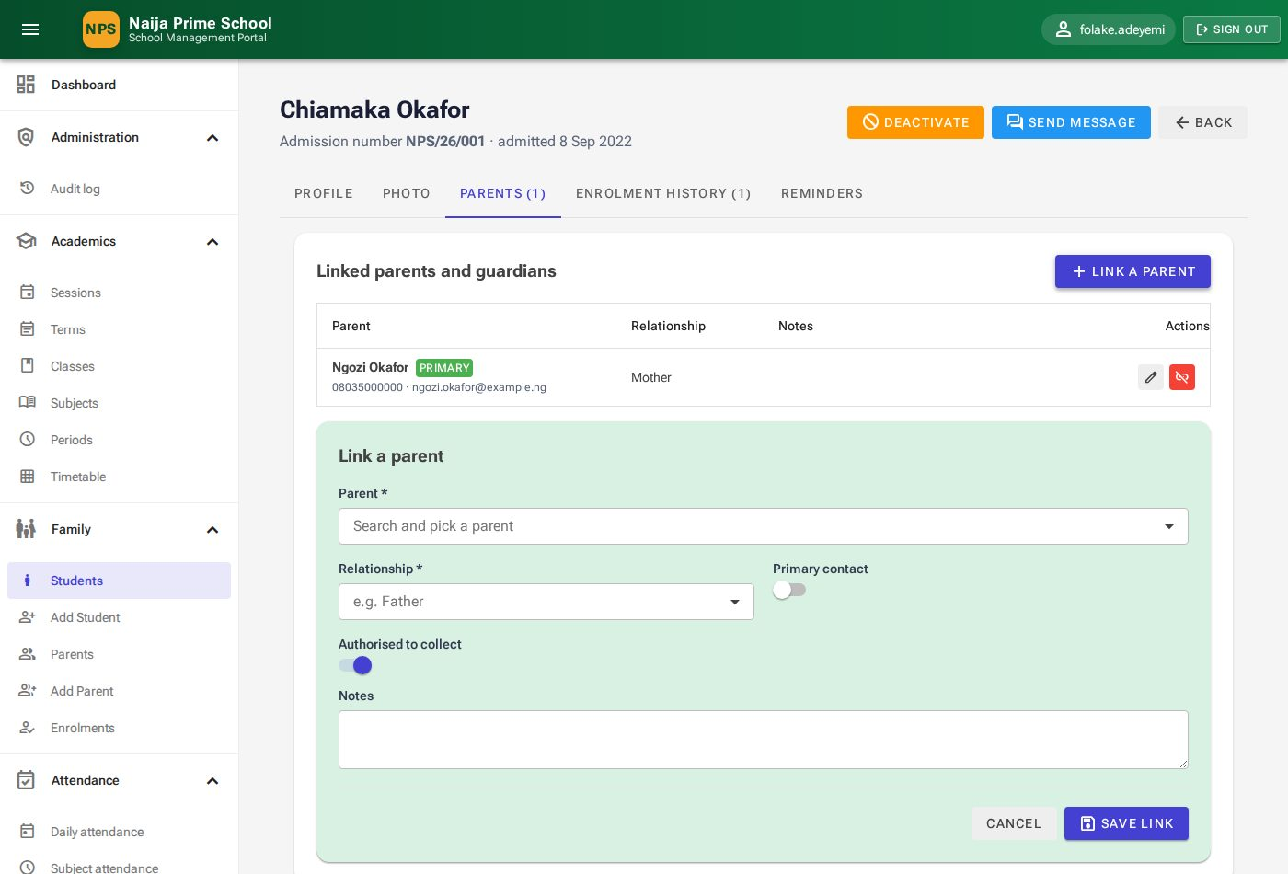
Figure 23: Linking a parent to a pupil
Linked parents show Primary and, if collection is not allowed, Cannot pick up badges. Use ✏ to change a link and the unlink icon to remove it. Once linked, the parent sees the pupil in their portal.
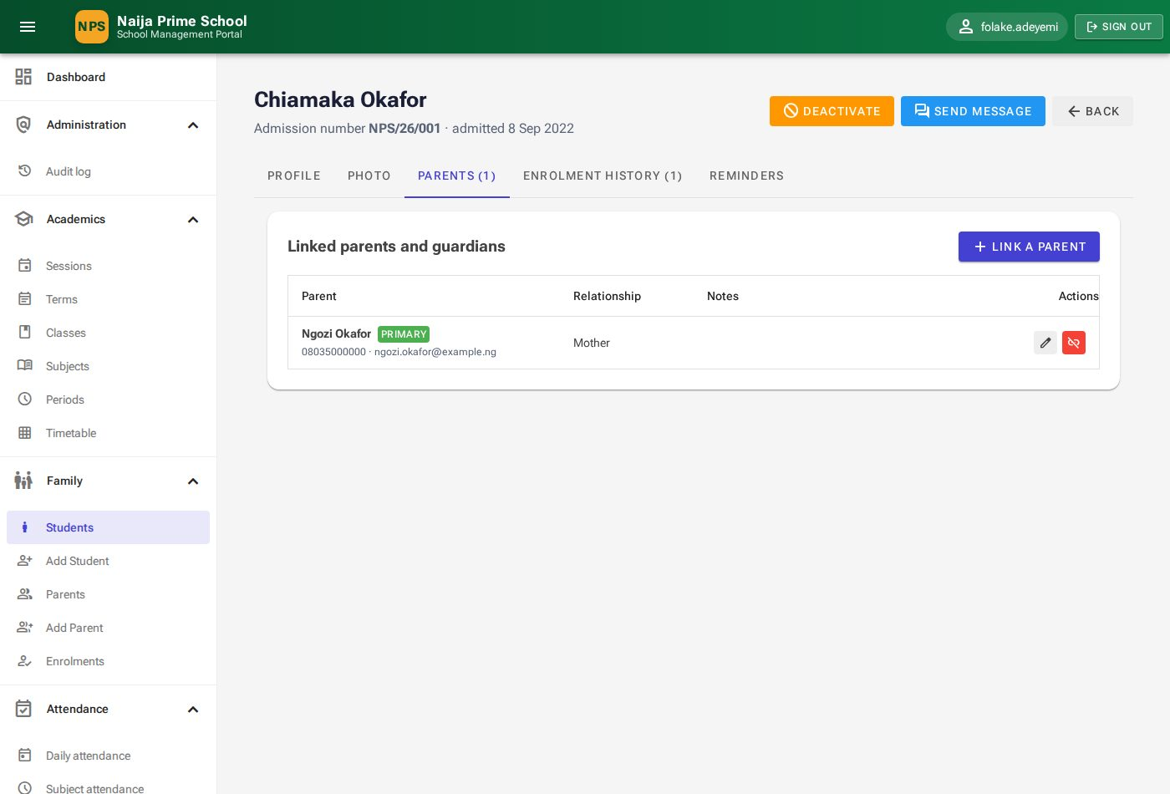
Figure 24: Parents tab

6.5 Enrolments
A pupil has at most one active enrolment per session. On the pupil's Enrolment history tab click New enrolment, choose the Class and Enrolment date, and click Enrol. To move a pupil, first withdraw the current enrolment (🚪 Withdraw), then enrol them in the new class.
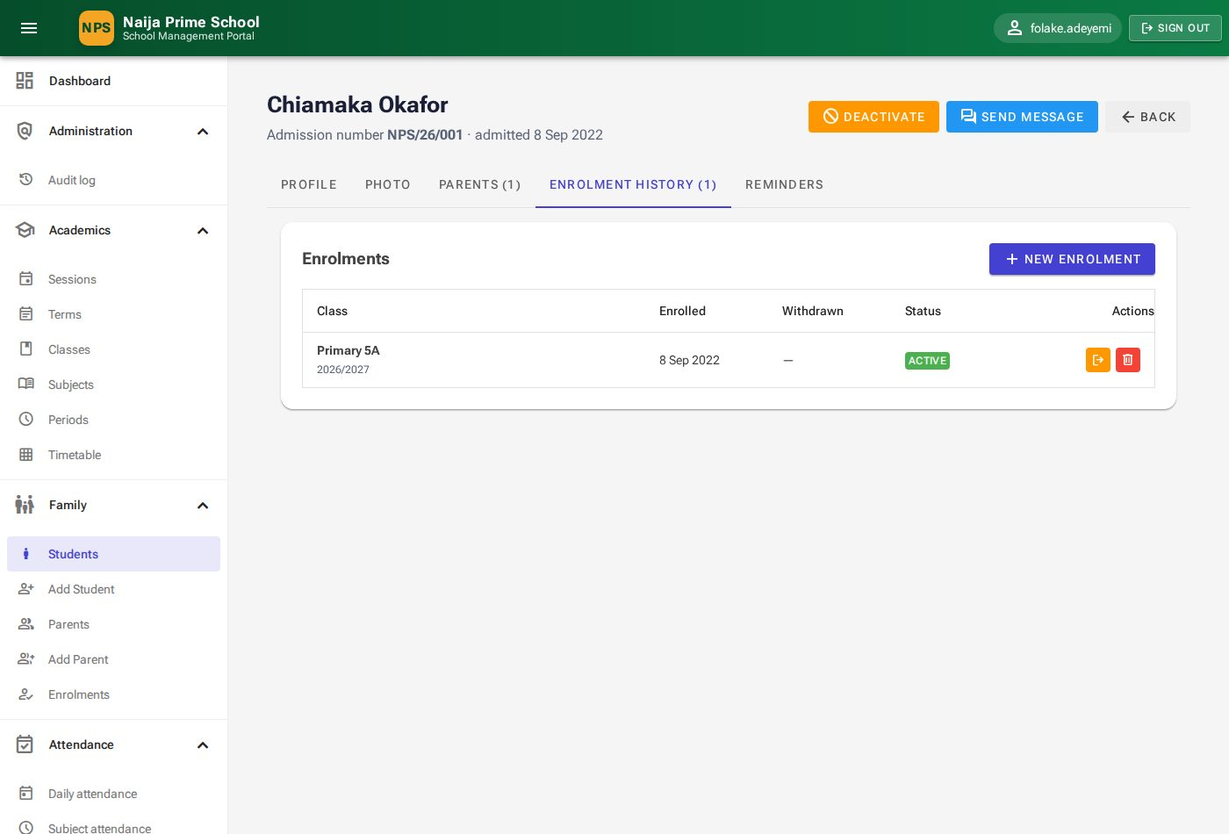
Figure 25: Enrolment history
Family → Enrolments lists all enrolments with filters for session, class and status, and the same Withdraw and delete actions.
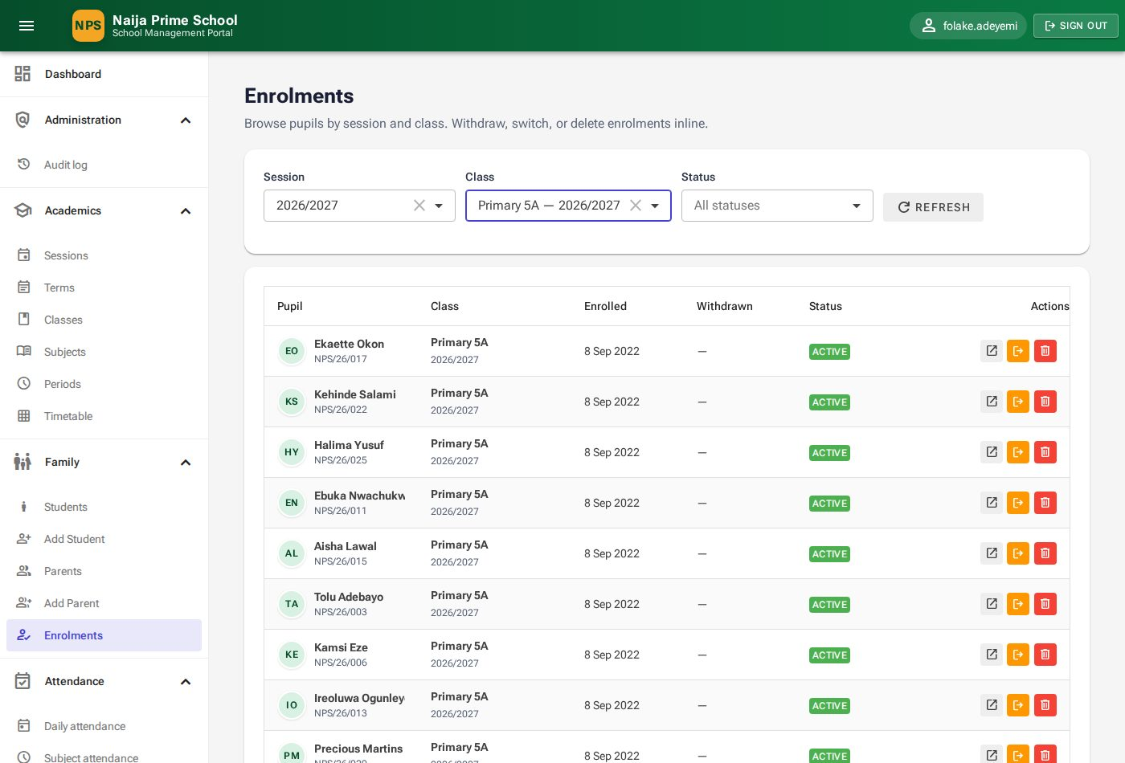
Figure 26: Enrolments register

6.6 Registering a parent
- Click Add new parent (or Family → Add Parent).
- Enter title, names, gender, marital status, phones, Email (required), address, occupation and employer.
- Under Portal sign-in enter a Username and Initial password for the parent.
- Click Save parent, then link the parent to their children (6.4).

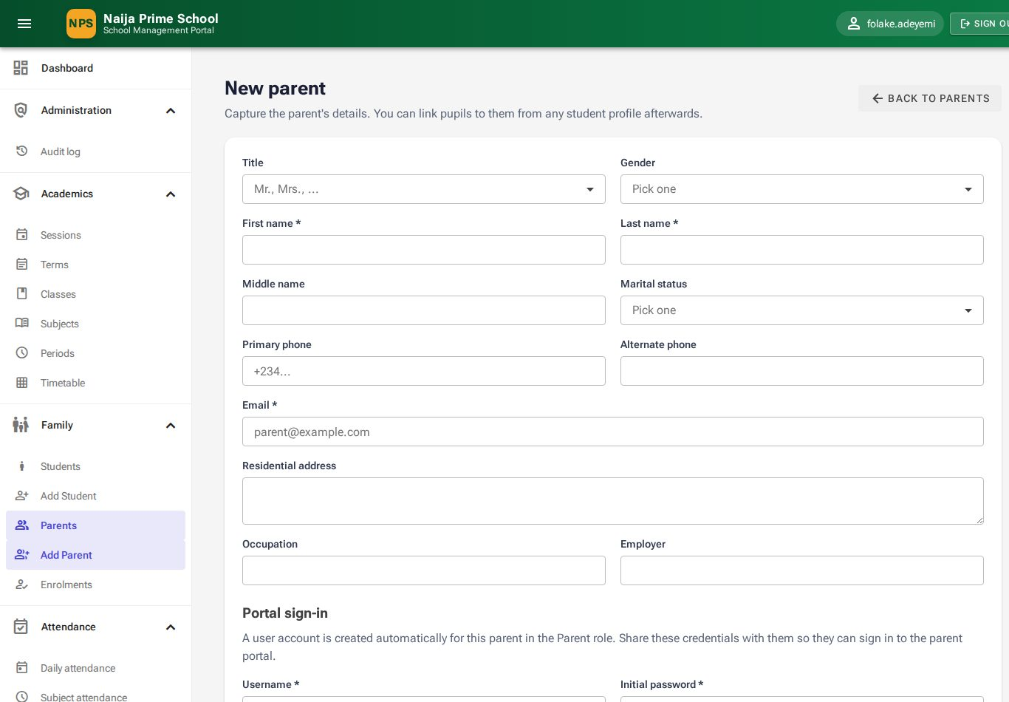
Figure 27: Registering a parent

6.7 The parents list and parent record
Family → Parents lists all parents with contact details, number of pupils and status. Open a parent with ✏ to edit their details, see their linked pupils, set their Reminders, Send message, or Deactivate them (which also blocks their portal sign-in).
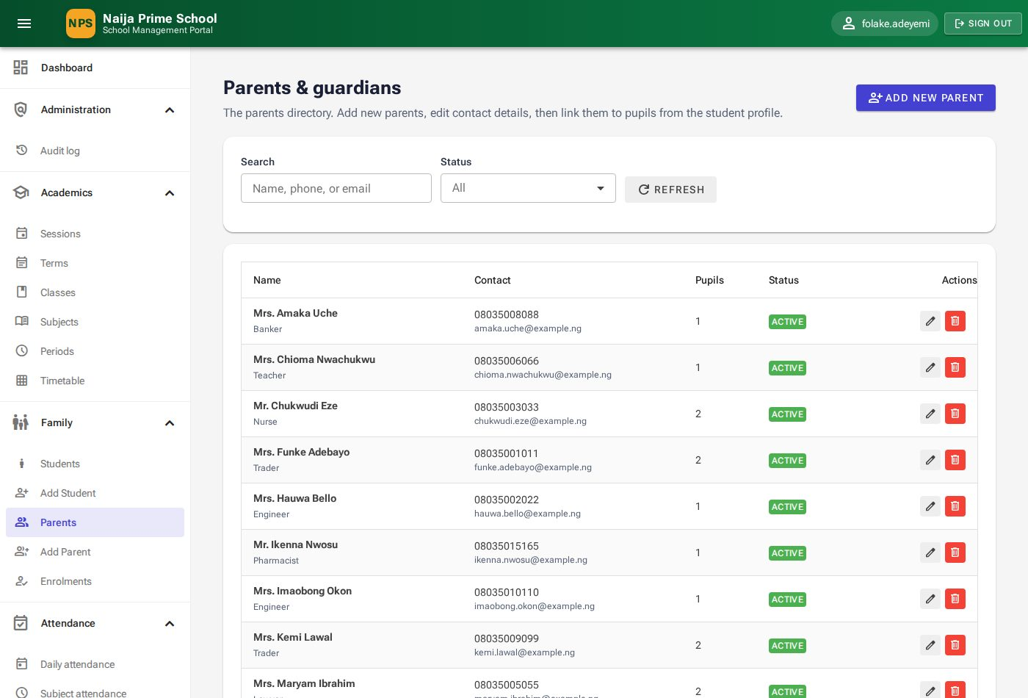
Figure 28: Parents & guardians
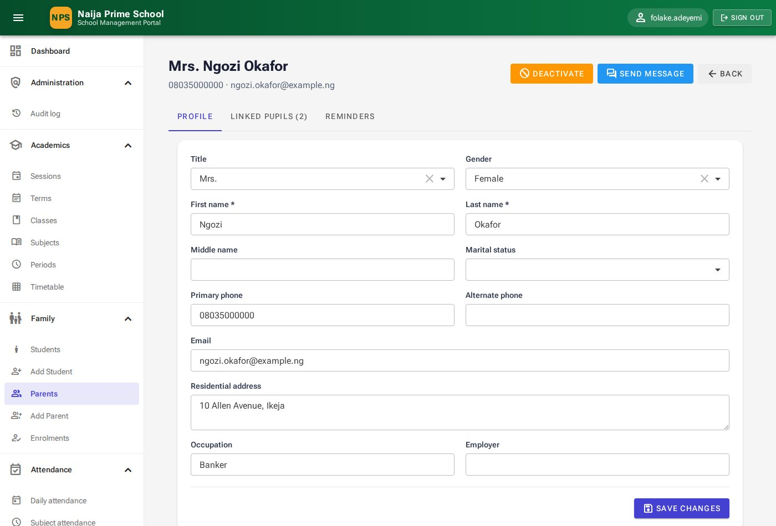
Figure 29: A parent's record
Important: A parent can only be deleted after they have been unlinked from all pupils. Deleting a parent also removes their portal login. Prefer Deactivate when a family leaves the school.

7. Attendance (Teachers)
Menu: Attendance. Teachers, the head teacher and the administrator can take registers.

7.1 Taking the daily register
- Open Attendance → Daily attendance. The current session is selected.
- Choose your Class; the Date is today.
- Click Open register. Every pupil enrolled in the class is listed as Present.
- Change the Status of anyone not present: Late, Excused, Sick, Absent or Suspended. For Late, type the Arrival time (for example 08:25). Add Remarks if useful.
- Click Save changes at any time, and Submit register when you are done.

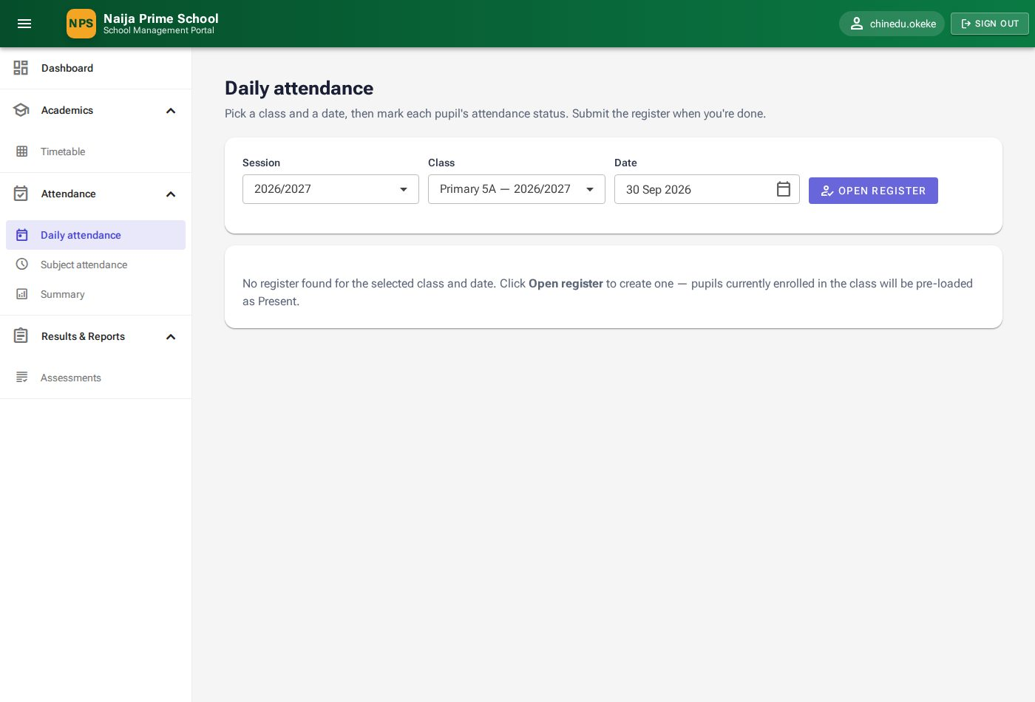
Figure 30: Choosing the class and date
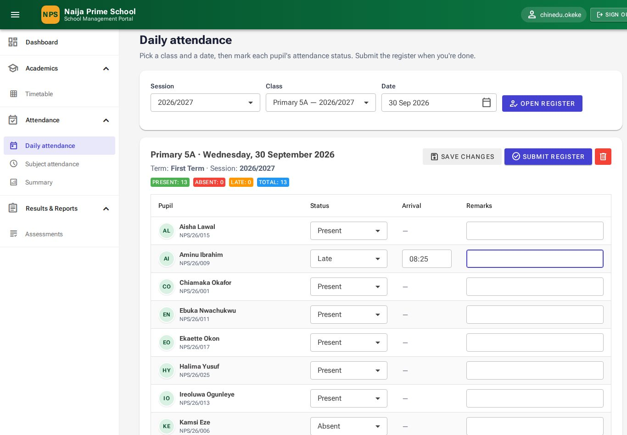
Figure 31: Marking the register
The badges above the list count Present (including late arrivals), Absent (everyone not present), Late and Total. A submitted register is locked; the head teacher can click Reopen to correct it and submit again.
Note: Registers cannot be opened for future dates. To view an earlier day, just change the date — submitted registers open read-only.

7.2 Subject (lesson) attendance
- Open Attendance → Subject attendance.
- Choose the Term, Class and Date. The lessons on the timetable for that day are listed.
- Click Take attendance on a lesson, mark the pupils as for the daily register, and click Submit.

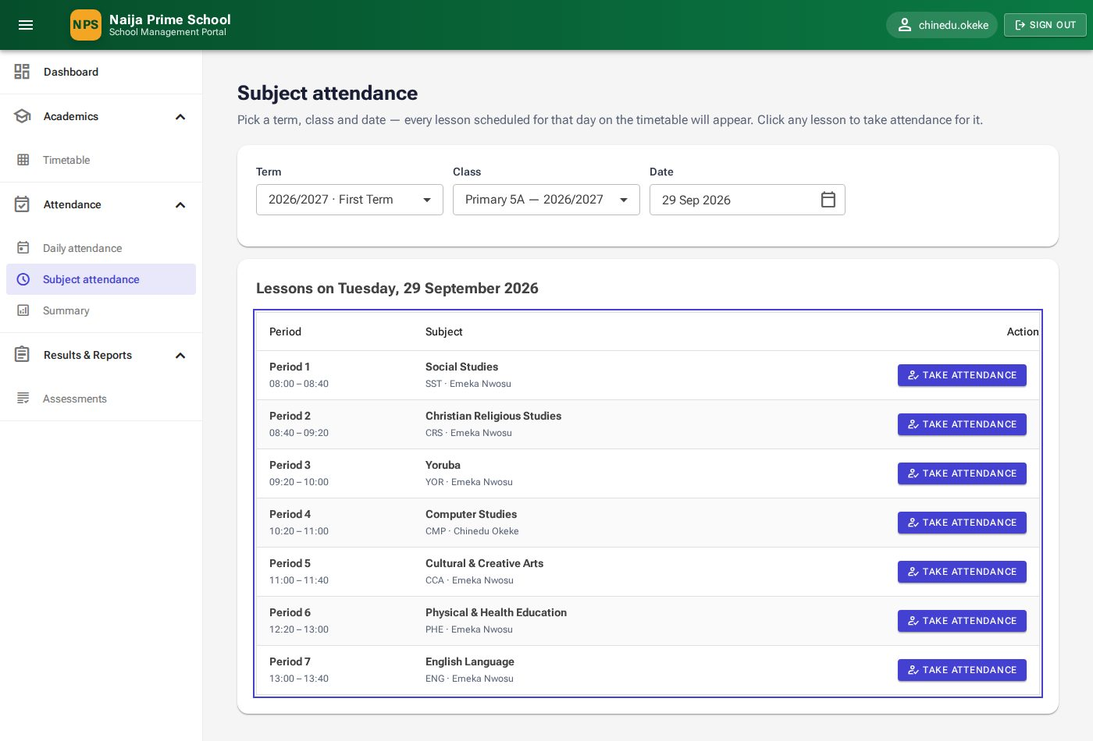
Figure 32: Lessons for the selected day

7.3 Attendance summary
Attendance → Summary shows, per pupil, the days counted, present, late, excused and absent, and the Present rate, for a chosen session, term and class.
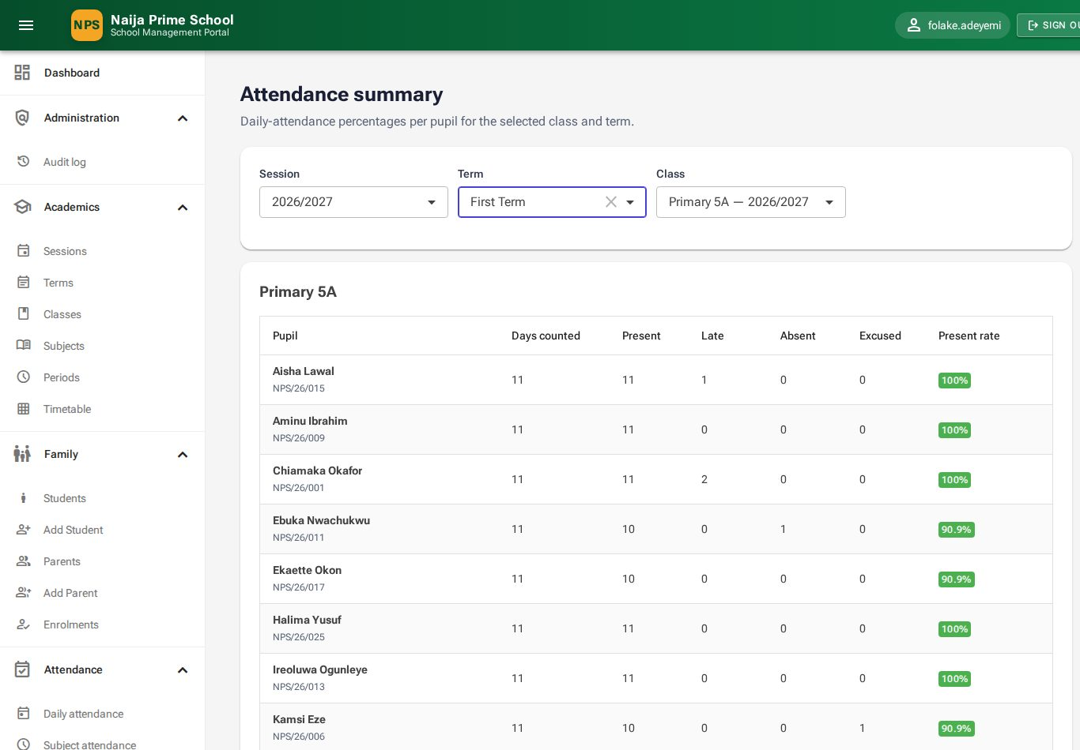
Figure 33: Attendance summary

8. Assessments, results and report cards

8.1 Assessments and scores (Teachers)
Menu: Results & Reports → Assessments. An assessment is one test or exam for a class and subject in a term — for example "First CA", "Second CA" or "Examination".
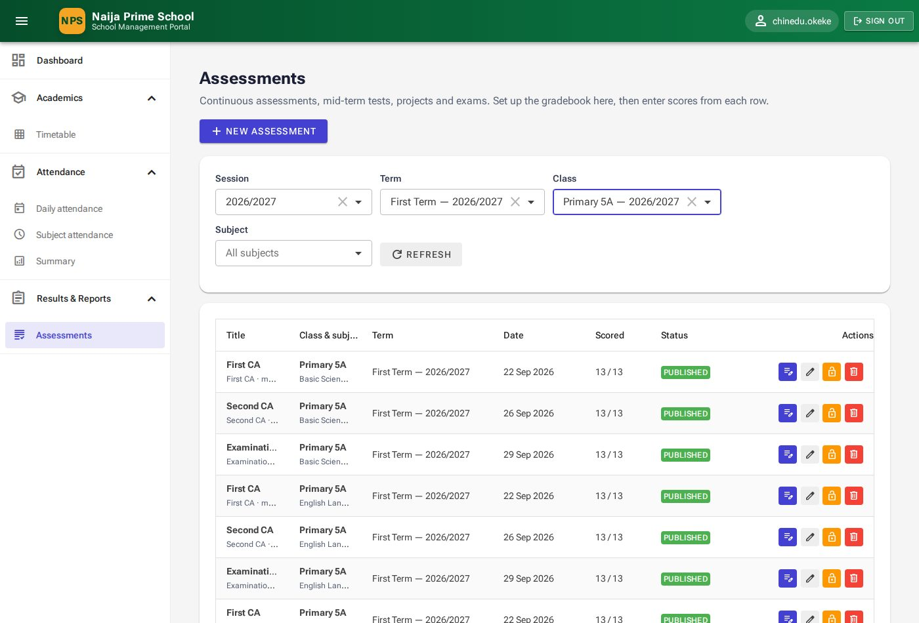
Figure 34: Assessments for Primary 5A

Creating an assessment
- Click New assessment.
- Choose Term, Class, Subject and Type (First CA, Second CA, Mid-Term Test, Assignment, Project, Examination).
- Enter a Title, the Maximum score (for example 20) and the Weight it carries in the final result (for example 20), and optionally the date and notes.
- Click Save. The assessment is created as a Draft.

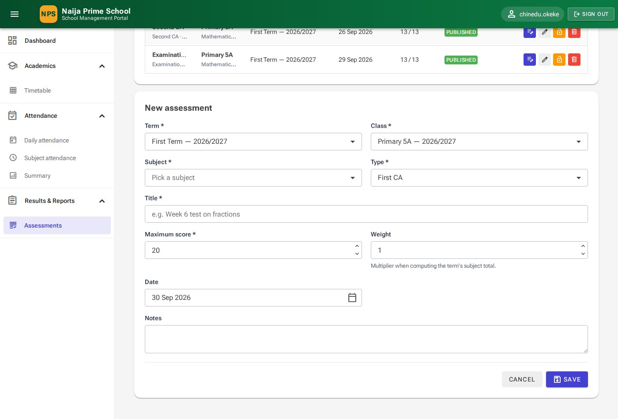
Figure 35: New assessment

Entering scores
- Click the 📝 Enter scores icon on the assessment.
- Type each pupil's Score. Scores cannot exceed the maximum. Tick Absent for pupils who missed it, and add Remarks if needed.
- Click Save scores. You can return and change scores until the assessment is published.
- When all scores are final, click the Publish icon on the assessment. A published score sheet is read-only ("Published — read only"); unpublish it to correct a mistake.

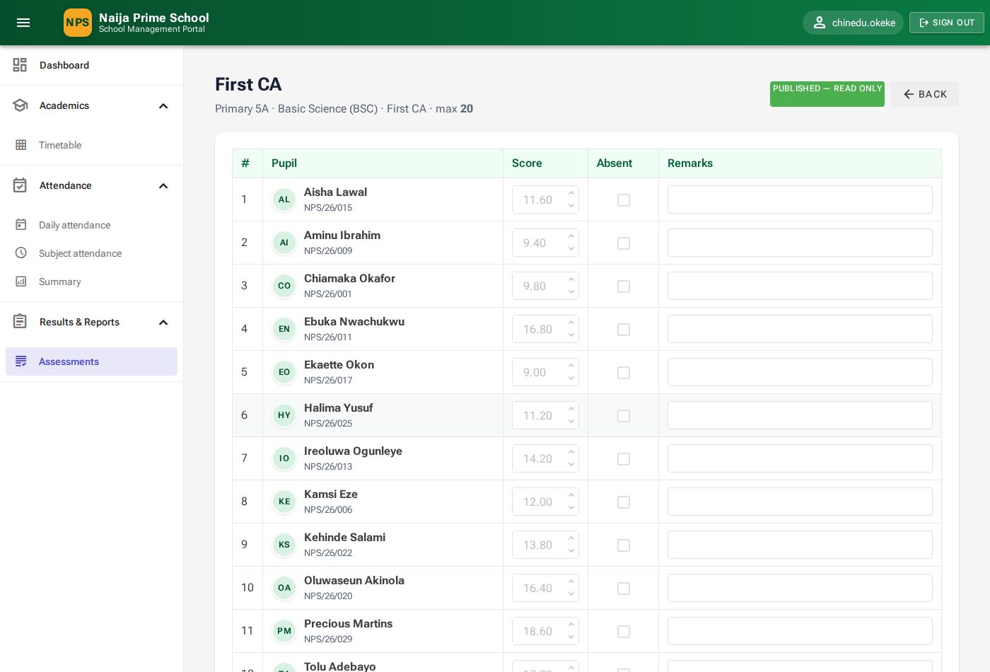
Figure 36: A published score sheet

8.2 Subject results (HeadTeacher)
Results & Reports → Subject results turns published assessments into a result per pupil and subject: weighted total, grade (A–F) and position in class.
- Choose the Term and Class, and optionally one Subject.
- Click Recompute to calculate draft results, or Compute & finalise (then Finalise) to lock them for report cards.

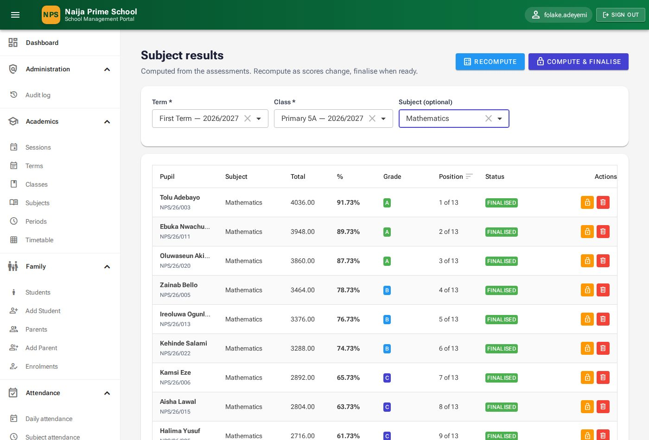
Figure 37: Mathematics results for Primary 5A

8.3 Report cards (HeadTeacher)
Results & Reports → Report cards lists one card per pupil per term with average, position, attendance and status (Draft or Published).
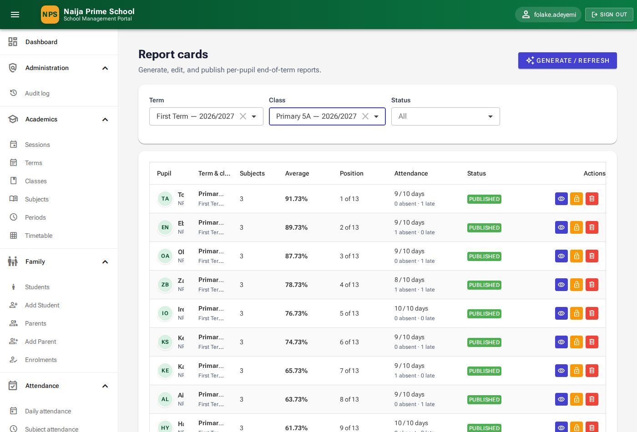
Figure 38: Report cards

Generating report cards
Click Generate / refresh, choose the Term and Class, optionally the date the Next term begins, and click Generate. Cards are created or refreshed with the latest results and attendance; published cards are left unchanged.
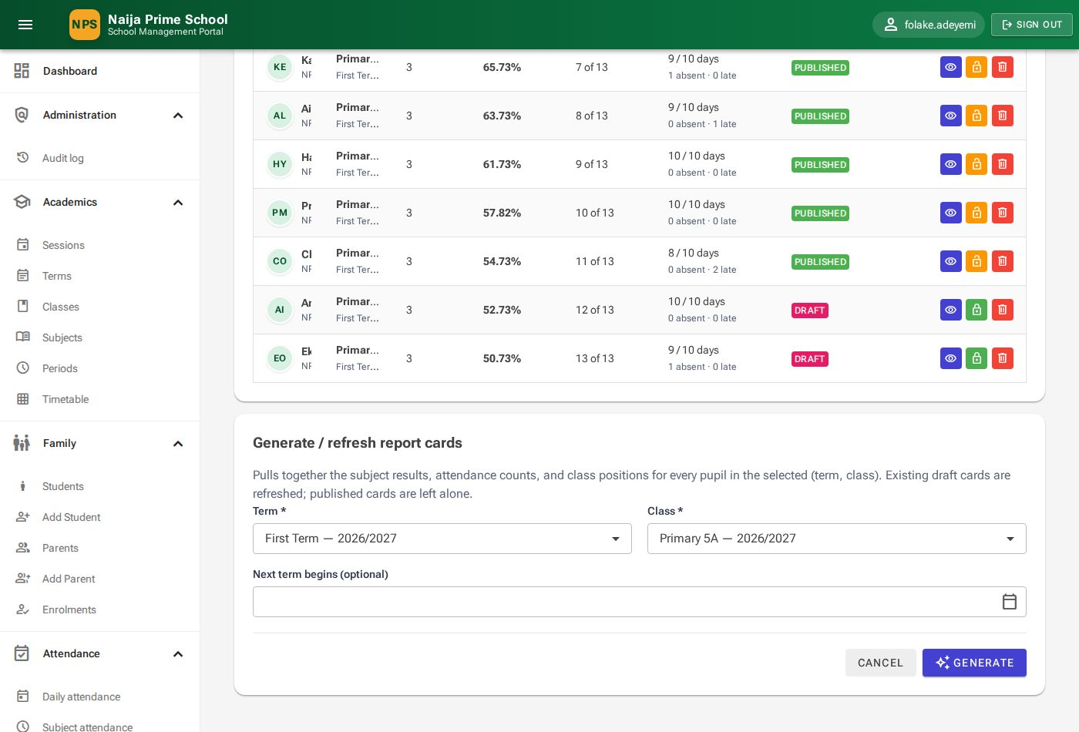
Figure 39: Generating report cards

Completing and publishing a card
- Open a card with the 👁 Open icon. The top shows subjects offered, average, position in class and days present; the Subjects tab lists each subject with grade and remark.
- On Affective traits and Psychomotor skills pick a rating for each item (Excellent to Poor). Ratings save as you choose them.
- On Comments type the Class teacher's comment and Head teacher's comment, set Next term begins, and click Save comments.
- Click Publish and confirm. Parents and the pupil can now see the card in their portals. Use Unpublish to make further changes.

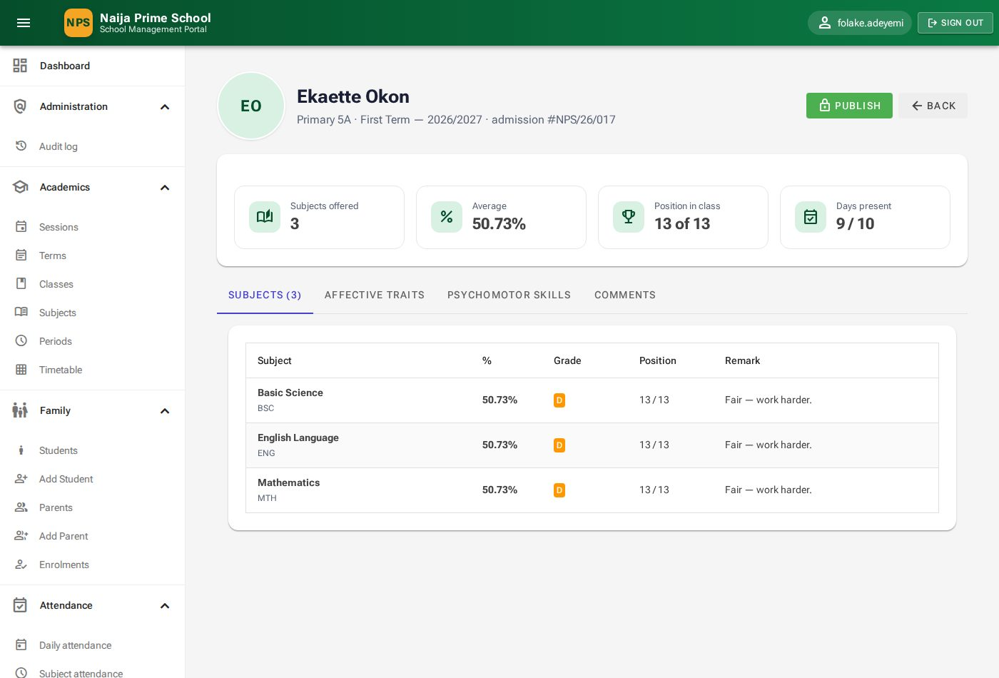
Figure 40: A report card
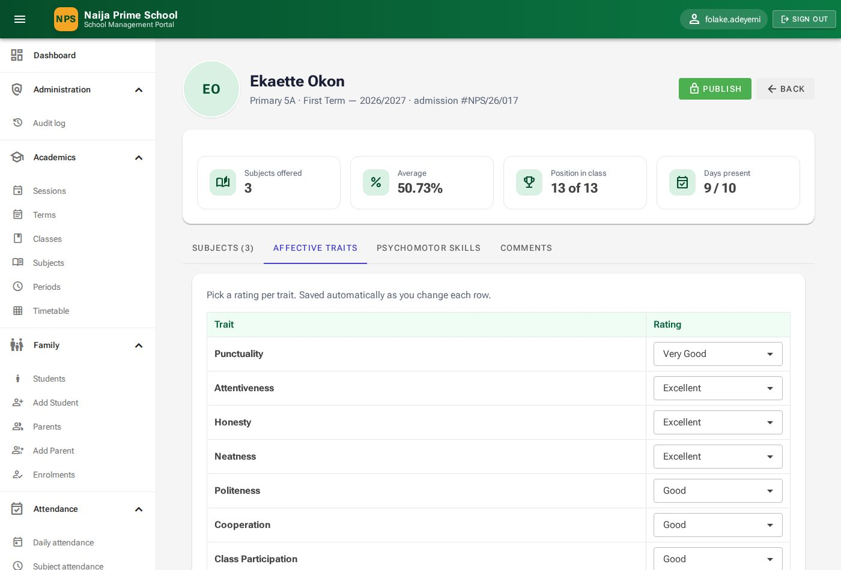
Figure 41: Rating affective traits
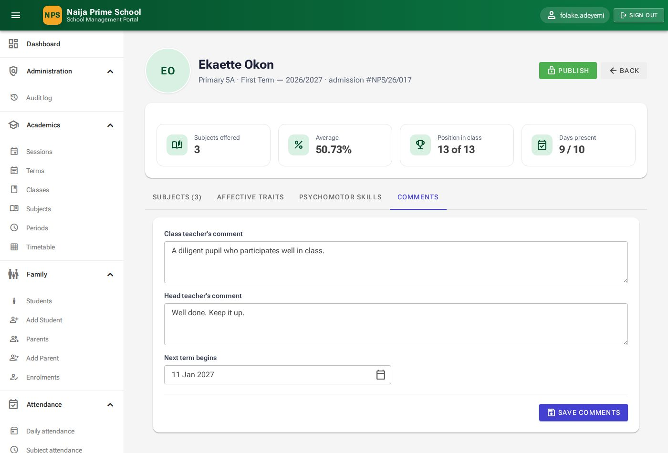
Figure 42: Comments tab

9. Fees and payments (SchoolBursar)
Menu: Finance. Available to the bursar, head teacher and administrator. The normal flow each term is: fee schedule → issue invoices → record payments.

9.1 Bursar dashboard
Finance → Bursar dashboard summarises a term: total invoiced, collected and outstanding, the number of invoices and payments, invoices by status (paid in full, partially paid, unpaid), money collected by method and invoiced by fee category.
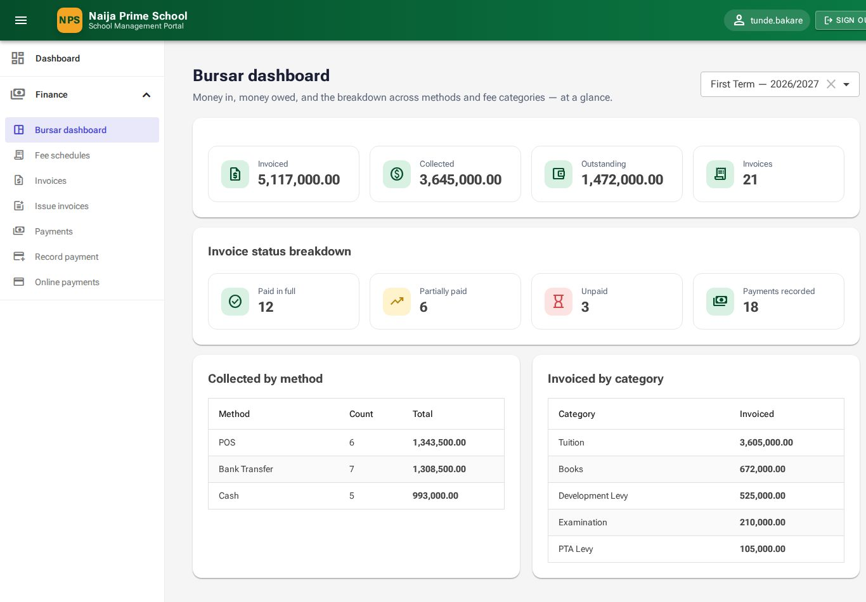
Figure 43: Bursar dashboard

9.2 Fee schedules
A fee schedule is the list of fees for one class level in one term (for example "Primary 5 — First Term fees").
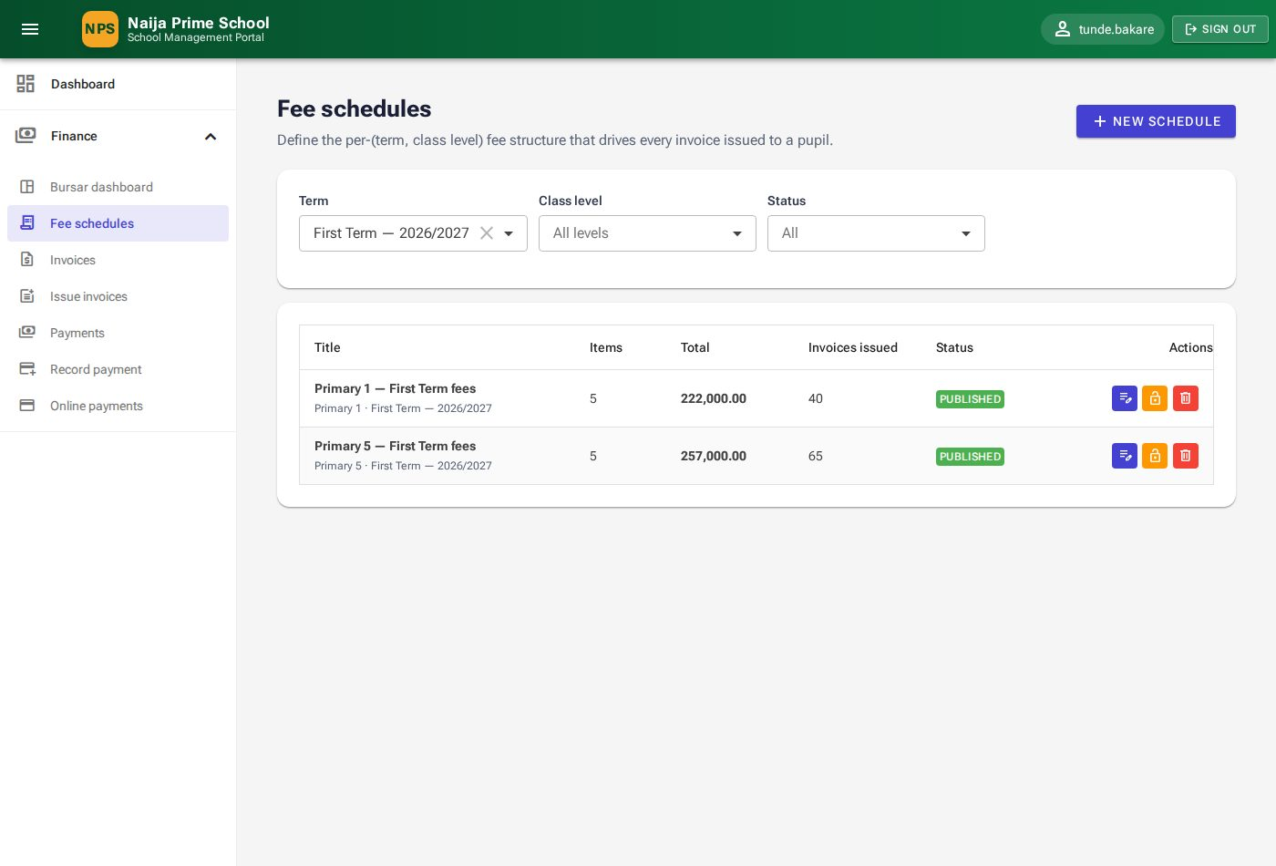
Figure 44: Fee schedules
- Click New schedule, choose the Term and Class level, enter a Title, and click Create schedule.
- On the schedule page click Add item for each fee: Category (Tuition, Development Levy, Examination, Books, Uniforms, Transport, Meals, PTA Levy …), Description, Amount, and whether it is Mandatory. Click Save.
- Check the total in the Line items heading, then click Publish. Only published schedules can be used to issue invoices.

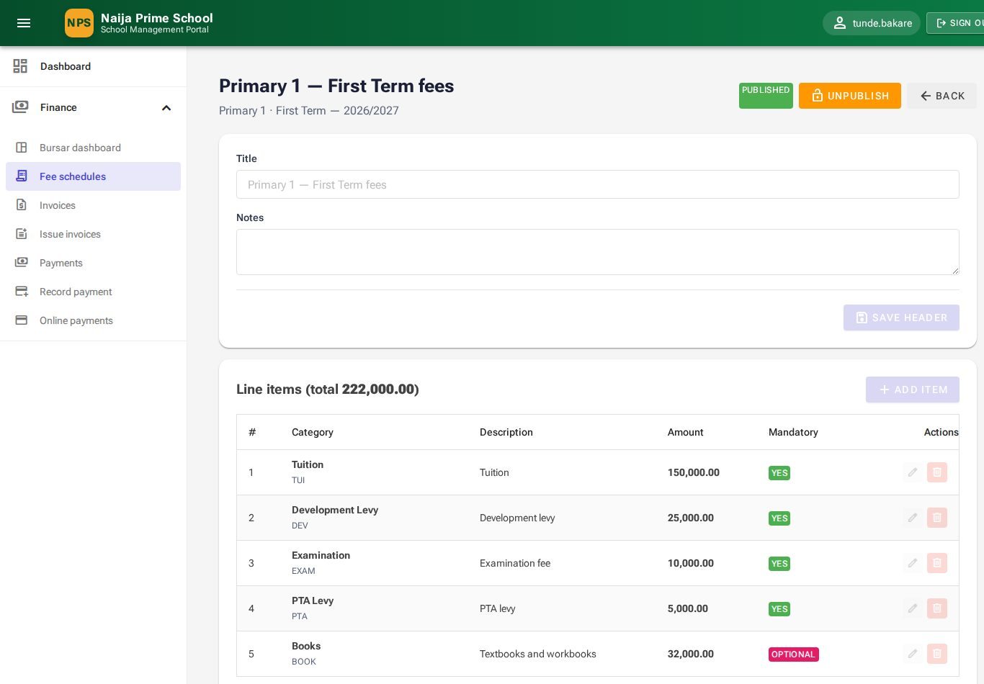
Figure 45: A fee schedule with its line items

9.3 Issuing invoices
- Open Finance → Issue invoices.
- Choose the Term, a published Fee schedule and the Class; set Issued on and an optional Due date.
- Click Issue invoices. One invoice is created for every pupil actively enrolled in the class. Pupils who already have an invoice from this schedule are skipped, so it is safe to run again after new admissions.

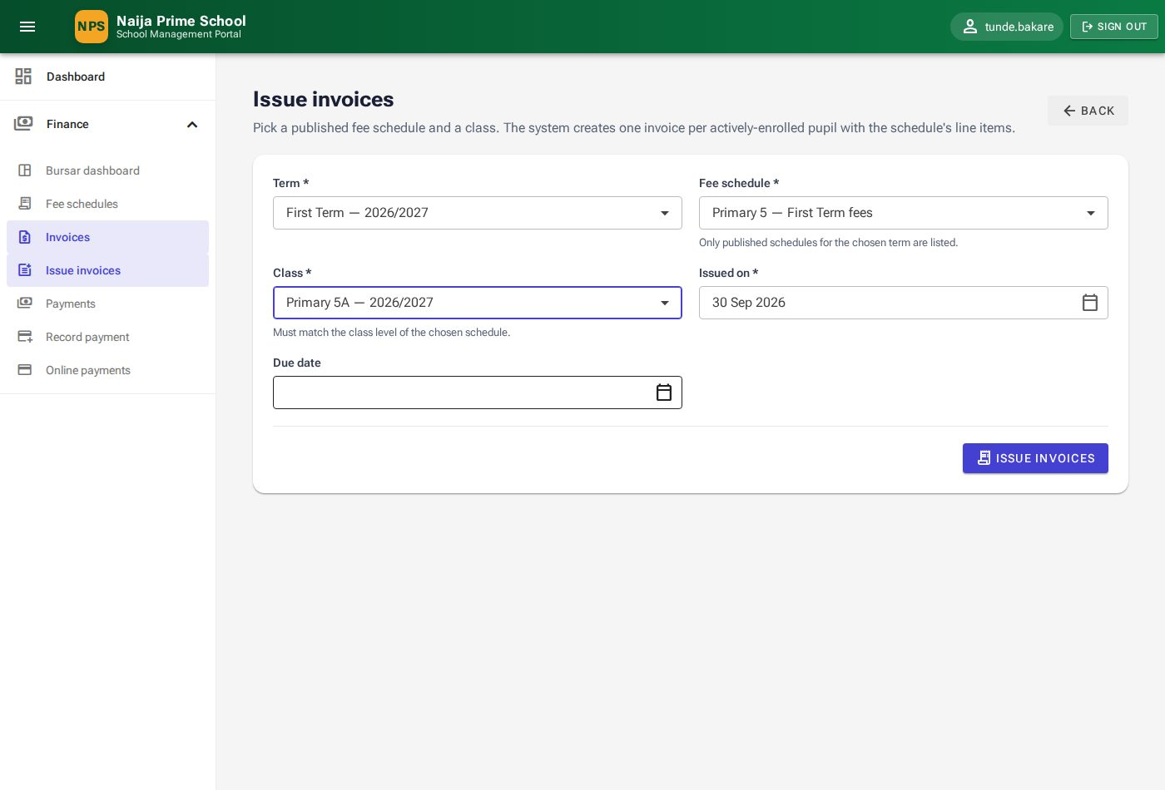
Figure 46: Issuing invoices to a class

9.4 Invoices
Finance → Invoices lists all invoices with total, paid, balance and status (Issued, Partially Paid, Paid, Overdue, Cancelled). Search by invoice number, pupil name or admission number, and filter by term and status.
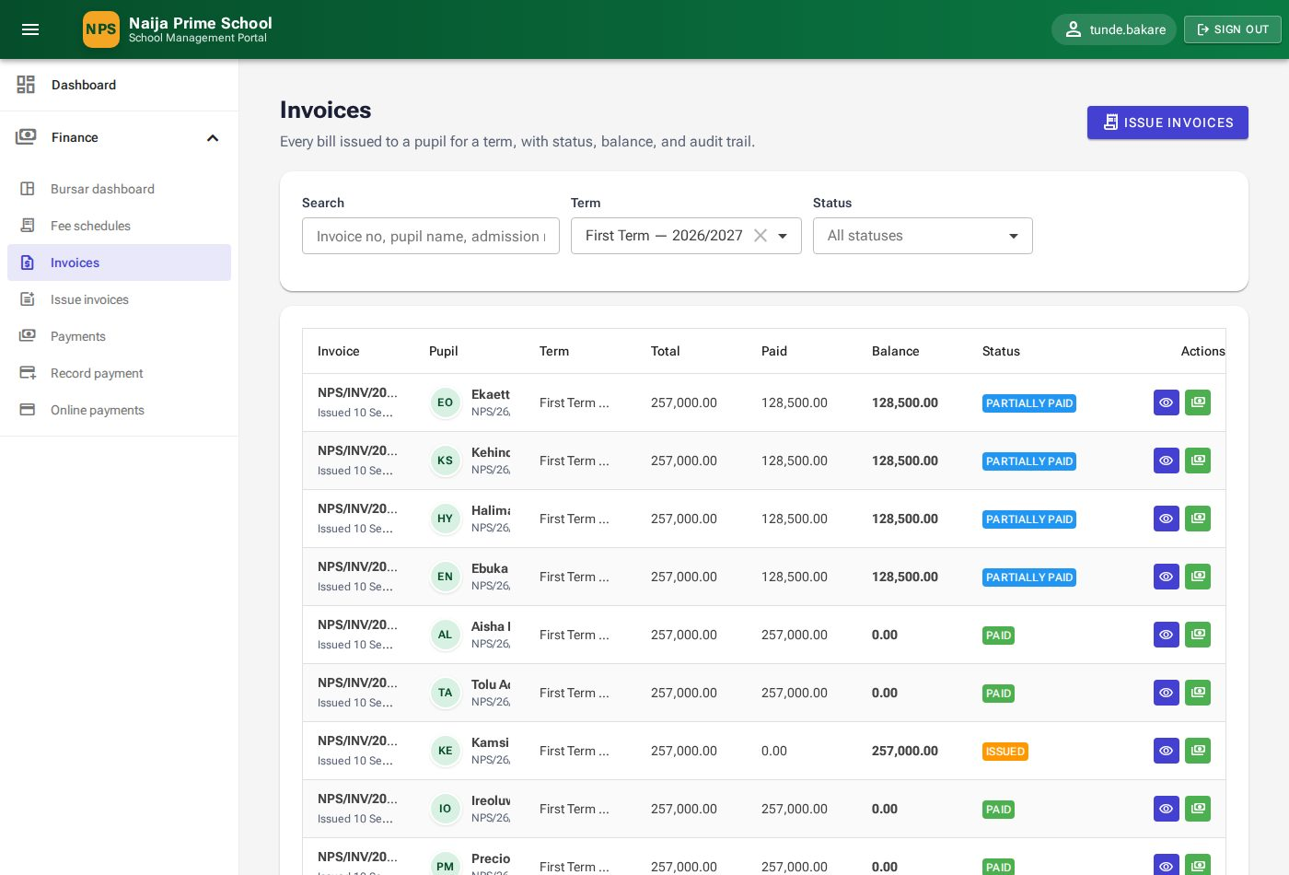
Figure 47: Invoices
Click 👁 View to open an invoice. It shows the subtotal, discount, amount paid and balance, the line items, and the payments applied.
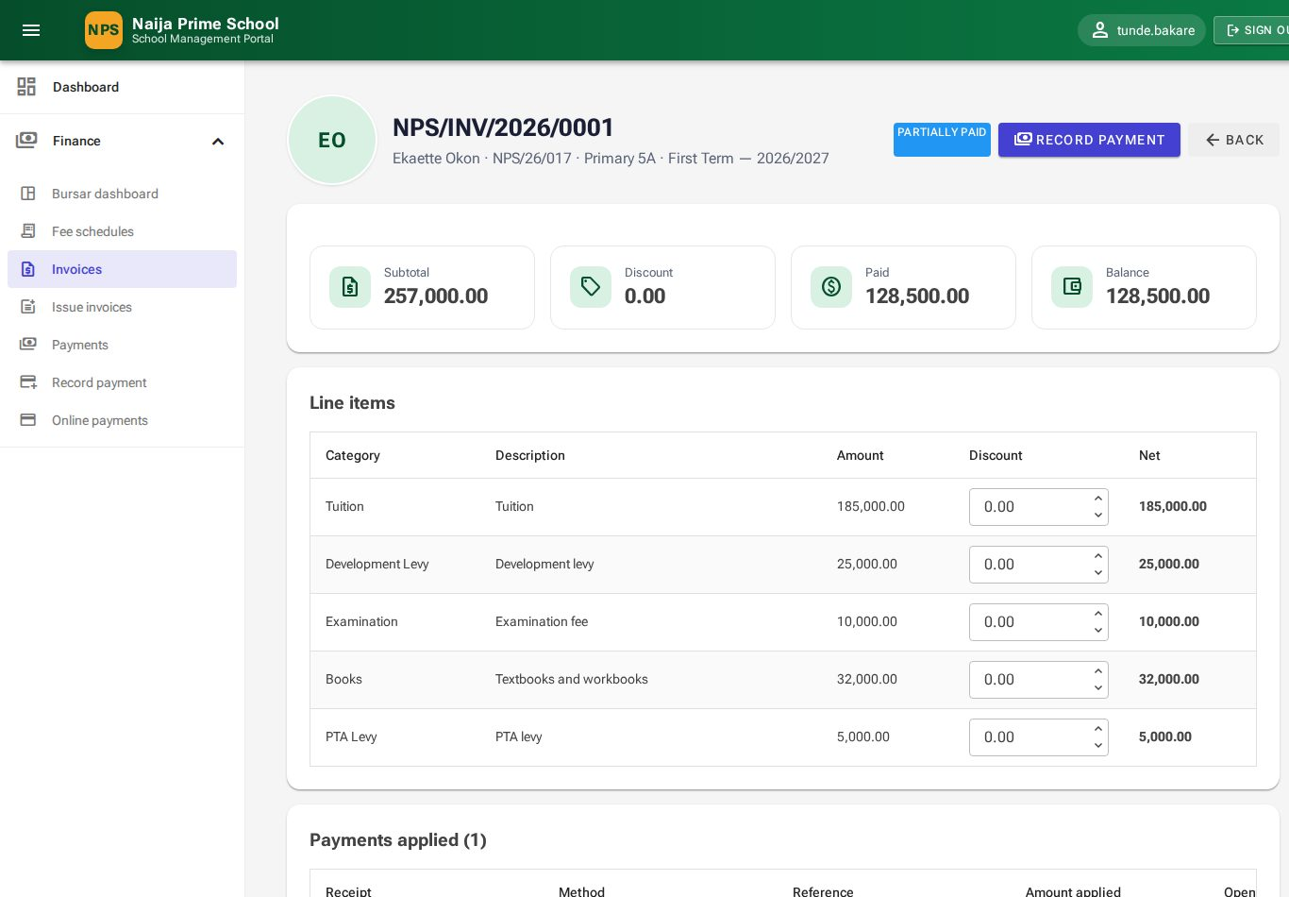
Figure 48: An invoice

Giving a discount
Type a discount against a line (for example a sibling discount on Tuition) and press Tab. The net and balance update at once. A discount cannot exceed the line amount, and it cannot bring the invoice below what has already been paid — refund the payment first if a family has overpaid.

9.5 Recording a payment
- Click Record payment on the invoice (or the 💳 icon on its row, or Finance → Record payment and pick the Pupil).
- Choose the Method (Cash, Bank Transfer, POS, Cheque, Mobile Money), the Payment date, the Amount received and a Reference (bank reference, cheque number).
- Under Outstanding invoices enter how much of the payment goes to each invoice — or click Auto-allocate oldest first. The total allocated cannot exceed the amount received; anything not allocated is kept as credit.
- Click Save payment. The receipt opens with its receipt number (for example NPS/RCP/2026/0019).

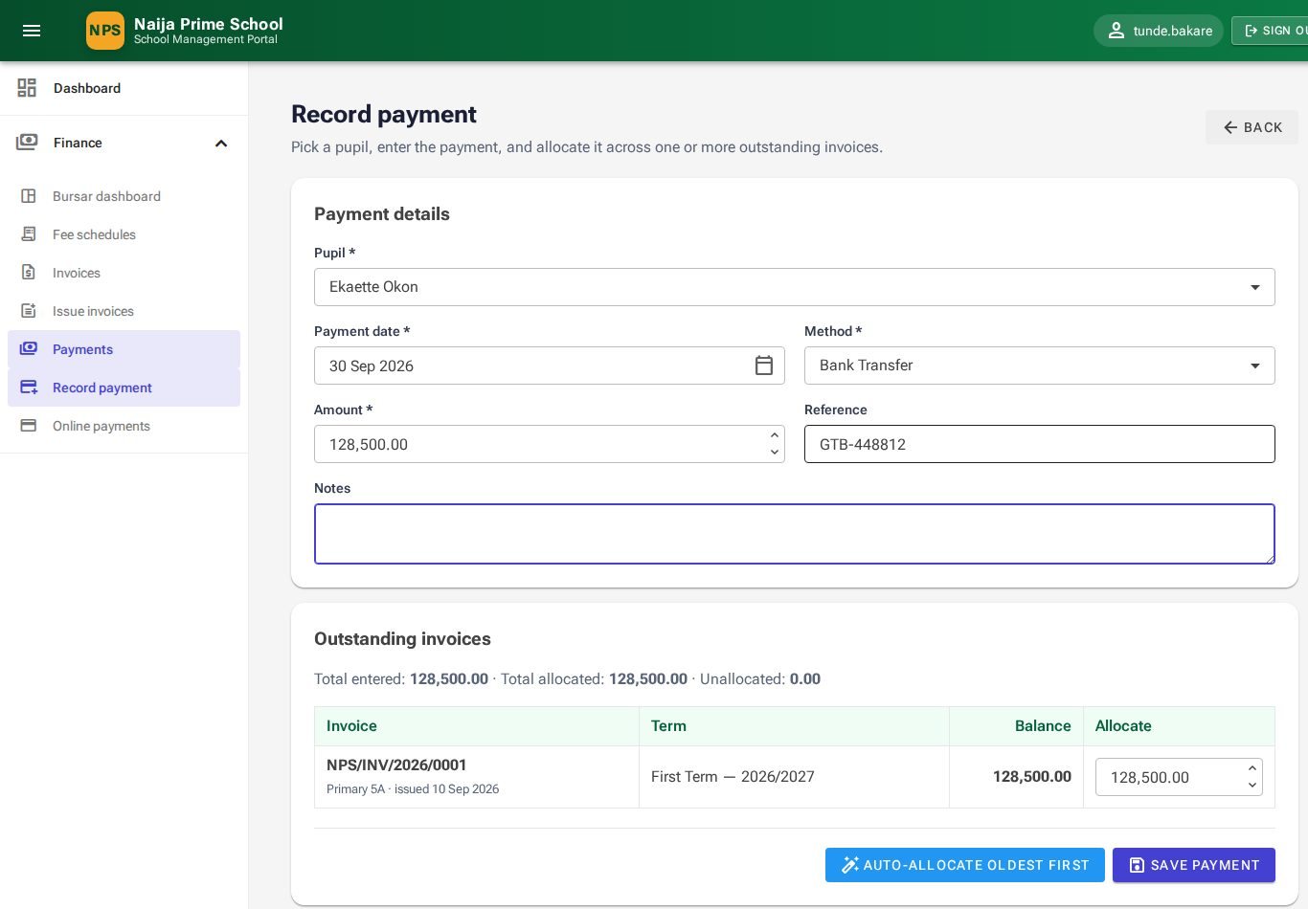
Figure 49: Recording a payment against an invoice

9.6 Payments, receipts and refunds
Finance → Payments lists every receipt with pupil, method, reference, amount and status, with filters for dates, method and status. Click 👁 to open a receipt, which shows the amount, method, reference and the invoices it paid.
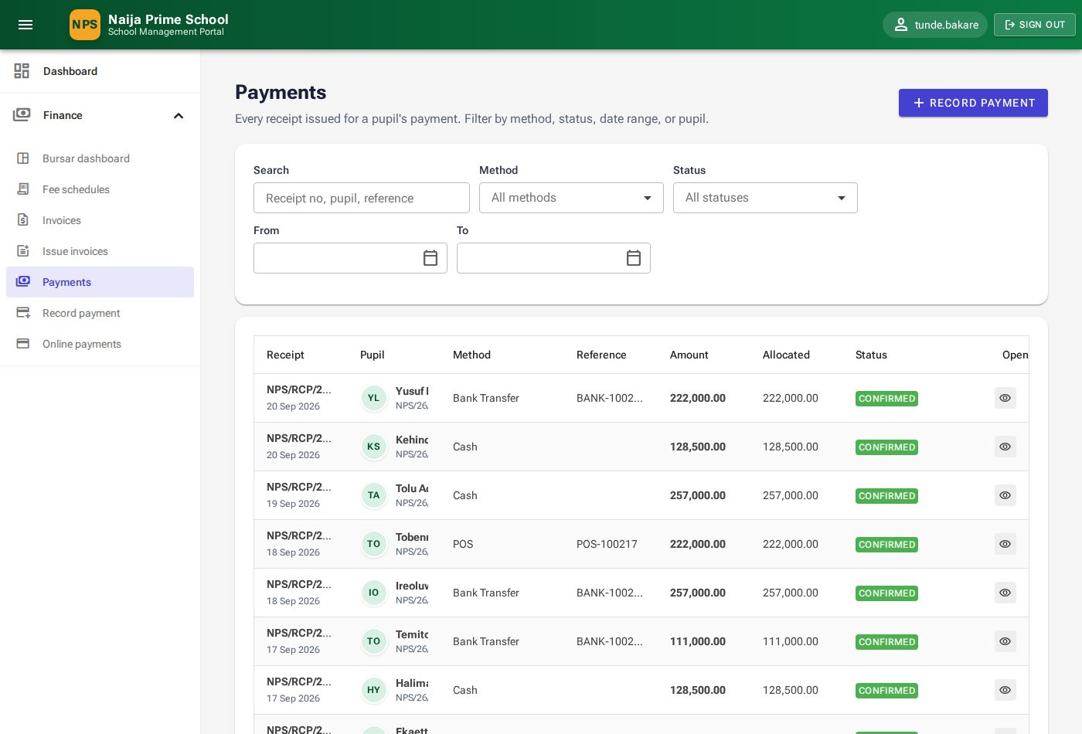
Figure 50: Payments
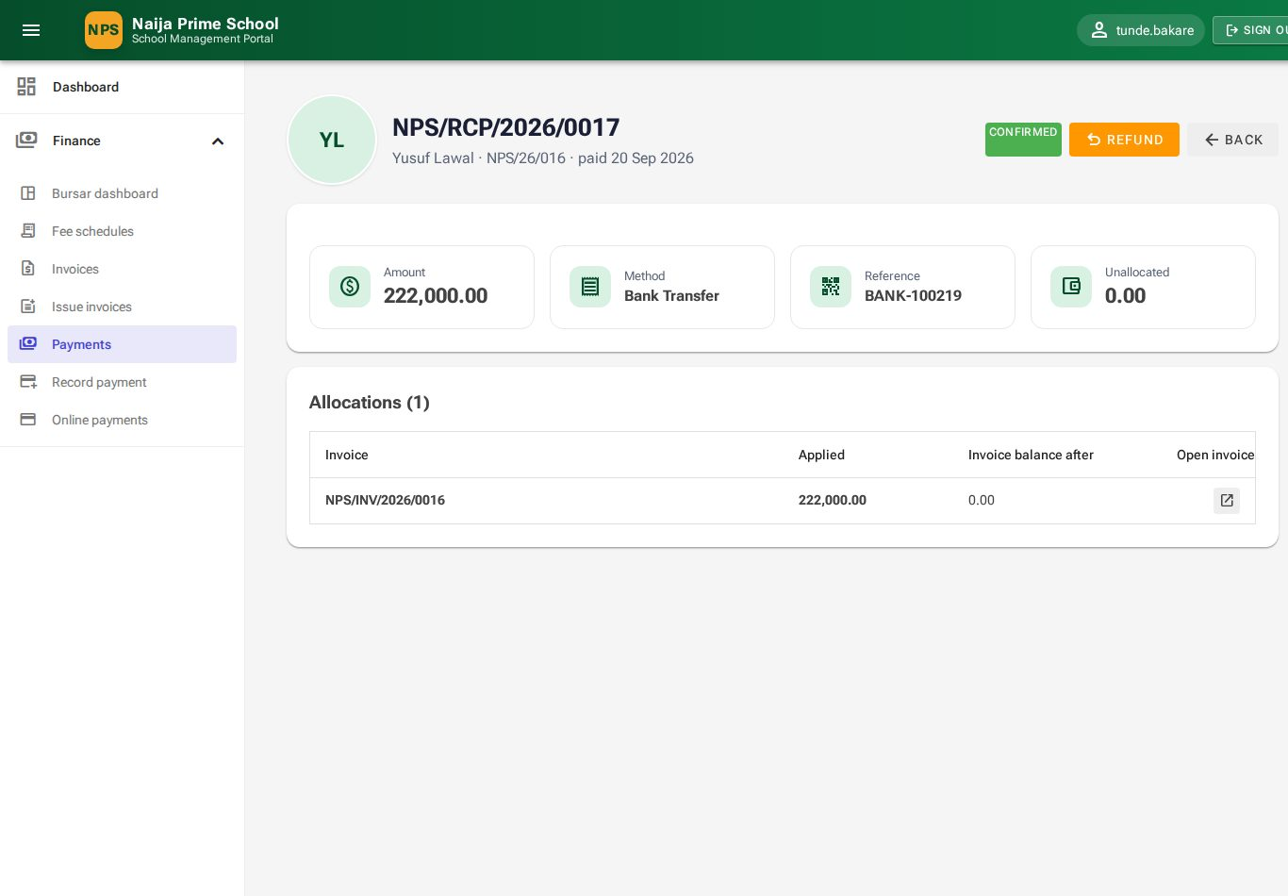
Figure 51: A receipt
Important: To reverse a payment (for example a bounced cheque or money returned to a parent), open the receipt, click Refund and confirm. The receipt is kept, marked Refunded, and the invoice balance goes back up by the refunded amount.

9.7 Online payments
Parents and pupils can pay invoices online by card, bank transfer or USSD through Paystack (chapter 14.5). A payment is recorded as a normal receipt with method Online Payment only after Paystack confirms it. Finance → Online payments lists every attempt:
- Succeeded — paid; links to the receipt.
- Pending / Abandoned — not yet confirmed; click 🔄 to check with Paystack now.
- Failed — no money was taken.
- Needs review — money arrived but something did not match (for example the amount); reconcile it and record the payment by hand with the Paystack reference.

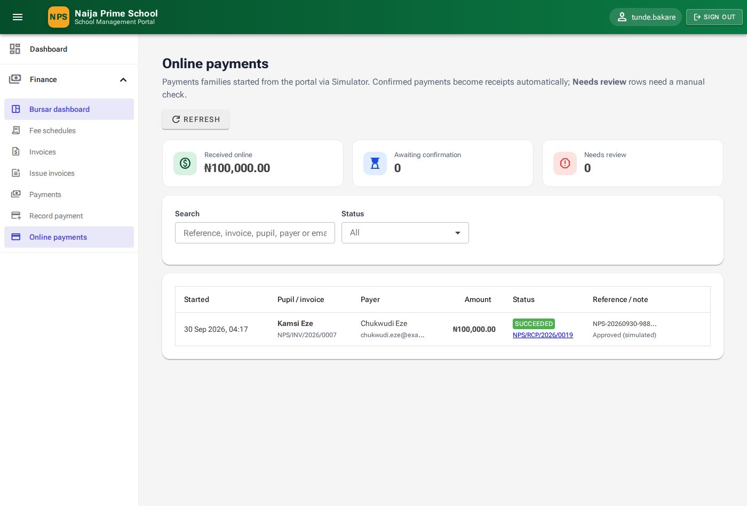
Figure 52: Online payments

10. Store and inventory (SchoolStoreKeeper)
Menu: Store & Inventory. Available to the storekeeper, head teacher and administrator.

10.1 Store dashboard
The dashboard shows how many items are in the catalogue, how many are below their reorder level, the total stock value, this month's movements in and out, a Low stock — needs replenishing list, stock value by category and recent movements.
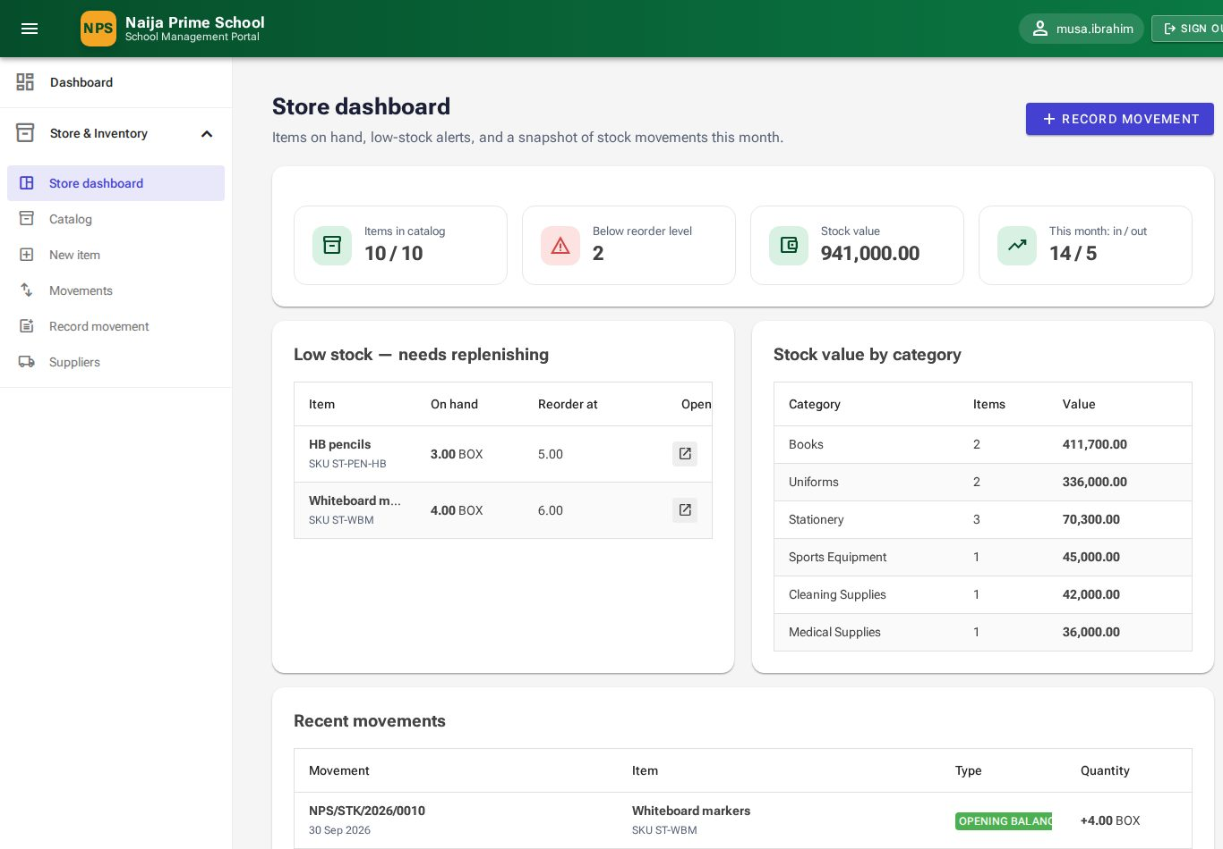
Figure 53: Store dashboard

10.2 The catalogue
Store & Inventory → Catalog lists every item with category, quantity on hand, reorder level, last cost and status. Items at or below their reorder level show a Low badge; turn on Low stock only to see just those.
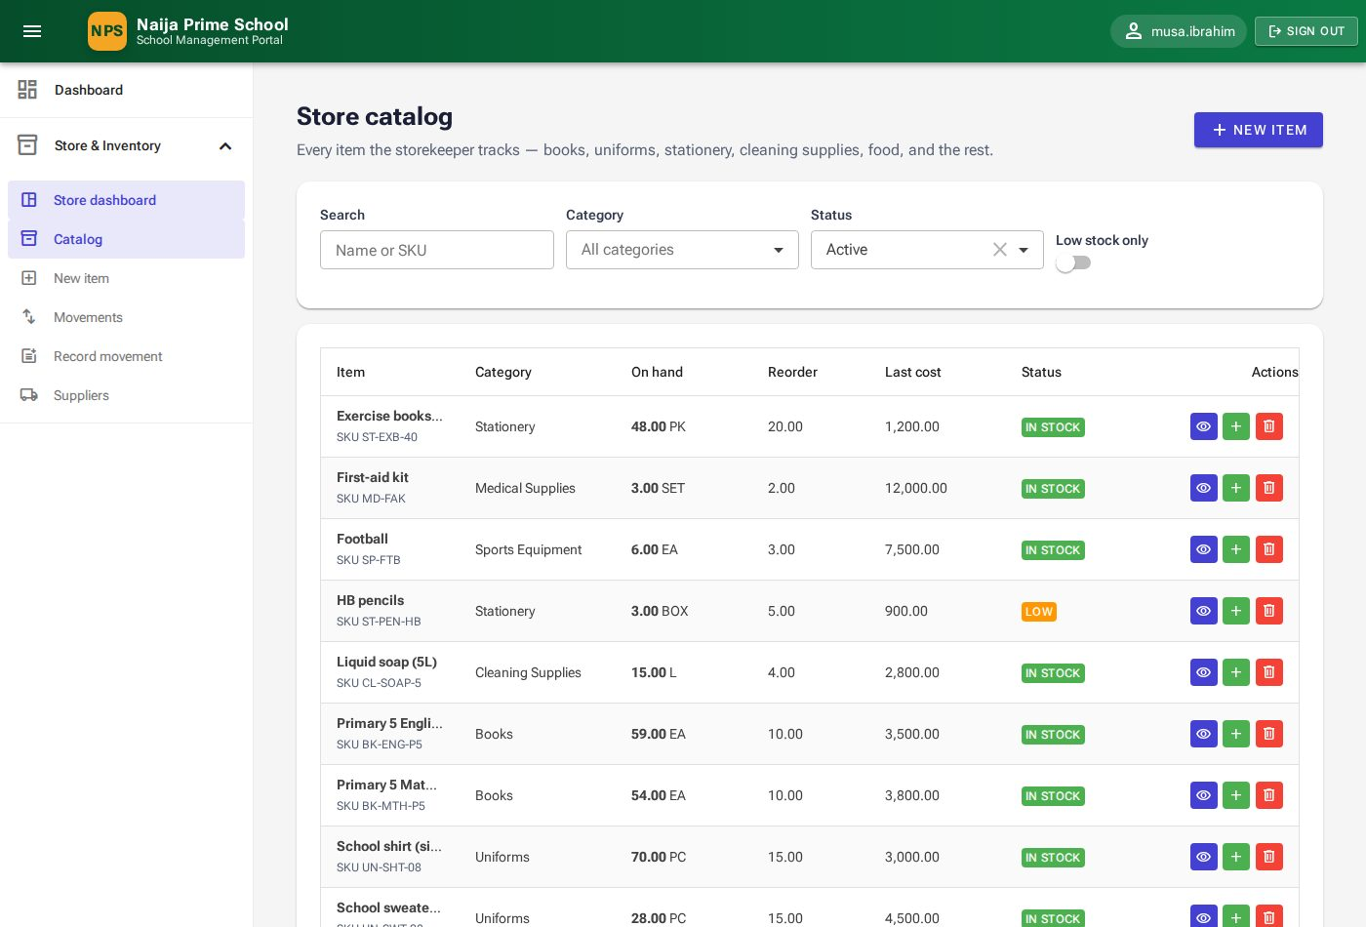
Figure 54: Store catalogue

Adding an item
- Click New item.
- Enter the Name, optional SKU (must be unique), Category, Unit of measure and Reorder level.
- If you already hold stock, enter the Opening quantity and Opening unit cost.
- Click Save item.

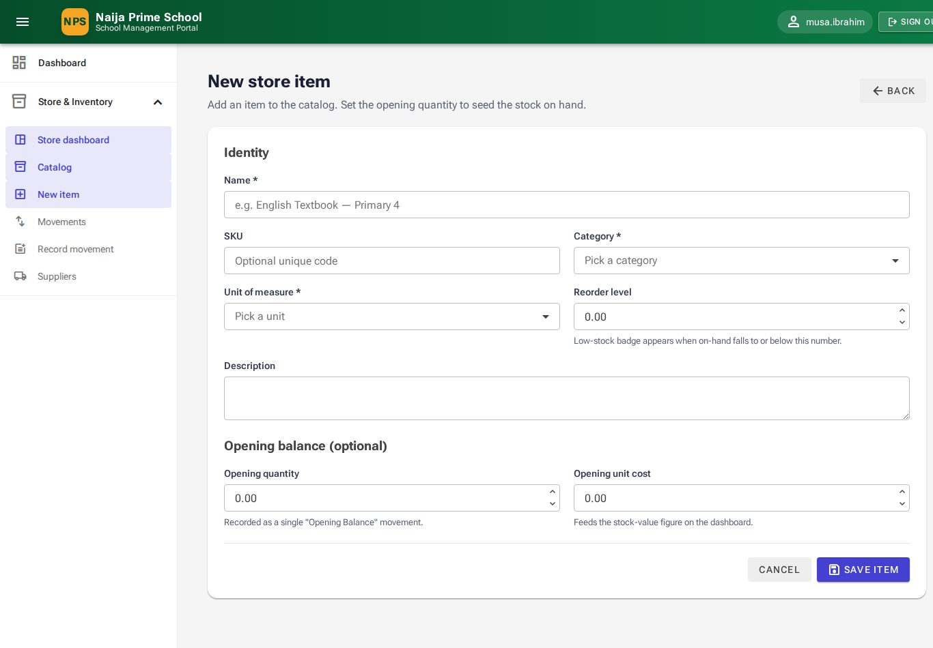
Figure 55: New store item
Open an item (👁) to see its quantity, reorder level, last unit cost, stock value and full movement history, and to edit its details.
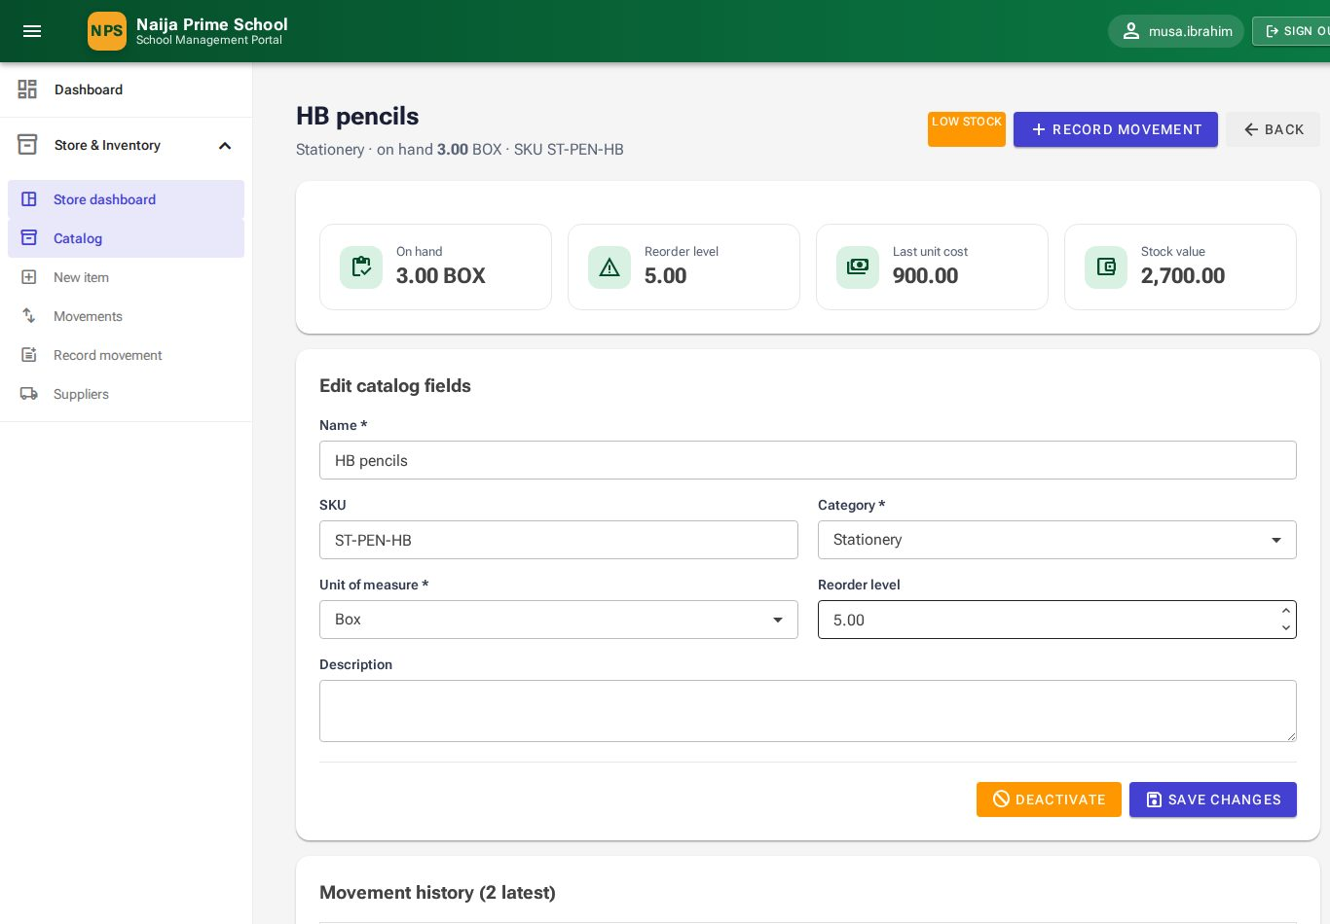
Figure 56: An item with its movement history

10.3 Recording stock movements
- Click Record movement (from the dashboard, the catalogue row, the item page or the menu).
- Choose the Item and Movement type: Purchase, Return or Adjustment In add stock; Issue, Write-off or Adjustment Out remove it.
- Enter the Date, Quantity, Unit cost and a Reference (for example the purchase order number).
- For purchases pick the Supplier; for issues pick one recipient — a Pupil, a Class or a Staff member.
- Click Save movement. The quantity on hand updates immediately.

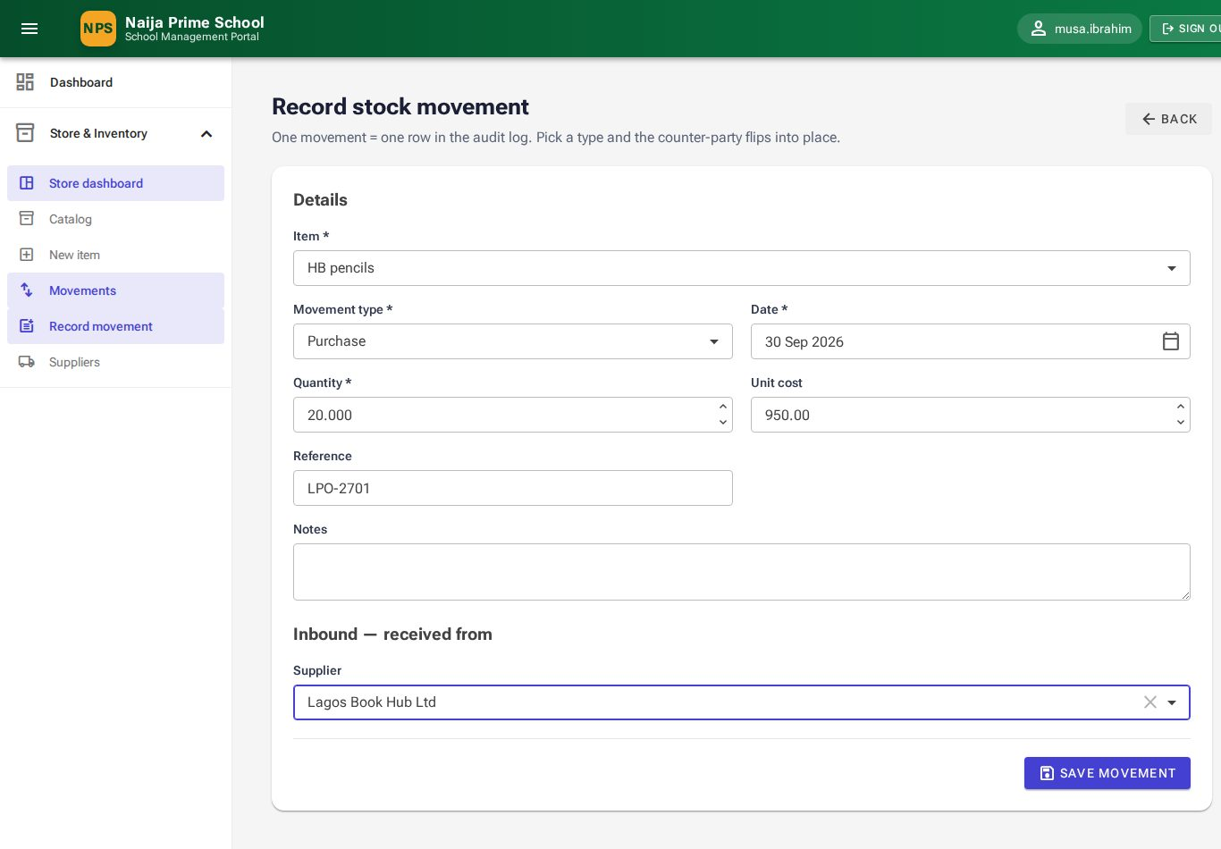
Figure 57: Recording a purchase
Note: You cannot issue more than is on hand; the portal tells you how many are available.
Store & Inventory → Movements is the complete log, filterable by type, direction and dates.
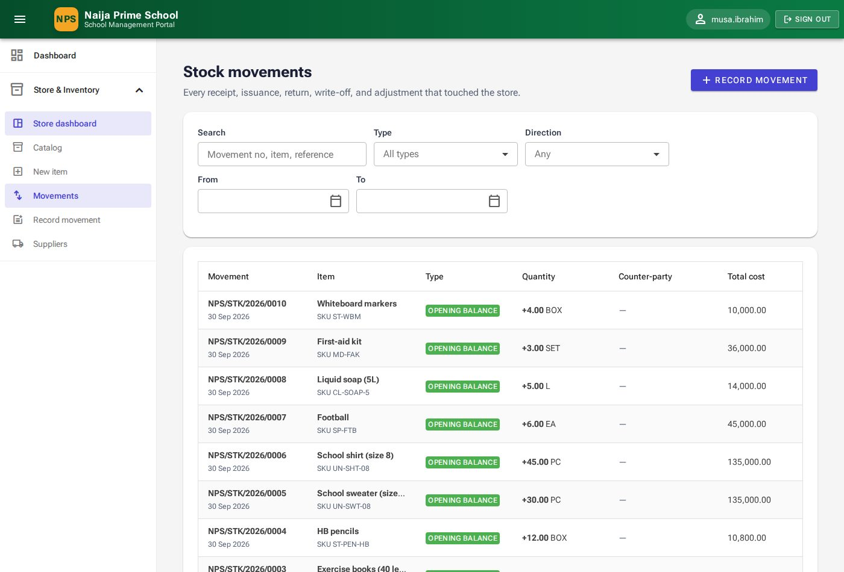
Figure 58: Stock movements

10.4 Suppliers
Store & Inventory → Suppliers lists suppliers with contact details and purchase totals. Click New supplier to add one. Suppliers with purchase history cannot be deleted — deactivate them instead.
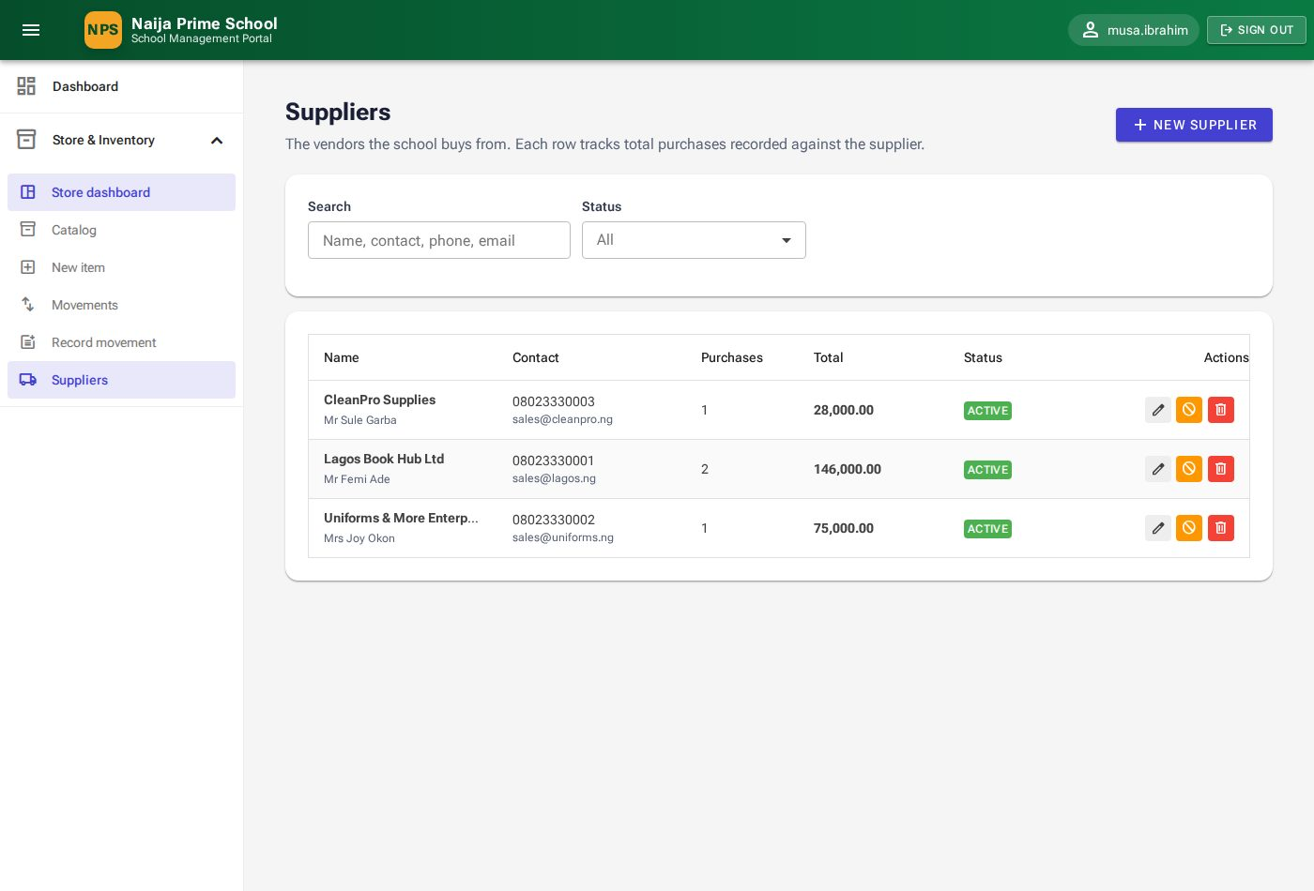
Figure 59: Suppliers

11. Announcements and reminders (HeadTeacher)
Menu: Communications. Announcements appear in the parent and student portals and, if not read, are followed up by email and SMS.

11.1 The announcements list
Communications → Announcements shows each notice with its status (Published or Draft), expiry, number of reads and email/SMS counters (sent, pending, failed, skipped). Row icons edit, send reminders now, publish/unpublish and delete.
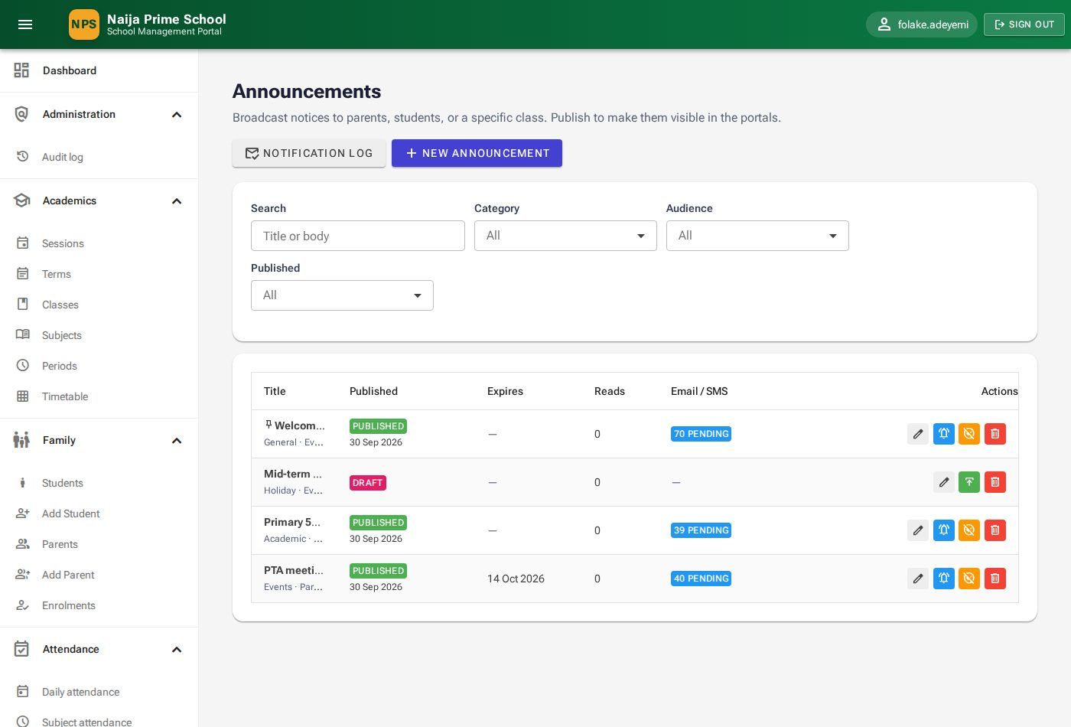
Figure 60: Announcements

11.2 Writing an announcement
- Click New announcement.
- Enter a short Title and the Body.
- Choose the Category (General, Academic, Finance, Events, Holiday, Health, Emergency).
- Choose the Audience: Everyone, Parents, Students, or Specific Class (then pick the Target class).
- Optionally set Expires on and turn on Pin to top for important notices.
- Click Publish now, or Save as draft to finish later.

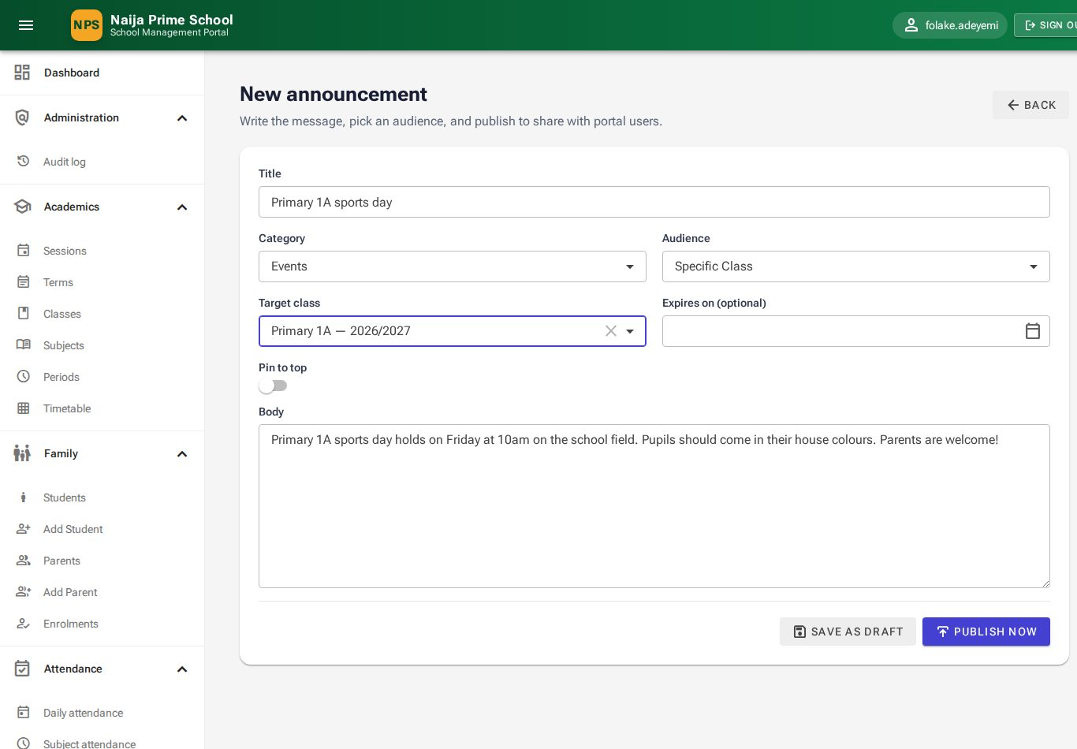
Figure 61: Writing a class announcement

11.3 Email and SMS reminders
When a notice is published, the portal waits a short grace period. Anyone in the audience who has not read it in the portal by then receives an email and/or SMS reminder. Communications → Notification log shows each reminder (and each message alert, chapter 12) with recipient, channel, status (Sent, Pending, Failed, Skipped) and a note explaining any skip.
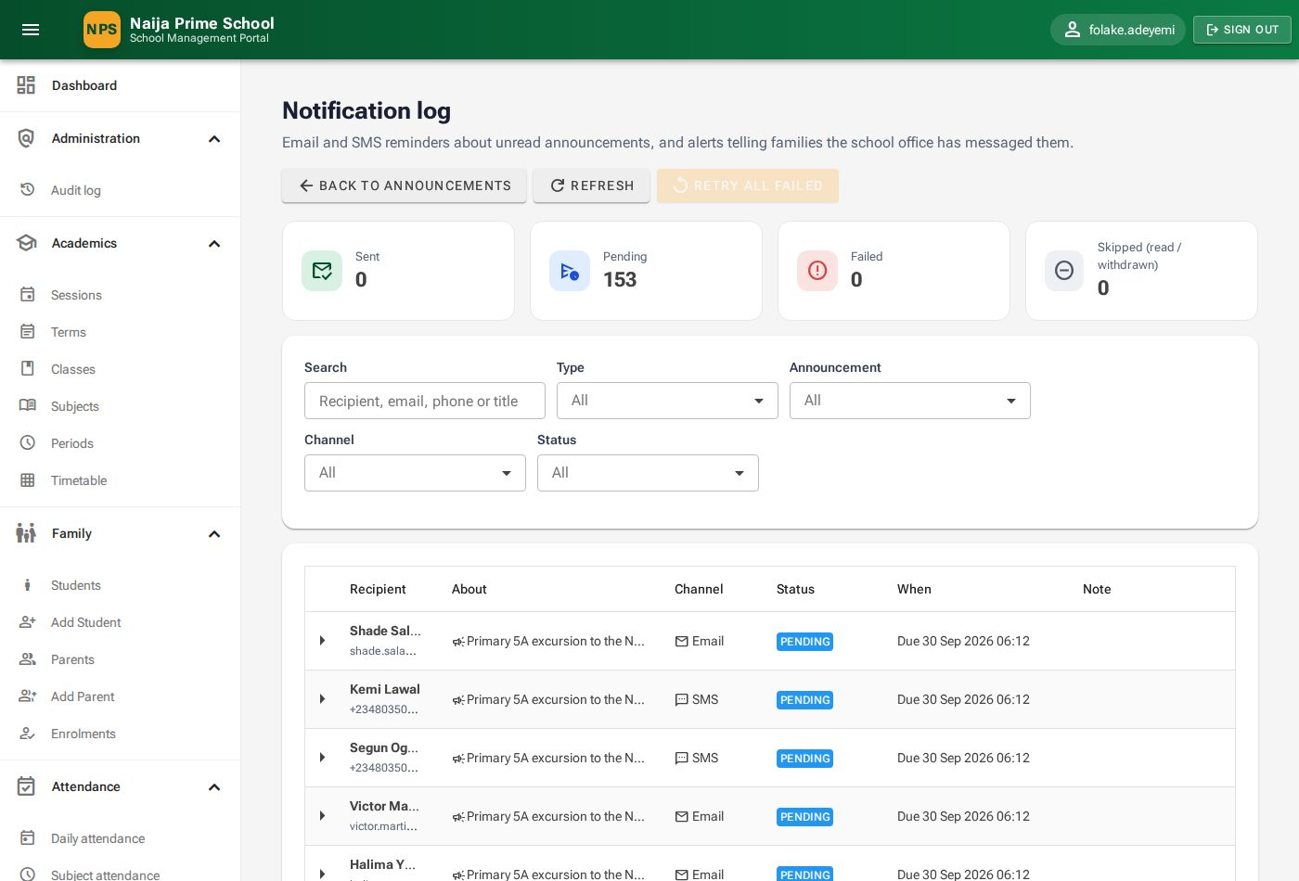
Figure 62: Notification log
- Filter by Type, Announcement, Channel, Status or search by recipient.
- Use Retry all failed (or the retry icon on a row) after fixing a problem such as a wrong phone number.
- Emergency announcements are treated as urgent and are not held back by quiet hours.

11.4 Reminder preferences
Each parent and pupil can choose whether to receive email and/or SMS reminders and set quiet hours (for example 21:00–07:00) during which reminders are held. They do this themselves under Reminder settings in their portal (14.7); the office can also set them on the Reminders tab of the parent or pupil record.
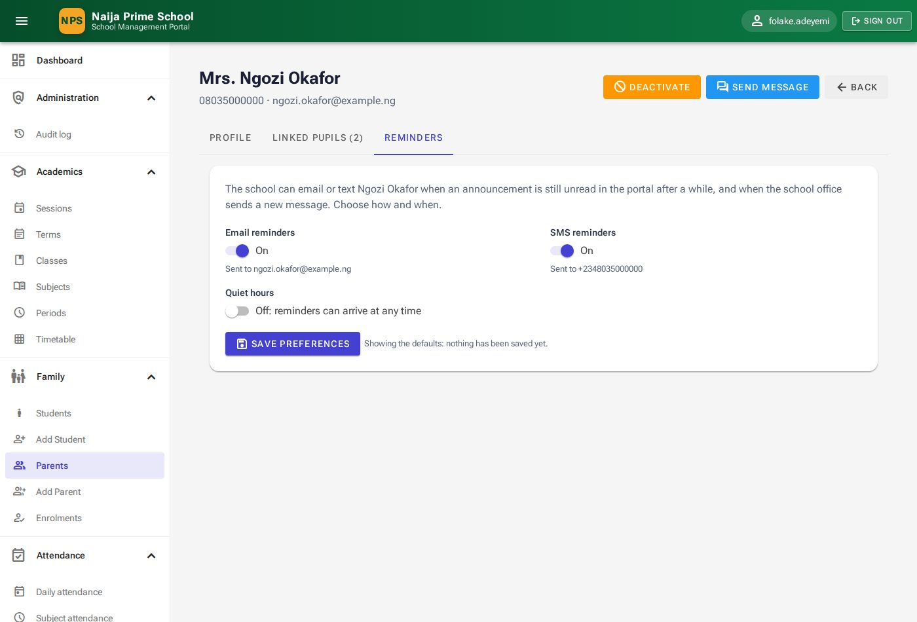
Figure 63: Reminder preferences on a parent's record

12. Messages (school office)
Menu: Communications → Inbox. Parents and pupils can write privately to the school office; the head teacher and administrator answer from a shared inbox.

12.1 The inbox
Conversations are listed newest first with the family member, the pupil it is about, the last message and the number of messages. A blue dot marks unread conversations and Awaiting reply marks those whose last message came from the family. Use Search, Status (Open or Resolved) and Unread only.
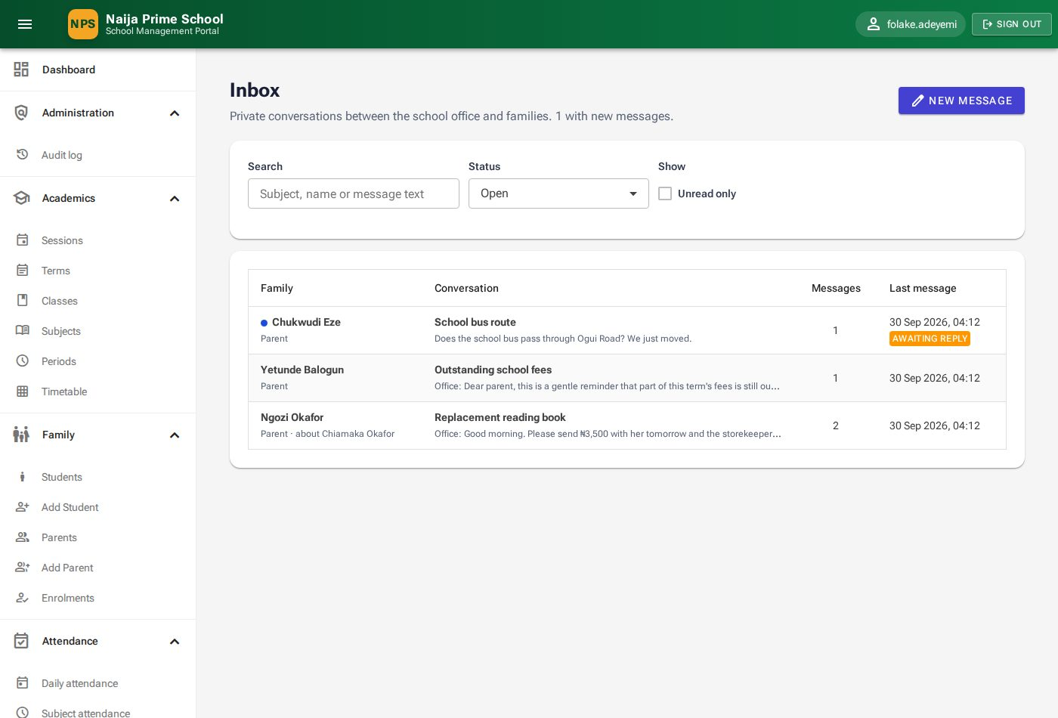
Figure 64: Inbox

12.2 Replying
- Click a conversation to open it. New messages appear automatically while it is open.
- Type in Write a reply… and click Send reply.
- When the matter is dealt with, click Mark resolved. Replying to a resolved conversation reopens it.
- Click Alert log to see the email/SMS alerts sent to the family about your replies.

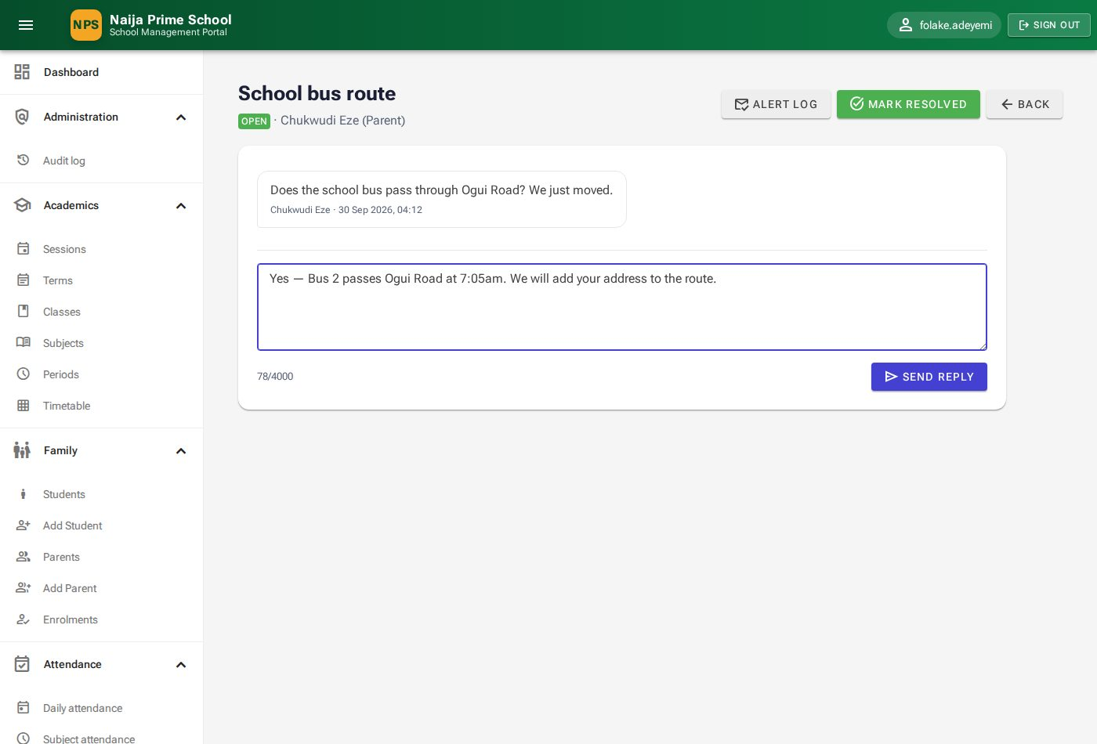
Figure 65: Replying to a parent
Note: After you reply, the family receives an email and SMS alert unless they read your reply in the portal within a few minutes. The SMS never contains the message text.

12.3 Starting a conversation
Click New message (or Send message on a parent or pupil record). Pick the recipient in To, optionally the pupil it is About, enter a Subject and Message, and click Send.
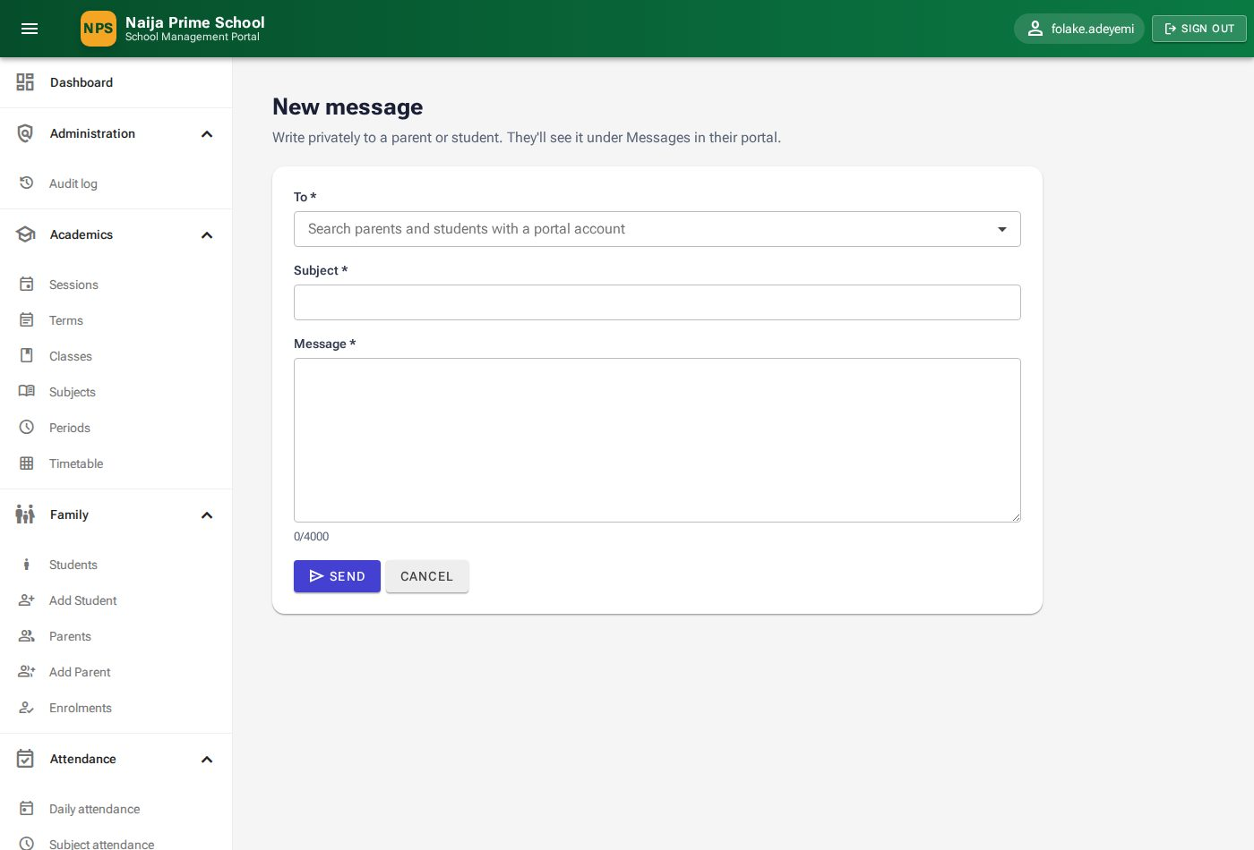
Figure 66: New message

13. Audit log (HeadTeacher and SuperAdmin)
Menu: Administration → Audit log. Every record created, updated, deleted or restored is logged with the date and time, the user, the record and — for updates — each changed field's before and after value. Passwords and security values are never shown, only "(hidden)".
- Filter by date range (From, To), User, Record type and Action, or Search for a name, number or any changed value (for example an old phone number).
- Click the ▸ arrow on a row to see the fields that changed.
- Click History to see the full timeline of that one record. The page address can be shared with a colleague.

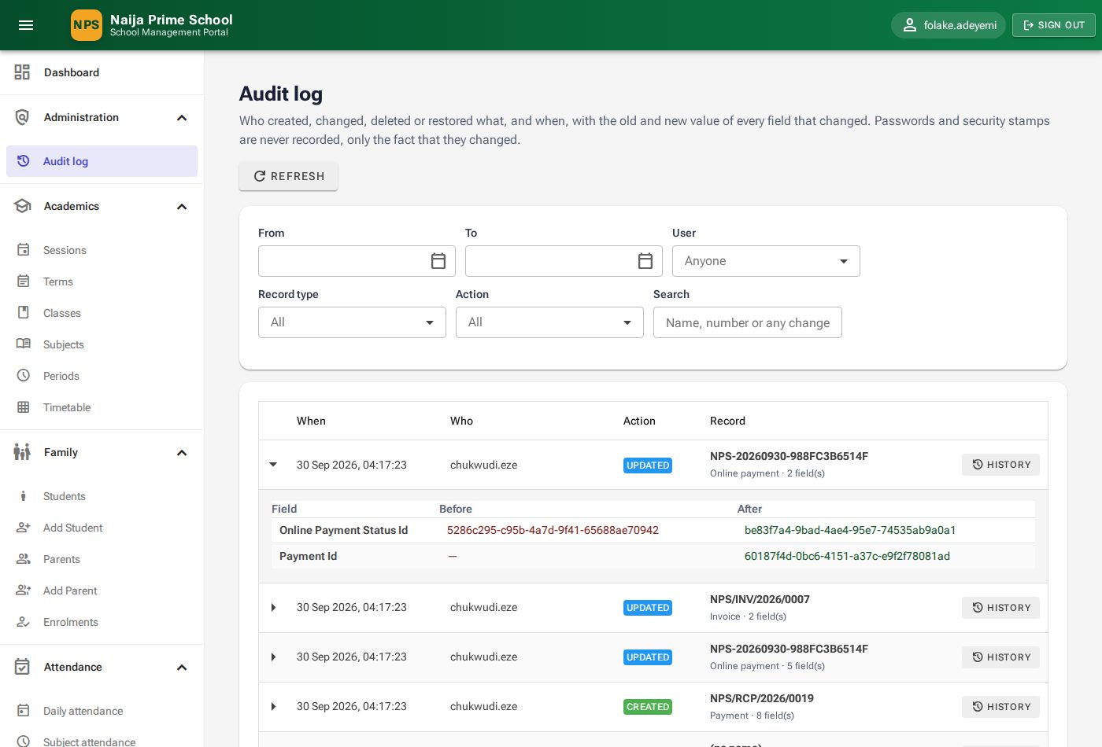
Figure 67: Audit log with one entry expanded
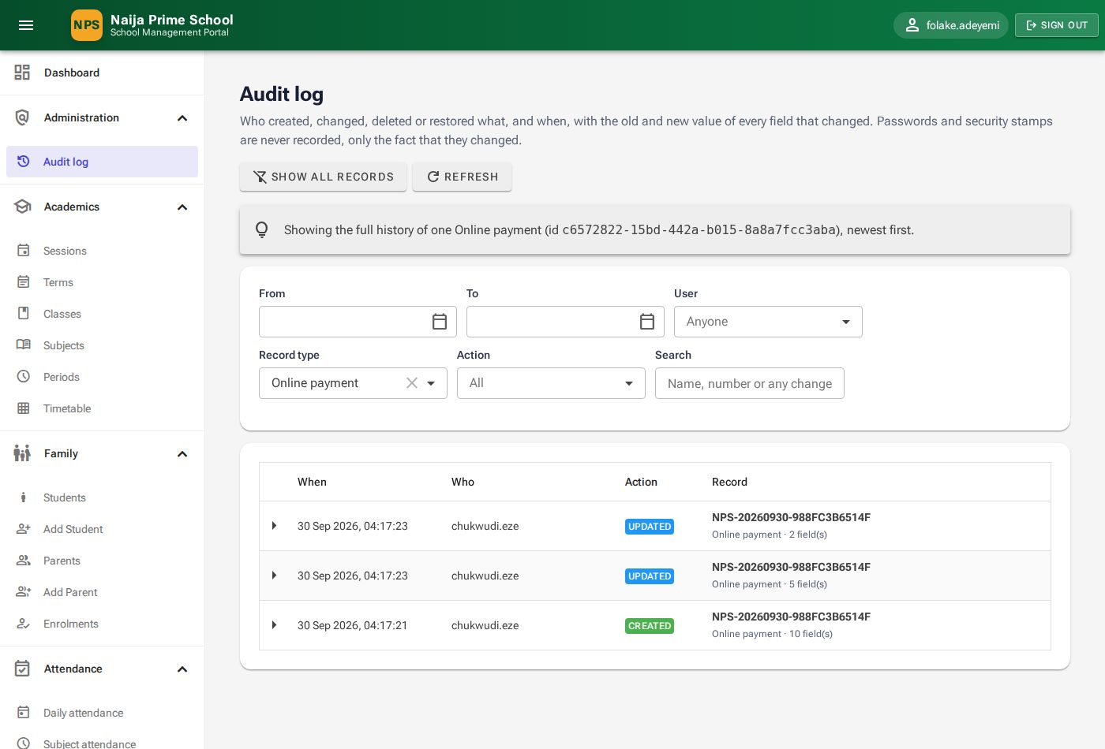
Figure 68: History of a single record

14. Parent portal
Parents sign in with the username and password given by the school office (2.1). The menu shows Parent portal with My wards, Announcements, Messages and Reminder settings.

14.1 My wards
My wards shows a card for each of your children with class, outstanding fees, attendance percentage and number of report cards, and totals across all your children. Click Open on a child for details.
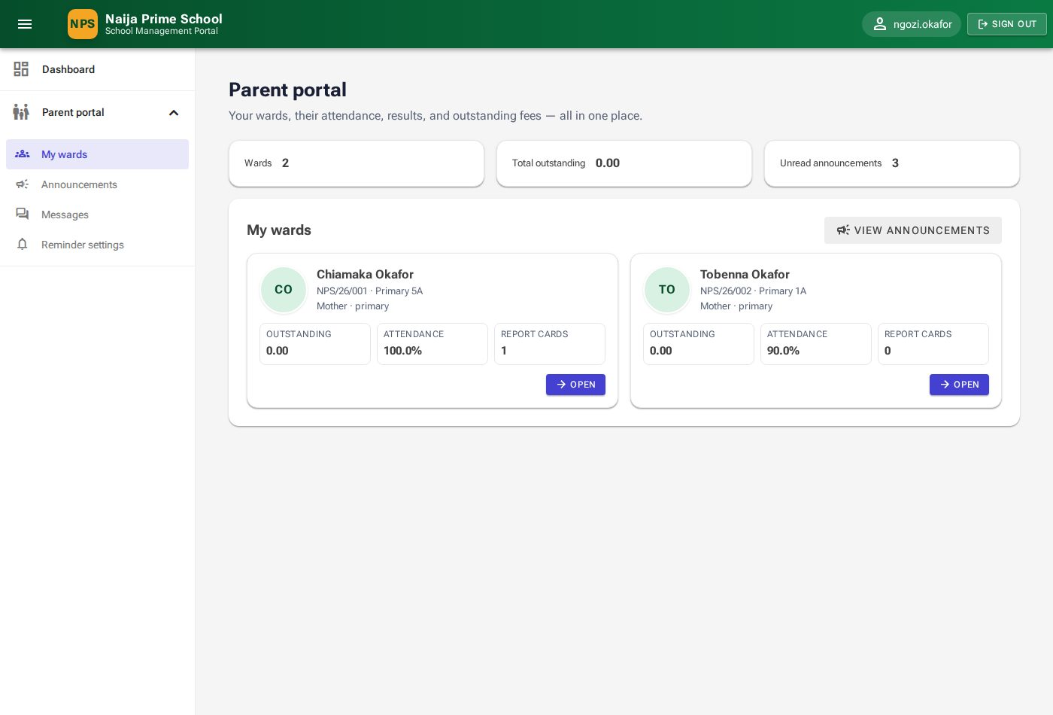
Figure 69: My wards

14.2 A child's overview
The Overview tab summarises the child's outstanding balance, attendance, report cards and days present this term.
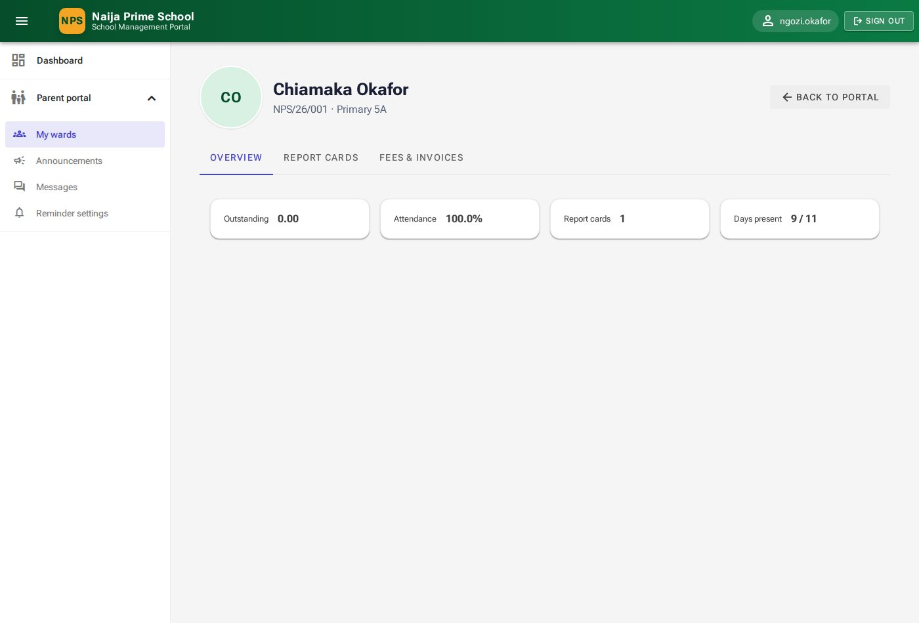
Figure 70: Overview tab

14.3 Report cards
The Report cards tab lists every published report card. Click the 👁 view button to open it: subjects with percentages, grades, positions and remarks; affective and psychomotor ratings; teachers' comments and the date the next term begins. Click Print for a paper copy.
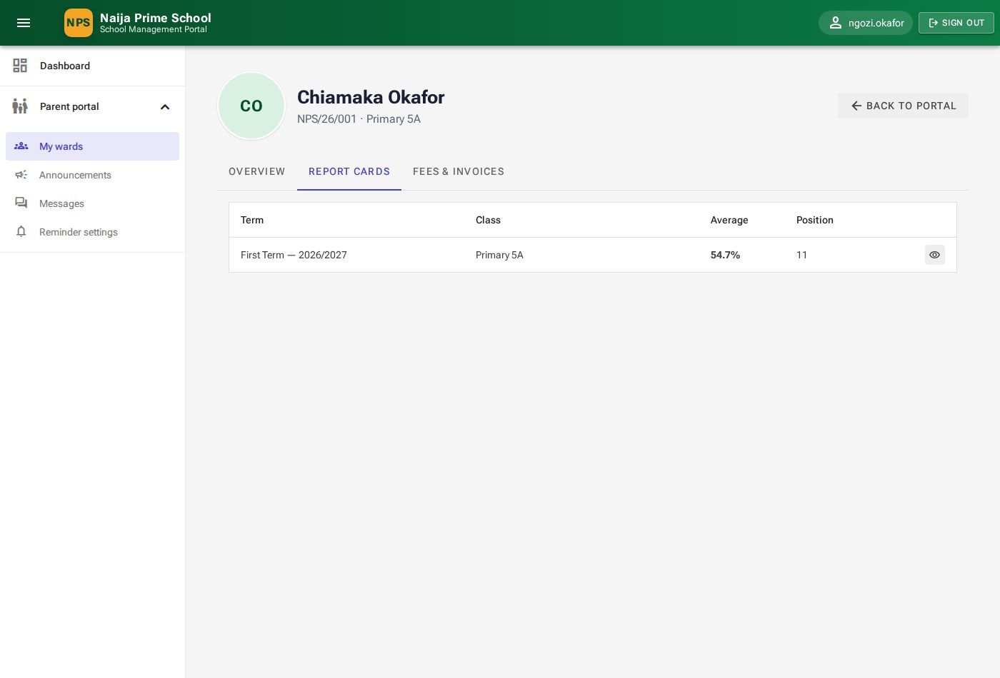
Figure 71: Report cards tab
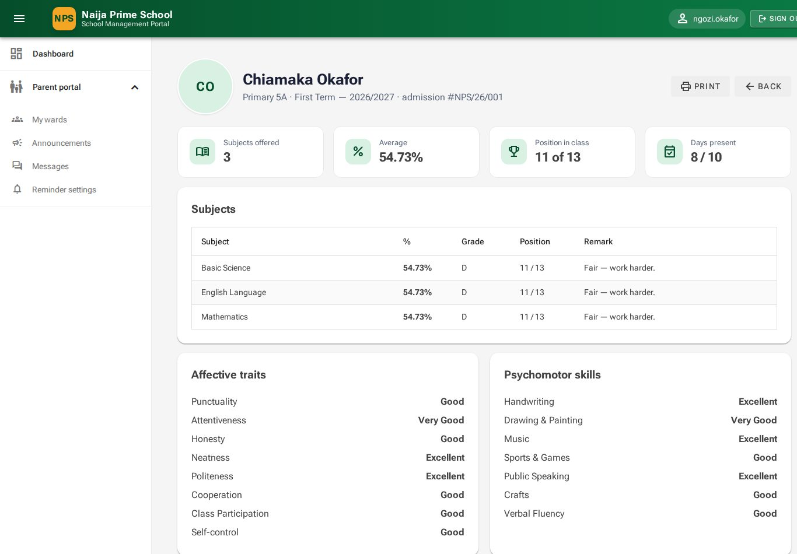
Figure 72: A report card as parents and pupils see it

14.4 Fees and invoices
The Fees & invoices tab lists your child's invoices with total, balance and status, and the payments made.
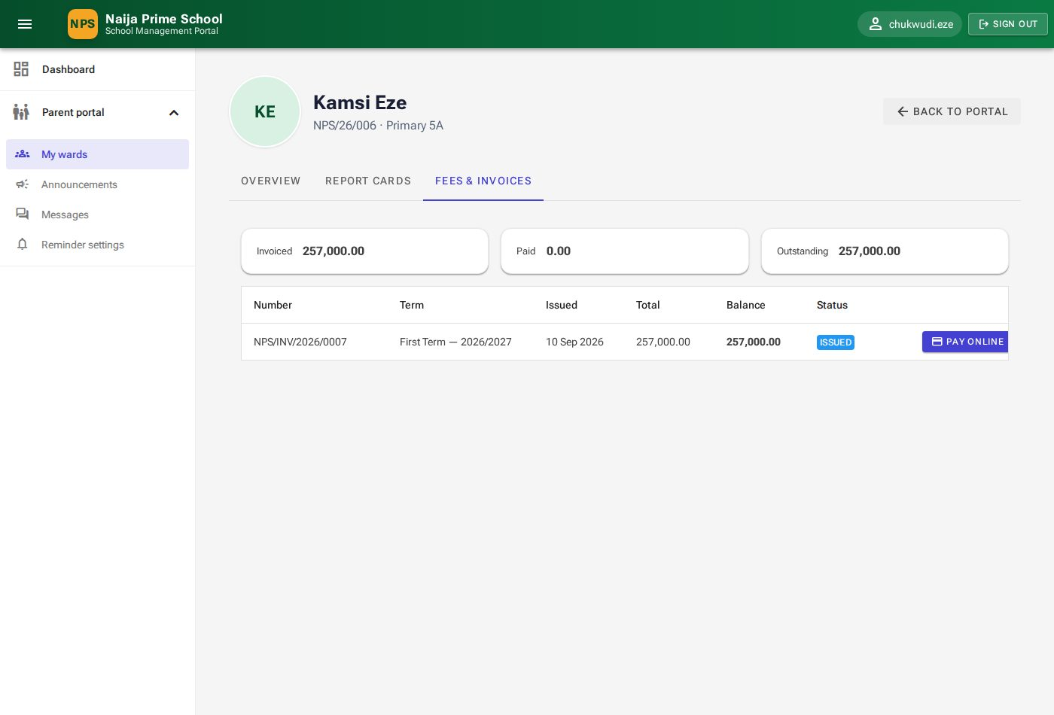
Figure 73: Fees & invoices tab with the Pay online button

14.5 Paying fees online
- On Fees & invoices, click Pay online next to an invoice with a balance.
- Check the invoice, pupil and outstanding balance. Keep the full balance in Amount to pay (₦) or enter a smaller part-payment (at least ₦100).
- Click Pay ₦… securely. You are taken to Paystack's secure checkout, where you pay by card, bank transfer or USSD. The school never sees your card details.
- When you finish, you return to the Payment status page. Payment received shows your receipt number, and the invoice balance is updated.

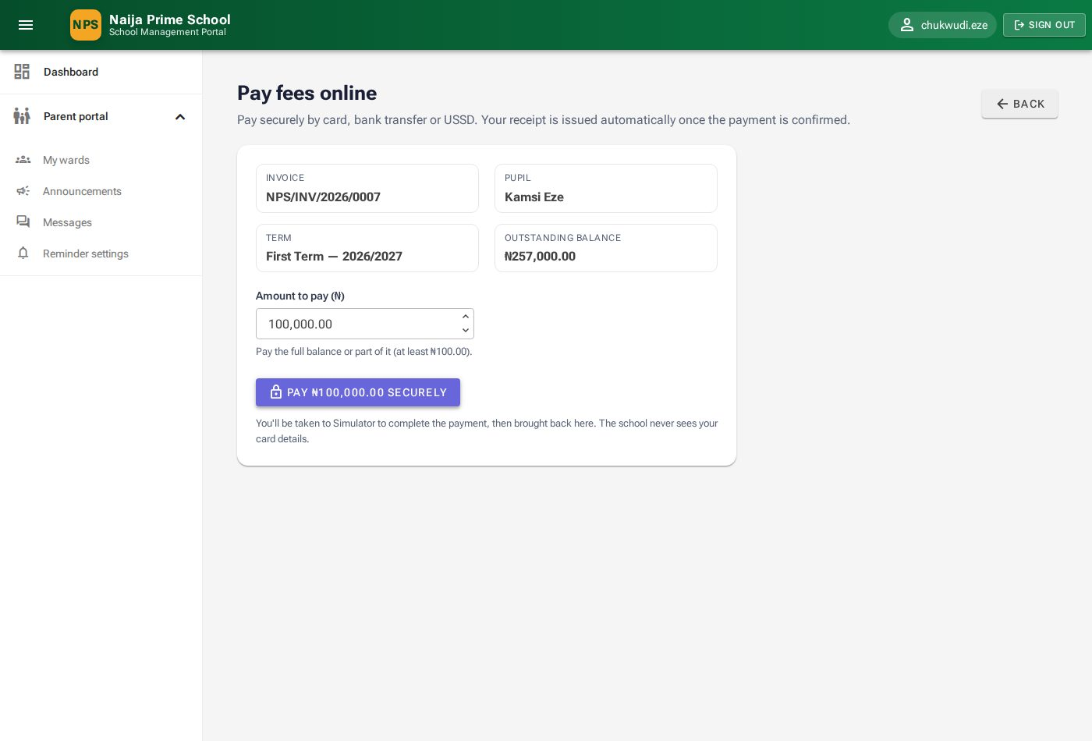
Figure 74: Choosing how much to pay
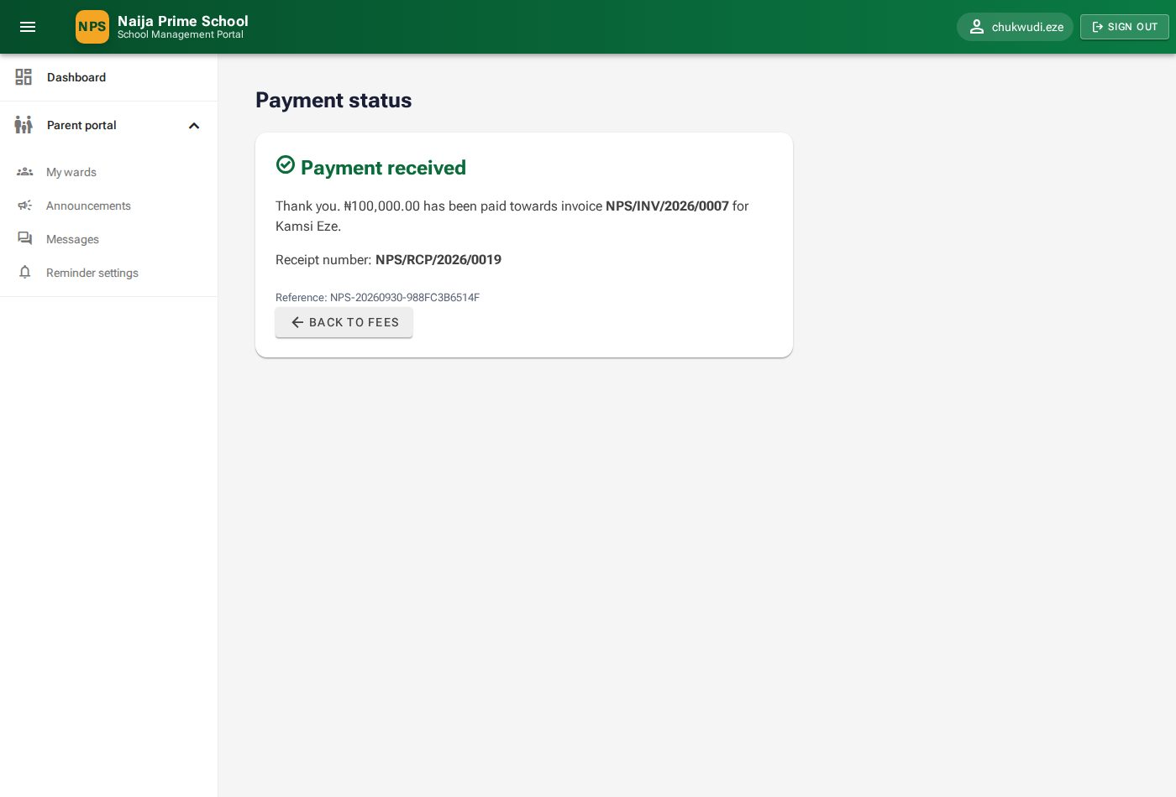
Figure 75: Payment received
- Waiting for confirmation — Paystack has not confirmed yet (common for transfers and USSD). Click Check again a little later.
- Payment not completed — no money was taken. Click Try again.
- Being checked by the bursary — the money arrived but needs a quick check. Do not pay again; the bursary will contact you.

Note: The picture of the checkout page in this manual comes from the demonstration system, where a simulator stands in for Paystack.
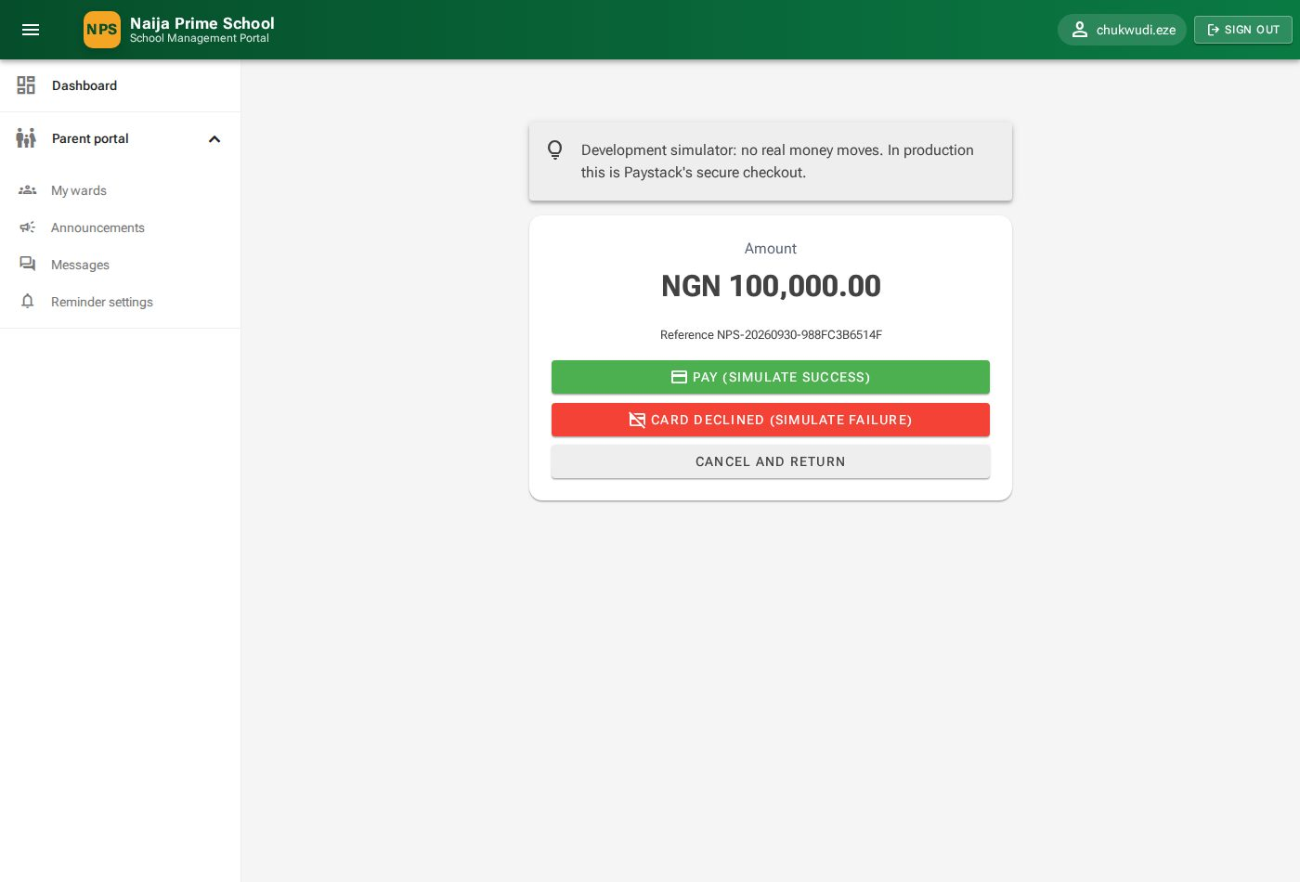
Figure 76: Checkout (demonstration simulator)

14.6 Announcements
Announcements shows notices for everyone, for parents, and for your children's classes. Pinned notices come first; new ones carry a New badge. Click Mark as read once you have read a notice — you will then not be sent an email or SMS reminder about it.
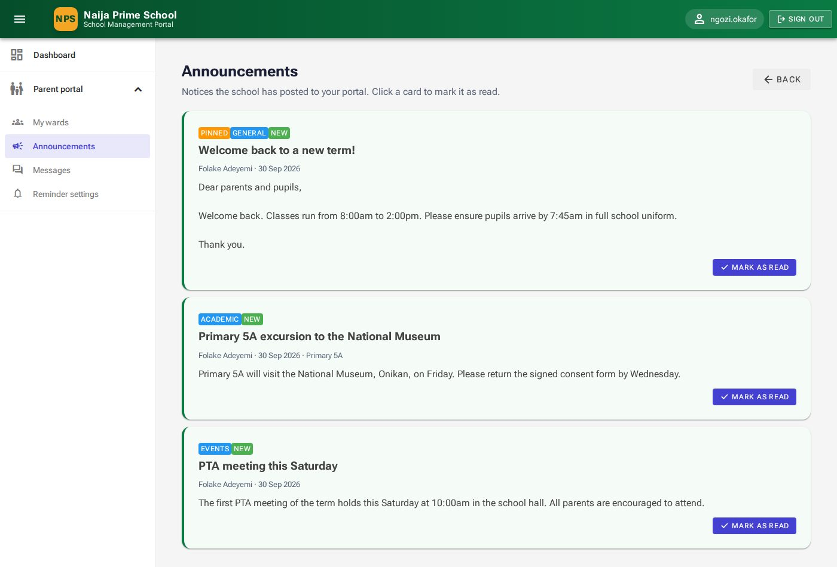
Figure 77: Announcements in the parent portal

14.7 Messages to the school
- Open Messages and click Message the school.
- Optionally choose which child it is About, then enter a Subject and your Message.
- Click Send. The conversation appears in your list.

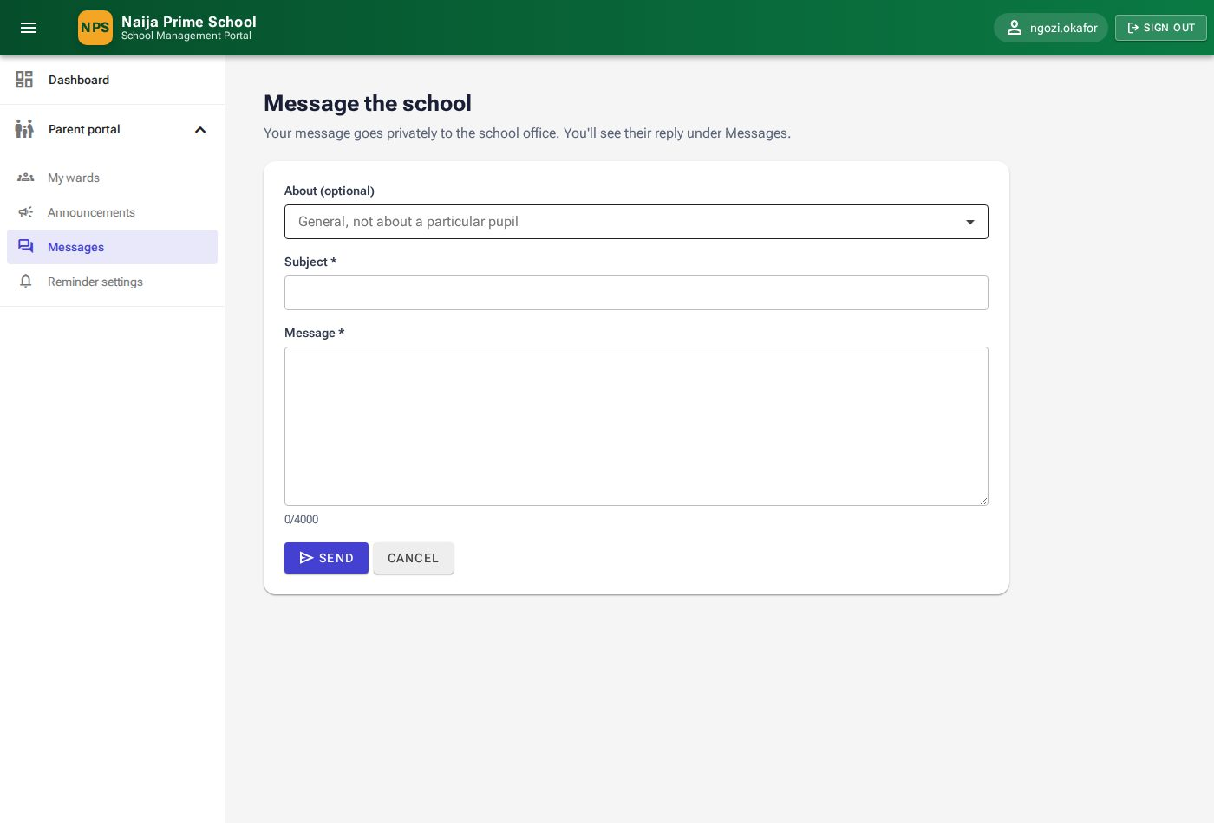
Figure 78: Writing to the school
Conversations with a New reply badge have an answer from the school. Open one to read and reply. You are also alerted by email/SMS when the school replies, unless you read it in the portal first.
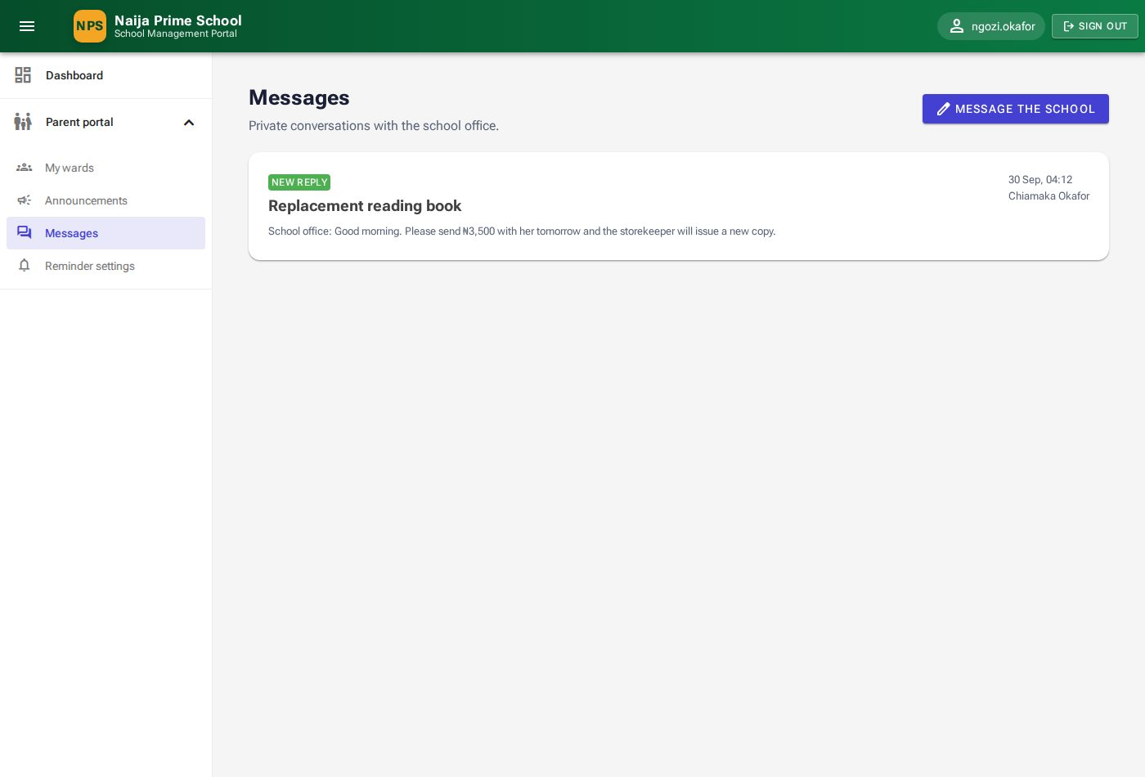
Figure 79: Your conversations
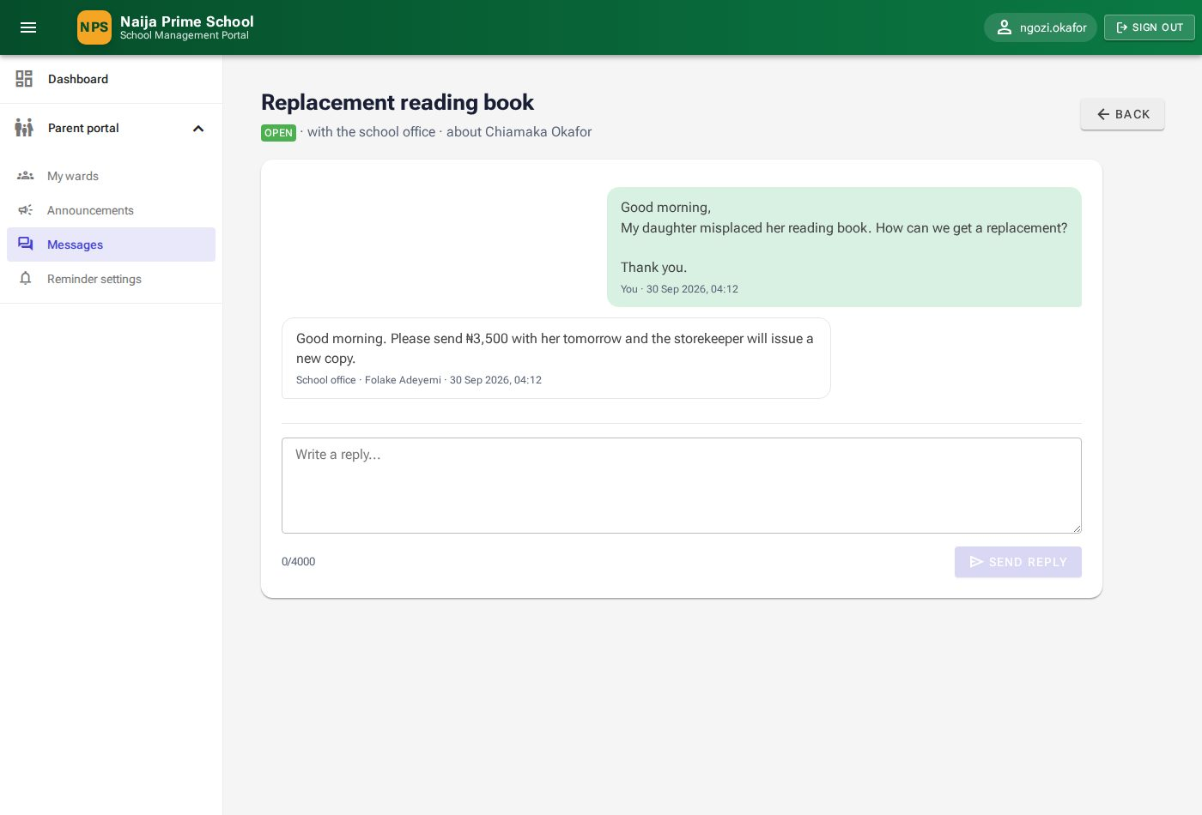
Figure 80: A conversation with the school office

14.8 Reminder settings
Choose whether you want Email reminders and SMS reminders for unread announcements and replies from the school, and set Quiet hours when you do not want to be disturbed. The page shows the email address and phone number reminders go to. Click Save preferences.
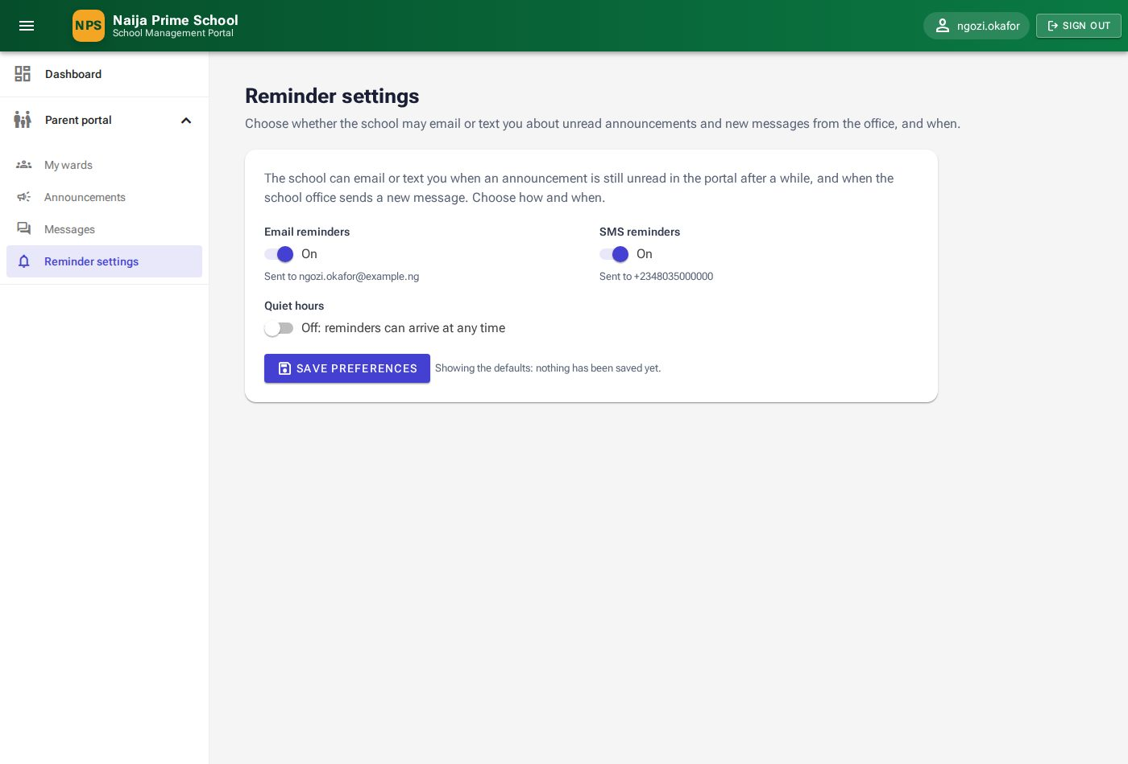
Figure 81: Reminder settings

15. Student portal
Pupils sign in with their own username and password. The menu shows Student portal with Today, My profile, My results, My attendance, My fees, Announcements, Messages and Reminder settings.

15.1 Today
The Today page shows your class, outstanding fees, attendance and report cards, today's timetable (period, time, subject, teacher and room) and shortcut buttons.
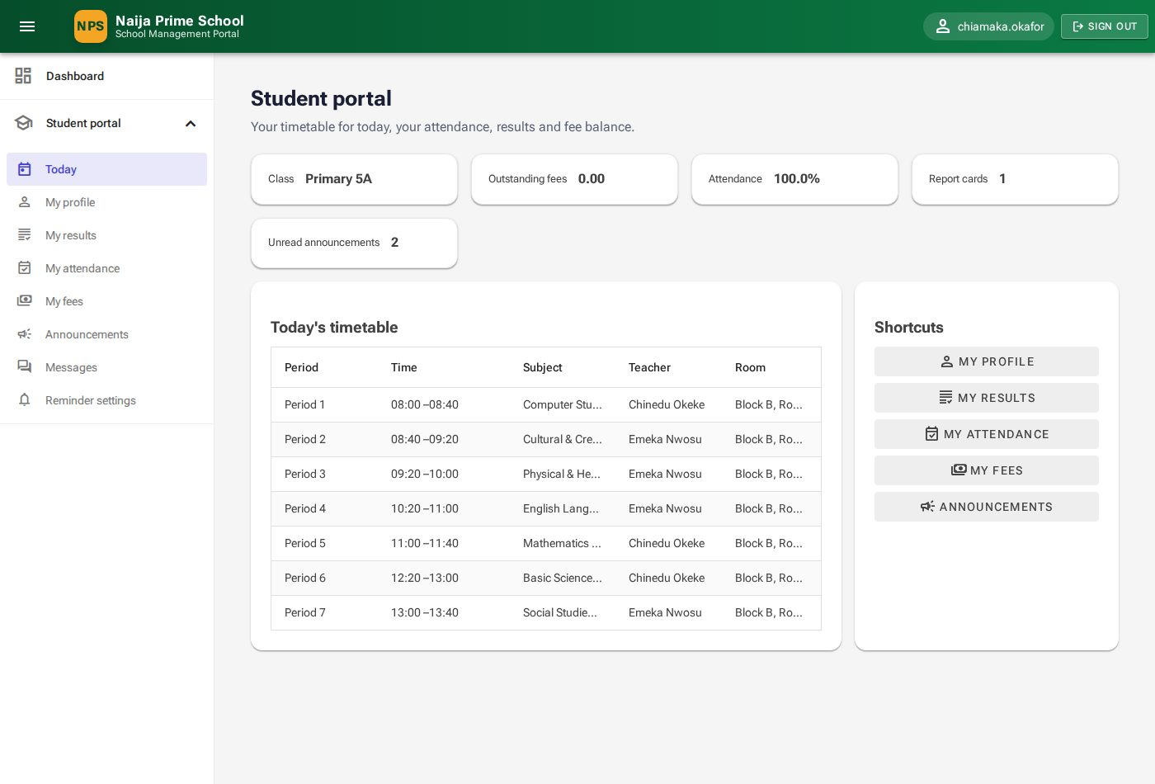
Figure 82: Student portal — Today

15.2 My profile
Your personal and admission details. If anything is wrong, tell the school office — pupils cannot edit their own records.
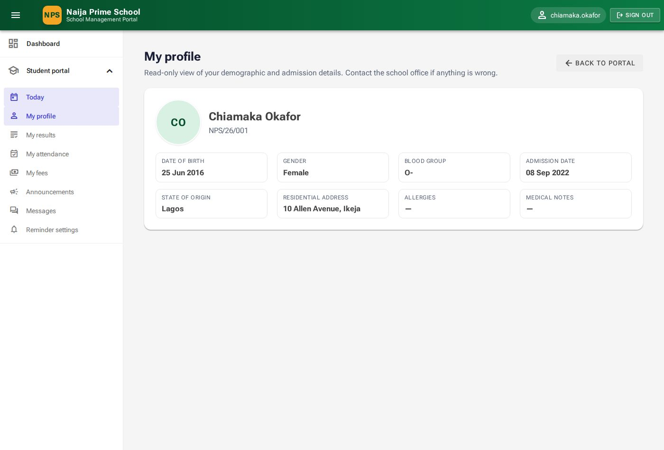
Figure 83: My profile

15.3 My results
Your published report cards with term, class, average and position. Click the view button to open a card (as in 14.3). Only your own cards can be opened.
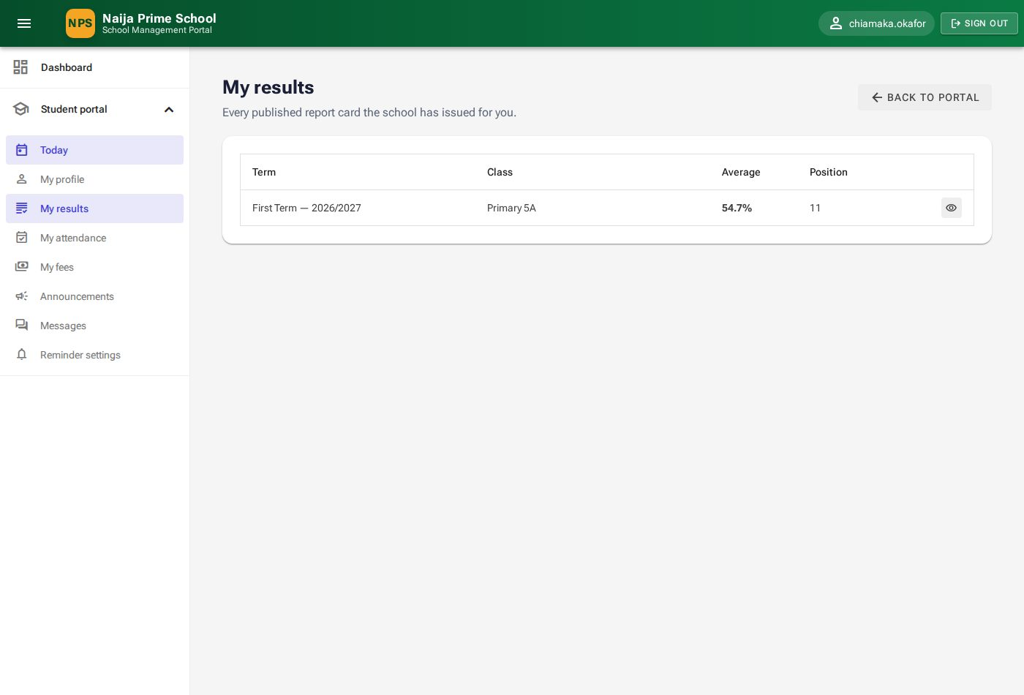
Figure 84: My results

15.4 My attendance
Days counted, present, late and absent this term, and your attendance percentage.
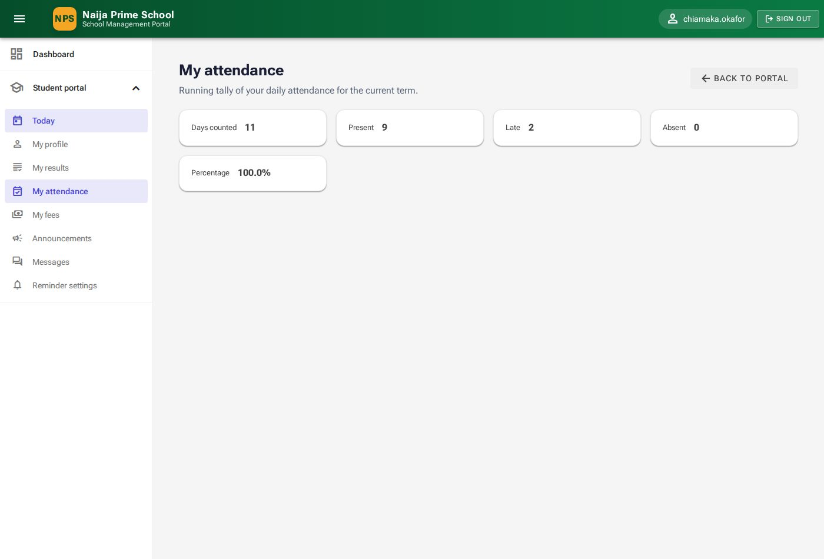
Figure 85: My attendance

15.5 My fees
Your invoices and payments. Where an invoice has a balance, Pay online works exactly as for parents (14.5).
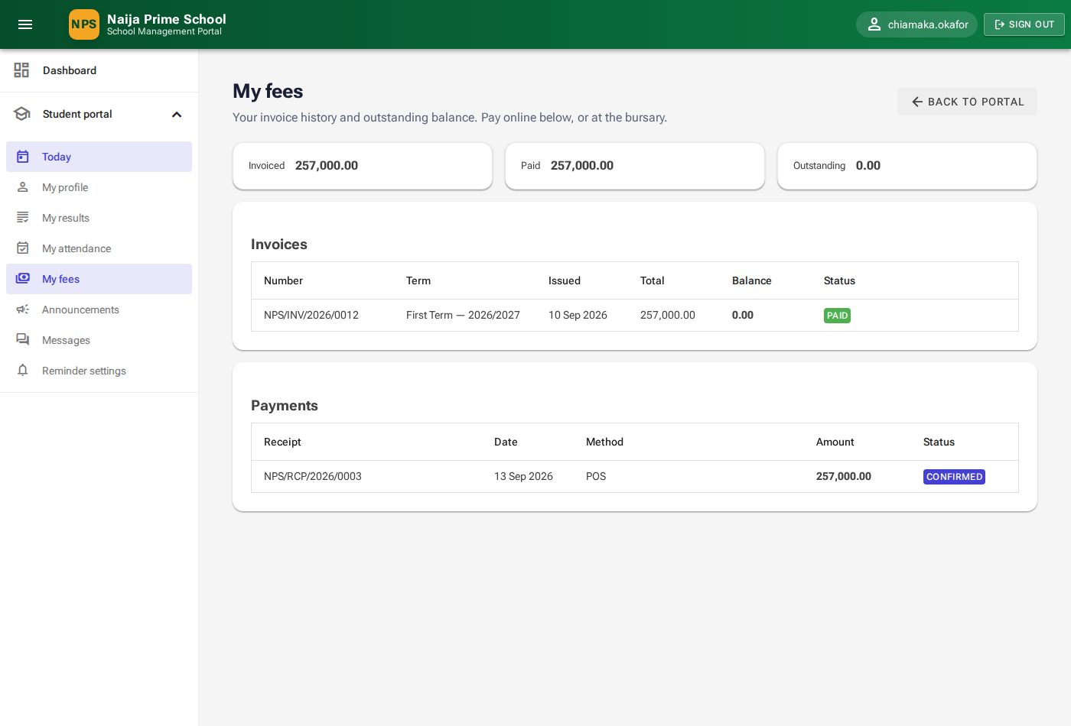
Figure 86: My fees

15.6 Announcements, messages and reminders
These work the same way as in the parent portal: see 14.6, 14.7 and 14.8.

Appendix A. Who can use what
✔ = can open and use the section. "Own" = only the person's own records or their own children's.
Section | Super-Admin | Head-Teacher | Teacher | Bursar | Store-Keeper | Parent | Student
User management | ✔
Audit log | ✔ | ✔
Sessions, terms, classes, subjects, periods | ✔ | ✔
Timetable | ✔ | ✔ | ✔
Students, parents, enrolments | ✔ | ✔
Attendance | ✔ | ✔ | ✔
Assessments and scores | ✔ | ✔ | ✔
Subject results, report cards | ✔ | ✔
Finance (fees, invoices, payments, online payments) | ✔ | ✔ |  | ✔
Store & inventory | ✔ | ✔ |  |  | ✔
Announcements, notification log, inbox | ✔ | ✔
Parent portal |  |  |  |  |  | Own
Student portal |  |  |  |  |  |  | Own
Portal announcements | ✔ | ✔ |  |  |  | ✔ | ✔
Portal messages and reminder settings |  |  |  |  |  | Own | Own

Appendix B. Status reference

Attendance statuses
Status | Counts as present? | Use for
Present (P) | Yes | Pupil in school on time.
Late (L) | Yes | Pupil arrived late — record the arrival time.
Excused (E) | No | Absence approved in advance.
Sick (S) | No | Absent through illness.
Absent (A) | No | Absent without explanation.
Suspended (SP) | No | Pupil on suspension.

Invoice statuses
Status | Meaning
Draft | Not yet issued to the family.
Issued | Issued, nothing paid yet.
Partially Paid | Some money received; a balance remains.
Paid | Fully paid.
Overdue | Past its due date with a balance.
Cancelled | Withdrawn; no longer payable.

Payment and online payment statuses
Status | Meaning
Confirmed | Payment received and applied.
Pending | Awaiting confirmation (e.g. cheque not yet cleared; online payment not yet confirmed).
Bounced | Cheque or transfer failed.
Refunded | Payment reversed; the invoice balance was restored.
Succeeded / Failed / Abandoned | Online payment outcomes (see 9.7).
Needs review | Online payment arrived but needs the bursar to reconcile it.

Stock movement types
Adds stock | Removes stock
Opening Balance, Purchase, Return, Adjustment In | Issue, Write-off, Adjustment Out

Appendix C. Troubleshooting and frequently asked questions
Question | Answer
I cannot sign in. | Check the username (or use your email address) and password — passwords are case-sensitive. After five wrong attempts the account is locked for 15 minutes. If your account has been deactivated, contact the school office or system administrator.
A menu item I need is missing. | Your role does not include it. Ask the system administrator to review your roles (4.5).
A list is empty. | Check the filters above the list — for example the session, term or class — and clear the search box.
My change was not saved. | Look for a red message in the corner of the screen or a red outline on a field; it explains what needs correcting.
A parent cannot see their child in the portal. | The parent must be linked to the pupil on the pupil's Parents tab (6.4), and both records must be active.
A parent cannot see a report card. | Only published report cards are shown. Publish the card (8.3).
I cannot delete a record. | Records with history are protected — for example a subject on a timetable, a supplier with purchases, or an item with movements. Deactivate them instead.
A family was charged the wrong amount. | Give a discount on the invoice line (9.4) before payment, or refund the payment (9.6) and record the correct one.
An online payment shows "Waiting for confirmation". | Wait a few minutes and click Check again. The bursar can also verify it from Finance → Online payments. Do not pay twice.
Families are not receiving reminders. | Check their reminder settings (11.4) and contact details, then the Notification log for the reason (for example opted out, missing phone number, or read in the portal).

Appendix D. Glossary
Term | Meaning
Session | An academic year, e.g. 2026/2027.
Term | First, Second or Third Term within a session.
Class (class arm) | A group of pupils at one level in one session, e.g. Primary 5A.
Enrolment | A pupil's membership of a class for a session.
Ward | A child linked to a parent or guardian.
Register | The attendance record for one class on one day (or one lesson).
Assessment | A test, assignment or exam with a maximum score and a weight.
Fee schedule | The list of fees for one class level in one term.
Invoice | The bill for one pupil generated from a fee schedule.
Receipt | The record of a payment received, with its receipt number.
Allocation | The part of a payment applied to a particular invoice.
Reorder level | The stock quantity at or below which an item should be re-ordered.
Quiet hours | Times when a family does not want email/SMS reminders.
Audit trail | The permanent log of every change made in the portal.

