Lecture: Pham Trong Nghia

TA: Nguyen Thai Vu

**REPORT**

**PROJECT 2**

Fundamentals of Artificial Intelligence -Adversarial

MENU

**1.** **Overview** 2

• **Personal Information** 2

**1.1.** **Brief Description of Project** 2

**2.** **Idea Minimax Algorithm** 2

**2.1.** **Concept** 2

**2.2.** **Activity** 2

**3.** **Completemess: 100%** 3

**4.** **Time/space complexity** 3

**5.** **Consultation** 1

# **Overview**

## **Personal Information**

* ID: 20127362
* Name: Võ Thanh Sương

## **Brief Description of Project**

* Job: Implement tic-tac-toe game with a 3x3 map and apply adversarial technique to solve, which allows Players to compete with an unbeatable Computer.
* IDE used: VS Code
* Algorithm used: Minimax Algorithm

# **Idea Minimax Algorithm**

## **Concept**

Minimax is a kind of backback algorithm used in the decision-making process and the game theory to find the optimal movement for a player, assuming your opponent also plays optimally.

## **Activity**

_ The algorithm searches for moves recursively, the best move to the machine winning or drawing. It looks at the current state of the game and the available moves in that state, then for each valid move it will play (alternating min and max) until it finds a last state (win, draw or lose).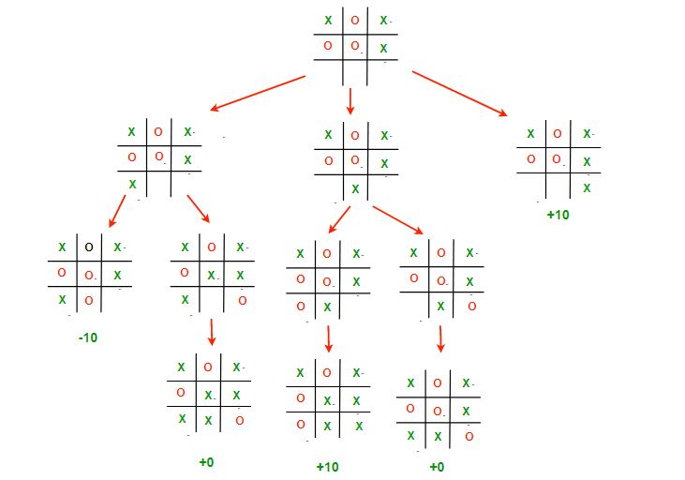

# **Completemess: 100%**

# **Time/space complexity**

Time complexity : O(b^m)

Space complexity : O(bm)

# **Consultation**

_ <https://www.geeksforgeeks.org/minimax-algorithm-in-game-theory-set-3-tic-tac-toe-ai-finding-optimal-move/>

<https://youtube.com/playlist?list=PLXG93_2g9SCY_M9Q_4D5DN6_u0vQjVRdQ>

<https://www.youtube.com/watch?v=xx0qmpuA-vM&t=682s>

1. **Link Demo**

https://drive.google.com/file/d/11RskX-X9dTyWvb1j2wNjEwfw4Vn7zODj/view?usp=sharing