Biography
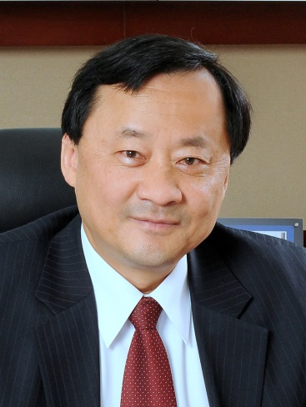
Benjamin W. Wah is currently the Provost and Wei Lun Professor of Computer Science and Engineering of the Chinese University of Hong Kong. He also serves as the Chair of the Research Grants Council of Hong Kong. Before then, he served as the Director of the Advanced Digital Sciences Center in Singapore, as well as the Franklin W. Woeltge Endowed Professor of Electrical and Computer Engineering and Professor of the Coordinated Science Laboratory of the University of Illinois, Urbana-Champaign, IL. He received his Ph.D. degree in computer science from the University of California, Berkeley, CA, in 1979. He has received a number of awards for his research contributions, which include the IEEE CS Technical Achievement Award (1998), the IEEE Millennium Medal (2000), the IEEE-CS W. Wallace-McDowell Award (2006), the Pan Wen-Yuan Outstanding Research Award (2006), the IEEE-CS Richard E. Merwin Award (2007), the IEEE-CS Tsutomu Kanai Award (2009), and the Distinguished Alumni Award in Computer Science of the University of California, Berkeley (2011). Wah's current research interests are in the areas of big data applications and multimedia signal processing.
Wah cofounded the IEEE Transactions on Knowledge and Data Engineering in 1988 and served as its Editor-in-Chief between 1993 and 1996, and is the Honorary Editor-in-Chief of Knowledge and Information Systems. He currently serves on the editorial boards of Information Sciences, International Journal on Artificial Intelligence Tools, Journal of VLSI Signal Processing, and World Wide Web. He has served the IEEE Computer Society in various capacities, including Vice President for Publications (1998 and 1999) and President (2001). He is a Fellow of the AAAS, ACM, and IEEE.
April 2015 version

