User Manual

Zoom Visualizer

Ben Weiss

Glen Xu

Anthony Anastasopoulos

# Prerequisite

In order to install the application, run it, and complete the testing, you will need to install the latest Java Development Kit, i.e. JDK 15. You can check your current JDK version by the command:

$ java -version

If your current version is lower than 15, then download the Java SE Development Kit 15 for your system.

The following is the installation process for macOS. Windows and Linux users may use this as a reference, or look for more detailed description on <[https://docs.oracle.com/javase/15/install/toc.htm](https://docs.oracle.com/javase/10/install/toc.htm)>.

For macOS users, visit the website <<https://www.oracle.com/java/technologies/javase-jdk15-downloads.html>>, accept the license agreement, and download the JDK .dmg file, jdk-15_osx-x64_bin.dmg. 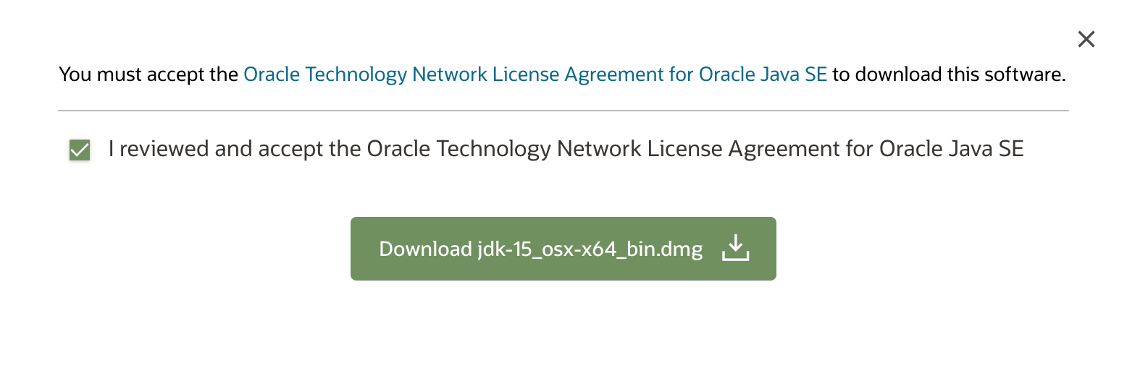(Figure 1)

Figure 1

Then, from either the browser **Downloads** window or from the file browser, double-click the .dmg file to start it. A Finder window appears that contains an icon of an open box and the name of the .pkg file. (Figure 2)

After that, double-click the JDK 15.pkg icon to start the installation application. (Figure 3) Keep clicking **Continue** and **Install** to the next step.

Figure 2

A window will show up and displaying the following message: (Figure 4)

Installer is trying to install new software. Enter your password to allow this.

Enter your Administrator user name and password and click **Install Software**. The software will be installed and a confirmation window will be displayed.

After the JDK is installed, the associated JRE is installed at the same time. The JavaFX SDK and Runtime are also installed and integrated into the standard JDK directory structure. you can delete the .dmg file if you want to save 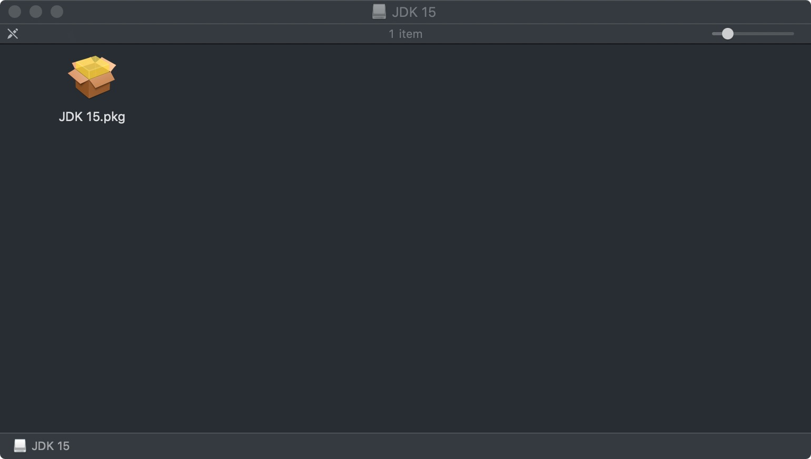disk space.

# Installation

When you build a Java application project that has a main class, the IDE automatically copies all of the JAR files on the projects classpath to your projects dist/lib folder. The IDE

also adds each of the JAR files to the Class-Path element in the application JAR files manifest file (MANIFEST.MF).

To run the project from the command line, go to the dist folder and type the following:

java -jar "berry.jar"

To distribute this project, zip up the dist folder (including the lib folder) and distribute the .zip file.

Figure 3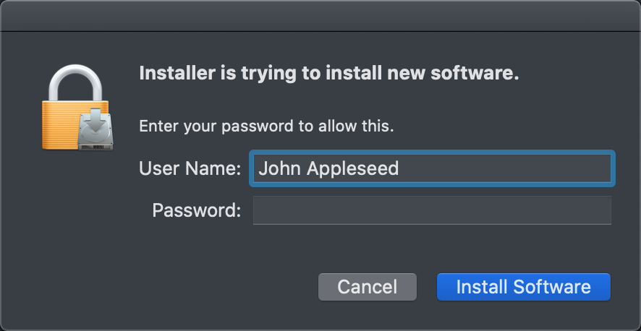

F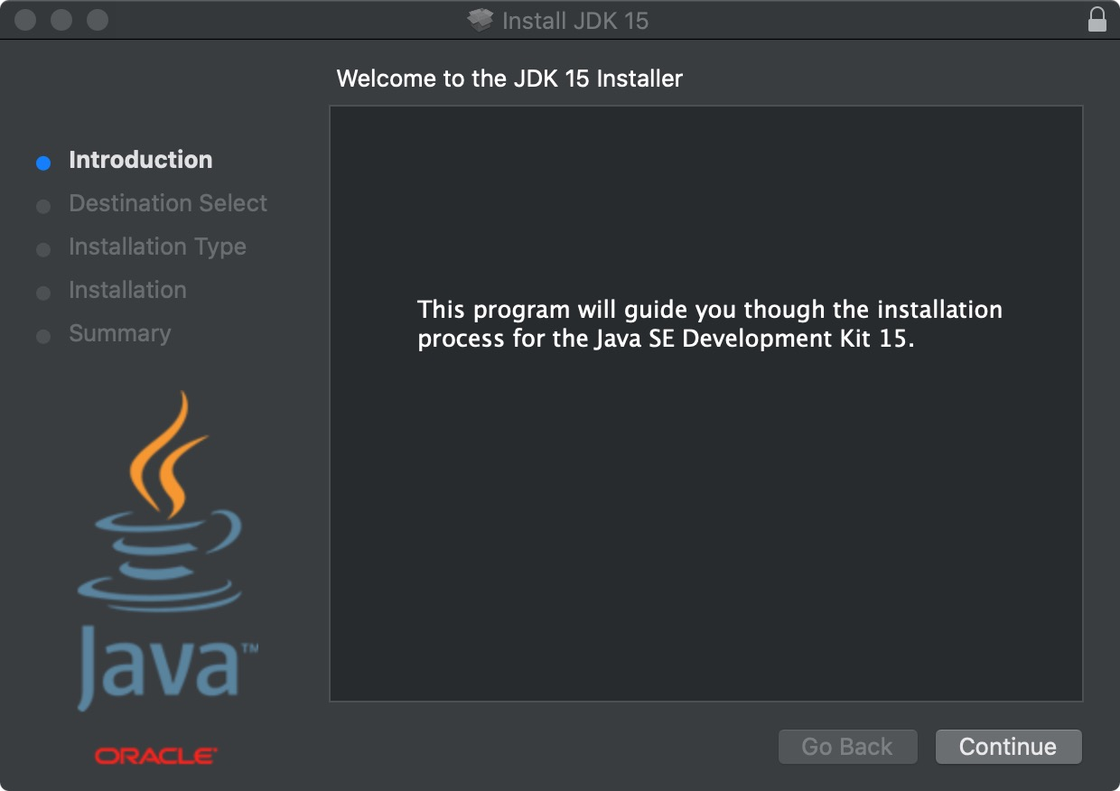igure 4

Figure 5

# User Guide

## Home Page

The home page consists of a **Record Answers** button and a **Visualization** button on the top, a chat box in the centre capturing the incoming messages from Zoom, and a text box on the bottom, where the host can choos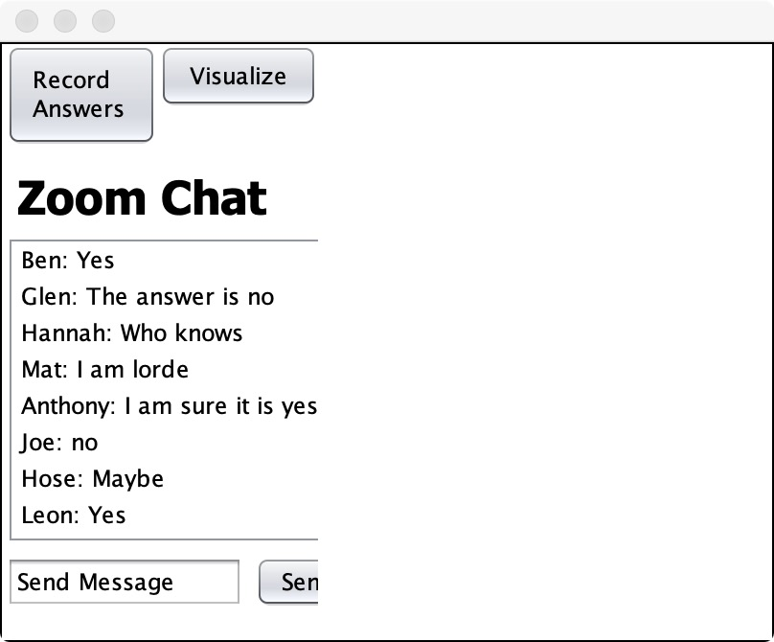e to send messages. (Figure 5)

Sending Messages

The host can send messages by inputing message in the text box, and press the **Send** button. The message will appear in the chat box, together with other incoming messages from Zoom. (Figure 6)

Figure 6

RECORDing ANSWERS

The host can press the **Record Answers** button to enable and disable the process of receiving the incoming messages from Zoom. Due to time contai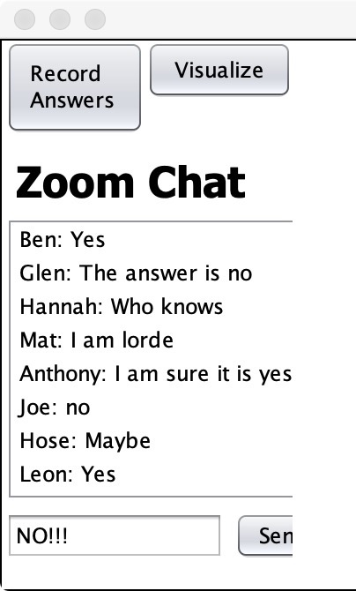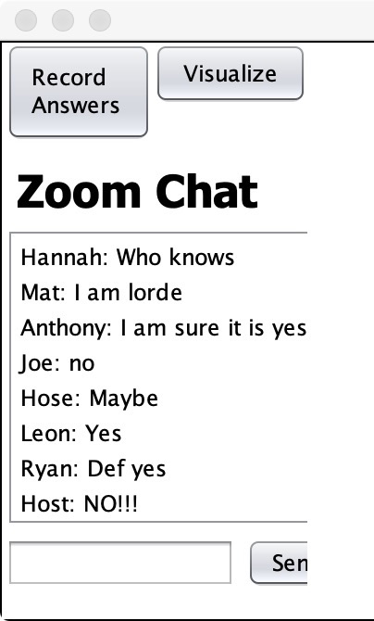ns, and the fact that this is for prototype use only, we have not yet established the connection from our product to Zoom, thus this function is temporally disabled.

Selecting Messages

The host can select the messages they would or would not like to be involved in the visualization. (Figure 7) If they find some messages are irrelevant to the question, and the algorithm did not exclude them automatically, they can do it manually.

Visualizing Answers

After the ho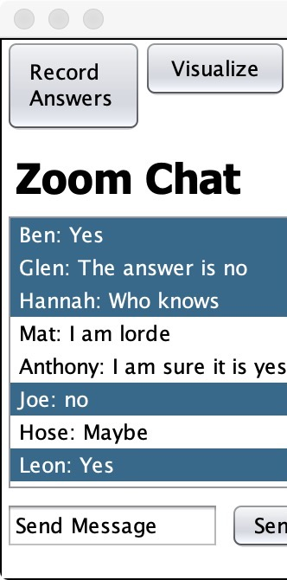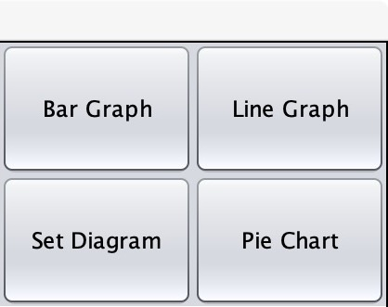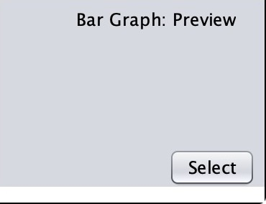st determines all the messages to highlight, they can press the **Visualize** button to choose the type of chart. (Figure 8) They can click on the type they find suitable for the particular question, and press the **Select** button, to enter the visualization page. (Figure 9)

Figure 8

Figure 9

Figure 7

## Visualization Page

The visualization page consists of a **Back** button, and a **Hide Menu** button on the top, three text boxes in the top centre area to edit the chart with a **Submit** button, and a large chart for the visualized messages on the bottom. Note that since this is for prototype use only, and we have not yet established the connection from ou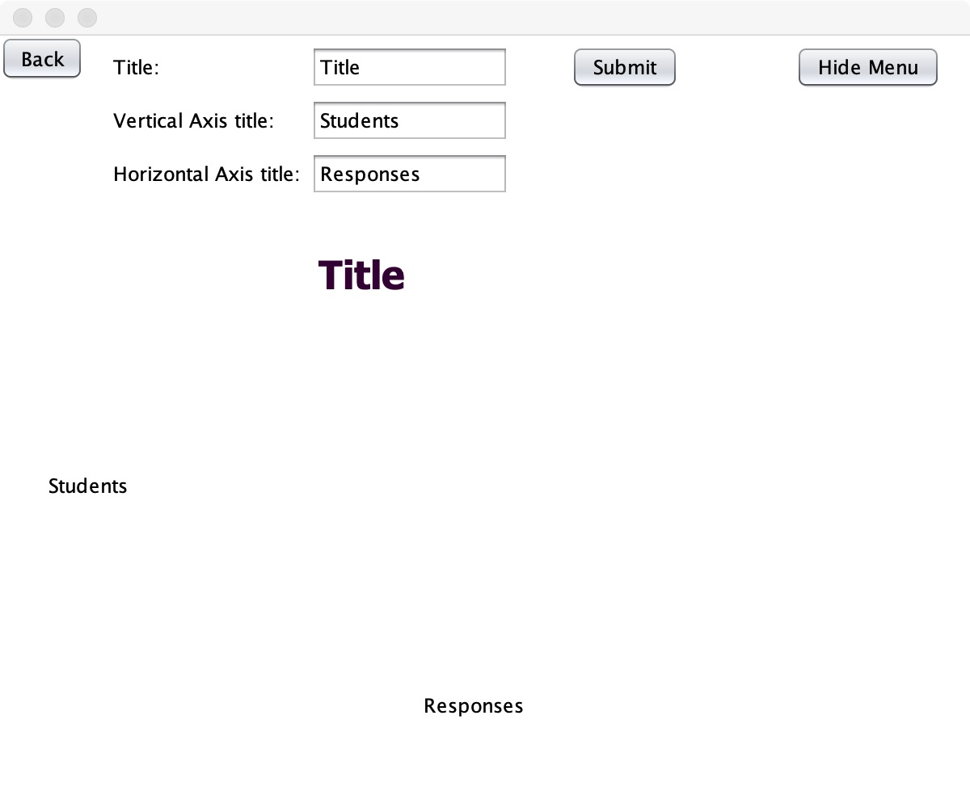r product to Zoom, thus the visualization function is also temporally disabled.

Editing the Chart

The host can edit the title and the attributes of the axis for the chart by typing into the three text boxes on top, and then pressing the **Submit** button. The information of the chart on the bottom will change accordingly. (Figure 10)

Figure 10

Hiding the Menu

The host can hide all the buttons and text boxes on the top of the window by clicking the **Hide Menu** button. (Figure 11) This enables that only the visualization is shown on the screen and shared to the audience of the video conference, without distracting the audience from the content of the conference.

Figure 11

Th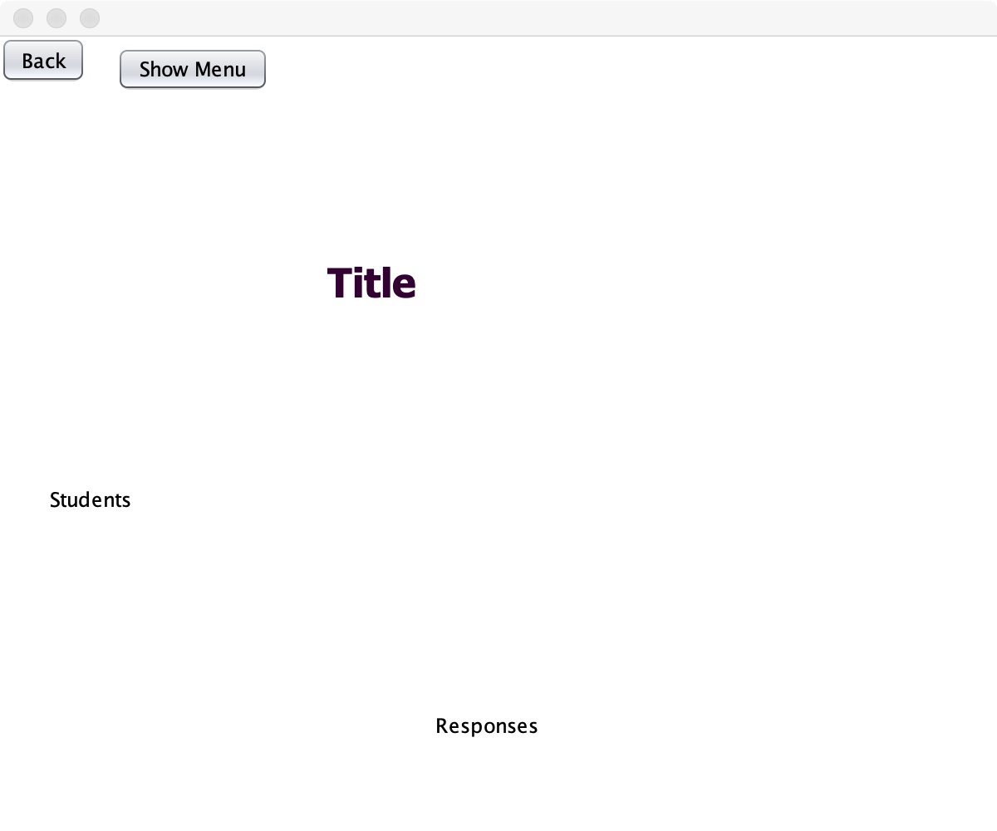ank you so much for using the computer prototype of this Zoom visualization tool. We hope that this user manual addresses all possible curiosities you may have about the system usage.

In case of any subtle discrepancy or inconsistency between the final release of the computer prototype and this user manual, the former shall prevail.