Project 1

<Guessing Password>

Name: Haolan Ye (Benjamin)

Class: CSC-5 40717

Date: 01/31/2015

**Contents**

1. **Inspiration…………………………………………......1**
2. **Introduction…………………………………………...1**
3. **Summary…………………………………………........2**
4. **Problems during coding………………………………2**
5. **Pseudo Code………………………………………...…4**
6. **System Libraries…………………………………...….4**
7. **Variable List……………………..…………..………..5**
8. **Function List...………………………………………...6**
9. **Concept Covered…..……………..………….………..6**
10. **Flowchart...………………..………………………...8**
11. **Code...……………………..………………………..13**
12. **Inspiration:**

This game is to guessing a 4-digit password. The first inspiration of making this game is from Hangman (A game of guessing words). The second inspiration is from a 4-digit coded lock of my luggage. After I travelled to a city, I forgot the password of my lock. Then, I tried lots of times to guess the pass-word. Every time after I guessed, I need to try to unlock it.

1. **Introduction:**

Different from Hangman, players should guess the numbers instead of words in Guessing Password. First, computer will generate a 4-digit number (from 0000 to 9999). Then, players only can guess one digit of password at one time. Players should input the number they guess and the digit of this number in order. Afterward, the computer will tell you whether the number and digit are wrong or not. Players only have 12 chances to guess the password. When the player guesses the number correctly, the chances won’t change. If players cannot guess all digits of password after 12 chances, the computer will display game over.

When players do not know how to play this game, they can type “s” and then press Enter to ask the computer to display the sample input of this game. Players cannot guess the same number in a specific digit after this digit has been done. Every time players input the number, they only can input a 1-digit number or “s”(for sample input).

1. **Summary:**

|  |  |
| --- | --- |
| Total Line of Code | 200 |
| Blank Line | 11 |
| Comment Line | 25 |
| Variable | 13 |
| Function | 8 |

This game contains most concepts that we have learned in the class. When I made this game, I found lots of problems that I haven’t thought about. Approximately, I spent 7 hours to code and check this game (not including documentation). I came up with the structure of this game in the 2nd week of the class. Even though I had structure early, I spent most of time to solve some difficult problems of my game.

1. **Problems during coding**
2. **Cannot generate the password that begins with 0**

At the beginning of coding this game, I used integer variables to store the password, but when I output the password, I found computer cannot generate the integer begins with 0. Therefore, I used char array to store the password. First, randomly generate char ‘0’ to ‘9’, and then store it into array.

The advantages of char array for password:

1. The computer can check whether the guess is correct more easily
2. Every digit of password can store at the specific place in the array
3. **Do not know how to check the char whether is the char array**

Before taking this class, I learned Java on YouTube by myself. In Java, there is a function that can return the index of the char in the string. But in C++, I do not know how to get the index of the char from string. Afterward, I wrote a function with for loop that returns the index of char.

1. **Record the digits that have been done**

When I test the game a couple days ago, after I guessed a digit of password correctly, I tried to input the same guess. The game still display I have guessed correct. After I input the same correct digit for 4 times, I won the game. Therefore, I have to record the digits that have been guessed correctly. Otherwise, the game will have a huge bug. I use vector to record them. After player guessed a digit of password correctly, that digit will be stored in the integer vector. Afterward, when players tried to input the same correct answer at one digit, the computer will remind the players.

1. **Pseudo Code**

Introduce the game

Randomly get a 4-digit password, store the copy of the password in string

Create dash (string)

When (chance left>0 and the number of correct guesses<4)

Display the dash and chances left

Prompt user for guess(if players need sample input, type “s”)

Check whether the number and digit are correct or not

If the number and digit both are correct

Replace the digit of dash

If this digit has been guessed correctly, remind the player

Else record this digit, and then correct guess +1

If number is correct but digit is not

Display the result of this guess

Chance left -1

If number and digit are both wrong

Display the result of this guess

Chance left -1

Output the result of this game and output to a file

1. **System Libraries**

* **<iostream>**
* **<cstdlib>**
* **<string>**
* **<vector>**
* **<fstream>**

1. **Variables List**

|  |  |  |  |
| --- | --- | --- | --- |
| Type | Variable Name | Description | Declare Location(line) |
| ofstream | output | Output to the file | 35 |
| const int | TOTCHNS | Total chance of game | 39 |
|  | SIZE | Size of the password | 40 |
| string | dash | Password look like | 41 |
|  | answer | Answer of password | 42 |
|  | dashed | String that returns to dash | 114 |
|  | part1 | Substring from the first digit to one digit before guess | 175 |
|  | part2 | Substring from one digit after guess to the end of password | 176 |
|  | str | Store the string that comes from file | 190 |
| int | times | Times player tried | 43 |
|  | gusCorr | Number of correct guess | 44 |
|  | chnsLft | How many chance left | 45 |
|  | digit | The digit of number that player guess | 46 |
| char | guess | The number player guess | 47 |
|  | pswd[SIZE] | The password that store in char array | 48 |
|  | result | The result of one guess | 70 |
| vector<int> | inputDg | Done digits | 49 |
| ifstream | input | Input the file to display onto the console | 191 |
| boolean | temp | Temp for boolean | 166,181 |

1. **Function List**

|  |  |  |  |  |
| --- | --- | --- | --- | --- |
| Type | Name | Argument | Function | Location |
| string | toDash | int | Get the dash for display | 113 |
| void | introduce | None | Introduce the game | 120 |
| void | ask | char&,int& | Prompt player for number and digit | 134 |
| char | check | char, const char[],int | check whether number and digit are correct | 154 |
| bool | indexOf | char, const char[],int | return whether the char is in the char array | 165 |
| void | replace | string&,char,int | replace of the correct digit | 174 |
| bool | inside | const vector<int>,int | return whether this digit is finished | 180 |
| void | sample | None | display the sample of guessing | 189 |

1. **Concept covered**

|  |  |  |  |
| --- | --- | --- | --- |
| Concept | Type | Code | Location(line) |
| Input / Output | cout | cout<<endl | 66 |
|  | cin | cin>>guess | 138 |
| Variables | int, char,string, ifstream,ofsreamt | int times=0 | 43 |
| Comment |  | //system Libraries | 8 |
| Type casting | static_cast<type> | static_cast<unsigned short>(time(0)) | 33 |
| Making decisions | if | if(chnsLft==0) | 98 |
|  | if-else | if(inside(inputDg,digit))  else | 74 |
|  | if-else-if | if(guess==pswd[digit-1])  else if(indexOf(guess,pswd,size))  else | 156 |
|  | switch | switch(result) | 71 |
| Loop | for | for(int i=0;i<SIZE;i++) | 54 |
|  | while | while(chnsLft>0&&gusCorr<SIZE) | 64 |
|  | do-while | do {} while (guess<48||guess>57) | 135 |
| File I/O | ifstream | ifstream input;  input.open("Sample.dat"); | 191 |
|  | ofstream | ofstream output;  output.open("Times.dat"); | 35 |
| Function | void, int, string, char, bool | string toDash(int) | 21 |
| Array | char[] | char pswd[SIZE]={} | 48 |
| vector | vector<int> | vector<int> inputDg(SIZE,5) | 49 |

1. **Flowchart (1)main flowchart(3 pages)**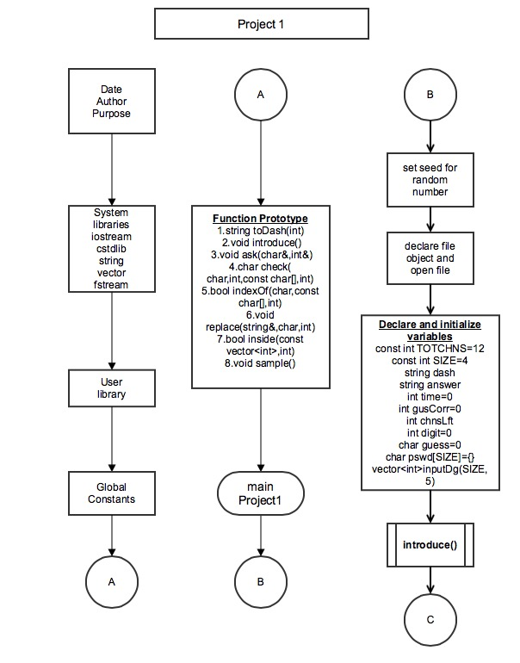

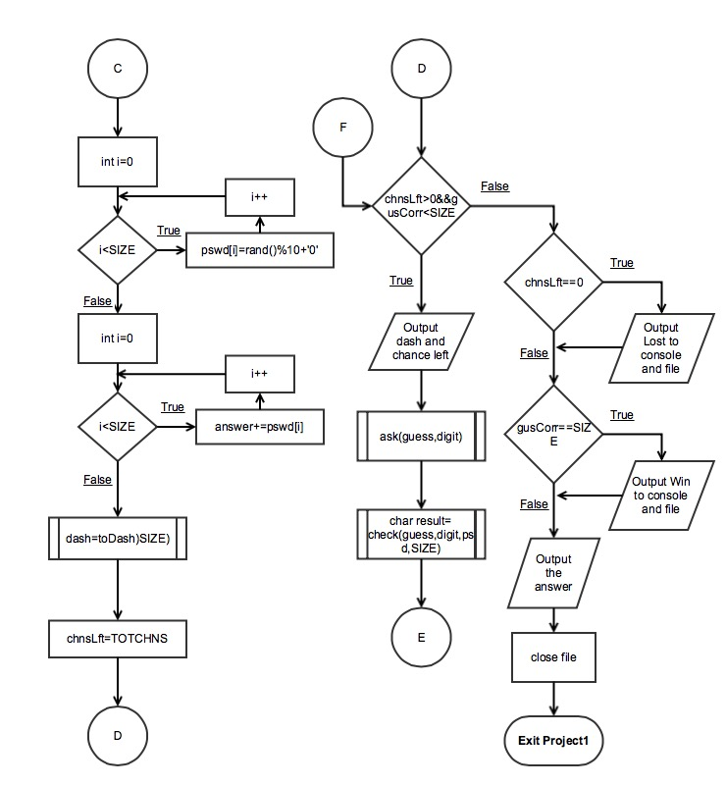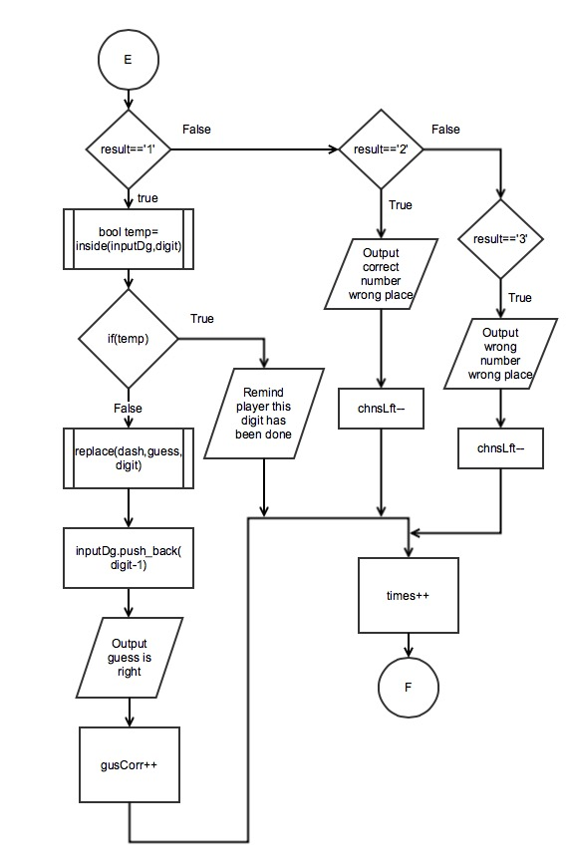

**(2) Function flowchart(2 pages)**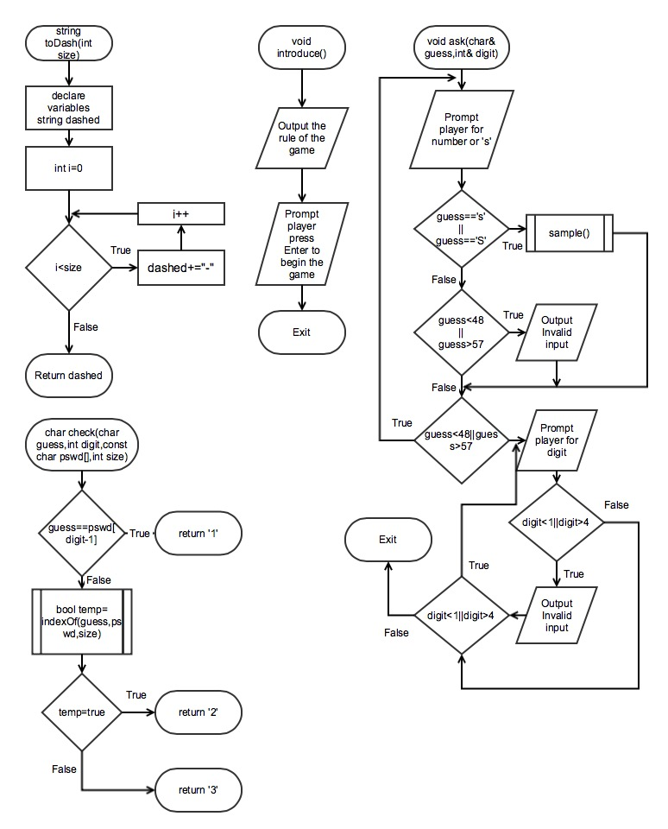

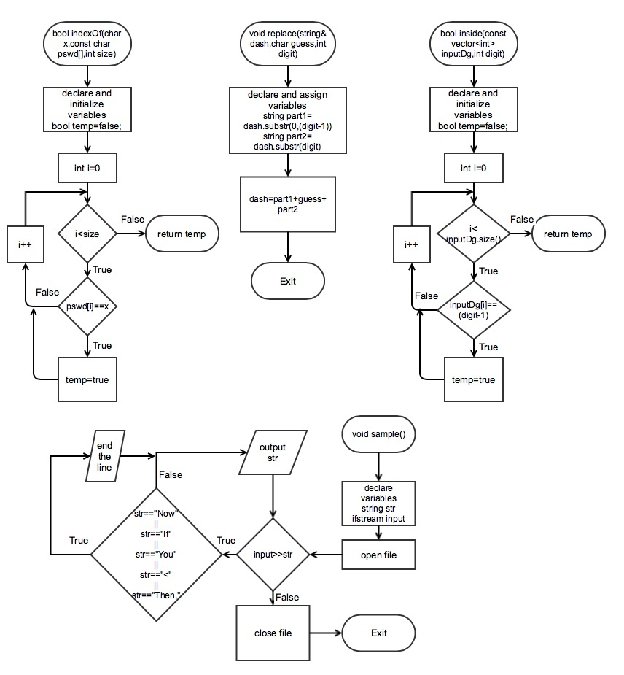

**11. Code**

/*

* File: main.cpp

* Author: Haolan Ye(Benjamin)

* Created on January 27, 2015, 12:32 PM

* Purpose: Project1(Name of the game:Bomb Password)

*/

//system Libraries

#include <iostream>

#include <cstdlib> //for random number

#include <string>

#include <vector>

#include <fstream> //file I/O

using namespace std;

//User Libraries

//Global Constants

//Function Prototypes

string toDash(int);//change the password to dash

void introduce();//introduce the game

void ask(char&,int&);//ask user for guessing

char check(char,int,const char[],int);//check whether number and digit are correct

bool indexOf(char,const char[],int);//return whether the char is in the char array

void replace(string&,char,int);//replace of the correct digit

bool inside(const vector<int>,int);//return whether this digit is finished

void sample();//display the sample of guessing

//Execution begins here

int main(int argc, char** argv) {

//set seed for random number

srand(static_cast<unsigned short>(time(0)));

//declare a file object

ofstream output;

//open the file

output.open("Times.dat");

//declare and initialize variables

const int TOTCHNS=12;//total chance of the game

const int SIZE=4;//the size of the char array

string dash;

string answer;

int times=0; //how many times user tried

int gusCorr=0;//how many correct number have been guessed

int chnsLft; //chance counter(how many chances left)

int digit=0; //digit of the user guesses

char guess=0; //the number user guesses

char pswd[SIZE]={};//the password store in the array

vector<int> inputDg(SIZE,5);//the digits finished

//introduce the game

introduce();

//get a random 4-digit password and put it in array

for(int i=0;i<SIZE;i++) {

pswd[i]=rand()%10+'0';

}

//Use for loop get the password into strings

for(int i=0;i<SIZE;i++) {

answer+=pswd[i];

}

dash=toDash(SIZE);//get the dash

chnsLft=TOTCHNS;

//game begins

while(chnsLft>0&&gusCorr<SIZE) {

//Prompt user for the guess

cout<<endl;

cout<<"The password now looks like this: "<<dash<<endl;//Output dash

cout<<"You have "<<chnsLft<<" chances left"<<endl;//output chances left

ask(guess,digit);//Prompt user for guess

char result=check(guess,digit,pswd,SIZE);//check the guess

switch(result) {

case'1': { //if the number and place both are correct

if(inside(inputDg,digit)) { //if user have finished that digit

cout<<"You already finish this digit,"

<<"try other digits"<<endl;

} else {//user didn't finish this digit

replace(dash,guess,digit);//replace of the correct digit

inputDg.push_back(digit-1);//record the digit which has been finished to vector

cout<<"Your guess is correct."<<endl;

gusCorr++;

}

break;

}

case'2': { //if number is correct but digit is wrong

cout<<"This is the correct number but in wrong place."<<endl;

chnsLft--;

break;

}

case'3': { //if number and digit both wrong

cout<<"Wrong number and wrong place."<<endl;

chnsLft--;

break;

}

default:;

}

times++;//keep track of how many times user have input

}

if(chnsLft==0) { //No chances left for player

cout<<"You lost"<<endl;

output<<"You lost"<<endl;

}

if(gusCorr==SIZE) { //when 4 digits have been guessed correctly

output<<"You win this game after "<<times<<" tries"<<endl;

cout<<"You win this game after "<<times<<" tries"<<endl;

}

cout<<"The answer is "<<answer<<endl;

output.close();

//Exit stage right

return 0;

}

string toDash(int size) {

string dashed="";

for(int i=0;i<size;i++) {

dashed+="-";

}

return dashed;

}

void introduce() {

cout<<"***************** Welcome to Bomb password *****************"<<endl;

cout<<"* In this game, you should guess the 4-digit password *"<<endl;

cout<<"* First, you will input a number that you guess *"<<endl;

cout<<"* Then, you will input the digit of this number *"<<endl;

cout<<"* The digit of the number from left to right is 1,2,3,4 *"<<endl;

cout<<"* After you input these two information,the computer *"<<endl;

cout<<"* will tell you whether the number and digit are correct *"<<endl;

cout<<"* Attention: some digits of password may be the same number*"<<endl;

cout<<"************************************************************"<<endl;

cout<<"Press Enter to start the game";

cin.ignore();

}

void ask(char& guess,int& digit) {

do {

cout<<"Please input a number you guess"<<endl;

cout<<"If you need sample for input, type \'s\'"<<endl;

cin>>guess;

cin.ignore();

if(guess=='s'||guess=='S') //when player need sample

sample(); //output sample via ifstream

else if(guess<48||guess>57)

cout<<"Invalid input"<<endl<<endl;

} while(guess<48||guess>57);

do {

cout<<"Please input the digit of this number"<<endl;

cin>>digit;

cin.ignore();

if(digit<1||digit>4)

cout<<"Invalid input"<<endl<<endl;

} while(digit<1||digit>4);

}

char check(char guess,int digit,const char pswd[],int size) {

//Because array counts from 0,but digit from left to right is 1,2,3,4,so it need digit-1 for array

if(guess==pswd[digit-1]) { //when guess and digit are correct

return '1';

} else if(indexOf(guess,pswd,size)) { //number is right but digit is wrong

return '2';

} else { //both are wrong

return '3';

}

}

//return whether the char is in the array

bool indexOf(char x,const char pswd[],int size) {

bool temp=false;

for(int i=0;i<size;i++) {

if(pswd[i]==x)

temp=true;

}

return temp;

}

void replace(string& dash,char guess,int digit) {

string part1=dash.substr(0,(digit-1));

string part2=dash.substr(digit);

dash=part1+guess+part2;

}

//return whether is digit has been finished

bool inside(const vector<int> inputDg,int digit) {

bool temp=false;

for(int i=0;i<inputDg.size();i++) {

if(inputDg[i]==(digit-1))

temp=true;

}

return temp;

}

//display sample via file

void sample() {

string str;

ifstream input;

input.open("Sample.dat");

while(input>>str) {

if(str=="Now"||str=="If"||str=="You"||str=="<"||str=="Then,")

cout<<endl;

cout<<str<<' ';

}

cout<<endl<<endl;

input.close();

}