Project 1

<Guessing Password>

<Version 2.0>

Name: Haolan Ye (Benjamin)

Class: CSC-5 40717

Date: 02/11/2015

**Contents**

1. **Inspiration…………………………………………......2**
2. **Introduction…………………………………………...2**
3. **Summary…………………………………………........3**
4. **Problems during coding………………………………3**
5. **Pseudo Code………………………………………...…5**
6. **Screen shot…………..………………..…………..........6**
7. **System Libraries…………………………………...….9**
8. **Variable List……………………..…………..………..9**
9. **Function List...………………………………..……...11**
10. **Concept Covered…..………….……..……..……....12**
11. **Flowchart...………………..………………………..14**
12. **Code...……………………..………………………..22**
13. **Inspiration:**

This game is to guessing a 4 or 6-digit password. The first inspiration of making this game is from Hangman (A game of guessing words). The second inspiration is from a 4-digit coded lock of my luggage. After I travelled to a city, I forgot the password of my lock. Then, I tried lots of times to guess the password. Every time after I guessed, I need to try to unlock it.

1. **Introduction:**

Different from Hangman, players should guess the numbers instead of words in Guessing Password. There are three different levels (Easy, Medium, and Hard) for players to select. First, according to the level that players choose, computer will randomly generate a 4-digit number (from 0000 to 9999) for level 1 & 2, 6-digit number (from 000000 to 999999) for level 3. Then, for every level, players only can guess one digit of password at one time. Players should input a number they guess and the digit of this number in order. Afterward, the computer will tell you whether the number and digit are wrong or not. Players only have 12 (level 1&2)/18 (level 3) chances to guess the password. When the player guesses the number correctly, the chances left won’t count down. At the end of the game, Top 10 records will be displayed.

On Easy level, when players do not know how to play this game, they can type “s” and then press Enter to ask the computer to display the sample input of this game. On Medium and Hard level, players have one time to type “h” if they want to get the hint for a digit of password. The hint will be changed to binary number. Players cannot guess the same number in a specific digit after this digit has been done.

1. **Summary:**

|  |  |
| --- | --- |
| Total Line of Code | 377 |
| Blank Line | 8 |
| Comment Line | 33 |
| Variable | 26 |
| Function | 13 |

This game contains most concepts that we have learned in the class. When I made this game, I found lots of problems that I haven’t thought about. I came up with the structure of this game in the 2nd week of the class. Even though I had structure early, I spent most of time to solve some difficult problems of my game. Different from Version 1, version 2 has 3 different levels for players to select. In addition, version 2 can record how long players finished their game. At the end of the game, Top 10 Records will be outputted.

1. **Problems during coding**
2. **Cannot generate the password that begins with 0**

At the beginning of coding this game, I used integer variables to store the password, but when I output the password, I found computer cannot generate the integer begins with 0. Therefore, I used char array to store the password. First, randomly generate char ‘0’ to ‘9’, and then store it into array.

The advantages of char array for password:

1. The computer can check whether the guess is correct more easily
2. Every digit of password can store at the specific place in the array
3. **Do not know how to check the char whether is the char array**

Before taking this class, I learned Java on YouTube by myself. In Java, there is a function that can return the index of the char in the string. But in C++, I do not know how to get the index of the char from string. Afterward, I wrote a function with for loop that returns the index of char.

1. **Record the digits that have been done**

When I test the game a couple days ago, after I guessed a digit of password correctly, I tried to input the same guess. The game still display I have guessed correct. After I input the same correct digit for 4 times, I won the game. Therefore, I have to record the digits that have been guessed correctly. Otherwise, the game will have a huge bug. I use vector to record them. After player guessed a digit of password correctly, that digit will be stored in the integer vector. Afterward, when players tried to input the same correct answer at one digit, the computer will remind the players.

1. **Hint**

In order to make the game easy for everyone, I tried to give the hint to players. After I did that, I found the hint could be displayed every time that players type “h”. Also, giving the accurate number of a digit is so easy for everyone. Therefore, I create a new variable to keep track of how many hints used. And then, I write a new function to display the hint in binary number.

1. **Pseudo Code**

Introduce the game

Prompt players for level selection

According to level that player selects, randomly generate password, stores the copy of the password in string

Create dash (string)

Get the current time

When (chance left>0 and the number of correct guesses<size of password)

Do (

Display the dash and chances left

Prompt user for guess (Easy level, if players need sample input, type “s”)

(Medium and Hard level, if players need hint, type “h”)

) Until players input number and digit correctly

Check whether the number and digit are correct or not

If the number and digit both are correct

Replace the digit of dash

If this digit has been guessed correctly, remind the player

Else record this digit, and then correct guess +1

If number is correct but digit is not

Display the result of this guess

Chance left -1

If number and digit are both wrong

Display the result of this guess

Chance left -1

If player wins the game, save the playing time to file, and sort the file

Output the result of this game and output to a file

Display Top 10 Records

1. **Screen Shot**
2. **Select the level**

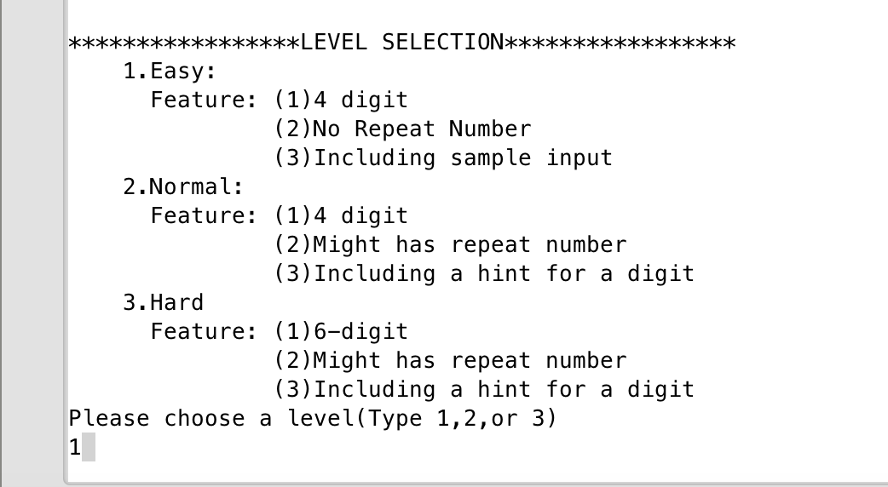**(2) Guess the number (Wrong guess)**

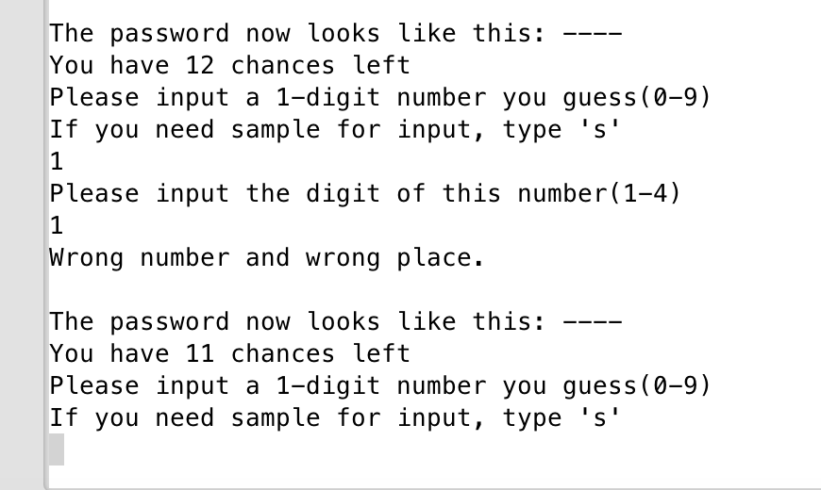

**(3) Guess number (correct number wrong place)**

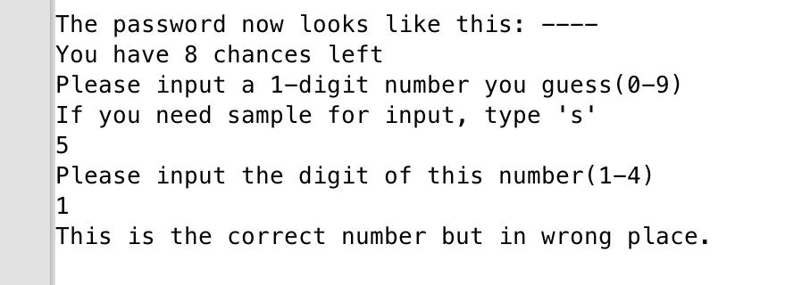

**(4) Guess number (correct)**

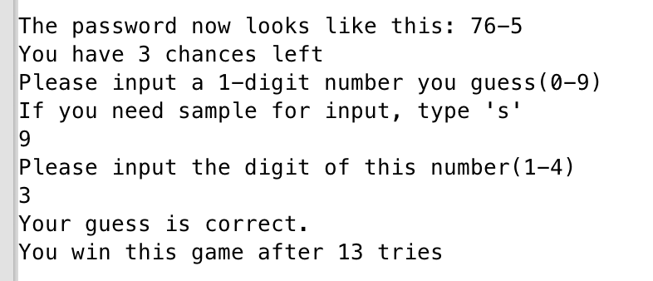

**(5) Display the Record**

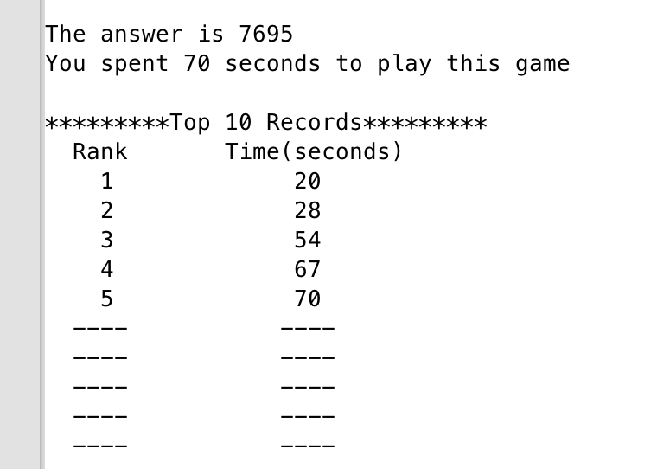

**(6) Display the sample input**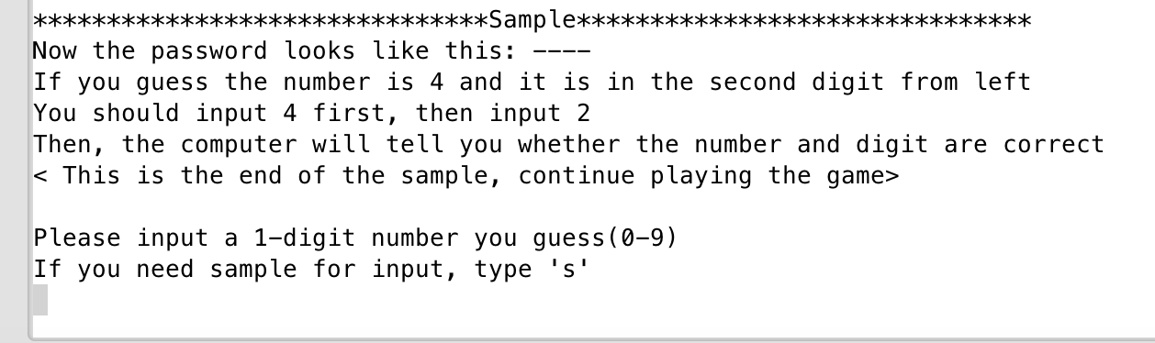

**(7) Display the hint**

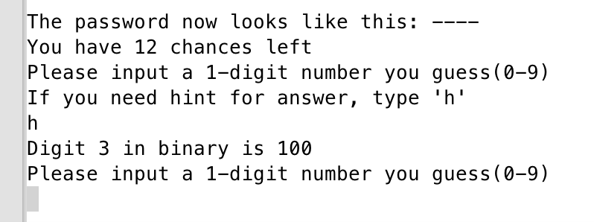

1. **System Libraries**

* **<iostream>**
* **<cstdlib>**
* **<string>**
* **<vector>**
* **<fstream>**
* **<iomanip>**

1. **Variables List**

|  |  |  |  |
| --- | --- | --- | --- |
| Type | Variable Name | Description | Declare Location(line) |
| ofstream | output | Output to the file | 42,344 |
| const int | TOTCHNS1 | Total chance for level 1&2 | 46 |
|  | TOTCHNS2 | Total chance for level 3 | 47 |
|  | SIZE1 | Size of the password (level 1&2) | 48 |
|  | SIZE2 | Size of the password (level 3) | 49 |
|  | COL | Column of 2 dimension array | 20 |
| string | dash | Password look like | 50 |
|  | answer | Answer of password | 51 |
|  | dashed | String that returns to dash | 160 |
|  | part1 | Substring from the first digit to one digit before guess | 231 |
|  | part2 | Substring from one digit after guess to the end of password | 232 |
|  | str | Store the string that comes from file | 246 |
| int | size | Size of password depends on level | 52 |
|  | level | Level of the game player select | 53 |
|  | tyTime | Times player tried | 54 |
|  | strTime | The time when game begins | 55 |
|  | endTime | The time when game end | 56 |
|  | usdTime | End time – starting time | 57 |
|  | gusCorr | Number of correct guess | 58 |
|  | chnsLft | How many chance left | 59 |
|  | hin | Hint of a digit of password | 60 |
|  | digit | The digit of number that player guess | 61 |
|  | temp | Temp for int | 284 |
|  | tip | The tip that will be display | 285 |
|  | rm | Remainder | 305 |
|  | rs | Result for conversion to binary | 306 |
| char | guess | The number player guess | 62 |
|  | pswd[SIZE2] | The password that store in char array | 63 |
|  | temp | Temp for random number | 262 |
|  | result | The result of one guess | 111 |
| vector<int> | inputDg | Done digits | 64 |
|  | ary | For binary conversion | 308 |
|  | tmRecd | Record of the time | 322 |
| ifstream | input | Input the file | 247,358 |
| boolean | temp | Temp for boolean | 222,237,259,286 |
| int[][] | rc | Records of player | 356 |

1. **Function List**

|  |  |  |  |  |
| --- | --- | --- | --- | --- |
| Type | Name | Argument | Function | Location |
| string | toDash | int | Get the dash for display | 159 |
| void | introduce | None | Introduce the game | 167 |
| void | gtPswd | char[],int,const int,const int | According to level, generate password | 258 |
| void | ask | char&,int&, int, int  vector<int>,char[],int& | Prompt player for number and digit | 181 |
| char | check | char, const char[],int | check whether number and digit are correct | 210 |
| bool | indexOf | char, const char[],int | return whether the char is in the char array | 221 |
| void | replace | string&,char,int | replace of the correct digit | 230 |
| bool | inside | const vector<int>,int | return whether this digit is finished | 236 |
| void | sample | None | display the sample of guessing | 245 |
| void | hint | vector<int>,char[],int | display the hint for players | 283 |
| int | bin | int | Change a number to binary | 304 |
| void | record | int | save the top 10 player record | 321 |
| void | dspRecd | None | Display the top 10 record | 352 |

1. **Concept covered**

|  |  |  |  |
| --- | --- | --- | --- |
| Concept | Type | Code | Location(line) |
| Input / Output | cout | cout<<endl | 70 |
|  | cin | cin>>guess | 188 |
| Variables | int, char,string, ifstream,ofsream | int level | 53 |
| Comment |  | //system Libraries | 8 |
| Type casting | static_cast<type> | static_cast<unsigned short>(time(0)) | 40 |
| Making decisions | if | if(level==1) | 184 |
|  | if-else | if(ipDg.size()!=0)  else | 284 |
|  | if-else-if | if(guess==pswd[digit-1])  else if(indexOf(guess,pswd,size))  else | 212 |
|  | switch | switch(result) | 112 |
| Loop | for | for(int i=0;i<size;i++) | 161 |
|  | while | while(chnsLft>0&&gusCorr<size) | 105 |
|  | do-while | do {} while (guess<48||guess>57) | 182 |
| File I/O | ifstream | ifstream input;  input.open("Sample.dat"); | 247 |
|  | ofstream | ofstream output;  output.open("Record.dat"); | 344 |
| Function | void, int, string, char, bool | string toDash(int) | 23 |
| Array | char[] | char pswd[SIZE2]={} | 63 |
|  | int [][] | int rc[ROW][COL]={} | 356 |
| vector | vector<int> | vector<int> inputDg | 64 |
| Sorting | Sorting | for(int i=0;i<tmRecd.size()-1;i++) {  for(int j=i+1;j<tmRecd.size();j++) {  if(tmRecd[i]>tmRecd[j]) {  int temp=tmRecd[i];  tmRecd[i]=tmRecd[j];  tmRecd[j]=temp;  }  }  } | 334 |
| Search | search | bool temp=false;  for(int i=0;i<inputDg.size();i++) {  if(inputDg[i]==(digit-1))  temp=true;  }  return temp; | 237 |
| Formatt Output | setw() | cout<<setw(5)<<rc[i][j]<<" "; | 371 |
| Random number | char | srand(static_cast<unsigned short>(time(0)));  temp=rand()%10+'0'; | 40,290 |
| Pass array to function | function | void gtPswd(char [],int,const int,const int) | 25 |

1. **Flowchart (1)main flowchart(3 pages)**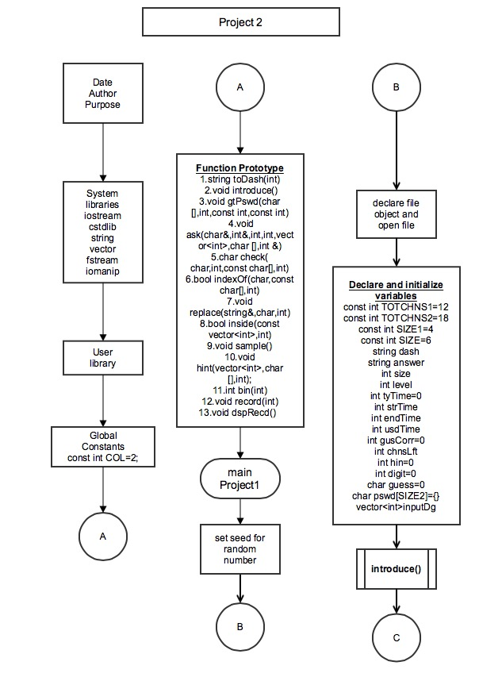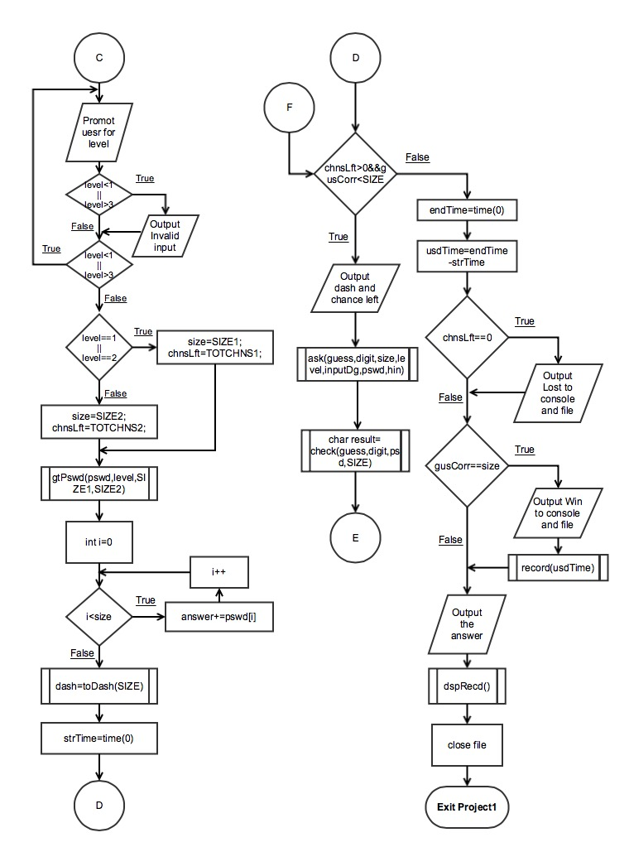

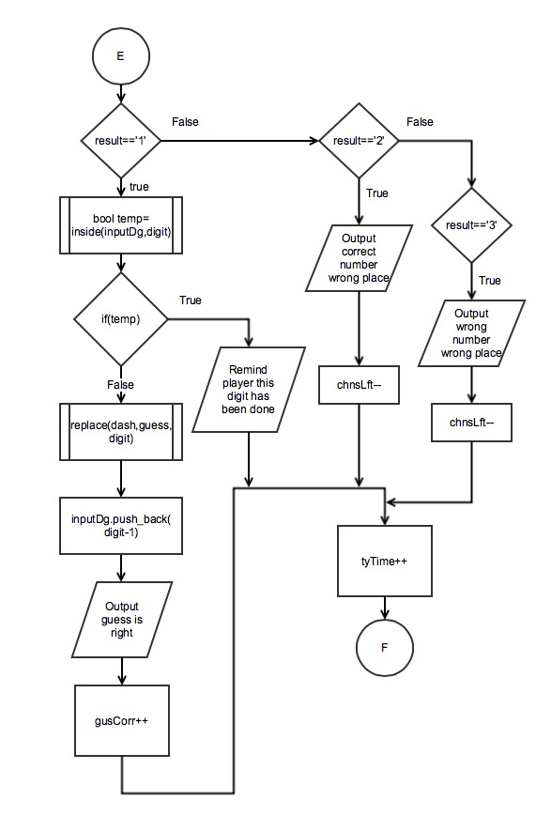

**(2) Function flowchart(5 pages)**

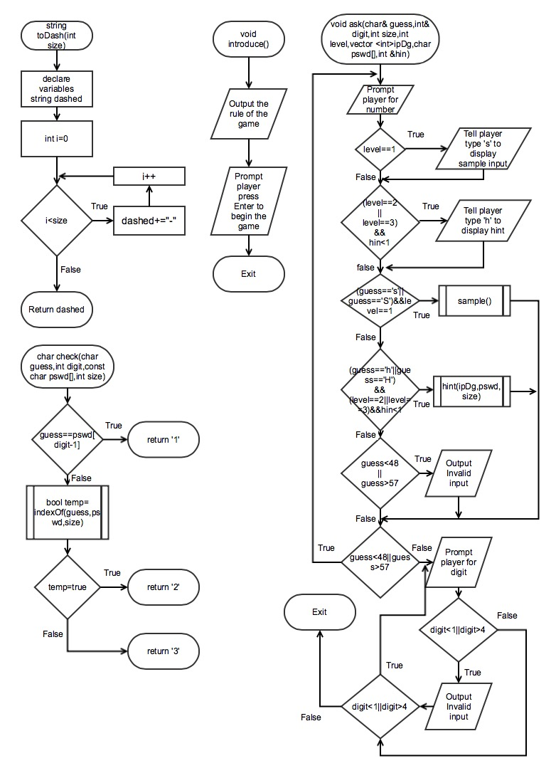

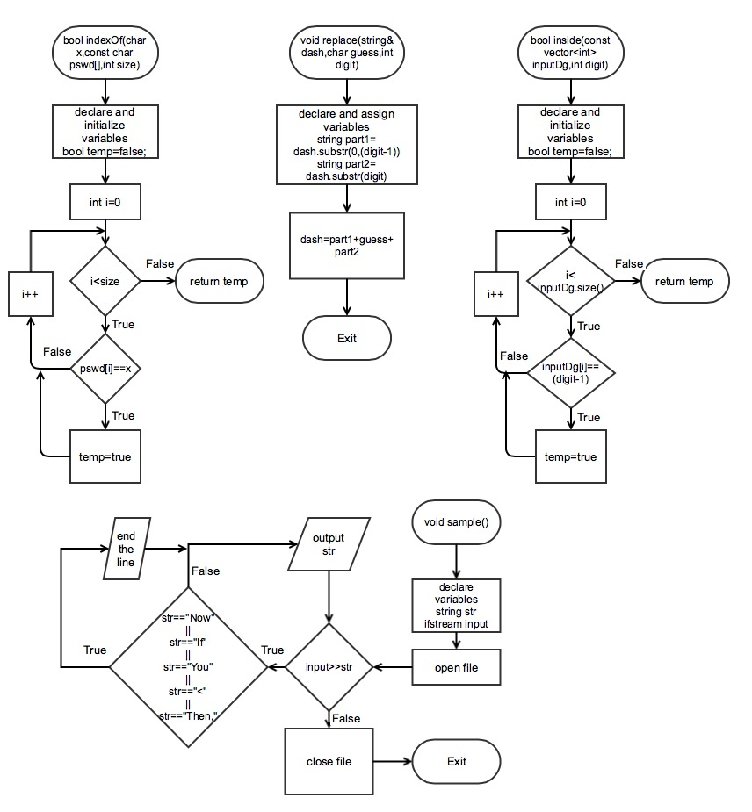

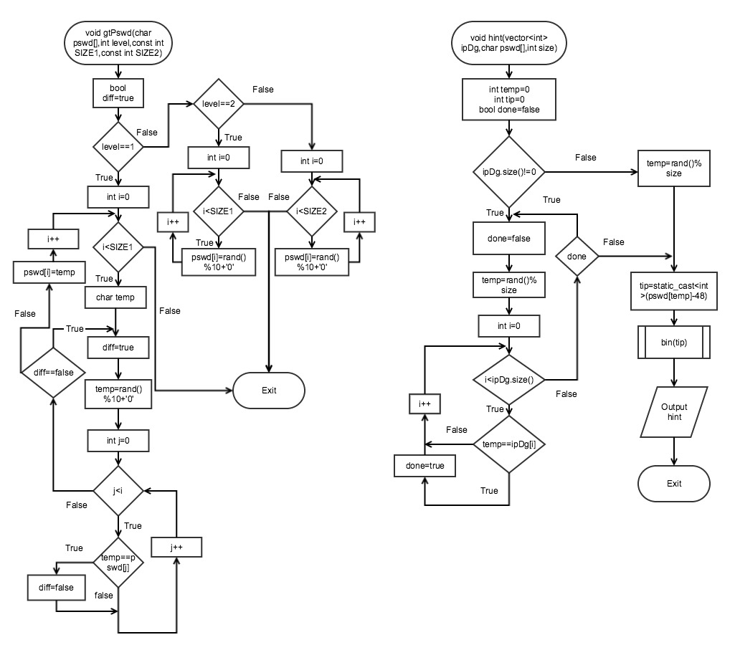

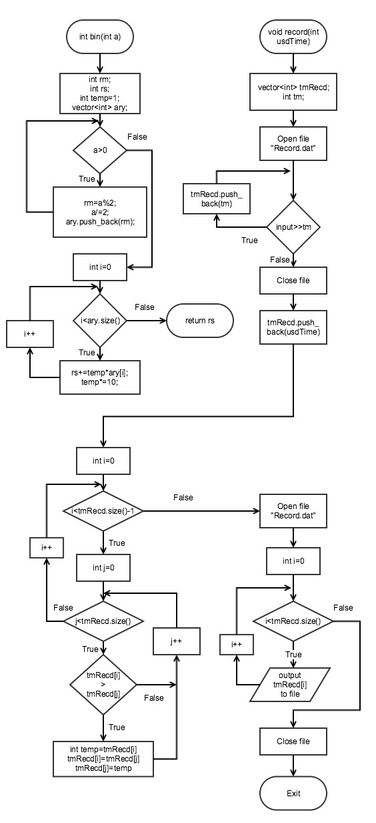

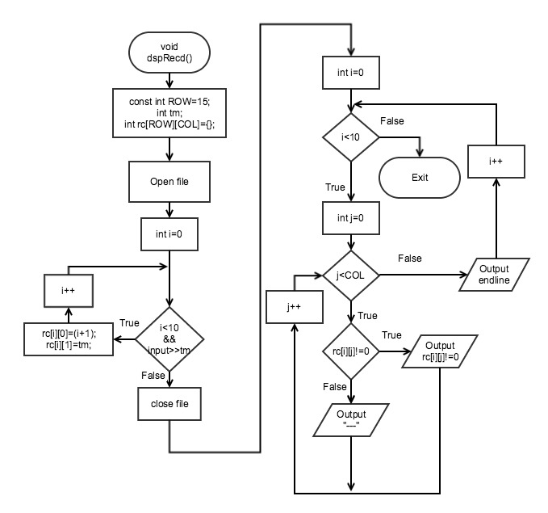

**12. Code**

/*

* File: main.cpp

* Author: Haolan Ye(Benjamin)

* Created on January 27, 2015, 12:32 PM

* Purpose: Project2(Name of the game:Bomb Password)

*/

//system Libraries

#include <iostream>

#include <cstdlib> //for random number

#include <string>

#include <vector>

#include <fstream> //file I/O

#include <iomanip>

using namespace std;

//User Libraries

//Global Constants

const int COL=2;//For 2-dimension array

//Function Prototypes

string toDash(int);//change the password to dash

void introduce();//introduce the game

void gtPswd(char [],int,const int,const int);

void ask(char&,int&,int,int,vector<int>,char [],int &);//ask user for guessing

char check(char,int,const char[],int);//check whether number and digit are correct

bool indexOf(char,const char[],int);//return whether the char is in the char array

void replace(string&,char,int);//replace of the correct digit

bool inside(const vector<int>,int);//return whether this digit is finished

void sample();//display the sample of guessing

void hint(vector<int>,char [],int);//display the hint for players

int bin(int);//change an integer to binary

void record(int);//save the top 10 player record

void dspRecd();//Display the top 10 record

//Execution begins here

int main(int argc, char** argv) {

//set seed for random number

srand(static_cast<unsigned short>(time(0)));

//declare a file object

ofstream output;

//open the file

output.open("Times.dat");

//declare and initialize variables

const int TOTCHNS1=12;//total chance of the level 1 and 2

const int TOTCHNS2=18;//total chance of the level 3

const int SIZE1=4;//smaller size

const int SIZE2=6;//larger size

string dash;

string answer;

int size;

int level;

int tyTime=0; //how many tyTime user tried

int strTime; //start time of the game

int endTime; //ending time of the game

int usdTime; //total time player play the game

int gusCorr=0;//how many correct number have been guessed

int chnsLft; //chance counter(how many chances left)

int hin=0;//count how many times player use hint

int digit=0; //digit of the user guesses

char guess=0; //the number user guesses

char pswd[SIZE2]={};//the password store in the array

vector<int> inputDg;//the digits finished

//introduce the game

introduce();

//Prompt user for level

do {

cout<<endl<<"*****************LEVEL SELECTION*****************"<<endl;

cout<<" 1.Easy:"<<endl;

cout<<" Feature: (1)4 digit"<<endl;

cout<<" (2)No Repeat Number"<<endl;

cout<<" (3)Including sample input"<<endl;

cout<<" 2.Normal:"<<endl;

cout<<" Feature: (1)4 digit"<<endl;

cout<<" (2)Might has repeat number"<<endl;

cout<<" (3)Including a hint for a digit"<<endl;

cout<<" 3.Hard"<<endl;

cout<<" Feature: (1)6-digit"<<endl;

cout<<" (2)Might has repeat number"<<endl;

cout<<" (3)Including a hint for a digit"<<endl;

cout<<"Please choose a level(Type 1,2,or 3)"<<endl;

cin>>level;

if(level<1||level>3)

cout<<"Invalid Input"<<endl;

}while(level<1||level>3);

//According to level that player chose, set the size of pswd and chances left

if(level==1||level==2) {

size=SIZE1;

chnsLft=TOTCHNS1;

} else {

size=SIZE2;

chnsLft=TOTCHNS2;

}

//get a random password and put it in array

gtPswd(pswd,level,SIZE1,SIZE2);

//Use for loop get the password into strings

for(int i=0;i<size;i++) {

answer+=pswd[i];

}

dash=toDash(size);//get the dash

strTime=time(0);//record beginning time

//game begins

while(chnsLft>0&&gusCorr<size) {

//Prompt user for the guess

cout<<endl;

cout<<"The password now looks like this: "<<dash<<endl;//Output dash

cout<<"You have "<<chnsLft<<" chances left"<<endl;//output chances left

ask(guess,digit,size,level,inputDg,pswd,hin);//Prompt user for guess

char result=check(guess,digit,pswd,size);//check the guess

switch(result) {

case'1': { //if the number and place both are correct

if(inside(inputDg,digit)) { //if user have finished that digit

cout<<"You already finished this digit,"

<<"try other digits"<<endl;

} else {//user didn't finish this digit

replace(dash,guess,digit);//replace of the correct digit

inputDg.push_back(digit-1);//record the digit which has been finished to vector

cout<<"Your guess is correct."<<endl;

gusCorr++;

}

break;

}

case'2': { //if number is correct but digit is wrong

cout<<"This is the correct number but in wrong place."<<endl;

chnsLft--;

break;

}

case'3': { //if number and digit both wrong

cout<<"Wrong number and wrong place."<<endl;

chnsLft--;

break;

}

default:;

}

tyTime++;//keep track of how many tyTime user have input

}

endTime=time(0);

usdTime=endTime-strTime;//Get the used time

if(chnsLft==0) { //No chances left for player

cout<<"You lost"<<endl;

output<<"You lost"<<endl;

}

if(gusCorr==size) { //when 4 digits have been guessed correctly

output<<"You win this game after "<<tyTime<<" tries"<<endl;

cout<<"You win this game after "<<tyTime<<" tries"<<endl;

record(usdTime);

}

cout<<endl<<"The answer is "<<answer<<endl;

cout<<"You spent "<<usdTime<<" seconds to play this game"<<endl<<endl;

dspRecd();//display the record

output.close();

//Exit stage right

return 0;

}

//According to level,generate the dash that will be displayed

string toDash(int size) {

string dashed="";

for(int i=0;i<size;i++) {

dashed+="-";

}

return dashed;

}

//Introduction and Rule of the game

void introduce() {

cout<<"****************** Welcome to Bomb password *******************"<<endl;

cout<<"* In this game, you should guess the 4 or 6-digit password *"<<endl;

cout<<"* First, you will input only one number that you guess *"<<endl;

cout<<"* Then, you will input the digit of this number *"<<endl;

cout<<"* The digit of the number from left to right is 1,2,3... *"<<endl;

cout<<"* After you input these two information,the computer *"<<endl;

cout<<"* will tell you whether the number and digit are correct *"<<endl;

cout<<"* If your guess is correct, your chances left won't count down*"<<endl;

cout<<"***************************************************************"<<endl;

cout<<"Press Enter to start the game";

cin.ignore();

}

//ask user for guessing

void ask(char& guess,int& digit,int size,int level,vector <int>ipDg,char pswd[],int &hin) {

do {

cout<<"Please input a 1-digit number you guess(0-9)"<<endl;

if(level==1)

cout<<"If you need sample for input, type \'s\'"<<endl;

if((level==2||level==3)&&hin<1)

cout<<"If you need hint for answer, type \'h\'"<<endl;

cin>>guess;

cin.ignore();

if((guess=='s'||guess=='S')&&level==1) { //when player need sample

sample();//output sample via ifstream

} else if((guess=='h'||guess=='H')&&(level==2||level==3)&&hin<1) {

//when player needs hint

//limit only 1 hint player can get

hint(ipDg,pswd,size);//display the hint

hin++;

} else if(guess<48||guess>57) {

cout<<"Invalid input"<<endl<<endl;

}

} while(guess<48||guess>57);

do {

cout<<"Please input the digit of this number"<<"(1-"<<size<<")"<<endl;

cin>>digit;

cin.ignore();

if(digit<1||digit>size)

cout<<"Invalid input"<<endl<<endl;

} while(digit<1||digit>size);

}

char check(char guess,int digit,const char pswd[],int size) {

//Because array counts from 0,but digit from left to right is 1,2,3,4,so it need digit-1 for array

if(guess==pswd[digit-1]) { //when guess and digit are correct

return '1';

} else if(indexOf(guess,pswd,size)) { //number is right but digit is wrong

return '2';

} else { //both are wrong

return '3';

}

}

//return whether the char is in the array

bool indexOf(char x,const char pswd[],int size) {

bool temp=false;

for(int i=0;i<size;i++) {

if(pswd[i]==x)

temp=true;

}

return temp;

}

void replace(string& dash,char guess,int digit) {

string part1=dash.substr(0,(digit-1));

string part2=dash.substr(digit);

dash=part1+guess+part2;

}

//return whether this digit has been finished

bool inside(const vector<int> inputDg,int digit) {

bool temp=false;

for(int i=0;i<inputDg.size();i++) {

if(inputDg[i]==(digit-1))

temp=true;

}

return temp;

}

//display sample via file

void sample() {

string str;

ifstream input;

input.open("Sample.dat");

while(input>>str) {

if(str=="Now"||str=="If"||str=="You"||str=="<"||str=="Then,")

cout<<endl;

cout<<str<<' ';

}

cout<<endl<<endl;

input.close();

}

//randomly generate the password according to level

void gtPswd(char pswd[],int level,const int SIZE1,const int SIZE2){

bool diff=true;

if(level==1) { //every digit is different number

for(int i=0;i<SIZE1;i++) {

char temp;

do {

diff=true;

temp=rand()%10+'0';

for(int j=0;j<i;j++) {

if(temp==pswd[j]) diff=false;

}

}while(diff==false);

pswd[i]=temp;

}

} else if(level==2) {

for(int i=0;i<SIZE1;i++) {

pswd[i]=rand()%10+'0';

}

} else {

for(int i=0;i<SIZE2;i++) {

pswd[i]=rand()%10+'0';

}

}

}

//Display the hint for player

void hint(vector<int> ipDg,char pswd[],int size) {

int temp=0;

int tip=0;

bool done=false;//determine whether this digit has been done

if(ipDg.size()!=0) { //when player already finish some digits

do {

done=false;

temp=rand()%size;

for(int i=0;i<ipDg.size();i++) {

if(temp==ipDg[i]) done=true;

}

}while(done);

} else { //when player didn't finish any digits

temp=rand()%size;

}

//change the tip from char to integer

tip=static_cast<int>(pswd[temp]-48);

//Display the hint in binary form

cout<<"Digit "<<(temp+1)<< " in binary is "<<bin(tip)<<endl;

}

//change the decimal to binary

int bin(int a) {

int rm;//remainder

int rs;//result

int temp=1;

vector<int> ary;//to store each digit of binary number

while(a>0) {

rm=a%2;

a/=2;

ary.push_back(rm);

}

for(int i=0;i<ary.size();i++) {

rs+=temp*ary[i];

temp*=10;

}

return rs;

}

//Record the playing time and sort the time record

void record(int usdTime) {

vector<int> tmRecd;

int tm;

//Get the previous records from file

ifstream input;

input.open("Record.dat");

while(input>>tm) {

tmRecd.push_back(tm);

}

input.close();

//Save the playing time to vector

tmRecd.push_back(usdTime);

//Sort the record with vector

for(int i=0;i<tmRecd.size()-1;i++) {

for(int j=i+1;j<tmRecd.size();j++) {

if(tmRecd[i]>tmRecd[j]) {

int temp=tmRecd[i];

tmRecd[i]=tmRecd[j];

tmRecd[j]=temp;

}

}

}

//Output the current record to file

ofstream output;

output.open("Record.dat");

for(int i=0;i<tmRecd.size();i++) {

output<<tmRecd[i]<<endl;

}

output.close();

}

//Get the Top 10 Records and display

void dspRecd() {

//declare variables

const int ROW=15;

int tm;//the time record from file

int rc[ROW][COL]={};//2D array

//Open the file

ifstream input;

input.open("Record.dat");

for(int i=0;i<10&&input>>tm;i++) {

rc[i][0]=(i+1);

rc[i][1]=tm;

}

input.close(); //Close the file

cout<<"*********Top 10 Records*********"<<endl;

cout<<" Rank Time(seconds)"<<endl;

//Formatted output the Top 10 records

for(int i=0;i<10;i++) {

for(int j=0;j<COL;j++) {

if(rc[i][j]!=0)

cout<<setw(5)<<rc[i][j]<<" ";

else

cout<<" ---- ";

}

cout<<endl;

}

}