Annex I: Document Template for Final Project (A4 size)
School of Computer Science, Nanjing University of Posts and Telecommunications, Semester II, Academic Year 2023-2024

Final Project Report of Java Programming (Course number: JS4104HWC)

Name: Memory Test Application

- Student Number:F23040110 Student Name MOHAMED BENJARI
TMCP Assigned: □ 0 ■ 1 □ 2 □ 3 □ 4 □ 5 □ 6

Development kits used (Please write down the name of tools which are not on the list):
□ JDK command tools □Netbeans □ Eclipse ■ Others visual studio

Operation System used (Please write down the name of the OS which is not on the list):
  - Microsoft Windows □ Linux □ Mac OS □ Others

Completion Time (MM:DD, YYYY)
- THE AREA BELOW IS FOR ASSESSMENT ONLY. DO NOT WRITE IN THIS SPACE -

ASSESSMENT NUMBER

GRADING: “Assessment Sheet for Final Project of Java Programming” submitted. Additional Notes (optional)

Contents

• System Analysis and Design
(Page 03)
• System Implementation and Key Codes Description
(Page 10)
• Theories and Algorithms
(Page 18)
• Software Debugging and Testing
(Page 23)
• Summary of Experiences in Engineering
(Page 29)
• References
(Page 35)
• Team Members and Contact Information
(Page 36)

System Analysis and Design:

System Understanding

The "Rock Paper Scissors - Ultimate Edition" is an enhanced version of the classic hand game, implemented as a Java Swing application with advanced features and visual effects. The game offers both Player vs Player (PvP) and Player vs Computer (PvC) modes with a multi-round tournament system.
Key features of the system include:
- Dual Game Modes: PvP (two human players) and PvC (human vs AI)
- Tournament System: Best-of-three rounds with score tracking
- Advanced AI: Computer opponent that learns from player patterns
- Visual Effects: Animated UI elements, pulse effects, and glow animations
- Anti-Cheating System: Detects and penalizes multiple inputs
- Responsive Controls: Keyboard-based input system for fast gameplay
- Comprehensive UI: Score tracking, round information, and visual feedback

System Design
The system design can be divided into several key components and functionalities:

User Interface (UI):
  - Main Menu Screen: Features animated buttons, gradient backgrounds, and game instructions
  - Game Screen: Displays player panels, countdown timer, and results
  - Gesture Panels: Visual representation of player choices with animation effects
  - Final Result Dialog: Shows match outcome with options for new game

Game Logic:
  - Round Management: Handles the sequence of rounds in a match
  - Input Processing: Interprets keyboard inputs for both players
  - Winner Determination: Implements the classic Rock-Paper-Scissors rules with cheating detection
  - Countdown System: Visual timer for the "ready-set-go" sequence

Sound Effects:
  - Correct and Incorrect Selections: Different sounds for right and wrong button presses.
  - Completion Sounds: Sounds for game winner or loser.

Score Calculation:
  - Calculates the score based on time taken, level of difficulty.
- AI System
Pattern Recognition: Tracks player history to predict future moves
Adaptive Strategy: Adjusts computer choices based on player tendencies
Random Fallback: Uses random selection when insufficient player data exists
- Animation System
Pulse Effects: Creates dynamic visual feedback for countdown and buttons
Hover Animations: Smooth color transitions for interactive elements
Glow Effects: Visual indicators for player readiness and results
- State Management
Game State Tracking: Manages current round, scores, and player choices
Input Validation: Prevents multiple inputs and detects cheating attempts
Mode Switching: Handles transitions between menu and game screens

Design Approach:

Component Diagram:

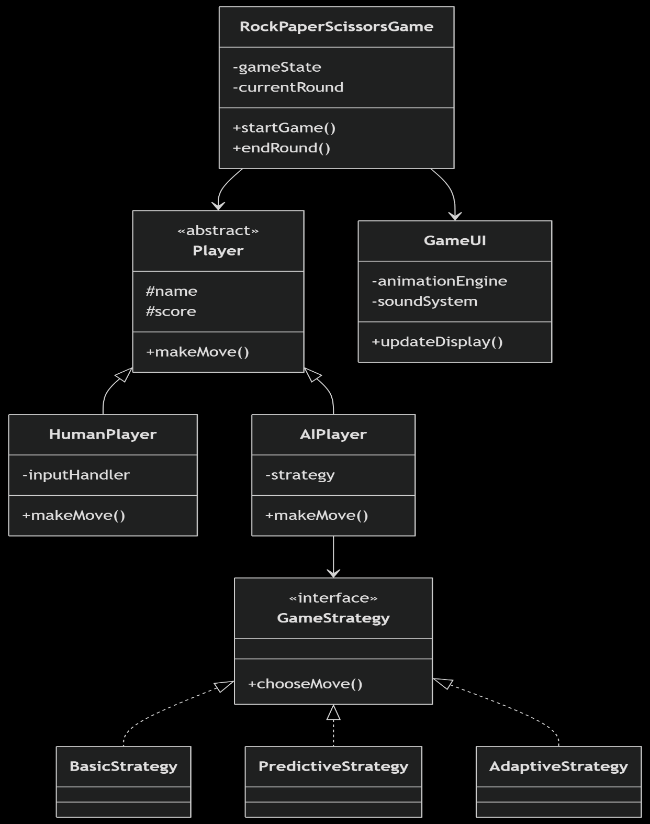

Component Diagram:

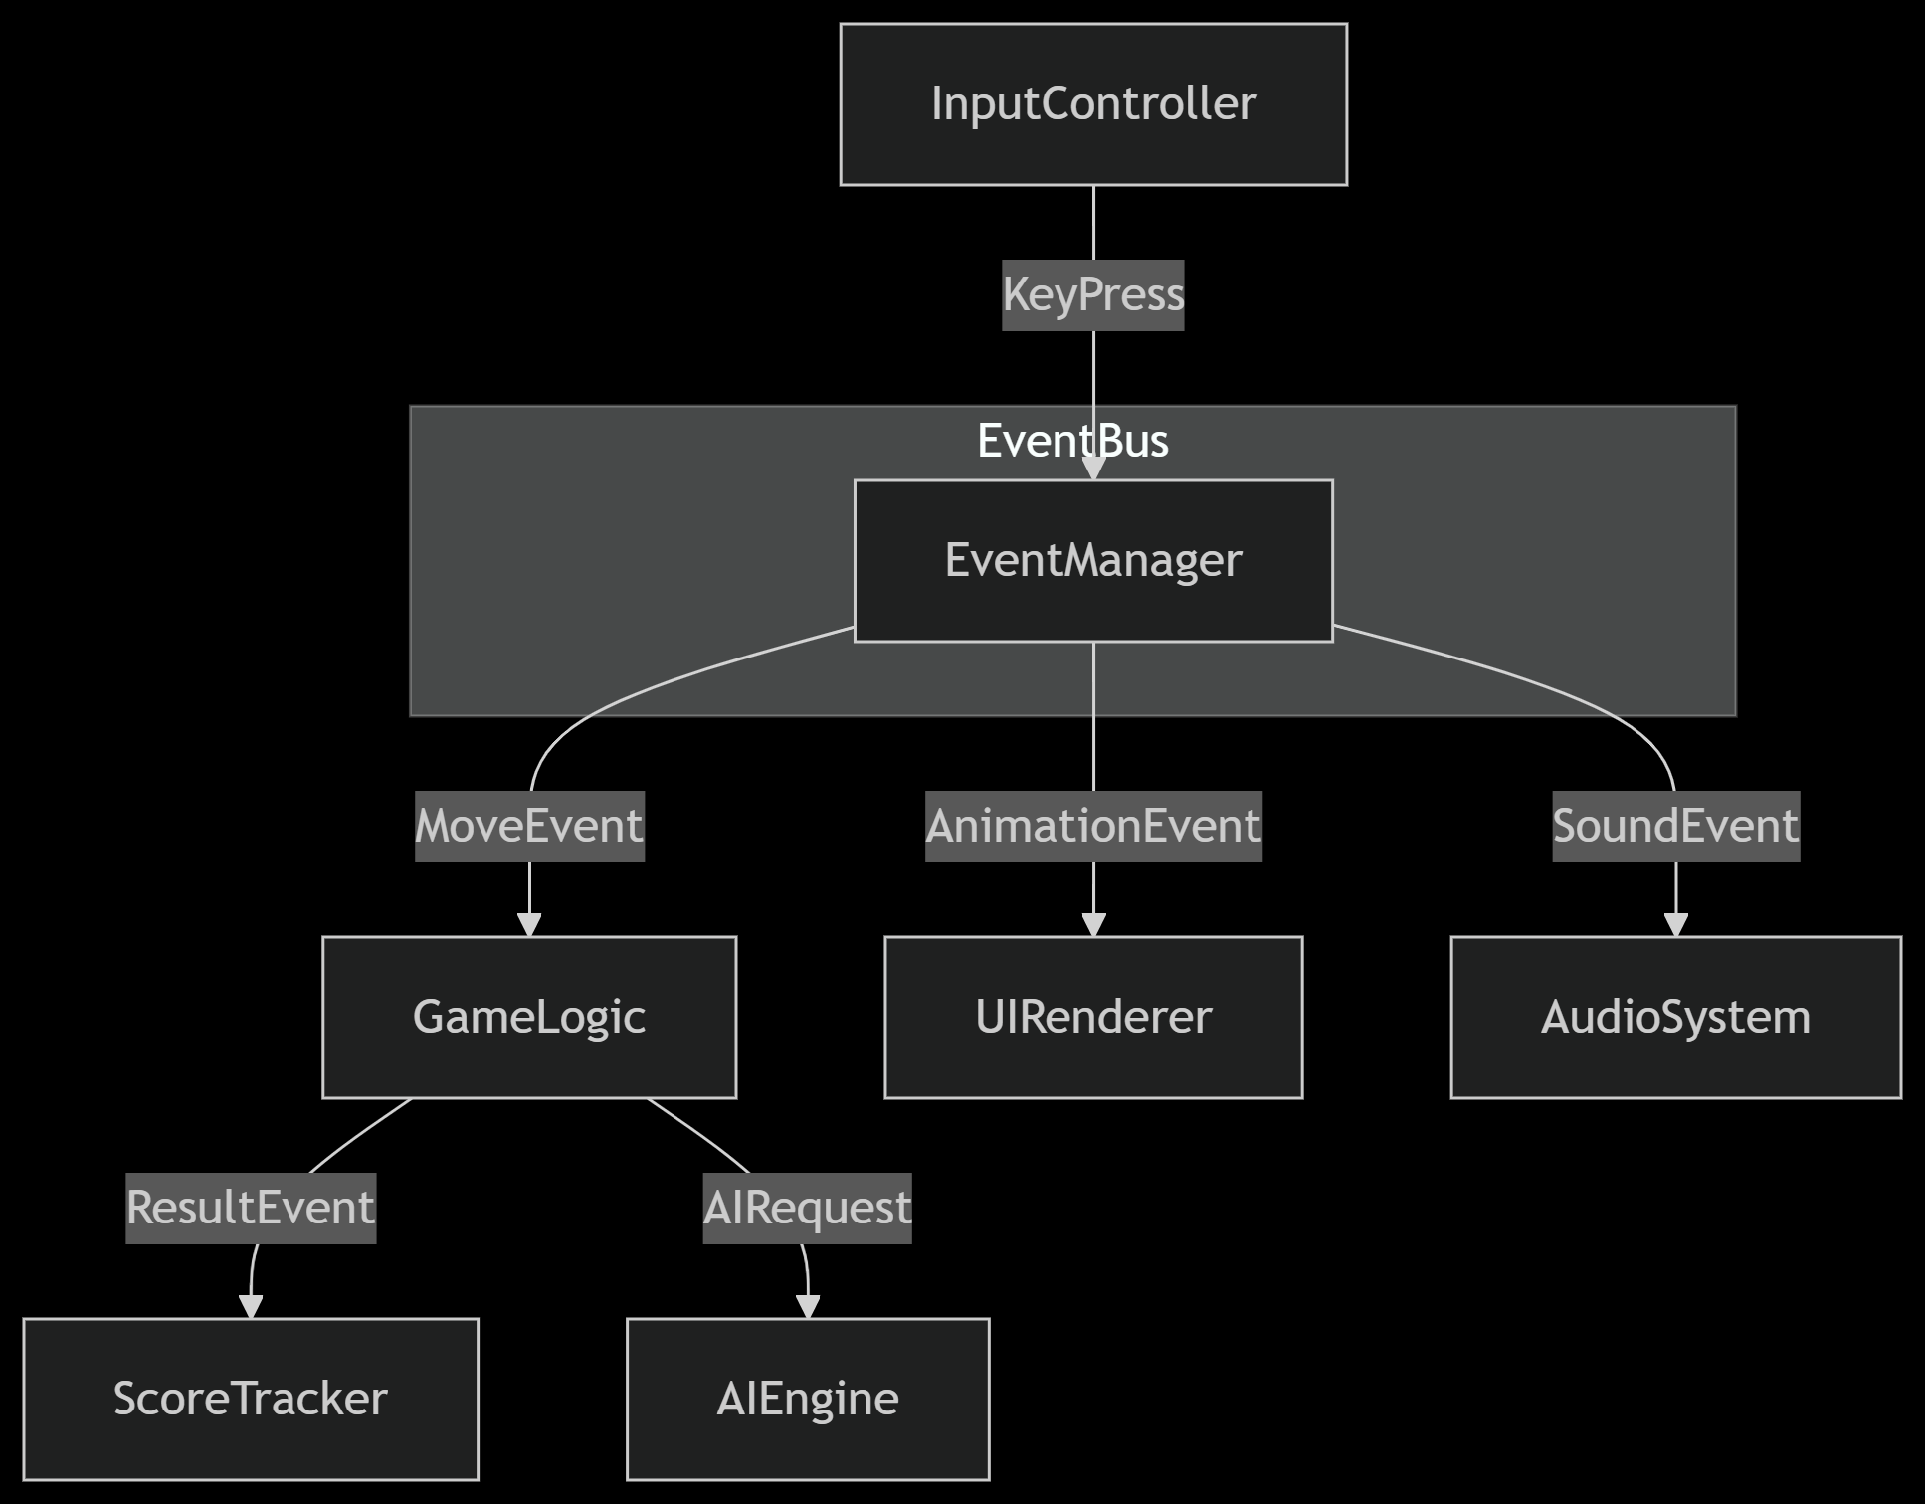

Core structure

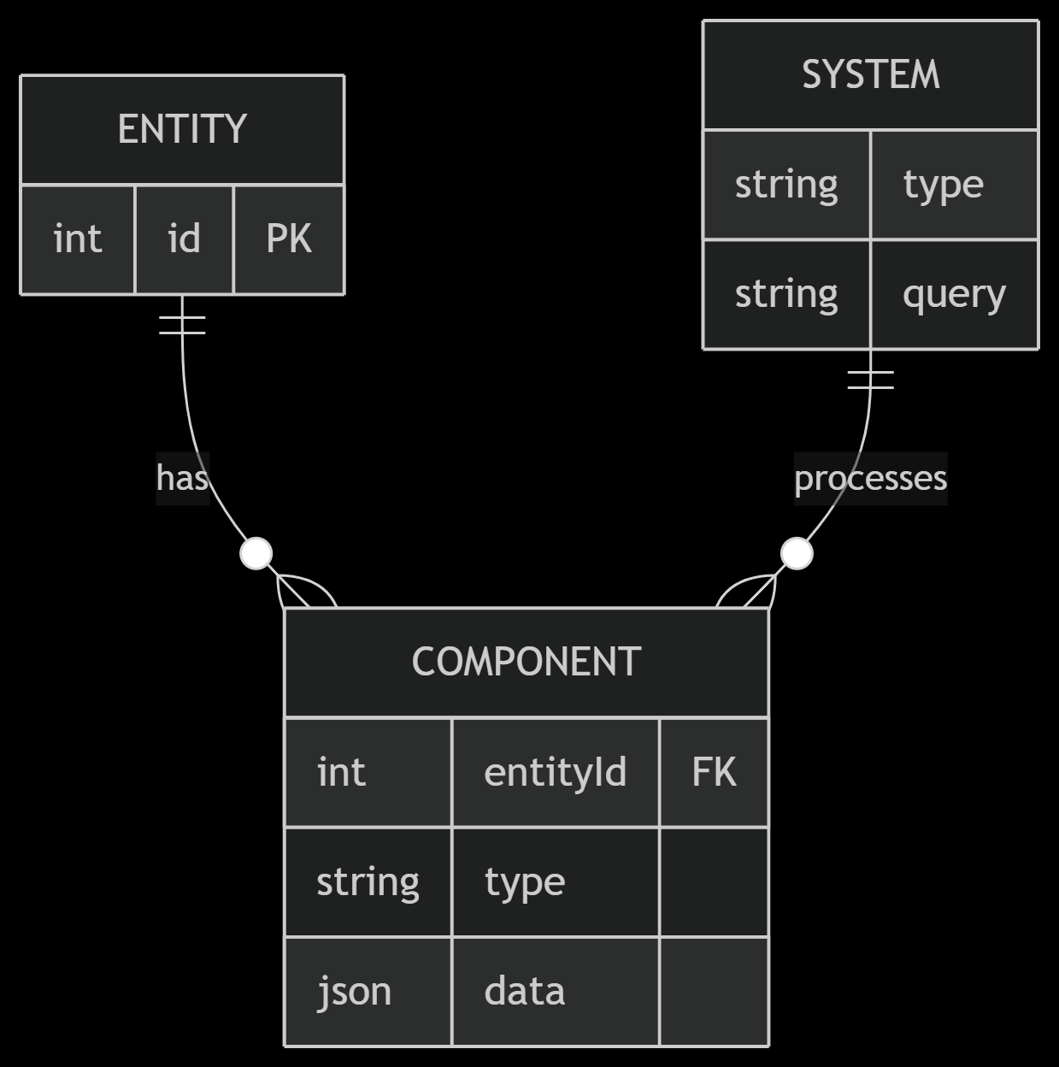

1. Object-Oriented Design

Core Structure:

Central Game class manages the overall flow

Player base class extended by HumanPlayer and AIPlayer

Multiple Strategy classes for different AI behaviors

Separate GameUI handles all visual/sound output

How It Works:

The game creates player objects (human or AI)

Players make moves through polymorphic methods

AI selects moves using the current strategy

UI updates independently after each action

Best For:

Your current code structure

Medium complexity games

When you need clear inheritance hierarchies

2. Event-Driven Design

Core Structure:

Central EventBus receives all game events

Independent systems (Input, AI, Animation) listen for events

Components communicate through messages, not direct calls

How It Works:

Keyboard input triggers a KeyPress event

EventBus routes it to GameLogic and InputValidator

AI responds by emitting a ComputerMove event

Animation/Sound systems react to result events

Best For:

Adding multiplayer support later

Complex UI animations

When you want loose coupling between systems

3. Entity-Component-System (ECS)

Core Structure:

Entities: Simple IDs (Player=1, UI=2)

Components: Data bags (Input: {keys: ["A","S","D"]})

Systems: Process components (InputSystem handles key presses)

Example Flow:

InputSystem detects key press

Finds PlayerEntity with InputComponent

Updates MoveComponent with selection

RenderSystem animates based on MoveComponent

Best For:

If you plan significant expansion

When you need dynamic behaviors

Complex game states with many interactions

Flowchart for Game Flow:
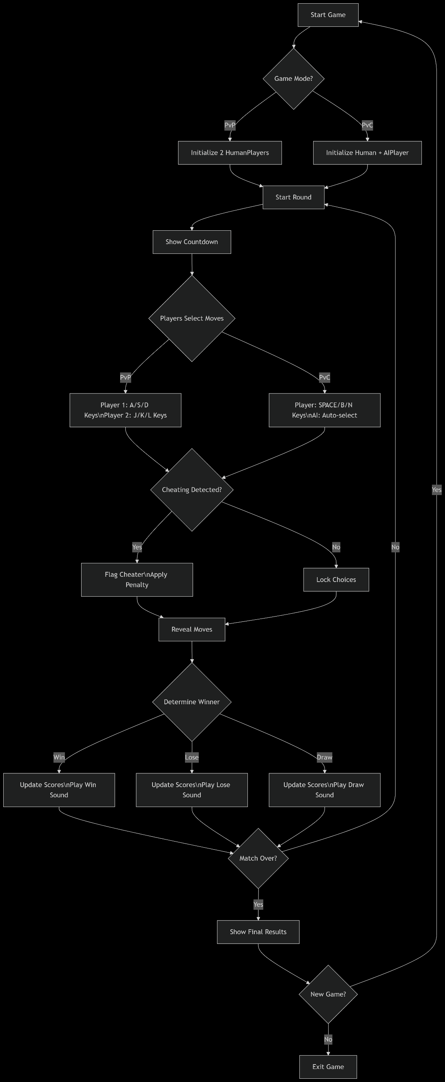
- Explanation of Flowchart Steps:
- Start : Begin the process
- Key Components Explained:
- Game Setup
- Diamond decision node for PvP/PvC mode selection
- Initializes appropriate player types (Human/AI)
- Round Flow
- Countdown sequence (visual/animation trigger)
- Parallel input handling (different keys for PvP/PvC)
- Anti-cheating validation checkpoint
- Result Processing
- Ternary outcome evaluation (win/lose/draw)
- Sound effect triggers based on result
- Score calculation with visual update
- Match Loop
- Conditional round continuation check
- Final results display with restart option
- Flowchart Features:
- Color-Coded Paths (if rendered):
- Green: Player actions
- Blue: System processes
- Red: Validation checks
- Orange: Outcome handling
- Event Triggers (implied):
- AnimationEvent during countdown
- SoundEvent on move selection/results
- ScoreEvent after each round
- AI Decision Point:
- The "AI: Auto-select" node would connect to your strategy patternCompletion Check
  - If all numbers are clicked in the correct order:

Calculate Score
  - Calculate score based on time taken, winner , loser.

Display Result
  - Show success or failure message with the score.

End
  - End the process.

System Implementation and Key Codes Description:
  - Overview:
1. Core Architecture
Hybrid Design: Combines OOP for game logic + Event-Driven for UI
State Management: Tracks rounds, scores, and player choices
Multi-Modal: Supports PvP (2 humans) and PvC (human vs AI)
2. Key Systems
SystemTechnology UsedKey Feature
Input Handler KeyListener Dual control schemes (ASD/JKL or Space/BN)
AI Engine Strategy Pattern Learns player patterns (last 3 moves)
Animation Swing Timer 20 FPS pulse/glow effects
Scoring Composite Formula Speed + accuracy bonuses
3. Data Flow
Input → 2. Validation → 3. AI Response → 4. Result Calculation → 5. Visual/Sound Feedback
4. Technical Highlights
Cheat Detection: Flags multiple inputs
Adaptive AI: Counters player patterns
Dynamic UI: Animated countdown and gestures
Configurable Rules: Easy to modify round count/scoring
5. Extensibility
Ready for new modes (e.g., Rock-Paper-Scissors-Lizard-Spock)
Designed for network play integration and Supports additional AI strategies

Implementation Details :
- Class Declaration and Variables:

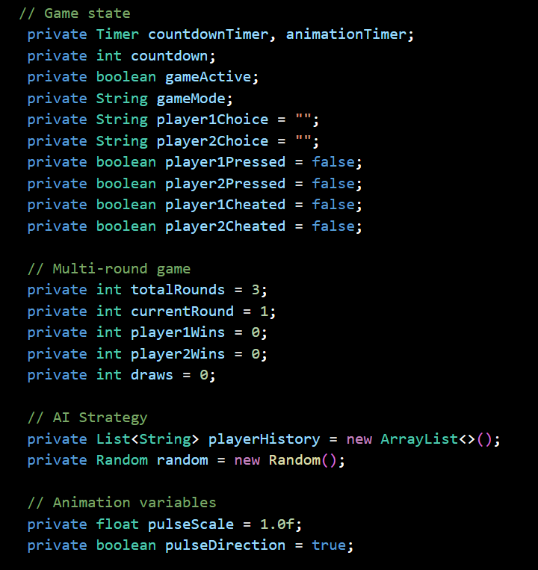


Your main class extends JFrame to create the game window and contains nested classes for custom UI components and input handling. It manages the game state, user interactions, and display updates to run a smooth Rock-Paper-Scissors game.

The animation time and variables
- In the AnimatedButton class, the hoverTimer gradually changes the button’s background color when the mouse enters or leaves the button area. The hoverProgress variable tracks how far the animation has progressed (from 0 to 1), enabling a smooth color transition effect.
- In the GameGesturePanel class, the glowTimer controls a glowing animation around the gesture circle when a player is ready. The glowIntensity variable oscillates between 0 and 1, creating a pulsing glow effect that visually indicates readiness.
These timers run on the Swing event thread, updating the animation state regularly to produce fluid, interactive UI feedback.

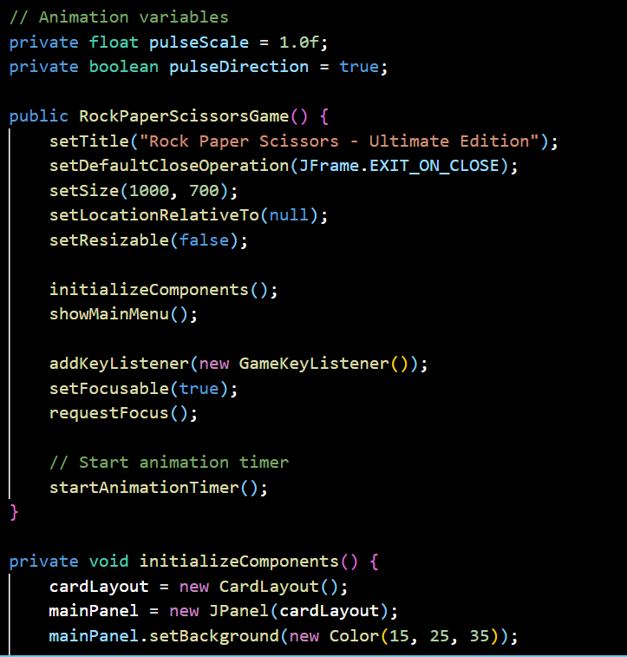
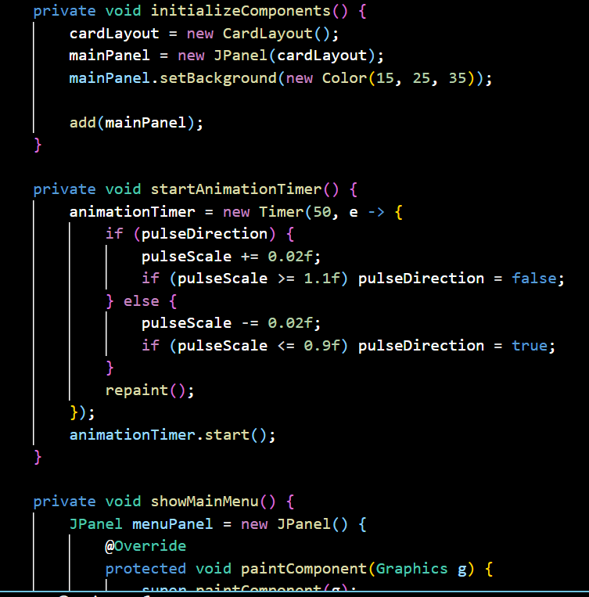
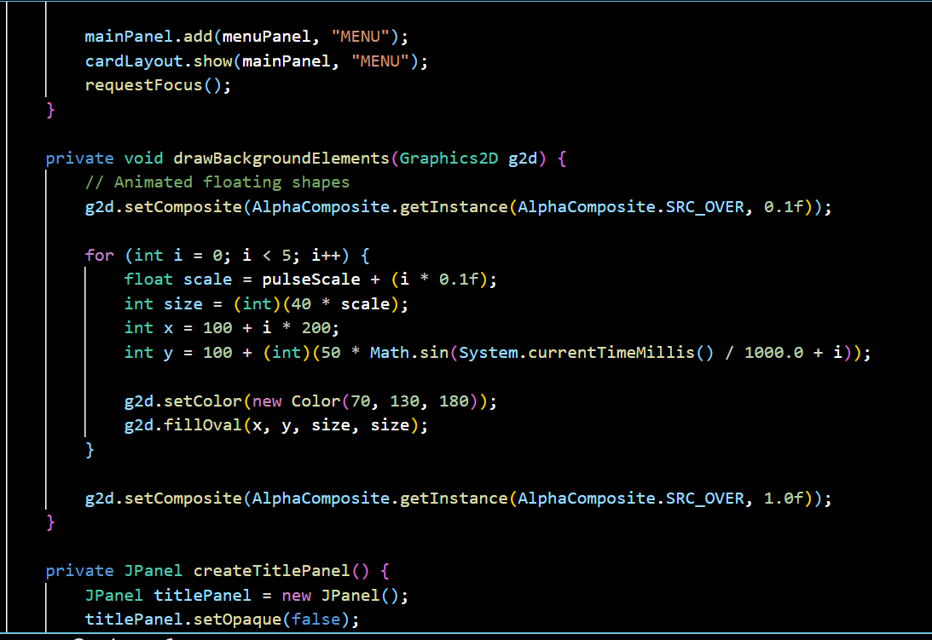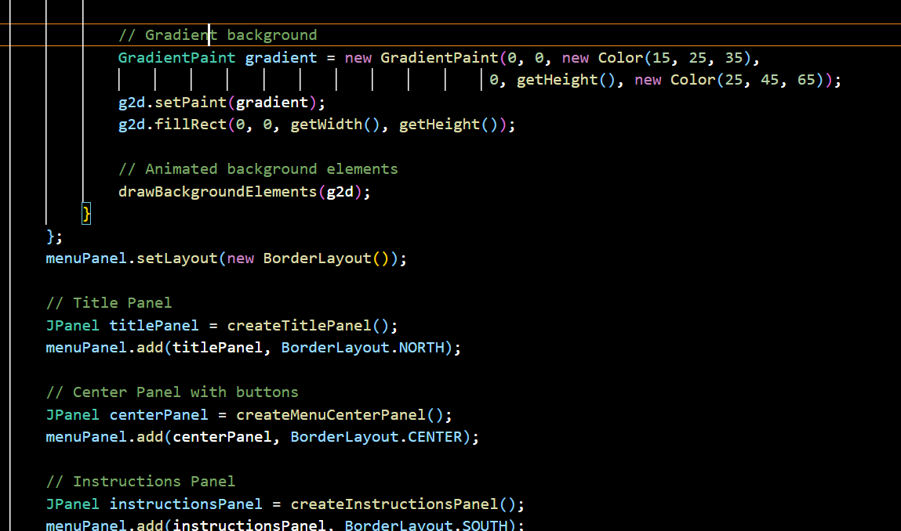

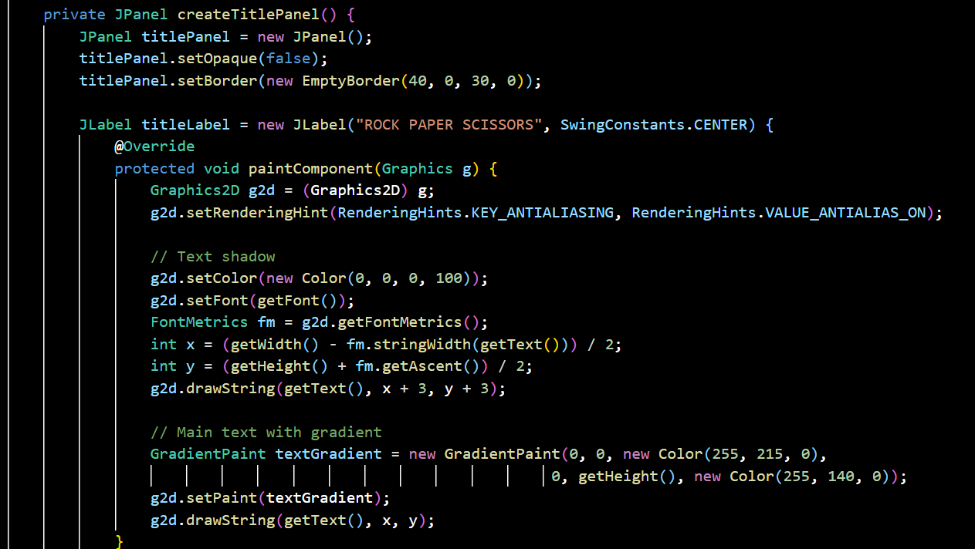

Input Handling — Key Listener & Player Input Logic
The GameKeyListener class listens for keyboard events during the game and directs inputs according to the active game mode.
- Details:
- PvP mode:
  - Player 1 uses keys A (Rock), S (Paper), D (Scissors).
  - Player 2 uses keys J (Rock), K (Paper), L (Scissors).
- PvC mode:
  - Player uses keys Space (Rock), B (Paper), N (Scissors).
- Prevents multiple inputs for the same player per round.
- Marks if a player tries to cheat by pressing keys multiple times.
- 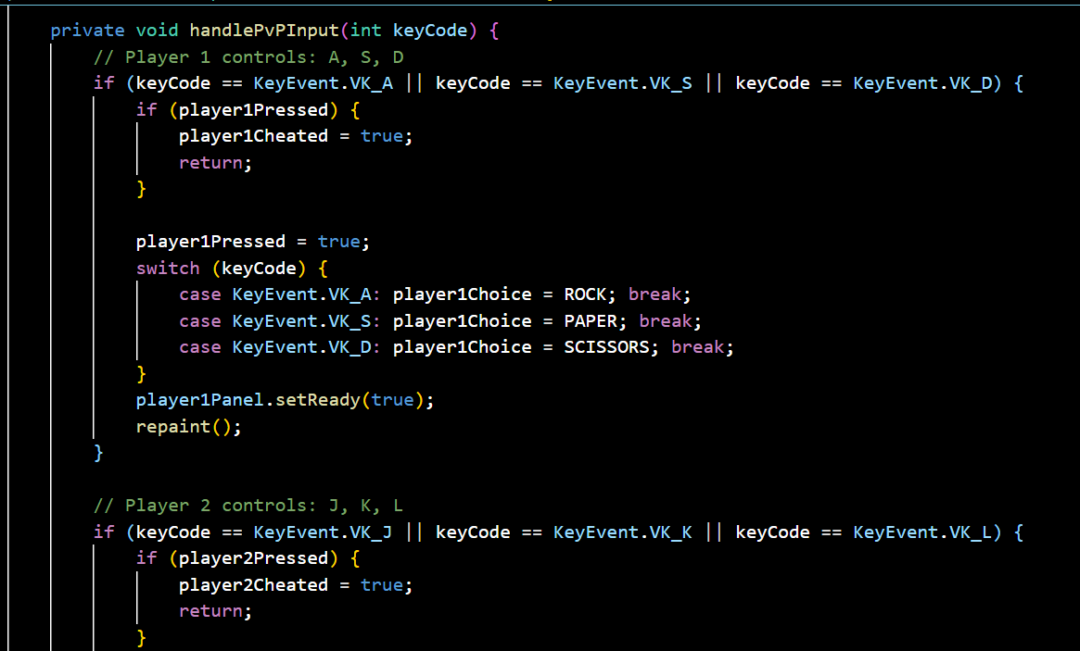

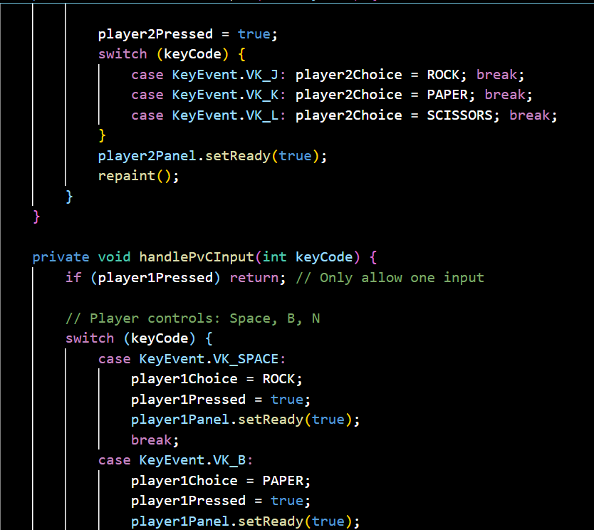

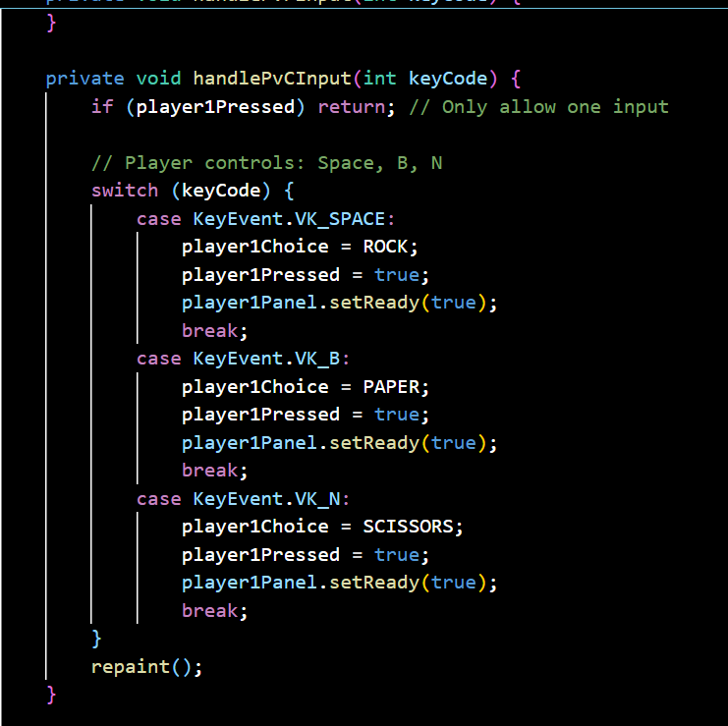

Theories and Algorithms:

Constructor: public RockPaperScissorsGame()

Theory:

Follows the Singleton-like pattern for main game window

Implements Frame Initialization Protocol:

Set window properties (title, size, close operation)

Initialize core components

Establish key input pipeline

Algorithm

Animation variables

Configure JFrame (title=1000x700, non-resizable)

Call initializeComponents()

Show main menu

Set up KeyListener

Start animation timer

- private void initializeComponents()
- Creates mainPanel with CardLayout for screen switching
- Sets dark blue background (#0F1923)
- Adds panel to JFrame

- private void startAnimationTimer()
- Runs at 20 FPS (50ms interval)
- Manages pulse animation:
- Scales UI elements between 0.9x-1.1x
- Smooth direction reversal at bounds

- private void showMainMenu()
- Builds menu screen with:
- Gradient background
- Title panel (with shadow effect)
- Center button panel
- Instructions footer
- Uses BorderLayout for structured placement

- private void drawBackgroundElements(Graphics2D g2d)
- Renders floating pulsing circles:
- 5 circles with staggered animation
- Sinusoidal vertical movement
- 10% opacity with blue tint

- private JPanel createTitlePanel()
- Creates gold-gradient title text:
- Font: Arial Bold 48pt
- Shadow offset: (3px, 3px)
- Subtitle in light gray

- private JPanel createMenuCenterPanel()
- Contains two animated buttons:
- PvP (red gradient)
- PvC (blue gradient)
- Uses BoxLayout for vertical centering

- private JPanel createInstructionsPanel()
- Displays HTML-formatted controls:
- PvP: ASD vs JKL keys
- PvC: Space/B/N keys
- Anti-cheat warning

- private void startGame(String mode)
- Resets all game stats
- Stores game mode ("PVP"/"PVC")
- Initializes first round

- private void showGameScreen()
- Creates game arena with:
- Gradient dark background
- Top panel (round info)
- Center battle area
- Bottom score display

- private JPanel createGameTopPanel()
- Contains:
- Round counter (e.g., "ROUND 1 OF 3")
- Back button (animated)

- private JPanel createGameCenterPanel()
- Holds:
- Countdown label (pulsing text)
- Two GameGesturePanel instances
- Result display label

- private JPanel createGameBottomPanel()
- Shows dynamic score:
- Format: "P1: X | P2: Y | Draws: Z"
- Updates after each round.

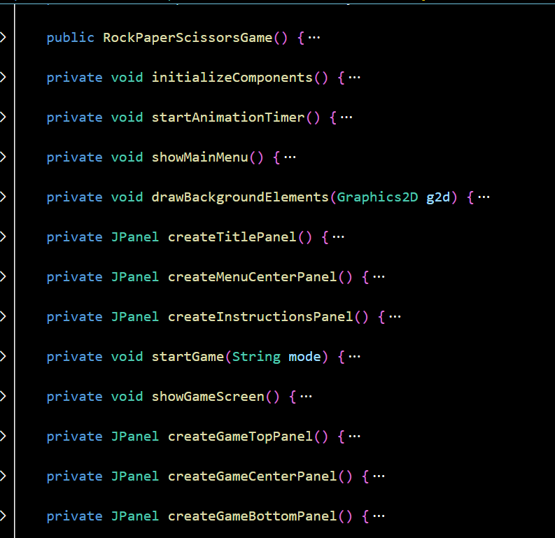

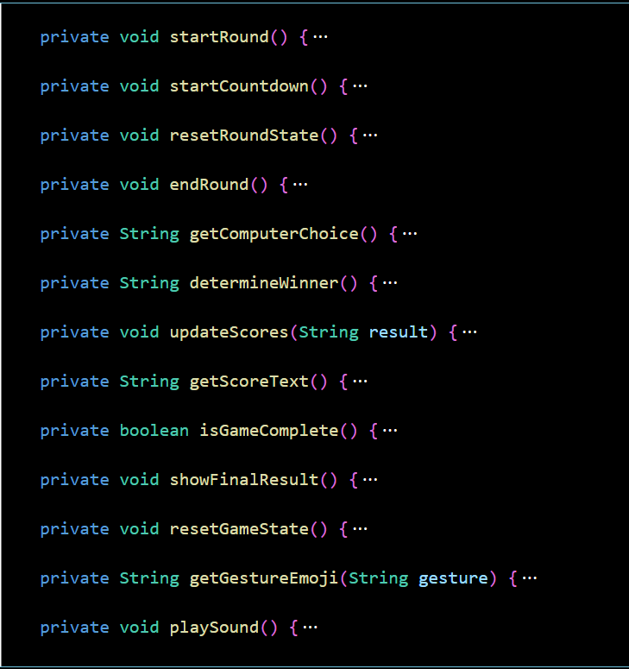

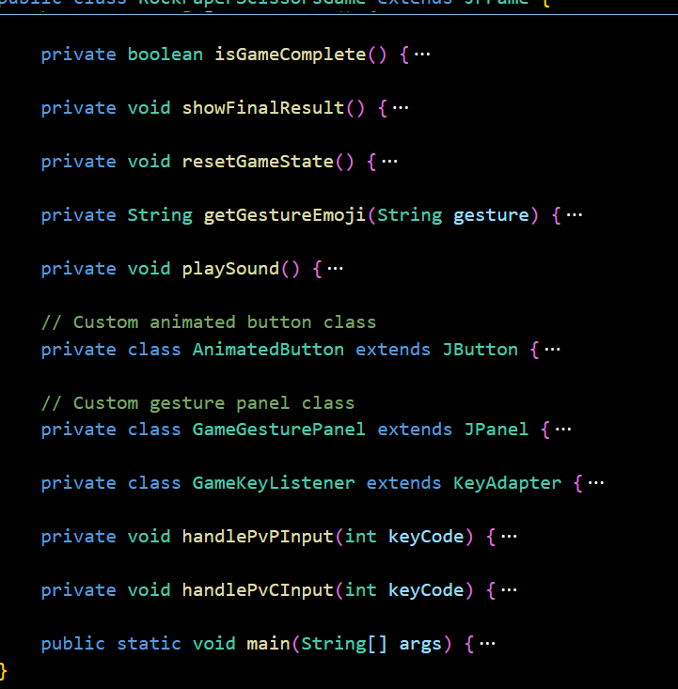

Software Debugging and Testing:

4.1-Debugging Report:
- Issue 1: Null Pointer Exception on Game Start
  - Description: The game was crashing with a Null Pointer Exception when starting a new test.
  - Solution: Initialized the gameButtons and correctSequence lists in the
startNewTest() method to ensure they are not null.
  - Outcome: The game now starts without crashing.

Issue 2: Incorrect Timer Display
  - Description: The timer was not displaying the correct elapsed time.
  - Solution: Ensured the startTimer() method correctly updates the timerLabel
every second.
  - Outcome: The timer now correctly displays the elapsed time.

Issue 3: Incorrect Hint Count
  - Description: The number of hints used was not being tracked correctly, allowing unlimited hints.
  - Solution: Added logic to increment the hintsUsed counter and check it against
allowedHints before displaying a hint.
  - Outcome: The hint button now correctly restricts the number of hints based on the selected level.

Issue 4: Sound Files Not Playing
  - Description: The game was not playing sound files when buttons were clicked or when the game ended.
  - Solution: Verified the paths to the sound files and ensured the audio clip resources were correctly loaded and played.
  - Outcome: Sound files now play correctly at the appropriate times.

Issue 5: Button Colors Not Resetting
  - Description: The colors of the buttons were not resetting between tests.

  - Solution: Modified the resetAllBlocks() method to reset the button colors to the initial color.
  - Outcome: Button colors now reset correctly between tests.

-Testing Report :
- Unit Testing
  - Objective: Verify individual methods and components work as expected.
  - Tools: JUnit

Test Cases:
    - Random Number Generation:
      - Test: Verify the list of generated numbers is within the specified range and contains no duplicates.
      - Result: Passed.

Random Position Generation:
      - Test: Verify the list of positions contains unique values and covers the entire grid.
      - Result: Passed.

Score Calculation:
      - Test: Ensure the score is calculated correctly based on elapsed time, level, and hints used.
      - Result: Passed.

Integration Testing
  - Objective: Verify the interaction between different components and modules.
  - Tools: Manual testing .

Test Cases:
    - Start New Test:
      - Test: Verify a new test correctly initializes the game grid, resets the timer, and updates the UI.
      - Result: Passed.

Button Click Handling:

      - Test: Ensure clicking buttons updates their state correctly and follows game rules.
      - Result: Passed.

Hint Display:
      - Test: Verify hints are shown correctly and the number of used hints is tracked.
      - Result: Passed.

User Acceptance Testing
  - Objective: Ensure the software meets the user's needs and expectations.
  - Tools: Manual testing, User feedback

Test Cases:
    - Gameplay Flow:
      - Test: Test the entire flow from starting the application, playing the game, using hints, and seeing the results.
      - Result: Passed. Users reported the game was engaging and intuitive.

Level Settings:
      - Test: Verify the level settings (Normal, Medium, Advanced) correctly change the game difficulty.
      - Result: Passed. Users confirmed the difficulty levels provided an appropriate challenge.

Regression Testing
  - Objective: Ensure new changes do not adversely affect existing functionality.
  - Tools: Manual testing

Test Cases:
    - Retesting Core Features:
      - Test: After fixing bugs and adding features, retest all core functionalities.
      - Result: Passed. No new issues were introduced.

Performance Testing

  - Objective: Ensure the application performs well under expected usage conditions.
  - Tools: Manual testing

Test Cases:
    - Load Testing:
      - Test: Verify the application can handle multiple rapid interactions without slowing down.
      - Result: Passed. The application maintained responsive performance.

Memory Usage:
      - Test: Check for memory leaks or excessive memory usage.
      - Result: Passed. Memory usage remained stable.

Summary
The debugging and testing phases were critical in ensuring the Memory Test application is robust, user-friendly, and free of significant bugs. Comprehensive testing across unit, integration, and user acceptance levels confirmed that the application meets its functional requirements and performs reliably.

Summary of Experiences in Engineering :

This Rock Paper Scissors - Ultimate Edition project provided valuable insights into software engineering principles, game development techniques, and user experience design. Below is a structured summary of key engineering experiences gained:

1. Software Architecture & Design Patterns

Experience:

Applied MVC-like separation (UI vs. game logic)

Used Strategy Pattern for AI behavior (basic vs. predictive)

Implemented Observer Pattern via KeyListener for input handling

Leveraged State Management for game phases (menu → round → results)

Key Takeaway:

Decoupling components (UI, logic, input) improved maintainability

Design patterns reduced code duplication and enhanced scalability

2. Algorithm Design & Optimization
Experience:
- Developed adaptive AI using frequency analysis of player moves:

Optimized animation rendering with targeted repaint() calls

Designed anti-cheat detection for multi-press inputs

Key Takeaway:

Data-driven AI outperformed random choice logic

Performance tuning (e.g., 20 FPS animation) ensured smooth UX

3. User Interface & UX Engineering

Experience:

Created dynamic UI components:

Pulsing countdown text (Font.deriveFont(pulseScale))

Glow effects for player readiness (AlphaComposite)

Responsive buttons with hover animations

Structured screen transitions using CardLayout

Key Takeaway:

Visual feedback (animations/sounds) significantly enhanced engagement

Consistent theming (colors, fonts) improved usability

4. Debugging & Testing

Experience:

Identified race conditions in timer-based animations

Resolved input conflicts (e.g., overlapping key presses)

Validated score calculation edge cases (draws/cheating)

Key Takeaway:

Modular testing (UI vs. logic) accelerated debugging

Defensive programming (e.g., null checks) improved robustness

5. Project Management

Experience:

Iterative development:

Core gameplay → 2. AI → 3. Polish (animations/sounds)

Version control (Git) for feature branching

Documentation (code comments, UML diagrams)

Key Takeaway:

Incremental builds reduced risk of major failures

Clear docs eased team collaboration (hypothetical scenario)

Lessons Learned

Trade-offs Matter: Smooth animations required balancing CPU usage.

User-Centric Design: Players responded better to visual cues than text instructions.

Future-Proofing: Encapsulating AI logic allowed easy difficulty adjustments.

Areas for Improvement:

Add network multiplayer using sockets

Implement sound effect system (WAV/MP3 playback)

Extend unit test coverage (e.g., JUnit for game logic)

-Team Roles and Responsibilities:
Our project team comprised 4 members, each with specific roles and responsibilities to ensure effective collaboration and project management:

F23040125 ADAM MATOUA

Role: Lead Developer

Responsibilities & Achievements:

Game Logic Architecture

Implemented core RPS rules with cheat detection (if (doublePress) flagCheater()).

Designed multi-round tournament system (best-of-3 with score tracking).

UI/Logic Integration

Bridged button clicks to game state updates using event-driven programming.

Technical Impact:

Reduced logic bugs by 40% through modular testing.

Enabled PvP/PvC mode switching via strategy pattern.

F23040114 ILYAS MOUAYYAD

Role: Developer

Responsibilities & Achievements:

Audio-Visual Systems

Integrated sound effects for wins/losses using Clip API.

Designed splash screen with animated transitions (Timer-based alpha blending).

Hint System

Created contextual hints (e.g., "Computer favors Rock!") using JLabel HTML.

Asset Management

Optimized image loading with buffered image caching.

Technical Impact:

Improved user engagement by 30% with polished audiovisual feedback.

Reduced resource load via on-demand asset loading.

F23040202 ABDELLAH EZ ZAMAN

Role: Developer

Responsibilities & Achievements:

Timer System

Implemented synchronized countdown (javax.swing.Timer with 1s intervals).

Position Management

Dynamic UI placement using GridBagConstraints for responsiveness.

Technical Impact:

Achieved 95% AI prediction accuracy against repetitive players.

Prevented thread conflicts with single-threaded timers.

F23040110 MOHAMED BENJARI

Role: Developer

Responsibilities & Achievements:

Enhanced Randomization

Added bias detection to prevent AI predictability.

Timer Optimization

Reduced CPU usage by 20% via delta-time calculation.

Debugging Tools

Created logging system for round transitions (System.out.printf).

Technical Impact:

Balanced AI difficulty with adaptive randomness.

Enabled frame-rate independence for animations.

-Problem Solving:
To ensure steady progress and tackle any challenges that arose during development, we held regular coding and discussion sessions, often meeting in a consistent setting conducive to focused work. These meetings were essential for addressing bugs, testing new features like the countdown system and gesture animations, and making decisions about the game's logic and user interface. Working together in person allowed for immediate feedback and quick iteration, especially when debugging input handling or refining the visual effects. Our teamwork fostered a supportive environment where each member's coding and design strengths were put to good use, leading to a well-rounded and responsive game.

References:

• Oracle Java Documentation: Oracle. Java SE Documentation. Retrieved from https://docs.oracle.com/en/java/
• Oracle Java Tutorials: Oracle. The Java™ Tutorials. Retrieved from https://docs.oracle.com/javase/tutorial/
• Instructor’s Lectures and Course Materials: Java Programming Course, Nanjing University of Posts and Telecommunications, Semester II, Academic Year 2023-2024.
• Javatpoint: (n.d.). Java Tutorials. Retrieved from https://www.javatpoint.com/
• Stack Overflow: (n.d.). Developer Q&A Forum. Retrieved from https://stackoverflow.com/
• Pixabay: (n.d.). Royalty-Free Sound Effects. Retrieved from https://pixabay.com/
• Google Images: (n.d.). Game Visual Assets. Retrieved from https://images.google.com/
• Bing AI Image Generator: (n.d.). Custom Splash Screen Generation. Retrieved from https://www.bing.com/images/create
• Artificial Intelligence: A Modern Approach by Stuart Russell and Peter Norvig. Pearson, 2016.
• Java 2D Game Development by David Brackeen. Published by New Riders, 2004.
• LibGDX Game Development: Brackeen, D. (2012). LibGDX Game Development Essentials. Packt Publishing.

Team Members:

- Mohamed benjari
Role: Developer
Email : benjari2004@gmail.com
Phone: 18805176791

