Calibrating on the wrong ground

Replicating a commercial lidar workflow with open tools, and finding that the test set had been selecting against the terrain that mattered
Benjamin Jay Britton, 20 September 2026
Replicalm reproduces the NCALM bare-earth workflow described in the Estrada-Belli et al. 2025 supplementary material using PDAL, GDAL, NumPy and SciPy, with no TerraScan, ArcGIS Pro, Golden Surfer or paid LAStools module. The point of the exercise is that the published method cannot be run without those licenses, so its results cannot be reproduced or extended by anyone who lacks them.
This post is about the part of that work which was not a porting exercise. The pipeline was tuned against reference surfaces from the original workflow, it scored well, and it produced a visualization with a large and obvious artifact in it. The artifact was not in the parameters. It was in how the parameters had been chosen.

The workflow
Given a point cloud, produce a bare-earth raster:
1. tile at 1 km with a 10 m buffer, per the source 2. classify ground with filters.smrf 3. flag low outliers 4. compute height above the ground model with filters.hag_delaunay, apply the source's −0.5 m / 600 m cuts and its ±0.2 m class 8 band 5. krige onto a declared grid 6. fill enclosed holes, trim the one-sided coverage fringe, write with the black-means-nodata convention and a mask band
Steps 1, 4 and the export are the source's numbers unchanged. Steps 2 and 5 are translations, because no free tool implements TerraScan's progressive TIN densification with its four-parameter surface, and the translation is where the interesting failure lived.

Calibration said one thing
The harness cut a 400 m window from each of three tiles, swept classifier settings, and scored RMSE and terrain complexity against the reference. It chose cloth simulation (filters.csf, rigidness 2) over SMRF on the tile with known structures, one ground pass instead of the source's two, and the noise filters switched off — each by a clear margin on the score it was given.
Rendered at tile scale, that configuration produced this:
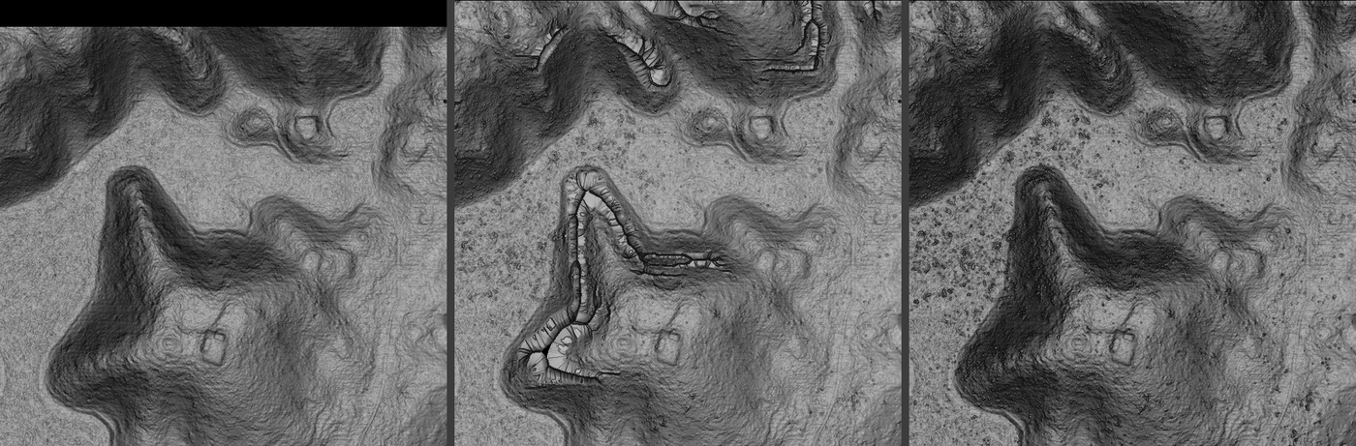
Archive, flat-calibrated output, and the locked baseline over a mound group
Left: the archive G1 from the original workflow. Center: the flat-calibrated configuration. Right: the locked baseline. Same point cloud, same 0.5 m grid.
The beaded necklaces along the mound flanks in the center panel are not in the data and not in the archive. They are runs of cells pinned to a local extreme where the interpolator could find no ground returns nearby.

The diagnosis went wrong twice before it went right
First hypothesis: the kriging fallback guard. krige_grid rejected any estimate falling outside the range of its neighbors, on the stated grounds that ordinary kriging interpolates and cannot legitimately extrapolate. That premise is false — OK weights sum to one but are not constrained positive, and a cell near the top of a slope should estimate above all its neighbors. The guard did fire preferentially on steep ground (8.2% of cells above 30° against 0.17% on the flat) and diverted them to inverse distance, which is a convex combination and therefore clamps. The mechanism was right and the magnitude was not: removing the guard moved window RMSE from 0.564 to 0.551.
Second hypothesis: the search radius. A ladder from 14.4 m down to 1.5 m cut window RMSE by 4.2×, which looked decisive. It was an artifact of the scoring: fill fraction fell from 97.4% to 85.4% across that ladder, and the cells being dropped were the steep ones. Re-scored on a fixed cell set that every radius could solve, radii from 3 to 14.4 m are identical to three decimals, and 1.5 m is slightly worse.
``` radius own fill rmse 20-30deg 30-90deg (same cells every row) 14.40 100.0% 0.057 0.51% 1.79% 8.00 98.9% 0.057 0.51% 1.79% 5.00 97.5% 0.057 0.51% 1.79% 3.00 95.7% 0.057 0.51% 1.79% 1.50 93.1% 0.065 1.24% 3.12%
`
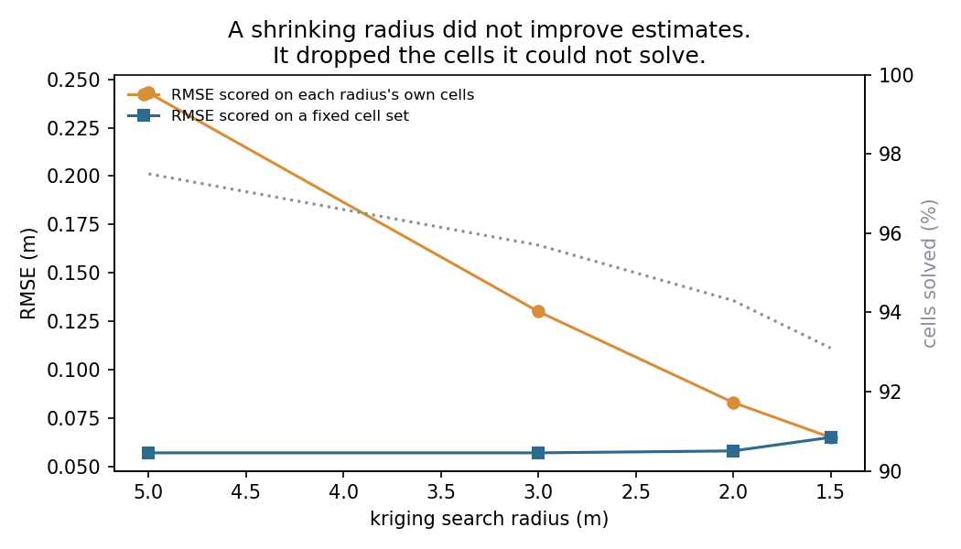
RMSE against search radius, scored two ways
The same six runs scored two ways. Against each radius's own output the error falls steeply; against a cell set every radius can solve it is flat. The dotted line is the share of cells solved, and it is the whole explanation.
What it actually was. The cells that failed had a median of 74 returns within 1.5 m and zero classified as ground. The returns were there; the classifier was discarding them.
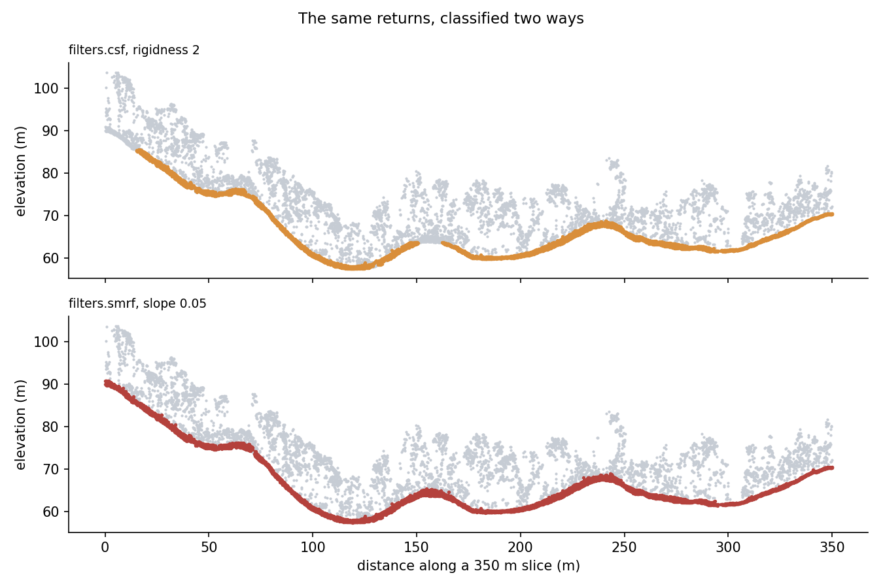
The same returns classified by CSF and by SMRF
A 3 m slice through the mound group, same returns in both panels. Gray is every return; color is what each filter kept as ground. CSF abandons the steep left flank entirely — nothing before 15 m — and breaks again at 150 m and 240 m. SMRF tracks the surface continuously across all of them.
Ground fraction fell from 45% on flat ground to 28% above 30°, and to nil on the flanks — a rigidness-2 cloth cannot drape a 30° mound face, so the flank returns sit further below it than the threshold allows and are never ground.
``` arm gnd/m2 steep support window rmse csf_r2 (chosen) 4.16 67.8% 0.294 csf_r1 4.46 81.1% 0.242 smrf_s05 4.96 100.0% 0.049
`
Loosening the cloth helps and does not close it. The instrument was wrong.

Why the calibration could not have found this
Error is not distributed evenly over terrain. On this tile, 97.7% of all cells more than 0.5 m from the reference sit on slopes above 10°, which are 15.5% of the tile.
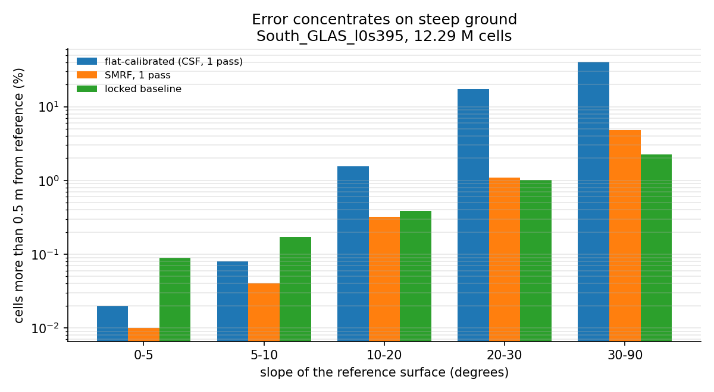
Error against slope for three configurations
Below 10° every configuration tried agrees to within 0.08% of cells. Above 30° they range from 2.25% to 40.38%. Flat ground cannot distinguish them.
And the harness selected for flat ground. best_window picked the 400 m window with the highest reference coverage — which finds open, fully-covered terrain by construction. Measured after the fact:
``` tile coverage-selected relief-selected cov steep cov steep l8s431 94.9% 0.13% 92.7% 3.92% l0s444 86.7% 0.17% 80.1% 2.93% l0s395 97.9% 0.20% 82.0% 28.26% l2s444 95.1% 0.00% 90.9% 11.28% l2s443 95.2% 0.02% 87.2% 2.53%
`
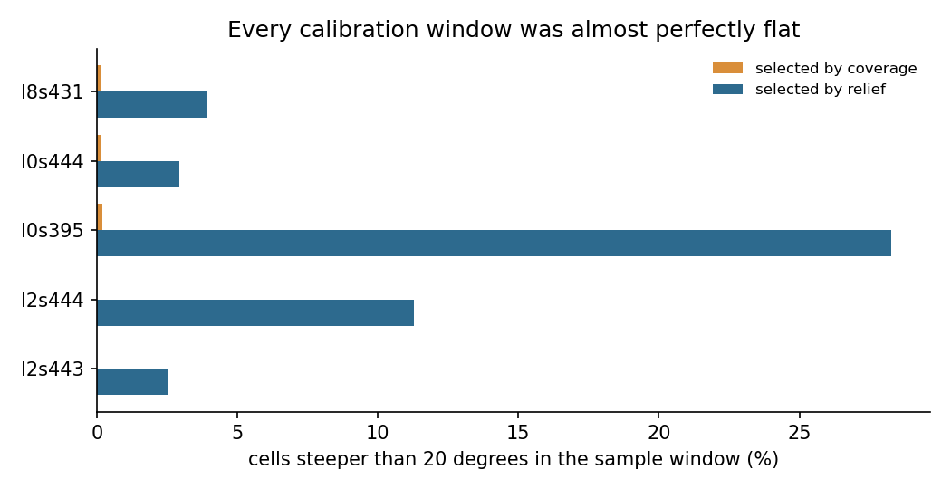
Steep-cell content of calibration windows, by selection rule
Every calibration window contained between 0.00% and 0.20% steep ground. The sweeps were not under-weighting slopes; they had none. A classifier sweep across eight tiles that produced no clear default was measuring flat ground eight times, where there is no default to find.
Re-run on relief-selected windows, the answer is not ambiguous:
``` arm tiles support over30 terrace rmse smrf_1pass 6 98.1% 10.18% 2.90% 0.2258 smrf_2pass 6 98.1% 10.34% 2.87% 0.2362 csf_r2 6 79.4% 36.72% 11.96% 0.5286 source verbatim 6 98.3% 17.68% 2.98% 0.4416
`

A second artifact, and a parameter the source could not specify
With the classifier fixed, steep faces still rendered as concentric steps. filters.smrf works on its own grid, cell, left at 1.0 m while the output was 0.5 m. On a near-vertical trench wall a 1 m cell spans a meter of real elevation, so the threshold admits and rejects returns in bands down the face.
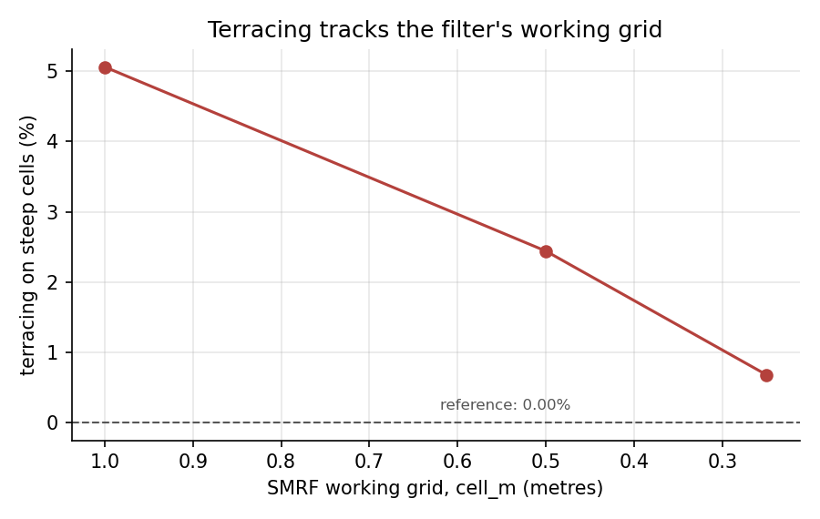
Terracing against SMRF working grid
Terracing — the share of steep cells whose own gradient has collapsed below a quarter of the reference's — halves with each halving of the grid. TerraScan has no equivalent parameter, so the source cannot specify it and the translation has to choose. Tying it to the output cell is the choice with a measurement behind it.
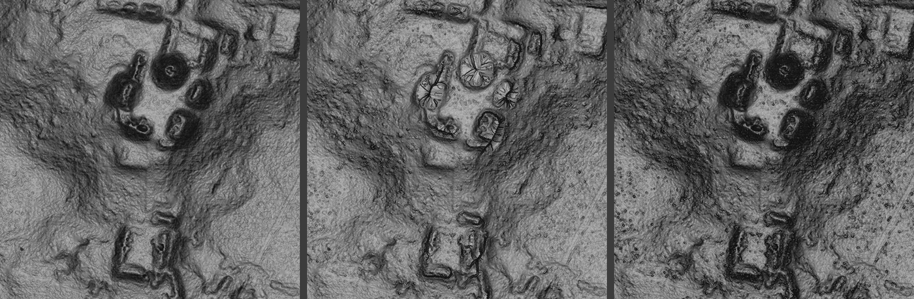
Trench window, three configurations

Where it ended up
Against the reference, tile-wide, on the 12.29 M cells all configurations deliver:
configuration | RMSE | 20–30° | 30–90° | terracing
flat-calibrated | 0.3370 | 17.38% | 40.38% | 9.83%
SMRF, 1 pass | 0.0678 | 1.10% | 4.85% | 0.85%
locked baseline | 0.0601 | 1.01% | 2.25% | 0.26%
archive | — | — | — | 0.00%

Median difference from the reference is 1.5 mm. Coverage is 99.56%, unchanged across configurations — none of the improvement is bought by dropping cells.

Three results worth carrying elsewhere
The variogram has no range to derive anything from. Fitted at max-lag windows of 5 to 80 m on ten tiles, the range tracked the window every time at 0.30–1.44× its width and the sill grew 3× to 140× without plateauing. The radius_from_variogram helper was returning ~1.4 × max_lag and presenting it as a measurement. The baseline sets the radius from point density instead, and says so.
max_points is the real neighborhood control, not the radius. At 4 ground points per m² the 16th neighbor is within ~1.2 m, so the cap binds and 5 m and 20 m radii give identical results to four decimals. The radius acts only where points are sparse — which is the coverage boundary, where the one-sided fringe is one radius wide and carried a third of the tile's error budget.
Thinning dense tiles buys provenance, not accuracy. At 8.18 pts/m², 76% of cells fell back to inverse distance because the 16 nearest neighbors sit within 0.8 m and the matrix loses rank. Declustering drops the fallback to 0.3% and moves RMSE by 0.002 m. It buys a working covariance model and the right to call the output kriged. It does not buy elevation accuracy.

What is still open
One comparison on the trench window produced a 2× difference in RMSE and a 10× difference in terracing that no isolated variable has yet accounted for. It was attributed to the two-pass structure, then to the noise filters, and both attributions were wrong — three variables differed in that comparison and it was treated as two, twice. The remaining candidate, the SMRF slope term, has not been swept on terrain where terracing is visible. The accepted output uses slope = tan 9° = 0.1584, so the baseline may be correct by inheritance rather than by measurement.
That, and four other unresolved items, are recorded in docs/open_observations.md.

The locked baseline
setting | value
ground filter | filters.smrf, one pass
slope | 0.1584 (tan 9°, the source's pass-1 iteration angle)
threshold | 0.5 m (source: 3.0 m — does not transfer)
working grid | 0.5 m, tied to the output cell
ELM | off — removed 0.00% of points on every window tested
statistical outlier | on — effect is tile-dependent
search radius | scaled to density, ceiling 20 m (the source's figure)
neighbors | 16

config.verify_baseline() raises if a configuration has drifted from these, so a production run stops rather than silently producing something else.

The general point
The pipeline was never badly parameterized. It was well parameterized for the ground it was shown, and it was shown the wrong ground — because the window selector optimized for coverage, and coverage is highest exactly where terrain is flattest. Archaeological features are not on flat ground. The selection rule and the target were in opposition, and nothing in the scores could reveal it, because the scores were computed on the terrain the rule had chosen.
The fix was not a better score. It was a harder test set.

