The specks were the forest

An archaeologist notices freckles on a plaza floor, and the fix turns out to be upstream of everything I was looking at
Benjamin Jay Britton, 22 September 2026
Replicalm reproduces the NCALM bare-earth lidar workflow with open tools — PDAL, GDAL, NumPy, SciPy — so that results depending on TerraScan, ArcGIS Pro and Golden Surfer can be reproduced by people who do not have those licenses. An earlier post covered the part where the test set turned out to be selecting against the terrain that mattered.
This one starts after that was fixed, with a surface that matched the reference to 0.0601 m RMSE and a visualization that looked right.
Then a closer look at the Pixoyal group: small dark specks scattered across otherwise flat ground, absent from the reference. Freckles. Not obviously wrong, easy to overlook — and exactly the sort of thing that makes an archaeologist hesitate over whether a faint mark is a low platform or an artifact of processing.
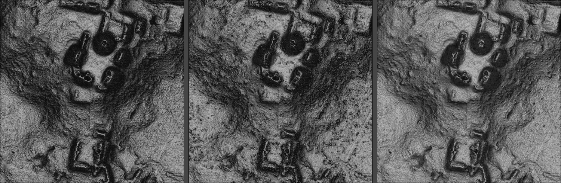
The Pixoyal group: original workflow, baseline, Clear
Left: the original commercial workflow. Center: where this post starts — note the plaza floors. Right: where it ends.

What they were made of
Measuring before theorizing, on a 500 × 500 cell window:
``` median cluster size 1 cell our surface above the reference 78.9% of them, median 2.6 cm local roughness there 0.0768 m vs reference 0.0358 m ground returns within 0.6 m of each median 5 their height above the 3 m local median +5.8 cm, 76.2% positive their scatter among themselves 8.8 cm
`
Two things stand out. The bias is one-sided — 76.2% positive — and ranging noise is symmetric, so this is not sensor noise. And the returns defining each speck scatter by more than the feature they define: 8.8 cm of disagreement describing a 5.8 cm bump. Signal-to-noise of about 0.66.
So: real returns, sitting genuinely above their surroundings, disagreeing with each other about by how much.

Two wrong answers first
The interpolator. Our variogram fits returned a nugget of exactly zero on 34 of 60 fits across ten tiles, which makes ordinary kriging an exact interpolator — it honors every observation, so anything in the ground class goes straight into the raster. Flooring the nugget smooths it away, and at 4% of sill the surface matched the reference's flat-ground texture precisely.
It was the wrong fix for a reason worth stating: measurement noise alone justifies a nugget of about 0.6%. Matching the reference's flat-ground texture took seven times that. What produced that texture is not documented and we have not established it — but whatever it was, tuning our surface to match it would have meant blurring real micro-relief along with the clutter, rather than removing the clutter.
A measurement trap, while we are here. Speck counts across the nugget arms came out non-monotonic — 5% and 10% scoring far better than their neighbors. That was not the surfaces. G1 normalizes each raster by its own extremes, and one outlier sky-view-factor cell in the 5% arm restretched the entire image. Two arms had been scored against a different tonal mapping than the rest before anyone noticed. Per-raster normalization means two tiles rendered separately are not tonally comparable, which has implications well beyond this sweep.

What they actually are
The decisive evidence came from the flight geometry. Where two source chunks both contribute returns to a speck, they disagree by 0.47 m against 0.11 m on control ground. Mean scan angle is identical to control — 11.5° against 11.2° — so it is not an incidence-angle artifact. And the returns are 11% darker than control ground.
Something at those locations stops pulses at variable heights, independently of viewing angle, and reflects less than soil or limestone. Limestone returns consistently and brightly. Low vegetation — scrub, brush, root mass — returns at whatever height it happens to occupy for a given pulse.
That is the reading the numbers pointed to, and it survived every test aimed at it. It also explains the single-chunk pattern: one pass hits a dense patch of brush at an angle, the overlapping pass finds a gap and reaches the soil, and the two disagree by half a meter about where the ground is.

The labels were in the data all along
The delivered G-LiHT clouds carry TerraScan's own classification. Matching our SMRF ground returns to them by position gives a direct label for every point:
``` our ground returns, by what NCALM called them in specks control all NCALM ground (2) 50.4% 66.2% 65.2% NCALM near-ground (8) 37.4% 33.0% 29.7% NCALM unclassified (1) 12.2% 0.8% 5.1%
`
A 15× enrichment. At speck cells, 12.2% of what we call ground, the original workflow explicitly threw out.
That makes the ceiling computable. Rebuild the surface with exactly those points removed — 3.88% of returns — and:
``` before after flat-ground roughness 1.26x 1.00x the reference specks 3,901 253 RMSE 0.0825 0.0140
`
Wholly a classification residue. Not interpolation, not the nugget, not the search radius, not the slope handling. The freckles were vegetation we were calling ground.

Finding them without TerraScan
Three rules were tried. Two failed in a way worth recording.
Demoting returns that stand above their neighborhood's floor removes 72% of synthetic brush — and 100% of a synthetic rock of the same footprint. A feature narrower than the search radius has neighbors on the flat ground around it, so the floor stays low and the whole feature reads as high. Adding a slope-compensated spread test did no better: 54% of the brush, 92% of the rock, and 0% of brush on a 20° slope.
Using the flight-chunk disagreement directly — the signal that produced the diagnosis — demotes 3.1% of ground returns, touches 3.4% of speck cells and 10.2% of steep cells. It damages architecture three times harder than it cleans flat ground, because on a slope two chunks legitimately sample different parts of the same real surface.
What worked is the rule the synthetic test had condemned. Against TerraScan's labels, height above the local floor separates at d′ = 1.82 — rejected points sit 0.42 m above their patch floor against 0.08 m for kept points. The synthetic test had used a 0.4 m feature against a 0.6 m radius, the pathological case. On real data at a 0.75 m patch it is the best discriminator available.
Clear: demote a ground return standing more than 0.20 m above the tenth percentile of ground returns within 0.75 m.
``` baseline Clear oracle recall of what TerraScan rejected — 92.5% 100% ground returns removed — 17.75% 3.88% flat-ground roughness vs reference 1.26x 0.99x 1.00x specks 3,901 426 253 error above 20 degrees 1.86% 0.29% —
`
Validated unchanged on three windows it was not fitted to. It improves steep ground by 6×, which was the outcome I most expected to go the other way.

Measuring without the answer key
Every number above is referenced to NCALM's output. That is the right frame for a replication and the wrong one for asking whether a surface is accurate — if ours were better, all of those figures would get worse.
So: withhold ground returns, build the surface without them, and measure the residual where those returns actually are. No reference DEM involved. And count returns lying below the modeled surface, since a pulse can be stopped early by vegetation but cannot arrive below the soil.
``` baseline Clear predicts held-out ground returns (MAE) 0.0492 m 0.0429 m returns left below the surface 8.11% 4.80%
`
13% better prediction of real measurements, and the returns left stranded beneath the surface nearly halved. Clear is not merely more archive-like; it is a better account of the ground.
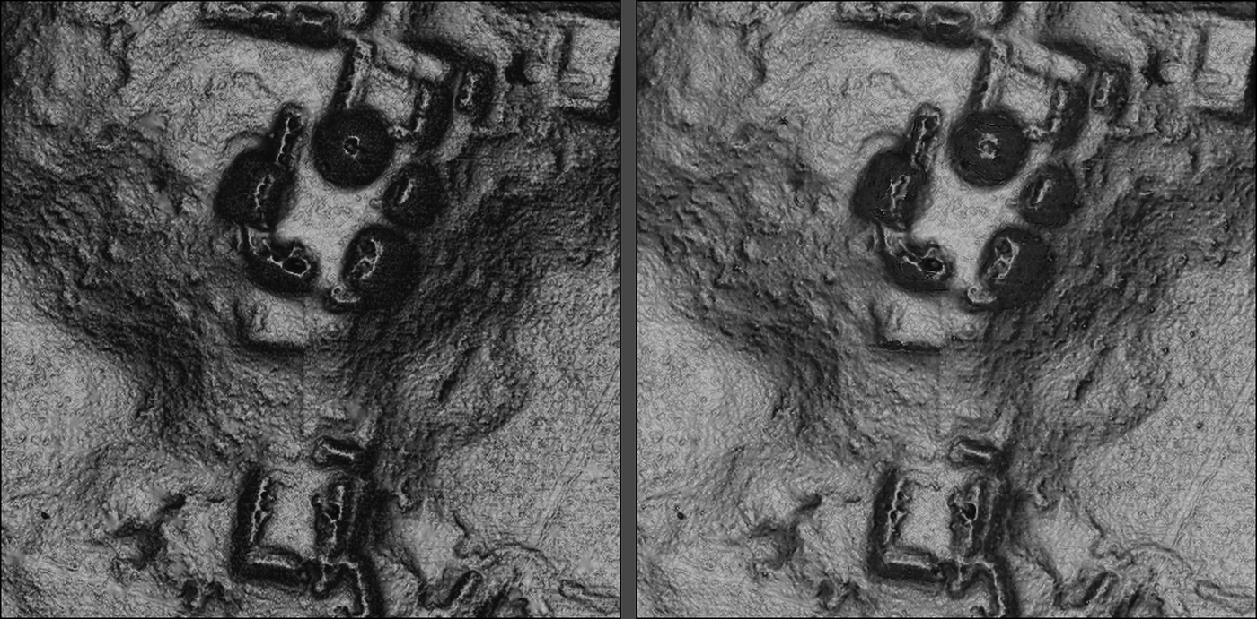
Pixoyal: the original workflow and Clear
Left: the original workflow. Right: Replicalm with Clear.

What it costs, and what is still open
Clear removes 17.75% of ground returns where the oracle removes 3.88%. The difference is collateral — genuine returns, some of them on platform edges, which is why the architecture in the right-hand panel is very slightly softer than the reference. At 4.2 returns per square meter, losing 17.75% still leaves 3.4, which the density work says is ample; but the 14-point gap is the honest measure of not having TerraScan's labels.
Closing it needs a discriminator that separates clutter from small real features. At four returns per square meter, a 0.4 m bush and a 0.4 m rock are each described by about five points with the same geometry. The statistical signal is real; it is not available per point. One avenue remains untried: every test here looked only at returns already classified as ground, and the full return stack — what else that pulse hit, and at what height — is discarded before any rule sees it.

The general point
The specks looked like an interpolation artifact. They were measured as one, theorized about as one, and two fixes were built for them as one. They were vegetation that the ground filter had accepted, and no amount of work downstream of that could remove them — only blur them. The reference surface is smoother than measurement noise alone would account for; how it got that way is not something these measurements can settle.
The thing that broke it open was already in the data: the delivered clouds carry the original classification, and nobody had thought to compare against it. Not a new measurement — a new look at one already sitting in the file.
Full record of what remains unexplained, including three items from this work: docs/open_observations.md
— Benjamin Jay Britton, 2026

